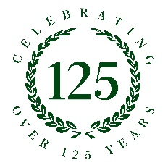
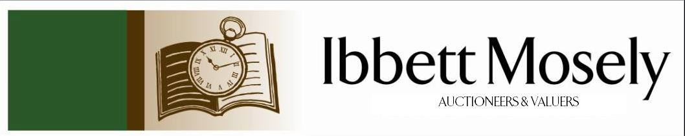

Catalogue of Antiques and Collectibles
to be Auctioned on

Wednesday 2nd September 2026ffff
at 11am

IBBETT MOSELY AUCTION ROOMS
ARGYLE ROAD, SEVENOAKS, KENT TN13 1HJ
And Online Via
www.easyliveauction.com/ibbettmosely/

Viewing at Sale Room on:

Friday 28th August
Tuesday 1st September

Between 10am – 5pm

Catalogues: £2.00

Auctioneer and Valuer: Alan White FNAVA
Auction Clerk and Saleroom Manager: Benjamin Burridge
Photographer and Porter: Samantha Crowe-White

Front Cover: Selection of coins and jewellery including Krugerrand, sovereigns, diamond rings, and gold necklace.

Welcome to Ibbett Mosely Auctions
2nd September 2026 Auction Catalogue

This sale will also be held online at www.easyliveauction.com/ibbettmosely/
please visit the website to register or log in to view and bid. Images and condition reports of each lot are included.

Alternatively, commission bids (bids left ‘on the book’) may be left with us, as well as a limited amount of telephone bids. Please telephone 01732 456731 or email auctions@ibbettmosely.co.uk for further details.

Unsold lots from this sale will be placed into a week-long online timed auction that can be found at www.easyliveauction.com/ibbettmosely/

Please telephone 01732 456731 or email auctions@ibbettmosely.co.uk with any questions.

Collection of items is available on Thursday 3rd September from 10am - 4pm. Collection of items from 4th September onwards, by prior appointment only.

We do not arrange collection or deliver your items ourselves, collection of items is the responsibility of the buyer. You are welcome to collect in person, or via your own carrier, we can provide details for a local carrier if you need it.

We would really appreciate it if you could leave us a review on Google. Good or bad, we will listen to all your feedback so we know what we are doing well, and how we can improve. Scan the QR code below to be taken to our Google page. You can do this with your phone camera.
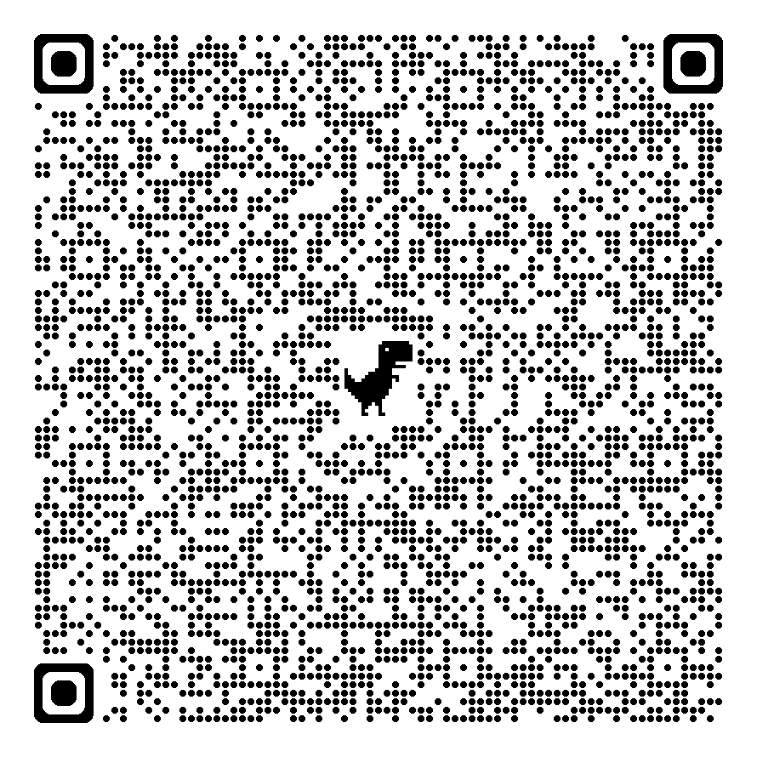
1. | An early 20th century pinchbeck-framed pendant set with two black and white photographs of lady and gentleman, 3.5cm in diameter. |  |  |  |  | £40-£60
2. | A set of four German white metal Sterling Standard table forks (4). |  |  |  |  | £90-£120
3. | A set of four George V silver oval salts with blue glass liners, maker R. R., Sheffield 1916, together with four spoons, one Sheffield 1914, in lined case, approx. 2.25oz. |  |  |  |  | £60-£80
4. | A Zulu dancing shield with stick handle (a.f.), 34cm wide x 77cm high. |  |  |  |  | £60-£80
5. | A pair of early 20th century Japanese gilt-metal vases decorated in relief with dragons, 25cm high (2). |  |  |  |  | £80-£100
6. | A Japanese Meiji period satsuma ware fluted dish, decorated figures and lakeland scenes, 25cm in diameter. |  |  |  |  | £80-£120
7. | A Japanese satsuma ware part teaset decorated dragons and scary characters, comprising teapot, sugar bowl, cream jug, six teacups and saucers (15 pieces). |  |  |  |  | £80-£120
8. | A small Chinese-style tea bowl decorated various characters, a small Japanese porcelain part coffee set, an English oriental-pattern tazza, and six other decorative pieces, some a.f. (14 pieces). |  |  |  |  | £60-£80
9. | An early 20th century Georgian-style oak mantel clock with German quarter striking movement, silvered dial, 43cm high. |  |  |  |  | £40-£60
10. | A part set of three Bohemian ruby-tinted and gilt-decorated champagne-type glasses on circular feet, each 13cm high (3). |  |  |  |  | £40-£60
11. | A "Caldey Island" grey lustre pottery part coffee set comprising: five mugs and six saucers (11). |  |  |  |  | £20-£40
12. | A pair of late 19th century French oak armoires, each fitted a mirrored panel door enclosing satin beech lined interior, and above a single drawer to base, on bun feet, each 110cm wide x 251cm high, and with carved crests, a.f. (2). |  |  |  |  | £250-£350
13. | A small Victorian mahogany occasional table on turned legs, 51cm wide, and a French marble-top bedside cabinet, 36cm wide, a.f. (2). |  |  |  |  | £30-£50
14. | A "Helmsman" model yacht, in stained-wood and glazed cabinet, yacht approx. 42cm high, cabinet 41cm wide x 66cm high, a.f. |  |  |  |  | £30-£50
15. | An antique carved and boarded oak chest with hinged lid, 106cm wide, a.f. |  |  |  |  | £80-£100
16. | A reproduction stained-beech Dutch-style bombe commode fitted three drawers, on claw and ball feet, 73cm wide. |  |  |  |  | £80-£100
17. | Two Regency-style circular convex wall mirrors, one with ball surmounts, each 41cm in diameter. (2) |  |  |  |  | £40-£60
18. | A hammered copper chekanka-style plaque decorated deer and bird in oak frame, 29cm x 47cm, together with a pair of brass altar-style candlesticks, each 40cm high (3). |  |  |  |  | £60-£80
19. | After Roland Hilder - Farm buildings in landscape, lithograph, 21cm x 21cm, in mahogany frame, 44cm x 42cm. |  |  |  |  | £20-£30
20. | A small collection of Rainham pottery for the Royal Navy Sailing Association and Medway Regatta 1961-1967 comprising: five mugs, seven saucers and dishes, a sugar shaker, a bowl and cover, and a jug and cover, some a.f. (15 pieces). |  |  |  |  | £80-£100
21. | An early 20th century rectangular-shaped wall mirror in stained mahogany frame with inlaid centre border and inlaid with stringing, 71cm x 84cm, together with a further mirror in mahogany frame inlaid with stringing, 71cm x 84cm (2). |  |  |  |  | £60-£80
22. | A small reproduction mahogany waterfall bookcase fitted single drawer, on ogee bracket feet, 56cm wide x 112cm high. |  |  |  |  | £40-£60
23. | Maria Ros Esteva - Sailing boat and a skiff in calm seas, oil on canvas, 75cm x 118cm. |  |  |  |  | £250-£350
24. | 19th century school - portrait miniature on ivory of young woman in pale blue dress, 6cm x 5cm, in ebonised frame, 12cm x 10cm, and a further miniature of older lady, 7.5cm x 6cm (cracked), in ebonised frame, 15cm x 13cm (2). Submission Ref: XULJ7BF8. |  |  |  |  | £40-£60
25. | A Victorian oak straight front chest of two short and three long drawers, on turned feet, 122.5cm wide. |  |  |  |  | £60-£80
26. | A set of six pale beech Ercol-style stick back dining chairs on turned tapering legs united by stretchers (6). |  |  |  |  | £70-£100
27. | A pair of early 20th century Chinese cloisonne vases decorated multicoloured panels with foliage, flowers and butterflies, 19cm high (2). |  |  |  |  | £50-£70
28. | A pair of early 20th century Chinese cloisonne slender neck vases decorated panels of flowers, of fluted form, each 15cm high (one a.f.), together with a small pair of cloisonne vases decorated birds and dragons in inverted lancet panels, each 12cm high (4). |  |  |  |  | £80-£100
29. | Two Chinese cloisonne elephant-form teapots with monkey finials, each 17cm long (2). |  |  |  |  | £60-£80
30. | A part suite of silver-plated, bone handled and stainless steel cutlery in a Walker & Hall oak canteen, approx. 70 pieces (one piece missing). |  |  |  |  | £80-£100
31. | A suite of silver-plated and stainless steel cutlery mounted on two fitted panels, approx. 76 pieces (2). |  |  |  |  | £60-£80
32. | A Royal Doulton figure "Tinkle Bell" HN1677 12cm high, another figure "Sweet Anne" registration no. 743560 10cm high, another "A Victorian Lady" HN728 19cm high, another "Janet" HN1537 16.5cm high, and another "Autumn Breezes" HN1911 19cm high (5). |  |  |  |  | £40-£60
33. | A small map of Westmoreland published by Archibald Fullarton & Co. Glasgow, 21cm x 25cm, and a further map of Cumberland, 26cm x 20cm (2). |  |  |  |  | £30-£50
34. | A Carlton ware chinoiserie pattern blue ground vase 15cm high, a squat vase in same pattern 10cm high, and a potpourri vase and cover 14cm high (3). |  |  |  |  | £20-£30
35. | A nest of three mahogany occasional tables, 58.5cm wide. |  |  |  |  | £20-£30
36. | A suite of silver-plated and stainless steel cutlery by Chinacraft Ltd Sheffield, in stained wood canteen, approx. 68 pieces. |  |  |  |  | £40-£60
37. | A pair of Japanese bronze vases, one decorated a rooster in a blossoming tree and the other decorated fish and willow tree branches, each 18cm high, one signed to base (2). |  |  |  |  | £80-£100
38. | After Demétre Chiparus - Cold cast bronze figure of exotic dancer in pose, modern, 53cm high. |  |  |  |  | £50-£60
39. | An Iconic Replicas Ltd Supermarionation Replica Collection model of Thunderbird 3, limited edition no. 380/800, on display stand, and with box and certificate, the certificate bearing a facsimile signature of Gerry Anderson, model approx. 56cm high. |  |  |  |  | £250-£350
40. | After David Suff 1987 - "Hidcote III" no. 155/200, coloured etching, 29cm x 28cm. |  |  |  |  | £30-£50
41. | A pair of small George V silver baskets with handles over, and pierced borders, Birmingham 1925, in lined case, approx. 3oz. |  |  |  |  | £120-£180
42. | A silver-plated three piece condiment set in lined case, two pairs of fish servers in cases, a breakfast server, a set of coffee bean spoons, a set of teaspoons, both sets in lined cases, a Venus silver-plated propelling pencil, and three other pieces (qty). |  |  |  |  | £60-£80
43. | A quantity of loose silver-plated cutlery, mainly in Kings Pattern, together with three fiddle-pattern tablespoons, four table forks, and one dessert fork (qty). |  |  |  |  | £40-£60
44. | A Hornby O gauge clockwork model train set including a 4-4-2 "Lord Nelson" locomotive, an 0-4-0 locomotive, two further small locomotives, two train sheds, other buildings, rolling stock, and a large quantity of two-rail track (qty in 5 unbranded boxes). |  |  |  |  | £200-£300
45. | A white and gilt metal Turkish-style bracelet set green central stone flanked by ruby-coloured stones and zircons, 19.5cm long. |  |  |  |  | £30-£50
46. | A small 19th century Chinese blue and white shallow bowl, 34cm in diameter, together with two blue and white spice jars with covers, one cracked, each 16cm high (3). |  |  |  |  | £40-£60
47. | A 20th century pearl and green bead necklace, 69cm long, with 14ct gold sapphire and diamond clasp, in lined box, a.f. |  |  |  |  | £150-£200
48. | Group of Ernst Teichert Meissen blue and white porcelain comprising: a part-fruit set with part-pierced border, 8pcs, a part coffee set of 6 cups and saucers, a small tray, a non-matching teapot, sugar bowl and cream jug, slightly a.f. (24pcs). |  |  |  |  | £80-£120
49. | A pair of Argentinian leather Gaucho horse stirrups with blind fret decoration, 24cm wide by 34cm high, together with a brass studded leather belt (3). |  |  |  |  | £50-£70
50. | A collection of mixed stamps, comprising: - an album of British issues, a quantity of pages of world stamps, a number of first day covers, together with a Stanley Gibbons catalogue 1967 (qty). |  |  |  |  | £20-£30
51. | A Belleek Collectors 25th Anniversary yellow rose decorated vase, 30cm high, boxed, a Shamrock-pattern castle vase, black mark, 19cm high, boxed, a Georgian shell vase, 24cm high, boxed, a large Shamrock-pattern vase, 26cm high, unboxed, and a spare Belleek box (5). |  |  |  |  | £20-£30
52. | After Mark Spain - Female portrait, limited edition print "In Profile", no. 168/250, 28cm x 27cm, a ditto profile "II", limited edition print 168/250, a pair, together with a ditto life study nude no. 19/195 35cm x 20cm (3). |  |  |  |  | £60-£80
53. | After David Greenty - "By a Neck", cold-cast bronze, 40cm high, slightly a.f. |  |  |  |  | £60-£80
54. | After Auguste Rodin - "Eternal Springtime", reproduction cold-cast bronze, 26cm high. |  |  |  |  | £20-£30
55. | After Janet Treby - "Take Me Home", limited edition print, no. 62/195, 59cm x 31cm, retailed by Kings Gallery Canterbury, and a serigraph after the same artist "Ecole de Ballet III", 52cm x 38cm, retailed by the Park West Gallery (2). |  |  |  |  | £20-£30
56. | After Rolf Harris (1930-2023) - "Self Portrait in Striped Shirt" giclee print, no. 643/695, retailed by Kings Gallery Canterbury, another print "Barge at Westminster" no. 598/695, 41cm x 71cm, unframed, and another print "All You Need is Love" 30cm x 44cm, framed but unglazed (3). |  |  |  |  | £20-£30
57. | After Fletcher Sibthorp (b.1967) - Study of flamenco dancer, limited edition print 114/395, 68cm x 47cm, together with a modern still life print of a poppy, 30cm x 54cm, and a decorative serigraph print after an unknown artist, 24cm x 50cm (3). |  |  |  |  | £15-£20
58. | An early 20th century Japanese table cabinet with lacquered and segmented veneer decoration, fitted a rising lid, three drawers, and six further drawers, enclosed by two panelled doors, 44cm wide x 54cm high. |  |  |  |  | £100-£150
59. | A part set of four Schmid porcelain Beatrix Potter figures, three with musical box features, comprising:- Peter Rabbit, Poorly Peter Rabbit, Tom Kitten and Mitten, and Mr Jeremy Fisher, 13cm high to 19cm high respectively, together with a Beswick Beatrix Potter figure "Mrs Rabbit", and a Royal Worcester figure "Polly put the Kettle on" (6). |  |  |  |  | £20-£30
60. | A part set of nine Royal Worcester porcelain figures of the Months of the Year modelled by F. G. Doughty, each approx. 15-17cm high, July, September and October missing (9). |  |  |  |  | £60-£80
61. | Six Royal Worcester figures from the Monday's Child series covering Monday, Tuesday, Wednesday, Friday, and two of Saturday, between 14cm and 22cm high (6). |  |  |  |  | £40-£60
62. | After E. H. Shepard - "No. 8 Come on Tigger its Easy", chapter 4 page 71, chromolithograph, 40cm x 30cm, in moulded frame, 53cm x 42cm, and a set of four smaller chromolithographs from Winnie the Pooh in single frame 32cm x 66cm (2). |  |  |  |  | £50-£70
63. | A Royal Albert Crown China part afternoon tea set comprising:- 2 bread and butter plates, 12 tea plates, 12 saucers, 10 cups, a milk jug, and a slop bowl (38 pieces). |  |  |  |  | £20-£30
64. | An early 19th century map of Kent by Charles Smith of London January 6th 1804, 54cm x 65cm. |  |  |  |  | £20-£30
65. | An Elizabeth II silver shell-form caddy spoon marked Birmingham 1988, approx. 0.5oz, a continental white metal small coaster decorated a swordfish, a continental hammered white metal pin tray, and a small silver-plated waiter (4). |  |  |  |  | £100-£150
66. | A set of four continental white metal flower holders on leaf-form bases, each 7cm high, maker R. Miracolief (4). |  |  |  |  | £90-£120
67. | A continental white metal bottle coaster with vine leaf and grape pattern border, 13cm in diameter, and a small pot and lid (2). |  |  |  |  | £100-£150
68. | A continental white metal half pint tankard, Sterling Standard, 11.5cm high. |  |  |  |  | £180-£220
69. | A continental white metal part hammered bowl with border of vine leaves and grapes. |  |  |  |  | £80-£120
70. | A continental white metal flowerhead bowl, 18cm in diameter. |  |  |  |  | £200-£300
71. | A continental white metal bowl with relief decoration of vine leaves and grapes, maker Lanorato Amano, 21cm in diameter. |  |  |  |  | £200-£300
72. | A continental white metal Sterling Standard pedestal bowl, with fluted decoration, on circular foot, maker Lanorato Amano, 19cm in diameter x 14cm high. |  |  |  |  | £280-£320
73. | A continental white metal Sterling Standard shallow bowl with spiral decoration, 30cm in diameter. |  |  |  |  | £250-£350
74. | Thomas Bowls after R. West - "A Perspective View of Ye Great Court of Trinity College Cambridge from Ye South", black and white etching, 35cm x 46cm, Bernard Gotch - View of Brasenose College Oxford, watercolour, 28cm x 37cm, and a further engraving of Brasenose College, 27cm x 32cm (3). |  |  |  |  | £40-£60
75. | After R. Beilby - A plan of Newcastle-upon-Tyne and Gateshead c. 1788, black and white engraved map, 33cm x 45cm. |  |  |  |  | £50-£70
76. | Dorothy Parsons - Two small fishing boats in harbour, crayon and watercolour, 38cm x 56cm. |  |  |  |  | £60-£80
77. | After Claude Lorrain - Six mixed etchings of various views, including one from a drawing in the collection of the Duke of Devonshire, each 21.5cm x 27cm (6). |  |  |  |  | £40-£60
78. | After Thomas Lord Busby - part set of four satirical engravings each 12cm x 14cm, and a further satirical stipple engraving "Breaking Up" 21cm x 25.5cm (5). |  |  |  |  | £40-£60
79. | A Japanese imari-style vase with floral panel decoration 25cm high, a modern Chinese floral decorated vase 22cm high, together with three spice jars, and two English pottery vases (7). |  |  |  |  | £60-£80
80. | A Dinky Supertoys "Cole's Mobile Crane", a Dinky Toys fire engine, a blue and red foden flatbed truck, together with a quantity of further Dinky diecast models, a.f. (qty). |  |  |  |  | £40-£60
81. | A quantity of modern Dinky, Solido, Matchbox, and other diecast toy vehicles various, mostly boxed (qty). |  |  |  |  | £25-£40
82. | A mixed HO and HO/OO scale train set by Tri-ang, Hornby, Piko, and Bachmann, comprising: locomotives, buildings, track, and other accessories, some boxed (qty). |  |  |  |  | £80-£100
83. | A decorative black cast-iron circular garden table, 106cm in diameter, together with six chairs including two elbow chairs (7). |  |  |  |  | £60-£80
84. | A small late Victorian pale oak pedestal desk fitted nine drawers, with later turned knob handles, 106cm wide x 75cm high x 60cm deep. |  |  |  |  | £80-£100
85. | The Queen's Golden Jubilee Coin Cover Collection - a quantity of commemorative coin covers in seven albums, some cupronickel, and some copper (7). |  |  |  |  | £80-£120
86. | A Regency mahogany sofa table, the top with cross banded edge, canted corners, fitted two drawers and two dummy drawers, on quadruple turned supports, and platform base with splay legs, on small bun feet, 146cm wide extended. |  |  |  |  | £100-£150
87. | A Regency mahogany bow-fronted chest of two short and three long drawers, on splay bracket feet, 102cm wide. |  |  |  |  | £60-£80
88. | A Victorian mahogany linen press, the upper part enclosed by two panelled doors, adapted as a wardrobe, below a moulded cornice, the lower part fitted two short and two long drawers, feet missing, 145cm wide x 193cm high. |  |  |  |  | £100-£150
89. | A Regency mahogany bow-fronted chest of two short and three long drawers, on splayed bracket feet, 104cm wide. |  |  |  |  | £80-£100
90. | A matched set of six early 19th century fruitwood, beech and elm Lancashire spindle-back chairs, with rush seats, on turned legs united by stretchers, including two elbow chairs, a.f. (6). |  |  |  |  | £80-£100
91. | A Copeland late Spode part dinner service, with transfer printed mottled border, with gilt edges, including dinner plates, meat platters, soup plates, one large tureen and three sauce tureens, some pieces a.f. (approx. 40 pieces). |  |  |  |  | £30-£50
92. | A small Regency mahogany bow-fronted sideboard fitted single drawer flanked by two deep drawers, inlaid with stringing, on six turned and ringed legs, 120cm wide. |  |  |  |  | £80-£100
93. | A 20th century glass-topped occasional table, on angled chrome and ebonised wood base, 48cm in diameter x 64cm high, and a further occasional table 54cm high (2). |  |  |  |  | £30-£50
94. | A Merrythought soft toy of a tigress, approx. 120cm long, overall, and a similar cub, 88cm long (2). |  |  |  |  | £15-£20
95. | An 18ct gold cocktail design dress ring, channel set 11 rectangular rubies and 21 round-cut diamonds, approx. 7g, in lined box. |  |  |  |  | £600-£800
96. | A pair of 18k leaf-design ear clips (also fitted for pierced ears), set nine rubies and eight round-cut diamonds, approx. 6g, in lined box (2). |  |  |  |  | £500-£700
97. | A set of six Victorian mahogany dining chairs with slightly carved mid rails, upholstered stuff over-seats, on octagonal turned and ringed legs (6). |  |  |  |  | £40-£60
98. | A Lladro porcelain figure "Wedding" 19cm high, boxed, two Nao figures, each 20cm high, boxed, a Capodimonte figure of musician with monkey 30cm high, unboxed (a.f.), and a Coalport Lady of Fashion figure "Sarah", on wood base, 24cm high, unboxed (5). |  |  |  |  | £20-£30
99. | A Border Fine Arts figure of a red stag 19cm high, a ditto of a doe and fawn 13cm high, together with a barn owl, an otter, collie puppies, a fox, a border collie clock, and other figures by different manufacturers, three boxed (20). |  |  |  |  | £40-£60
100. | A 1939/45 Star, Second World War Defence and War Medals, possibly awarded to a nurse, a further war medal, together with some veteran badges, and other objects (qty). |  |  |  |  | £20-£30
101. | A reproduction French-style simulated marquetry circular coffee table, with gilt brass mounts, on tapering legs, 81cm in diameter. |  |  |  |  | £150-£200
102. | A Georgian oak mule chest with hinged lid, and panelled front, above two drawers, on block feet, 126cm wide. |  |  |  |  | £60-£80
103. | A Victorian part-carved walnut work table, on quadruped base, 49cm wide, a.f. |  |  |  |  | £40-£60
104. | An 18th century style panelled oak livery cupboard, fitted two doors, on block feet, 134cm wide x 174cm high. |  |  |  |  | £80-£100
105. | A Russian police-type fur hat (large size), a Davey Crockett type raccoon hat, and a decorative costume tiara (3). |  |  |  |  | £15-£20
106. | An "Estrella" piano accordion in plastic simulated mother-of-pearl case, 38cm wide, with carrying case. |  |  |  |  | £20-£30
107. | A small Turkish rug, central field with three large medallions, on mustard ground, wide border, 104cm x 164cm. |  |  |  |  | £40-£60
108. | A Kazak rug with three hooked medallions, on multiple red and blue ground, wide octagonal medallion border, 119cm x 190cm. |  |  |  |  | £80-£100
109. | A small Caucasian rug, with four guls, on rust ground, wide border, 83cm x 141cm. |  |  |  |  | £40-£60
110. | A Yomut Bokhara rug, the central field with 45 guls, on rust ground, wide multi-banded border, 131cm x 181cm. |  |  |  |  | £60-£80
111. | A part suite of bone handled, stainless steel and silver-plated table cutlery, in a pale oak art deco style canteen, approx. 57 pieces. |  |  |  |  | £40-£60
112. | Five "Tudor" crystal beakers, together with a small quantity of other drinking glassware (28). |  |  |  |  | £30-£40
113. | A large early 19th century English wine glass with opaque white twist stem on circular foot, 22cm high, together with a smaller English wine glass with clear stem, on circular foot (chipped), 14cm high (2). |  |  |  |  | £80-£120
114. | A silver-plated salver with piecrust edge 25cm in diameter, a pair of silver-plated and bone-handled fish servers in lined case, a set of silver-plated fruit knives and forks in lined case, a quantity of mixed silver-plated cutlery, a silver-plated and Pyrex glass serving dish, and a small quantity of other silver-plated ware (qty). |  |  |  |  | £30-£50
115. | A collection of reproduction Halcyon Days and Bilston enamelled boxes various, comprising mainly of Christmas boxes from the 1970s to 1990s, in original branded boxes, two unboxed (25). |  |  |  |  | £50-£70
116. | A Royal Worcester porcelain "Victorian Series" figure "Emily" no. 169, 19cm high, a Royal Doulton figure of a green budgerigar, 17cm high, six Royal Doulton figures of ladies including "Veneta" HN2722, and two small continental porcelain figures of children, some in branded boxes, others in un-associated boxes (10). |  |  |  |  | £25-£40
117. | A small tortoiseshell and metalware loop 4cm long, a small tortoiseshell and metalware scent bottle case 5.5cm long, a small snuff box, a spectacles case, a horn beaker with small silver shield 10.5cm high, three glass toilet jars with silver-plated and tortoiseshell tops, a spare top, and a simulated tortoiseshell hair tidy and box, and three napkin rings (13). |  |  |  |  | £70-£90
118. | A glass faceted paperweight for the Silver Jubilee of Queen Elizabeth II 1977, a Caithness glass paperweight inset with small clock, a further Caithness "Garland" glass paperweight, and a Whitefriars glass Millifiore-pattern paperweight, in three boxes (4). |  |  |  |  | £20-£30
119. | An Edwardian silver and tortoiseshell powder bowl London 1908, a hobnail cut-glass toilet jar with silver and tortoiseshell top, five silver and tortoiseshell trinket boxes in sizes, two silver and tortoiseshell pill boxes, and two more glass jars with silver and tortoiseshell tops (11). |  |  |  |  | £100-£150
120. | An Elizabeth II silver sauce boat, maker Mappin & Webb Sheffield 1962, a small George V silver cup Birmingham 1930, four silver pepperettes, approx. 8oz (6). |  |  |  |  | £200-£300
121. | A small mallet-shaped glass caster with silver top, marks rubbed, a glass scent bottle with silver collar, Birmingham 1900, a small silver spill vase, Sheffield 1905, a glass match holder with silver rim, Birmingham 1900, a green tinted spill vase with silver mount, and a glass toilet jar with silver top (6). |  |  |  |  | £40-£60
122. | A small late Victorian silver cream jug with relief decoration, London 1898, a late Victorian silver four division toast rack, Birmingham 1899, a small silver ring tree, Birmingham 1926, and a further ring tree, Birmingham 1902, approx. 5oz weighable (4). |  |  |  |  | £120-£180
123. | An Elizabeth II silver caddy spoon, Birmingham 1987, six silver fiddle-pattern teaspoons, London 1901, two small silver pin trays, Birmingham 1978, together with a silver mustard and salt, a pair of sugar nips, two silver-handled button hooks, a small match holder, a number of odd tea and salt spoons, and other objects, approx. 13oz weighable (qty). |  |  |  |  | £350-£450
124. | A three piece silver-backed non-matching dressing table set, a silver box lid, Birmingham 1901, a small gent's silver-backed hair brush, a silver covered scent bottle, Birmingham 1901, and two glass toilet jars with silver tops, approx. 4oz weighable (8). |  |  |  |  | £120-£180
125. | A set of six late Victorian silver teaspoons and sugar nips in lined case, a further pair of sugar nips, a pair of silver serving spoons, Sheffield 1904, in lined case, a set of six coffee spoons, Birmingham 1931, in lined case, and four silver-handled spoons and knives, boxed, approx. 7.5oz weighable (qty). |  |  |  |  | £180-£220
126. | Two 20th century Chinese squat vases, 8cm and 7.5cm high respectively, both predominantly blue and white, two circular Chinese porcelain boxes, 9cm and 8cm in diameter respectively, a modern Chinese onyx vase, a Japanese multicoloured plate, 23cm wide, and seven other decorative pieces of Chinese and oriental style (13). |  |  |  |  | £60-£80
127. | A pair of early 20th century Meiji period satsuma ware vases decorated figures and mountainous landscape, each 16cm high, together with a taller vase decorated birds, flowers and foliage, 25cm high (3). |  |  |  |  | £150-£200
128. | A Stewart Crystal fruit bowl, 22cm in diameter, a Thomas Webb glass butter dish and cover, a Stewart Crystal jug and cover, together with a part suite of Waterford Crystal drinking glassware, and other pieces (approx. 49 pieces). |  |  |  |  | £80-£100
129. | A Chinese carved hardwood occasional table of urn-stand form, on four cabriole-shaped legs, 74cm wide x 72cm deep. |  |  |  |  | £300-£400
130. | A George III style pale mahogany tripod occasional table, with piecrust edge, the top 56cm in diameter. |  |  |  |  | £30-£50
131. | An early Victorian rosewood circular snap-top breakfast table, 132cm in diameter, on carved tripod base. |  |  |  |  | £150-£200
132. | A set of eight Victorian rosewood kidney-back dining chairs, on turned and fluted legs, upholstered stuffed over seats (8). |  |  |  |  | £80-£100
133. | A Victorian mahogany show-wood button upholstered spoon-back chair, on cabriole-shaped legs. |  |  |  |  | £60-£80
134. | A set of six gilt-metal and stainless steel shish kebab skewers, with bird and animal terminals, each 38cm long, two silver-plated fiddle pattern table spoons, two decorative fruit spoons, and four other pieces (14). |  |  |  |  | £30-£50
135. | A pair of Royal Doulton stoneware vases of fluted shape and with floral border, each 21cm high, a taller slender vase in blue, brown and green, 22cm high, and a blue, green and brown mottled stoneware vase decorated butterflies, 18cm high (4). |  |  |  | £40-£60
136. | A pair of Royal Doulton stoneware vases, blue and green ground decorated grapes and other fruit, each 23cm high, and a smaller mottled vase decorated flowers, 21cm high (3). |  |  |  | £40-£60
137. | An early Edwardian stained wood open-fronted dwarf bookcase, fitted six adjustable shelves, 147cm wide x 122cm high. |  |  | £40-£60
138. | Douglas Smart (1879-1970) - “The Waters Edge at Lowestoft” circa 1920, inscribed verso, watercolour, 15cm x 23cm. |  |  | £30-£50
139. | An early 20th century oak filing or music cabinet, with tambour shutter front, 48cm wide x 115cm high, a.f. | £30-£50
140. | An early 20th century mahogany display cabinet, on cabriole legs, 56cm x 121cm, and a circular folding coaching table by “Thornton and Herne” (2). | £60-£80
141. | Maggie Smith - Still life, flowers, watercolour 76cm x 56cm. |  | £50-£70

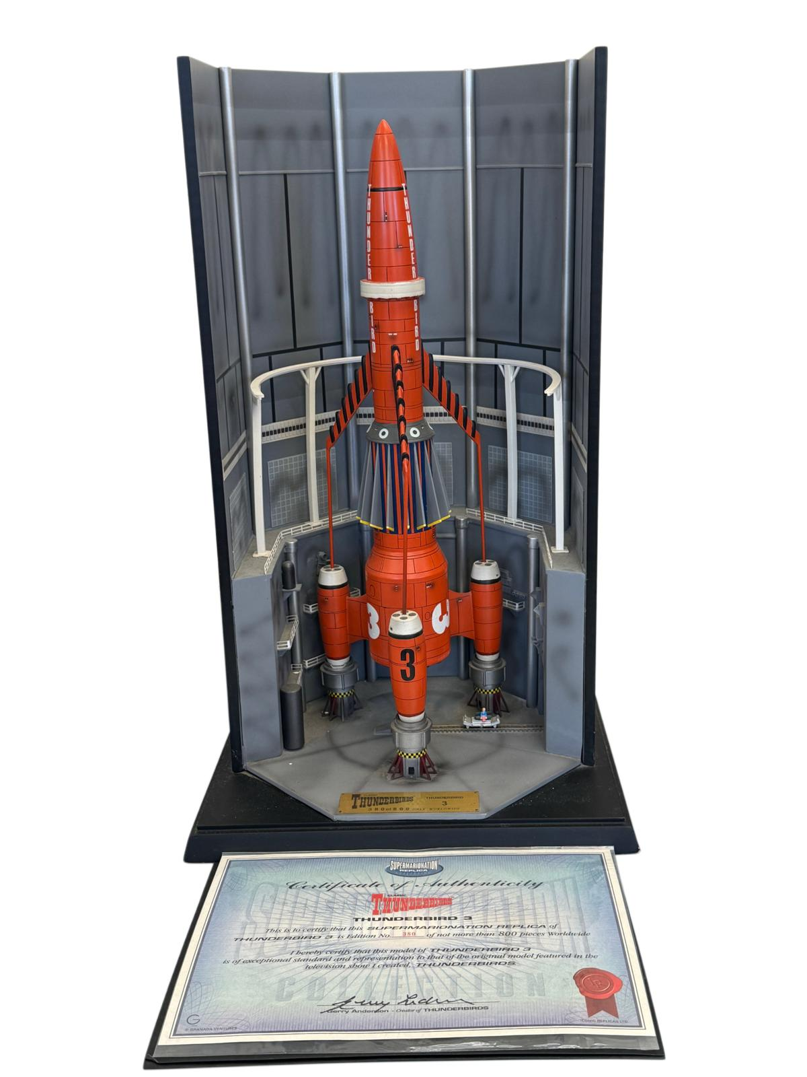
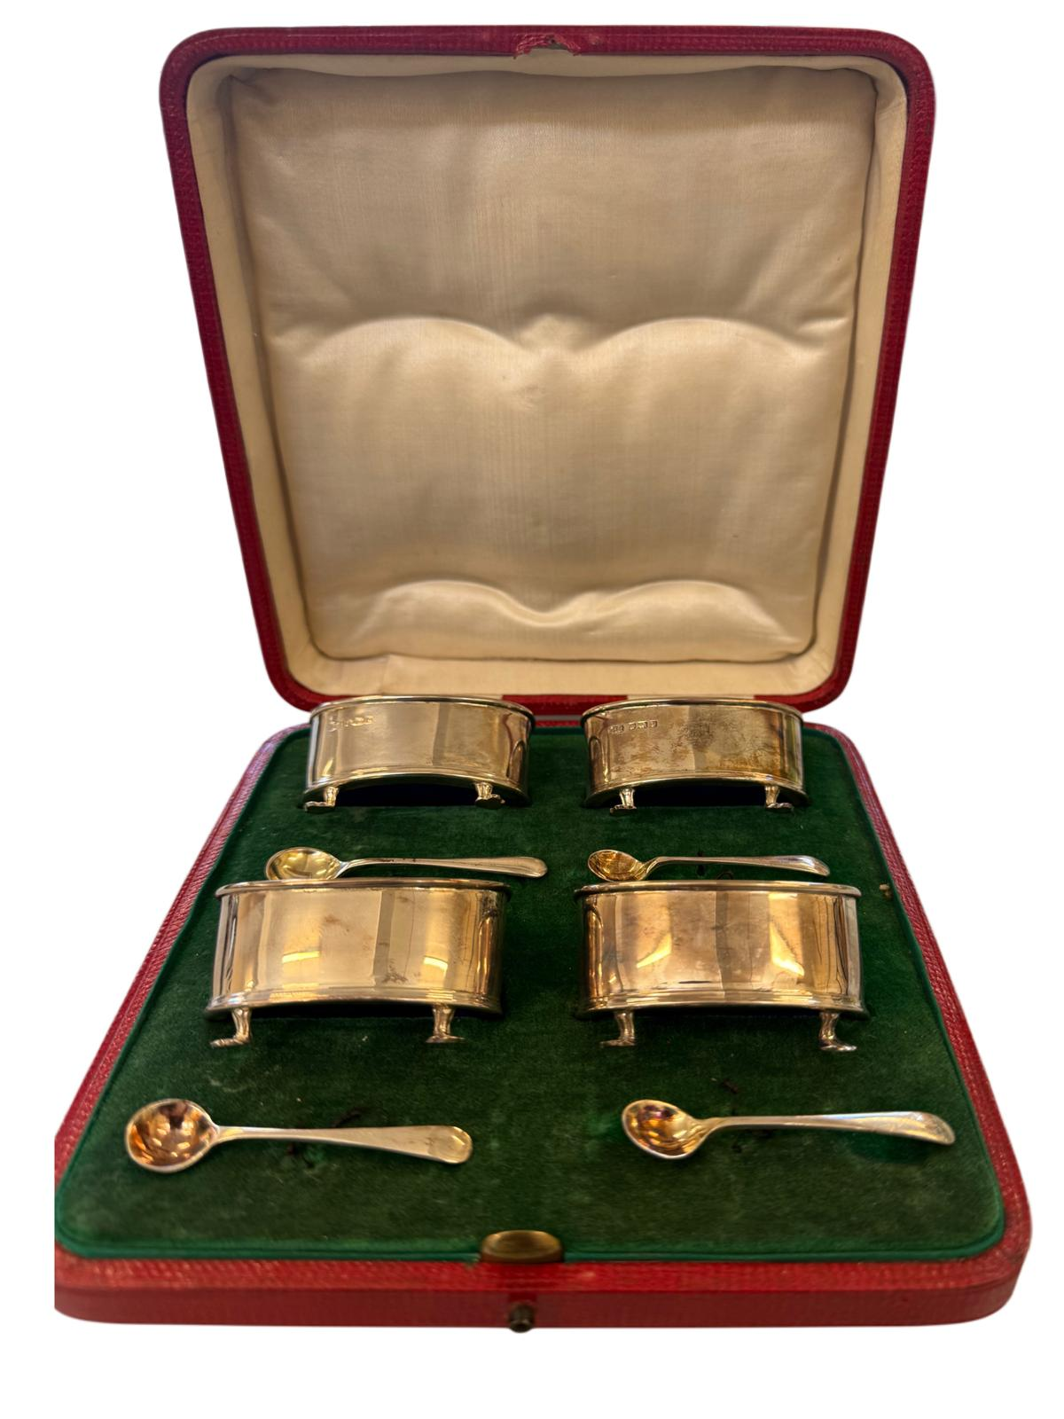
Lot 3 – A set of four George V silver salts with four spoons, in lined case, approx. 2.25oz. Estimated sale price: £60-£80
Lot 39 – An Iconic Replicas Ltd Supermarionation Replica Collection limited edition model of Thunderbird 3, with certificate and box, 56cm high. Estimated sale price: £250-£350

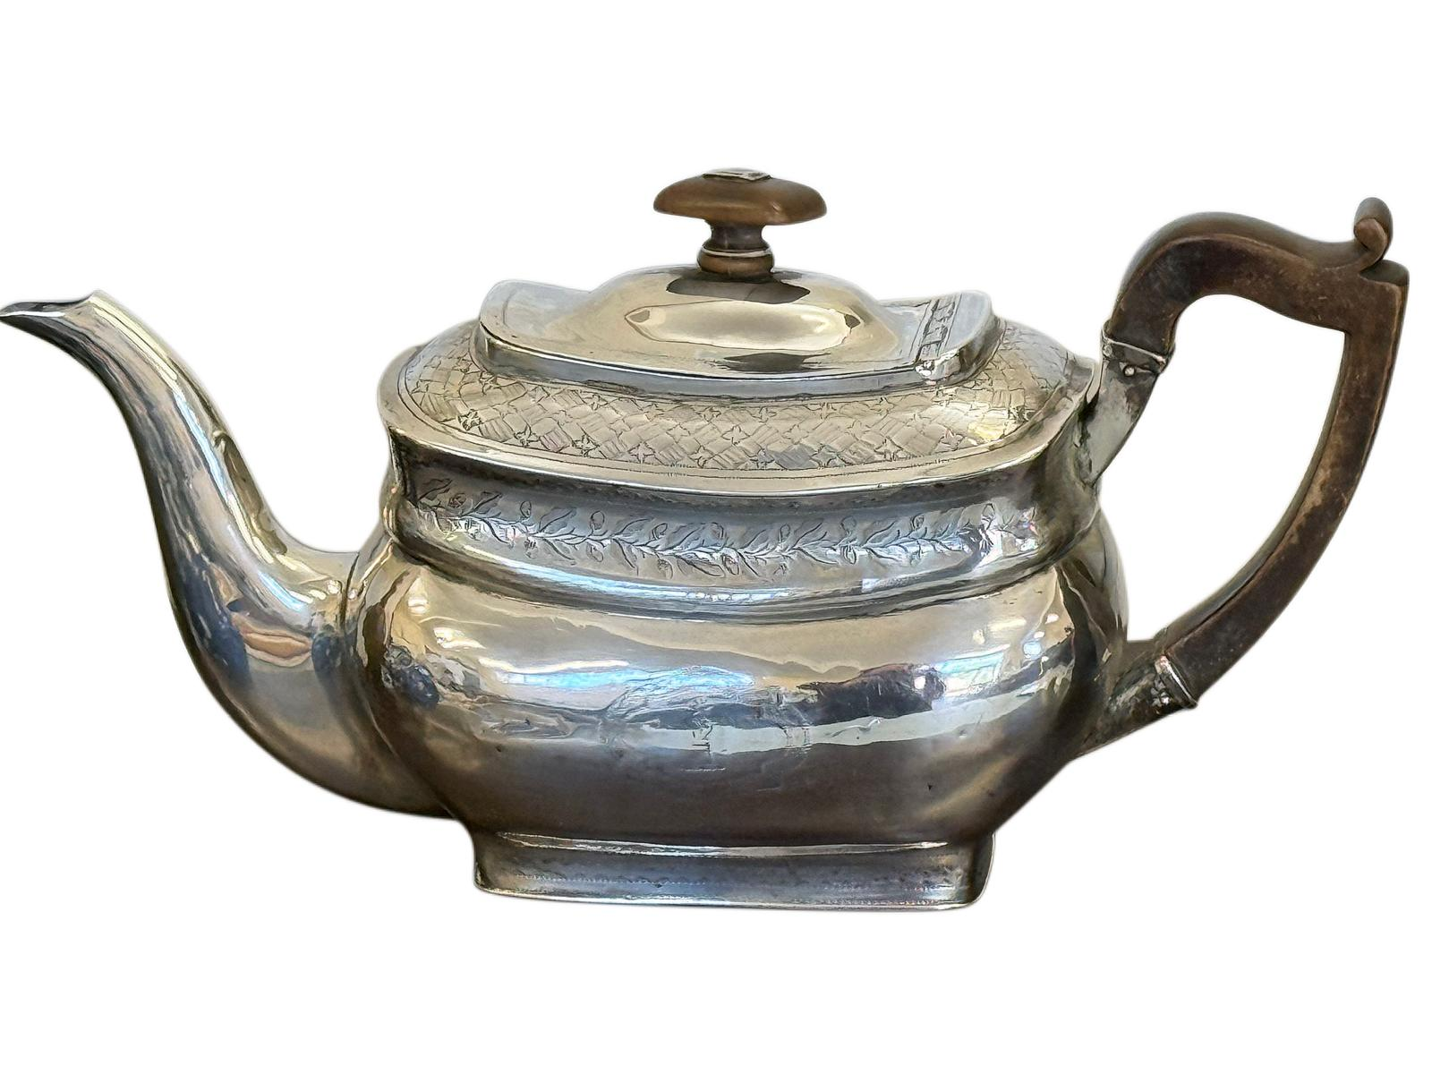
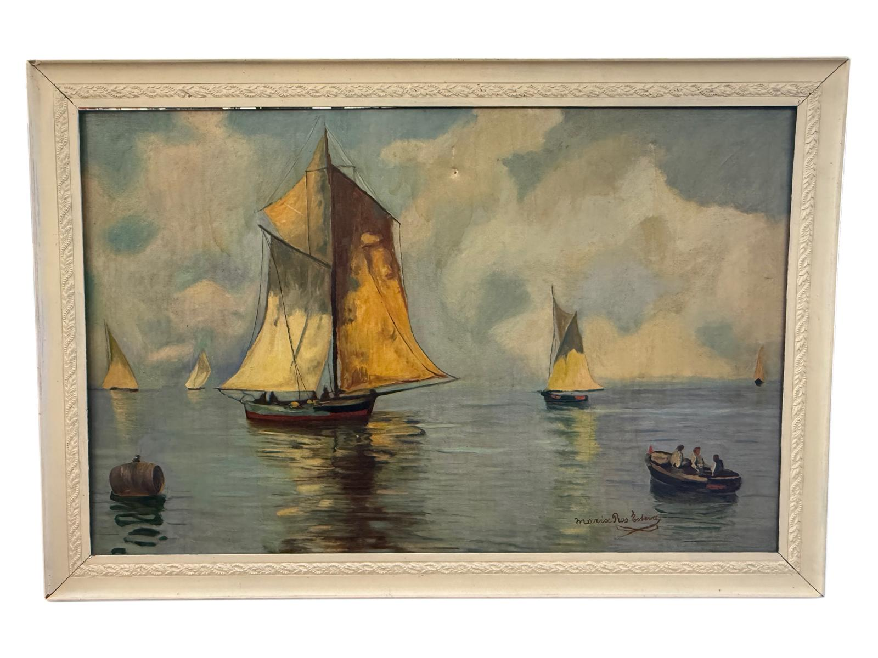
Lot 225 – A George III Irish silver teapot, approx. 15oz, stained wood handle and finial. Estimated sale price: £400-£600

Lot 23 – Maria Ros Esteva - Sailing boat and a skiff in calm seas, oil on canvas, 75cm x 118cm. Estimated sale price: £250-£350

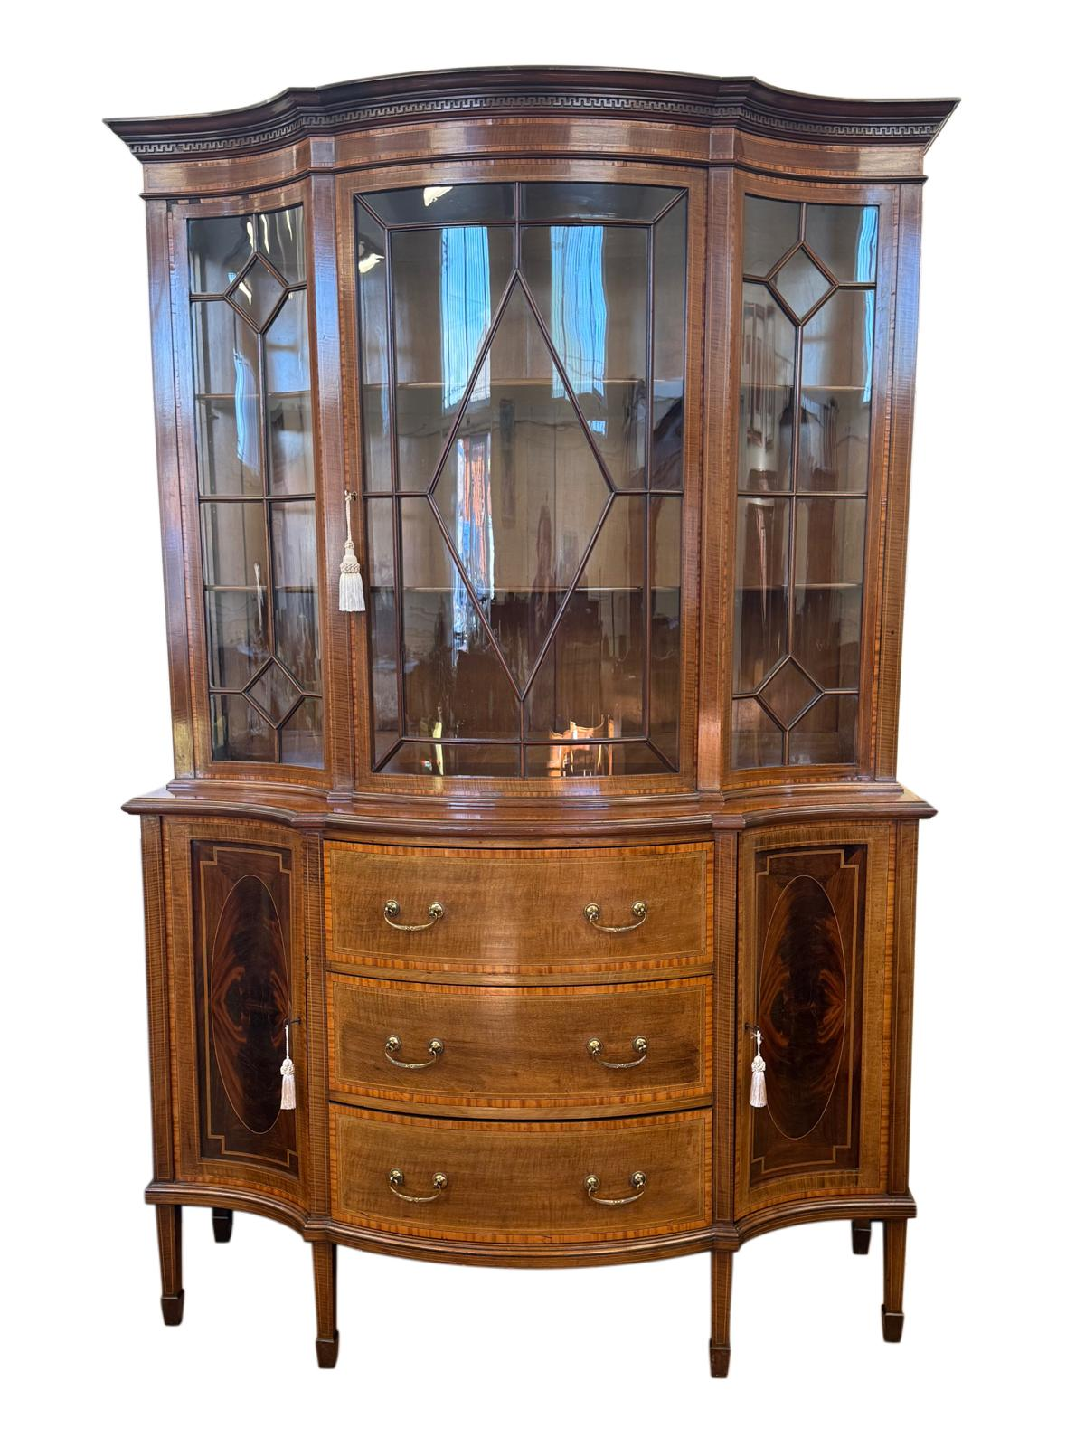
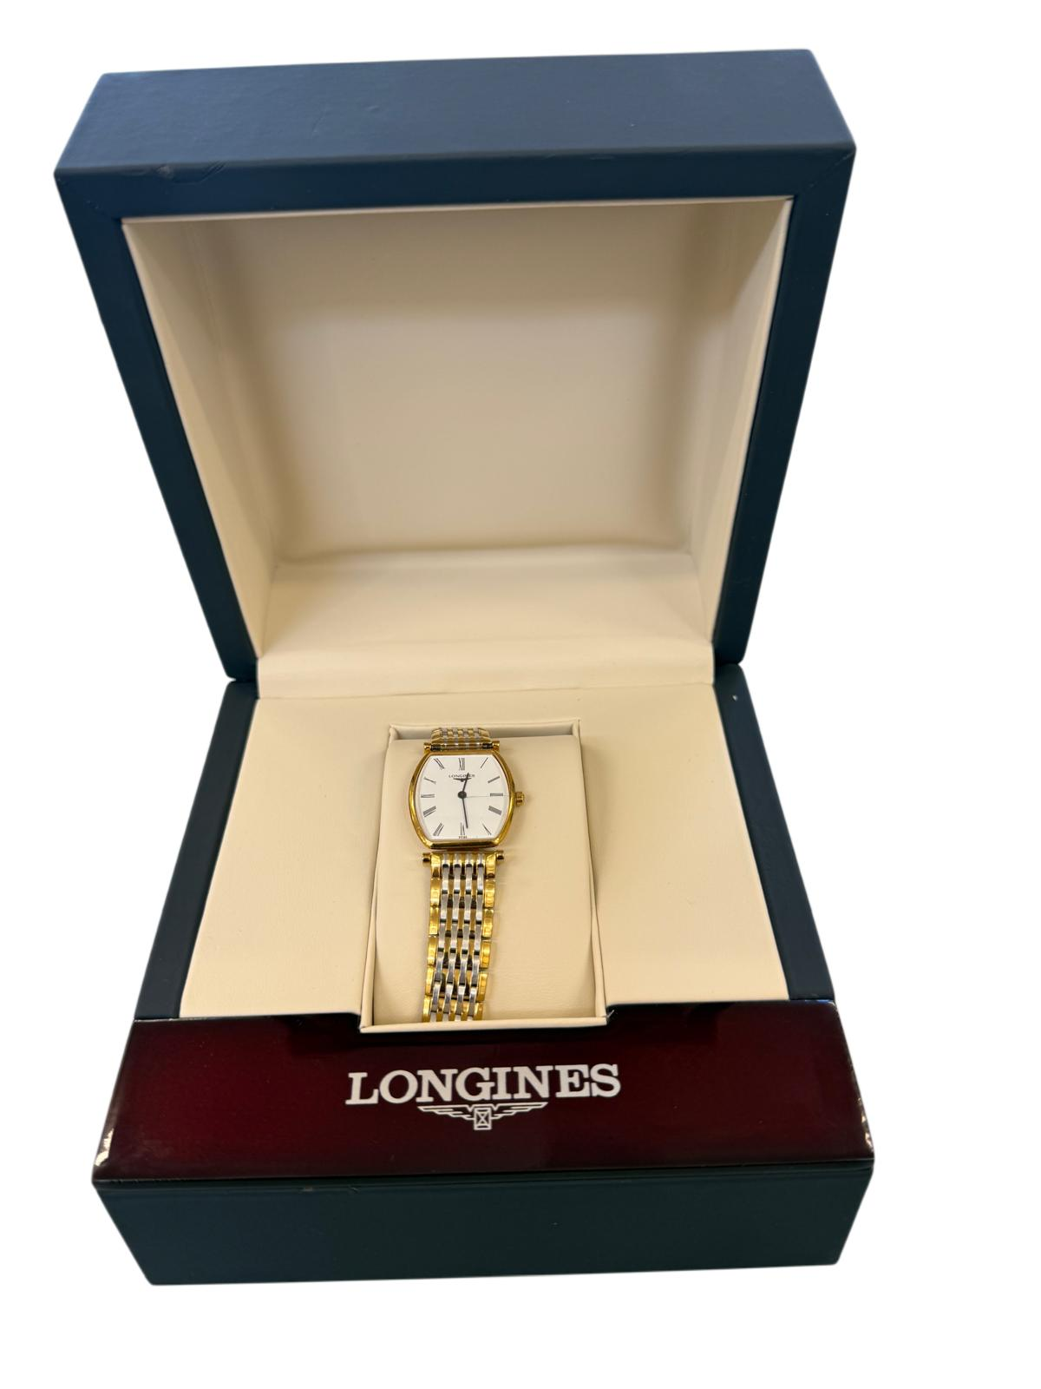
Lot 200 – A lady's "Longines" tonneau-shaped "La Grande Classique" wristwatch, in gold-plated case, on gold-plated and stainless steel brick-link bracelet strap, in branded box with leaflet. Estimated sale price: £120-£180

Lot 164 – An Edwardian inlaid and cross-banded mahogany display cabinet, 137cm wide x 208cm high. Estimated sale price: £100-£150

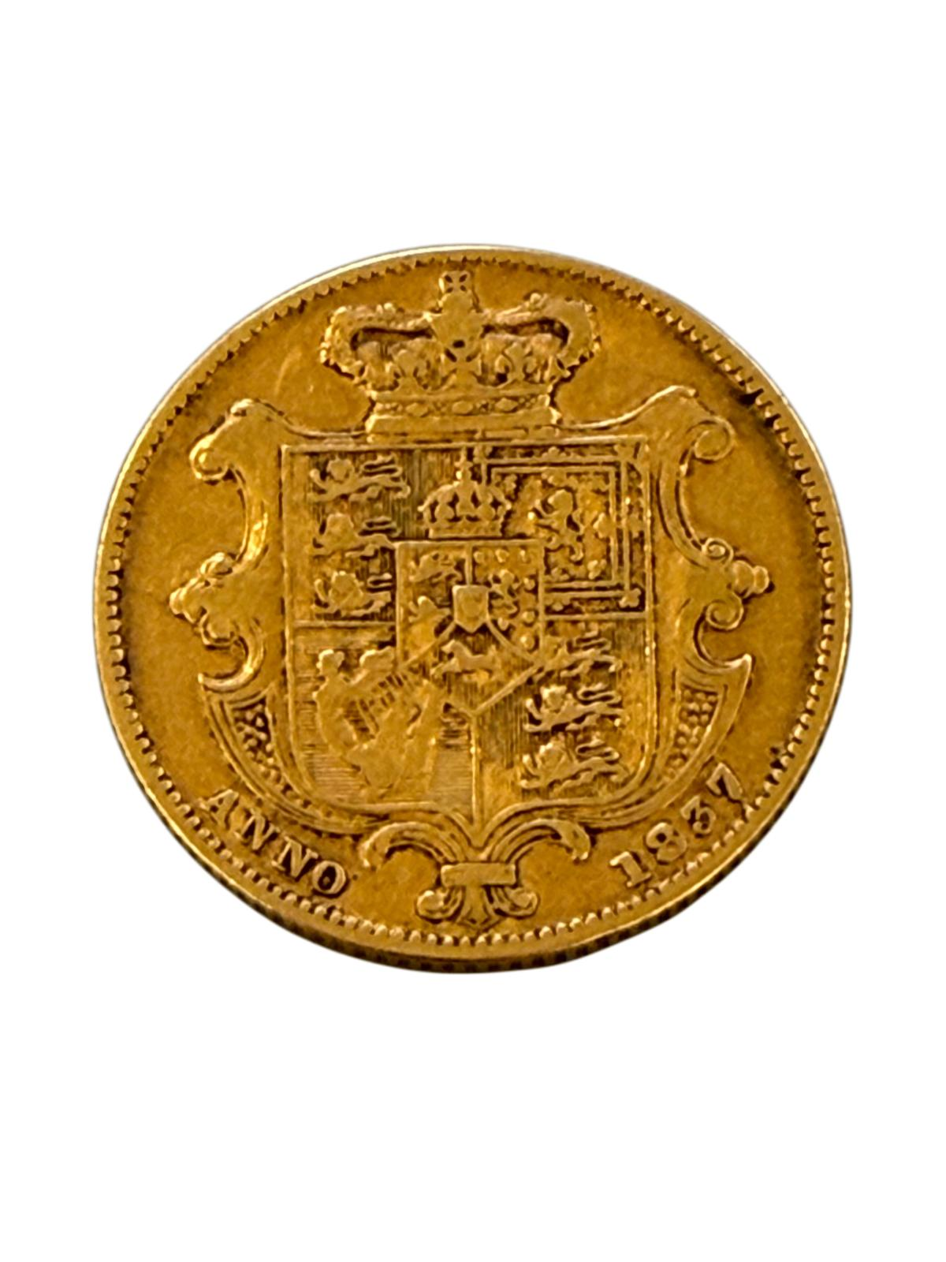
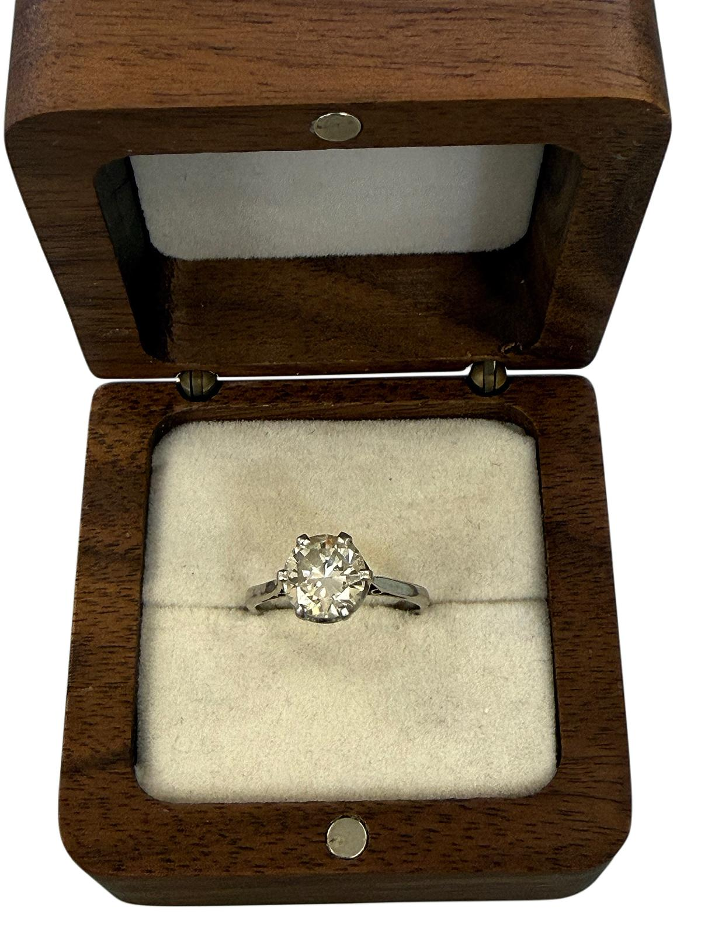
249 – A platinum diamond solitaire dress ring, approx. 1.3 carats, size L, approx. 4g. Estimated sale price: £1800-£2200
Lot 224 – A William IV 1837 gold sovereign. Estimated sale price: £650-£750
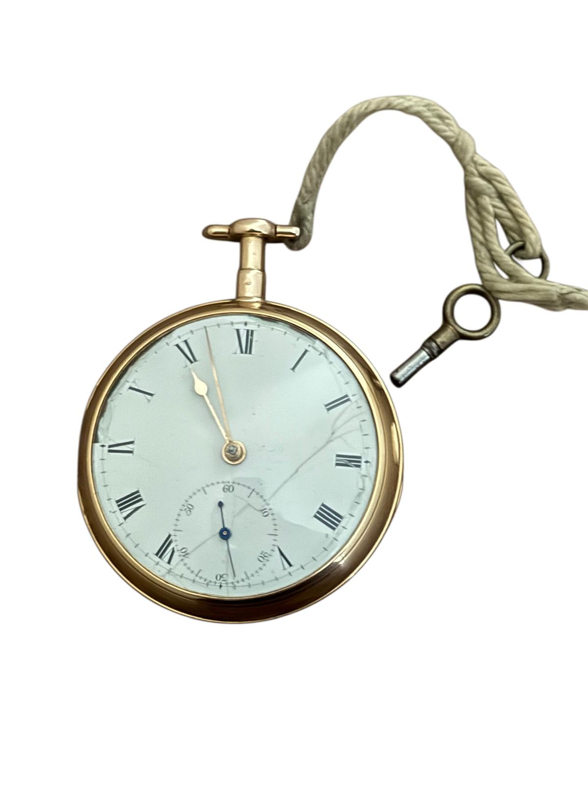
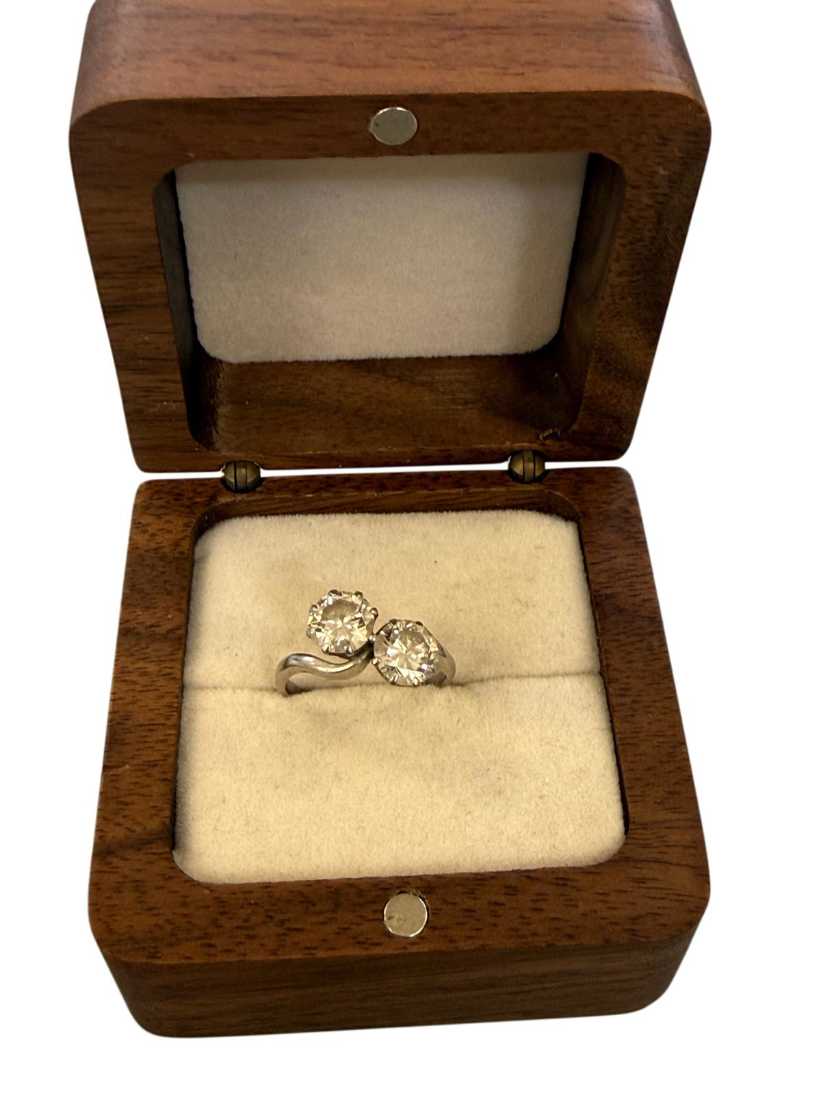
Lot 250 – A platinum two-stone diamond crossover style dress ring, approx. 3g and 1.5 carats overall. Estimated sale price: £1800-£2200
Lot 234 – A George III 18ct gold open-faced key wound pocket watch, 5cm in diameter. Estimated sale price: £1100-£1300

142. | Poems of Dedication by Stephen Spender, 1947, another new edition 1984, another “Holes in the Sky” by Louis McNiece, 1st edition, another Autumn Journal 1939, another Springboard 1941-44, another Loo Stranger, 1936, by W.H Auden, another Plant and Phantom, 2nd impression by Louis McNiece, and Another Time, by W.H Auden, all by Faber and Faber, together with other poetry books, and some classic volumes (approx. 85 volumes overall). | £100-£150
143. | Maggie Smith - An avenue of trees, watercolour, 39cm x 51cm. | £60-£80
144. | A Regency mahogany square piano, by "John Broadwood and Sons, London", on turned and reeded legs, 168cm wide, serial no. 55265 (restored by David Winston). Submission Ref:AH6QJPJQ. | £400-£600
145. | A mahogany upright piano by "D'almaine" over strung action, iron frame, no. W2050, 139cm wide. Submission Ref:5ZH8GX26. | £120-£180
146. | A 19th century style "Oxford Lavender" tear catcher scent bottle, 17cm long, no stopper, two small bud vases, a part ruby-tinted and cut-glass scent bottle, no top, and a pair of glass knife rests (6). | £20-£30
147. | A Royal Worcester "Vitreous" achete meat platter, 48cm wide (cracked), a blue and white willow-pattern meat dish, a Staffordshire pottery clock group, 22.5cm high, a small Royal Doulton stoneware vase, 15cm high, a German porcelain figure of budgerigar, a Danish porcelain figure of cockatoo, a T. Goode & Co. tea bowl, and a Dresden porcelain table centrepiece, 31cm high (8). | £25-£40
148. | A Masons Ironstone "Chartreuse" pattern part dinner service, 34 pieces, a Masons Ironstone "Mandalay" pattern bon-bon dish, a Royal Grafton "Majestic" pattern part tea set, 26 pieces, and three Royal Worcester coffee cans and saucers (67 pieces total) | £30-£50
149. | A beaded lace jug cover, a set of ecru chair backs, a number of doilies, and other lace and textiles (qty). | £20-£30
150. | A St. Ives style circular copper dish tabletop, with sailing ship to centre and stylised fish around the edge, 60cm in diameter, and a decorative brass tabletop, 58cm in diameter, together with an inkwell, a pen tray, and three other pieces (7). | £30-£50
151. | H. V. Turner - "Dotheboys Hall", watercolour, 7cm x 10cm, and another, river scene with view of church (2). | £20-£30
152. | An "Old Hall" stainless steel three-piece part tea set, and a decorative 400-day mantel timepiece under dome 22cm high (4). | £20-£30
153. | A stained wood and part-painted Australian boomerang 59cm long, and a further plainer boomerang 57cm long, a.f. (2). | £20-£30
154. | An Edwardian inlaid mahogany two-handled tray with galleried edge, 68cm wide. | £30-£50
155. | A pair of small circular stained wood boxes each inset a copper coronation medallion for Edward VII and Queen Alexandra, an Edwardian 1 Florin plaque, a Queen Victoria plaque, a further Edward VII plaque, an Andrew Carnegie plaque, a square shaped portrait plaque G. W. De Saulles c.1885, a piece of Festival of Britain soap in box, and a National Service medal in box (9). | £25-£40
156. | A Victorian ebonised and gilt-metal circular foot stool, with needlework top, 33cm in diameter. | £40-£60
157. | A miniature silver-plated sovereign purse, an Elgin-style pocket watch with keyless wound movement, and a stopwatch in silver-plated case (3). | £30-£50
158. | A nest of three Edwardian inlaid mahogany occasional tables, 51cm wide, a Victorian walnut and ebonised octagonal-top occasional table (in poor condition), two bedroom chairs, a small upholstered chair, and a small tray on stand (7). | £20-£30
159. | An Edwardian inlaid mahogany centre table with shaped ends, on four turned and ringed legs united by a stretchered under-tier, 76cm x 96cm. | £80-£100
160. | A stained glass window panel with portrait of Jesus, 38cm x 55cm (a.f.), and a gilt painted wood free standing panel, the centre decorated with print of The Madonna of Chancellor Rolin after Jan van Eyck, 52cm wide x 67cm high (2). | £20-£30
161. | A square Persian rug style upholstered pouffe, 62cm x 81cm. | £20-£30
162. | A set of gilt-metal buttons with relief decoration of child's head, in lined case by "John Pinches of London", a small framed plaque, an intaglio die stamp, and a relief die stamp, all of the same portrait, together with three un-related printed portraits in single frame 22cm x 37.5cm (5). | £25-£40
163. | Two Victorian silver crowns 1890 and 1891, a further quantity of mixed English and foreign silver coins, a quantity of Italian and Japanese occupation paper money, and a further quantity of mixed English and foreign coins various (qty). | £40-£60
164. | An Edwardian inlaid and cross-banded mahogany display cabinet, of bowed and concave outline, the upper part with astragal-glazed panels and door, the lower part fitted three drawers flanked by two panelled doors, on six square tapering legs with spade feet, 137cm wide x 208cm high. | £100-£150
165. | A reproduction mahogany twin pedestal dining table with snap-top ends, and central leaf, 101cm wide x 212cm long extended. | £40-£60
166. | An Edwardian inlaid mahogany salon suite comprising: open-arm settle, a pair of elbow chairs, and four side chairs, with trellis splats and part scrolled top rails (7). | £100-£150
167. | A Liverpool Football Club 2012-2013 season home shirt, signed by Jamie Carragher, with a charity certificate of authenticity, XL size, the player is now a pundit. | £30-£50
168. | Four "Compare the Market" meerkat soft toys comprising: "Yakov's Toy Shop", Star Wars "Oleg as BB-8", "Sergei as Obi-Wan Kenobi", and "Aleksandr as Batman", in limited edition packaging (4). | £40-£60
169. | A Porche 928 Workshop Manual, comprising eight volumes (I, Ia, to VII), in ring folders, a.f (8). | £80-£100
170. | A limited edition part box set for Fat Boy Slim's Big Beach Bootique 5 c.2012, signed by Norman Cook, comprising: single sided 7inch flexi disk, and some card inserts, a.f. | £20-£30
171. | A volume of "Private Eye A Cartoon History" edited by Nick Newman and signed by Ian Hislop c.2013, together with three books by Kate Adie including "Corsets to Camouflage" signed by the author, "The Kindness of Strangers", and "Nobody's Child", both with facsimile signature (4). | £20-£30
172. | A Star Wars Forces of Destiny figure of "Rey of Jakku" in packaging (a.f.), a further figure of "Kylo Ren" from the Black Forces series in box, and a Star Wars soft toy figure of BB-8 in packaging (3). | £25-£40
173. | A display box containing set of military and commemorative medals from the Sultanate of Oman, including 15th Anniversary medal, a commemorative medallion in Spink & Son box, and a Middle Eastern short dagger with bone handle (3). | £40-£60
174. | Two Channel Islands commemorative silver proof £5 coins, one Queen Elizabeth II Diamond Wedding Anniversary issue, and a gold-plated issue from "The Golden Steam Age" series, together with a 2007 Diamond Wedding crown, and a small quantity of old pennies (qty). | £20-£30
175. | A silver-plated rose bowl on circular foot 20cm in diameter, a set of six silver-handled tea knives in lined case, together with silver-plated tea knives, a fruit set, loose fish knives and forks, and other silver-plated objects (qty). | £40-£60
176. | A Dinky Toys red horse box no. 581 in blue box, a Dinky Supertoys "Coles Mobile Crane" in box, a "Dinky Vanwall Racing Car" in yellow box, and two unboxed artillery pieces (5). | £25-£40
177. | A set of six silver and bone-handled fish knives and forks, Chester 1929, a part set of fruit knives and forks, two silver-handled button hooks, a continental child's rattle, and other decorative pieces (qty). | £50-£70
178. | A 9ct gold flowerhead cluster dress ring, a Tissot wristwatch on silver mesh strap, a 9ct gold-cased wristwatch (a.f.), a decorative white metal bracelet, a small trumpet-form bar brooch, together with mixed wristwatches, a small evening purse, and other pieces (qty). | £100-£200
179. | A "Sestrel" marine gimble compass, no. 2873, 17cm in diameter x 9cm high. | £40-£60
180. | A coopered well bucket, 54cm high. | £30-£50
181. | A mixed quantity of silver British coinage, comprising: twenty-two Maundy issue three pence coins of mixed dates 1886-1920, six Victorian shillings, a 1921 sixpence, two fourpence coins 1839 and 1836, an 1843 1.5 pence, and three George VI three pence coins, together with a cupronickel 1947 shilling, and a silver-plated "York CCCC 1890" token/medallion (37 total). | £100-£200
182. | A mixed quantity of silver international coinage including: 1929 French 20 Francs, Egyptian 10 Piastres, two USA 1 Dime coins 1875 and 1907, a Curacao 1944 10 Cents, South African 2.5 Shillings 1894, French 2 Francs 1916, a Straits Settlements 1900 10 Cents, a Portuguese Indian 1/8 Rupia 1881, and six further international silver coins, together with eight non-silver international coins from Denmark, Egypt, Portugal and Belgium (23 total). | £100-£200
183. | An early Victorian rosewood work table, with fold-over swivel top and fitted a drawer, on shaped and open fret carved end supports and trestle base with bun feet, the basket missing, 53cm wide. | £50-£70
184. | A Japanese blue and white pottery charger dish decorated figures of priests in a landscape, 46cm in diameter. | £50-£70
185. | A Carlton walking ware teapot (a.f.), a sugar bowl, cream jug, cover, and a salt and pepper, together with a lustre ware green willow pattern part fruit set, seven pieces of Dresden floral pattern china, a pair of Fuggly-style pottery figures 15cm high, and a small English porcelain figure of a Turk a.f. (21). | £15-£20
186. | A wood and cardboard model "Fort Dallas", together with a quantity of Britains "Deetail" US Cavalry, Cowboy and Indian figures in two boxes (3). | £20-£30
187. | A collection of four Sasha Morgenthaler dolls c.1960s-70s, part of the Diverse collection, comprising two adults and two children, wearing plastic and material clothes, lacking some accessories (4). | £80-£100
188. | A part-suite of "Luigi Bormioli" Florian Bleu cocktail-style drinking glasses with art deco style blue stems comprising: eight glasses 20cm high, and eight 19cm high (16). | £30-£50
189. | Three sets of collectable nickel-plated coins comprising: "100 Years of Football", "Historic Cars from Shell", and "Man in Flight", in paper/card holders (3). | £15-£20
190. | A Playmobil pirate ship with some figures 58cm long, together with a Playmobil castle set, siege engine, and other figures (qty). | £20-£30
191. | A Scalextric C653 Grand Prix set, in branded box, together with a box of track support piers (2). | £20-£30
192. | A scratch-built scale model based on a French-style fortified town, the base 80cm x 50cm. | £20-£30
193. | A quantity of Rupert the Bear annuals c.1990s, and a small number of earlier annuals (qty). | £15-£20
194. | An R. Dakin & Co. Walt Disney figure of Minnie Mouse, a ditto of Pinocchio (a.f.), a ditto of Dumbo, a ditto Jose Carioca (a.f.), a quantity of smaller later Disney figures including Snow White and the Seven Dwarfs, and Pocahontas, together with some accessories from the Disney Atlantis movie (2 boxes). | £15-£20
195. | A "Papo" pirate ship with figures c.2004 49cm long, together with a jousting set with knights and horses (2). | £15-£20
196. | A George V 1914 gold sovereign. | £650-£850
197. | A Royal Grafton porcelain "Venetian" pattern green part tea set designed by "The David Linley Co for Mappin & Webb" comprising: teapot, two milk jugs, two sugar bowls, four saucers, and twelve tea cups (21). | £40-£60
198. | A cast-metal ships-type bell, on cast-brass bracket, 17cm high. | £30-£50
199. | A "David Linley" wooden Christmas wreath, 43cm in diameter, with instructions. | £40-£60
200. | A lady's "Longines" tonneau-shaped "La Grande Classique" wristwatch, in gold-plated case, quartz movement, white dial, on gold-plated and stainless steel brick-link bracelet strap, in lined box, and branded outer box with booklet, and branded carrier bag. | £120-£180
201. | A lady's "Monili" 18ct gold (UAE) trellis-form pendant with single pearl on slender link chain, in branded box, together with a pair of matching earrings for pierced ears (2). | £80-£120
202. | A Tiffany & Co. Spanish silver "P" pendant on slender link chain, in branded pouch. | £25-£40
203. | A 14ct gold elephant charm 2cm, a 9ct gold charm of homing pigeon with envelope, a further metalware charm, together with a mounted green topaz, and a small cabochon stone (5). | £40-£60
204. | An 18ct white gold diamond solitaire dress ring, approx. 0.78 carats. | £300-£500
205. | A 14k gold and oval-jade pendant on slender curb-link chain. | £150-£200
206. | A gent's "Angelus" gold-plated and stainless steel wristwatch with gilt dial on leather strap, in branded wallet, a.f. | £40-£60
207. | A continental 18k necklace attached an oval pendant with Arabic-style character. | £150-£200
208. | A 20th century silver bangle with safety chain (a.f.), a number of small silver necklaces, a pair of silver sugar nips Sheffield 1963, together with a small quantity of costume and decorative jewellery (qty). | £60-£80
209. | A "Mont Blanc" ballpoint pen, a gold-plated "Cross" pen, a silver-plated "Cross" pen, and a "Mikimoto" golf club pen (4). | £40-£60
210. | A small Roman coin, possibly Constantine the Great, a Japan Festival commemorative coin in case, two silver threepenny piece coins, an Elizabeth II two pound coin, two further Elizabeth II commemorative crowns, and a Gulf International Bank 25 Year commemorative coin (8). | £20-£30
211. | A green leather cylinder-shaped travelling jewellery case by "Aspinall of London", in branded box, together with a "Liberty" clutch bag a matching smaller purse, and two "Liberty" carrier bags (5). | £30-£40
212. | A 9ct gold "Esso" long service lapel badge with gold stud, in box, and a metal pin badge with gold stud, in box, approx. 3.5g weighable (2). | £100-£120
213. | A small 20th century Chinese bronze incense burner with part pierced cover, 18cm high, on small carved wood stand, 22cm high overall. | £150-£200
214. | A pair of decorative silver-plated bottle coasters, with wooden inserts, each 17cm in diameter (2). | £60-£80
215. | A silver-plated and alabaster cameo brooch, a silver-plated flowerhead necklace, together with a quantity of decorative and costume brooches, necklaces, and other pieces (qty). | £80-£120
216. | A Wemyss ware black and white figure of cat, produced by the Griselda Hill pottery, 18cm high. | £30-£50
217. | A gent's Rotary "Incabloc" wristwatch with bar numerals, in gold-plated case, on leather strap, and a lady's "Sekonda" wristwatch with simulated mother-of-pearl dial, gold-plated and stainless steel case, on expanding strap (2). | £30-£50
218. | A George VI silver tea strainer by James Dixon and Sons Sheffield 1944, a George V silver butter knife by A. E. Jones Birmingham 1923, and a George VI silver sugar scoop London 1937, together with a pair of silver-plated fruit spoons in lined case, and a quantity of silver-plated, stainless steel, and bone handled cutlery various, approx. 2.5oz weighable (qty). | £80-£120
219. | A matched pair of 20th century Cantonese-style vases, decorated figural panels, flowers and foliage, 26cm and 26.5cm respectively (2). | £80-£100
220. | Nine Lladro figures various including: sleeping baby Jesus (a.f.), a white duck, some nativity related figures, and a yawning boy (9). | £50-£70
221. | A silver-plated nurses-type belt 71cm long, and a small silver-plated sovereign purse on chain (2). | £20-£30
222. | A lady's 18ct gold keyless wound fob watch, with gilt metal dial, 3cm in diameter. | £150-£200
223. | A 14k metalware dress ring set central sapphire and two tiny diamonds, a 9ct gold dress ring (a.f. to setting), and a small metalware locket on slender link chain (3). | £40-£60
224. | A William IV 1837 gold sovereign. | £650-£850
225. | A George III Irish silver teapot, maker R.S., Dublin 1807, approx. 15oz, stained wood handle and finial. | £400-£600
226. | A George III silver wine funnel, London 1800, approx. 5oz. | £150-£200
227. | A George III silver mustard pot London 1796 (glass liner missing), and a George III silver pepperette on pedestal foot London 1813, approx. 5.5oz (2). | £150-£200
228. | A George III silver fiddle-pattern gravy strainer spoon, maker J.F., Dublin 1808, approx. 6oz. | £150-£200
229. | A George III silver marrow scoop London 1771, and a George III silver meat skewer London 1785, approx. 4oz (2). | £150-£250
230. | A George III silver Hanoverian-pattern fish slice, London 1802, approx. 4.5oz. | £120-£150
231. | A mixed suite of Hanoverian-pattern silver table cutlery, including table forks, table spoons, dessert spoons, teaspoons, salt and mustard spoons, various dates including London 1800 and 1794, and Dublin 1808, approx. 67oz. | £2000-£3000
232. | A silver-plated cloche 34cm wide x 25cm high, a fiddle-pattern soup ladle, together with a coffee pot, and a hot water jug (4). | £50-£70
233. | A gold-plated hunter cased keyless wound pocket watch with white enamelled dial, and engine-turned decoration, 4.5cm in diameter. | £80-£120
234. | A George III 18ct gold open-faced key wound pocket watch, with decorative pierced cock, by "P. Grimalde no. 65 London", case hallmarked for London 1804, white enamelled dial, 5cm in diameter. | £1100-£1300
235. | A silver-plated keyless wound pocket watch with Swiss movement and white enamelled moon phase dial, 5cm in diameter. | £300-£400
236. | A late Victorian silver half hunter cased keyless wound pocket watch, with white enamelled dial, movement inscribed "Victor Hullberg 105 Liverpool Road London no. 3144", hallmarked for London 1877, on a silver curb-link chain approx. 1oz weighable. | £150-£250
237. | A silver-plated keyless wound open-faced Traveler pocket watch, no. 19480237, white enamelled dial, threaded front and rear covers, 5cm in diameter. | £80-£100
238. | Three pairs of 9ct gold earrings for pierced ears, two pairs of 9ct gold ear studs, approx. 12g weighable, together with a quantity of silver jewellery, beaded necklaces, quartz wristwatches, and other decorative and costume jewellery (qty). | £300-£400
239. | A platinum four stone diamond dress ring, approx. 10g gross, a platinum eternity ring set tiny diamonds, approx. 4.7g, and a further eternity ring set zircons (3). | £200-£300
240. | A pair of Georg Jensen white metal rectangular cufflinks in branded box, a lady's silver fob watch on metal chain with silver bar and agate fob, a small Scottish silver thistle brooch in lined case, and a gent's silver signet ring set agate (4). | £70-£90
241. | A pair of 18ct white gold diamond ear studs each approx. 0.4 carats. | £200-£300
242. | A pair of 18ct gold diamond ear studs, each approx. 0.3 carats. | £150-£200
243. | A lady's Rotary 9ct gold quartz wristwatch, white enamelled dial, on leather strap, and an earlier lady's wristwatch in 9ct gold case, on gold-plated strap (2). | £120-£180
244. | A 9ct gold tiny-link necklace set five pearls, a pair of 14k pearl cluster ear studs, and a 9ct gold wreath-style brooch set six pearls, approx. 4g weighable (4). | £100-£150
245. | A 1974 gold Krugerrand in 9ct gold pendant mount, approx. 36g overall. | £1600-£1800
246. | A 1980 gold half Krugerrand, in 9ct gold pendant mount, approx. 19g overall. | £800-£900
247. | A Victorian 1898 gold sovereign, old head, in 9ct gold pendant mount, approx. 10g overall. | £600-£800
248. | A 1980 1/10th gold Krugerrand, in 9ct gold pendant mount, on slender link metal chain, approx. 5g weighable, in lined box. | £160-£180
249. | A platinum diamond solitaire dress ring, approx. 1.3 carats, size L, approx. 4g. | £1800-£2200
250. | A platinum two-stone diamond crossover style dress ring, one stone .78 carats, the other .72 carats, approx. 1.5 carats overall, approx. 3g, size I. | £1800-£2200
251. | A 9ct gold and platinum dress ring set a large zircon, and with marcasite style shoulders, approx. 2.2g weighable, size I-J. | £80-£100
252. | A 9ct gold eternity ring set 14 zircons, approx. 3g, size J. | £100-£150
253. | A 9ct white gold crossover band dress ring set three diamonds, approx. 10.6g, size L. | £180-£220
254. | A pink topaz set metalware dress ring, size J. | £80-£100
255. | A 22ct gold wedding band, size J-K, approx. 10.4g. | £280-£320
256. | A 9ct gold Italian Franco-link necklace, 41.5cm long, approx. 21g. | £600-£800
257. | A 9ct gold slender-link necklace, approx. 58cm long and 11.6g. | £320-£420
258. | A 9ct two-colour gold beaded and articulated necklace, approx. 39cm long and 15.2g. | £400-£500
259. | A green malachite bead necklace, approx. 72cm long, in E. W. Payne box. | £80-£100
260. | A pair of 9ct white gold half hoop diamond earrings, each set three stones, approx. 6.3g overall (2). | £80-£100
261. | An amethyst and seed pearl set pendant, 2.5cm in diameter. | £200-£300
262. | An 18ct gold brooch of music bar form, set four small amethysts and four seed pearls, 6cm wide, approx. 5.8g. | £300-£400
263. | A silver Scottish brooch set a pink cairngorm, two oval silver agate brooches, two further agate brooches, a part necklace, and one earring (7). | £80-£120
264. | A 9ct gold articulated necklace, approx. 40cm long and 11.8g, in E.W. Payne box. | £250-£350
265. | A lady's 9ct gold wristwatch with silvered dial by "Garrard", Swiss movement, on articulated strap, approx. 11.4g weighable, in "Garrard & Co." box. | £200-£300
266. | A pearl necklace, with 9ct gold clasp, approx. 61cm long. | £80-£100
267. | A small cameo brooch depicting heads of women possibly sirens, in 9ct gold mount, approx. 6.1g. | £90-£120
268. | A gent's 18ct gold signet ring set agate, approx. 10.3g, size S-T. | £250-£350

END OF SALE

UPCOMING DATES

Auctions

Wednesday 21st October 2026
Wednesday 9th December 2026

Viewing on Monday* and Tuesday before sale from 10am to 5pm
and on morning of sale from 9am to 10.30am
Sale commences at 11am
*When viewing falls on a bank holiday, it will be held on the prior Friday instead

Valuation Days

Wednesday 16th September 2026
Wednesday 28th October 2026
Wednesday 18th November 2026
Wednesday 16th December 2026

Sevenoaks Saleroom, Argyle Road,
Sevenoaks TN13 1HJ
Between 11am - 4pm

Notes

