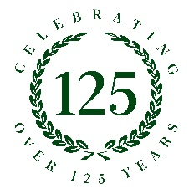
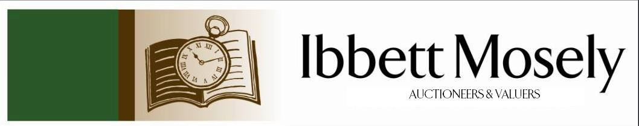

Catalogue of Antiques and Collectibles
to be Auctioned on

Wednesday 8th July 2026ffff
at 11am

IBBETT MOSELY AUCTION ROOMS
ARGYLE ROAD, SEVENOAKS, KENT TN13 1HJ
And Online Via
www.easyliveauction.com/ibbettmosely/

Viewing at Sale Room on:

Monday 6th July
Tuesday 7th July

Between 10am – 5pm

Catalogues: £2.00

Auctioneer and Valuer: Alan White FNAVA
Auction Clerk and Saleroom Manager: Benjamin Burridge
Photographer and Porter: Samantha Crowe-White

Welcome to Ibbett Mosely Auctions
8th July 2026 Auction Catalogue

This sale will also be held online at www.easyliveauction.com/ibbettmosely/
please visit the website to register or log in to view and bid. Images and condition reports of each lot are included.

Alternatively, commission bids (bids left ‘on the book’) may be left with us, as well as a limited amount of telephone bids. Please telephone 01732 456731 or email auctions@ibbettmosely.co.uk for further details.

Unsold lots from this sale will be placed into a week-long online timed auction that can be found at www.easyliveauction.com/ibbettmosely/

Please telephone 01732 456731 or email auctions@ibbettmosely.co.uk with any questions.

Collection of items is available on Thursday 9th July from 10am - 1pm. Collection of items from 10th July onwards, by prior appointment only.

We do not arrange collection or deliver your items ourselves, collection of items is the responsibility of the buyer. You are welcome to collect in person, or via your own carrier, we can provide details for a local carrier if you need it.

We would really appreciate it if you could leave us a review on Google. Good or bad, we will listen to all your feedback so we know what we are doing well, and how we can improve. Scan the QR code below to be taken to our Google page. You can do this with your phone camera.
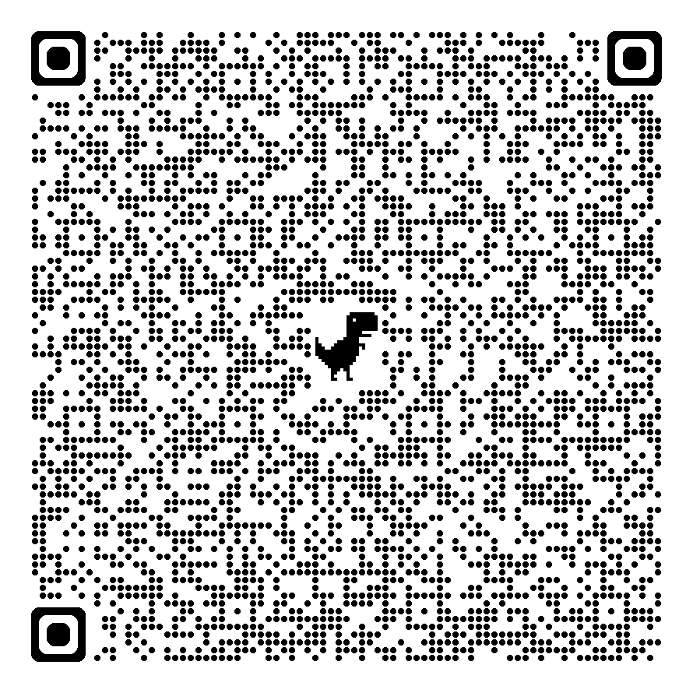
1. | Two Nigerian carved wood busts of lady's heads, each 19cm high, a pair of oriental carved wood and bone-inlaid candle sticks each 24cm high, a part-carved wooden figure of a water buffalo, 20cm long, and a number of other carved wood figures and boxes including tortoises and other animals (14). |  |  | £70-£100
2. | Group of Ernst Teichert Meissen blue and white porcelain comprising: a part-fruit set with part-pierced border, 8pcs, a part coffee set of 6 cups and saucers, a small tray, a non-matching teapot, sugar bowl and cream jug, slightly a.f. (24pcs). |  |  | £150-£200
3. | A cobalt blue glass vase with etched decoration, on circular foot and stained wood base, 20cm high, a similarly shaped plain blue glass vase, 19.5cm high, together with a German milch glass vase with some floral decoration, 42cm high (3). |  |  | £60-£80
4. | An Art Nouveau style opalescent and lustre glass bowl with scalloped edge on a part-pierced brass stand and three legs, 21cm high. |  |  | £100-£150
5. | A collection of 'Buckingham Palace' collectable china including mugs, tea cups and saucers, boxes and covers, plates, dated 1993-1996, three pieces boxed (35 pieces). |  |  | £60-£80
6. | A pair of 18k white gold square-shaped gents' cufflinks, each set four princess cut diamonds approx. 14g gross. |  |  | £300-£400
7. | A pair of Argentinian leather Gaucho horse stirrups with blind fret decoration, 24cm wide by 34cm high, together with a brass studded leather belt (3). |  |  | £70-£100
8. | A small Edward VII silver tazza with pierced edge and two scrolled handles, on circular foot, maker Goldsmiths and Silversmiths co. ltd. London 1909 approx. 6 oz. |  |  | £180-£220
9. | An Edward VII silver sugar caster on circular foot, maker Goldsmiths and Silversmiths co. ltd, London 1905 approx. 3.4 oz. |  |  | £100-£150
10. | A George V silver salver with pie crust edge, on three shaped feet, maker PK&P Sheffield 1932 approx. 24 oz. |  |  | £800-£900
11. | An oval silver plated and galleried tray, silver plated punch bowl, 27cm in diameter, silver plated salver, sugar bowl, cream jug, and two other pieces (7). |  |  | £50-£70
12. | A Lady's Omega 9ct gold wristwatch (a.f.), circular case and dial, bar numerals, on link strap, in Omega box, together with a cameo dress ring, a pair of oriental ear clips, approx. 11g weighable (4). |  |  | £250-£350
13. | A Nazi German Third Reich 2nd pattern NSDAP banner or flag top, the pole fixing marked "RZM M3/40/38", M3/40 is believed to be the maker's code for "Gebruder Cossack", wing span 24cm, height 25cm, a.f. |  |  | £100-£150
14. | A replica Nazi German Luftwaffe officer's 2nd pattern dagger, with plastic handle, and some engraved decoration to the 24cm blade, no maker's name, 42cm overall. |  |  | £40-£60
15. | A set of six volumes of "The War in Pictures", published by "Oldhams Press Limited", 1946 (6). |  |  | £20-£30
16. | A lady's 9ct gold garnet and pearl brooch, a small cameo brooch in 9ct gold mount 4cm long, a lady's silver cocktail wristwatch, a gent's silver wristwatch, a silver tankard charm, a Seiko wristwatch, together with a quantity of metal charms, decorative and costume jewellery, other pieces, and an Austrian 1 Thaler coin, dated 1780, possibly a commemorative re-strike, in metal mount, approx. 12g weighable gross (qty). |  |  | £180-£220
17. | A 7in 45 rpm single record "It's only Rock and Roll" by the Rolling Stones, a further record "Relax" by Frankie Goes to Hollywood, a 33 rpm LP record of National Anthems, and another "The Three Little Pigs" (4). |  |  | £20-£30
18. | A collection of mixed stamps, comprising: - an album of British issues, a quantity of pages of world stamps, a number of first day covers, together with a Stanley Gibbons catalogue 1967 (qty). |  |  | £30-£50
19. | A part set of five Elizabeth II silver egg spoons Sheffield 1966 approx. 1oz, in case fitted for six, a silver-plated soup ladle, a small quantity of silver-plated ware various, together with glassware, and a single porcelain plate (qty). |  |  | £40-£60
20. | A Belleek Collectors 25th Anniversary yellow rose decorated vase, 30cm high, boxed, a Shamrock-pattern castle vase, black mark, 19cm high, boxed, a Georgian shell vase, 24cm high, boxed, a large Shamrock-pattern vase, 26cm high, unboxed, and a spare Belleek box (5). |  |  | £40-£60
21. | A Belleek "Rossmore" pattern table lamp, 23.5cm high, boxed, a set of four mini vases, boxed, a "Country Trellis" pitcher, 26cm high, boxed, together with a number of other smaller pieces, in associated and un-associated boxes (18). |  |  | £70-£100
22. | A Herend porcelain large painted figure of a rooster, fishnet pattern, 42cm high. |  |  | £80-£100
23. | Three 20th century Imari plates, each 21cm in diameter, one cracked, together with two Meissen-style blue and white ribbon type plates, each 24cm in diameter (5). |  |  | £40-£60
24. | A decorative cast-metal polearm, beech shaft, approx. 210cm long. |  |  | £20-£30
25. | A reproduction mahogany twin pedestal Regency-style dining table, with reeded edge, and rounded corners, on splay legs, with brass paw terminals and castors, and central leaf, 120cm x 242cm extended, together with eight Georgian-style upholstered dining chairs on square chamfered legs (9). |  |  | £200-£300
26. | After Mark Spain - Female portrait, limited edition print "In Profile", no. 168/250, 28cm x 27cm, a ditto profile "II", limited edition print 168/250, a pair, together with a ditto life study nude no. 19/195 35cm x 20cm (3). |  |  | £100-£150
27. | After Mark Spain - "Classic Cool" giclee print, no. 72/392, 49cm x 60cm, together with a ditto "American Dream" giclee print, no. 74/295, 48cm x 58cm, retailed by Kings Gallery Canterbury (2). |  |  | £80-£120
28. | After Jack Vettriano (1951-2025) - "Winter Light and Lavender", limited edition print no. 241/275, 60cm x 72cm, retailed by Kings Gallery Canterbury. |  |  | £80-£100
29. | After David Greenty - "By a Neck", cold-cast bronze, 40cm high, slightly a.f. |  |  | £100-£150
30. | After Auguste Rodin - "Eternal Springtime", reproduction cold-cast bronze, 26cm high. |  |  | £40-£60
31. | After Janet Treby - "Take Me Home", limited edition print, no. 62/195, 59cm x 31cm, retailed by Kings Gallery Canterbury, and a serigraph after the same artist "Ecole de Ballet III", 52cm x 38cm, retailed by the Park West Gallery (2). |  |  | £40-£60
32. | After Milton H. Greene - Reproduction photograph, Marilyn Monroe Ballerina sitting, 24cm x 26cm. |  |  | £20-£30
33. | After Rolf Harris (1930-2023) - "Self Portrait in Striped Shirt" giclee print, no. 643/695, retailed by Kings Gallery Canterbury, another print "Barge at Westminster" no. 598/695, 41cm x 71cm, unframed, and another print "All You Need is Love" 30cm x 44cm, framed but unglazed (3). |  |  | £30-£50
34. | After Fletcher Sibthorp (b.1967) - Study of flamenco dancer, limited edition print 114/395, 68cm x 47cm, together with a modern still life print of a poppy, 30cm x 54cm, and a decorative serigraph print after an unknown artist, 24cm x 50cm (3). |  |  | £20-£30
35. | An early 20th century Japanese table cabinet with lacquered and segmented veneer decoration, fitted a rising lid, three drawers, and six further drawers, enclosed by two panelled doors, 44cm wide x 54cm high. |  |  | £150-£200
36. | A George III needlework sampler by Mary Grigg Banwell, 34cm x 32cm, framed 44cm x 42cm. |  |  | £60-£80
37. | A Victorian needlework sampler by "Matilda Applin, aged 11 years, June 24th 1847, Glaston", with poetry text, 29cm x 29cm, framed 32cm x 33.5cm. |  |  | £50-£70
38. | A George III needlework sampler by "Sarah Scarratt September 10th 1818" with religious text and decorative border, 32cm x 32.5cm, in an inlaid mahogany frame, 38cm x 38cm, together with a further George III sampler by "Mary Forster September 23rd 1778" depicting the ten commandments, 37cm x 28cm, in pale mahogany frame, 51cm x 43cm, a.f. (2). |  |  | £50-£70
39. | A Regency needlework sampler by "Lillias Halley aged 10 August 1823", 38cm x 31cm, in gilt frame, 46cm x 38.5cm, together with a Scottish William IV sampler by "Augusta Jane Steele Closeburn Village October 26th 1832", 41.5cm x 32cm, in similar frame, 46cm x 38.5cm (2). |  |  | £60-£80
40. | A needlework sampler by "Mary Henderson", 43cm x 31cm, in gilt frame, 57cm x 43cm, together with a smaller sampler, 38cm x 29cm (2). |  |  | £30-£50
41. | A part set of four Schmid porcelain Beatrix Potter figures, three with musical box features, comprising:- Peter Rabbit, Poorly Peter Rabbit, Tom Kitten and Mitten, and Mr Jeremy Fisher, 13cm high to 19cm high respectively, together with a Beswick Beatrix Potter figure "Mrs Rabbit", and a Royal Worcester figure "Polly put the Kettle on" (6). |  |  | £40-£60
42. | A part set of nine Royal Worcester porcelain figures of the Months of the Year modelled by F. G. Doughty, each approx. 15-17cm high, July, September and October missing (9). |  |  | £90-£120
43. | Six Royal Worcester figures from the Monday's Child series covering Monday, Tuesday, Wednesday, Friday, and two of Saturday, between 14cm and 22cm high (6). |  |  | £60-£90
44. | A Paddington Bear hand puppet by "Gabrielle Designs", wearing brown duffel coat, and parcel label attached, 31cm high. |  |  | £50-£70
45. | A Trademark "Bowie - Silver Duke" life mask by Mark Wardel, no. 120/300, 20cm high, with certificate, in un-associated box. |  |  | £100-£150
46. | Montagu Slater - "The Centenary Poe" book of poetry etc. published 1949 by Theodore Brun ltd, no. 101, and signed by the author, no dust jacket, together with a further volume "Noblesse Oblige" edited by Nancy Mitford, first edition published 1956, with dust jacket (2). |  |  | £50-£70
47. | After E. H. Shepard - "No. 8 Come on Tigger its Easy", chapter 4 page 71, chromolithograph, 40cm x 30cm, in moulded frame, 53cm x 42cm, and a set of four smaller chromolithographs from Winnie the Pooh in single frame 32cm x 66cm (2). |  |  | £70-£100
48. | A silver-plated keyless wound goliath pocket watch, 9cm in diameter, in carrying case with metal-bound front. |  |  | £40-£60
49. | A gent's Seiko "Pogue" wristwatch, in stainless steel case, no. 6139-6002, gilt-coloured dial, on bracelet strap. |  |  | £60-£80
50. | A George V silver-backed engine turned four-piece dressing table set, maker Bravingtons Ltd Birmingham 1938, in lined case. |  |  | £100-£150
51. | A collecting of glass toilet jars, hair tidies, and pill boxes, with silver tops, Chester 1915, and other mixed dates, together with a pair of bone glove stretchers, a set of six mother of pearl handled silver-plated fruit knives with silver ferrules in lined case, and a silver-plated muffin dish (a quantity). |  |  | £150-£200
52. | Twenty One enamelled Henley Regatta badges, together with 7 Stewards Enclosure badges, and a sesquicentenary badge, from 1985 to 2013 (29). |  |  | £70-£100
53. | An early 20th century "Elliot" mantel clock in walnut veneered case, three train striking movement, gilt dial, retailed by "William Bruford & Son Ltd Eastbourne & Exeter", 24cm high. |  |  | £30-£50
54. | A "Weimar" white and gilt porcelain two-handled sauce tureen, 34cm wide. |  |  | £20-£30
55. | A continental white metal 800 standard long-handled spoon, with blue enamel terminal, a further spoon, with oriental-style decoration, a hammered spoon, and three chopsticks, unmarked, approx. 5oz weighable (6). |  |  | £80-£100
56. | A folder of mixed loose stamps from approx. 32 countries, including: - African countries, Argentina, Brazil, Canada, Denmark, Italy, United Kingdom, and USA (a quantity). |  |  | £15-£20
57. | A Doulton Lambeth Faience ware squat vase, 12cm high, small chip to neck rim, and further body chip, and a pair of further vases, in the same pattern, one cracked and chipped, each 15.5cm high (3). |  |  | £60-£80
58. | A Dolphin English leather brief case, with expanding action, 43cm wide (a.f.). |  |  | £15-£20
59. | A Gent's Citizen Cryston stainless steel wristwatch, quartz movement, boxed, and a brown buffel credit card case, a.f. (2). |  |  | £40-£60
60. | A Royal Doulton "Under the Greenwood Tree" Robin Hood jug, 13.5cm high. |  |  | £15-£20
61. | A Merrythought soft toy of a tigress, approx. 120cm long, overall, and a similar cub, 88cm long (2). |  |  | £20-£30
62. | A Newlyn-style oval shaped copper tray, with scalloped edge, and decorated stylised fish, 48cm wide. |  |  | £20-£30
63. | An 18th century map of Nottinghamshire, c. 1776, 20cm x 16cm. |  |  | £30-£50
64. | An early 19th century map of Kent, by C. Greenwood, 1839, 30cm x 43cm, a.f. |  |  | £30-£50
65. | An 18th century road map by Emanuel Bowen, c. 1785, of Warwickshire, the road from Oxford to Coventry, 19cm x 12cm, later colouring. |  |  | £30-£50
66. | A map of Oxfordshire, by Pigot & Son, Manchester, 37cm x 24cm. |  |  | £30-£50
67. | An American Edco dress ring, set an amethyst coloured stone, in box, together with a pocket ashtray, and an evening purse (3). |  |  | £30-£50
68. | A Martin Yeats pink and white mottled glass bowl, 10cm high, a Villeroy and Boch blue tinted rummer, and a part lustre glass stemmed bowl (3). |  |  | £15-£20
69. | Royal Doulton "Morning Star" pattern part dinner service, 28 pieces (28). |  |  | £20-£30
70. | A 20th century German-style cuckoo clock, with plastic hands, a weight and pendulum, 24cm high. |  |  | £20-£30
71. | A French pink and green glass "Gaudard" oil lamp, with plain glass chimney, 55cm high. |  |  | £20-£30
72. | After Salvador Dali - a poster book containing 6 coloured print posters, in English, French, and German, 43cm x 31cm. |  |  | £20-£30
73. | Three albums of British and world stamps, various, and six albums of tea cards (9). |  |  | £30-£50
74. | A Meccano set no 4, in tricolour box, some pieces missing, a.f. |  |  | £20-£30
75. | A small set of "Scalextric" racing track, with some barriers, some other accessories, a racing car in VIP club box, a "Smoothflow" power unit, and a Scaletrix catalogue, 11th edition (a quantity). |  |  | £40-£60
76. | A lady's 18k gold keyless wound fob watch with gilt dial, Swiss movement, 5cm in diameter, in "John Bennett" of London box. |  |  | £300-£400
77. | A Prattware pottery miniature cradle, with green and brown mottle decoration, 23cm long. |  |  | £50-£70
78. | A quantity of late 19th/early 20th century porcelain figures by Samson of Paris, Dresden, Derby, and various continental manufacturers, height ranging from 9cm to 15cm, all damaged, cracked and in need of repair (17). |  |  | £20-£30
79. | Early 20th century school - circular miniature portrait on ivory of little girl, in mourning pendant style frame, 5cm in diameter. Submission ref: MH7R4VEK. |  |  | £90-£120
80. | 19th century English school - Miniature landscape on ivory, with some figures, 7cm by 9cm, in ebonised frame, and an oval portrait on ivory of young woman, 11cm x 8cm, in ebonised frame (2). Submission ref: DRK8A585. |  |  | £100-£150
81. | An early 20th century mantel clock, in arched walnut case, white enamelled dial, striking movement, 28cm high. |  |  | £40-£60
82. | Henry Woods - Watercolour of street scene, signed bottom left, 35cm x 25cm, in carved oak Liberties of London frame, 59cm x 48cm. |  |  | £150-£200
83. | A 19th century engraved map of Sussex, 21cm x 26cm, a small engraving of "Burns's Cottage", 12cm x 17cm, together with three other small paintings and prints (5). |  |  | £40-£60
84. | After A. G. Veal (1871) - A horse racing lithograph on a Vienna porcelain plaque, 11cm x 16cm, in decorative gilt frame, 26cm x 31cm. |  |  | £40-£60
85. | An American wall clock in veneered and stained wood case, by "Chauncey Jerome New Haven Connecticut", 65cm high x 38cm wide. |  |  | £20-£30
86. | A small Elizabeth II silver waiter, with shaped piecrust edge, 15cm in diameter, maker R&B, Sheffield 1972, approx. 4oz. |  |  | £100-£150
87. | A set of six Victorian mahogany dining chairs with slightly carved mid rails, upholstered stuff over-seats, on octagonal turned and ringed legs (6). |  |  | £80-£100
88. | An antique needlework sampler by Ann Jeffries, 32cm x 31cm, in stained wood frame, 40cm x 40cm. |  |  | £40-£60
89. | A Victorian pale mahogany commode, on octagonal turned legs, with liner, 61cm wide. |  |  | £20-£30
90. | A Lladro porcelain figure "Wedding" 19cm high, boxed, two Nao figures, each 20cm high, boxed, a Capodimonte figure of musician with monkey 30cm high, unboxed (a.f.), and a Coalport Lady of Fashion figure "Sarah", on wood base, 24cm high, unboxed (5). |  |  | £30-£50
91. | A Lladro figure "My Little Explorers" 23cm high, another "Puppy Parade" 23cm high, another "Summer on the Farm" 24cm high (a.f.), and another "Walk With the Dog" 27cm high, all boxed (4). |  |  | £30-£50
92. | A Lladro figure "Winter Frost" 24cm high, another "A Barrow of Fun" 20cm high, another "A Reading Lesson" 30cm high, and another "Glorious Spring" 28.5cm high, all boxed (4). |  |  | £50-£70
93. | A Lladro figure "Country Life" 30cm high, another "Fall Clean Up" 32cm high, another "Spring Splendour" 30cm high, and another "Springtime Friends" 17cm high, all boxed (4). |  |  | £50-£70
94. | A 9ct gold Victorian-style seven stone garnet-set dress ring approx 2.7g, together with a quantity of metal dress rings, necklaces, earrings, badges, and other costume pieces (a quantity in two boxes). |  |  | £150-£200
95. | A Border Fine Arts figure of a red stag 19cm high, a ditto of a doe and fawn 13cm high, together with a barn owl, an otter, collie puppies, a fox, a border collie clock, and other figures by different manufacturers, three boxed (20). |  |  | £80-£100
96. | A 1939/45 Star, Second World War Defence and War Medals, possibly awarded to a nurse, a further war medal, together with some veteran badges, and other objects (qty). |  |  | £30-£40
97. | A Charles III Mexican silver 8 Reales (Piece of Eight) coin, on an English silver curb-link watch chain, a further smaller silver curb-link watch chain with metal fob, a small silver sporting medal, an Elizabeth I sixpence, a George III shilling, a metal vesta case, and other objects (qty). |  |  | £60-£80
98. | A pair of reproduction French-style oyster veneered two tier etageres, with gilt brass mounts, on tapering legs, each 49.5cm wide (2). |  |  | £180-£220
99. | A pair of reproduction French-style simulated marquetry circular occasional tables, with gilt brass mounts, on tapering legs, each 63cm in diameter (2). |  |  | £200-£300
100. | A reproduction French-style simulated marquetry circular coffee table, with gilt brass mounts, on tapering legs, 81cm in diameter. |  |  | £200-£300
101. | A Georgian oak mule chest with hinged lid, and panelled front, above two drawers, on block feet, 126cm wide. |  |  | £80-£100
102. | A Chinese famille vert and rose fish bowl, decorated figural panels, flowers and foliage, on limed wood stand, 70cm high overall. |  |  | £100-£200
103. | 20th century Japanese school - A pair of prints of lake scenes showing Mt Fuji, and with houses and boats, with gilt highlights, each 25cm x 20cm. (2) |  |  | £20-£30
104. | Hugh Evelyn after John Mollo - "Physician, Full Dress, 1805-1825", a coloured silhouette print, oval, 17cm x 11cm, together with "A Consultation" lithograph, 12cm x 18cm (2). |  |  | £20-£30
105. | A heavy cut and hobnail cut glass fruit bowl 23cm in diameter, a Thomas Webb cut glass bowl 15cm in diameter, and a Royal Brierley glass bowl 13cm in diameter (3). |  |  | £20-£30
106. | A Victorian part-carved walnut work table, on quadruped base, 49cm wide, a.f. |  |  | £70-£100
107. | A pair of 19th century Chinese famille noir and famille vert vases decorated flowers and birds, each 25cm high, adapted as lamps, slightly a.f. (2). |  |  | £70-£100
108. | Five Bosson's pottery heads and figures, comprising: Woodpecker 1968, Rawhide 1967, Pancho 1960, Desert Hawks 1961, and Buccaneer 1964 (5). |  |  | £20-£30
109. | A Spode "Persia" pattern combination set (Y8018), 12 place settings, including: 4 sizes of plate, 2 meat platters, gravy boat and saucer, tea set, and other pieces, and including a spare terrine lid. (approx. 81 pieces) |  |  | £80-£120
110. | A set of silver-plated and stainless steel cutlery by John Turton of Sheffield, in contemporary stained wood canteen, 85 pieces, together with six spoons in a different pattern (91 pieces overall). |  |  | £40-£60
111. | George Dunkerton Hiscox - View of Windsor and castle from an orchard, watercolour, signed bottom left, 47cm x 73cm. |  |  | £60-£80
112. | Attributed to George Dunkerton Hiscox - Silver birch trees in wooded landscape, watercolour, 48cm x 40cm. |  |  | £20-£30
113. | A small early 20th century mahogany open-fronted hanging bookcase, with scroll edges, 78cm wide x 85cm high, together with a smaller oak bookcase, 38cm wide x 61cm high (2). |  |  | £30-£40
114. | Early 20th century English school - Unfinished watercolour of Windsor Castle, 10cm x 16cm. |  |  | £15-£20
115. | A 20th century Vine Cricket Club Bicentenary Cricket Week poster for the 16-21 July 1934, 32cm x 19cm, together with a later part copy of The Charm of Cricket Past and Present, describing the history of the match (2). |  |  | £20-£30
116. | An early 19th century opaque twist stem wine glass 15cm high (a.f.), together with a number of etched wine, port and tot glasses, mixed sizes and dates, two hangman beakers, and a decorative pale green glass vase (20). |  |  | £60-£80
117. | A stripped and stained pine shoe-shine box, with handle over, 32cm wide. |  |  | £20-£30
118. | A reproduction Staffordshire figure "The Sailor's Return" 25cm high, a similar figure "The Sailor's Farewell" 22cm high, together with a reproduction blue and white pottery dolls part tea set (12). |  |  | £20-£30
119. | A gent's stainless steel Seiko Quartz LC wristwatch with bracelet strap. |  |  | £20-£30
120. | A silver-plated salver with decorative piecrust edge, 26cm in diameter, and a ditto waiter 22cm in diameter, together with a quantity of pewter mugs, an inkwell, and other objects (qty). |  |  | £30-£50
121. | A 20th century dress maker's dummy, on tripod base, 143cm high. |  |  | £20-£30
122. | An 18th century style oak dresser, with planked rack top, above six drawers and two panelled doors, on bracket feet, 144cm wide x 194cm high. |  |  | £100-£150
123. | An 18th century style panelled oak livery cupboard, fitted two doors, on block feet, 134cm wide x 174cm high. |  |  | £100-£200
124. | A silver-plated three bottle tantalus with a pair of hobnail cut decanters and a non-matching ditto 30cm wide, and a French glass decanter and stopper 42cm high, together with three Waterford glass champagne glasses, a Waterford glass photo frame, and other glassware (qty). |  |  | £40-£60
125. | An Art Nouveau style Bohemian pottery amphora vase by R. S. & K. with relief decoration 18cm high (a.f.), together with a Paragon China commemorative casket "Wedding of the Prince of Wales and Lady Diana Spencer 1981" in lined box (a.f.), a Sutherland china figure of a cat, a small modern cloisonne box, and a porcelain inkwell (5). |  |  | £30-£50
126. | A Waterman cartridge pen in branded box, four other loose pens, together with compacts, an evening purse, and other objects (qty). |  |  | £20-£30
127. | A 1939-pattern Home Guard great coat size 5, with shoulder flashes and unit patches. Evidence of moth in several areas. |  |  | £60-£80
128. | A pair of Kate Spade sunglasses in two-tone case, a pair of Ray Bans sunglasses in a Coco Chanel case, and a number of other pairs of sunglasses (qty). |  |  | £25-£40
129. | Three albums of stamps various, two Royal Mail Millennium Collection books, and a quantity of loose stamps various (qty). |  |  | £30-£50
130. | A small French indenture sheet 25cm x 19cm in plastic protective frame, a 17th century page from a ledger, and an 18th century French handwritten document (3). |  |  | £20-£30
131. | A Russian police-type fur hat (large size), a Davey Crockett type raccoon hat, and a decorative costume tiara (3). |  |  | £20-£30
132. | A pair of 20th century Chinese style brass vases and covers on wood stands each 20cm high, a small card game indicator, a.f., and a modern piece of silver-plated abstract sculpture 12cm high (4). |  |  | £20-£30
133. | A small George V decorative glass scent bottle, with silver and bone top, London 1924, together with a set of six silver-plated coffee bean spoons in lined case, silver-plated baskets, a quantity of further silver-plated ware, and a small pewter hip flask (qty). |  |  | £30-£50
134. | A late Victorian jewellery box containing a quantity of decorative and costume jewellery, some military cap and rank badges, and other pieces (qty in 1 box). |  |  | £30-£50
135. | A Pelham Puppets "Wuff, Snuff, and Tuff" on single control in long box c.1952, together with three plastic and metal Tonka Toys, a number of Matchbox toy vehicles in box, and a quantity of other mixed toys various (qty). |  |  | £40-£60
136. | An early 20th century travelling part chess set in box (2 pieces missing), a further chess set in beech box, a playing cards set, together with a solitaire board, and a number of decorative tins (qty). |  |  | £20-£30
137. | A black lacquered no. 33 theodolite c.1933, in fitted box, with stained beech tripod. |  |  | £20-£30
138. | An "Estrella" piano accordion in plastic simulated mother-of-pearl case, 38cm wide, with carrying case. |  |  | £30-£50
139. | A bakerlite and brass stick telephone, a bakerlite model 332L telephone, a 706L black telephone, a 706F cream coloured telephone, and a further bakerlite telephone (5). |  |  | £20-£30
140. | A Hornby O gauge three-rail tinplate train shed 47cm long, a ditto station and platform, a train buffer, together with some Trix Twin railway track, a quantity of rolling stock, an HO/OO scale locomotive, a transformer, and other accessories, a.f. (qty). |  |  | £30-£50
141. | A pair of early 20th century Chinese famille rose vases and covers, each 29cm high, a.f. (2). |  |  | £40-£60
142. | A Japanese tinplate clockwork toy tricycle with celluloid figural rider 9cm long, a Hong Kong made plastic and felt clockwork toy mouse 12cm long, and a Japanese clockwork toy of elf-type figure riding a donkey 14cm long (3). |  | £20-£30
143. | A pair of "Tilley" paraffin landing lights each 67cm high, a Davey's Patent Improved Regulation Ships Lamp "Starboard" 57cm high, and a tinplate megaphone 46cm long (4). |  | £30-£50
144. | A copper and brass "Later Service" bugle 27cm long. | £20-£30
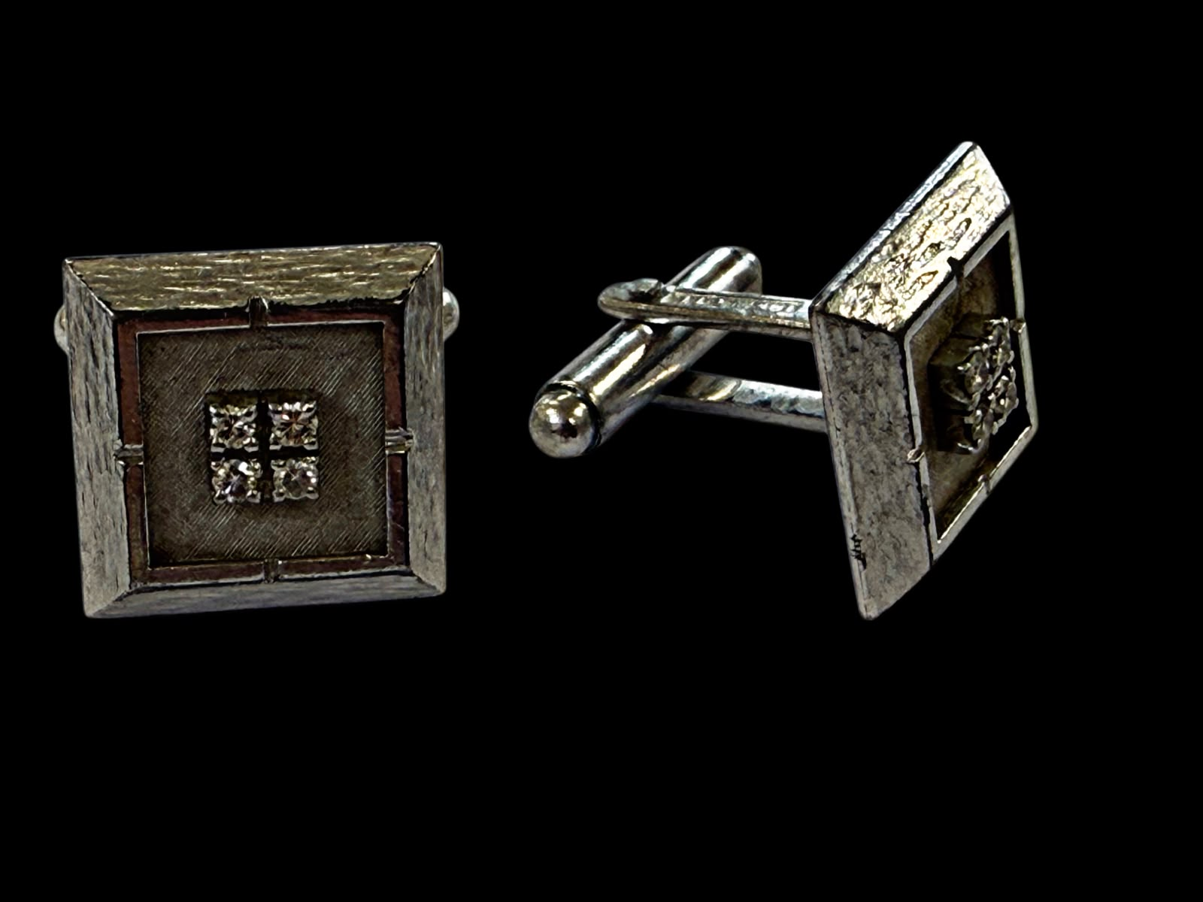
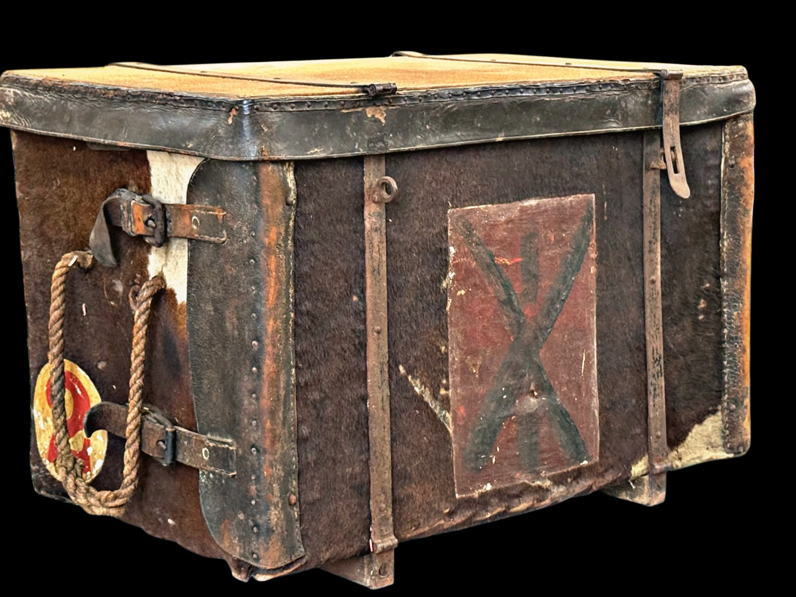
Lot 145 – An early 20th century "No. 2 Reserve Field Medical Pannier" with hide covering, 70cm wide x 46cm high. Est: £100-£150
Lot 6 – A pair of 18k white gold square-shaped gents' cufflinks, each set four princess cut diamonds approx. 14g gross. Est: £300-£400

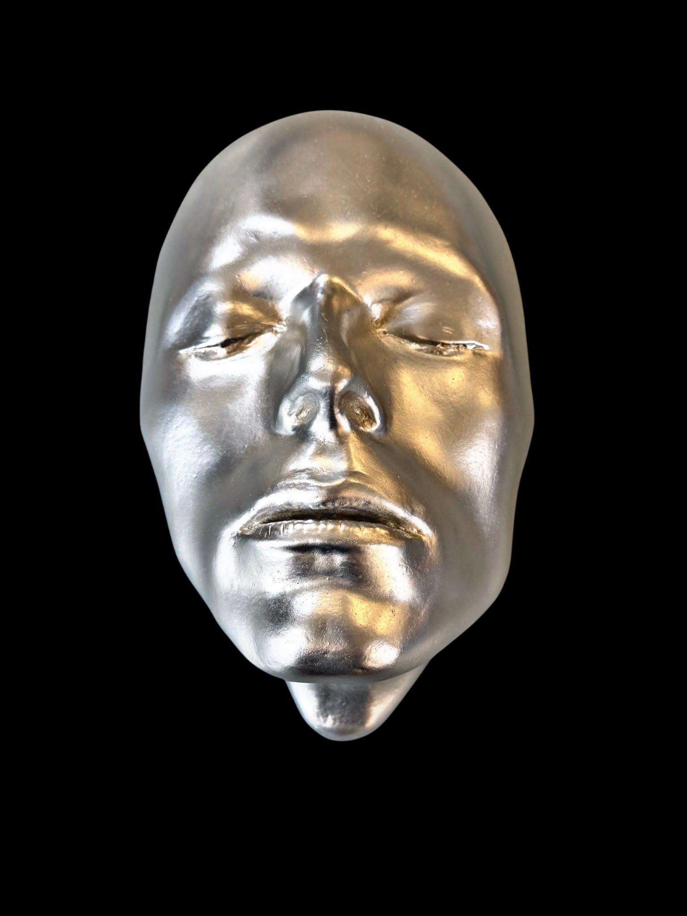
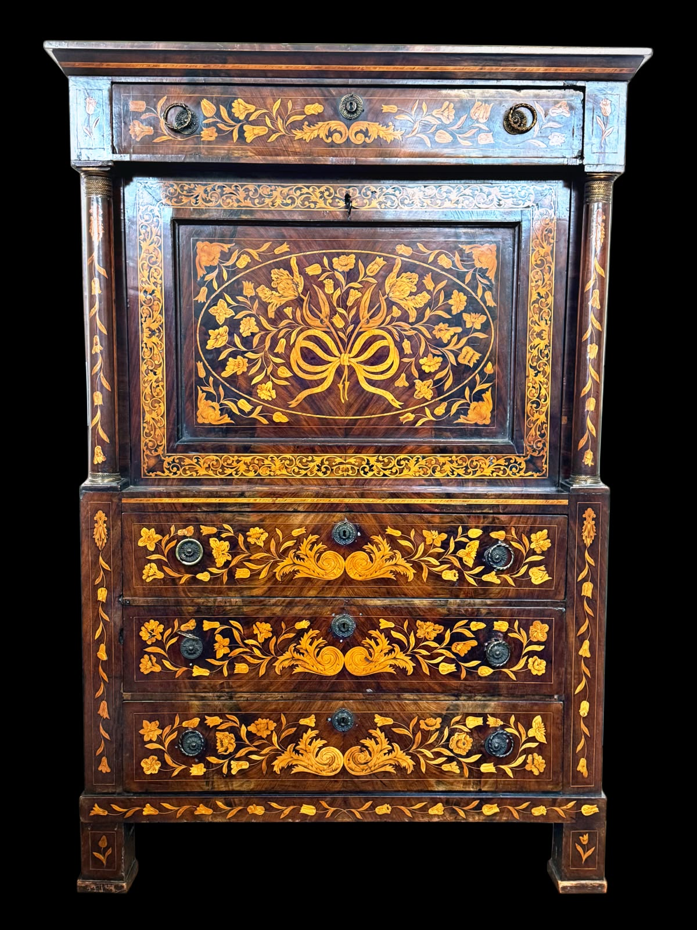
Lot 176 – An early 19th century Dutch mahogany and floral marquetry inlaid secretaire, 107cm wide x 159cm high. Est: £500-£800

Lot 45 – A Trademark "Bowie - Silver Duke" life mask by Mark Wardel, no. 120/300, 20cm high, with certificate. Est: £100-£150

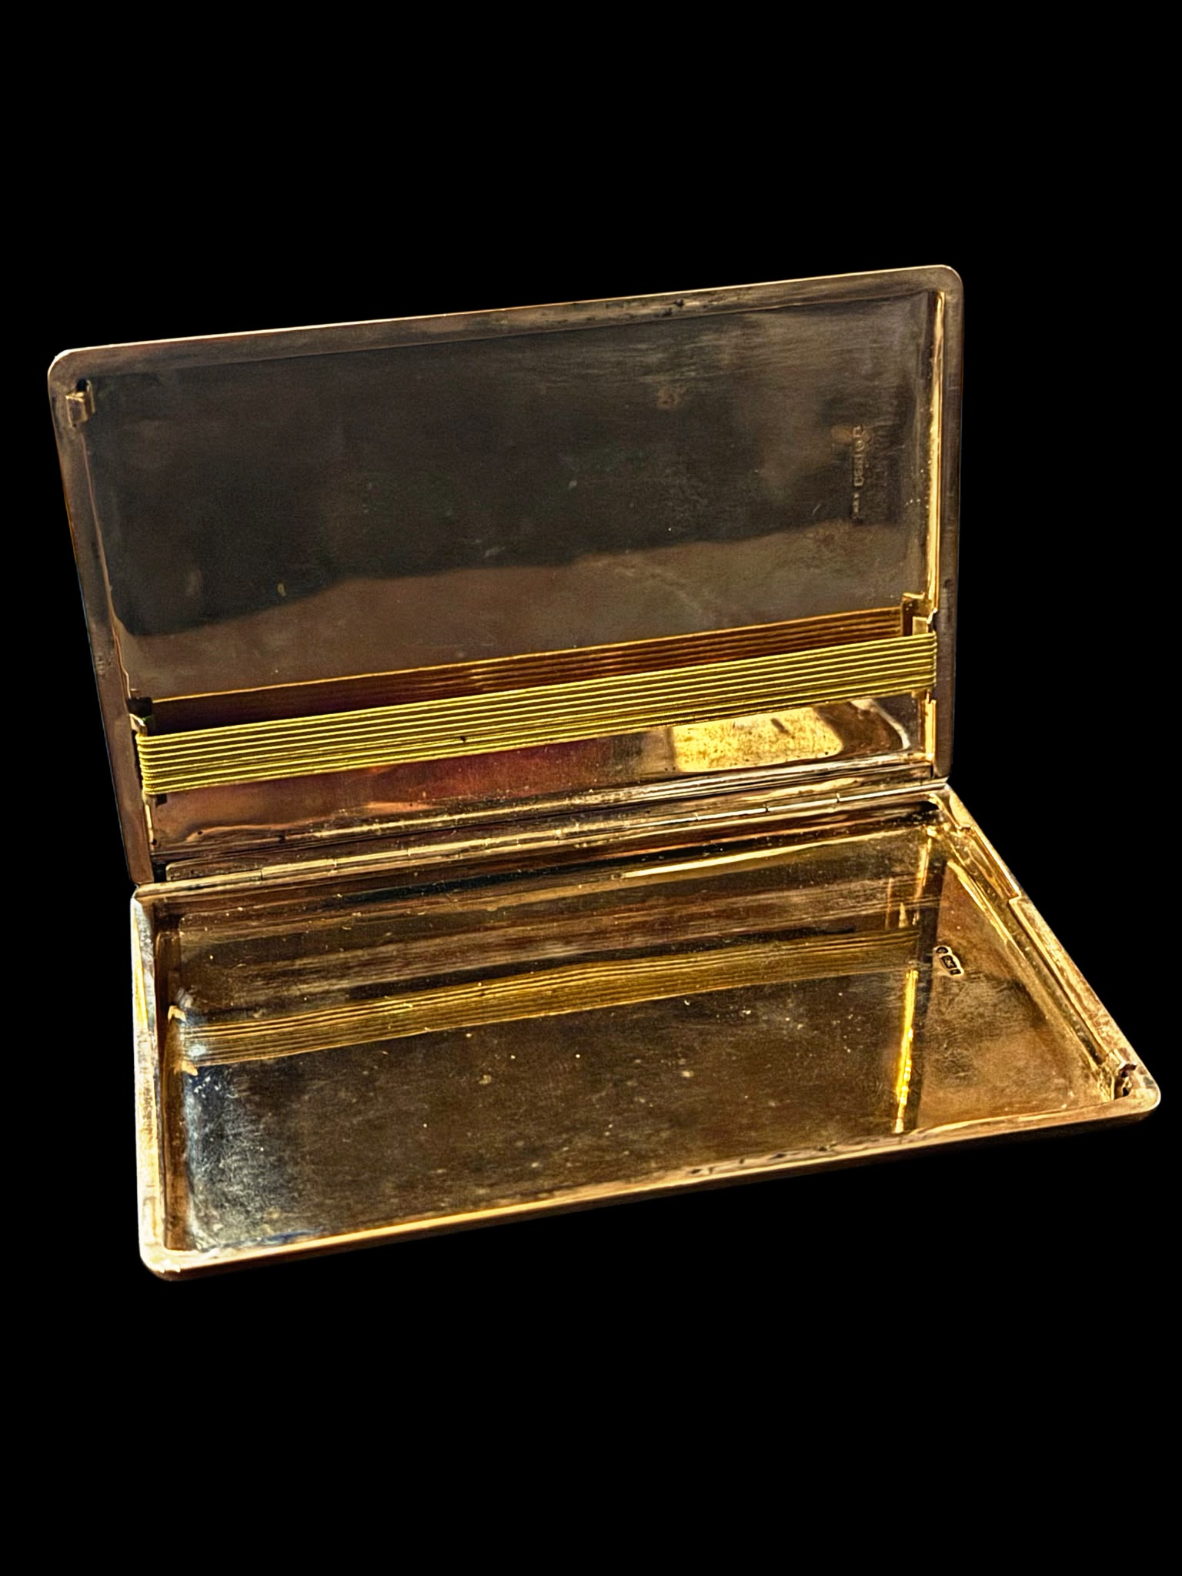
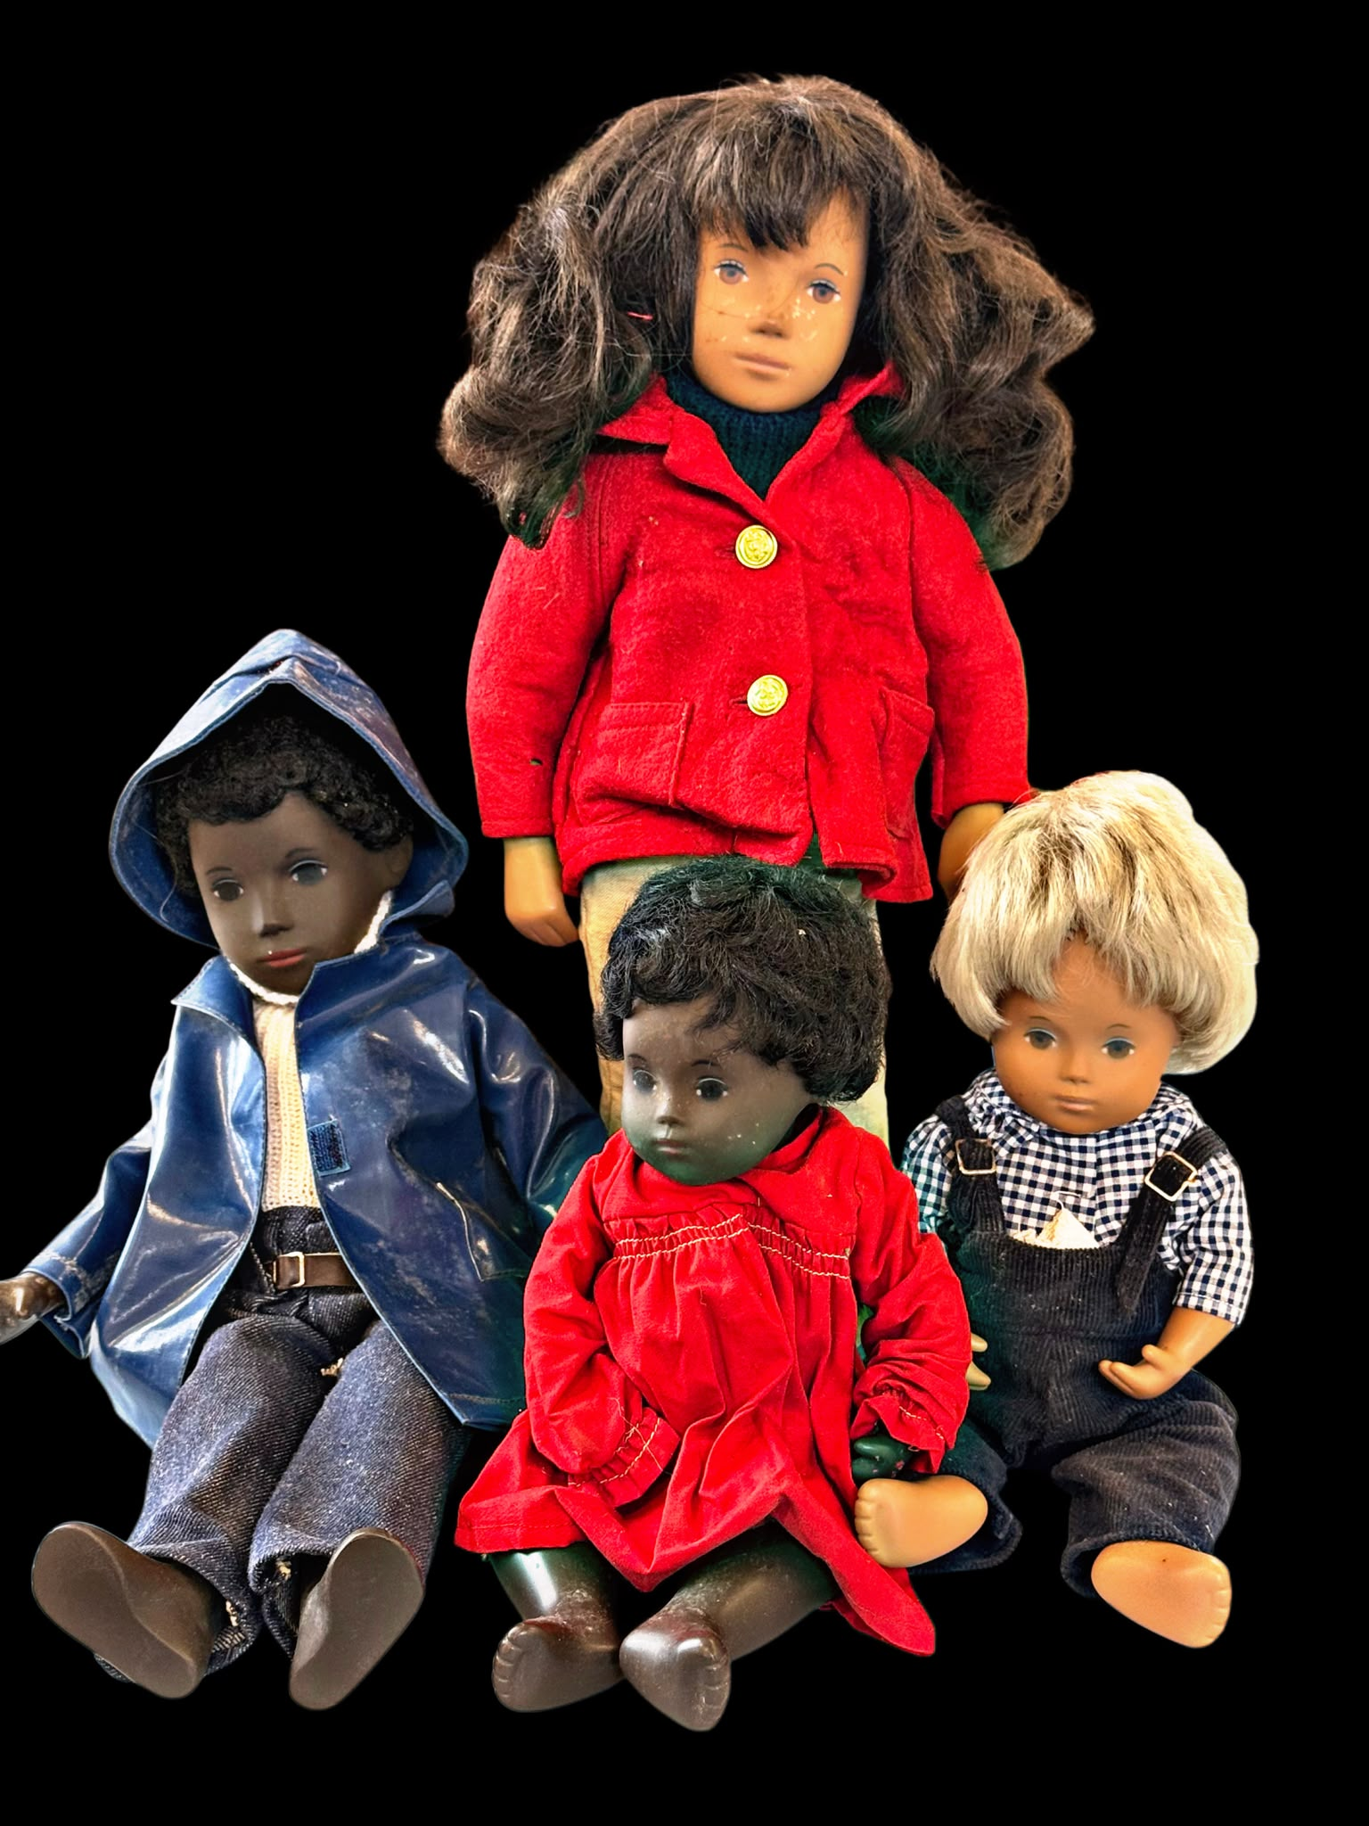
Lot 187 – A collection of four Sasha Morgenthaler dolls c.1960s-70s, part of the Diverse collection, comprising two adults and two children, wearing plastic and material clothing. Est: £100-£150

Lot 259 – An Elizabeth II 9ct gold rectangular cigarette case with engine turned decoration, maker S. J. R. London 1957, approx. 176g. Est: £5500-£6500

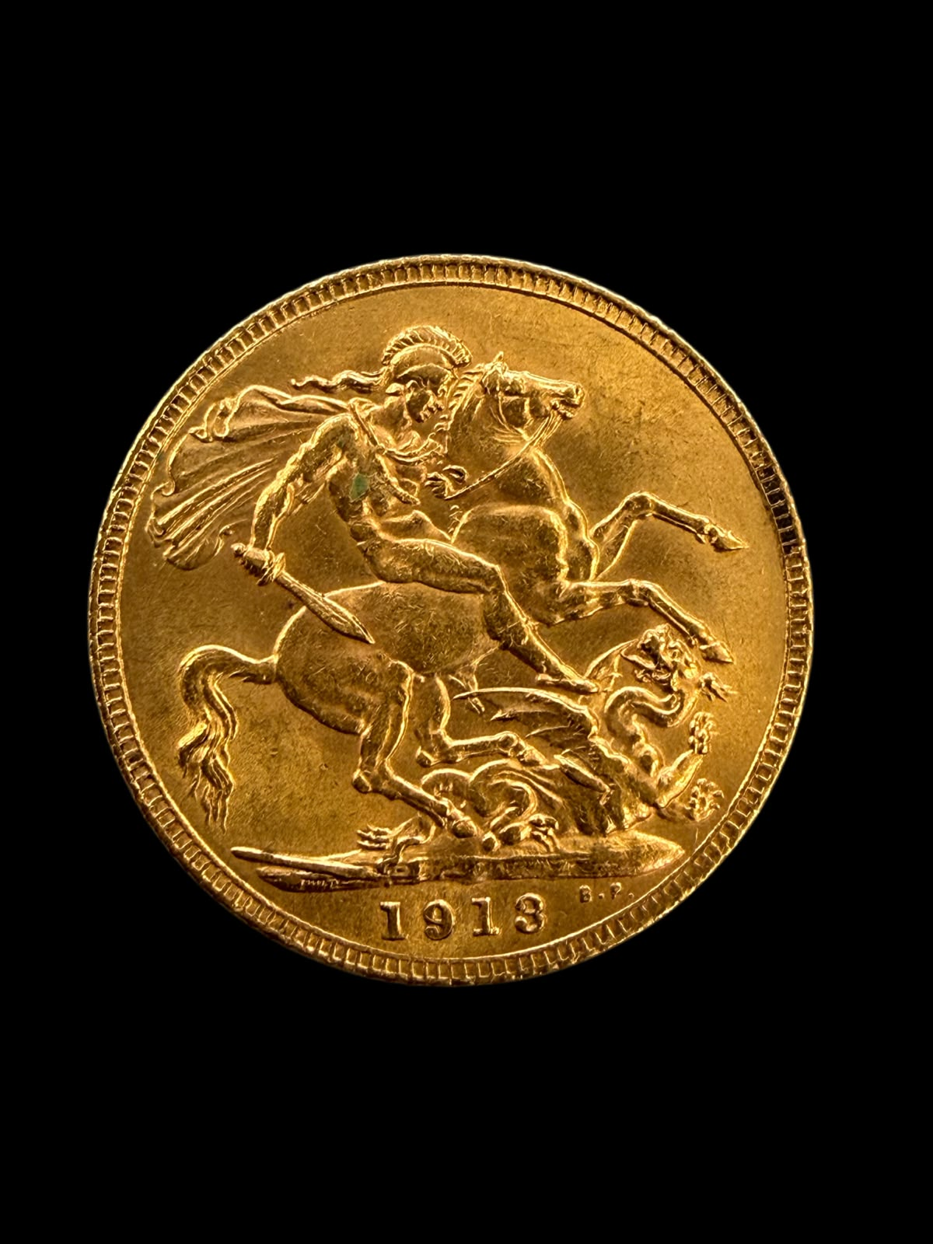
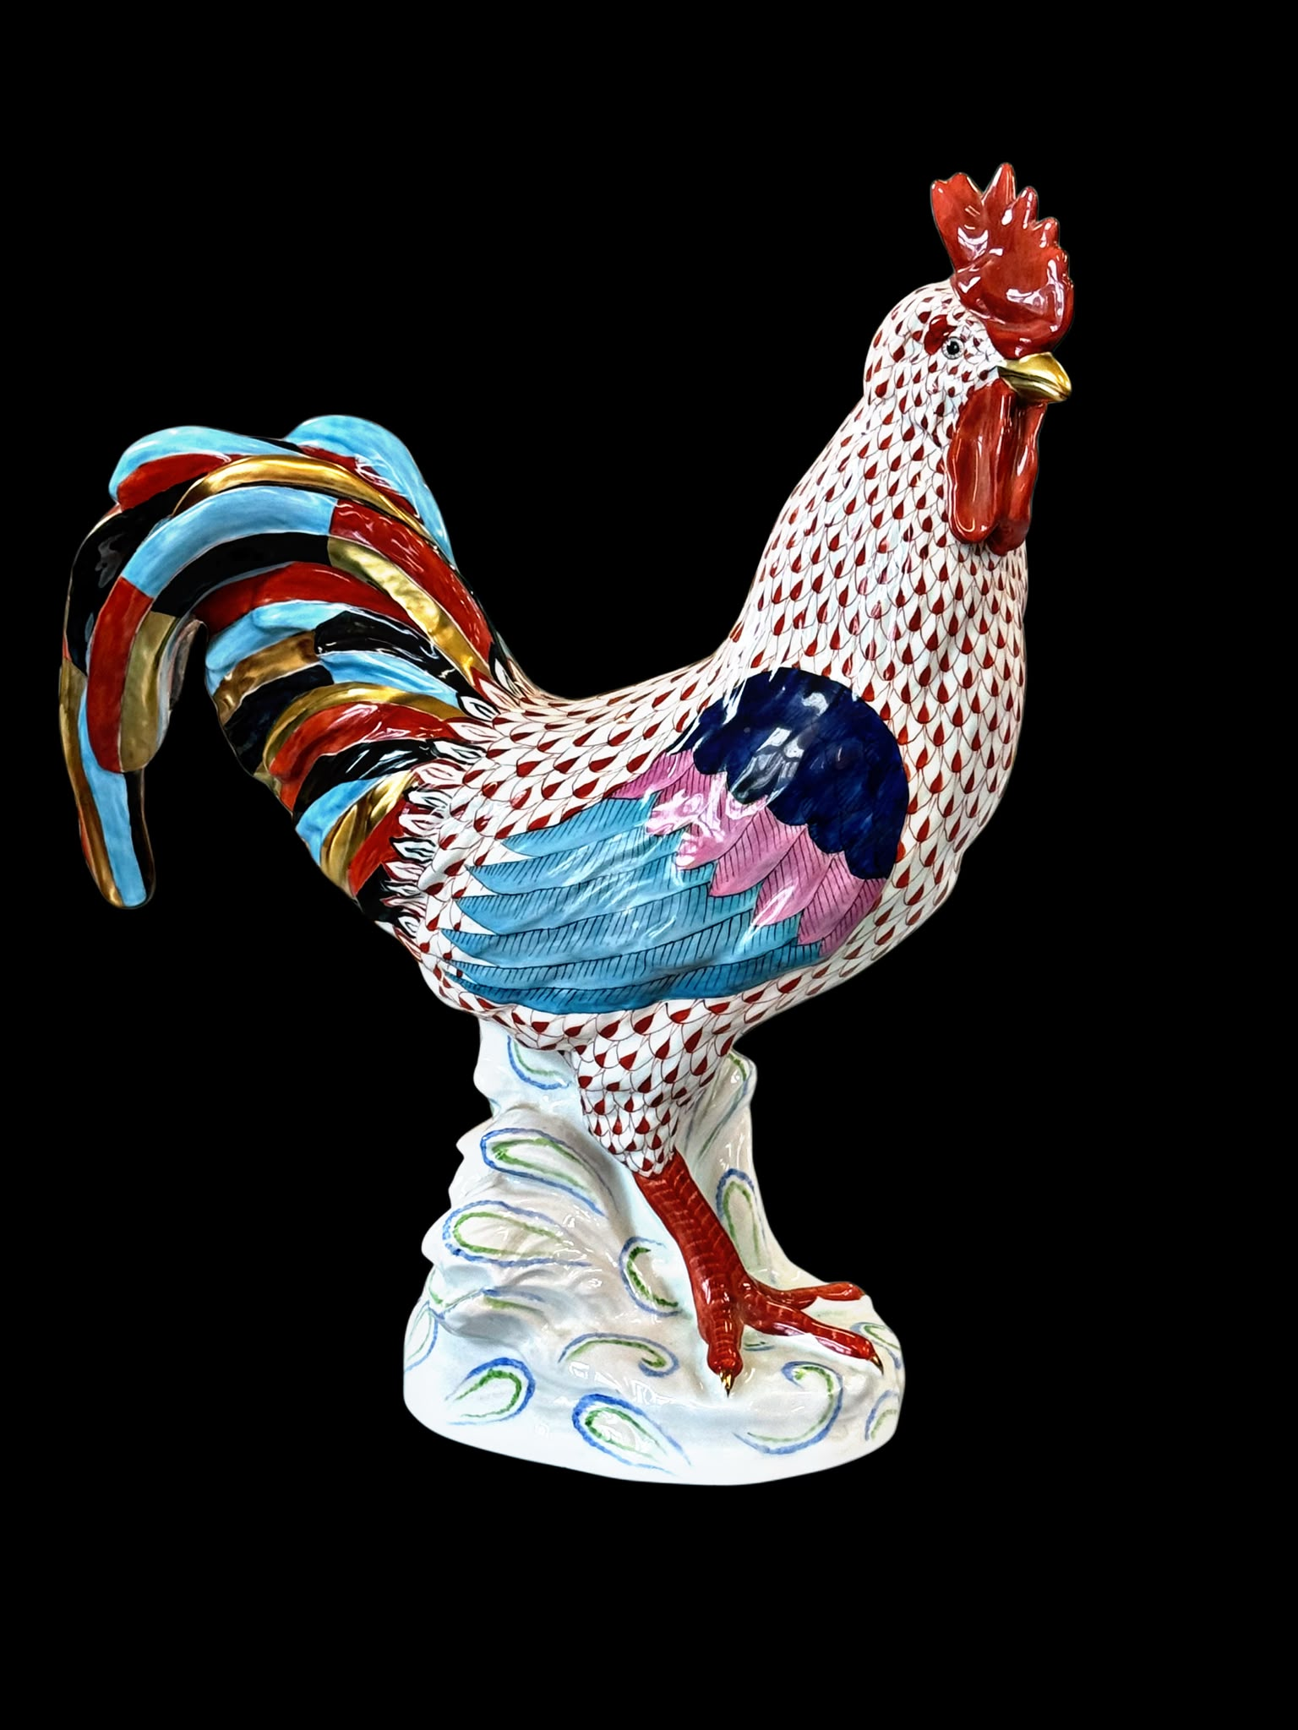
Lot 22 – A Herend porcelain large painted figure of a rooster, fishnet pattern, 42cm high. Est: £80-£100

Lot 251 – A George V 1913 gold sovereign. Est: £600-£800

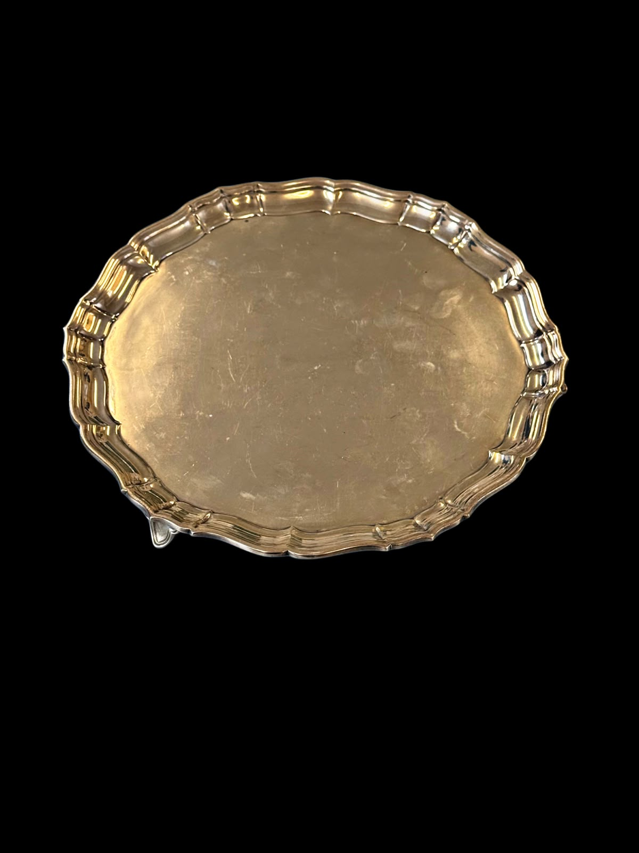
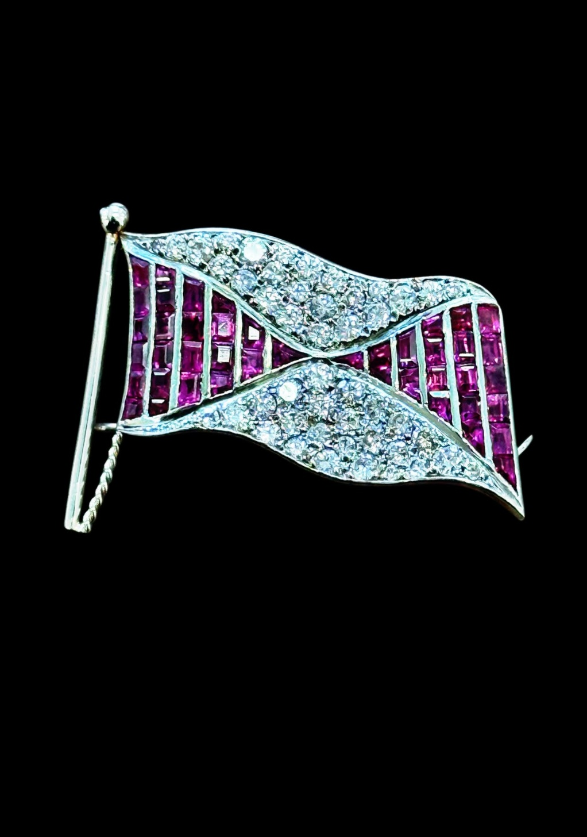
Lot 255 – A platinum flag-design brooch, set approx. 44 small diamonds and 40 small rectangular rubies, approx. 10g gross.
Est: £800-£1200

Lot 10 – A George V silver salver with pie crust edge, on three shaped feet, maker PK&P Sheffield 1932 approx. 24 oz. Est: £800-£900

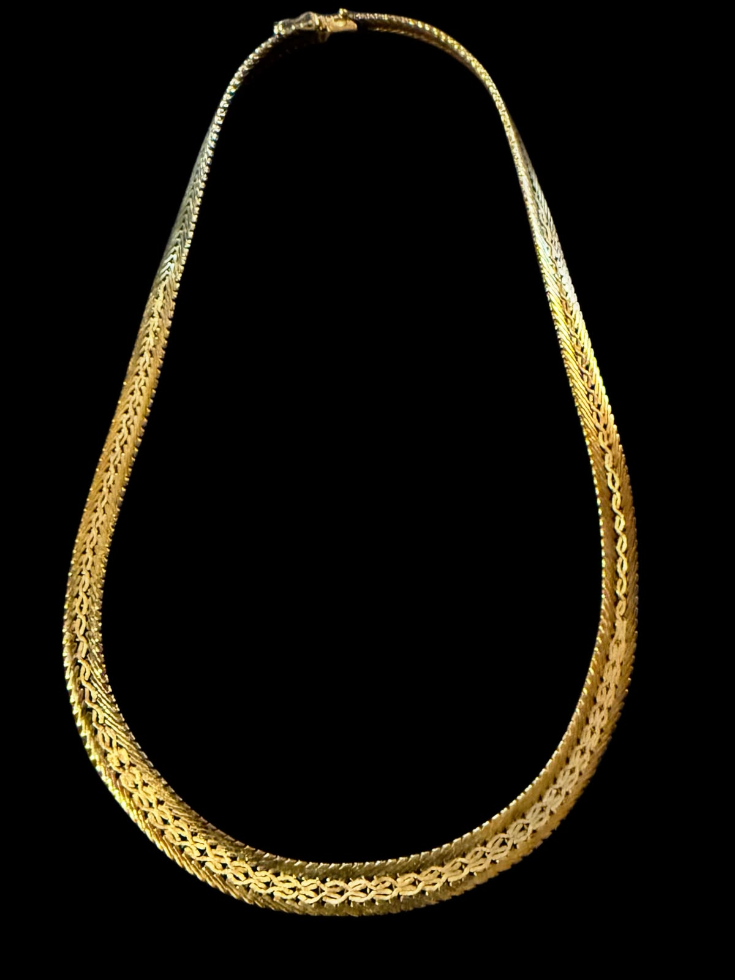
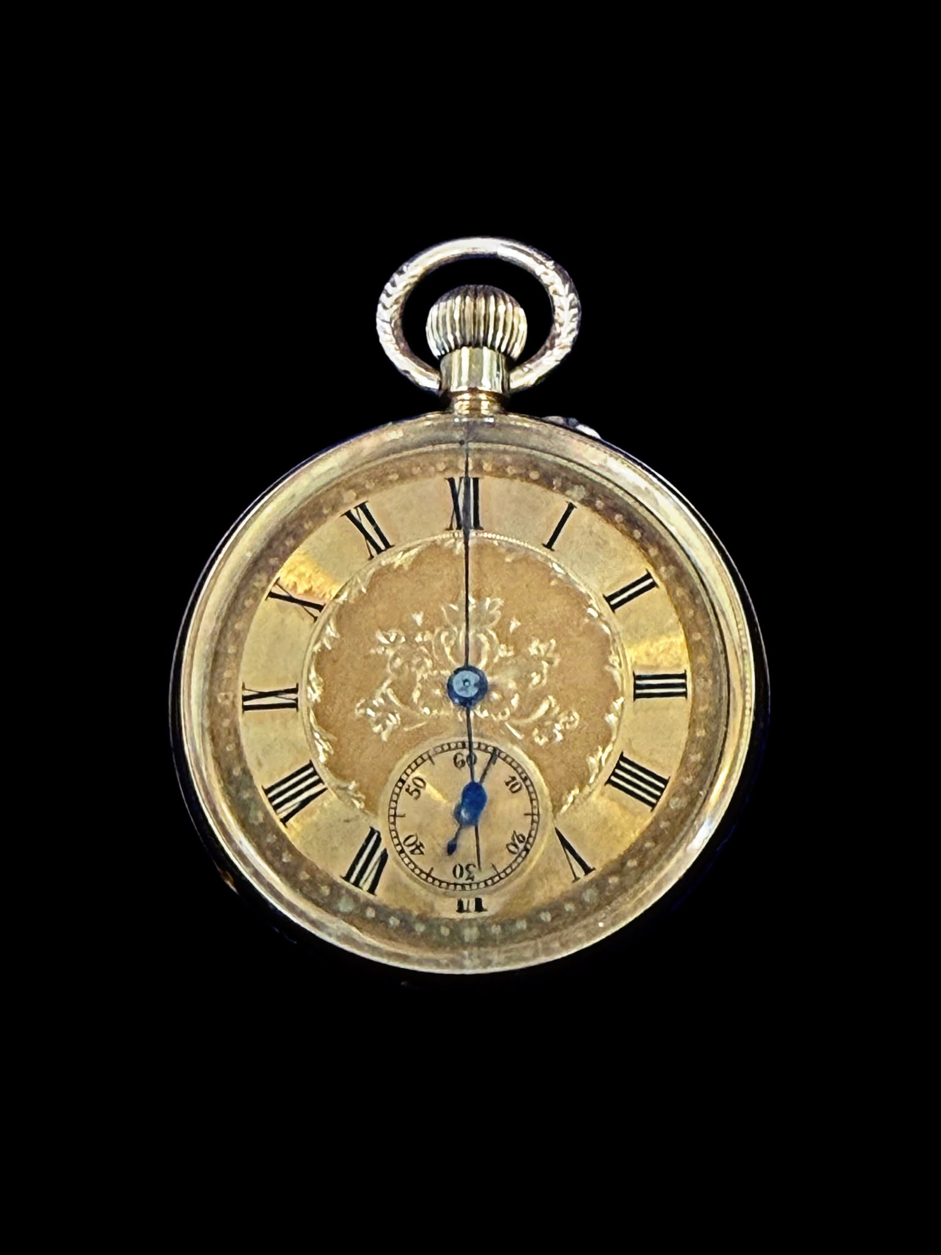
Lot 261 – An 18ct gold Egyptian-style articulated necklace, approx. 55g and 46cm long, in "Robin Francis" lined box.
Est: £1800-£2200

Lot 76 – A lady's 18k gold keyless wound fob watch with gilt dial, Swiss movement, 5cm in diameter, in "John Bennett" of London box.
Est: £300-£400

145. | An early 20th century "No. 2 Reserve Field Medical Pannier" by "S. Maw Son & Thompson of London" with hide covering, and iron fittings, 70cm wide x 46cm high, a.f. | £100-£150
146. | A British army entrenching tool in a 1937 webbing pouch, three water bottles, two Bren gun magazine pouches, a number of bags, a kit bag, a small shovel, two field telephones, and a German 40mm brass shell case (qty). | £20-£30
147. | A Victorian mahogany wine cooler with single large drawer, on squat column and quadriform base with carved feet, 91cm wide. | £40-£60
148. | A small early 20th century storage cabinet fitted three glazed doors, 40cm wide x 87cm high. | £20-£30
149. | A 20th century harpsicord in painted case in the style of Robert Gobel, on unpainted turned legs, united by two stretchers, 196cm long. Submission ref: 3R5WWB3Z. | £600-£800
150. | Douglas Smart (1879-1970) - “The Waters Edge at Lowestoft” circa 1920, inscribed verso, watercolour, 15cm x 23cm. | £50-£70
151. | Colin Boothman - Landscape, with trees and an outbuilding, oil on canvas, 60cm x 90cm, and after Sue Rowling - a monoscreen print “Spring Morning” 25cm x 21cm (2). | £50-£70
152. | An early 20th century oak filing or music cabinet, with tambour shutter front, 48cm wide x 115cm high, a.f. | £40-£60
153. | An early 20th century mahogany display cabinet, on cabriole legs, 56cm x 121cm, and a circular folding coaching table by “Thornton and Herne” (2). | £80-£100
154. | Maggie Smith - Still life, flowers, watercolour 76cm x 56cm. | £100-£150
155. | Poems of Dedication by Stephen Spender, 1947, another new edition 1984, another “Holes in the Sky” by Louis McNiece, 1st edition, another Autumn Journal 1939, another Springboard 1941-44, another Loo Stranger, 1936, by W.H Auden, another Plant and Phantom, 2nd impression by Louis McNiece, and Another Time, by W.H Auden, all by Faber and Faber, together with other poetry books, and some classic volumes (approx. 85 volumes overall). | £150-£200
156. | A George III style mahogany chest of three long drawers, 82cm wide. | £80-£100
157. | Maggie Smith - An avenue of trees, watercolour, 39cm x 51cm. | £80-£100
158. | An Edward VII silver-handled button hook, Birmingham 1904, a pair of silver-plated and horn-handled fish servers, together with a set of twelve silver-plated napkin rings with beaded decoration (15). | £60-£80
159. | A Victorian mahogany writing table with rounded corners, on turned end supports, and trestle base with turned feet, 91cm wide. | £35-£45
160. | A 19th century elm and beech kitchen Windsor elbow chair, on turned and rings legs, united by stretchers. | £20-£30
161. | A Victorian mahogany fold-over swivel top card table, of serpentine outline, on heavy platform base, 85cm wide. | £50-£60
162. | An early 20th century oak cutlery canteen by Walker & Hall of Sheffield, fitted interior, with six silver-plated knife rests, and a tea strainer, 48cm wide. | £40-£50
163. | A reproduction mahogany bureau, the fall front above two drawers, on cabriole legs, 61cm wide. | £20-£30
164. | Early 20th century Japanese school - Monotone print of lake scene with Mt Fuji in background, 42cm x 14.5cm. | £20-£30
165. | A Victorian cast iron piano stool on tripod base, with revolving adjustable seat, 50cm high un-extended, a.f. | £20-£30
166. | An early 20th century Burmese hardwood side cabinet, the two panelled doors revealing a fitted interior for the storage of records, on squat turned legs, and bun-form feet, 119cm wide x 107cm high. | £35-£45
167. | A late Victorian mahogany davenport desk, with raised stationery compartment, and fitted interior, four drawers and four false drawers, turned and ringed front supports, 53cm wide. | £35-£45
168. | A pair of Hereke rugs with overall pattern of flowers on ivory-coloured ground, wide multicoloured border, each 137cm x 201cm. (2) | £100-£150
169. | An early 20th century Sarouk rug, with large central medallion on ivory ground, the wider field on rust ground, wide multicoloured border, 125cm x 202cm. | £50-£60
170. | A Japanese blue and white charger, decorated a bird of prey in blossoming tree, 46cm in diameter. | £50-£70
171. | A 20th century Japanese charger, with rust red border and central roundel, decorated flowerhead medallion, wide floral border, 39cm in diameter. | £70-£90
172. | A 19th century Majolica urbino style charger dish, with King's head to centre, surrounded by decorative panels, 39cm in diameter, a.f. | £40-£60
173. | An early 20th century amber tinted Bohemian glass liquor set, comprising:- a tray, two decanters and two small glasses (5). | £30-£50
174. | A mid Victorian walnut and burr walnut card table, the shaped bow-fronted hinged top opening to a quatrefoil baize lined surface, on waisted stem with lobed collar and moulded quadruped base, 95cm wide. | £80-£120
175. | A 20th century carved wood Chinese-style camphor lined chest, with rising lid, 100cm wide x 55cm high. | £40-£60
176. | An early 19th century Dutch mahogany and floral marquetry inlaid secretaire, the rectangular top above a frieze drawer, and a recessed fall front flanked by column pilasters, with gilt brass mounts, the fall revealing a fitted interior of pigeon holes, drawers and a central door, above three long drawers, on block feet, 107cm wide x 159cm high. | £500-£800
177. | An early Victorian rosewood work table, with fold-over swivel top and fitted a drawer, on shaped and open fret carved end supports and trestle base with bun feet, the basket missing, 53cm wide. | £80-£100
178. | An early Victorian rosewood Wellington chest of seven drawers, with lockable pilasters, and knob handles, on plinth base, 56cm wide x 124cm high. | £150-£200
179. | A pair of early 20th century Japanese Imari vases with floral and foliate decoration, each 25cm high (cracked), and a similarly decorated cylinder vase as an umbrella stand, 61cm high (3). | £80-£100
180. | A Japanese blue and white pottery charger dish decorated figures of priests in a landscape, 46cm in diameter. | £80-£100
181. | Frank Egginton (British 1908-1990) - Tree-lined landscape with horse and cart and figures, watercolour, inscribed verso on label "Hillsborough, County Down", 53cm x 73cm, in stained-wood frame, 79cm x 97cm. | £100-£150
182. | A 19th century Dutch walnut and floral marquetry inlaid open-arm elbow chair with shaped crest and back splat, on cabriole shaped legs, with shell carved knees, and upholstered drop-in seat, bears a trade label for "W. F. Greenwood & Sons, 24 Stonegate, York", together with a pair of similarly decorated side chairs on slender cabriole legs (3). | £200-£300
183. | A set of six WMF silver tablespoons with decorative handles, a set of four continental silver tablespoons, and a pair of Bruckmann continental silver tablespoons, in two cases, approx. 20oz overall (12). | £300-£400
184. | A Carlton walking ware teapot (a.f.), a sugar bowl, cream jug, teacup, commemorative bowl and cover, egg cup, and a salt and pepper, together with a lustre ware green willow pattern part fruit set, seven pieces of Dresden floral pattern china, a pair of Fuggly-style pottery figures 15cm high, and a small English porcelain figure of a Turk a.f. (24). | £20-£30
185. | Two plastic albums of cigarette cards, six further albums of cigarette cards, fourteen loose pages of cigarette cards, together with a small number of military cap badges (qty in one box). | £20-£30
186. | A wood and cardboard model "Fort Dallas", together with a quantity of Britains "Deetail" US Cavalry, Cowboy and Indian figures in two boxes (3). | £30-£50
187. | A collection of four Sasha Morgenthaler dolls c.1960s-70s, part of the Diverse collection, comprising two adults and two children, wearing plastic and material clothes, lacking some accessories (4). | £100-£150
188. | A part-suite of "Luigi Bormioli" Florian Bleu cocktail-style drinking glasses with art deco style blue stems comprising: eight glasses 20cm high, and eight 19cm high (16). | £50-£70
189. | A 20th century yew wood bowl of modern art design, initialled to base G.S., 43cm in diameter. | £20-£30
190. | Three sets of collectable nickel-plated coins comprising: "100 Years of Football", "Historic Cars from Shell", and "Man in Flight", in paper/card holders (3). | £20-£30
191. | A small collection of collectable Corgi Classics diecast toy vehicles including: "Inspector Morse's Jaguar", "Lovejoy's Morris Minor", "Goldeneye Ferrari 355", and other vehicles, all boxed (16). | £15-£20
192. | A Playmobil pirate ship with some figures 58cm long, together with a Playmobil castle set, siege engine, and other figures (qty). | £30-£50
193. | A collection of 1990s Action Man figures wearing various outfits, together with a gyrocopter, a part moon rover, a motorcycle, and other accessories (qty in 3 boxes). | £60-£80
194. | A Scalextric C653 Grand Prix set, in branded box, together with a box of track support piers (2). | £40-£60
195. | A scratch-built scale model based on a French-style fortified town, the base 80cm x 50cm. | £40-£60
196. | A collection of Tomy Thomas the Tank Engine and other locomotives and rolling stock (qty). | £25-£40
197. | Two "View-Master" stereoscopic viewers, with a quantity of picture reels including Universal Studios, Snoopy, Aristocats, Jungle Book, the Waltons, and others, together with a Polaroid 670AF Supercolour camera (qty). | £50-£70
198. | A quantity of 33 RPM LP records by various artists including: Peter Gabriel, Electric Light Orchestra, Jean-Michel Jarre, and others, a quantity of single 45 RPM records including: King, Spandau Ballet, Sad Cafe, and others, together with "The Guinness Book of Hit Singles No. 4" (5 boxes). | £80-£100
199. | A quantity of Rupert the Bear annuals c.1990s, and a small number of earlier annuals (qty). | £20-£30
200. | An R. Dakin & Co. Walt Disney figure of Minnie Mouse, a ditto of Pinocchio (a.f.), a ditto of Dumbo, a ditto Jose Carioca (a.f.), a quantity of smaller later Disney figures including Snow White and the Seven Dwarfs, and Pocahontas, together with some accessories from the Disney Atlantis movie (2 boxes). | £20-£30
201. | A "Papo" pirate ship with figures c.2004 49cm long, together with a jousting set with knights and horses (2). | £20-£40
202. | A quantity of various Star Wars spaceships, vehicles and figures including: the Millennium Falcon, a Naboo Starfighter, a TIE Fighter, an X-Wing, an A-Wing, Obi-Wan Kenobi (American version), various Stormtroopers, Imperial Pilot, Jango Fett, Jar Jar Binks, Darth Maul, C-3PO, Luke Skywalker, Han Solo, and other figures (qty). | £60-£80
203. | A Mexican silver leaf brooch, a pair of matching earrings, a metal thistle brooch set garnets, a metal heart shaped locket and slender chain, a filigree-style bracelet, a further pair of earrings, together with a number of ladies' quartz wristwatches and decorative costume jewellery (qty). | £40-£60
204. | After Roger Jackson - A reproduction photograph of The Rolling Stones in Green Park c.1967, no. 1/495 by Sonic Editions, 29cm x 39.5cm, and a further photograph of the band on and around a bench seat, part of the same set, 40cm x 30cm (2). | £40-£60
205. | Wendy Reeves (b.1944) - A lake-land scene with island and black faced sheep, watercolour, signed bottom right, 35cm x 49cm, and after R. Symmons - "Castle Crag Borrowdale in the Lake District" lithograph, 33cm x 44cm (2). | £40-£60
206. | A Nike Dri-fit Middlesex Cricket Club player's shirt, c. 2017-2021, with 16 signatures, including: Stephen Finn, Nathan Souter, Nick Gubbins, Thilan Wallalawitha, James Harris, possibly Eoin Morgan, Mitchell Marsh, and Toby Roland-Jones. | £20-£30
207. | A Royal Mint 2011 UK Executive proof coin set, in lined wooden box, no. 2509, together with a Greenwich Mint medallion year 2000 (2). | £80-£120
208. | A gold-plated commemorative coin set "Diana, Her Life in Pictures" in lined box, a further set of gold-plated coins "Historic Moments Queen Elizabeth's Reign" in lined box, a further set of gold-plated coins "Royal Couples", together with three further sets of gold-plated coins "Credo", "Ave Maria", and "Pater Noster", all in lined cases (6). | £80-£100
209. | Five 20th century Egyptian papyrus pictures, in sizes (5). | £20-£30
210. | An early Victorian rosewood fold-over swivel top card table, on reeded vase pedestal and quadruped base, 92cm wide, with original invoice. | £80-£100
211. | An early 20th century Dutch-style simulated walnut hanging display cabinet, approx. 76cm wide x 74cm high. | £60-£80
212. | A French gilt-brass mantel clock with domed top and eagle surmount, no pendulum, 34cm high. | £40-£60
213. | After Gerald Coulson - "Chariots of Fire" chromolithograph, signed in mount by the artist and Johnny Johnson, 51cm x 69cm, another "Overdue", signed in mount by the artist, 47cm x 68cm, and another "Guardian Spirit", signed by the artist in mount, 55cm x 67cm, all with Fine Art Trade Guild seal (3). | £40-£60
214. | A Lladro figure of a swan 21cm high, in non-matching branded box, a further figure of a white swan with wings spread 19cm high, with box, three duckling collection figures with box, and a retired Lladro figure of duck (a.f.), 11cm high, with box (6). | £40-£60
215. | A Brooks & Bentley porcelain group of African Elephant Family from the African Wilderness Collection, a figure of a Pygmy Hippo, a figure of a Baby One-Horned Asian Rhinoceros, and a further figure of an African Elephant Calf, all with boxes (6 figures in 4 boxes). | £20-£30
216. | An early 20th century inlaid walnut mantel timepiece, 18cm high, and an aneroid barometer on carved oak stand 18cm high, a.f. (2). | £20-£30
217. | A 20th century Polish kelim tapestry panel, some pieces of beadwork, a lace collar, and a child's sailor collar (6). | £20-£30
218. | An Airfix 1:32 scale motor racing set model MR15, boxed, together with two accessory track packs, a scrap book relating to motor racing and Graham Hill, and a race programme for the 1960 British Grand Prix at Silverstone, a.f. (5). | £20-£30
219. | After Geoff Nutkins - "A Gentleman's War", coloured lithograph, signed by Bob Doe, and four other Battle of Britain pilots, 44cm x 62cm, another lithograph after Robert Taylor "St. Croix-Sur-Mer", signed by Johnnie Johnson and others, 51cm x 71cm, and another after Philp West "The Pride of Britain", 39cm x 62cm (3). | £20-£30
220. | Attributed to Louis (Lod) Pulinch (Belgian 1843-1910) - "View of the Meuse, near Anseremme, Dinant", inscribed verso on label, oil on canvas, 36cm x 51cm, in gilt frame, 57cm x 73cm, a.f. | £60-£80
221. | An unmarked stained wood chess set, in coffer-form box, 32 pieces, a further set with some pieces a.f., some draughts, and three sets of wood and plastic dominoes, boxed (a quantity). | £20-£30
222. | A 19th century Sevres porcelain part dinner service, each piece decorated a family crest, including: eight dinner plates, a soup tureen, a fruit bowl, a covered dish, and other pieces, some a.f., c.1870 (16). | £20-£30
223. | A pair of early 20th century Japanese Imari vases, with floral panels, each 22cm high, one chipped (2). | £30-£50
224. | AMI Ltd - A framed montage of black and white photographs of Stan Laurel and Oliver Hardy, in single mount, one photograph signed, certificate verso, in ebonised frame, 69cm x 89cm. | £40-£60
225. | A part-set of silver-plated bone handled and stainless steel cutlery, in a stained-oak canteen 44cm wide, approx. 54 pieces, in mixed patterns. | £15-£20
226. | A lady's "Avia Incabloc" wristwatch in gold-plated and stainless steel case, in branded box. | £30-£50
227. | A Capodimonte figure of priest and peasant man, signed "Tyche Tosca", on gilt foot, 21cm high. | £40-£60
228. | A Royal Albert Crown China part afternoon tea set comprising:- 2 bread and butter plates, 12 tea plates, 12 saucers, 10 cups, a milk jug, and a slop bowl (38 pieces). | £30-£50
229. | An early 19th century map of Kent by Charles Smith of London January 6th 1804, 54cm x 65cm. | £30-£50
230. | A set of six Russian silver coffee spoons with decorative handles maker possibly Heikki Kaksonen, each 12cm long, in un-associated box, approx. 2oz (6). | £70-£100
231. | An Elizabeth II silver butter-type knife Sheffield 1993, a continental silver caddy spoon, a number of Georgian and later silver salt spoons, a mustard spoon, and three other spoons various, approx. 6oz (13 pieces). | £250-£300
232. | A George V 1914 sovereign. | £750-£850
233. | A 9ct gold gate-link bracelet set nine seed pearls, approx. 10g. | £300-£400
234. | A 9ct gold decorative necklace of Italian design, approx. 3g. | £100-£150
235. | A metal and lacquered-pearl necklace. | £70-£100
236. | A 9ct gold pierced pendant set two sapphires and five graduated seed pearls. | £70-£100
237. | A 9ct gold bangle, with some engraved decoration, and safety chain, approx. 5g (a.f.). | £150-£200
238. | A 9ct gold "Baby" brooch. | £40-£60
239. | A small 9ct gold badge engraved "N Z". | £60-£80
240. | A 9ct gold slender-link necklace, together with a small curb-link necklace, a.f. (2). | £70-£100
241. | A pair of zircon-set ear studs in pink box. | £30-£50
242. | A gilt bronze GWR 150th Anniversary Medallion 1985, in lined Royal Mint case. | £60-£80
243. | An "Ortak" silver pendant set agate, on slender link chain, in lined box. | £30-£50
244. | A "Heathergems" silver cross pendant on slender link chain, a further oval silver pendant set agate, an Irish silver Celtic-style pendant on slender chain, and a mother-of-pearl fish pendant on slender chain (3 branded boxes). | £30-£50
245. | A "Heathergems" drop pendant, set poppy jasper, a pair of earrings and a lapel pin in box, together with a similar pendant and pair of earrings in box (2). | £40-£60
246. | A "Toucan of Scotland" thistle pendant set with a ruby-coloured stone (July birth stone), on slender silver chain, together with a pair of ear studs, boxed. | £30-£40
247. | A drop pendant set a tiger's eye, on slender link chain, in "Harris" box. | £30-£40
248. | A small collection of decorative silver jewellery including an ID bracelet, a letter K pendant, two bracelets, and four other pieces (8). | £40-£60
249. | A silver Celtic cross pendant on slender link chain, and two articulated necklaces (3). | £20-£30
250. | Two silver dress rings set agate, and a plain wedding band, approx. 0.75oz weighable (3). | £40-£50
251. | A George V 1913 gold sovereign. | £600-£800
252. | A late Victorian 1901 gold half sovereign. | £300-£400
253. | A modern 18ct white gold pendant set seven graduated diamonds, together with a pair of matching ear studs each set five stones, approx. 6g gross, in lined box (3). | £250-£350
254. | A platinum eternity ring set diamonds in illusion setting. | £120-£180
255. | A platinum flag-design brooch, set approx. 44 small diamonds and 40 small rectangular rubies, approx. 10g gross. | £800-£1200
256. | A pair of 18ct white gold flowerhead ear studs each set a central emerald and six tiny diamonds (2). | £150-£200
257. | A decorative swan brooch set a central simulated pearl and 17 small diamonds. | £100-£150
258. | A 9ct gold leaf brooch set nine small diamonds, approx. 9g gross. | £250-£350
259. | An Elizabeth II 9ct gold rectangular cigarette case with engine turned decoration, maker S. J. R. London 1957, approx. 176g. | £5500-£6500
260. | A 9ct gold curb-link bracelet, 19.5cm long, approx. 59g. | £1600-£1800
261. | An 18ct gold Egyptian-style articulated necklace, approx. 55g and 46cm long, in "Robin Francis" lined box. | £1800-£2200
262. | An 18ct gold cocktail design dress ring, channel set 11 rectangular rubies and 21 round-cut diamonds, approx. 7g, in lined box. | £800-£900
263. | A pair of 18k leaf-design ear clips (also fitted for pierced ears), set nine rubies and eight round-cut diamonds, approx. 6g, in lined box (2). | £600-£800
264. | A 1996 Jules Rimet Cup (World Cup) opening night champagne package comprising: a vintage bottle of 1966 Veuve Clicquot Ponsardin Champagne, a menu and table plan for the supper held on the occasion of the opening match of the 1966 competition in the presence of Queen Elizabeth II, and the Duke of Edinburgh, at the Empire Stadium, Wembley, Monday 11th of July 1966, together with a rosette badge, a.f., a stained wood box also containing the bottle stopper and corkscrew, and an addendum announcing the death of Mr J.H.W Mears, the Chairman of the F.A. who died on the 30th of June 1966. This may have been gifted to a Mr G.W. Dean, who was a guest at the dinner. Box 36cm wide x 11cm high. | £300-£400
265. | A Regency mahogany square piano, by "John Broadwood and Sons, London", on turned and reeded legs, 168cm wide, serial no. 55265 (restored by David Winston). Submission Ref: AH6QJPJQ. | £600-£800
266. | A mahogany upright piano by "D'almaine" over string action, iron frame, no. W2050, 139cm wide. Submission Ref: 5ZH8GX26. | £200-£250

END OF SALE

UPCOMING DATES

Auctions

Wednesday 2nd September 2026
Wednesday 21st October 2026
Wednesday 9th December 2026

Viewing on Monday and day before sale from 10am to 5pm
and on morning of sale from 9am to 10.30am
Sale commences at 11am

Valuation Days

Wednesday 15th July 2026
Wednesday 12th August 2026
Wednesday 16th September 2026
Wednesday 28th October 2026
Wednesday 18th November 2026
Wednesday 16th December 2026

Sevenoaks Saleroom, Argyle Road,
Sevenoaks TN13 1HJ
Between 11am - 4pm

Notes

