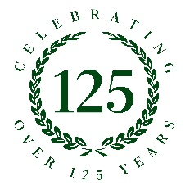
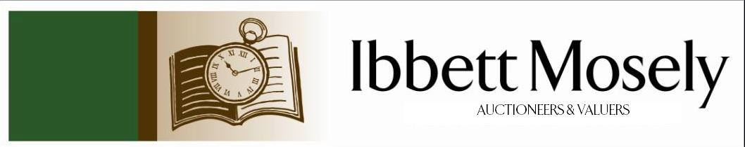

Catalogue of Antiques and Collectibles
to be Auctioned on

Wednesday 21st October 2026ffff
at 11am

IBBETT MOSELY AUCTION ROOMS
ARGYLE ROAD, SEVENOAKS, KENT TN13 1HJ
And Online Via
www.easyliveauction.com/ibbettmosely/

Viewing at Sale Room on:

Monday 19th October
Tuesday 20th October

Between 10am – 5pm

Catalogues: £2.00

Auctioneer and Valuer: Alan White FNAVA
Auction Clerk and Saleroom Manager: Benjamin Burridge
Photographer and Porter: Samantha Crowe-White

Welcome to Ibbett Mosely Auctions
21st October Auction Catalogue

This sale will also be held online at www.easyliveauction.com/ibbettmosely/
please visit the website to register or log in to view and bid. Images and condition reports of each lot are included.

Alternatively, commission bids (bids left ‘on the book’) may be left with us, as well as a limited amount of telephone bids. Please telephone 01732 456731 or email auctions@ibbettmosely.co.uk for further details.

Unsold lots from this sale will be placed into a week-long online timed auction that can be found at www.easyliveauction.com/ibbettmosely/

Please telephone 01732 456731 or email auctions@ibbettmosely.co.uk with any questions.

Collection of items is available on Thursday 22nd October from 10am - 1pm. Collection of items from 23rd October onwards, by prior appointment only.

We do not arrange collection or deliver your items ourselves, collection of items is the responsibility of the buyer. You are welcome to collect in person, or via your own carrier, we can provide details for a local carrier if you need it.

We would really appreciate it if you could leave us a review on Google. Good or bad, we will listen to all your feedback so we know what we are doing well, and how we can improve. Scan the QR code below to be taken to our Google page. You can do this with your phone camera.
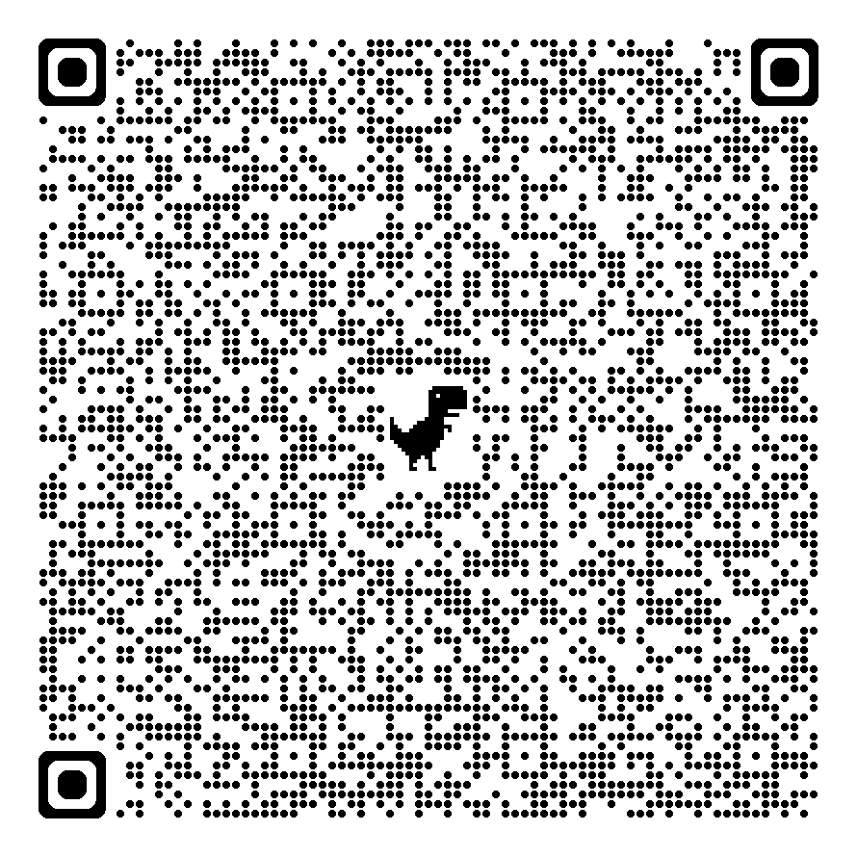
1. | An Edward VII silver spill vase, with scalloped edge, 29cm high, maker Henry Wilkinson and Co Ltd, London 1901, weighted base. | £100-£150
2. | An Edward VII silver pedestal rose bowl, with mesh insert, on circular foot, maker Mappin & Webb, Sheffield 1908, 13.5cm high, approx. 19oz. | £500-£700
3. | A Victorian silver teapot, with flowerhead finial, and part scrolled handle, maker Edward, Edward Junior, John and William Barnard, London 1840, approx. 24oz, with ivory insulators. Submission ref: 2CDREEX8 | £600-£800
4. | A Royal Copenhagen vase, decorated a figure of mother and little girl on a beach, 17cm. | £60-£80
5. | The Queen's Golden Jubilee Coin Cover Collection - a quantity of commemorative coin covers in seven albums, some cupronickel, and some copper (7). | £200-£220
6. | A small Caucasian rug, with four guls, on rust ground, wide border, 83cm x 141cm. | £40-£60
7. | A Yomut Bokhara rug, the central field with 45 guls, on rust ground, wide multi-banded border, 131cm x 181cm. | £60-£80
8. | A Venetian-style pier glass type wall mirror with crested top, and reverse etched decoration to the panels, 58.5cm wide x 108cm high. | £80-£100
9. | After Charles & Ray Eames - A "Vitra Eames" white plastic armchair on chrome-plated steel quadruped base with plastic feet, 62cm wide x 80cm high. | £60-£80
10. | A part row of four theatre chairs with rising seats, iron frames, with stained beech top rails, on stained pine double stretcher base, marked on one end "18HS" possibly meaning part of a row of 18 house seats, fitted two programme/opera glass holders, approx. 183cm long x 85cm high. | £40-£60
11. | After Felicks Topolski - "This England", a school series print, 48cm x 74cm. | £30-£50
12. | A late Victorian child's blue and white mixed willow, three men on a bridge, and zigzag fence pattern part combination set comprising: teaware, dinner plates, meat platter, a tureen, and other pieces (23 pieces, 2 a.f.). | £40-£60
13. | A Victorian part tea set comprising: tea pot, milk jug, sucrier, slop bowl, twelve teacups and saucers, a bread and butter plate, Victorian diamond registration mark to base of teapot and bread and butter plate, together with six plain white Shelley tea plates, with gilt edges (35 pieces overall). | £40-£60
14. | Two coin album pages with a quantity of farthing coins, approx. 48 coins, together with a set of 50 Dickens character cigarette cards, and a set of 25 Carreras Ltd Highwayman cigarette cards, in plastic album pages (4). | £40-£60
15. | A single volume of "The Travels of Anacharsis the Younger in Greece during the middle of the 4th century BC" third edition, illustrated by H. Richter London 1800, after Abbe Barthelemi. | £50-£70
16. | A part relief decorated pottery flowerpot of owl form 28cm high, and a pale blue glazed pottery vase with autumn leaf pattern 31cm high (2). | £30-£50
17. | After E. A. Abbey - Pair of etchings of tavern and interior scenes, each 24cm x 34cm, in mahogany and satinwood banded frames, each 49cm x 60cm (2). | £40-£60
18. | A Victorian Royal Warrant seal, 16cm in diameter, in tin box. | £40-£60
19. | E. Bright (1920) - Pastel portrait of young girl signed and dated 1920, 42cm x 31cm, in gilt frame, 47cm x 36.5cm. | £80-£100
20. | A French-made violin by "Vuillaume of Paris", in lined walnut case by "W. E. Hill & Sons 140 New Bond Street London", together with a bow, violin 36.5cm long to button and 58cm long to scroll end, fitted one string only. | £200-£300
21. | A printed photograph album of the visit of HRH The Prince of Wales (future Edward VIII) to the Gold Coast Colony in 1925, 242 pages and two coloured map pages. | £40-£60
22. | An African plated heavy metal tribal ankle bracelet or khalkhal, with engraved decoration, 10cm wide. | £40-£60
23. | A "Mansfield Holiday Zoom MM" 8mm cine camera, in branded leather case, together with a "Minori" Editor PII, in metal box case, with instructions (2). | £30-£50
24. | A gilt wood cartel type wall clock with Swedish "Westerstrands" movement, striking a bell, no. 056757, metal covers to back, 52cm high, with key. | £80-£100
25. | A pair of First World War French made binoculars, by "Lemaine Fabt.", of Paris, in leather case, c. 1916, retailed by John and Bennett Green, a "Queen Mary 1914" brass box, with small card dated 1915, two attendance medals, a medal ribbon bar, and a service certificate to Drummer, later Private, W. H. Tompkins, of 1st/5th Battalion Queens Own Royal West Kent Regiment (7). | £40-£60
26. | A "Tudric" hammered pewter cream jug, for Liberty and Co, no. 01536, 5cm high, on bun feet. | £25-£40
27. | A Victorian silver-plated Golden Jubilee vesta case, with engraved decoration, an open silver-plated salt on three legs, two silver-plated napkin rings, and a Charles Horner Dorcas silver-plated thimble size 7 (5). | £40-£60
28. | A George III mahogany chest-on-chest, oak carcass, fitted nine drawers, with oval plate handles, on bracket feet, 104cm wide x 169cm high. | £200-£300
29. | After Grace Mott Johnson (American 1882-1967) - Cold cast bronze of two gun dogs tied to a tree, in mould signature below standing dogs paw, on stained wood base, 37cm high x 36cm wide. | £200-£250
30. | An early 20th century mahogany hall or serving table, labelled "Waring", of bow and breakfront outline, with thumb and relief carved decoration, on shell and scroll carved cabriole legs, and claw and ball feet, 137cm wide. | £200-£300
31. | A 19th century mahogany open-fronted dwarf bookcase, with three adjustable shelves, flanked by column pilasters, on plinth base, 124.5cm wide. | £70-£100
32. | A Tiffany-style segmented lamp shade, 31cm in diameter. | £20-£30
33. | A silver-plated salver, with shell, piecrust and scrolled edge, 27cm in diameter, a rectangular basket, with handle over, 22cm wide, an Indian-style squat vase, a small stainless steel circular tray, and two vegetable dishes (6). | £40-£60
34. | A Dinky Toys diecast Dingo Scout car, no. 673, three other Dinky Toy vehicles, together with other Corgi and Lesney diecast vehicles various, all unboxed (qty). | £30-£40
35. | A small "Nathan" teak sideboard enclosed by two panelled doors, on turned tapering legs, 102cm wide. | £60-£80
36. | A mid-century teak Danish-style sideboard fitted doors and cupboards, a fall front, and a single shelf, 150cm wide x 123cm high. | £60-£80
37. | A Georgian-style mahogany snap-top occasional table with rounded square top on tripod base, 64cm wide, together with a mahogany oval drop leaf occasional table, 69cm x 101cm extended (2). | £40-£60
38. | A Victorian pale mahogany drop-leaf breakfast table with rounded corners on turned and part ringed legs, 95cm x 103cm extended. | £40-£60
39. | A George III and later mahogany chest of two short and three long drawers, with shaped plate handles, brush grained oval to top, on bracket feet, 81cm wide. | £90-£120
40. | A small George III mahogany candle stand with pie crust edge on tripod base, 46.5cm high, and a George III mahogany tripod occasional table with piecrust edge on tripod base, 51cm high, a.f. (2). | £60-£80
41. | A "Victory" tennis racket 68.5cm long, and a further tennis racket 69cm long (2). | £10-£15
42. | A studio pottery vase with lustre finish in the Verceran style, 31cm high, chipped. | £20-£30
43. | A "Pollock's late Richardson's" satirical toy theatre booth made from printed card, with cut-out characters, 26cm x 21cm, together with an early 20th century scrapbook a.f. (2). | £20-£30
44. | A cast alloy sculpture of a Greek soldier's crested helmet, on simulated marble base, 21cm high. | £20-£30
45. | A decorative metal filigree hair slide with pierced decoration, 14cm high. | £20-£30
46. | An oval Indonesian woven rattan and stained wood trinket box, surmounted by figure of a crocodile as the handle, 16cm wide. | £40-£60
47. | A set of bone-handled and silver-plated fish knives and forks (10). | £20-£30
48. | A silver open-faced key wound gent's pocket watch, by the "A. W. W. Co. Waltham Massachusetts", white enamelled dial, Birmingham 1904 (a.f.) | £60-£80
49. | A pair of early 20th century Chinese cloisonne vases decorated multicoloured panels with foliage, flowers and butterflies, 19cm high (2). | £30-£50
50. | A pair of early 20th century Chinese cloisonne slender neck vases decorated panels of flowers, of fluted form, each 15cm high (one a.f.), together with a small pair of cloisonne vases decorated birds and dragons in inverted lancet panels, each 12cm high (4). | £50-£70
51. | A Hornsea pottery Heirloom pattern part coffee set comprising: five cups, six saucers, six small plates, six larger plates, and a coffee pot (24 pieces). | £20-£30
52. | A mixed quantity of lead crystal, moulded drinking and domestic glassware various (qty). | £25-£35
53. | A Elizabeth II pair of silver sugar nips, Sheffield 1960, a silver-handled cake slice, Sheffield 1961, and a pair of glass and silver-mounted salts with spoons in lined case, together with a quantity of silver-plated ware including: large tray, tankard, goblets, assorted cutlery, and other pieces, approx. 0.8oz weighable (qty). | £40-£60
54. | Three 20th century marquetry inlaid panels, two depicting a fishing harbour, approx. 26.5cm x 18cm, the other a street scene, 29cm x 21cm (3). | £25-£40
55. | A Zulu dancing shield with stick handle (a.f.), 34cm wide x 77cm high. | £40-£60
56. | A pair of early 20th century Japanese gilt-metal vases decorated in relief with dragons, 25cm high (2). | £50-£70
57. | A small Chinese-style tea bowl decorated various characters, a small Japanese porcelain part coffee set, an English oriental-pattern tazza, and six other decorative pieces, some a.f. (14 pieces). | £40-£60
58. | A "Caldey Island" grey lustre pottery part coffee set comprising: five mugs and six saucers (11). | £15-£20
59. | A pair of late 19th century French oak armoires, each fitted a mirrored panel door enclosing satin beech lined interior, and above a single drawer to base, on bun feet, each 110cm wide x 251cm high, and with carved crests, a.f. (2). | £180-£220
60. | A reproduction stained-beech Dutch-style bombe commode fitted three drawers, on claw and ball feet, 73cm wide. | £60-£80
61. | Two Regency-style circular convex wall mirrors, one with ball surmounts, each 41cm in diameter. (2) | £20-£30
62. | A hammered copper chekanka-style plaque decorated deer and bird in oak frame, 29cm x 47cm, together with a pair of brass altar-style candlesticks, each 40cm high (3). | £60-£80
63. | A small collection of Rainham pottery for the Royal Navy Sailing Association and Medway Regatta 1961-1967 comprising: five mugs, seven saucers and dishes, a sugar shaker, a bowl and cover, and a jug and cover, some a.f. (15 pieces). | £80-£100
64. | Maria Ros Esteva - Sailing boat and a skiff in calm seas, oil on canvas, 75cm x 118cm. | £150-£200
65. | A "Molton Brown" leather candle box containing four chrome-plated dice-form candle holders, and two candles, box 33cm long. | £20-£30
66. | An Austrian white metalware and crystal pendant on rope-twist chain, together with a pair of drop earrings, in felt bag. | £40-£60
67. | A three-strand pearl necklace with metal clasp set zircons. | £40-£60
68. | A Moorcroft "Heartsease" pattern pen tray, trial 19/06/01, 20cm long. | £50-£70
69. | A 20th century toleware-type tray of shaped outline decorated flowers, 67cm wide, and a smaller similar tray, 49cm wide (2). | £40-£60
70. | A Chinese-style octagonal toleware-type two-handled tray decorated figures in a landscape, simulated as a lacquer tray, 68cm wide. | £50-£70
71. | A pair of composition Washington character dolls in period style costume, each 30cm high, in un-associated box (2). | £40-£60
72. | Four composition Madame Alexander dolls of girls in various dresses, possibly based on characters from Little Women, each with a stand, 38cm high, one in need of re-stringing (4). | £40-£60
73. | A large Persian Sarouk rug, 275cm x 355cm. | £200-£300
74. | A Swedish Pukeberg glass meat platter with reverse relief decoration of bull, 38.5cm in diameter, together with two beef dinner plates similarly decorated, each 26cm in diameter, and a cheese platter, 28cm in diameter (4). | £30-£50
75. | A Swedish Pukeberg glass square ashtray designed by Uno Westerberg with abstract decoration, 21cm x 21cm, and a small "Boda" mottled glass nightlight holder, 4cm high (2). | £20-£30
76. | Three Swedish Pukeberg glass vases with etched decorated figures and birds, 20cm, 12cm, and 10cm high respectively. (3) | £30-£50
77. | An Orrefors glass relief decorated sculpture of mountain and figures of polar bears, 13cm high, and a smaller piece of sculpture decorated with polar bear, 12cm high (2). | £40-£60
78. | A George VI silver two-handled pedestal bowl form sporting trophy, inscribed "Grand Coronation Thames and Medway Barge Sailing Match 21st May 1953, Champion Bow Sprit Class First Prize, Presented by the Corporation of Lloyds, Won by Sara, Owners F. T. Everard and Sons, Captain J. Uglow", maker H.P. London 1938, approx. 24oz. | £750-£950
79. | A gilt brass carriage timepiece with white enamelled dial, inscribed "Aldred & Son, Great Yarmouth", 10cm high, engraved "Presented to Ethel Anne Everard by Messrs Fellows & Co. of Great Yarmouth at the Launch of the MS Ability Sept 12th 1927". | £50-£70
80. | Frank Mason (1875-1965) - "Mayflower the Departure of the Pilgrim Fathers to the New World", watercolour and gouache, 14cm x 19cm. | £60-£80
81. | Frank Mason (1875-1965) - A view of a fjord inscribed "To Miss E. Everard from Frank H. Mason", watercolour, 30cm x 18cm. | £80-£120
82. | Frank Mason (1875-1965) - "MV Supremity at Hommelvik October 1st 1947 to Miss Ethel Everard", watercolour, 16cm x 26cm. | £80-£120
83. | Frank Mason (1875-1965) - "MV Singularity at the Coronation Royal Naval Review Spithead June 15th 1953 signed by the guests onboard", watercolour, with signatures to mount, 25cm x 35cm. | £180-£220
84. | Frank Mason (1875-1965) - "Will Everard" at Wisbech, inscribed on mount, oil on board under glass, 29cm x 40cm. | £150-£250
85. | After Jan van Vianen and Henri de Passebon - "First Rate Ship of the Line Flying an Admirals Flag", aquatint engraving, 32cm x 40.5cm, together with a chromolithograph of HMS Britannia after George Chambers, 44.5cm x 59.5cm (2). | £40-£60
86. | After Stefano della Bella (1610-1644) - Three portrait images of head of camel, black and white etching, 11.5cm x 15cm. | £80-£100
87. | J R Hutchinson - Single volume book "The Press Gang Afloat and Ashore", published London 1913, with black and white printed illustrations. | £30-£50
88. | A Japanese carved wood figure of fisherman with catch, as a table lamp base, 37cm high, and two further carved wood figures of slightly skeletal form, each 32cm high, all a.f. (3). | £50-£70
89. | A late 19th/early 20th century French Graz-type rifle bayonet, blade length 51cm, no scabbard. | £40-£60
90. | A lady's fob watch with white enamelled dial inscribed "J. Evans of Stourbridge", 3.5cm in diameter, a.f. to one hand. | £60-£80
91. | A lady's fob watch, key wound Swiss movement, decorative dial, 3cm in diameter. | £60-£80
92. | A lady's open-faced keyless wound fob watch with crème enamelled dial, 3.5cm in diameter, a.f. | £40-£60
93. | A lady's open-faced key wound fob watch with white enamelled and gilt decorated dial, 4cm in diameter. | £60-£80
94. | A similar lady's fob watch with key wound movement, decorative white enamelled dial, slightly a.f., 4cm in diameter. | £50-£70
95. | A gent's silver hunter-cased pocket watch made for the Turkish market, with decorative enamelled dial, 5cm in diameter, pseudo marks to inside of back cover alongside 800 standard mark, together with key. | £80-£100
96. | A gent's Hebdomas-style top wind pocket watch, in hunter case, exposed escapement, 5cm in diameter, a.f. | £120-£180
97. | A gent's key wound Waltham open faced pocket watch c.1876, serial number 6947467, in silver case, Birmingham 1898, white enamelled dial, slightly a.f., 5cm in diameter. | £70-£100
98. | A gent's Waltham keyless wound pocket watch in gold-plated hunter case, white enamelled dial, 5cm in diameter, a.f. | £70-£100
99. | A gent's open-faced keyless wound pocket watch in Dennison gold-plated case, white enamelled dial, Swiss movement, 5cm in diameter, a.f. | £60-£80
100. | A gent's key wound pocket watch in silver case, Chester 1897, white enamelled dial, inscribed "Robert Hughes Llangollen", 5cm in diameter. | £80-£100
101. | A gent's Victorian silver key wound pocket watch, London 1878, white enamelled dial, 4.5cm in diameter. | £80-£100
102. | A gent's open-faced keyless wound pocket watch in silver case, Birmingham 1926, white enamelled dial, in Dennison case, 4.75cm in diameter. | £80-£100
103. | Three decorative metal gent's watch chains, two with keys attached (3). | £50-£70
104. | A small map of Westmoreland published by Archibald Fullarton & Co. Glasgow, 21cm x 25cm, and a further map of Cumberland, 26cm x 20cm (2). | £20-£30
105. | A nest of three mahogany occasional tables, 58.5cm wide. | £20-£30
106. | A small 19th century Chinese blue and white shallow bowl, 34cm in diameter, together with two blue and white spice jars with covers, one cracked, each 16cm high (3). | £30-£50
107. | Thomas Bowls after R. West - "A Perspective View of Ye Great Court of Trinity College Cambridge from Ye South", black and white etching, 35cm x 46cm, Bernard Gotch - View of Brasenose College Oxford, watercolour, 28cm x 37cm, and a further engraving of Brasenose College, 27cm x 32cm (3). | £20-£30
108. | After R. Beilby - A plan of Newcastle-upon-Tyne and Gateshead c. 1788, black and white engraved map, 33cm x 45cm. | £20-£30
109. | Dorothy Parsons - Two small fishing boats in harbour, crayon and watercolour, 38cm x 56cm. | £20-£30
110. | After Claude Lorrain - Six mixed etchings of various views, including one from a drawing in the collection of the Duke of Devonshire, each 21.5cm x 27cm (6). | £20-£30
111. | A Japanese imari-style vase with floral panel decoration 25cm high, a modern Chinese floral decorated vase 22cm high, together with three spice jars, and two English pottery vases (7). | £30-£50
112. | A Regency mahogany sofa table, the top with cross banded edge, canted corners, fitted two drawers and two dummy drawers, on quadruple turned supports, and platform base with splay legs, on small bun feet, 146cm wide extended. | £60-£80
113. | A Victorian mahogany linen press, the upper part enclosed by two panelled doors, adapted as a wardrobe, below a moulded cornice, the lower part fitted two short and two long drawers, feet missing, 145cm wide x 193cm high. | £60-£80
114. | A matched set of six early 19th century fruitwood, beech and elm Lancashire spindle-back chairs, with rush seats, on turned legs united by stretchers, including two elbow chairs, a.f. (6). | £40-£60
115. | A Copeland late Spode part dinner service, with transfer printed mottled border, with gilt edges, including dinner plates, meat platters, soup plates, one large tureen and three sauce tureens, some pieces a.f. (approx. 40 pieces). | £20-£30
116. | A small Regency mahogany bow-fronted sideboard fitted single drawer flanked by two deep drawers, inlaid with stringing, on six turned and ringed legs, 120cm wide. | £50-£70
117. | A pair of engraved metal Persian ceremonial maces, each 68cm long (2). | £80-£120
118. | A Masai beaded collar necklace with beaded strands, 85cm long. | £20-£30
119. | A West African carved wood panel of mask form depicting a seated woman on the upper part, 66cm high. | £30-£50
120. | An African carved wood tribal figure of man seated on stool, 60cm high, a.f. | £30-£50
121. | A reproduction engraved steel Kulah Khud with two plume holders and fixed nose guard in upright position, with hanging mesh, together with an engraved shield, 48cm in diameter (2). | £40-£60
122. | A cast alloy chess set of medieval style, with circular tray-shaped playing board 57cm in diameter, a.f. | £40-£60
123. | A Nazi German style SS Panzer crewman's jacket with "Der Fuhrer" cuff title and reproduction Iron Cross 2nd Class medal ribbon, also with Panzer Tank Assault Badge by Frank and Reif of Stuttgart, size unknown, the Der Fuhrer Regiment was part of the Second SS Panzer Division "Das Reich". | £80-£100
124. | A reproduction banjo by "Lorenzo" with part inlaid case and chrome-plated tuning knobs, no. 236/P, believed to have been made in Korea, 86cm long (one string missing). | £50-£70
125. | After Ray Ford - A Studio X chromolithograph of George Best, signed by the player, 29cm x 20cm. | £20-£30
126. | A soldier's service and pay book in the name of a female clerk, an Imperial Service medal, Second World War defence and war medals, together with some badges relating to the naval training ship Worcester, a military-style sash and badge, a further medal, a small number of army and air force buttons, and four unframed photographs (qty). | £25-£40
127. | An engraved metal Islamic-style panel of figures within an interior scene, 29cm x 23cm, in decorative frame, 38cm x 32cm. | £20-£30
128. | A printed map of China after Thomas Bassett, reproduction chromolithograph, 26cm x 34cm. | £30-£50
129. | A quantity of coins and medallions including: Roman Sestertius of Emperor Trajan (low grade), a copper Soldi coin, a Napoleon brooch, a small number of silver coins, and other pieces, in stained wood box. | £20-£30
130. | A pair of Chinese elm yoke-back elbow chairs, with some carved and pierced decoration including the geometric symbol for good fortune (2). | £400-£500
131. | A Chinese silver-plated circular tray engraved with figures and a floral border, 46cm in diameter, and a smaller similar tray, 30cm in diameter (2). | £30-£50
132. | A collection of 23 mixed wristwatches with quartz movements in a Havana cigar box. | £20-£30
133. | A collection of carved wooden page turners in sizes, from various countries (13). | £30-£50
134. | Three teddy bears various, two with non-working growlers, 38cm, 34cm, and 28cm high respectively (3). | £30-£50
135. | A "Swatch" quartz wristwatch with Arabic numerals c.2003, together with a quantity of mixed quartz and other wrist and pocket watches various (qty). | £40-£60
136. | Three photograph and postcard albums various, together with a quantity of loose postcards and photographs various, and a school officer cadet corps photograph (qty). | £40-£60
137. | A Poole pottery Delphis-pattern charger, 35cm in diameter. | £20-£30
138. | Quantity of diecast and plastic toys including Corgi Major, Matchbox, and Models of Yesteryear, all unboxed (qty). | £20-£30
139. | A box of magic lantern type slides of pieces of sculpture and works of art, two empty collectors cases, an empty half sovereign collection case, and a mid-century picnic set (5). | £20-£30
140. | A silver-plated and blue enamelled part dressing table set, together with silver-plated napkin rings, commemorative spoons, a compact, and other pieces (qty). | £30-£50
141. | An ostrich egg with engraved decoration of warthog and water buffalo inscribed "Botswana" signed "N Daba" on silver-plated stand, 17cm high, a small pair of mounted deer antlers, and a carved wood figure of a mountain goat, 19cm high, a.f. (3). | £20-£30
142. | A commemorative book for the Panerai Classic Yacht Challenge "Eilean A Classic Yacht" in outer box, a similar volume for the "Panerai Classic Yacht challenge", and a further volume for "Panerai Designer Wristwatches" (3). | £20-£30
143. | Viet Lam after Nguyen Thanh Binh - Study of three Vietnamese schoolgirls, mixed media and heightened in white, two prints, each 20cm x 19.5cm, together with a printed poster after Huck Gee, 49cm x 36cm, unframed (3). | £40-£60
144. | A quantity of military history and aviation books, and two on luxury cars (15 in total). | £15-£20
145. | A quantity of mixed china various including: Wedgwood blue jasper, Portmeirion storage jars, teaware, and other decorative pieces including some continental glassware (qty). | £20-£30
146. | A quantity of porcelain figures various including: Beswick birds and animals, Dalmatian dogs, and other pieces (qty). | £20-£30
147. | A framed photograph of Formula 1 driver possibly Francois Severt seated on a Tyrrell 002 racing car c.1970s, 40cm x 30cm, a framed set of nine children's birthday cards, and two frames (4). | £15-£20
148. | A stained wood partner's desk of French style fitted drawers and cupboards, on cabriole legs with claw and ball feet, 103cm deep x 181cm wide x 74cm high. | £60-£80
149. | A 925 standard silver dress ring set a central opal and two rows of zircons, size L-M, in branded box. | £30-£50
150. | A 20th century glass-topped occasional table, on angled chrome and ebonised wood base, 48cm in diameter x 64cm high, and a further occasional table 54cm high (2). | £20-£30
151. | A Kazak rug with three hooked medallions, on multiple red and blue ground, wide octagonal medallion border, 119cm x 190cm. | £40-£60
152. | Two 20th century Chinese squat vases, 8cm and 7.5cm high respectively, both predominantly blue and white, two circular Chinese porcelain boxes, 9cm and 8cm in diameter respectively, a modern Chinese onyx vase, a Japanese multicoloured plate, 23cm wide, and seven other decorative pieces of Chinese and oriental style (13). | £40-£60
153. | A pair of early 20th century Meiji period satsuma ware vases decorated figures and mountainous landscape, each 16cm high, together with a taller vase decorated birds, flowers and foliage, 25cm high (3). | £80-£120
154. | A Chinese carved hardwood occasional table of urn-stand form, on four cabriole-shaped legs, 74cm wide x 72cm deep. | £200-£300
155. | A George III style pale mahogany tripod occasional table, with piecrust edge, the top 56cm in diameter. | £20-£30
156. | Two sets of four Victorian rosewood kidney-back dining chairs, on turned and fluted legs, upholstered stuffed over seats (8 total). | £40-£60
157. | A set of six gilt-metal and stainless steel shish kebab skewers, with bird and animal terminals, each 38cm long, two silver-plated fiddle pattern table spoons, two decorative fruit spoons, and four other pieces (14). | £20-£30
158. | An early Edwardian stained wood open-fronted dwarf bookcase, fitted six adjustable shelves, 147cm wide x 122cm high. | £20-£30
159. | Douglas Smart (1879-1970) - “The Waters Edge at Lowestoft” circa 1920, inscribed verso, watercolour, 15cm x 23cm. | £20-£30
160. | Maggie Smith - Still life, flowers, watercolour 76cm x 56cm. | £20-£30
161. | Poems of Dedication by Stephen Spender, 1947, another new edition 1984, another “Holes in the Sky” by Louis McNiece, 1st edition, another Autumn Journal 1939, another Springboard 1941-44, another Loo Stranger, 1936, by W.H Auden, another Plant and Phantom, 2nd impression by Louis McNiece, and Another Time, by W.H Auden, all by Faber and Faber, together with other poetry books, and some classic volumes (approx. 85 volumes overall). | £60-£80
162. | Maggie Smith - An avenue of trees, watercolour, 39cm x 51cm. | £40-£60
163. | A Regency mahogany square piano, by "John Broadwood and Sons, London", on turned and reeded legs, 168cm wide, serial no. 55265 (restored by David Winston). Submission Ref:AH6QJPJQ. | £200-£300
164. | A mahogany upright piano by "D'almaine" over strung action, iron frame, no. W2050, 139cm wide. Submission Ref:5ZH8GX26. | £80-£120
165. | A Winstanley pottery figure of a tabby and white cat, 21cm long, a further silver tabby cat seated, 20.5cm high, a further tabby cat in standing position, 32cm high, and a seated figure of a Siamese-type cat, 26cm high (4). | £80-£100
166. | A Winstanley pottery figure of a silver tabby cat lying on its back, 30cm long, a further figure of a black and white cat in playful pose, 22cm long, a ginger and white wall figure, 18cm high, and a silver tabby wall figure (potentially misshapen), 21cm high (4). | £60-£80
167. | Two Leonardo Collection figures of Siamese kittens, 12cm and 13cm high respectively, a black and white cat figure, 21cm high, five "Country Artists" figures of cats, a "Babbacome" pottery figure of seated ginger and white cat, 31cm high, and two unmarked figures of Siamese cats, 32cm long and 38cm high respectively, one a.f. (11). | £30-£50

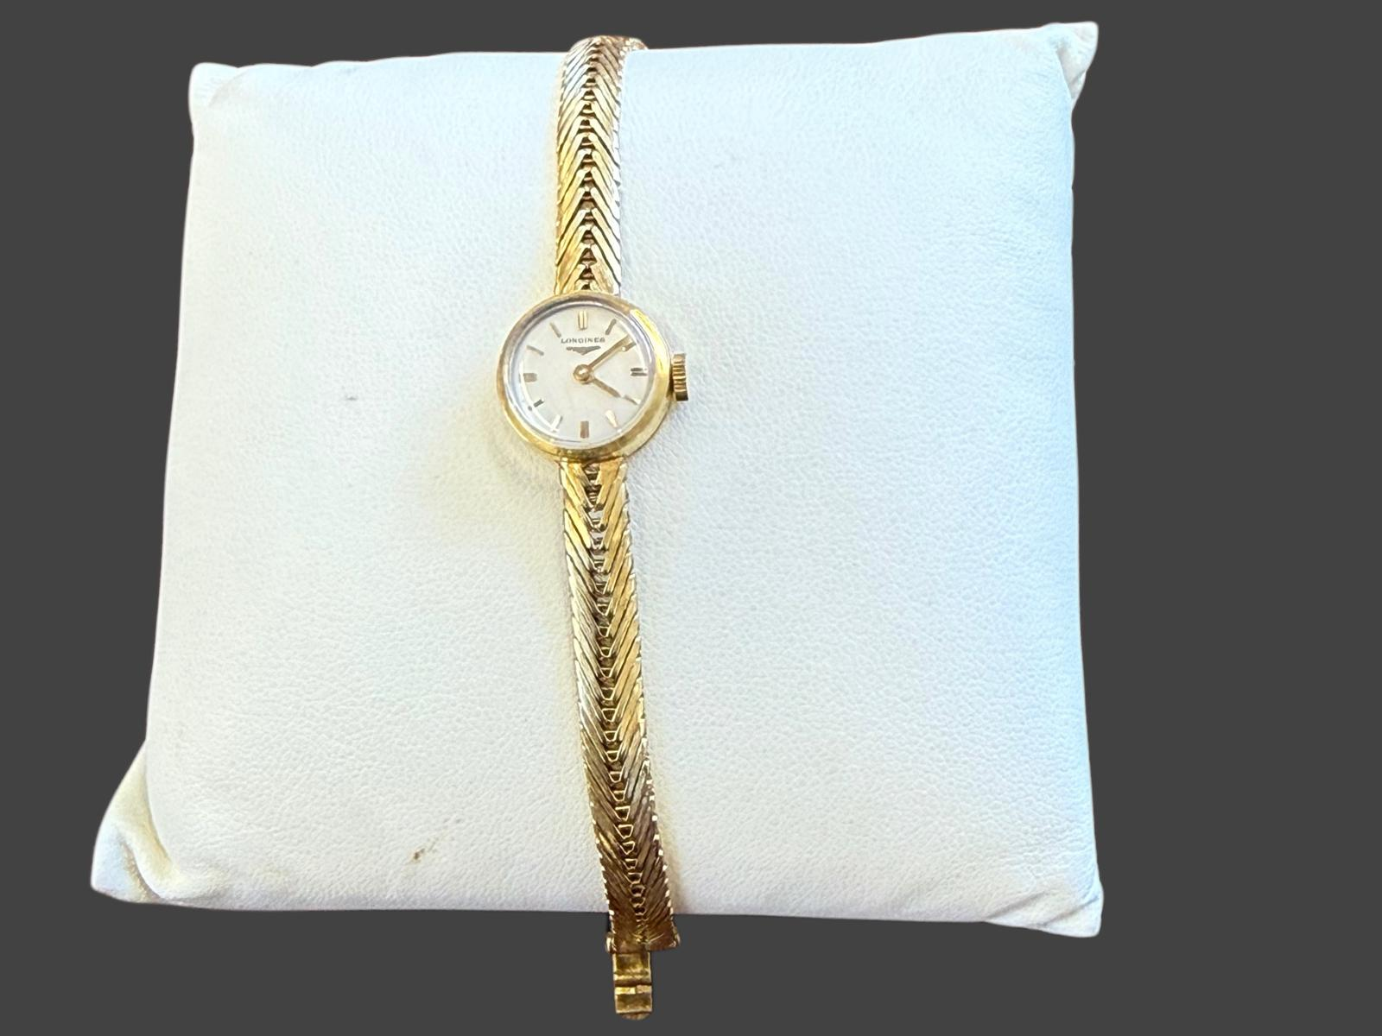
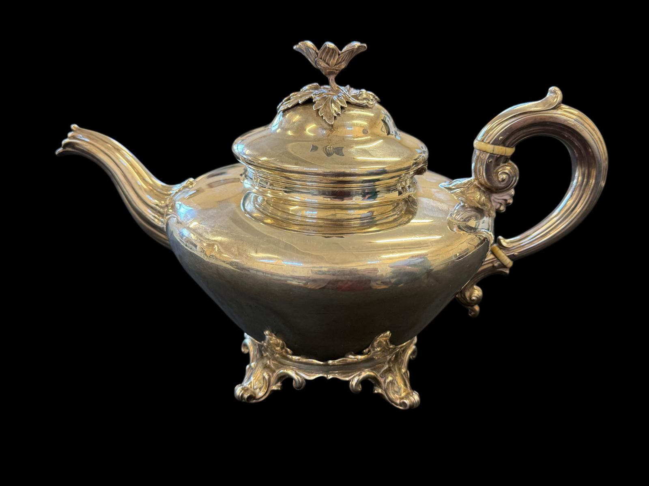
Lot 3 – A Victorian silver teapot, approx. 24oz, with ivory insulators. Estimated sale price: £600-£800
Lot 193 – A lady's 18ct gold Longines wristwatch, approx. 13g, in lined case. Estimated sale price: £500-£600

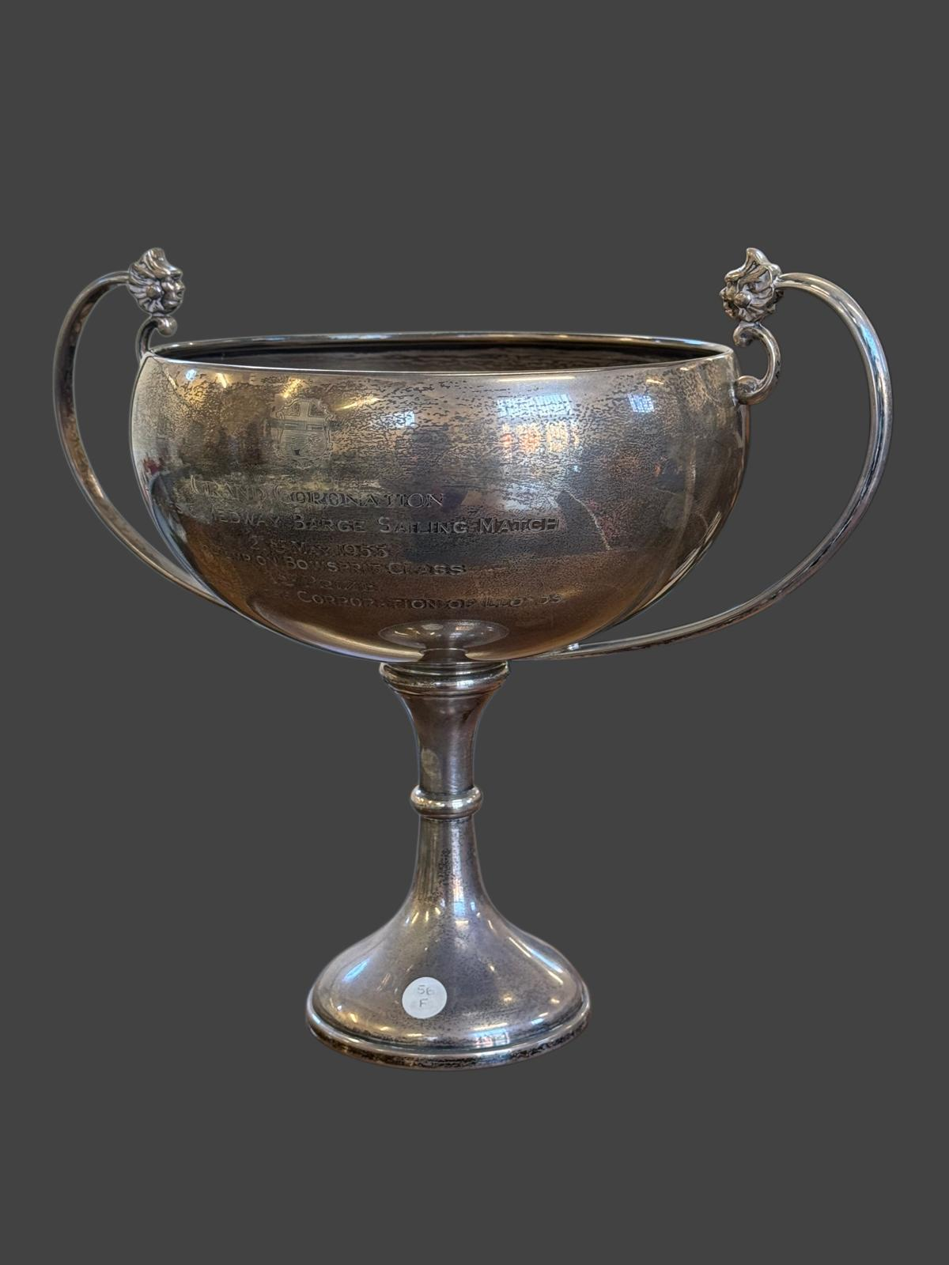
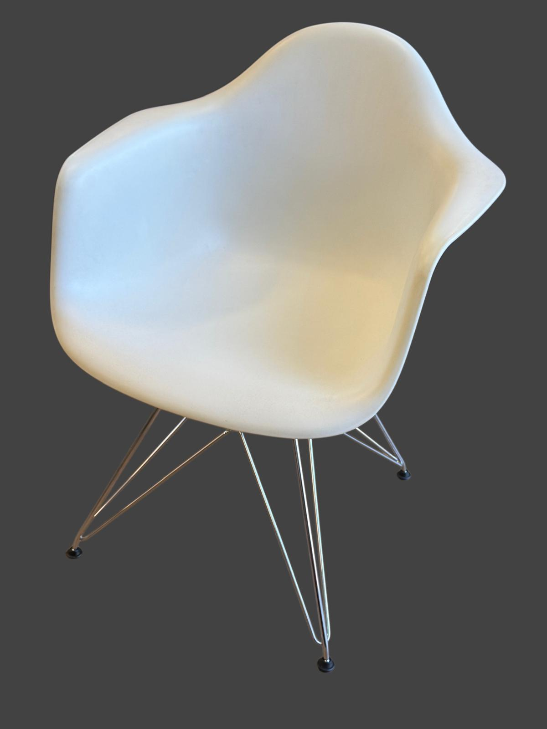
Lot 78 – A George VI silver sporting trophy, approx. 24oz. Estimated sale price: £750-£950
Lot 193 – A "Vitra Eames" white plastic armchair on chrome-plated steel base, 62cm wide x 80cm high. Estimated sale price: £60-£80
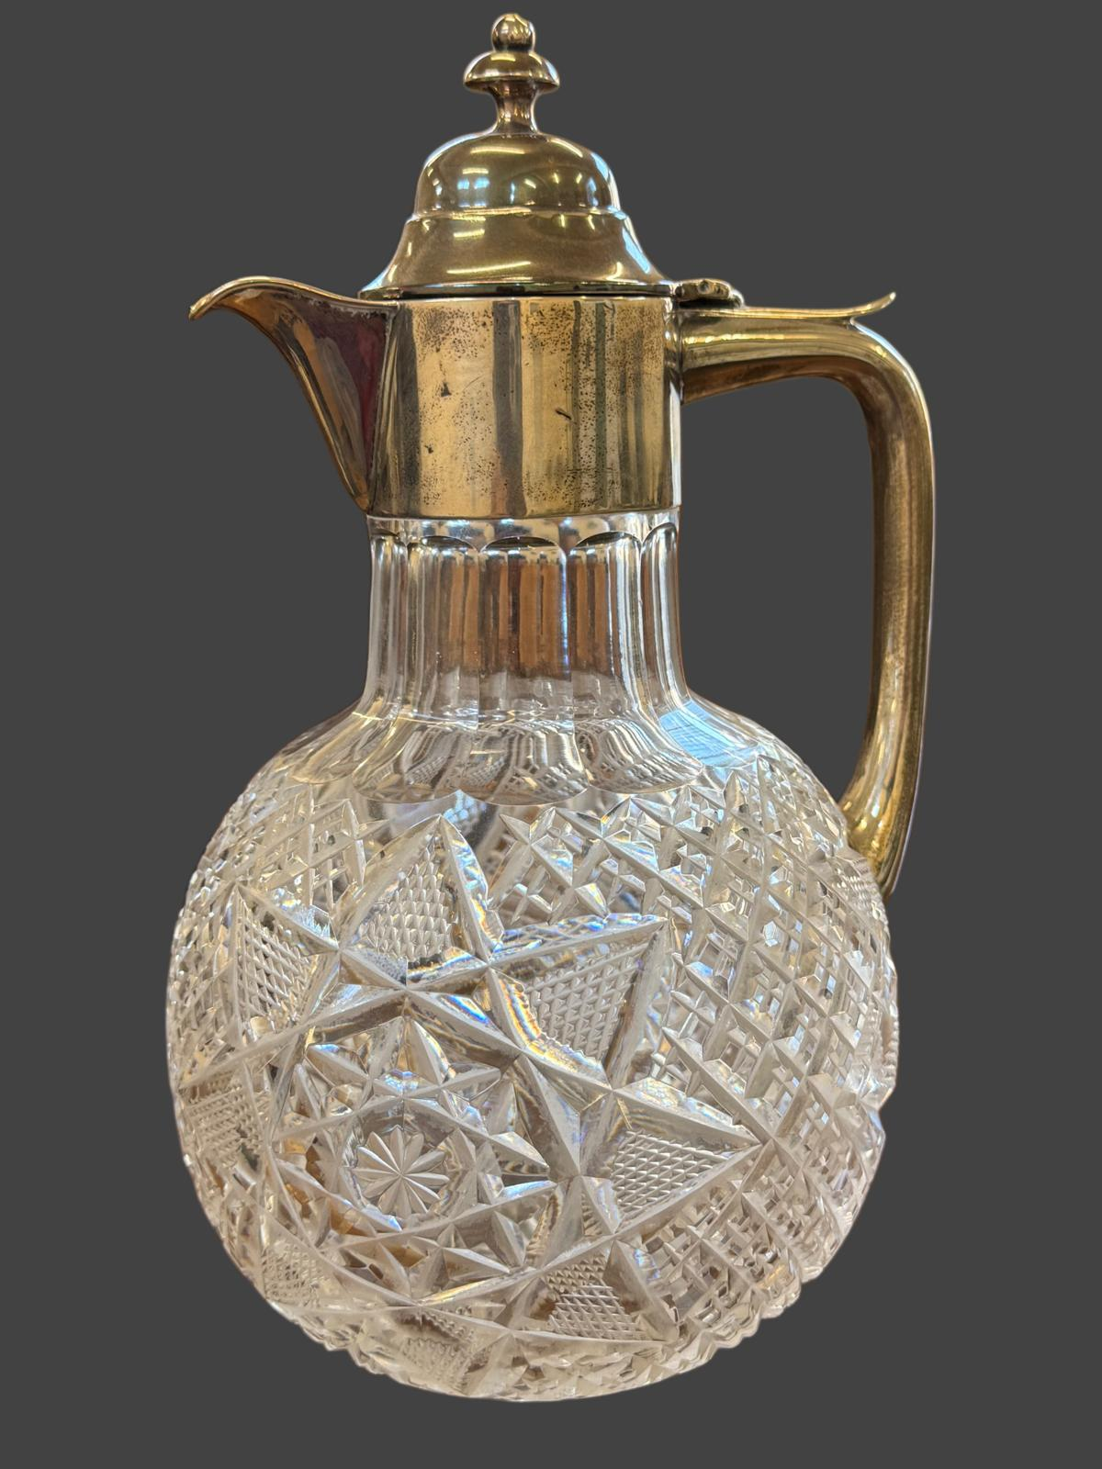
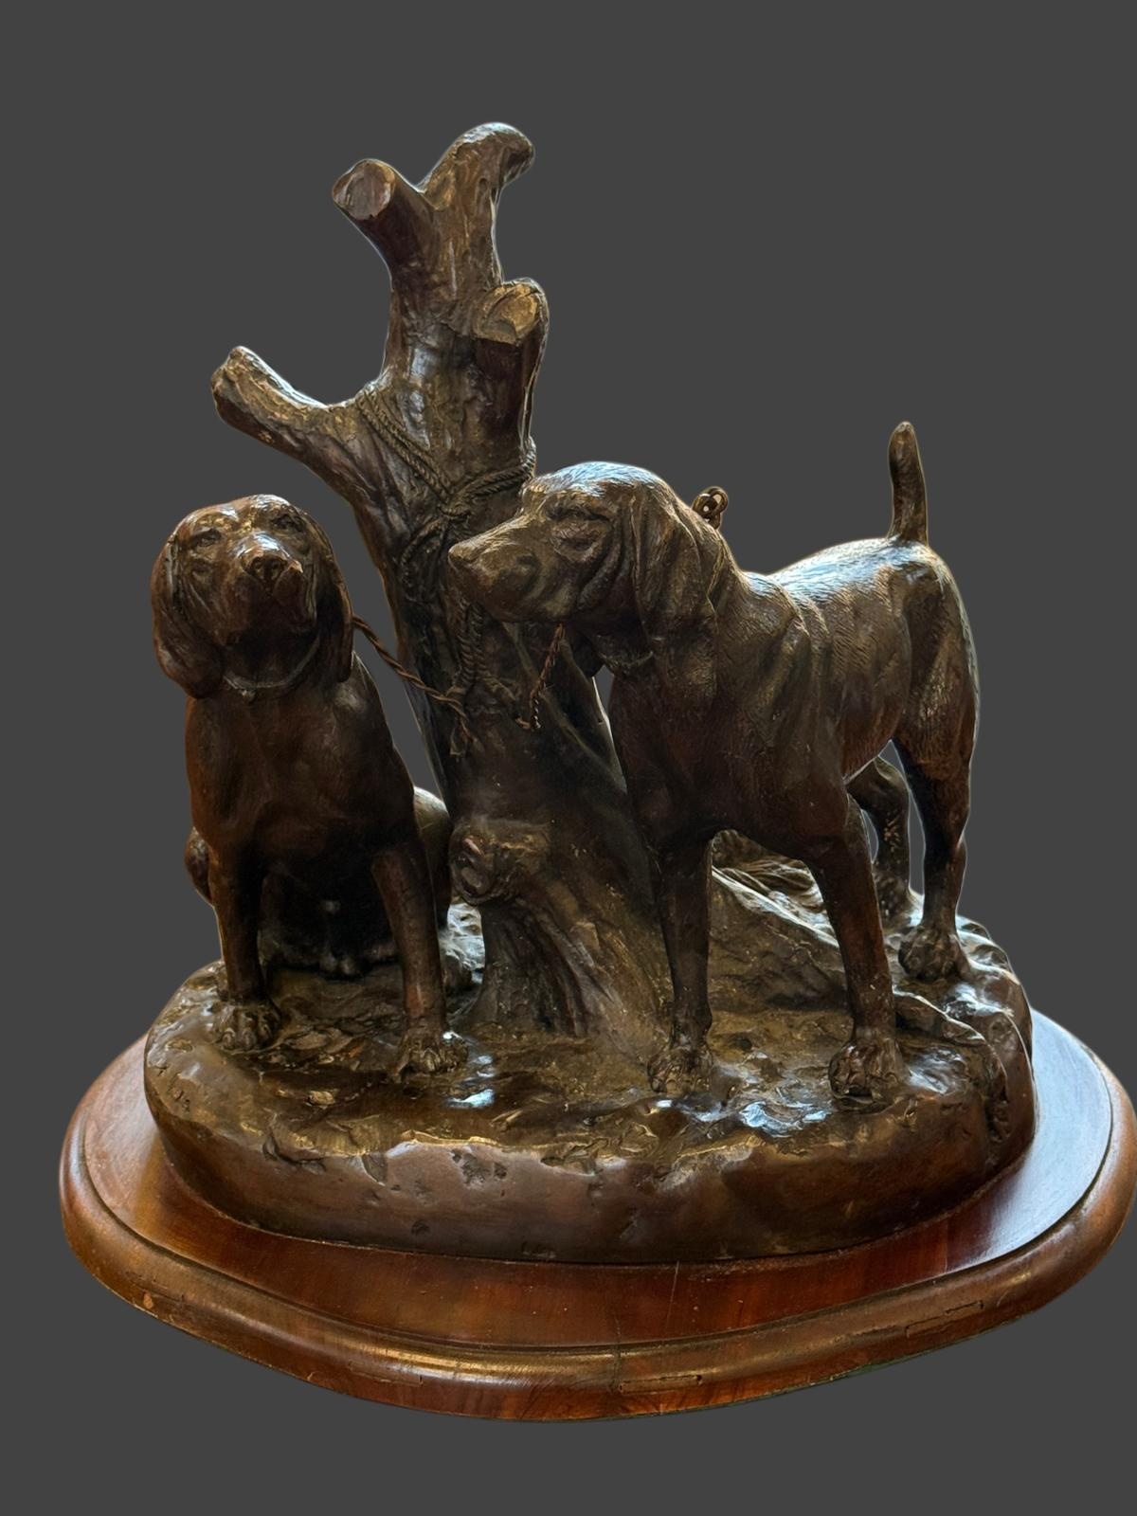
Lot 29 – Cold cast bronze of two gun dogs tied to a tree, after Grace Mott Johnson, on stained wood base, 37cm high x 36cm wide. Estimated sale price: £200-£250
Lot 171 – A George V cut glass claret jug with silver mount, handle and cover, 23cm high. Estimated sale price: £300-£500
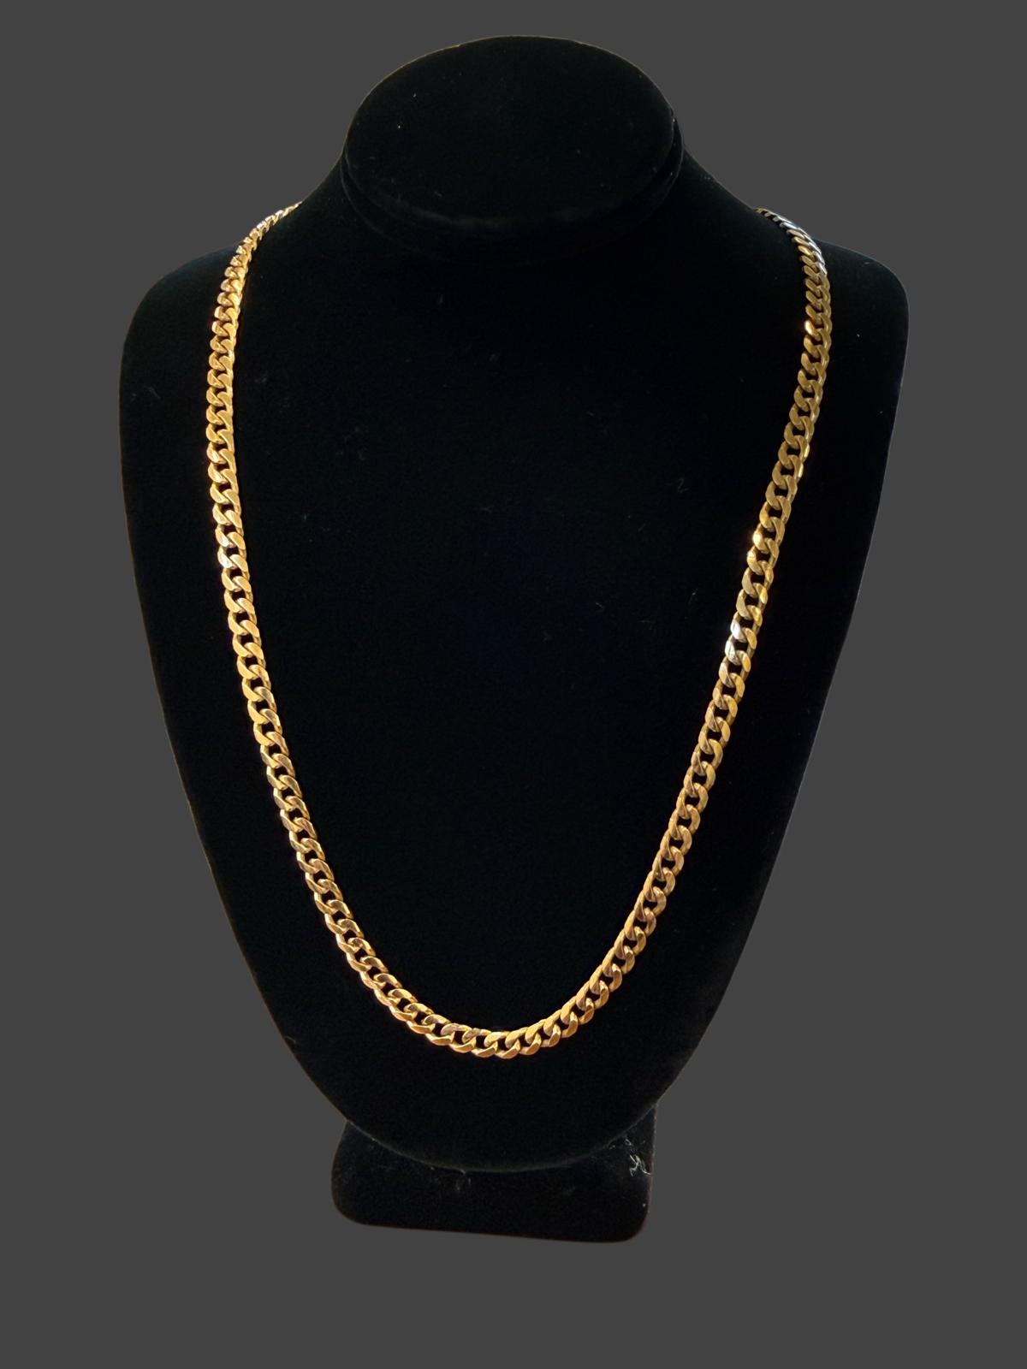
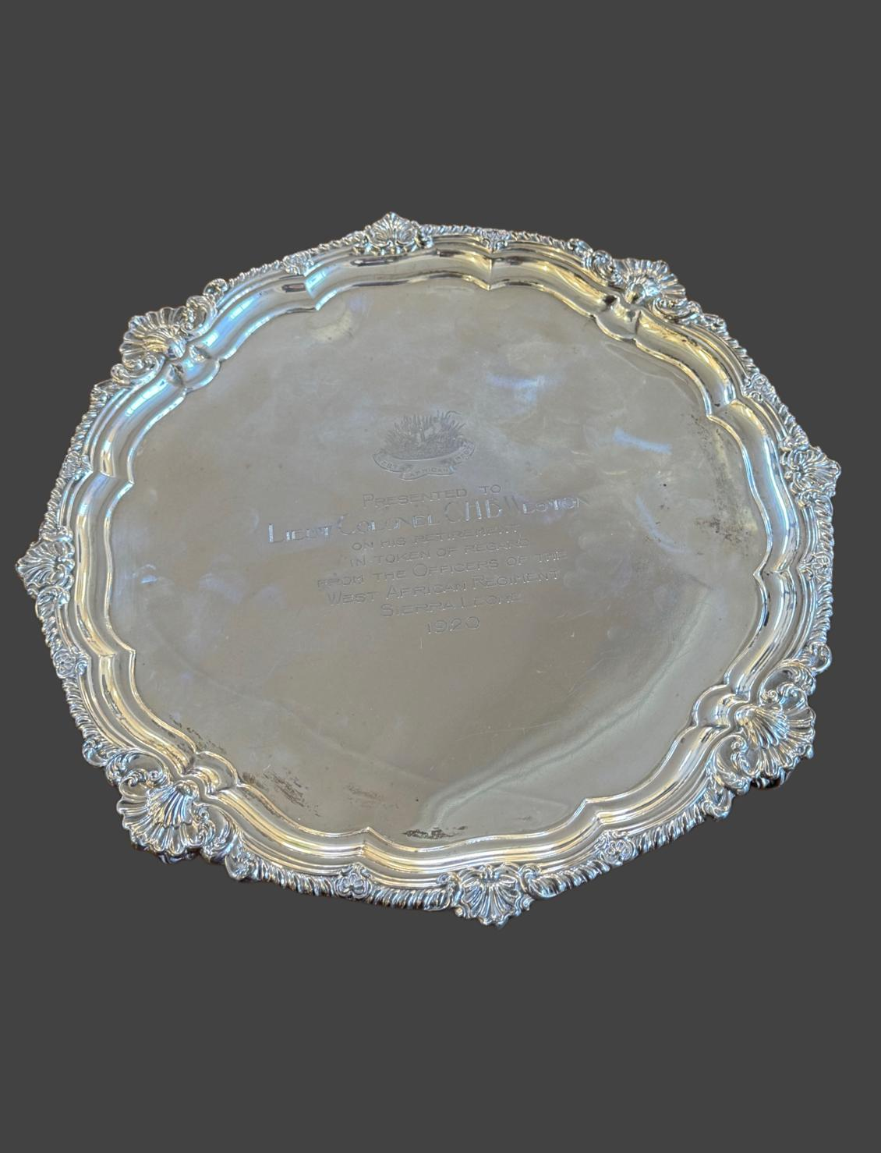
Lot 243 – A George V silver salver, approx. 34oz. Estimated sale price: £800-£1000
Lot 184 – A 9ct gold curb-link necklace, 51cm long, approx. 18g. Estimated sale price: £500-£600
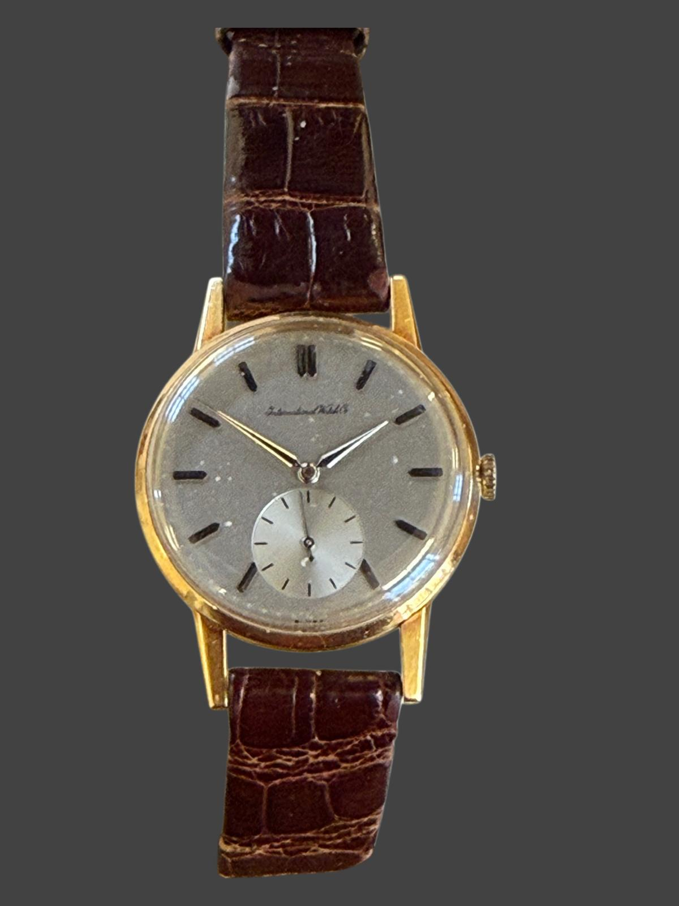
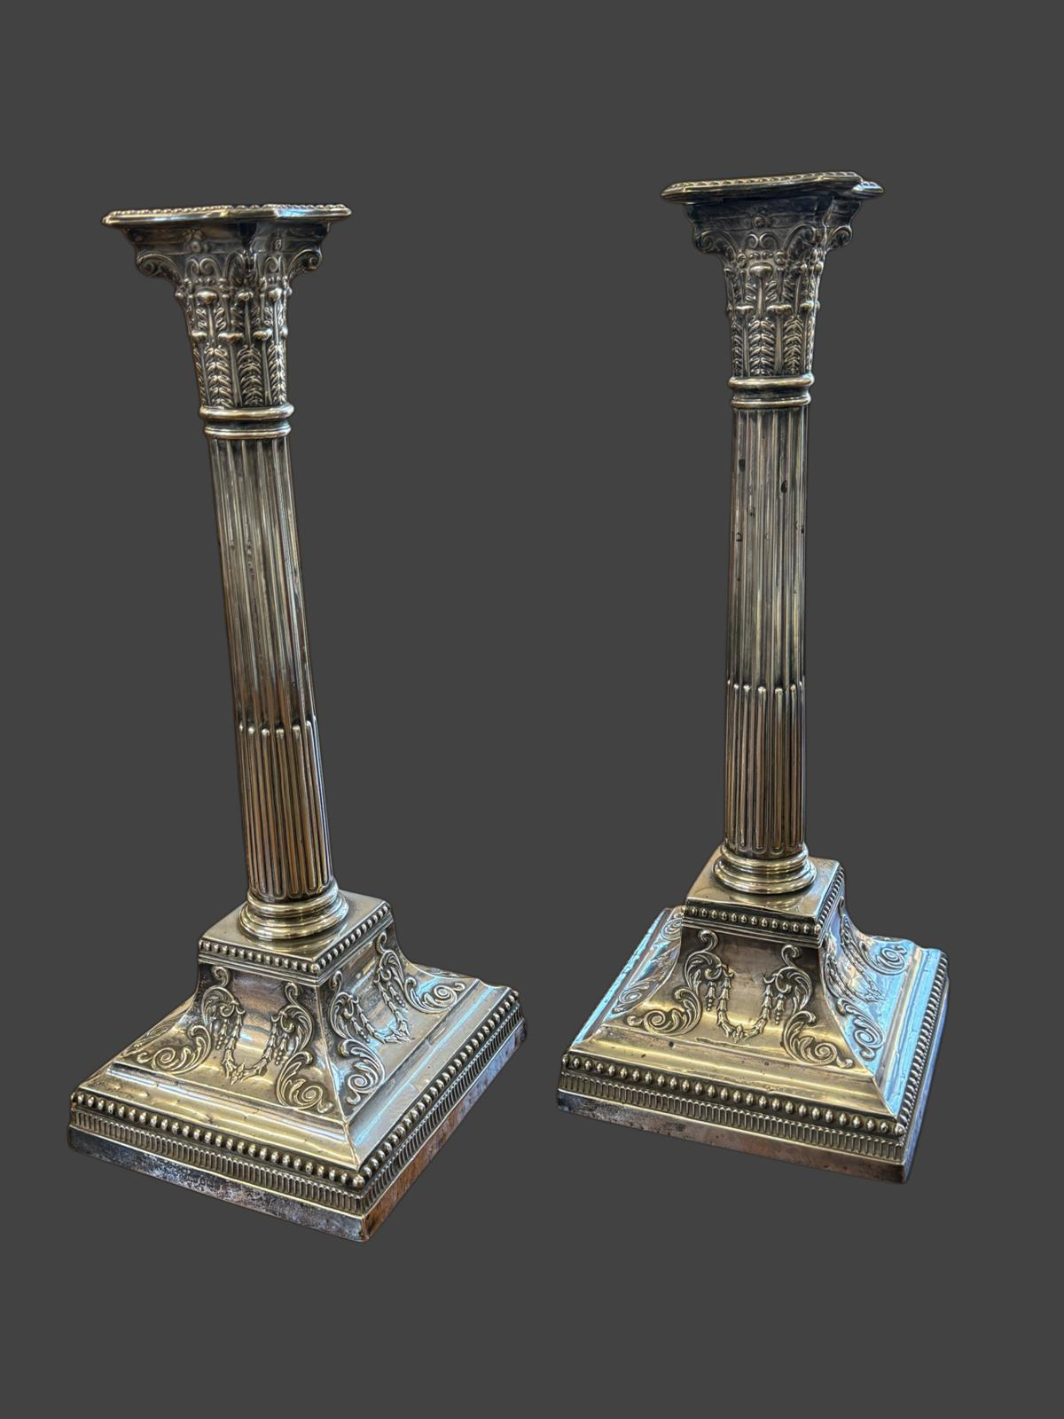
Lot 268 – A near pair of Edward VII/George V silver candlesticks, each 33.5cm high, weighted bases. Estimated sale price: £450-£650
Lot 195 – A gent's 18ct gold International Watch Co. wristwatch, and on leather strap, approx. 36g gross. Estimated sale price: £600-£800
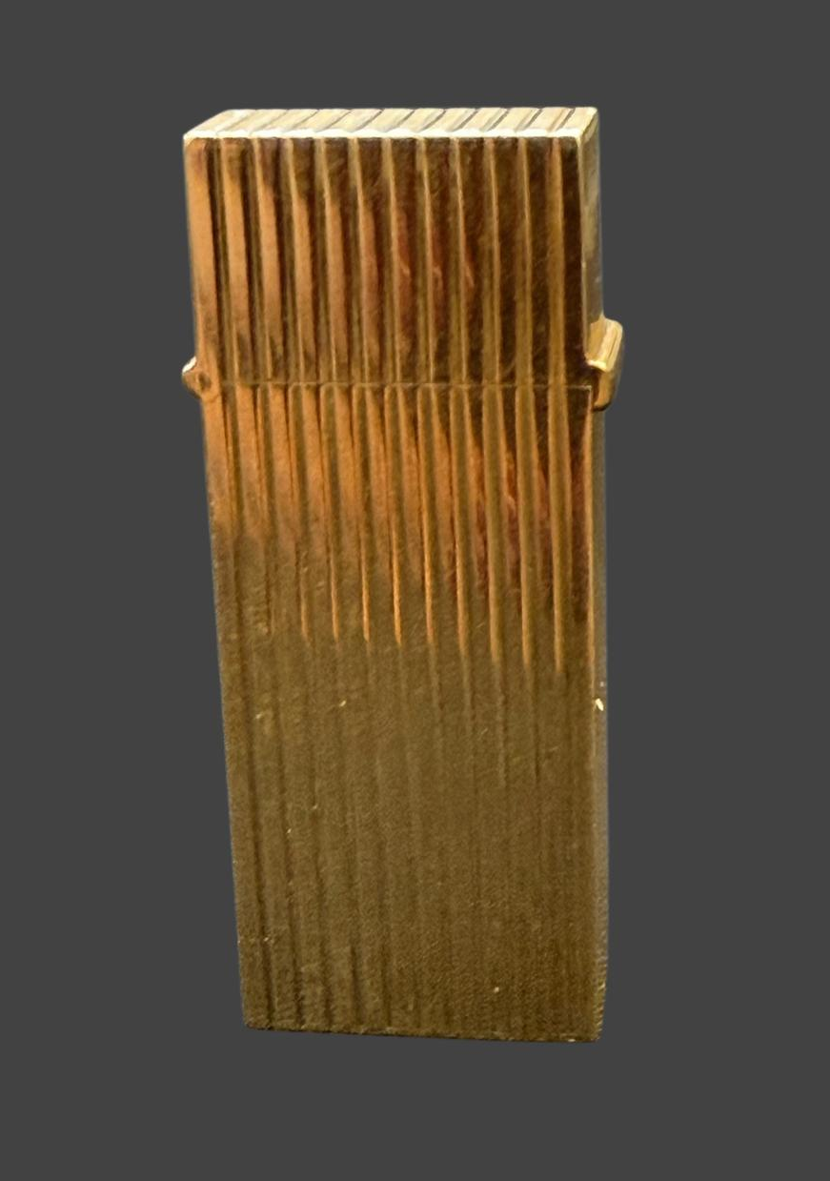
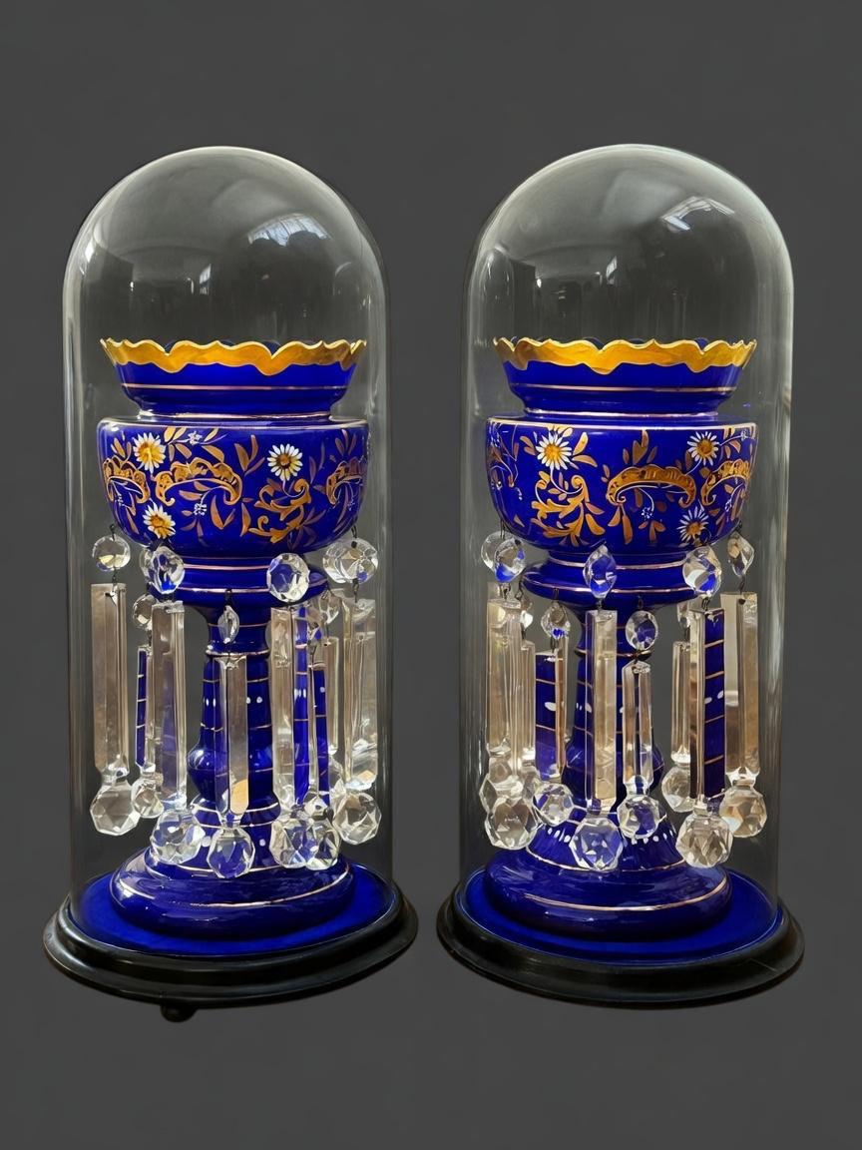
Lot 196 – A pair of Victorian blue glass table lustres, each 37cm high, and each under a glass dome 52cm high. Estimated sale price: £200-£300
Lot 196 – A 9ct gold Dunhill-style cigarette lighter, approx. 30g gross. Estimated sale price: £500-£700
168. | A "Motorola Personal Phone", with carrying case, charger, spare battery, and instructions, in branded box. | £10-£15
169. | A pair of silver-plated and bone-handled fish servers, with silver ferrules Sheffield 1902, in lined case. | £20-£30
170. | A "Timex" solid state quartz gent's wristwatch no. 909701, a lady's gold-plated and stainless steel Accurist wristwatch with quartz movement, a lady's "Limit" quartz wristwatch, all in branded boxes, and a gent's "Rigi Incabloc" gold-plated and stainless steel wristwatch, unboxed (4). | £20-£30
171. | A George V cut glass squat-form claret jug with silver mount, handle and cover, Birmingham 1911, 23cm high. | £300-£500
172. | A silver-plated four branch five sconce candelabrum, 27cm high, a silver-plated waiter with piecrust edge and golf-related engraving, 21cm in diameter, a silver-plated kettle on stand with burner, 24cm high, a glass spill vase on weighted silver foot, Birmingham 1983, and a silver-plated sugar bowl with ruby tinted glass liner (5). | £40-£60
173. | A brass trivet with pierced decoration 13cm high, a preserve pan with cast-iron handle, together with a kettle and stand with burner, two goblets, toasting fork, some horse brasses, and other metalware objects (qty). | £50-£70
174. | A George III white metal oval toddy ladle with stained handle, the bowl inset with a 1787 Half Guinea coin, bears the maker's mark for Hester Bateman, 37cm long. | £60-£80
175. | A set of six George V silver apostle teaspoons, Birmingham 1907, in lined case, and a George V silver christening set comprising feeding spoon and pusher, Birmingham 1932, in lined case, approx. 2.2oz weighable (2). | £60-£80
176. | A pair of George III circular open salts with gilt linings each on three feet, maker Hester Bateman, London 1779, each 5.5cm in diameter, together with two later silver salt spoons, approx. 2oz (4). | £50-£70
177. | A George III silver miniature chamber stick, London 1814, and a small Victorian pepperette, Birmingham 1884, approx. 4oz (2). | £100-£150
178. | A pair of Elizabeth II silver squat candlesticks with weighted bases, Birmingham 1973, a pair of cut glass and silver knife rests, Chester 1902, and an Elizabeth II silver whiskey decanter label (5). | £80-£120
179. | A George VI silver squat cream jug, Birmingham 1942, approx. 2.5oz. | £60-£80
180. | A Victorian silver squat cream jug, London 1893, approx. 1.6oz. | £50-£70
181. | An Edward VII silver photograph frame, Birmingham 1909, a further silver photo frame with the flags of the UK and Belgium, an oval photo frame, a small circular frame, and a further rectangular frame (5). | £100-£150
182. | A small silver caddy spoon with mother-of-pearl handle (marks rubbed), a miniature silver and enamelled hand mirror, Birmingham 1924, a small silver bell-form child's rattle with bone teething ring (marks rubbed), a small pickle fork, Birmingham 1896, a George V silver part christening set of spoon and fork, Sheffield 1935, with a replacement bone handled and silver-plated knife, in lined case, and a small silver and mother-of-pearl pen knife (6). | £60-£80
183. | A pair of George III silver teaspoons with bright-cut decoration, London 1803, a George V silver christening spoon and fork, Sheffield 1921, two further small spoons, Birmingham 1890, a small silver salt with spoon (marks rubbed), and a silver napkin ring, Birmingham 1917, approx. 3.6oz weighable (9) | £60-£80
184. | A 9ct gold curb-link necklace, 51cm long, approx. 18g. | £500-£600
185. | A 9ct gold rope-twist necklace 45cm long, approx. 8g, a.f. | £250-£350
186. | An Elizabeth II silver ID-type bracelet on curb link chain, approx. 0.6oz. | £30-£50
187. | A 9ct gold bangle of oval shape, approx. 10g. | £200-£300
188. | A platinum dress ring set a single central sapphire, two baguette diamonds, and eight small rose-cut diamonds, size M, approx. 3g overall. | £100-£150
189. | A ruby and diamond eternity ring, size J, approx. 3g. | £90-£120
190. | An 18ct white gold diamond and sapphire crossover dress ring, size L, approx. 3g. | £150-£200
191. | A 9ct gold sapphire and pearl flowerhead cluster dress ring, size M-N, approx. 4g. | £120-£180
192. | A Victorian-style 18ct gold ruby and diamond dress ring set three rubies and six tiny diamonds, size M, approx. 3g. | £150-£200
193. | A lady's 18ct gold Longines wristwatch, with silvered dial, on articulated-style bracelet strap, approx. 13g, in lined case. | £500-£600
194. | A lady's 18ct gold square-dial wristwatch by "Kutchinsky" on articulated-style strap, approx. 30g. | £600-£800
195. | A gent's 18ct gold International Watch Co. wristwatch with bar numerals, silvered dial, and on leather strap, approx. 36g gross. | £600-£800
196. | A 9ct gold Dunhill-style cigarette lighter, approx. 30g gross. | £500-£700
197. | A gent's 18ct gold and mother-of-pearl part dress stud set, each piece set a small sapphire, in lined case, cufflinks missing. | £180-£220
198. | A 9ct gold cross pendant 2cm long, on a 9ct gold slender-link chain, approx. 2.5g. | £60-£80
199. | A 9ct gold cross pendant 2.5cm long, approx. 0.9g, on slender-link metal chain. | £40-£60
200. | Two pairs of silver gent's cufflinks, a silver bar-link bracelet, a silver napkin ring, a small-link bracelet, three pearl necklaces, and a small quantity of decorative and costume jewellery (qty). | £70-£100
201. | A 9ct gold flowerhead-style brooch set central turquoise and 15 seed pearls, approx. 6.2g. | £180-£220
202. | A stainless steel gent's Seiko quartz chronograph wristwatch on bracelet strap, and two stainless steel Casio quartz wristwatches (3). | £70-£100
203. | A Lladro figure of young woman with piglets, 27cm high, further figures of boy with donkey, girl with young child, girl reading a story, a Nao figure of young woman feeding calf, 33cm high, and five further Lladro and Nao figures, two a.f. (10). | £60-£80
204. | A ruby-tinted glass beaker with decorative silver holder marked London 1930, a ruby-tinted jug, a wine glass, a salt, a decorative continental vase (a.f.), and a small plain glass scent decanter (6). | £30-£40
205. | A small late Victorian silver cherry fork with mother-of-pearl handle marked Birmingham 1899, a miniature continental silver chair, a silver-handled cake slice, and a quantity of silver-plated articles including a magnifying glass (qty). | £30-£50
206. | A beaded lace jug cover, a set of ecru chair backs, a number of doilies, and other lace and textiles (qty). | £15-£20
207. | An Edwardian inlaid mahogany centre table with shaped ends, on four turned and ringed legs united by a stretchered under-tier, 76cm x 96cm. | £60-£80
208. | A square Persian rug style upholstered pouffe, 62cm x 81cm. | £15-£20
209. | A reproduction mahogany twin pedestal dining table with snap-top ends, and central leaf, 101cm wide x 212cm long extended. | £30-£50
210. | Four "Compare the Market" meerkat soft toys comprising: "Yakov's Toy Shop", Star Wars "Oleg as BB-8", "Sergei as Obi-Wan Kenobi", and "Aleksandr as Batman", in limited edition packaging (4). | £20-£30
211. | A limited edition part box set for Fat Boy Slim's Big Beach Bootique 5 c.2012, signed by Norman Cook, comprising: single sided 7inch flexi disk, and some card inserts, a.f. | £15-£20
212. | A volume of "Private Eye A Cartoon History" edited by Nick Newman and signed by Ian Hislop c.2013, together with three books by Kate Adie including "Corsets to Camouflage" signed by the author, "The Kindness of Strangers", and "Nobody's Child", both with facsimile signature (4). | £15-£20
213. | A Star Wars Forces of Destiny figure of "Rey of Jakku" in packaging (a.f.), a further figure of "Kylo Ren" from the Black Forces series in box, and a Star Wars soft toy figure of BB-8 in packaging (3). | £20-£30
214. | A "Sestrel" marine gimble compass, no. 2873, 17cm in diameter x 9cm high. | £20-£30
215. | A small 20th century Chinese bronze incense burner with part pierced cover, 18cm high, on small carved wood stand, 22cm high overall. | £100-£150
216. | A pair of decorative silver-plated bottle coasters, with wooden inserts, each 17cm in diameter (2). | £30-£50
218. | Nine Lladro figures various including: sleeping baby Jesus (a.f.), a white duck, some nativity related figures, and a yawning boy (9). | £30-£50
219. | A silver-plated cloche 34cm wide x 25cm high, a fiddle-pattern soup ladle, together with a coffee pot, and a hot water jug (4). | £30-£50
220. | A silver-plated keyless wound pocket watch with Swiss movement and white enamelled moon phase dial, 5cm in diameter. | £100-£200
221. | A late Victorian silver half hunter cased keyless wound pocket watch, with white enamelled dial, movement inscribed "Victor Hullberg 105 Liverpool Road London no. 3144", hallmarked for London 1877, on a silver curb-link chain approx. 1oz weighable. | £100-£150
222. | A silver-plated keyless wound open-faced Traveler pocket watch, no. 19480237, white enamelled dial, threaded front and rear covers, 5cm in diameter. | £60-£80
223. | After Lucelle Raad - "The Crabcatchers", chromolithograph 29.5cm x 28cm, and another "By the Sea", 28cm x 29.5cm, both limited edition 27/950 and 116/950 respectively (2). | £25-£40
224. | After Michael McDonagh Wood - "Blue Posts" no. 18/500, lithograph, 28cm x 37cm, and another "Venetian Villa" no. 26/500, 37cm x 27.5cm (2). | £30-£50
225. | Davy Brown (b. 1950) - "Farm near Gargunnock" oil on board, inscribed verso and signed bottom right, 72cm x 62cm. | £300-£500
226. | An Afghan Kunduz rug, the centre with 16 octagonal guls on red ground, wide multi-banded border, 181cm x 103cm. | £100-£150
227. | An early Victorian rosewood circular occasional table on turned and part-carved column and quadraform base with bun feet, top 53cm in diameter. | £80-£120
228. | A Samson of Paris porcelain figure of French Napoleonic Hussar 23cm high (slightly a.f.), and a Sitzendorf porcelain figure of a Napoleonic guardsman with musket 23cm high (2). | £60-£80
229. | A Murano glass vase with Millefiori pattern on green and multicoloured ground, 39cm high. | £60-£80
230. | A 20th century miniature quaich as a salt with spoon, 7cm in diameter, a further tasting cup "La Bonne Pesche", 10cm in diameter, a lidded tankard, and three further pint tankards (7). | £30-£50
231. | John Lewis (Welsh b.1933) - View of a gravel pit, oil on board, 110cm x 122cm. | £200-£300
232. | A pair of Edward VII silver squat column candlesticks, on stepped and weighted bases, each 15.5cm high, London 1909, together with an Edwardian silver circular weighted trinket box, Birmingham 1909 (3). | £180-£220
233. | A silver-plated three piece tea set in the Queen Anne style, a silver-plated sugar caster, and an oval two-handled and galleried tray 55cm wide (5). | £50-£70
234. | A 20th century art pottery bowl with glazed centre, 35cm in diameter. | £30-£50
235. | An Edwardian mahogany-cased lancet shaped mantel clock with some cross banding and stringing, French striking movement, white enamelled dial, 34cm high, together with key. | £60-£80
236. | A Gillies Jones art glass bowl, 16cm in diameter x 13cm high. | £20-£30
237. | A 20th century Chinese decorative vase surmounted by figures of children, with You Xian Ju Jianzhi mark to base, 32cm high, together with a small pin tray from the same factory, 9cm in diameter (2). | £40-£60
238. | A small bronze figure of a putto holding the base of a torch, 14cm high, possibly previously mounted on a clock. | £40-£60
239. | A pale mahogany dental surgeon's table cabinet with rising lid and six graduated drawers, the top containing a small metal box, six small pottery trays, and three small glass jars, 33cm wide x 39cm high. | £40-£60
240. | A quantity of 20th century British silver coinage including shillings, sixpences and half crowns, a 2006 Brunel and Victoria Cross commemorative coin set, three pre-decimalisation proof coin sets, a Coinage of Great Britain set, together with a quantity of copper, nickel-plated, and other legal tender coinage and commemorative crowns (qty). | £60-£80
241. | An album of mixed British and some Commonwealth stamps from Edward VII to George VI, a further six albums of British and world stamps, a box file of stamps and covers, together with a quantity of mixed first day covers various (qty). | £60-£80
242. | A Hornby 00 gauge LMS Class 5 4-6-0 locomotive and tender, together with some boxed and unboxed rolling stock, unboxed trains, station buildings, track, and a control unit (qty). | £50-£70
243. | A George V silver salver, with shell gadrooned and piecrust edge, on four scrolled feet, the centre with the regimental crest of the "West African Regiment", and inscribed "Presented to Lieut. Colonel C. H. B. Weston, on His Retirement In Token of Regard From The Officers of The West African Regiment, Sierra Leone, 1920", maker The Goldsmiths and Silversmiths Co. Ltd., London 1920, approx. 34oz. Note - The West African Regiment was in existence between 1898 and 1928. | £800-£1000
244. | A late 17th/early 18th century map of Kent by Robert Morden, 36cm x 64cm, together with a smaller map of Hampshire by the same cartographer, 38cm x 44cm (2). | £40-£60
245. | Three small Chinese silver teaspoons, a set of 12 Victorian silver teaspoons London 1892, and a pair of silver-plated sugar nips, a silver short-handled toast fork Sheffield 1920, two sets of silver-handled tea knives (cased), a silver-backed and tortoiseshell hand mirror, a pair of small silver spill vases Birmingham 1910 (1 a.f.), and three glass vessels with silver mounts/tops, approx. 5.8oz weighable (qty). | £100-£150
246. | A pewter figural ashtray depicting a blacksmith, three silver-plated bonbon dishes on stand, a set of fish knives and forks, two shallow serving spoons in case, a silver-plated hair tidy and jar, together with a quantity of bone handled, silver-plated and stainless steel cutlery and other objects (qty). | £60-£80
247. | A Danish porcelain figure of a guinea pig, 14cm long, a Poole pottery figure of a dolphin, and a decorative Poole pottery vase (3). | £25-£40
248. | A silver commemorative £25 coin dated 1986 to commemorate the wedding of Prince Andrew and Sarah Ferguson, in lined Falkland Islands case, approx. 5oz. | £100-£150
249. | A Garnier painted metal underground station sign for Elephant and Castle 23cm x 171cm with brown edging, a smaller Garnier Bakerloo Line sign 23cm x 63.5cm, a blue and white sign for the South Eastern & Chatham Railway 12cm x 105cm, and an Underground ticket clipping machine possibly from Moorhead station, all a.f. (4). | £80-£100
250. | A George IV silver cream jug, with scrolled and floral relief decoration, London 1822, approx. 7oz. | £150-£200
251. | An 18th century style oval chromolithograph portrait of gentleman wearing red coatee 7cm x 6cm, in ebonised frame 14.5cm x 12cm, together with a similar portrait of woman 8cm x 6.5cm, in ebonised frame (2). | £40-£60
252. | A silver-plated and stainless steel suite of table cutlery in Dubarry pattern, in mahogany canteen, by Viners of Sheffield, 56 pieces. | £30-£50
253. | An art-deco style simulated slate and marble clock garniture, the clock with non-striking movement 22.5cm high, the side pieces each 15cm high (3). | £40-£60
254. | A souvenir Irish carved wood shillelagh, 50cm long, together with a mahogany walking cane with bone top, 88cm long (2). | £30-£50
255. | An Edwardian photograph album containing a collection of black and white family photographs including: a tea clipper ship in port, some fox hunting scenes, one or two railway scenes, other transport, and other more general material, a.f. | £30-£50
256. | A metal-link bracelet with 9ct gold padlock, a gent's 9ct gold signet ring with agate to centre, three further dress rings various, a silver caddy spoon and two napkin rings, and three pocket watches various, together with a George III silver crown and further coins, and a quantity of decorative and costume jewellery (qty). | £80-£100
257. | A 19th century style pale mahogany demi-lune side table inlaid with some stringing, on four square tapering legs with spade feet, 121cm wide. | £40-£60
258. | A George II style walnut veneered bureau bookcase, the upper part fitted two adjustable shelves enclosed by a pair of glazed panelled doors, and two candle stands below, the lower part with sloping fall revealing a stepped interior above three short and two long drawers, on bracket feet, 106cm wide x 206cm high, a.f. | £150-£200
259. | A Regency mahogany bow-fronted chest of three long drawers, on later turned feet, 93cm wide, a.f. | £40-£60
260. | An 18th century style oak gateleg table fitted two end drawers, on turned and ringed legs, 114cm x 132cm extended. | £40-£60
261. | A 19th century inlaid oak hanging corner cupboard, the interior fitted shaped shelves enclosed by a pair of panelled doors, 87cm wide x 107cm high. | £30-£50
262. | An early 19th century English porcelain part tea and coffee service decorated in the Imari pattern comprising: six teacups, six coffee cups, and six saucers, together with a Grosvener china Old English pattern part coffee set, some pieces a.f. (24 pieces overall). | £25-£40
263. | An early 19th century French porcelain part tea and coffee set with floral decoration, gilt borders, 20 pieces. | £30-£50
264. | A quantity of Chinese blue and white porcelain various, including: set of five plates, four further plates, two bowls, a teapot, and other pieces, mainly 19th century (24 pieces overall). | £80-£100
265. | A Chinese blanc de chine figure of Guan Yin, 23cm high, together with five tea bowls in mixed sizes (6). | £40-£60
266. | An early 19th century English porcelain part dessert service painted with flower sprays within royal blue cream and gilt border, some pieces a.f. (14 pieces). | £20-£30
267. | A Dartington glass commemorative goblet to mark the marriage of the Prince of Wales and Lady Diana Spencer, 18.5cm high, a further decorated goblet, and two large cut-glass whisky tumblers (4). | £20-£30
268. | A near pair of Edward VII/George V silver column candlesticks, each 33.5cm high, marked London 1903 and Sheffield 1912 respectively, weighted bases (2). | £450-£650
269. | A George III style inlaid satinwood bureau bookcase, the upper part fitted two shelves enclosed by a pair of astragal-glazed doors, below a blind fret carved broken swan neck pediment, the lower part with sloping fall revealing a fitted interior above four long graduated drawers on bracket feet, 102cm wide x 231cm high. | £300-£500
270. | An elm coffee table with planked top fitted a drawer to one end, on squat square moulded legs, the top 98cm x 73cm. | £30-£50
271. | An Edwardian pale mahogany circular occasional table on slender cabriole legs with pad feet and united by stretchers, 68cm in diameter. | £30-£50
272. | An early Edwardian mahogany dining table with satinwood banding and wind-out action, on square tapering legs with brass casters, three extra leaves, 105cm x 305cm extended, together with a set of six country-made George III style elm dining chairs, including two elbow chairs (7). | £150-£200
273. | A Victorian button-upholstered open arm parlour chair on turned legs with casters. | £30-£50
274. | An early 20th century German-made plastic and composition doll in Dutch costume, 37cm long. | £40-£60
275. | An "SEL Model Major" stationary steam engine on green base, 14cm x 15cm, together with three tool accessories on bakerlite bases (4). | £40-£60
276. | A Dinky Toys military issue diecast tank transporter, a centurion tank, a small green flatbed lorry, a forklift truck, and a small tinplate toy tractor (5). | £30-£50
277. | A set of four Victorian silver open salts, each on three feet, London 1879, together with three salt spoons, in lined case, approx. 8oz. | £150-£200
278. | A small oval gilt-metal French-style trinket box 7cm wide, a small rectangular box with some engine-turned decoration, and a further slightly decorative box 9cm wide (3). | £60-£80
279. | Two Masai-type spears with stained wood shafts, 150cm and 153cm long respectively (2). | £20-£30
280. | A small oval North American Indian quill and woven workbox 13cm wide, and a hair pipe type breastplate 25cm wide x 39cm long (2). | £40-£60
281. | A hide camel waterbag with overall geometric decoration, 150cm long. | £30-£50
282. | A painted wooden decoy duck of mallard drake form, 38cm long. | £30-£50
283. | An Indonesian painted wood fire dragon figure with separate wings, 55.5cm long, and an oval Japanese lacquered box, 14.5cm wide (2). | £30-£50
284. | A small George V silver capstan inkwell marked Birmingham 1932 with weighted base (a.f.), a Middle Eastern silver-plated scent bottle, and a small glass and silver-plated cruet set in basket form holder (3). | £30-£50
285. | A stained wood weaving boat shuttle fitted with central turned bobbin, 49cm long. | £15-£20
286. | A Victorian pierced brass fender on animal feet 134cm wide, a pair of brass andirons, four fire irons, and a rectangular trivet (8). | £30-£50
287. | A Victorian inlaid and crossbanded walnut overmantle mirror, 82cm wide x 48cm high. | £20-£30
288. | A late Victorian walnut and mahogany "Polyphon" fitted a glass door and with pine sides, on a non-matching mahogany cabinet base, 48cm wide x 166.5cm high, together with thirteen metal disks and a winding handle. | £300-£500
289. | A late Regency mahogany and caned crib, on turned and ringed stand and trestle feet, 102cm long x 121cm high, a.f. | £80-£100
290. | A set of four Punch & Judy puppets with painted wooden heads, between 24cm and 37cm high (4). | £150-£200
291. | An Edwardian inlaid mahogany longcase clock with three train movement, striking on five gongs and eight bells, and gilt brass dial, the hood with three brass finials, the trunk door flanked by reeded quarter column pilasters, on plinth base, 241cm high. | £200-£300
292. | An early 20th century stained oak free standing stereoscopic viewer, with a number of slides showing various subjects, on stepped square base, 23cm wide x 119.5cm high. | £100-£150
293. | A Victorian inlaid walnut and carved beech oval breakfast table on turned and carved column and quadruped base, the top 86cm x 117cm. | £80-£100
294. | Two similar moulded glass claret jugs with silver-plated mounts and handles, 29cm high, a silver-plated rectangular entrée dish with cover, 29cm x 23cm, and a silver-plated biscuit barrel, 16cm high (4). | £30-£50
295. | A pair of Victorian blue glass table lustres with prismatic glass drops, and gilded and floral decoration, each 37cm high, and each under a glass dome 52cm high (2). | £200-£300
296. | A 20th century pale stained wood and metal-framed kneehole desk fitted seven drawers, 137cm wide x 76cm high x 76cm deep. | £30-£50

END OF SALE

UPCOMING DATES
2026

Auctions

Wednesday 9th December 2026

Viewing on Monday* and Tuesday before sale from 10am to 5pm
and on morning of sale from 9am to 10.30am
Sale commences at 11am
*When viewing falls on a bank holiday, it will be held on the prior Friday instead

Valuation Days

Wednesday 28th October 2026
Wednesday 18th November 2026
Wednesday 16th December 2026

Sevenoaks Saleroom, Argyle Road,
Sevenoaks TN13 1HJ
Between 11am - 4pm

AUCTION DATES 2027

Ibbett Mosely Auction Rooms, Argyle Road,
Sevenoaks, TN13 1HJ.

Wednesday 27th January
Wednesday 10th March
Wednesday 28th April
Wednesday 16th June
Wednesday 28th July
Wednesday 8th September
Wednesday 20th October
Wednesday 8th December

Viewing on Monday* and Tuesday before sale from 10am to 5pm
and on morning of sale from 9am to 10.30am
Sale commences at 11am
*When viewing falls on a bank holiday, it will be held on the prior Friday instead

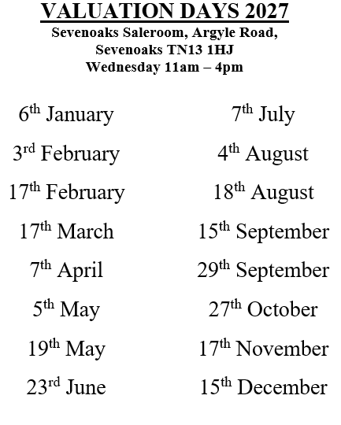

Notes

