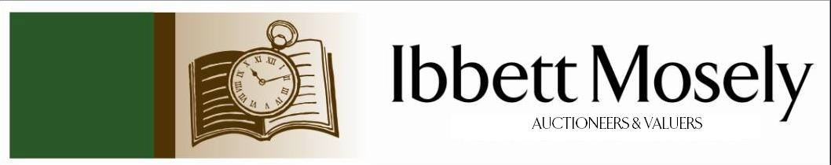

Catalogue of Antiques and Collectibles
to be Auctioned on

Wednesday 18th March 2026ffff
at 11am

IBBETT MOSELY AUCTION ROOMS
ARGYLE ROAD, SEVENOAKS, KENT TN13 1HJ
And Online Via
www.easyliveauction.com/ibbettmosely/

Viewing at Sale Room on:

Monday 16th March
Tuesday 17th March

Between 10am – 5pm

Catalogues: £2.00

Auctioneer and Valuer: Alan White FNAVA
Auction Clerk and Trainee Valuer: Nicola Rainsley-Hughes MNAVA
Auction Clerk and Saleroom Manager: Benjamin Burridge
Photographer and Porter: Samantha Crowe-White
Office Administrator: Wendy Weaver

Front Cover: Lot 335 – A Victorian yellow and white metal old mine cut diamond flower spray brooch, set 71 old cut diamonds, approx. 5 carats, 6.1cm x 3.3 cm, weight approx. 15.9g. Est: £3000-£4000

Welcome to Ibbett Mosely Auctions
18th March 2026 Auction Catalogue

This sale will also be held online at www.easyliveauction.com/ibbettmosely/
please visit the website to register or log in to view and bid. Images and condition reports of each lot are included.

Alternatively, commission bids (bids left ‘on the book’) may be left with us, as well as a limited amount of telephone bids. Please telephone 01732 456731 or email auctions@ibbettmosely.co.uk for further details.

Unsold lots from this sale will be placed into a week-long online timed auction that can be found at www.easyliveauction.com/ibbettmosely/

Please telephone 01732 456731 or email auctions@ibbettmosely.co.uk with any questions.

Collection of items is available on Thursday 19th March from 10am - 1pm. Collection of items from 20th March onwards, by prior appointment only.

We do not arrange collection or deliver your items ourselves, collection of items is the responsibility of the buyer. You are welcome to collect in person, or via your own carrier, but local courier PSP Logistics are available to carry out deliveries of items. Please contact them directly to arrange and pay for delivery.

Please be aware we are not able to offer food or drink at this sale

1. | A 20th century scrapbook, dated 1939, containing scraps, newspaper cuttings, and a number of postcards of actors and actresses, some with facsimile signatures. | £40-£60
2. | Two Parker 75 Cisele fountain pens, in silver cross-hatch pattern cases, together with a yard-o-led silver-plated propelling pencil, and a lead case (4). | £50-£70
3. | An early 20th century violin, possibly of Swiss manufacture, with some mother-of-pearl decoration, in poor condition, 37cm from base to knob, overall length 60cm, together with a bow, AF. (2) | £40-£60
4. | After James Gilray - "Tiddy Doll, the Great French Gingerbread Baker", aquatint, 28cm x 39cm, mounted, another "Sad Sloppy Weather", 29cm x 24cm, another "Dreadful Hot Weather", 29cm x 24cm, and a further satirical print, "French Salutation and English Salutation", 24cm x 36cm, all unframed and mounted (4). | £80-£100
5. | A Victorian silver snuff box, with presentation inscription, "As a token of esteem and respect, to James Westwood, from the companionship of the Hull News, Hull, July 1883", hallmarked Birmingham 1840, approx. 2oz. | £80-£100
6. | A Livery medal for the Worshipful Company of Cooks, in lined case, inscribed verso "Robert George Pead, admitted on the Livery 14th September 1827". | £40-£60
7. | An oval silver-plated butter or preserve dish, with pierced edge, on four decorative feet, 14cm wide. | £20-£30
8. | A Victorian horn-handled and silver-mounted five piece carving set, Sheffield 1883, in lined case. | £80-£100
9. | A mixed lot of silver-plated ware, various, including a set of twelve teaspoons and sugar nips (qty). | £40-£60
10. | A pair of gents' gold-plated cufflinks, together with other cufflinks, pens, and commemorative coins, various (QTY). | £30-£50
11. | A Whitefriars tangerine cello vase, 18cm high. | £200-£300
12. | A Whitefriars tangerine nailhead vase, 17cm high. | £60-£80
13. | A set of six silver-plated napkin rings in lined box, a silver-plated muffin dish, and two teapots (4). | £30-£50
14. | A small number of mixed silver dessert and teaspoons, and a caddy spoon (AF), together with a quantity of silver-plated and bone-handled cutlery, various (QTY). | £60-£80
15. | A child's Captain America toy shield, a Teamsters Mighty Machines T-Rex rib cage transport toy, together with a modern chess set, other child's toys, some Pro-Stars footballer figures boxed, Minecraft trading cards, and a quantity of Match Attax football cards in two albums. (A quantity, in two bags). | £20-£30
16. | A Liskeard Knobbly glass vase 14cm high, an art glass vase possibly after Vladislav Urban 14cm high, together with three lustre glass light shades, and a porcelain box (6). | £40-£60
17. | An enamelled World War One commemorative medallion boxed, a pewter Tree of Life hip flask, a Cartier Collection jewellery book 2014, together with a quantity of silver-plated ware, cutlery, a dressing table set, and other objects (QTY). | £20-£30
18. | A quantity of loose postcards and stamps, various, together with two postcard albums, three empty stamp albums, first day covers, and other related items (a quantity, in three bags). | £30-£50
19. | A toy Superman figure, a Thor figure, two Batman figures, other figures, children's toys, farm animal toys, and other related items (a quantity in three bags). | £25-£40
20. | A pair of Edwardian silver-plated and bone-handled fish servers with silver ferrules, Sheffield 1905, together with other silver-plated ware (QTY). | £30-£50
21. | A gent's "Swatch" wristwatch, with quartz movement, in gold-plated and stainless steel case, and contained in a Tissot box, together with a quantity of loose quartz wristwatches, various, and a modern percussion pistol lighter (QTY). | £40-£60
22. | A Tonka Toys plastic "Rescue Wrangler" jeep in black, 41cm long, a ditto dune squad truck, 33cm long, and a ditto Rescue Truck, in red, 89cm long (3). | £80-£100
23. | A lady's Sekonda "Seksy" cocktail-style wristwatch, in branded box, a lady's Accurist gold-plated and stainless steel wristwatch, a Tag Heuer style wristwatch, and a small quartz mantel timepiece, all unboxed. (4). | £20-£30
24. | A 20th century Chinese cloisonné tazza, 11cm high, a pair of small vases, each 10cm high, a pair of floral decorated vases on wood stands, 18cm high, six other miniature pieces, and a small decorative gilt metal censor (12). | £60-£80
25. | A "Halcyon Days" bilston enamel egg-shaped box, in branded box, a Winterthurs book collection pill box, a Royal Doulton snowman box, and a Crummles and Co Royal Marines box, all unboxed (4). | £20-£30
26. | A small 19th century Italian relief needlework picture by "Carlotta Lozzi 1831", 14cm x 19cm, in stained wood frame, a miniature on card of Tsarina Marie Fedorouna, and five gilt metal miniature frames (7). | £50-£70
27. | A Carlton ware "Lucy May" aeroplane teapot, 20cm long, and a John Sheppard limited edition MG Owners Club teapot 20/250, 25cm long (2). | £30-£40
28. | An Edward VII half sovereign, 1906. | £280-£320
29. | An Edward VII half sovereign, 1909. | £280-£320
30. | An Edward VII full sovereign, 1903. | £600-£800
31. | An Edward VII full sovereign, 1912. | £600-£800
32. | A 9ct gold sovereign case, with some engine-turned and engraved decoration, by Dennison and Co, Birmingham, probably 1913, suspended on a paperclip or fetter link chain, marks rubbed, approx. 30g overall. | £700-£900
33. | A late 19th century French gilded spelter and white marble figural timepiece, 44cm high. | £80-£100
34. | Edwin Hayes - Fishing boat in choppy sea, oil on canvas, 29cm x 49cm, in gilt frame 38cm x 59.5cm (AF), together with receipt from Alan Class and Co, London. | £150-£200
35. | W. H. Williamson - Fishing boats off a headland in stormy weather, oil on paper, 22cm x 40cm, in gilt frame, 29.5cm x 47cm, incorrectly labelled verso Edwin Hayes. | £350-£450
36. | A box of 30mm painted lead Napoleonic soldier figures, mounted for wargaming, depicting British Foot Guards, Prussian Infantry, French Light Cavalry, and French Infantry of the Line, a further box of painted figures depicting Royal Horse Artillery, Duke of Wellington, and foot guards, a further box of part-painted French Infantry figures, a set of six unpainted pewter samurai figures, and four Second World War figures, in single box (4). | £50-£70
37. | A Dinky Supertoys Refuse Wagon, no. 978, in yellow and red box, and a Corgi Junior Chipperfields Circus model gift set, no. 23, in picture box (2). | £40-£60
38. | A pair of 20th century Chinese cloisonne vases and covers, white ground, with floral decoration, 23cm high (2). | £30-£50
39. | A pair of 9ct gold oval cufflinks, approx. 9g, and a pair of rectangular gold-plated cufflinks, in single box, together with a small quantity of coins, including an 1896 penny (QTY). | £100-£150
40. | A modern Meccano set no. 2 in blue box, and a conversion set 2x, some parts possibly missing (2). | £30-£50
41. | A Corgi diecast Volvo P.1800 "The Saint", a Rover 2000 TC, a "Lady Penelope's FAB 1", a "James Bond Aston Martin D.B.5." (one figure missing), an "Astro 1", an ""American la France" turntable ladder, a Dinky Toys British armoured car, together with other Corgi, Dinky, and Lesney vehicles, unboxed (approx. 35). | £40-£60
42. | A George III silver dessert spoon, London 1802, a thistle-pattern silver coffee spoon, Birmingham 1990, together with a quantity of silver-plated cutlery, and an oval silver-plated egg cup stand, approx. 1oz weighable. (QTY) | £40-£60
43.† | Trevor Willoughby (1926-1995) - "Roses and Reflection", oil on canvas, signed and dated 1990 bottom left, a Mall Galleries label verso, 24cm x 34cm. | £100-£150
44. | Early 20th century English school - Part of an orchard, oil on board, 29cm x 39cm. | £20-£30
45.† | Paul Wyeth (1920-1983) - Still life, flowers, apples, and a teapot, oil on canvas, signed and dated top right 62, 59cm x 49cm. ARR may apply. | £120-£180
46.† | Paul Wyeth (1920-1983) - Portrait of young woman, in white dress, oil on wood panel, signed bottom left, and dated 72, 29cm x 16cm. ARR may apply. | £70-£100
47.† | Attributed to Paul Wyeth (1920-1983) - "Souvenir of the Country Life", inscribed, pencil, crayon, and colourwash, unsigned, inscribed verso "...... Easter 78", 13cm x 18cm. ARR may apply. | £40-£60
48.† | Paul Wyeth (1920-1983) - Portrait of "Frederick Clampitt Esq.", inscribed on "The Mall Galleries" label verso, oil on canvas, signed and dated 1977, bottom left, 59cm x 49cm. ARR may apply. | £70-£100
49.† | Paul Wyeth (1920-1983) - Portrait of a recumbent collie dog, pencil, crayon, and colourwash, signed and dated 1975 bottom left, 18.5cm x 14cm, inscription verso. ARR may apply. | £50-£70
50.† | Attributed to Paul Wyeth (1920-1983) - Continental scene, near coast, with Cypress trees, pencil and watercolour, unsigned, inscribed verso "For our dear friends Sheila and Fred, 17th September 1969", 25cm x 18cm. ARR may apply. | £70-£100
51.† | Paul Wyeth (1920-1983) - Still life, flowers in a glass vase, oil on canvas, signed and dated 1971 bottom right, 49cm x 39cm. ARR may apply. | £120-£180
52.† | Attributed to Paul Wyeth (1920-1983) - "Corfu, Wyeth 70", inscribed bottom right, pencil and colourwash, 20cm x 15cm. ARR may apply. | £50-£70
53. | William Collingwood Smith (1815-1887) - "Italian lake scene, Vevay", watercolour, 24.5cm x 32cm, signed bottom right. | £200-£300
54. | A continental metalware dress ring of foliate and leaf design, set rubies and seed pearls. | £400-£600
55.† | Anthony Gillespie (Scottish, contemporary) - "St. Trophime, Arles", inscribed verso, on a label, oil on board, 18cm x 20cm. | £300-£500
56.† | After Paul Sample (American 1896-1974) - Battle scenes based on the American War of Independence 1775-1783, signed and dated 1966, monochrome prints, each 45cm x 58cm (2). | £30-£50
57. | After Peter Swaffer - "South West Front, Canterbury Cathedral", etching, 25cm x 30cm. | £30-£50
58. | After William Lionel Wylie - View of Tower Bridge, with various vessels and figures, etching, 31cm x 54cm. | £100-£150
59. | An English teddy bear, with swivel arms and legs, 46cm long. | £60-£80
60. | Three silver-plated ballpoint pens, with engine-turned and other decoration, each inscribed "Patek Philippe, Geneve", each approx. 13cm long, together with an engraved silver propelling pencil, with knife blade, London 1899, by S. Morden and Co. (4). | £80-£120
61. | A rolled gold "Lady Yard-o-Led" propelling pencil, on gold-plated link chain, in branded box. | £30-£50
62. | A late 19th/early 20th century Black Forest Lindenwood carved rabbit hanging coat hook, the figure wearing a shooting jacket, and with horn hook legs, patent verso, "No. 16870, Carl Speiss Schloss Laufen", fitted a Swiss musical movement, 30cm long. | £150-£200
63. | A carved oak square-form plaque "Manners Makyth Man" 25cm x 25cm, a ditto carved paper knife, a cribbage board with brass top, a further game board, and a set of bone and ebonised dominoes in box (5). | £30-£50
64. | A Victorian 1884 gold sovereign, with young head, in 9ct gold pendant mount. | £600-£800
65. | A 15ct gold padlock, attached to a 9ct gold curb-link chain, approx. 7g overall. | £250-£350
66. | A small 9ct gold curb-link chain, 18cm long, approx. 6g. | £250-£350
67. | A 9ct gold pinkie ring, a 22ct gold wedding band, and two silver gem-set rings, approx. 3g weighable (4). | £60-£100
68. | A mantel timepiece, in a mahogany propellor boss case (believed from a Sopwith Camel), 32cm high, movement in need of a little restoration, on brass foot. | £60-£80
69. | A Siamese white-metal bracelet decorated panels of dancers, a smaller bracelet, a small brooch, a pair of drop earrings, a decorative ring, two silver bangles, a metal bangle, and two unrelated pairs of earrings (11). | £100-£150
70. | A small George VI silver bowl Chester 1939, a George III silver teaspoon London 1802, a George III silver caddy spoon, four napkin rings, a small jug-form pepperette Birmingham 1906, and a part set of five teaspoons Birmingham 1916 in lined box, approx. 8oz overall (9). | £240-£280
71. | A silver-plated kettle on stand, with burner, a compressed form teapot, a circular tray, two pierced baskets, together with cutlery and other silver-plated ware (QTY). | £60-£80
72. | A Hardy Bros bakerlite "Neroda" tortoiseshell pattern fishing fly box, with rounded corners, 16cm wide. | £80-£100
73. | A metal fishing fly box, no. 13561, possibly by P. D. Malloch, Perth, with 29 fully dressed salmon flies, singles and doubles, and 22 salmon flies on metal eyed hooks,15 cm wide, together with a similar box of approx. 60 trout flies, 15cm wide (2). | £80-£100
74. | A gent's "Avia" stainless steel square-shaped wristwatch, on leather strap, together with a brass inkwell with calendar, 9cm wide (2). | £50-£70
75. | A post WW1 shell case style torch, by E. Fandem and Co Ltd, 29cm long, c.1919. | £20-£30
76. | Cicely M. Barker - "The Book of Flower Fairies", 1st edition, green cover, with coloured chromolithographic illustrations, plastic outer cover. | £100-£120
77. | An early Victorian needlework sampler, by "Mary Royce 1840", 23cm x 18cm. | £60-£80
78. | A "Pedigree" plush teddy bear, 45cm long. | £40-£60
79. | A George II silver marrow scoop London 1742 (mark rubbed), a George III silver caddy spoon London 1800, a silver sifter spoon, a silver cream jug and mustard pot, together with various silver-plated spoons, and a glass scent bottle, approx. 5.5oz weighable (QTY). | £80-£120
80. | An early 20th century carved and stained beech mantel clock, with German striking movement, 38cm high. | £20-£30
81. | A Tri-ang KL44 tinplate toy crane, in red and pale blue colour scheme, on four wheels, 53cm long x 25cm high, a.f. | £15-£20
82. | A boxed 6-record set of "Elvis Presley's Greatest Hits", together with a further record "Elvis in the Movies", in card sleeve, 33 1/3 rpm (7). | £15-£20
83. | A modern steel side table, with glass top, 107cm wide, together with a matching rectangular mirror (2). | £20-£30
84. | A late Victorian satin walnut double height Sutherland table, the flaps with canted corners, on trestle-style feet, 60cm x 75cm, extended. | £40-£60
85. | A Chinese famille jeune scent bottle, decorated blossom and birds, with jade domed top, slightly a.f., 7cm high. | £80-£100
86. | Two sets of silver-plated and bone-handled fish knives and forks, each in oak canteens, a pair of silver and bone-handled tea knives and forks Sheffield 1834, six bone-handled and silver-plated dessert forks, a pair of bone-handled and silver-plated fish servers (unboxed) with silver terminals and ferrules Sheffield 1909, together with a silver-plated vegetable dish and cover (qty). | £20-£30
87. | A set of eight silver-plated dome-form flowerhead-decorated buttons, in "Harvey and Gore of Regent Street" box, together with a part-set of French coloured-shell patent buttons and some needles in lined box (2). | £40-£60
88. | 20 volumes of Hansard Parliamentary Debates 5th series 1979-1980, and 35 volumes of Hansards 6th series 1980-1983, and 1996-97, 55 volumes overall (7 boxes). | £70-£100
89. | A bottle of "Sassicaia" red wine year 2000, ullage level low neck. | £100-£150
90. | L. Burleigh Bruhl (1861-1942) - A pair of watercolours, probably of Bruges, signed bottom left and right respectively, each 52cm x 32cm. | £30-£50
91. | A pair of silver-plated and bone-handled fish servers, two King's pattern basting spoons, a set of fish knives and forks, together with other small objects, and an art deco style chrome-plated figural cricket trophy inscribed "To The GUV'NOR, From the London Boys, 1935", 15cm high (qty). | £60-£80
92. | A gent's "Yeoman" wristwatch, in 9ct gold case, approx. 20g, on textured strap. | £400-£600
93. | A gent's Swiss-made wristwatch, in 9ct gold case, approx. 15g, on old leather strap. | £300-£500
94. | A pair of gent's 9ct gold cufflinks (AF), a 9ct rolled gold bangle with chain, three silver napkin rings, a Sevenoaks Swimming Club medal 1959, and a small quantity of costume jewellery, all contained in a Victorian walnut workbox. (QTY) | £180-£220
95. | A pair of early 20th century Chinese pottery figures of deities on wood stands, each 50cm high, a further pottery figure of Zhenwu 34cm high (AF), and a further figure of a deity 24cm high (4). | £80-£100
96. | A pair of small Chinese famille vert vases and covers, each 16cm high, and a Chinese blue and white vase, adapted as a table lamp, 29cm high, all AF (3). | £60-£80
97. | A pair of Japanese pottery vases decorated in kakeimon colours decorated figural and floral panels, each with dragon handles, 35cm high, adapted as table lamps, one handle AF (2). | £70-£100
98. | P. A. Travers-Smith - "No. 4 Government House, From the Domain, Tasmania", watercolour, 21cm x 20cm. | £60-£80
99. | A Regency rosewood and brass-inlaid circular snap-top breakfast table, on quadruped base, the top 120cm in diameter, in need of restoration. | £200-£300
100. | An early 20th century brass club fender with upholstered top, 184cm wide. | £60-£80
101. | A small Regency mahogany snap-top occasional table, with rounded rectangular top, 38cm x 55cm, on tripod base. | £30-£50
102. | A George III oak chest of two short and three long drawers, with brass swan neck handles, on bracket feet, 114cm wide, AF. | £80-£100
103. | A George III oak chest of two short and three long drawers, on bracket feet, 106cm wide. | £60-£80
104. | A late 19th century gilt-wood open arm settee, upholstered in green, on cabriole-shaped legs, and with some carved decoration, together with a pair of fauteuils, and two side chairs, in need of reupholstering and restoration (5). | £200-£300
105. | An Edwardian inlaid mahogany writing table, fitted three drawers, with brass knob handles, on square tapering legs, 105cm wide (AF). | £60-£80
106. | A set of four gilt-wood two branch wall lights adapted for electricity, each 55cm high, AF. (4). | £100-£150
107. | A late Victorian walnut Sutherland table 75cm x 81cm extended, and a small oak oval gateleg table (2). | £40-£60
108. | An early 20th century mahogany Georgian-style chest of three long drawers, 98cm wide. | £40-£60
109. | A small 20th century mahogany bow-fronted chest of four long drawers, on splayed feet, 60cm wide. | £30-£50
110. | A small Chinese carved hardwood marble-top urn stand 35cm wide, and a larger rosewood urn stand 41cm wide (2). | £80-£120
111. | A late 19th/early 20th century glass pedestal fruit bowl on German silver pedestal, 28cm high, sponsors mark for Berthold Muller, import marks for London 1927, together with a pair of campana-shaped spill vases on silver pedestals, each 22cm high, slightly AF (3). | £200-£300
112. | An Edward VII silver fruit bowl of punch bowl design, maker Mappin & Webb, Sheffield 1902, approx. 21oz. | £400-£600
113. | A pair of Elizabeth II silver salts, Birmingham 1961, a non-matching silver mustard pot, a pair of silver sugar nips, a silver napkin ring, a small spill vase, a number of silver and silver-plated spoons, and a silver-plated pepperette, approx. 8.5oz weighable (QTY). | £200-£250
114. | A late 19th century gilt-metal twin branch candelabrum, from a clock set, 31cm high, and a similar candlestick, 16cm high (2). | £40-£60
115. | A pair George IV silver open salts, with gadrooned edges, possibly London 1813, gilt linings, marks rubbed, approx. 6oz (2). | £180-£220
116. | Thomas Rowden (1842-1926) - "Ponies on Dartmoor", signed and dated 1905, watercolour, 15cm x 28cm, ex lot 75 Phillips, New Bond Street, 10th July 1995, with catalogue. | £60-£80
117. | Pablo Picasso - Volland Suite print, plate 62, etching, sculptor and his model, with sculpted head, 20cm x 25cm, together with exhibition catalogue. | £40-£60
118. | John Strype after John Stow - 18th century coloured map of "Spitalfields", c.1755, 30cm x 37cm. | £40-£60
119. | A small Liverpool James Pennington leaf-shaped porcelain pickle dish, c.1768, 10cm wide, ex. Roderick Jellicoe, and a small Derby porcelain lidded salt, c.1760, with satyr handles, and insect decorated cover, 9cm high, ex. Roderick Jellicoe 2017 (2). | £80-£100
120. | James Boswell (1906-71) - Stoke Poges Church, with downs and trees in background, gouache on board, 35cm x 64cm, ex Shell Mex BP advertising dept., and Wilkins and Wilkins, 2004. | £40-£60
121. | Western Han Dynasty - Chinese figure of lady, on hardwood stand, 26cm high overall, in blue box, ex. R & G McPherson Antiques, 2003. | £80-£100
122. | A Song Dynasty black glazed jar or bowl, 11cm in diameter, ex. R & G McPherson Antiques 2013. | £40-£60
123. | A Chinese Kangxi cuckoo pattern blue and white saucer dish, 10cm in diameter, and a small Ming pottery chest 11cm wide, ex. Glade Antiques 2004 (2). | £50-£80
124. | A Han Dynasty small terracotta figure of an ox, c.200AD, 14cm long, ex. Glade Antiques, and a Tang Dynasty glazed pottery ewer, 10cm high, ex. Brian Page Antiques 2004, both AF (2). | £60-£80
125. | A Chinse Nanking cargo blue and white tea bowl and saucer, labelled, and a blue and white plate, 23cm in diameter, ex. R & G McPherson Antiques 2001 (3). | £40-£60
126. | A Chinese 10th/11th century Liao Dynasty glazed pottery pig, 10cm long, AF. | £80-£100
127. | A Chinese Hoi An Hoard miniature jar, no cover, 3cm high, together with a Vung Tau cargo blanc de chine saucer, and tea bowl, ex. R & G McPherson Antiques (3). | £30-£50
128. | A small Chinese Song Dynasty celadon bowl, with gold coloured repairs, 9cm in diameter, in blue box, ex. R & G McPherson Antiques 2004. | £50-£70
129. | A Michael Flatley Lord of the Dance poster with fourth week added slip at the London Coliseum, chromolithograph 75cm x 49cm. | £20-£30
130. | A Gods Little Acre film poster copyright 1957 United Artists, unframed, 56cm x 71cm, and a further poster "The Son of Robin Hood" copyright 1959 unframed 56cm x 71cm (2). | £20-£30
131. | A reproduction film poster for Alfred Hitchcock's "North by Northwest", chromolithograph in clip frame, 100cm x 70cm. | £15-£20
132. | A 1997 reproduction Bond film poster "Dr No" chromolithograph 99cm x 62cm, together with four books about spying, and the SAS(5). | £20-£30
133. | Matthew Hilton c.1980 - an XO edition elbow chair in pale beech, black upholstered seat, on shaped legs, stamped on back. | £150-£200
134. | An early 20th century Chinese blue and white vase, decorated panels of birds and dragons, with loose ring handles, on a pale stained wooden stand, 77cm high overall. | £200-£300
135. | A similar vase, decorated panels of birds and vegetation, on dark stained wooden stand, approx. 82cm high overall. | £200-£300
136. | An early 20th century Chinese blue and white hexagonal-form blue and white vase, decorated panels of character-style marks, with two shaped handles, 41cm high. | £60-£80
137. | A 20th century Chinese-style vase, decorated in blue and white with flowers, foliage and scrolls, on stained wood stand, 34cm high overall. | £40-£60
138. | A 20th century Chinese cylinder brush pot form vase, decorated birds, foliage and geometric forms, on stained-wood stand, 35cm high overall. | £40-£60
139. | A 20th century Chinese vase, decorated birds and foliage, on stained-wood stand, 35.5cm high overall. | £50-£70
140. | A small reproduction Chinese hardwood table screen, the oval panel with needlework picture of cat, 29cm high, together with an eggshell porcelain vase, 21cm high (2). | £30-£50
141. | A Chinese-style blanc de chine figure of Guanyin, 30cm high, in decorative box. | £20-£30
142. | A British Museum black stained terracotta army figure of officer, 41cm high, a further figure of an emperor 39cm high, and another of a warrior 39cm high, all boxed (3). | £20-£30
143. | An unboxed Lladro porcelain figure no. 5123 "My Precious Bundle" 27cm high, together with a further figure "Cheerful Panda" 9cm high in branded box (2). | £20-£30
144. | A pair of George V silver-faceted candlesticks, on octagonal bases, 27cm high, Sheffield 1913, weighted bases (2). | £280-£320
145. | A quantity of mixed silver, including five photograph frames, a boxed manicure set, Birmingham 1927, a boxed dressing table set, Birmingham 1980, five Chinese cocktail stirrers, a boxed set of six metal coffee spoons, a metal spill vase, no liner, and some loose manicure tools (QTY). | £240-£280
146. | Eight silver-topped glass salts, mixed dates, two of continental manufacture (8). | £60-£801
147. | A Baltic amber disc necklace, 70cm long, and a cherry red bead necklace, 89cm long (2). | £140-£180
148. | A gent's silver-cased key wound pocket watch, Chester 1904, a further gent's open faced pocket watch, and four lady's fob watches (6). | £120-£180
149. | A silk embroidered linen table runner decorated with the cipher of Tsar Nicholas II, 99cm 104cm, and two further table runners embroidered with the Russian Imperial Crown (3). | £250-£350
150. | A carved horn walking cane with hares head terminal and decorative silver collar, 81cm long. | £60-£80
151. | A Japanese blue ground satsuma ware vase, decorated flowers and butterflies, 24cm high. | £70-£100
152. | A pair of hobnail cut glass perfume decanters with silver tops, 22cm high, and three smaller jars, mixed dates (5). | £40-£60
153. | A 19th century Cantonese vase, decorated figural panels and interior scenes, 37cm high. | £100-£150
154. | A pair of late Victorian pink opaline glass vases, decorated with birds and flowers, each 26cm high (2). | £50-£70
155. | To 21203 Private L.H. Williams, Royal Welsh Fusiliers - WW1 trio group, died 25th March 1918, with some information. | £80-£100
156. | To 2010 Sgt. E. Rowlands, Welsh Fusiliers - died 08/04/1916, WW1 trio group, with some information. | £80-£100
157. | To 1053 Lance Corporal R. Lloyd, Royal Welsh Fusiliers, served in the Balkans - WW1 trio medal group. | £80-£100
158. | To 1743 Private H. Timberlake, Royal Irish Fusiliers - WW1 trio group. | £80-£100
159. | To Chief Artificer G. H. Wilson, Royal Navy - WW1 trio medal group. | £80-£100
160. | A World War II German Wehrpass and medal group for Feld Webel Johannes Muhrs 3rd Battalion the 551st Grenadier Regiment, comprising: - Iron Cross, 2nd Class, Ost medal, Wound badge, in black, and Infantry Assault badge in silver, killed 2nd August 1944 in Latvia, housed in black frame. | £150-£200
161. | A Sony "Alpha" digital SLR camera, with a "Stability" lens, and other accessories, together with a Bell and Howell cine projector, a film splicer, and other accessories (QTY). | £30-£50
162. | A "Travel Master" Dictaphone recording machine, in leather case, 27cm wide overall. | £20-£30
163. | A "Minolta" Dynax 7000i SLR camera, with accessories, together with other mixed cameras, and ephemera (QTY). | £30-£50
164. | Of Battle of Britain and other war interest - "The Battle of Britain", and other books relating to the battle, together with other books covering the Second World War, including the Holocaust, and the Warsaw Uprising, and some on other conflicts (QTY). | £20-£30
165. | A French enamelled autoguide sign "Hotel Recommande", 52cm (AF). | £20-£30
166. | An oriental relief carved lacquered wood panel, of battle and fighting scene, 41cm x 30cm. | £30-£50
167. | A quantity of commemorative crowns various, together with nickel-plated, copper, and other crowns, contained in a mahogany box. | £20-£30
168. | A postman's wall clock, now fitted a quartz movement, together with original movement, and pendulum, in need of restoration. | £20-£30
169. | A Lladro nativity group "Joyful Event", 38cm high. | £80-£120
170. | A Lladro figural group "Melodies", 44cm high, indisintctly signed, possibly M. C. Pladio, in need of slight repair. | £60-£80
171. | A Lladro figure "Water Collector", 25cm high x 41cm long (AF). | £30-£50
172. | Late 19th century school - "The China Telegraph Expedition", steel engraving, 21cm x 29cm, in decorative black frame, label verso. | £30-£50
173. | W. S. Morrish 1888 - Heathland landscape with cattle and fisherman, oil on board, 20cm x 39cm, in decorative gilt frame, and a further work of fisherman in fast flowing water within a landscape, oil on canvas, signed C. Knight, 23cm x 41cm, in decorative gilt frame (2). | £100-£150
174. | Charles T. Howard (Exh. 1897-1903) - "On The Way Home", watercolour, signed bottom right, 25.5cm x 36cm, in gilt frame, 45cm x 55cm, Sundridge Galleries label verso, and another, Evelyn Howard (Exh. 1895-1904) - "A Devon Village", watercolour, signed bottom left, 27cm x 37cm, in gilt frame, 46cm x 56cm, Sundridge Galleries label verso (2). | £60-£80
175. | Victorian School - Coastal scene, with fishing smack, dated 1857, watercolour, indistinctly signed, 27.5cm x 44cm, in gilt frame, 48cm x 64cm, Sundridge Galleries label verso. | £20-£30
176. | A Royal Crown Derby paperweight, in the form of a dolphin, 18cm long, with gilt button seal, together with three 20th century porcelain figures of Napoleonic soldiers, "Officer, Rifle Brigade 1815", "Officer Light Dragoons 1815", and "A Marshal of the Empire", 22cm to 19cm high respectively (4). | £30-£50
177. | A lady's Tissot stainless steel wristwatch with sapphire crystal decoration, no. L822, OKK-HA-18122, quartz movement, in un-associated box. | £40-£60
178. | A late Victorian mahogany envelope card table with green baize top, fitted a single drawer, on cabriole legs, united by a stretcher undertier, 54cm un-extended. | £100-£150
179.† | Roy Abernethy (contemporary British) - The old wall 1983, oil on board, canvas and mixed media, 140.5cm x 212cm. | £200-£300
180.† | David Joy (Scottish contemporary) - North Sea scape, oil on canvas, signed and dated 1998, 44cm x 54cm, in modern moulded frame, 55cm x 65cm. | £100-£150
181.† | David Joy (Scottish contemporary) - North Sea scape, oil on canvas, signed and dated 2001, 70cm x 90cm, in modern silvered frame 81cm x 101cm. | £200-£300
182. | A reproduction walnut rectangular coffee table with glass inset top, on moulded platform base, 87cm x 138cm. | £30-£50
183. | A pair of nests of two reproduction walnut occasional tables, on moulded feet and platform stretchers, each 55cm wide. | £30-£50
184.† | Margaret Knott (British late 20th/early 21st century) - Multicoloured landscapes, a pair of lithographs printed in colours, signed in pencil bottom right, each 23cm x 23cm (2). | £40-£60
185. | Twelve bottles of 2009 Chateau Batailley in wood case (12). | £300-£500
186. | Twelve bottles of 2009 Chateau Batailley in wood case (12). | £300-£500
187. | An American wooden model two-masted clipper ship, 69cm long. | £30-£50
188. | A Japanese plastic battery-operated model of a P-47 Thunderbolt fighter bomber, c. 1960s, with retractable undercarriage, 34cm long. | £25-£40
189. | A collection of scratch-built wooden military vehicles, c. 1970s, comprising: - a tank transporter, Saracen APC, a Saladin armoured car, a 25-pounder gun, a metal four-wheeled armoured car, a land rover, a white scout car, and a 1.5 cwt lorry, together with two Matchbox vehicles, and a painted wood sentry box (11). | £80-£100
190. | Five Action Man figures various, two with realistic hair, dressed as two German soldiers, a Russian soldier, a British infantryman, and a Canadian Mountie, together with other accessories, including dinghy, sandbags, weapons, sled and huskies, and other accessories (5 boxes). | £60-£80
191. | A Marx Toy figure of Johnny West, with accessories and horse, together with Cherokee Indian figure, and accessories (3). | £20-£40
192. | A scratch-built wooden wild west style fort, 62cm wide, together with a number of Britains/Timpo Toys plastic and card western buildings, including bank, jail, etc. (7). | £30-£50
193. | A Subbuteo table soccer part set "Continental Display" edition, with part sets of figures, photographers, trainer and manager figures, in box, together with a further team set, and goals, all boxed, and other figures, some AF. | £20-£30
194. | A Meccano Highway Vehicles no. 3 set, in box. | £20-£30
195. | A wooden model of a two-masted clipper-type ship, 71cm long. | £30-£50
196. | A mixed collection of Corgi and Matchbox diecast toy vehicles, various, all unboxed, together with five boxed and packaged models (QTY). | £20-£30
197. | A "Tonka" tinplate crane lorry, in yellow, 44cm long, and a "Tri-ang" red breakdown lorry, 43cm long (2). | £30-£50
198. | A Mettoy Computa car, with six cones, and instructions, together with cards, in branded box. | £20-£30
199. | A quantity of Lima, Hornby, and other HO/OO scale locomotives, rolling stock, buildings, mostly unboxed, some boxed, together with a boxed "Battle Space" missile site, track, and control unit (QTY). | £30-£50
200. | A Moorcroft pottery "Anna Lily" pattern mantel timepiece, 16cm high, in box, c. 1998, and a vase in the same pattern, 13cm high, c. 1998, in box (2). | £60-£80
201. | K. E. Olszewski - Swans over the dunes, watercolour, 45cm x 61cm. | £40-£60
202. | Victorian school - portrait of seated young woman, oil on canvas, c. 1872, 49cm x 39cm. | £100-£150
203. | Early 20th century German school - "Heimkehr - The Homecoming", oil on board, indistinctly signed bottom left, dated 1905, 43cm x 35cm. | £200-£300

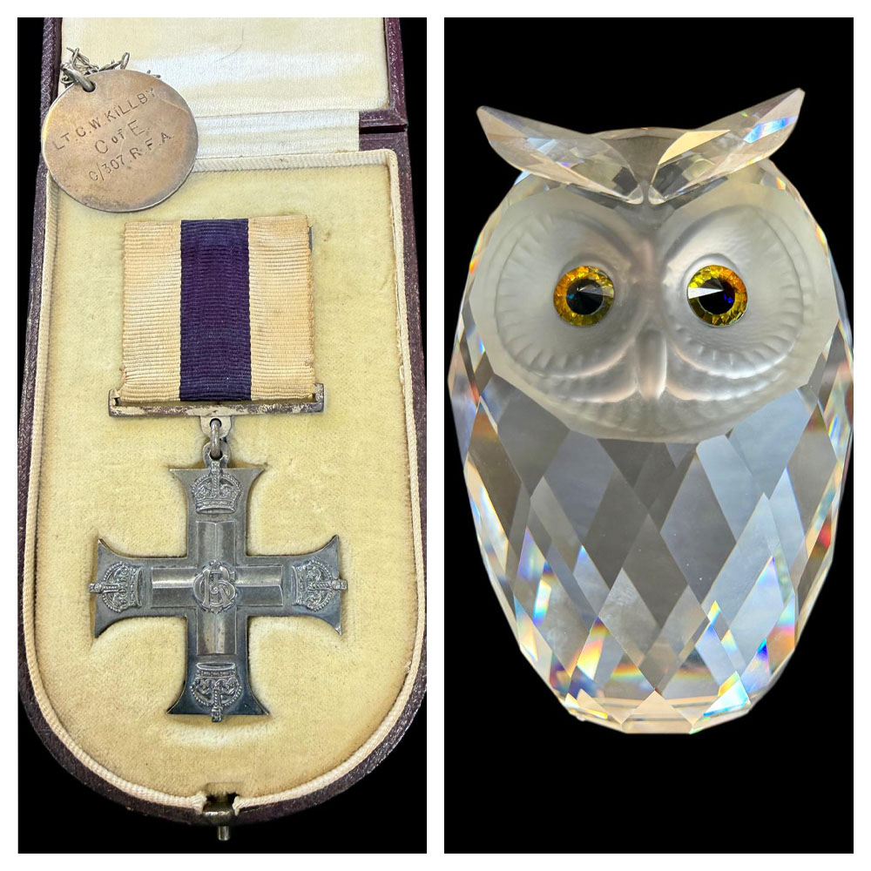
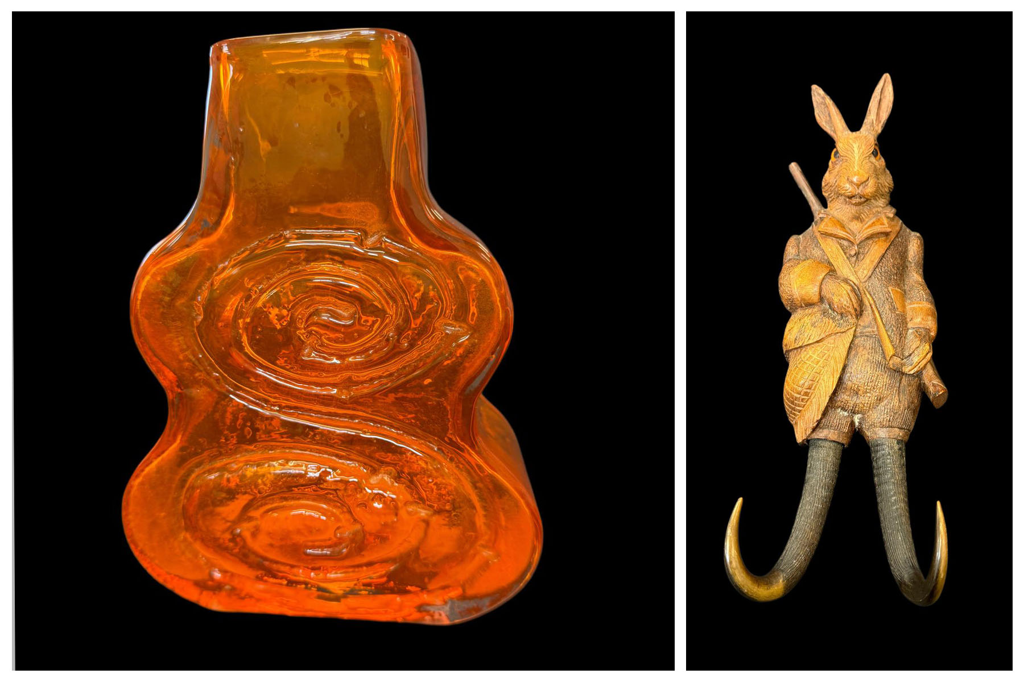
Lot 11 – A Whitefriars tangerine cello vase, 18cm high. Est: £200-£300
Lot 62 – A late 19th/early 20th century Black Forest carved rabbit hanging coat hook, fitted a Swiss musical movement, 30cm long. Est: £150-£200
Lot 319 – A George V military cross unengraved, believed to have been awarded to Lt. C.W Killby "C" battery 307 Brigade Royal Field Artillery. Est: £300-£500
Lot 282 – A boxed Swarovski crystal giant owl model, 16cm high. Est: £150-£200

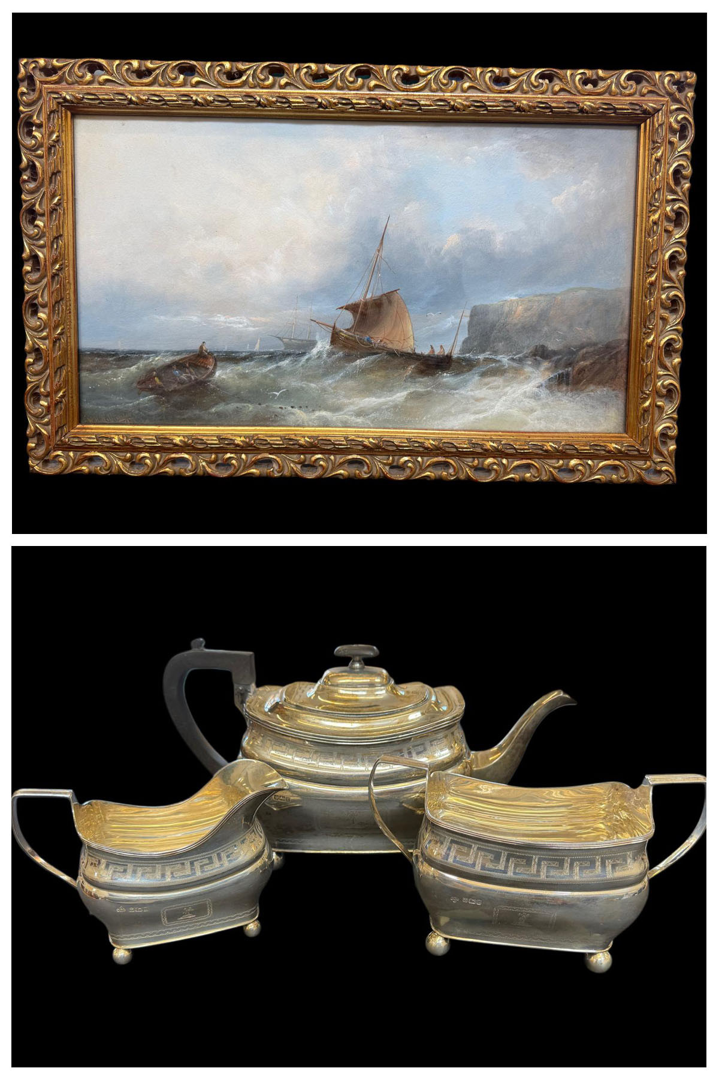
Lot 35 – W. H. Williamson - Fishing boats off a headland in stormy weather, oil on paper, 22cm x 40cm, in gilt frame, 29.5cm x 47cm. Est: £350-£450
Lot 326 – An Edwardian silver three-piece tea set, approx. 44oz. Est: £150-£200

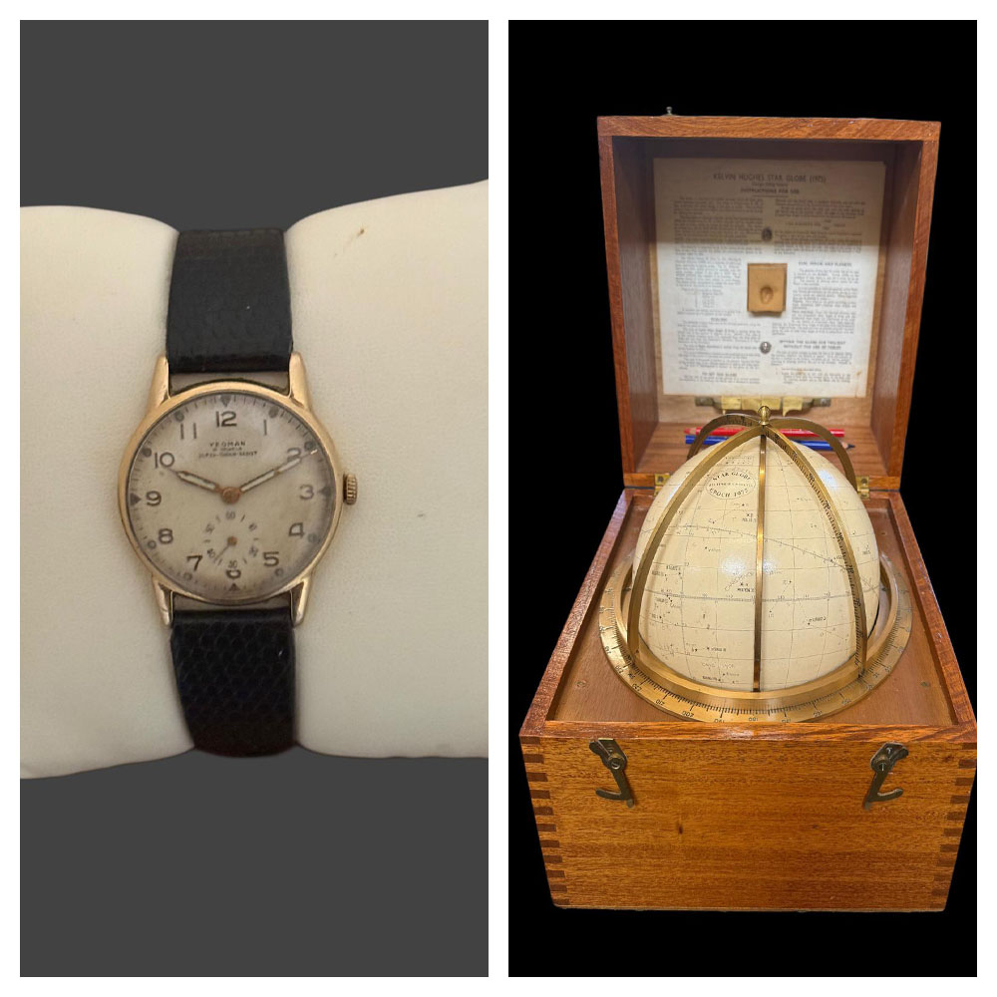
Lot 92 – A gent's "Yeoman" wristwatch, in 9ct gold case, approx. 20g, on textured strap. Est: £400-£600
Lot 272 – A Star Globe by "Kelvin and Hughes Ltd", Epoch 1975, in polished mahogany box. Est: £500-£700

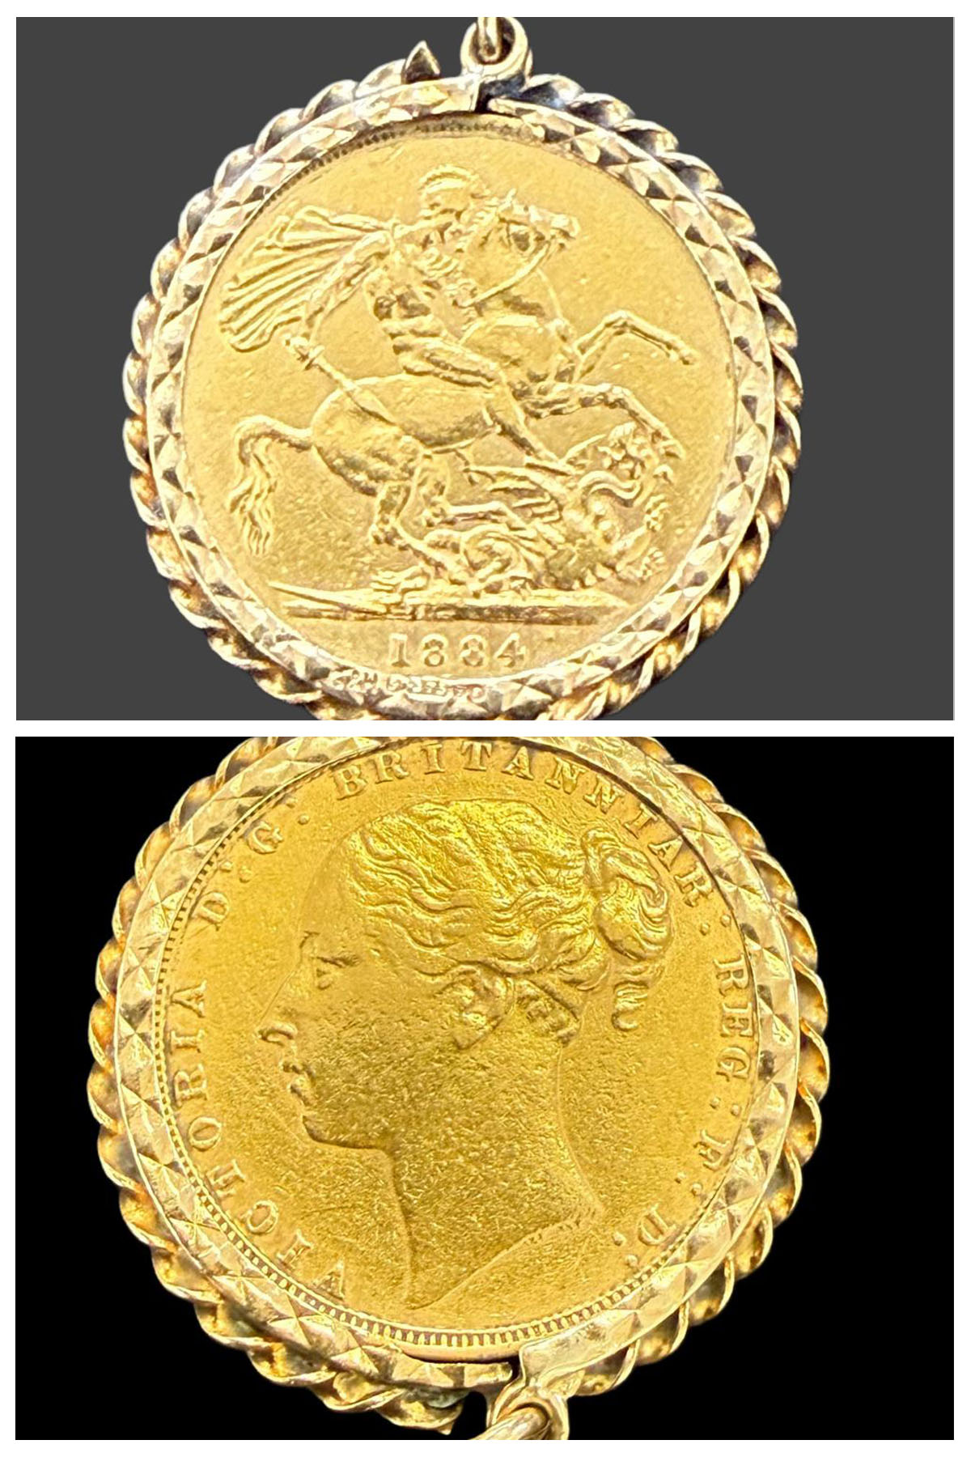
Lot 64 – A Victorian 1884 gold sovereign, with young head, in 9ct gold pendant mount. Est: £600-£800

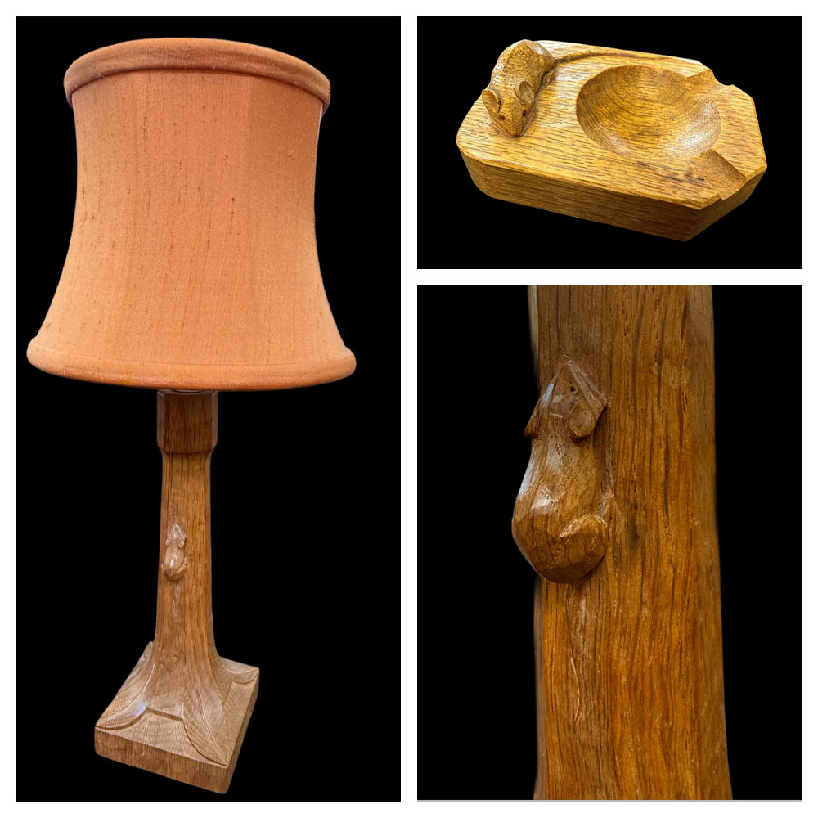
Lot 227 – Robert Thompson of Kilburn - A Mouseman oak table lamp, with leaf decoration to the square base, with modern electric fitting, and shade, lamp 26cm high, 44cm high including shade. Est: £400-£600
Lot 228 – Robert Thompson of Kilburn - an oak Mouseman ashtray, with carved mouse emblem, 10cm long. Est: £100-£150

204. | A late Victorian petit point picture of two parakeets among floral surround, 24.5cm x 19cm. | £80-£100
205. | An early 20th century East European icon, with two-door front, 34cm x 22cm. | £80-£100
206. | A Byzantine-style Lady of Perpetual Help style icon, with gilt decoration, 38cm x 29cm. | £80-£100
207. | A George III toleware galleried tray, with figural painting to centre, octagonal shape, 45cm wide. | £70-£100
208. | A Derby figure of putto, emblematic of spring, 13cm high, on shaped base. | £70-£100
209. | Two Bow porcelain figures of putti, emblematic of the seasons, each 12cm high, on circular flower encrusted bases (2). | £60-£80
210. | A Dresden figure of shepherd, a Vienna shepherdess, each 24cm high, and a small continental figure of putto, 15cm high, all AF (3). | £60-£80
211. | Two Chinese mugs, one with twist handle, 9.5cm and 14cm high respectively, a small famille rose brush pot, 12cm high, and a Cantonese-style vase, with figural and floral panels, 25cm high, all AF (4). | £50-£70
212. | Two similar Chinese plates, with floral and leaf borders, and flowers to centre, each 23cm in diameter, AF (2). | £80-£120
213. | Two Derby porcelain floral-decorated trios, and a Stevenson & Hancock teacup and saucer, similarly decorated (8). | £70-£90
214. | A Victorian Tunbridge-ware inkstand, fitted single glass bottle, flanked by small square boxes, 23cm wide. | £80-£120
215. | A Victorian parquetry and Tunbridge-ware stationery box, containing four Hepworth's Railway timetables, 1886 to 1900 in date, 17cm wide x 15cm deep. | £70-£100
216. | A Dutch painted pewter tea urn, with galleried brass stand, decorated cattle and figures in landscape, 48cm high. | £80-£120
217. | A Minton Sevres-style part tea set, with gilt leaf and floral decoration, 14 pieces, some AF (14). | £60-£80
218. | A Derby porcelain figure of man with dog, on scrolled base, 18cm high, a Bow figure of fruit seller, 14cm high, a small continental figure of youth, 10cm high, and a figure of a gallant, 15cm high, all AF (4). | £40-£60
219. | A small tortoiseshell and inlaid memo pad, 10cm x 6.5cm, with pencil, a small tortoiseshell and metal inlaid box, 9cm x 5cm, and a small bobbin (3). | £70-£90
220. | A set of six silver Art Nouveau Style buttons, Birmingham 1900, in lined case. | £100-£120
221. | A miscellaneous lot of various ceramics, including a Spode teacup and saucer, a tea bowl and saucer, a miniature lustre ware jug, and other objects, all AF (21 pieces). | £20-£30
222. | An Edward VII silver-handled button hook, Birmingham 1904, a pair of silver-plated and horn-handled fish servers, together with a set of twelve silver-plated napkin rings with beaded decoration (15). | £120-£180
223. | A 14k dress ring, set eight tiny stones, and central stone missing, approx. 3g (AF). | £80-£120
224. | A late 18th/early 19th century oak rocking chair, of lambing chair style, with drop-in seat, and brush-grained pine central panel, 115cm high x 66cm wide. | £150-£200
225. | A late 18th century oak open arm oval monks bench type chair/table, with hard seat, and drawer below, on square legs, united by stretchers, the top 80cm x 94cm (AF). | £100-£200
226. | An early 18th century boarded oak chest, the interior with candlebox, the lid with later hinges, 100cm wide. | £100-£150
227. | Robert Thompson of Kilburn - A Mouseman oak table lamp, with leaf decoration to the square base, with modern electric fitting, and shade, lamp 26cm high, 44cm high including shade. | £400-£600
228. | Robert Thompson of Kilburn - an oak Mouseman ashtray, with carved mouse emblem, 10cm long. | £100-£150
229. | A Gordon Russell Ellipses sideboard, fitted two drawers, above two panelled doors, on four square slightly tapering legs, 122cm wide x 91cm high, label verso, c. 1956. | £200-£300
230. | A Gordon Russell dining table, with extra leaf, on square tapering legs, 78cm x 154cm extended, together with a harlequin set of nine Burford dining chairs, including a pair of elbow chairs (10). | £200-£300
231. | A larger Gordon Russell dining table, with three extra leaves, on turned tapering legs, 99cm x 290cm extended. | £100-£150
232. | A Crestworth "Galaxy" glass fibre optic lamp, 39cm in diameter, in original box. | £40-£60
233. | A Royal Doulton figure "Nicola" HN2804 in branded box with certificate, together with four other figures, unboxed, comprising: - "Allison" HN2336, "Fleur" HN2368, "Lynne" HN2329, and "Elyse" HN2429 (5). | £30-£50
234. | Four Beswick Thelwell figures comprising: - "Kickstart" brown horse, "Kickstart" grey horse, each 8cm high, "Learner" brown horse, and "Learner" grey horse, each 11cm high, unboxed (4). | £30-£50
235. | Six Royal Doulton Queens of the Realm figures, comprising: - "Queen Anne Boleyn" HN3232, 23cm high, "Queen Victoria" HN3125, "Mary Queen of Scots" HN3142, "Queen Anne" HN3141, "Queen Elizabeth" HN3099, and "Queen Elizabeth II" HN4372, all in branded boxes and with certificates, together with another figure of "Florence Nightingale" HN3144 unboxed (7). | £50-£70
236. | A nest of three teak G-plan occasional tables, on trestle feet, 56cm wide. | £50-£70
237. | A quantity of silver-plated 'community plate' cutlery, with decorative handles (qty). | £30-£50
238. | A quantity of silver-plated cutlery, together with some knives, with simulated horn handles, in plastic tray (qty). | £20-£30
239. | Duval - a miniature oval portrait on ivory, of maiden wearing a lace dress, 8cm x 6cm, velvet mount, in plain gilt-wood frame, 14cm x 12cm, submission ref: 2A1YNF6N. | £60-£80
240. | Heim - a miniature oval portrait on ivory of lady in veiled dress, 8cm x 6cm, velvet mount, in plain gilt-wood frame, 14cm x 12cm. Submission ref: 85YLMXRX. | £60-£80
241. | Wills - a miniature portrait on ivory of maiden in period dress, 6cm x 4.5cm, velvet mount, in decorative frame, 15cm x 14cm. Submission ref: ZLSPBSWS. | £60-£80
242. | Attributed to Hercules Brabazon Brabazon (1821-1906) - "Rhodes", inscribed on a label verso, watercolour, 13cm x 21cm. | £150-£200
243. | F. Donald Blake - Blue fence, rear end of building, watercolour, signed bottom right, 34cm x 22cm. | £50-£70
244. | Blake - Winter wooded landscape, watercolour, 29cm x 39cm, signed bottom left. | £40-£60
245.† | Rowland Hilder (1905-1993) - A wooded landscape, preparatory watercolour sketch, signed bottom right, 25cm x 35cm. ARR may apply. | £100-£150
246. | B. B. - loch scene, with small fishing boat and figures, watercolour, initialled bottom right, 11cm x 21cm. | £20-£30
247. | Burmese School - Geometric panels on paper, watercolour and gouache, each 30cm x 42cm (4). | £40-£60
248. | 20th century school - artist's proof etching, indistinctly signed, 25cm x 16cm. | £15-£20
249. | Burmese school - dancers and musicians, colourwash on paper, each 42cm x 30cm (4). | £60-£80
250. | After George Morland - pair of circular stipple engravings, each 30cm in diameter, gilt and black glass mounts, 31cm x 31cm (2). | £40-£60
251.† | After Hester Bartock 1983 - clematis, lithograph, signed in pencil, 29cm x 25cm. | £15-£20
252. | After George Morland - "Della in the Country", and "Della in the Town", circular stipple engravings, a pair, in rectangular mounts, 28cm x 20cm, a pair (2). | £20-£30
253. | 19th century school - portrait of Thomas Laurence Bloxon, nephew of the artist Sir Thomas Laurence, inscribed in mount, lithograph, 30cm x 23cm. | £20-£30
254. | Attributed to Fritz Burger (1867-1927) - Tavern interior scenes, oil on canvas, a pair, each 27cm x 20cm, in gilt frames, 45cm x 38cm. | £100-£150
255. | After Eugene de Blass - The Flirtatious Maid, and another similar scene, chromolithographs, a pair, each 19cm x 24cm, and a Limoges plate, decorated a print, after the same artist (3). | £20-£30
256. | After Louis van Staaten - Dutch harbour scenes, lithographs, with heightening, a pair, each 39cm x 59cm (2). | £40-£60
257. | A pair of late 19th century gilt metal and sevres-style porcelain candlesticks, surmounted by Putti (possibly from a clock garniture), each 33cm high. | £60-£80
258. | A 20th century gilt metal mantel clock, with French movement, 40cm high. | £50-£70
259. | Deborah Jones (1921-2012) - Bedroom interior, with elegant four poster bed, and another of attic bedroom interior, oil on board, a pair, signed bottom left, each 20cm x 24cm (2). | £100-£200
260. | A late Victorian circular petit point picture, still life flowers, 40cm in diameter. | £30-£50
261. | An Edwardian inlaid mahogany oval bijouterie table, on square shaped and tapering legs, united by stretchers, 58cm wide. | £80-£120
262. | A pair of carved beech French-style fauteuils, on cabriole shaped legs, and with padded open arms (2). | £50-£70
263. | A three-piece silver-plated tea set, a water jug, a glass ashtray, with silver-plated mount, together with napkin rings, and other pieces (QTY). | £30-£50
264. | A small 15ct gold locket, a silver ingot on pendant, Sheffield 1997, a three piece silver condiment set, Birmingham 1902, a number of silver teaspoons, a pair of napkin rings, boxed, a cigar cutter, and other small objects, approx. 12oz weighable silver, locket approx. 6g (QTY). | £250-£350
265. | A George V silver capstan inkwell, Birmingham 1926, inscribed relating to Reading Regatta, weighted, a further smaller inkwell, weighted, Birmingham 1916, a sauceboat, London 1939, and a small sugar bowl, Sheffield 1908, approx. 10oz, weighable (4). | £300-£400
266. | 20th century school - river scene in winter landscape, oil on canvas, 29cm x 23cm. | £30-£50
267. | W. F. Mitchell - "HMS Undaunted", and "HMS Hero", lithographs, a pair, each 15cm x 22cm, in birds eye maple frames, 39cm x 46cm (2). | £40-£60
268. | Charles Riedel 1966 - Still life mixed flowers, in a vase, oil on canvas, 58cm x 78cm. | £40-£60
269. | David C. Bell 1995 - "Study for Agamemnon, leaving Portsmouth", watercolour, signed and dated bottom right, 30cm x 47cm. | £60-£80
270. | Helen Anderson - "The Blackface Ewe", pastel on paper, initialled, 20cm x 22cm, together with another by the same hand "The Bull and Butcher", 19cm x 23cm, and another of fishing boat, crayon and wash, 13.5cm x 19cm (3). | £20-£30
271. | After Harry Clow - "Feeling the Spray", chromolithograph, 32cm x 24cm, and Adam Mofar - "Sommer", watercolour, 38.5cm x 24cm (2). | £20-£30
272. | A Star Globe by "Kelvin and Hughes Ltd", Epoch 1975, in polished mahogany box, together with instructions, brass scale and frame, and two coloured pencils, box 26cm wide x 27cm high. | £500-£700
273. | A brass and black lacquered sextant by "Heath Navigational Ltd, no. 60316", with vernier scale, and "Hezzanith" clamp, in mahogany box, together with a "Lilley and Reynolds Limited" certificate, dated 14/5/1970. | £150-£200
274. | A Limoges dark blue and gilt vase and cover, 43cm high, a decorative oval box, together with a quantity of mixed decorative porcelain objects (a quantity). | £20-£30
275. | Two Dresden figural candlestick/centrepiece bases,each 40cm high, two Nao figures, a Royal Doulton figure "Emma", HN 3714, boxed, three fairings, together with other decorative figures and objects (a quantity). | £20-£30
276. | A British 1937 Webbing Military map case, two pairs of binoculars. and an enamelled box (4). | £20-£30
277. | A silver plated three bottle tantalus, with a pair of hob-nail cut decanters, and a non matching, ditto, 30cm wide, and a Cristelleries De Lorraine glass decanter and stopper, 42cm high (2). | £80-£100
278. | G.A Andrews- three modern silhouette pictures, each 9.5 in diameter, a glass silhouette picture, a small Moghul school painting, two small etchings and four other small decorative pictures and prints (11). | £25-£40
279. | Chess set in beech box, a playing card set, in lined box, together with a number decorative tins (a quantity). | £20-£30
280. | Emil Pichard after Compte Calix - a pair of coloured prints, "Imperiale de Dames", each 55cm x 37cm, two small watercolours of coastal scenes and two reproduction Roman prints (6). | £20-£30
281. | An Art Nouveau style Bohemian pottery amphora vase by "Riesner Stellmacher, and Kessel" with relief decoration, printed red factory mark, 18cm high, a.f. | £80-£120
282. | A boxed Swarovski crystal giant owl model, with coloured eyes and frosted face, part of the Woodland Friends Series, designer Max Schreck, etched mark to side, 16cm high. | £150-£200
283. | A small Swarovski group of two lovebirds in SCS drum box, another of two dolphins, a humming bird, another the whales, Save Me-the Seals, and a falcon head, 10cm high, all in drum boxes (7). | £160-£180
284. | A Swarovski crystal figure of heron, 15cm high, boxed, another of a unicorn, another Anna- from the Magic of Dance, another Antonio from the Magic of Dance, 20cm high, another of dragon and a floral display, all boxed (6). | £70-£100
285. | Twenty one Swarovski figures including polar bear, baby seal, medium hedgehog, skating bear, swan, further hedgehog, birds and other pieces, all in cylinder boxes, together with some stands (26). | £100-£150
286. | A small Swarovski group of four love birds, another of three south sea fish, another of prancing horse, another of poodle dog, a snail, a lizard, German shepherd, a cat and others (16). | £80-£120
287. | A small Swarovski figure of owl, 4cm high, boxed, another of miniature owl x2, together with a snail, an elephant, puppies and others, all boxed (22). | £100-£150
288. | Twenty eight small Swarovski figures, in boxes, including two tortoises, a kiwi, a parrot, two teddy bears, a rabbit and others, all boxed (28). | £70-£100
289. | A similar lot, including, poodle, tortoise, crocodile, swan, Koala, a partridge, an empty owl box, and others (26). | £60-£80
290. | A Swarovski Crystal Society annual edition 2000 figure "Columbine" 17cm, high, boxed, and a 1999 annual edition figure "Pierrot" and a 2001 figure "Harlequin" all make up for the Masquerade trilogy, and all boxed (3). | £70-£90
291. | A Swarovski annual edition figure of Kudu, 10cm high, part of the "Inspiration of Africa" series, boxed, 1994, another "The Elephant" 1993, and another "The Lion" 1995, all boxed (3). | £70-£90
292. | A Swarovski figure of a "Cheetah" from the African Wildlife collection 10cm high and boxed, an annual edition figure "The Pegasus" 1998, boxed (2). | £30-£50
293. | A Swarovski annual edition figure 1987 "Togetherness"- the lovebirds, boxed, another "Sharing"-the woodpeckers, 1988, boxed, together with a small chimpanzee figure, 4cm high and a squirrel, all boxed (4). | £80-£100
294. | A pair of pink and red mottled planffoniers, each 35cm in diameter (2). | £30-£50
295. | A collection of football figures, together with a referee, and a manager (a quantity). | £60-£80
296. | A yellow mottled Art Deco style plaffonier, with gilt metal fittings, 34.5cm in diameter. | £40-£60
297. | A child's "Comet" sewing machine, 20cm wide, in box and another similar machine, unboxed (2). | £40-£60
298. | A continental metal ware charm bracelet, a silver and zircon set bracelet, and a marquesite and amethyst coloured stone set bracelet (3). | £40-£60
299. | A Mexican silver backed pendant, inset with shell lining on metal link chain. | £50-£70
300. | A Danga's amber necklace in branded card bag, together with two Lapis coloured bead necklaces (3). | £40-£60
301. | A lady's Seiko gold plated and stainless steel wristwatch, with bar numerals. | £30-£50
302. | An Indo-Persian Kashan style runner, with flowerhead and foliate pattern, on a rust coloured grown, 104cm x 460 cm. | £150-£200
303. | A 19th century Dutch oak linen press, the upper enclosed by two panelled doors, below a dentil cornice, the lower part of slightly bombe form, fitted three drawers, on splay feet, 147cm wide x 199cm high. | £150-£200
304. | A Japanese blue and white charger, decorated a bird of prey in blossoming tree, 46cm in diameter. | £100-£150
305. | A 20th century Japanese charger, with rust red border and central roundel, decorated flowerhead medallion, wide floral border, 39cm in diameter. | £150-£200
306. | A Lotte Glob pottery shallow charger dish, with abstract coloured centre, 41cm in diameter, signed verso. | £60-£80
307. | A similar part glazed charger dish, with blue glazed centre, 40cm in diameter, signed verso, a.f. | £60-£80
308. | A 19th century Majolica urbino style charger dish, with King's head to centre, surrounded by decorative panels, 39cm in diameter, a.f. | £80-£100
309. | An oval pastel portrait of little girl, 43cm x 45cm, in ornate gilt frame, 65cm x 51cm. | £40-£60
310. | A panelled oak coffer, on block feet, 101cm wide. | £80-£100
311. | An Avirex type B-3 USAAF style flying jacket, a.f. | £50-£70
312. | An Irvin RAF Sheepskin flying jacket, by Leathercraft Ltd, size 42. | £60-£80
313. | A part suite of silver plated and bone handled cutlery, in a pale oak canteen, with silver plaque to lid, Sheffield 1906, approx. 94 pieces, together with a pair of unboxed silver and bone handled fish servers, Sheffield 1910, a part set of silver plated fish knives and forks, and a part set of silver plated and mother of pearl handled dessert knives and forks, in canteen (2). | £150-£200
314. | To C/KK 97902 R.H.B Besch, petty officer stoker mechanic, Royal Navy- group of eight medals comprising:- 1939-45 star, Atlantic Star, Africa Star, Burma Star with "pacific" clasp, War medal, Naval general service, medal with "Malaya" and "Minesweeping 1945-51" clasps, and two Korea medals, in frame, a.f, together with a photograph of the recipient, some medal ribbons and a small brass shot flask. | £150-£200
315. | A display panel with mounted Second World Water medals, comprising:- war medal and defence medal, shoulder flashes for Royal Armoured Corps, and Inns of Court, badge of 6th Armoured Division and two trades badges, together with a special constabulary medal to Percy F. Besch, a pipe, a small leather wallet, and a book on the RAF. | £30-£50
316. | A George IV silver half-pint mug, London 1827, a further mug, Birmingham 1913, together with a pair of squat silver candlesticks, with weighted bases, Sheffield 1911, approx. 9oz, weighable. | £300-£400
317. | A brass monocular microscope by "Cary, London" in mahogany rectangular box base, with fitted interior, 24cm wide x 38cm high, together with slides and other accessories. | £150-£200
318. | An early 20th century amber tinted Bohemian glass liquor set, comprising:- a tray, two decanters and two small glasses (5). | £80-£100
319. | A George V military cross unengraved, believed to have been awarded to Lt. C.W Killby "C" battery 307 Brigade Royal Field Artillery, believed killed 21st March 1918, together with a silver tag, London 1917, and a small handwritten note, in box, a compass in leather case, and a further compass, uncased (3). | £300-£500
320. | An early 20th century oak mantel clock in architectural case, two train movement, 40cm high. | £40-£60
321. | A late Victorian style dolls house, 56cm wide x 58cm high, together with some dolls house furniture. | £40-£60
322. | An early Victorian rosewood teapoy, on faceted vase column and qaudriform base, 36cm wide. | £40-£60
323. | A solitaire dress-ring set a large synthetic stone, surrounded by tiny stones and similarly set shoulders. | £60-£80
324. | An 18k gold lady's wristwatch, by Rex, approx. 18g gross, on bangle form strap, a.f. | £800-£900
325. | A silver-plated warming dish on stand, with burner, a small ice bucket, two goblets, a jug, a small dish, two pairs of tongs, two pepperettes, and a small beaker (11). | £60-£80
326. | An Edwardian silver three-piece tea set, Sheffield 1909, approx. 44oz (3). | £1600-£1800
327. | An oval silver-plated dish, a small rectangular two handled tray, a Mickey Mouse plate, a decorated bowl, two shallow dishes and two further trays (9 pieces). | £120-£180
328. | A Peruvian oval white metal sterling standard dish, approx. 68oz. | £600-£800
329. | A Peruvian white metal sterling standard two handled tray, approx. 48oz, 56cm wide. | £1500-£2000
330. | A Peruvian white metal sterling standard plate with reeded edge, 30cm in diameter, approx. 17oz. | £700-£900
331. | An Irish silver decorative spoon, two silver teaspoons, six Peruvian white metal teaspoons, other pieces of small cutlery, together with some silver-plated pieces and a lemon squeezer (a quantity) 9oz weighable. | £300-£500
332. | A Peruvian white metal sterling standard four-piece tea and coffee set, together with a two handled tray and a tea strainer, approx. 68oz. | £2500-£3500
333. | A suite of Peruvian "Camusso" white metal sterling standard table cutlery, twelve place settings, approx. 138 pieces, approx. 100oz. | £4000-£5000
334. | An emerald and diamond dress ring, with central emerald and fourteen tiny diamonds, one missing, indistinctly marked, a.f. | £300-£500
335. | A Victorian yellow and white metal old mine cut diamond flower spray brooch, set 71 old cut diamonds, approx. 5 carats, 6.1cm x 3.3 cm, weight approx. 15.9g. | £3000-£4000
336. | A yellow metal butterfly brooch, set two sapphire eyes, a single diamond below, and three seed pearls, the wings set moss agate, 6cm wide. | £600-£800
337. | A decorative French glass oval trinket box, signed "J. Guyot, Paris" with foliate decorated interior, cameo cut cover, with flowerhead border, 7cm x 5cm. | £80-£100
338. | A part suite of Mappin and Webb silver plated cutlery, with crown to terminals, together with some "Coronation" pattern knives and some "Anniversary" pattern cheese knives (a quantity). | £20-£30
339. | An ebonised walking cane, with carved resin terminal, 92cm long. | £30-£50
340. | A Japanese early 20th century relief bronze vase, decorated dragons, roundels and engraved panels, 25cm high. | £60-£80
341. | Sir Joseph Noel Paton (1821-1901) - "Lovers", pencil on paper, inscribed "Jan 7, 1896", inscribed on label verso, 30cm x 18cm, ex Maas Gallery Ltd 2005.  END OF SALE | £60-£80
Artist Resale Rights
ARR is calculated in GBP. Exchange rates are updated daily.
ARR is cumulative and applies to lots with a hammer over £1000
£0 - £50,000 - 4%
£50,000 - £200,000 - 3%
£200,000 - £350,000 - 1%
£350,000 - £500,000 - 0.5%
£500,000+ - 0.25%
ARR is capped at £12,500
† ARR will be subject to additional fees. See last page for more details.

UPCOMING DATES

Auctions

Wednesday 13th May 2026
Wednesday 15th July 2026
Wednesday 9th September 2026
Wednesday 11th November 2026

Viewing on Monday and day before sale from 10am to 5pm
and on morning of sale from 9am to 10.30am
Sale commences at 11am

Valuation Days

Wednesday 25th March 2026
Wednesday 22nd April 2026
Wednesday 20th May 2026
Wednesday 17th June 2026
Wednesday 22nd July 2026
Wednesday 19th August 2026
Wednesday 16th September 2026
Wednesday 14th October 2026
Wednesday 18th November 2026
Wednesday 9th December 2026

Sevenoaks Saleroom, Argyle Road,
Sevenoaks TN13 1HJ
Between 11am - 4pm

Notes

