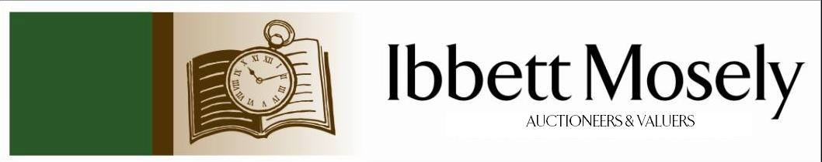

Catalogue of Antiques and Collectibles
to be Auctioned on

Wednesday 13th May 2026ffff
at 11am

IBBETT MOSELY AUCTION ROOMS
ARGYLE ROAD, SEVENOAKS, KENT TN13 1HJ
And Online Via
www.easyliveauction.com/ibbettmosely/

Viewing at Sale Room on:

Monday 11th May
Tuesday 12th May

Between 10am – 5pm

Catalogues: £2.00

Auctioneer and Valuer: Alan White FNAVA
Auction Clerk and Saleroom Manager: Benjamin Burridge
Photographer and Porter: Samantha Crowe-White

Welcome to Ibbett Mosely Auctions
13th May 2026 Auction Catalogue

This sale will also be held online at www.easyliveauction.com/ibbettmosely/
please visit the website to register or log in to view and bid. Images and condition reports of each lot are included.

Alternatively, commission bids (bids left ‘on the book’) may be left with us, as well as a limited amount of telephone bids. Please telephone 01732 456731 or email auctions@ibbettmosely.co.uk for further details.

Unsold lots from this sale will be placed into a week-long online timed auction that can be found at www.easyliveauction.com/ibbettmosely/

Please telephone 01732 456731 or email auctions@ibbettmosely.co.uk with any questions.

Collection of items is available on Thursday 14th May from 10am - 1pm. Collection of items from 15th May onwards, by prior appointment only.

We do not arrange collection or deliver your items ourselves, collection of items is the responsibility of the buyer. You are welcome to collect in person, or via your own carrier, but local courier PSP Logistics are available to carry out deliveries of items. Please contact them directly to arrange and pay for delivery.

Please be aware we are not able to offer food or drink at this sale

1. | A continental white metal 800 standard long-handled spoon, with blue enamel terminal, a further spoon, with oriental-style decoration, a hammered spoon, and three chopsticks, unmarked, approx. 5oz weighable (6). | £120-£180
2. | A pair of small late Victorian silver salts and spoons, in lined case, together with a silver-handled paperknife, a silver-plated eggcup, and other pieces of silver-plated ware. | £60-£80
3. | A folder of mixed loose stamps from approx. 32 countries, including: - African countries, Argentina, Brazil, Canada, Denmark, Italy, United Kingdom, and USA (a quantity). | £20-£30
4. | A Doulton Lambeth Faience ware squat vase, 12cm high, small chip to neck rim, and further body chip, and a pair of further vases, in the same pattern, one cracked and chipped, each 15.5cm high (3). | £100-£150
5. | A 9ct gold wedding band of wide design, approx. 3g, a silver napkin ring, an assistant referee's medal in box, together with a quantity of metal necklaces, earrings, and other decorative and costume jewellery, various. (a quantity). | £120-£150
6. | A German-style gold commemorative ducat coin, marking the 1965 visit of Queen Elizabeth II and Prince Philip to Germany, together with thirteen two shilling coins, a 1980 Dutch Guilder coin, a Canadian 10 cents coin, and a 1952 half penny coin (17). | £100-£200
7. | A Dolphin English leather brief case, with expanding action, 43cm wide (a.f.) | £20-£30
8. | A Gent's Rotary automatic wristwatch, in 9ct gold case, gold-plated and stainless steel expanding bracelet strap, approx. 4g weighable, in branded box. | £150-£200
9. | A lady's Raymond Weil gold-plated and stainless steel wristwatch, quartz movement, no.7264875 in Goldsmiths box, and a ditto Seiko wristwatch, in similar box, a.f. (2). | £80-£100
10. | A Gent's Citizen Cryston stainless steel wristwatch, quartz movement, boxed, and a brown buffel credit card case, a.f. (2). | £70-£90
11. | A Gent's "Oriosa" automatic 20 Atmos wristwatch, with expanding bracelet strap, in Seiko box, a.f. | £70-£90
12. | A gent's Jaeger Le Coultre stainless steel automatic wristwatch, no. 808571, on expanding bracelet strap, unboxed, a.f. | £60-£80
13. | A gent's "Timex" automatic wristwatch, with expanding strap, a gent's "Adec" wristwatch, on expanding bracelet strap, and a "Pierce" wristwatch on expanding bracelet strap, all in Rotary box, a.f. (4). | £50-£70
14. | A quantity of costume jewellery various, badges, brooches, and other pieces, contained in a small box, and a case (2). | £20-£30
15. | A pair of Edward VII silver-handled fish servers, Sheffield 1904, in lined box, two small silver photograph frames, Birmingham 1987, a pair of silver-plated grape scissors, together with a pair of Victorian silver fruit spoons, and a sifter spoon, in lined case (4 boxes). | £100-£150
16. | A "Metamec" gilt brass French-style carriage timepiece, retailed by "St James", white enamelled dial, 13cm high. | £40-£60
17. | A Cantonese-style double gourd vase, with figural bird and foliage panels, 20cm high, a.f. | £60-£80
18. | A Royal Doulton "Under the Greenwood Tree" Robin Hood jug, 13.5cm high. | £20-£30
19. | To 1009432 Private W. J. Shoult, Canadian Labour Batallion - WW1 medal pair, together with a Vimy Ridge Memorial medal, in bronze, a Canadian Legion medal, and a Royal Artillery pin badge (a.f), all in a leather case. | £50-£70
20. | A Queen Elizabeth II Silver Jubilee crown, in presentation box, from Royal Mint, a further crown, boxed, and two Prince of Wales and Lady Diana crowns, boxed (4). | £60-£80
21. | A lady's 18k "Technos" oval wristwatch, bar numerals, approx. 35g, gross, unboxed. | £180-£220
22. | A lady's 9ct gold circular "Cyma" wristwatch, Bar and Arabic numerals, on linked bracelet strap, approx. 18g gross. | £180-£220
23. | A lady's "Longines" 9ct gold circular wristwatch, bar numerals, on articulated strap, approx. 17g gross. | £180-£220
24. | A Parker 75 Insignia pen set, in rolled gold, and boxed, a.f. | £80-£120
25. | A Merrythought soft toy of a tigress, approx. 120cm long, overall, and a similar cub, 88cm long (2). | £40-£60
26. | An Art Deco style silver circular compact, with engine-turned decoration, Birmingham 1957, and a silver, ruby, and zircon pendant, on slender metal chain, approx. 2oz weighable (2). | £120-£150
27. | An emerald and zircon eternity ring, one stone missing. | £180-£220
28. | An 18ct gold five-stone ruby and diamond dress ring, size H to I. | £150-£200
29. | A pair of Elizabeth II silver twin branch three sconce two branch candelabra, on oval scalloped bases, each 30cm high, maker A. Taite and Sons Ltd, London 1962, approx. 42oz (2). | £1500-£2000
30. | An Edward VII silver watch chain with fob, and a vesta case attached, Birmingham 1906, and a metalware propelling fountain pen, approx. 2.3oz weighable (2). | £70-£100
31. | An early 20th century stained wood travelling chess set, in stained mahogany box, 20.5cm wide. | £40-£60
32. | A Newlyn-style oval shaped copper tray, with scalloped edge, and decorated stylised fish, 48cm wide. | £30-£50
33. | Henry Boatwright - Italian/Roman-style garden scene, with relaxing figures, and naked woman, oil on canvas, 45cm x 59cm. | £60-£80
34. | An 18th century map of Nottinghamshire, c. 1776, 20cm x 16cm. | £50-£70
35. | An early 19th century map of Kent, by C. Greenwood, 1839, 30cm x 43cm, a.f. | £60-£80
36. | An 18th century road map by Emanuel Bowen, c. 1785, of Warwickshire, the road from Oxford to Coventry, 19cm x 12cm, later colouring. | £50-£70
37. | A map of Oxfordshire, by Pigot & Son, Manchester, 37cm x 24cm. | £70-£90
38. | A Tiffany and Co white metal ballpoint pen, Sterling Standard, of German manufacture, in felt case, and branded box. | £70-£90
39. | An American Edco dress ring, set an amethyst coloured stone, in box, together with a pocket ashtray, and an evening purse (3). | £60-£80
40. | A Martin Yeats pink and white mottled glass bowl, 10cm high, a Villeroy and Boch blue tinted rummer, and a part lustre glass stemmed bowl (3). | £20-£30
41. | Royal Doulton "Morning Star" pattern part dinner service, 28 pieces (28). | £40-£60
42. | An early 20th century Imperial German child's pickelhaube, with crest to front, a.f. to spike top, 21cm high. | £50-£70
43. | A Sony "ciberstat" camera, A Sony handy cam, with carrying case, and a Kodak Instamatic X-15 camera, in case (3). | £30-£50
44. | A canteen of silver-plated, bone-handled and stainless steel cutlery, in an Art Deco stained oak box, approx. 41 pieces. | £30-£50
45. | A set of bone-handled and silver-plated fish knives and forks, in box, two sets of silver-plated teaspoons, in lined cases, a set of fruit spoons, in box, together with a circular tray, a number of goblets, and other objects, some a.f. (a quantity). | £20-£30
46. | A post WW1 shell case style torch, by E. Fandem and Co Ltd, 29cm long, c.1919. | £15-£20
47. | After James Gilray - "Tiddy Doll, the Great French Gingerbread Baker", aquatint, 28cm x 39cm, mounted, another "Sad Sloppy Weather", 29cm x 24cm, another "Dreadful Hot Weather", 29cm x 24cm, and a further satirical print, "French Salutation and English Salutation", 24cm x 36cm, all unframed and mounted (4). | £50-£70
48. | A Victorian horn-handled and silver-mounted five piece carving set, Sheffield 1883, in lined case. | £60-£80
49. | A Gordon Russell dining table, with extra leaf, on square tapering legs, 78cm x 154cm extended. | £80-£120
50. | A harlequin set of nine Burford dining chairs, including a pair of elbow chairs (9). | £80-£120
51. | A late 19th century French gilded spelter and white marble figural timepiece, 44cm high. | £50-£70
52.† | Trevor Willoughby (1926-1995) - "Roses and Reflection", oil on canvas, signed and dated 1990 bottom left, a Mall Galleries label verso, 24cm x 34cm. | £60-£80
53.† | Paul Wyeth (1920-1983) - Portrait of "Frederick Clampitt Esq.", inscribed on "The Mall Galleries" label verso, oil on canvas, signed and dated 1977, bottom left, 59cm x 49cm. ARR may apply. | £40-£60
54.† | Attributed to Paul Wyeth (1920-1983) - Continental scene, near coast, with Cypress trees, pencil and watercolour, unsigned, inscribed verso "For our dear friends Sheila and Fred, 17th September 1969", 25cm x 18cm. ARR may apply. | £40-£60
55.† | Attributed to Paul Wyeth (1920-1983) - "Corfu, Wyeth 70", inscribed bottom right, pencil and colourwash, 20cm x 15cm. ARR may apply. | £40-£60
56. | A pair of gent's 9ct gold cufflinks approx. 2.6g (AF), a 9ct rolled gold bangle with chain, three silver napkin rings, a Sevenoaks Swimming Club medal 1959, and a small quantity of costume jewellery, all contained in a Victorian walnut workbox. (QTY) | £150-£200
57. | A gent's "Yeoman" wristwatch, in 9ct gold case, approx. 20g, on textured strap. | £300-£400
58. | A gent's Swiss-made wristwatch, in 9ct gold case, approx. 15g, on old leather strap. | £200-£300
59. | A late 19th century gilt-metal twin branch candelabrum, from a clock set, 31cm high, and a similar candlestick, 16cm high (2). | £30-£50
60. | P. A. Travers-Smith - "No. 4 Government House, From the Domain, Tasmania", watercolour, 21cm x 20cm. | £40-£60
61. | A 20th century German-style cuckoo clock, with plastic hands, a weight and pendulum, 24cm high. | £30-£50
62. | A French pink and green glass "Gaudard" oil lamp, with plain glass chimney, 55cm high. | £30-£50
63. | A small George V silver two-handled bowl, with pierced edge, Birmingham 1911, approx. 1.5oz. | £40-£60
64. | After Salvador Dali - a poster book containing 6 coloured print posters, in English, French, and German, 43cm x 31cm. | £40-£60
65. | Three albums of British and world stamps, various, and six albums of tea cards (9). | £50-£70
66. | A Nike Dri-fit Middlesex Cricket Club player's shirt, c. 2017-2021, with 16 signatures, including: Stephen Finn, Nathan Souter, Nick Gubbins, Thilan Wallalawitha, James Harris, possibly Eoin Morgan, Mitchell Marsh, and Toby Roland-Jones. | £40-£60
67. | A Shelley "Sunrise and tall trees" pattern part afternoon tea set, comprising: - a bread and butter plate, five side plates, six saucers, five cups (one a.f.), sugar bowl, and milk jug, 19 pieces, together with an etched glass shallow bowl (20). | £40-£60
68. | A three-piece silver-plated tea set, a dish with handle over, and two wine goblets, boxed (6). | £20-£30
69. | An ESSO collection ESSO Road Tanker model lorry, a "Maisto" Jaguar XJ220 car, a ditto "James Toseland" Ducati 999 motorcycle, and a diecast super racer car, all boxed (4). | £20-£30
70. | A Meccano set no 4, in tricolour box, some pieces missing, a.f. | £30-£50
71. | A small set of "Scalextric" racing track, with some barriers, some other accessories, a racing car in VIP club box, a "Smoothflow" power unit, and a Scaletrix catalogue, 11th edition (a quantity). | £40-£60
72. | A Hornby Dublo L30 Diesel electric locomotive, in box, a set of Dublo metal track three rail, a Meccano A2 power unit, boxed, together with unboxed accessories, and other pieces (a quantity). | £80-£100
73. | A Victorian 1887 sovereign, jubilee head. | £600-£800
74. | After Lydia Fitzpatrick 1984 - "The Royal Crescent, Bath" chromolithograph, 31cm x 51cm. | £20-£30
75. | 20th century Japanese school - A pair of prints of lake scenes showing Mt Fuji, and with houses and boats, with gilt highlights, each 25cm x 20cm. (2) | £30-£50
76. | Curtis Fields (1921-2008) - "Pond reflections, Healdsburg" inscribed verso, part of the Wine Country series, oil on board laid on canvas, 25.5cm x 34cm, together with invoice and paperwork. | £60-£80
77. | Hugh Evelyn after John Mollo - "Physician, Full Dress, 1805-1825", a coloured silhouette print, oval, 17cm x 11cm, together with "A Consultation" lithograph, 12cm x 18cm (2). | £30-£50
78. | A 19th century blue and white Delft puzzle jug after an 18th century original, with inscription "Here gentlemen come try your skills, I'll hold a wager if you will, that you don't drink this liquor all, without you spill or lett some fall.", 19cm high, a.f. | £40-£60
79. | A pair of Japanese Meiji period satsuma ware vases decorated landscapes and figural panels, each 21cm high (2) | £60-£80
80. | A heavy cut and hobnail cut glass fruit bowl 23cm in diameter, a Thomas Webb cut glass bowl 15cm in diameter, and a Royal Brierley glass bowl 13cm in diameter (3). | £30-£50
81. | A Royal Crown Derby penguin paperweight 12cm high, a ditto duck-billed platypus 11cm high, a ditto kingfisher 11cm high, and a ditto cock-pheasant 18cm long, together with a pair of decorative napkin rings in lined box (5). | £70-£100
82. | A Victorian part-carved walnut work table, on quadruped base, 49cm wide, a.f. | £100-£150
83. | An Edwardian mahogany ten-drawer music chest with fall fronts, on bun feet, 54cm wide x 118cm high. | £50-£70
84. | A Victorian mahogany rosewood-banded and satinwood inlaid panel hanging cabinet, with dentil cornice above two panelled doors, 64cm wide x 74cm high. | £60-£80
85. | A Victorian pollard oak hanging secretaire cabinet, fitted two glazed panel doors above a fall front, with fitted interior, 62cm wide x 70cm high. | £60-£80
86. | A pair of 19th century Chinese famille noir and famille vert vases decorated flowers and birds, each 25cm high, adapted as lamps, slightly a.f. (2). | £100-£200
87. | A near pair of Doulton Lambeth blue ground vases decorated fruit, each 26cm high (2). | £40-£60
88. | An early 20th century carved and ebonised oak monks bench, with lidded box seat, 92cm wide. | £60-£80
89. | An Edwardian mahogany and satinwood-banded Sutherland table on square tapering and shaped legs united by a stretcher, 61cm x 74cm extended, together with an inlaid mahogany two-handled tray, 58cm wide (2). | £40-£60
90. | Five Bosson's pottery heads and figures, comprising: Woodpecker 1968, Rawhide 1967, Pancho 1960, Desert Hawks 1961, and Buccaneer 1964 (5). | £40-£60
91. | An American stained beech stereoscopic viewer, together with a collection of slides, including: A Wedding in Ramallah, Marines of HMS Niobe c. Boer War 1900, Indians of New Mexico, Columns of the Temple of Vespasian and the Arch of Severus Rome, Summer Palace Peking, Niagra Falls in Winter, Lake Lucerne Switzerland, together with views of Paris, Crystal Palace, Forthbridge, Cotton Plantation in the USA, and other various views by several manufacturers, approx. 55 slides in wooden box, a.f. (2). | £40-£60
92. | W. E. Tyler 1889 - Three Derbyshire landscapes, watercolours, signed and dated, two 11cm x 17cm, and the other 18cm x 12cm (3). | £20-£30
93. | A 1/10 scale mahogany model of a British Waterloo-period 9 pounder cannon, with limber, brass barrel, and with ram rod and other accessories, on wood base 79cm long, together with a Royal Artillery Headquarters certificate no. 70, and a proof certificate dated 12th February 1973, maker Cire Perdue, a reproduction of a weapon used at the Battle of Waterloo on June 18th 1815. | £60-£80
94. | A Spode "Persia" pattern combination set (Y8018), 12 place settings, including: 4 sizes of plate, 2 meat platters, gravy boat and saucer, tea set, and other pieces, and including a spare terrine lid. (approx. 81 pieces) | £150-£200
95. | An English violin inscribed on label, "made by W. G. Brookes, Farnham, Surrey, September 30th 1944", with carved scroll slightly a.f., and crack to front, 30cm long from base to knob, 59cm long overall, in fitted case, with bow and other accessories. | £60-£80
96. | A set of silver-plated and bone-handled fish knives and forks, with servers, in mahogany canteen, two smaller sets of fish knives and forks in lined cases, together with a set of six silver pastry forks and serving fork by Mappin & Webb, Sheffield 1937, in lined case (4). | £80-£100
97. | A set of silver-plated and stainless steel cutlery by John Turton of Sheffield, in contemporary stained wood canteen, 85 pieces, together with six spoons in a different pattern (91 pieces overall). | £70-£90
98. | A late Victorian walnut toilet box, with fitted interior, the jars with silver-plated tops, 30cm wide, and a further walnut box with mirrored lid, and fitted two doors to front, 30cm wide (2). | £40-£60
99. | A late Victorian walnut toilet box, with fitted interior, the jars and boxes with silver-plated lids, two fitted drawers to front, 30cm wide. | £40-£60
100. | George Dunkerton Hiscox - View of Windsor and castle from an orchard, watercolour, signed bottom left, 47cm x 73cm. | £80-£100
101. | Attributed to George Dunkerton Hiscox - Silver birch trees in wooded landscape, watercolour, 48cm x 40cm. | £40-£60
102. | A painted wooden Papa Jeune game, the centre decorated with the Brighton Pavilion, 30cm in diameter, together with a later copy of the rules, and a Victorian "Mosaik" game in box (2). | £30-£50
103. | A small early 20th century mahogany open-fronted hanging bookcase, with scroll edges, 78cm wide x 85cm high, together with a smaller oak bookcase, 38cm wide x 61cm high (2). | £40-£60
104. | Early 20th century English school - Unfinished watercolour of Windsor Castle, 10cm x 16cm. | £20-£30
105. | A 20th century Vine Cricket Club Bicentenary Cricket Week poster for the 16-21 July 1934, 32cm x 19cm, together with a later part copy of The Charm of Cricket Past and Present, describing the history of the match (2). | £30-£50
106. | A Victorian walnut music cabinet with glazed panel door revealing four shelves, decorative brass gallery to top, and canted corners, 54cm wide x 93cm high. | £40-£60
107. | Edgar E. West (Fl. 1857-1892) - View of Norman port with fishermen and townspeople along harbour wall and fishing boats within harbour with passing storm overhead, 68cm x 102cm, in gilt frame, 94cm x 130cm. | £200-£300
108. | Early 20th century German school - "Heimkehr - The Homecoming", oil on board, indistinctly signed bottom left, dated 1905, 43cm x 35cm. | £100-£150
109. | A late Victorian petit point picture of two parakeets among floral surround, 24.5cm x 19cm. | £60-£80
110. | An early 20th century East European icon, with two-door front, 34cm x 22cm. | £60-£80
111. | A Byzantine-style Lady of Perpetual Help style icon, with gilt decoration, 38cm x 29cm. | £60-£80
112. | A George III toleware galleried tray, with figural painting to centre, octagonal shape, 45cm wide. | £50-£70
113. | A Derby figure of putto, emblematic of spring, 13cm high, on shaped base. | £50-£70
114. | Two Chinese mugs, one with twist handle, 9.5cm and 14cm high respectively, a small famille rose brush pot, 12cm high, and a Cantonese-style vase, with figural and floral panels, 25cm high, all AF (4). | £40-£60
115. | Two similar Chinese plates, with floral and leaf borders, and flowers to centre, each 23cm in diameter, AF (2). | £60-£80
116. | Two Derby porcelain floral-decorated trios, and a Stevenson & Hancock teacup and saucer, similarly decorated (8). | £50-£70
117. | A Dutch painted pewter tea urn, with galleried brass stand, decorated cattle and figures in landscape, 48cm high. | £60-£80
118. | A Minton Sevres-style part tea set, with gilt leaf and floral decoration, 14 pieces, some AF (14). | £40-£60
119. | A set of six silver Art Nouveau Style buttons, Birmingham 1900, in lined case. | £70-£90
120. | A miscellaneous lot of various ceramics, including a Spode teacup and saucer, a tea bowl and saucer, a miniature lustre ware jug, and other objects, all AF (21 pieces). | £15-£20
121. | An Edward VII silver-handled button hook, Birmingham 1904, a pair of silver-plated and horn-handled fish servers, together with a set of twelve silver-plated napkin rings with beaded decoration (15). | £90-£120
122. | A Victorian mahogany writing table with rounded corners, on turned end supports, and trestle base with turned feet, 91cm wide. | £100-£150
123. | An early 20th century Burmese carved wood and camphor-lined chest on squat carved legs, and shaped feet, 101cm wide. | £120-£180
124. | A 19th century elm and beech kitchen Windsor elbow chair, on turned and rings legs, united by stretchers. | £60-£80
125. | A Victorian mahogany hall chair, with part scrolled back, on octagonal turned legs. | £60-£80
126. | A Victorian mahogany fold-over swivel top card table, of serpentine outline, on heavy platform base, 85cm wide. | £150-£200
127. | An early 20th century oak cutlery canteen by Walker & Hall of Sheffield, fitted interior, with six silver-plated knife rests, seven knives and a tea strainer, 48cm wide. | £100-£120
128. | A reproduction mahogany bureau, the fall front above two drawers, on cabriole legs, 61cm wide. | £50-£70
129. | Withdrawn Lot
130. | Early 20th century Japanese school - Monotone print of lake scene with Mt Fuji in background, 42cm x 14.5cm. | £50-£70
131. | A walnut virginal by John Morley, on four square legs united by a stretcher, 144cm wide, together with a book of music (2). | £300-£400
132. | A Victorian cast iron piano stool on tripod base, with revolving adjustable seat, 50cm high un-extended, a.f. | £50-£70
133. | An early 20th century Korean hardwood side cabinet, the two panelled doors revealing a fitted interior for the storage of records, on squat turned legs, and bun-form feet, 119cm wide x 107cm high. | £100-£150
134. | A late Victorian mahogany davenport desk, with raised stationery compartment, and fitted interior, four drawers and four false drawers, turned and ringed front supports, 53cm wide. | £100-£150
135. | A Burmese bronze rain drum, with two carry handles, and decorated surfaces, 71cm in diameter x 51cm high. | £300-£500
136. | A pair of Hereke rugs with overall pattern of flowers on ivory-coloured ground, wide multicoloured border, each 137cm x 201cm. (2) | £300-£400
137. | An early 20th century Sarouk rug, with large central medallion on ivory ground, the wider field on rust ground, wide multicoloured border, 125cm x 202cm. | £150-£200
138. | An early 20th century Senneh-type rug, decorated flowers and vases on ivory ground, triple border, 138cm x 201cm. | £150-£200
139. | After Valerie Thornton - "Bodium Castle" etching, no. 51/250, Christies Contemporary Art certificate verso, 39cm x 53cm, together with a further three etchings, "Le Besset", 41cm x 61cm, "Farm Buildings at Vauracon" no. 31/70, 26cm x 39cm, and abstract subject no. 17/50, 39cm x 55cm (4). | £100-£150
140. | A Lladro figure "Barnyard Reflections" 1993 (discontinued), 20cm high, and a further figure "Chef's Apprentice" 19cm high (2). | £80-£120
141. | An album of Star Wars first day covers, together with some signed photographs of characters from across the franchise, including Joel Edgerton, Michael Carter, and Phil Brown, in folder (a quantity). | £40-£60
142. | A small quantity of military medals, including a French Verdun medal 1916, a French First World War Fundraising medal, a further French WW1 medal, a Belgian Volunteer Cross medal 1940-45, a French WW2 Croix de Guerre, a French Marshal Foch medal, two further medals, a small brass plaque, and a set of five Russian medallions marking the Eastern Front War 1941-1945, together with four books on the SAS and spying (a quantity). | £30-£50
143. | A Swatch 2012 Olympics "Games Maker" wristwatch in branded box, a Russian medallion for the 1980 Moscow Games, a further Russian medallion commemorating the 1986 Goodwill Games, and a commemorative book to commemorate the centenary of the 1924 Paris Olympics (4). | £60-£80
144. | Published by Spink & Sons Ltd - Volume of British Battles and Medals 7th Edition 2006, together with "German Army Uniforms and Insignia 1933-1945" by Brian L. Davis 2nd Revised Edition (2). | £20-£30
145. | A Lladro figure of a young geisha girl, on carved wood stand, 32cm high. | £20-£30
146. | Seven Border Fine Arts figures and groups, including: three mice, a black-faced ewe and lambs, a fox, three young snowy owls, and a swan and cygnets, between 6cm high and 26cm long (7). | £80-£120
147. | A "Bowman" 'O' gauge 4-4-O steam locomotive, 31cm long, together with a small quantity of track, a.f. | £40-£60
148. | Two albums of British and world stamps, together with a small quantity of mixed first day covers, mainly Queen Elizabeth II (a quantity). | £80-£100
149. | A number of British coin proof sets in cases, c.1970s to 1990s, together with two Channel Island proof sets (24). | £100-£150
150. | A carved hardwood figure of Budai 12cm high, together with eight further carved wood oriental figures including: a small elephant, two tortoises, two fish, and three human figures (9). | £40-£60
151. | A late Victorian circular petit point picture, still life flowers, 40cm in diameter. | £20-£30
152. | 20th century school - river scene in winter landscape, oil on canvas, 29cm x 23cm. | £20-£30
153. | W. F. Mitchell - "HMS Undaunted", and "HMS Hero", lithographs, a pair, each 15cm x 22cm, in birds eye maple frames, 39cm x 46cm (2). | £20-£30
154. | David C. Bell 1995 - "Study for Agamemnon, leaving Portsmouth", watercolour, signed and dated bottom right, 30cm x 47cm. | £40-£60
155. | Helen Anderson - "The Blackface Ewe", pastel on paper, initialled, 20cm x 22cm, together with another by the same hand "The Bull and Butcher", 19cm x 23cm, and another of fishing boat, crayon and wash, 13.5cm x 19cm (3). | £15-£20
156. | After Harry Clow - "Feeling the Spray", chromolithograph, 32cm x 24cm, and Adam Mofar - "Sommer", watercolour, 38.5cm x 24cm (2). | £15-£20
157. | A brass and black lacquered sextant by "Heath Navigational Ltd, no. 60316", with vernier scale, and "Hezzanith" clamp, in mahogany box, together with a "Lilley and Reynolds Limited" certificate, dated 14/5/1970. | £100-£150
158. | A 19th century Dutch oak linen press, the upper enclosed by two panelled doors, below a dentil cornice, the lower part of slightly bombe form, fitted three drawers, on splay feet, 147cm wide x 199cm high. | £100-£150
159. | A Japanese blue and white charger, decorated a bird of prey in blossoming tree, 46cm in diameter. | £80-£100
160. | A 20th century Japanese charger, with rust red border and central roundel, decorated flowerhead medallion, wide floral border, 39cm in diameter. | £100-£150
161. | A 19th century Majolica urbino style charger dish, with King's head to centre, surrounded by decorative panels, 39cm in diameter, a.f. | £60-£80
162. | An early 20th century amber tinted Bohemian glass liquor set, comprising:- a tray, two decanters and two small glasses (5). | £50-£70
163. | An art nouveau style copper and plastic table lamp, with mottled art glass shade, 40.5cm high. | £40-£60
164. | A part set of five Mappin & Webb porcelain Jockey Club coffee cans and saucers, with a further saucer. (11). | £40-£60
165. | A 2021 Decimalisation 50th Anniversary Gold Sovereign Prestige set comprising: sovereign, half sovereign, quarter sovereign, and 1/8 sovereign, in Hattons of London box. | £800-£1000
166. | A 2022 Platinum Jubilee of Queen Elizabeth II gold proof half sovereign, in Harrington & Byrne box. | £300-£400
167. | A Royal Mint 2009 UK Executive Proof Coin Set, in lined wooden box, no. 2217. | £180-£220
168. | A Royal Mint 2011 UK Executive proof coin set, in lined wooden box, no. 2509, together with a Greenwich Mint medallion year 2000 (2). | £180-£220
169. | A Queen Elizabeth II convex magnifying glass, with silver mount, Sheffield undated, in box, together with a silver-plated birth certificate scroll holder, two glass Lady Diana holographic paperweights, two cloisonne balls, a small silver-plated scent chest, and a small silver-plated gallery tray, all boxed (8). | £40-£60
170. | A 65th Anniversary of the D-Day Landings silver Britannia coin in Westminster lined box, and a further Britannia marking the 65th anniversary of VE Day, each approx. 5oz (2). | £150-£200
171. | A Prince William & Catherine Middleton Royal Engagement 5oz silver commemorative Britannia with selective gold plating in lined Westminster box, and a further 2010 Papal Visit 5oz silver Britannia with selective gold plating in lined Westminster box (2). | £150-£200
172. | A part set of four silver Liberian 20 dollar commemorative coins for Diana Princess of Wales, in lined box, together with a nickel-plated crown commemorating the Royal Wedding 1981, three Platinum Jubilee 50 pence collection coins in lined box, a Queen Elizabeth II 80 Glorious Years limited edition silver stamp showcase, a Queen Elizabeth II commemorative gold-plated crown in folder, a 2012 London Olympics £5 coin, and a 50th anniversary Castles stamp collection ingot in case (a quantity). | £100-£150
173. | A Windsor & Allen Prince William & Catherine Middleton engagement crown, with replica Princess Diana engagement ring, in lined box. | £20-£30
174. | A 2015 14ct gold proof "Portraits of a Princess" coin set, comprising 8 slabbed coins depicting Princess of Wales, in lined wooden box, with certificate of authenticity, no. 000710. | £150-£200
175. | A gold-plated commemorative coin set "Diana, Her Life in Pictures" in lined box, a further set of gold-plated coins "Historic Moments Queen Elizabeth's Reign" in lined box, a further set of gold-plated coins "Royal Couples", together with three further sets of gold-plated coins "Credo", "Ave Maria", and "Pater Noster", all in lined cases (6). | £100-£150
176. | A Douglas Bader centenary silver three-coin set, in lined Westminster box, a "Centenary of the Accession of King George V" silver coin first day cover, boxed, and a Silver Wedding commemorative silver crown in presentation folder (3). | £100-£150
177. | An Ede & Ravenscroft Ltd. black mortar-board hat, size 7 3/8, in original box. | £20-£30
178. | A modern Steiff Good Doctor bear c.2020 in striped box, and another The Bear Who Cares c.2020 in similar box (2). | £40-£60
179. | A modern Steiff Rupert the Bear centenary bear no. 394 with certificate and in striped box, and a Queen Elizabeth II memorial bear no. 6741 with certificate and in box (2). | £40-£60
180. | Five 20th century Egyptian papyrus pictures, in sizes (5). | £30-£50
181. | An early Victorian rosewood fold-over swivel top card table, on reeded vase pedestal and quadruped base, 92cm wide, with original invoice. | £100-£150
182. | A small late Victorian over-mantle mirror with bevelled plates and turned supports, 61cm wide x 87cm high, together with a late Victorian stained-wood Sutherland table with canted corners (2). | £50-£70
183. | An early 20th century Dutch-style simulated walnut hanging display cabinet, approx. 76cm wide x 74cm high. | £80-£100
184. | A French gilt-brass mantel clock with domed top and eagle surmount, no pendulum, 34cm high. | £60-£80
185. | A Caucasian rug with three cross emblems on red ground, wide multicoloured border, 121cm x 183cm. | £50-£70
186. | J. Greenwich - A 4-6-2 class LMS steam locomotive pulling a passenger train, oil on board, 46cm x 75cm, ex-Gorringe's 13/02/2002, and after David Shepherd - "Nine Elms the Last Hours" chromolithograph, 48cm x 85cm (2). | £50-£80
187. | After Gerald Coulson - "Chariots of Fire" chromolithograph, signed in mount by the artist and Johnny Johnson, 51cm x 69cm, another "Overdue", signed in mount by the artist, 47cm x 68cm, and another "Guardian Spirit", signed by the artist in mount, 55cm x 67cm, all with Fine Art Trade Guild seal (3). | £60-£80
188. | An Action Man helicopter with winch and figure with realistic hair, together with a dinghy, and various weapons and accessories (3). | £40-£60
189. | An Action Man Scorpion tank, 56cm long. | £30-£50

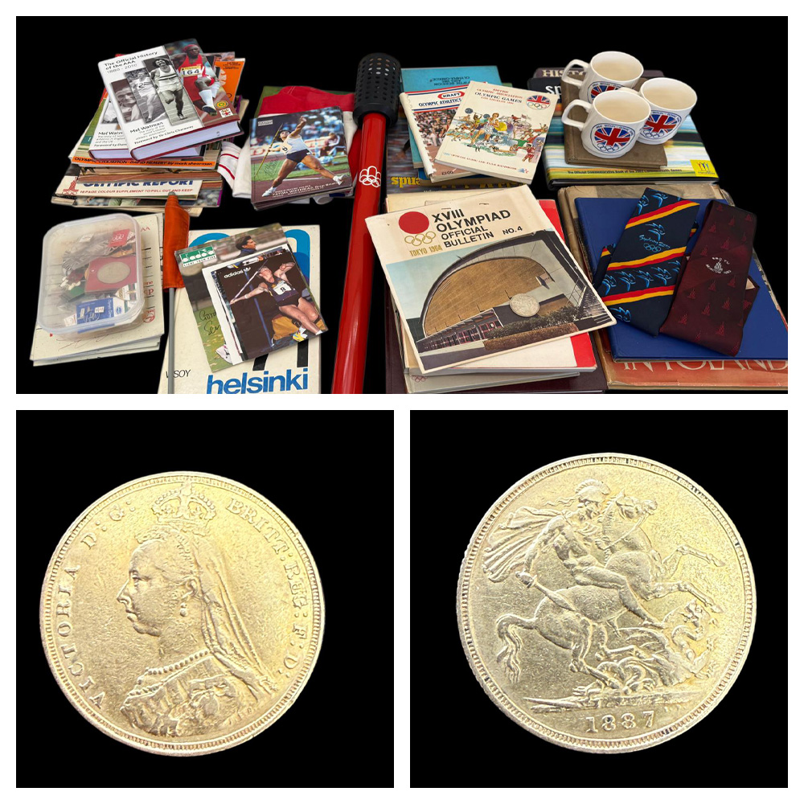
Lot 315 – A collection of sporting memorabilia relating to the Olympic Games, including an Olympic torch from the 1976 Montreal Games. Est: £1800-£2200
Lot 73 – A Victorian 1887 sovereign, jubilee head. Est: £600-£800

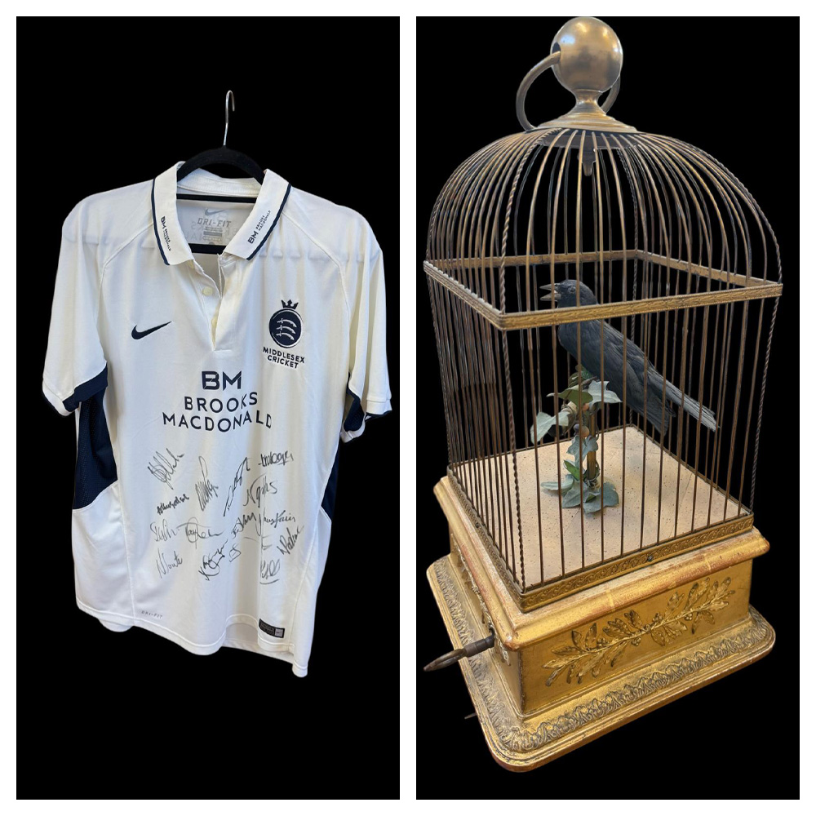
Lot 66 – A Nike Dri-fit Middlesex Cricket Club player's shirt, c. 2017-2021, with 16 signatures. Est: £40-£60
Lot 327 – A late 19th century European gilt-wood and gesso moulded automaton singing bird in a cage music box, 24cm wide x 47cm high, with a book on musical boxes by John E. T. Clark (2). Est: £800-£1200

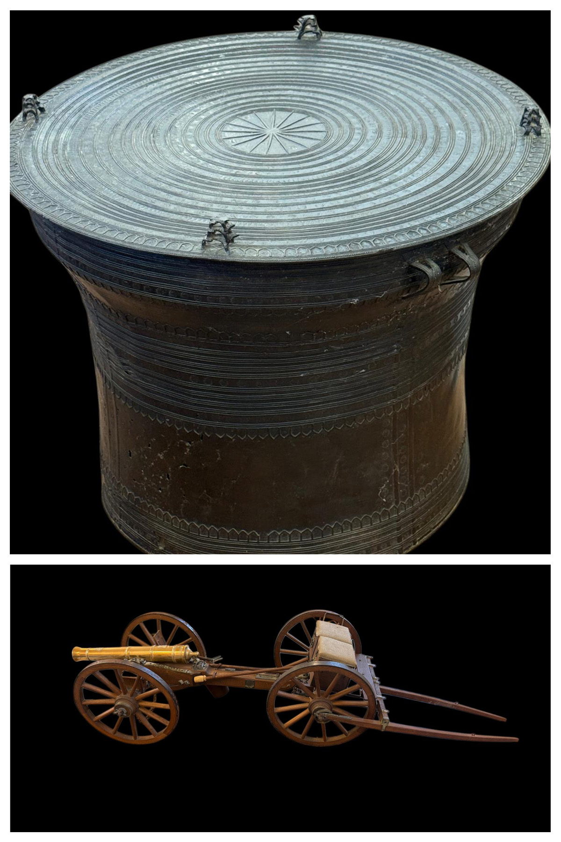
Lot 135 – A Burmese bronze rain drum, with two carry handles, and decorated surfaces, 71cm in diameter x 51cm high. Est: £300-£500
Lot 93 – A 1/10 scale mahogany model of a British Waterloo-period 9 pounder cannon, on wood base 79cm long, a reproduction of a weapon used at the Battle of Waterloo on June 18th 1815. Est: £60-£80

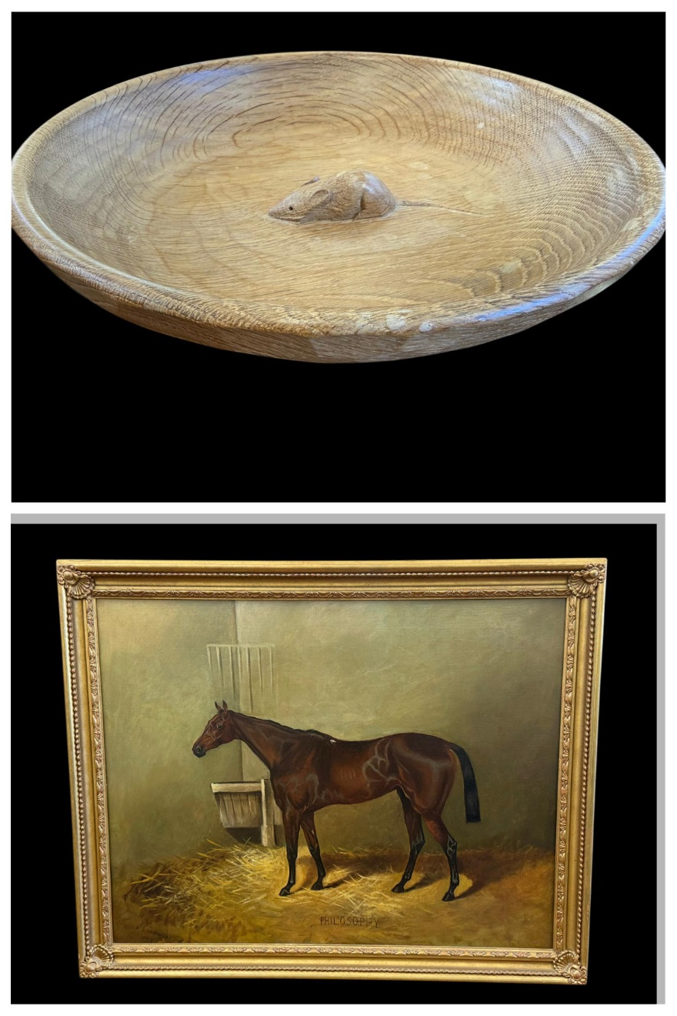
Lot 243 – A Robert 'Mouseman' Thompson carved oak fruit bowl of dished circular form, with adzed exterior finish, 28cm in diameter. Est: £200-£300
Lot 275 – J. C. Tunnard (1893) - Portrait of racehorse "Philosophy", oil on canvas, signed and dated bottom left, 69cm x 90cm, in gilt frame, 84cm x 104cm. Est: £300-£500

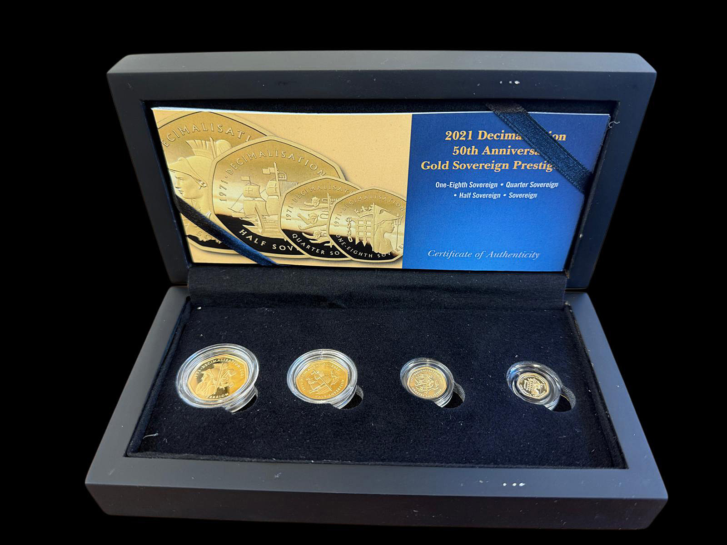
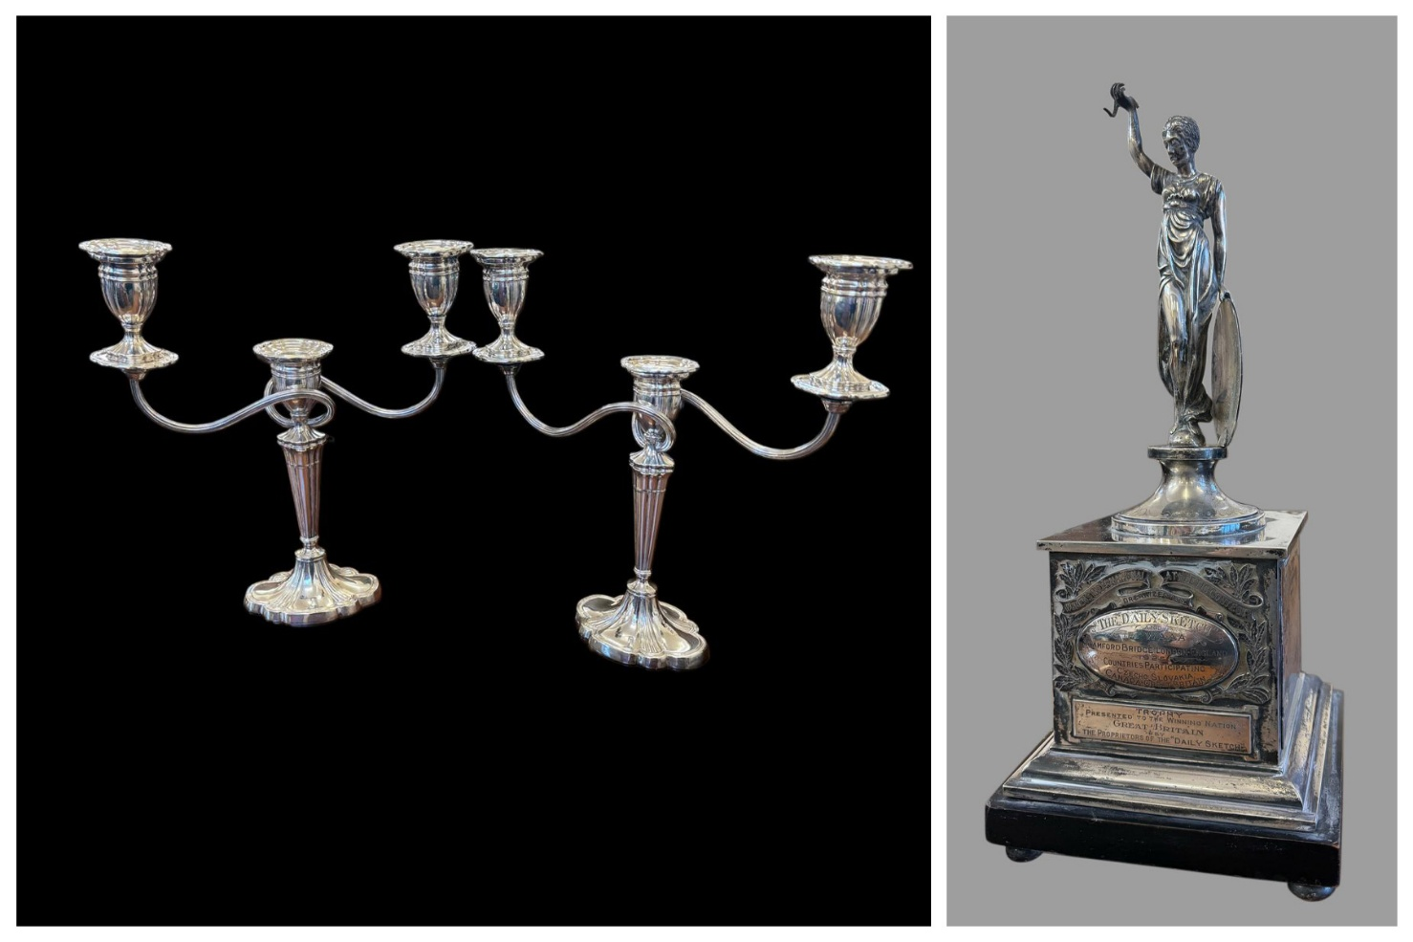
Lot 165 – A 2021 Decimalisation 50th Anniversary Gold Sovereign Prestige set comprising: sovereign, half sovereign, quarter sovereign, and 1/8 sovereign. Est: £800-£1000

Lot 29 – A pair of Elizabeth II silver twin branch candelabra, approx. 42oz.
Est: £1500-£2000
Lot 307 – A George V silver sporting trophy, 44cm high, approx. 70oz.
Est: £2200-£2600

190. | An Action Man black horse, 31cm high, together with two Action Men with realistic hair, a quantity of weapons and accessories, and a boxer dog (a quantity). | £30-£50
191. | Edwin Hayes - Fishing boat in choppy sea, oil on canvas, 29cm x 49cm, in gilt frame 38cm x 59.5cm (AF), together with receipt from Alan Class and Co, London. | £100-£150
192. | W. H. Williamson - Fishing boats off a headland in stormy weather, oil on paper, 22cm x 40cm, in gilt frame, 29.5cm x 47cm, incorrectly labelled verso Edwin Hayes. | £200-£300
193. | A Liskeard Knobbly glass vase 14cm high, an art glass vase possibly after Vladislav Urban 14cm high, together with three lustre glass light shades, and a porcelain box (6). | £20-£30
194. | A Tonka Toys plastic "Rescue Wrangler" jeep in black, 41cm long, a ditto dune squad truck, 33cm long, and a ditto Rescue Truck, in red, 89cm long (3). | £50-£70
195. | A Pelham Puppets "Wuff, Snuff & Tuff" on single control, in long box, c.1952. | £40-£60
196. | A Paragon china commemorative casket commemorating the wedding of the Prince of Wales and Lady Diana Spencer 1981 (a.f.), 24cm wide, in lined box. | £20-£30
197. | A modern violin by "Cadenza", 35cm from base to knob, 55cm overall, in case, together with bow and accessories. | £40-£60
198. | A Yamaha ebonised clarinet, model YCL24, in lined case, with spare reeds, together with a Besson clarinet in lined case a.f. (2). | £40-£60
199. | A 20th century Scottish sporran, a horn-handled skene-dhu, a Middle Eastern dagger, and a bamboo-handled fly swat (4). | £20-£30
200. | Two tinplate models of Consuelo Allen traction engines, each 31cm long. (2) | £20-£30
201. | A Second World War British military issue gas mask, two pairs of flying goggles, and two bowler hats (5). | £20-£30
202. | A quantity of various quartz wristwatches, a Philip Stein wristwatch in box, and two further boxed wristwatches (a quantity). | £30-£50
203. | A modern Action Man astronaut figure, a Charlie Weaver bartender figure, together with other soft toys, and two Airfix model kits (a quantity). | £20-£30
204. | A pair of vintage leather football boots size 5, and a pair of miniature child's boots (2 pairs). | £20-£30
205. | A small number of wood and lacquered boxes, together with a "Econosign" stencil paint box (a quantity). | £20-£30
206. | A quantity of decorative pottery, porcelain and glass, including: Staffordshire spaniels, a spill group, and other objects various (a quantity). | £40-£60
207. | Eight albums of first day covers various, together with a quantity of tea and cigarette cards in box, and a "Hong Kong Uncirculated Coin Collection" in presentation wallet (2 bags). | £40-£60
208. | A Sargadelos porcelain Cow No 2 and Calf figures, 19cm high and 10cm high respectively (2). | £40-£60
209. | A British 1937 Webbing Military map case, two pairs of binoculars. and an enamelled box (4). | £15-£20
210. | A silver plated three bottle tantalus, with a pair of hob-nail cut decanters, and a non matching, ditto, 30cm wide, and a Cristelleries De Lorraine glass decanter and stopper, 42cm high (2). | £60-£80
211. | Three modern silhouette pictures by G A Andrews, each 9.5 in diameter, a glass silhouette picture, a small Moghul school painting, two small etchings and five other small decorative pictures and prints (12). | £15-£20
212. | Chess set in beech box, a playing card set, in lined box, together with a number decorative tins (a quantity). | £15-£20
213. | An Art Nouveau style Bohemian pottery amphora vase by "Riesner Stellmacher, and Kessel" with relief decoration, printed red factory mark, 18cm high, a.f. | £60-£80
214. | Quantity of lady's decorative evening bags and purses, together with a pair of evening gloves (qty). | £30-£50
215. | A quantity of mixed silver-plated items including some cutlery, and a small fruitwood stick with silver-plated collar (a quantity). | £40-£60
216. | A Hornby Dublo diecast railway station platform, partially boxed, a ditto "Corridor Coach" boxed, together with some pieces of rolling stock, unboxed, some diecast toy vehicles, and a quantity of dolls house furniture (a quantity). | £30-£50
217. | A modern Steiff meercat, 30cm high, a ditto rabbit, and a further soft toy monkey, all unboxed (3). | £40-£60
218. | A gilded and enamelled brass bust of Tutankhamun's death mask on marble base, 26cm high, together with a small decorative wall mirror, brass figure of an elephant, and a small gong (4). | £40-£60
219. | A quantity of Matchbox, Hot Wheels, and other diecast cars and vehicles, mostly unboxed, together with four Exclusive First Edition boxed diecast coaches and buses, and two Lledo diecast vehicles boxed (in 5 crates). | £30-£50
220. | A quantity of Urago 1/18 scale diecast cars, together with Dinky military vehicles, Days Gone diecast vehicles, and others (in 4 crates). | £30-£50
221. | A near pair of Dreamglobe-type paperweights, each 14cm high, together with a number of Caithness and other glass paperweights, in mixed sizes, and a Hafod Grange paperweight in box (17). | £40-£60
222. | A collection of Ronson and other lighters, various, together with a quantity of chrome-plated and other cigarette cases and boxes (a quantity). | £20-£30
223. | A pair of silver-plated and bone-handled fish servers in lined case, together with a canteen of King's pattern silver-plated and stainless steel cutlery by "Viners of Sheffield", and two further part-canteens of cutlery (4). | £30-£50
224. | A Canon A1 SLR camera, an Olympus skylight lens, a Pentax autofocus camera, together with other photographic, box, and cine cameras, bags, and other accessories (3 boxes). | £50-£70
225. | Two early 20th century oak-case mantel clocks, each 44cm high, an art deco style mantel clock in oak case, together with six further smaller timepieces, and a West German made metronome (10). | £60-£80
226. | A quantity of loose horse brasses various, depicting symbols, animals and signs of the zodiac (a quantity). | £20-£30
227. | A quantity of silver-plated ware various, including candlesticks, a syphon holder, and toast racks, together with two boxes of silver-plated cutlery various (3 boxes). | £20-£30
228. | Two boxes of decorative marbles various, probably mainly early to mid 20th century (2). | £40-£60
229. | A number of 19th century historical portrait engravings, mostly 28cm x 21cm, including John Duke of Marlborough, Duke of Wellington, Oliver Cromwell, Charles I, the Earl of Essex, Catherine of Aragon, other monarchs ,and other historical figures (approx. 48). | £30-£50
230. | An "Omas" extra pen set comprising: fountain pen, two ballpoints, and a propelling pencil (unboxed), together with a French stainless steel Parker fountain pen, and other pens by Parker, Calibri, and other manufacturers (a box). | £20-£30
231. | A child's Top of the Pops wristwatch, a Disney Pocahontas wristwatch, further children's wristwatches, a quantity of other lady's and gent's wristwatches with quartz movements, and a number of lady's and gent's mechanical wristwatches (3 boxes). | £30-£50
232. | A small quantity of lady's and gent's wristwatches various, with quartz movements, some in branded boxes, some loose (2 boxes). | £20-£30
233. | Six albums of stamps various, including Victorian New Zealand issues, and other world stamps, together with other small albums, guides and first day covers (3 boxes). | £70-£90
234. | A George V silver four-division toast rack, London 1932, together with a silver-plated muffin dish, approx. 1.5oz weighable (2). | £50-£70
235. | A Lladro figure of a swan 21cm high, in non-matching branded box, a further figure of a white swan with wings spread 19cm high, with box, three duckling collection figures with box, and a retired Lladro figure of duck (a.f.), 11cm high, with box (6). | £60-£80
236. | A Brooks & Bentley porcelain group of African Elephant Family from the African Wilderness Collection, a figure of a Pygmy Hippo, a figure of a Baby One-Horned Asian Rhinoceros, and a further figure of an African Elephant Calf, all with boxes (6 figures in 4 boxes). | £40-£60
237. | After Jeremy King - "Mosside" limited edition coloured lithograph, no. 115/200, 59cm x 79cm, with Christies Contemporary Art certificate. | £30-£50
238. | E. Heaton - Landscapes with cottages, sheep and a haywain, oils on canvas, a pair, each 29cm x 39cm (2). | £20-£30
239. | A stained oak six-point stag's head, 36cm high, a.f. | £30-£50
240. | A cast-metal duck pastry mould, with three hinges, 23cm long. | £40-£60
241. | A Wilton Ware lustre bowl decorated figures in a garden landscape, 24cm in diameter, red ground with some gilt decoration. | £30-£50
242. | A late Victorian Doulton Lambeth cricket-pattern stoneware jug with diamond registration mark and relief decoration of cricketers in shaped panels, 23cm high. | £30-£50
243. | A Robert 'Mouseman' Thompson carved oak fruit bowl of dished circular form, with adzed exterior finish, 28cm in diameter. | £200-£300
244. | A Robert 'Mouseman' Thompson pale oak oval cheeseboard, with upswept handle, 39cm long. | £150-£250
245. | A silver curb-link watch chain style necklace, approx. 3.6oz. | £90-£120
246. | A reproduction photograph of 617 Squadron RAF "The Dambusters" with facsimile signatures of Guy Gibson, Micky Martin, Hobday, and other crew members from the raid, 23cm x 69cm, a print of a Dambusters Lancaster Bomber, a further print of a Lancaster after David Shepherd, and four further prints relating to 617 Squadron (7). | £30-£50
247. | An early 20th century inlaid walnut mantel timepiece, 18cm high, and an aneroid barometer on carved oak stand 18cm high, a.f. (2). | £30-£50
248. | A 20th century Polish kelim tapestry panel, some pieces of beadwork, a lace collar, and a child's sailor collar (6). | £25-£40
249. | A. A. Milne - Volume of "Winnie the Pooh" published by Methuen & Co. 1926, a further volume "The House at Pooh Corner" published 1928, and a further book "The Flowers of the Field" 5th Edition (3). | £30-£50
250. | Two albums of British and world stamps, an album of heraldic crests, and a box of loose stamps (4). | £40-£60
251. | Two albums of mixed world coins, together with a tin of mixed loose coins (3). | £20-£30
252. | An Airfix 1:32 scale motor racing set model MR15, boxed, together with two accessory track packs, a scrap book relating to motor racing and Graham Hill, and a race programme for the 1960 British Grand Prix at Silverstone, a.f. (5). | £40-£60
253. | A silver-plated square cigarette box, and a quantity of other silver-plated ware, various, together with a number of pewter tankards (2 boxes). | £30-£50
254. | A set of Victorian apothecary's scales, with glass trays, and some dram weights, in mahogany box, 19cm wide, together with a small parquetry box, a writing slope, and two further boxes (5). | £25-£40
255. | After Geoff Nutkins - "A Gentleman's War", coloured lithograph, signed by Bob Doe, and four other Battle of Britain pilots, 44cm x 62cm, another lithograph after Robert Taylor "St. Croix-Sur-Mer", signed by Johnnie Johnson and others, 51cm x 71cm, and another after Philp West "The Pride of Britain", 39cm x 62cm (3). | £40-£60
256. | Attributed to Louis (Lod) Pulinch (Belgian 1843-1910) - "View of the Meuse, near Anseremme, Dinant", inscribed verso on label, oil on canvas, 36cm x 51cm, in gilt frame, 57cm x 73cm, a.f. | £80-£120
257. | H. Moris (19th century) - View of Dutch sailing barges, oil on canvas, signed and dated 1874, and on plaque, 49cm x 73cm, in gilt frame, 71cm x 94cm, a.f. | £100-£150
258. | A Gurkha kukri, in scabbard, 42cm long, a Burmese Dha dagger, 46cm long, a miniature Zulu dancing shield, two pairs of goggles, a military photograph of an officer, and a miniature on card possibly of the same officer, together with a silver-cased pocket watch, various medals, three pairs of binoculars, and other ephemera (a quantity). | £80-£100
259. | A George V silver two-handled sporting trophy cup, for cross country run, Chester 1932, a smaller trophy cup, Birmingham 1925, an Indian metalware bowl, a silver-handled shoehorn, and six small spoons and forks, approx. 6oz weighable (10). | £180-£220
260. | A gent's mother of pearl dress stud set in box, a pair of gold-plated cufflinks, together with some 1960s sporting medals, a gilt-metal intaglio cut fob, costume brooches, and other pieces (a quantity). | £80-£100
261. | An unmarked stained wood chess set, in coffer-form box, 32 pieces, a further set with some pieces a.f., some draughts, and three sets of wood and plastic dominoes, boxed (a quantity). | £40-£60
262. | A 19th century Sevres porcelain part dinner service, each piece decorated a family crest, including: eight dinner plates, a soup tureen, a fruit bowl, a covered dish, and other pieces, some a.f., c.1870 (16). | £40-£60
263. | A Dinky Supertoys Bristol Britannia Airliner, no. 998, in blue white and yellow box, a D. H. Comet Airliner, no. 999, in box, together with a number of Dinky civil and military aircraft, and other diecasts, all unboxed and a.f. (a quantity). | £50-£70
264. | A Hornby and Tri-ang HO/OO scale mixed train set, including a 4-6-2 "Princess Elizabeth" steam loco, and tender, a 4-6-2 "Britannia" steam loco and tender, other locomotives, coaches, rolling stock, track and buildings, mostly unboxed, and some pieces a.f. (2 large boxes). | £60-£80
265. | A quantity of Dinky and Britains diecast military issue vehicles, together with some Britains lead farm animals, and other figures, and some plastic fencing (2 boxes). | £40-£60
266. | A small late Victorian photograph album containing family photographs, together with a hand-coloured photograph in bakerlite folding frame, other photographs, miniature portraits on card and porcelain, a maucclin ware photo album, ambrotypes and daguerreotypes (a quantity). | £40-£60
267. | A pair of early 20th century Japanese Imari vases, with floral panels, each 22cm high, one chipped (2). | £60-£80
268. | Two Chinese blue and white porcelain spice jars and covers, 15cm and 14cm high respectively, a Chinese cloisonné miniature moon flask, 13cm high, and a Japanese cloisonné vase, 21cm high a.f. (4). | £30-£50
269. | A blue ground Paul Milet Sevres vase, early 20th century, with gilt-metal rim and foot, 17cm high. | £70-£100
270.† | Ron Chadwick (b. 1954) - A set of six square oil paintings on canvas, of the Rolling Stones, comprising: Mick Jagger, Ronnie Wood, Keith Richards, Bill Wyman, Charlie Watts, and Brian Jones, each signed and dated, 1999 and 2000, each 61cm x 61cm, unframed (6). ARR may apply. | £180-£220
271.† | Ron Chadwick (b. 1954) - Portrait of Muhammed Ali, oil on canvas, signed and dated 2001, 92cm x 61cm. ARR may apply. | £30-£50
272.† | Ron Chadwick (b. 1954) - Portrait of the actor Marlon Brando (Godfather era), oil on canvas laid on board, 129cm x 46cm, unframed, signed and dated 1999. ARR may apply. | £30-£50
273. | AMI Ltd - A framed montage of black and white photographs of Stan Laurel and Oliver Hardy, in single mount, one photograph signed, certificate verso, in ebonised frame, 69cm x 89cm. | £60-£80
274.† | After Paul Hess (b. 1961) - An artist-signed limited edition colour cricket print, "Over the Hill", no. 84/195, in modern frame, 71cm x 88cm, print size 46cm x 63cm. | £40-£60
275. | J. C. Tunnard (1893) - Portrait of racehorse "Philosophy", oil on canvas, signed and dated bottom left, 69cm x 90cm, in gilt frame, 84cm x 104cm. | £300-£500
276. | J. C. Tunnard (1893) - Small portrait of racehorse "The Lady", oil on canvas, signed and dated bottom left, 29cm x 39cm, in gilt frame, 35cm x 45cm. | £150-£200
277. | Attributed to J. C. Tunnard - Portrait of black and white racehorse "Magpie", oil on canvas, unsigned, 34.5cm x 44.5cm, in gilt part-frame, 42.5cm x 52cm. | £100-£150
278. | 20th century school - Portrait of brown racehorse in exterior scene, oil on canvas, unsigned, 34cm x 45cm, in modern gilt frame, 41cm x 51cm. | £100-£150
279. | A 9ct gold bangle (dented), three small gilt-metal fobs with intaglio-cut seals, a miniature baby's rattle charm, together with a quantity of decorative and costume jewellery, approx. 10g weighable (a quantity). | £300-£400
280. | Early 20th century school - Portrait of male lion, oil on canvas, indistinctly signed, 61cm x 44cm, re-lined. | £50-£70
281. | A pair of Staffordshire pottery figures of lions with gilt highlighting to their manes, each 31cm long x 26cm high (2). | £60-£80
282. | A pair of Staffordshire figures of recumbent lions with some gilt highlighting to their manes, 32cm long x 25cm high (2). | £40-£60
283. | A polished stone figure of a Medici lion, 14cm long, on textured base, a small polished stone lion on slate book-form base, 12cm long, a spelter figure of a Medici lion, 20cm long, two Staffordshire-style pottery lions, each 14cm long, a copy of the "Chatsworth Sleeping Lion", 21cm long, and an alabaster figure of recumbent lion, 15cm long, some a.f. (7). | £60-£80
284. | A Victorian inlaid walnut octagonal tapering games and work table with decorative chess board top, on carved tripod base, 43cm in diameter x 73cm high. | £80-£120
285. | A Swarovski Crystal Society Annual Edition 2000 "Columbine" figure 17cm high boxed, a 1999 "Pierrot" figure, and a 2001 figure "Harlequin", all from the "Masquerade" trilogy, and all boxed (3). | £70-£90
286. | A Swarovski Crystal Society "Endangered Wildlife Collection" figure of pandas 9cm and 6cm high, another figure of tiger 18cm long, another figure of gorillas 9cm and 5cm high, together with a figure of a cheetah 10cm high, a lion 12cm high, and a gift figure for the Endangered Wildlife Collection of a lion cub (6). | £80-£100
287. | A Swarovski "Wonders of the Sea" group "Community", another "Harmony", and another "Eternity", all boxed (3). | £70-£90
288. | A Swarovski "Magic of Dance" figure "Isadora 2002", another figure "Antonio 2003", a further figure of a ballerina, and further figure "Anna 2004", all boxed (4). | £70-£90
289. | A Swarovski Crystal figure of eagle, 11cm high, a figure of a flamingo, 15cm high, a figure of eagle on branch, 11cm high, and a figure of a stork, 14cm high, all boxed, together with an unboxed eagle on stepped base, 32cm high (5). | £70-£100
290. | A Swarovski "Fabulous Creatures The Pegasus" figure (a.f.), annual edition 1998, in box, a figure of a giraffe 14cm high, in box, a ditto figure of a horse 10cm high, a further figure of a cat 12cm high, in box, together with other small Swarovski objects, some bases, a Waterford Crystal figure of a lion, and a ditto of an elephant, most boxed but a few unboxed (a quantity). | £70-£90
291. | A part-set of silver-plated bone handled and stainless steel cutlery, in a stained-oak canteen 44cm wide, approx. 54 pieces, in mixed patterns. | £20-£30
292. | An 18ct gold gent's wristwatch in half-hunter case, inscribed "Examined by Dent, Watchmaker to Her Late Majesty Queen Victoria", on leather strap, approx. 38g gross, a.f., in lined box. | £800-£1200
293. | A heart-shaped moonstone-set pendant, set with seed pearls to edge, unmarked, in lined box. | £300-£500
294. | A gent's 18ct gold band ring set three diamonds, together with a lady's pink sapphire and chip diamond set dress ring, approx. 5g weighable (2). | £400-£600
295. | An 18ct gold lady's keyless wound fob watch, on 9ct gold curb-link short chain, together with a further 18ct gold fob watch with gilt dial, approx. 80g gross, in un-associated box (2). | £600-£800
296. | A lady's insect brooch set a central pearl and 48 graduated diamonds and chip diamonds. | £300-£500
297. | A butterscotch amber bead necklace 37cm long, and a another butterscotch bead necklace 110cm long (2). | £100-£150
298. | A 9ct gold link watch chain, with jade earring fob, attached to a Vertex keyless wound pocket watch in gold-plated Dennison case, white enamelled dial, approx. 30g weighable, in lined box. | £1300-£1500
299. | Seven 18ct gold dress rings, various, six 9ct gold dress rings set mixed stones including diamonds, sapphires and cabochon opals, and five silver dress rings, approx. 32g weighable (18). | £1800-£2000
300. | A gent's 18ct gold wristwatch with white enamelled dial, on leather strap, a.f. | £180-£220
301. | A gent's stainless steel "Vertex Revue" wristwatch with bar numerals, a gold-plated and stainless steel "Roamer" wristwatch, and a "John J. Holgate" stainless steel gent's wristwatch (3). | £30-£50
302. | A 15ct gold bangle, in lined box (a.f.), approx. 15g. | £850-£950
303. | A pair of gent's 9ct gold cufflinks of octagonal form, approx. 3g, in un-associated box. | £150-£200
304. | A pair of gent's 9ct gold oval cufflinks, in Francis Jones box. | £90-£130
305. | A lady's "Avia Incabloc" wristwatch in gold-plated and stainless steel case, in branded box. | £50-£70
306. | A silver dragon fob, set agate, on metal chain. | £40-£60
307. | A George V silver sporting trophy, "The Women's International Athletic Contest Organised by the Daily Sketch and the WAAA Stamford Bridge London 1925", of square pedestal form surmounted by Britannia-style figure, with enamelled shield, Birmingham 1925, 44cm high, approx. 70oz. | £2200-£2600
308. | A quantity of silver-plated lady's athletics trophy cups for the Spartan Ladies Athletics Club, including a two-handled cup and cover "The Mary Peters Trophy" 38cm high, together with other trophies and some siècle bases (14). | £80-£100
309. | A George V silver two-handled trophy cup, "Spartan Ladies Athletic Club Singleton Trophy", maker James Dixon & Sons, Sheffield 1910, engraved with winners including Mary Peters who won the trophy in 1963, 1964 and 1966, siècle base missing, 29cm high, approx. 17oz. | £450-£550
310. | A George V silver two-handled trophy cup and cover, "Spartan Ladies Athletic Club 100 Yards Championship, Daily Sketch Challenge Cup", Birmingham 1922, also engraved with the winners between 1932 and 1961, but missing the war years, 25cm high, approx. 16oz. | £450-£550
311. | A late Victorian silver goblet trophy cup, "Spartan Ladies Athletic Club 150 Yards Intermediate Presented by Sir Nigel and Lady Ball 1951", also engraved with the winners between 1951 and 1961, London 1881, approx. 8oz. | £250-£350
312. | A Portuguese white-metal two-handled trophy cup "The Spartan Ladies Athletic Club The Sarney Memorial Challenge Cup Senior Long Jump Championship", also engraved with the winners from 1950 to 1961, 13cm high, approx. 6oz. | £80-£100
313. | A pair of George VI silver two-handled trophy vases "London Amateur Athletic Championships Replica of the Challenge Cup Long Jump Men's Senior", London 1946 and 1947, together with three further silver sporting trophies for the "Spartan Ladies Athletic Club", approx. 27oz (5). | £800-£900
314. | A George V silver two-handled trophy cup "Sidcup Girl Crusaders The Gilbert Lodge Challenge Cup 100 Yards Seniors", also engraved with the winners between 1928 and 1948 but missing 1940-47, 16cm high, London 1928, a further trophy cup "The Rana Swimming Club Championship Cup August 1912", engraved with winners 1912 to 1914, 16cm high, Sheffield 1909, together with a small silver figural trophy 19cm high, and three small silver trophy cups, approx. 17oz weighable (6). | £700-£900
315. | An Olympic torch from the 1976 Montreal Games, a BBC TV tie for the Moscow 1980 Olympic Games, a further tie for the Sydney 2000 Games, together with a quantity of books on the history of the AAA and WAAA, books and official programmes for Olympic Games including Tokyo 1964, team guide for Los Angeles 1984, histories of the Olympics, programmes for the Southern Counties Athletics Championships, some photographs signed by Fatima Whitbread, Sebastian (Lord) Coe, and Steve Backley, and a quantity of badges and lapel pins, together with other pieces of Olympic and sporting memorabilia (a collection). | £1800-£2200
316. | A Capodimonte figure of priest and peasant man, signed "Tyche Tosca", on gilt foot, 21cm high. | £60-£80
317. | An early 20th century Chinese carved hardwood open-shelved cabinet, with leaf carved and pierced pediment, on short square legs with animal feet, 104cm wide x 190cm high. | £650-£800
318. | Withdrawn Lot
319. | A late Victorian brass fire screen, with stained glass and leaded central panel, decorated a kingfisher and foliage, on squat shaped legs and shell feet, 48cm wide x 90cm high. | £80-£120
320. | A First World War brass trench art miniature coal scuttle made from a British 18-pounder shell case c.1915, 21cm long, together with a 20mm shell case with tip, a Queen Mary Christmas 1914 brass box (no contents), and a pair of Carl Zeiss Jena Silvamar 6x binoculars in leather case (4). | £80-£100
321. | A Royal Albert Crown China part afternoon tea set comprising:- 2 bread and butter plates, 12 tea plates, 12 saucers, 10 cups, a milk jug, and a slop bowl (38 pieces). | £60-£80
322. | A set of ten volumes of The Pictorial History of England by H. C. Hamilton Esq., published by W. S. Orr & Co. London 1847-1850, together with the index volume (11). | £60-£80
323. | A volume of "Ireland, it's Evils and their Remedies" by Michael Thomas Sadler 1828, and a further volume "The Anniversary" by Horace Harvey c.1839 (2). | £25-£40
324. | Robinson Jones - Two barques with two smaller sailing ships and a skiff in a seascape, signed bottom right, oil on panel, 39cm x 48cm, in gilt frame, 61cm x 71cm. | £180-£220
325. | A Staunton chess set, 32 pieces, the white rooks marked with a crown, the kings 11cm high, the queens 9cm high, in beech box, 21.5cm wide. | £600-£800
326. | A set of miniature volumes of the works of William Shakespeare, 40 volumes, on a miniature open-shelf stained-wood bookcase, 19cm wide. | £20-£30
327. | A late 19th century European gilt-wood and gesso moulded automaton singing bird in a cage music box, key-wound movement, gilt wire cage and brass ring top, 24cm wide x 47cm high, with a book on musical boxes by John E. T. Clark (2). | £800-£1200
328. | A Victorian needlework sampler by Elizabeth Munster(?) 1845, 43cm x 41cm, and a smaller sampler by Laura Bradley 1842, 32cm x 26cm (2). | £70-£100
329. | A mid-Victorian needlework sampler by Emma Brambles age 7 1857, 41cm x 29cm, and a Queen Elizabeth II coronation needlework sampler 1953, 44cm x 31cm (2). | £50-£70
330. | After Godefridus Schalcken - Possibly a self portrait, oil on canvas, 46cm x 58cm, in gilt frame, 82cm x 70cm. | £100-£150
331. | An early 19th century map of Kent by Charles Smith of London January 6th 1804, 54cm x 65cm. | £50-£70
332. | A gilt picture frame type wall mirror, with bevelled plate, 117cm x 84cm. | £80-£100
333. | A silver-plated oval entrée dish 30cm wide, a silver-plated Dutch-style meat skewer, a crumb scoop with bone handle, a table spoon, a glass sugar caster with silver-plated top, a pair of sugar nips, and a set of six silver-plated tea knives in lined box (7). | £30-£50
334. | A George V silver gravy boat with scrolled handle, on three feet, London 1934, approx. 10oz. | £250-£350
335. | A pair of George III Hanoverian-pattern sauce ladles London 1819, a fiddle pattern stilton scoop London 1828, a boxed silver christening set Birmingham 1947, two boxed sets of silver teaspoons, and a set of six silver-handled tea knives in box, approx. 11oz (7). | £250-£350
336. | An Elizabeth II silver goblet Birmingham 1973, a George V silver hair tidy with glass jar, Birmingham 1924, a pair of miniature ashtrays London 1981, a small silver magnifying glass Birmingham 1919, two silver cigarette cases Birmingham 1912 and 1919, and two small metalware propelling pencils, approx. 10oz. (9) | £250-£350
337. | A 20th century painted black and white rocking horse, on standard stained-wood rocker base, with mane and tail, fitted a red leatherette saddle, 150cm long x 126cm high. | £400-£600
338. | An Ami Stereo-Round Continental 2 jukebox, with curved display, fitted a later print of Madness Baggy Trousers, containing fifty 45-RPM records, domed cover to the turntable, 69cm wide x 161cm high, Model/Registration No. L2039RH. | £4000-£6000
339. | A Kazak rug, the central field with geometric medallions and stylised animals, on rust ground, wide multicoloured border, 190cm x 264cm. | £80-£120
 | END OF SALE
Artist Resale Rights
ARR is calculated in GBP. Exchange rates are updated daily.
ARR is cumulative and applies to lots with a hammer over £1000
£0 - £50,000 - 4%
£50,000 - £200,000 - 3%
£200,000 - £350,000 - 1%
£350,000 - £500,000 - 0.5%
£500,000+ - 0.25%
ARR is capped at £12,500
† ARR will be subject to additional fees. See last page for more details.

UPCOMING DATES

OUR UPCOMING DATES HAVE CHANGED
SEE BELOW FOR THE NEW DATES

Auctions

Wednesday 8th July 2026
Wednesday 2nd September 2026
Wednesday 21st October 2026
Wednesday 9th December 2026

Viewing on Monday and day before sale from 10am to 5pm
and on morning of sale from 9am to 10.30am
Sale commences at 11am

Valuation Days

OUR UPCOMING DATES HAVE CHANGED
SEE BELOW FOR THE NEW DATES

Wednesday 20th May 2026
Wednesday 10th June 2026
Wednesday 15th July 2026
Wednesday 12th August 2026
Wednesday 16th September 2026
Wednesday 28th October 2026
Wednesday 18th November 2026
Wednesday 16th December 2026

Sevenoaks Saleroom, Argyle Road,
Sevenoaks TN13 1HJ
Between 11am - 4pm

Notes

