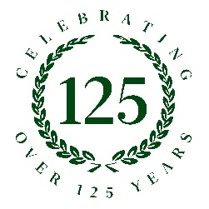
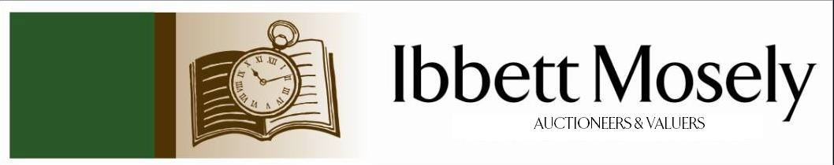

Catalogue of Antique, Edwardian and Victorian
Furniture and Effects
to be Auctioned on

Wednesday 19th November 2025ffff
at 11am

IBBETT MOSELY AUCTION ROOMS
ARGYLE ROAD, SEVENOAKS, KENT TN13 1HJ
And Online Via
www.easyliveauction.com/ibbettmosely/

Viewing at Sale Room on:

Monday 17th November
Tuesday 18th November

Between 10am – 5pm

Catalogues: £2.00

Auctioneer and Valuer: Alan White FNAVA
Auction Clerk and Trainee Valuer: Nicola Rainsley-Hughes MNAVA
Auction Clerk and Saleroom Manager: Benjamin Burridge
Photographer and Porter: Samantha Crowe-White
Office Administrator: Wendy Weaver
Auction Assistant: Amity Quartermaine

Welcome to Ibbett Mosely Auctions
19th November 2025 Auction Catalogue

This sale will also be held online at www.easyliveauction.com/ibbettmosely/
please visit the website to register or log in to view and bid. Images and condition reports of each lot are included.

Alternatively, commission bids (bids left ‘on the book’) may be left with us, as well as a limited amount of telephone bids. Please telephone 01732 456731 or email auctions@ibbettmosely.co.uk for further details.

Unsold lots from this sale will be placed into a week-long online timed auction that can be found at www.easyliveauction.com/ibbettmosely/

Please telephone 01732 456731 or email auctions@ibbettmosely.co.uk with any questions.

Collection of items is available on Thursday 20th November from 10am - 2pm. Collection of items from 21st November onwards, by prior appointment only.

We do not arrange collection or deliver your items ourselves, collection of items is the responsibility of the buyer. You are welcome to collect in person, or via your own carrier (part&parcel at worldwideauctiondelivery.com being one option), but local courier PSP Logistics are available to carry out deliveries of items. Please contact them directly to arrange and pay for delivery.

Please be aware we are not able to offer food or drink at this sale
1. | An Edward VII silver tazza, the pedestal decorated relief lozenges, on circular foot, maker Edward Barnard & Sons Ltd, London 1908, 12cm high, approx. 12oz. | £250-£350
2. | A 75.7cl bottle of Chivas Royal Salute 21 year old blended Scotch Whisky, in green Spode porcelain bottle, sealed, and bag, boxed, c.1980s. | £200-£300
3. | A 75cl jug decanter of Rutherfords 12 year old Scotch Whisky, the decanter decorated grouse, sealed, in red box, c.1980s. | £75-£100
4. | A bottle of Warre 1977 port, label missing, ullage level possibly mid-neck, capsule aged. | £30-£50
5. | A 'Playmobil' plastic toy helicopter, some Fisher Price and other toys, together with a 'Matchbox' Tracy Island, and other pieces including Lego (qty). | £30-£50
6. | A quantity of quartz watches, compacts, costume jewellery, and other objects, various. (qty). | £20-£30
7. | A bronze commemorative medallion for the 800th anniversary of St. Bartholomew's Hospital, c.1923, together with some sporting medals, coinage, paper money, and mixed stamps (qty). | £30-£50
8. | A Star Wars BB-8 droid toy, a Disney figure of Darth Vader, an R2-D2 toy, a Lightyear Zurg's Mothership, and other toys (a qty). | £20-£30
9. | A pair of modern Chinese pottery figures of lion dogs, two miniature mud figures, a Māori hand club, two Indian silk pictures, together with two Waterford champagne glasses, and other pottery and glass, various (qty). | £20-£30
10. | A silver-plated wine funnel, a small goblet, various continental spoons, and a selection of other silver-plated objects. (a qty). | £25-£40
11. | A quantity of diecast and other toy vehicles, all unboxed, and three pewter military figures (qty.) | £20-£30
12. | After Leo McDowell (1936-2011) - "Before the Castle Gate", chromolithograph, 51cm x 45cm, a textured print of wooded landscape, seven costume design prints for Don Quixote, together with other decorative pictures, prints, and a mirror. ( a qty). | £30-£50
13. | A diamond solitaire dress ring, unmarked, approx. .45 carats, and a pair of stone-set ear studs (3). | £200-£300
14. | An 18ct and 18k white gold pendant, set pink stones and a dark lacquered pearl, on choker-style necklace, approx. 11g gross, boxed. | £200-£250
15. | A single strand pearl necklace, with 9ct gold clasp, set a garnet, and two seed pearls, boxed. | £80-£100
16. | A piece of history ceramic poppy head, in presentation box, the stalk missing. | £20-£30
17. | A set of six George III silver teaspoons, probably London 1781, approx. 2oz, in un-associated box, together with a quantity of silver-plated spoons, and other cutlery. (qty). | £40-£60
18. | A 9ct gold gents pinky ring, set black onyx, a 10k ring, marks rubbed, approx. 8g weighable, together with a lady's fob watch, and a quantity of costume jewellery (qty). | £70-£100
19. | An Elizabeth II silver christening cup, engraved C.E.H.H., Birmingham 1949, a George III silver salt spoon, London 1801, a silver-plated mustard pot (no liner), and a silver-plated breakfast warmer, approx. 2oz weighable (4). | £40-£60
20. | A black and white photograph taken at the 1954 British Empire and Commonwealth Games in Vancouver, Canada, featuring Roger Banister of England and John Landy of Australia, running the 'Miracle Mile' race, a few months after Banister broke the four minute mile record, 19.5cm x 14cm. | £30-£50
21. | A pottery jug by Sarah Stoker decorated sunflowers, on a mottled green background, 13cm high. | £20-£30
22. | A Waterford glass bowl "The King's Bowl" designed by John Connolly, 25.5cm in diameter, with certificate and brochure, a further cut-glass bowl, a Swarovski miniature clock, a paperweight, a flower vase 20cm high, and a crystal tumbler (6). | £80-£120
23. | Miniature timepiece with silver-fronted case Sheffield 1994, 7cm high, a further miniature timepiece, a gilt-brass carriage timepiece, a porcelain clock, and a Tavistock and Jones wristwatch boxed (5). | £40-£60
24. | A carved beech figure of Madonna and Child 32cm high, two reproduction icons, a carved nude figure, a pair of carved praying hands, and three ebonised tribal figures (8). | £50-£70
25. | 20th Century copper hunting horn, 24cm long (repaired). | £20-£30
26. | Of Political Interest - A silver-plated tray of shaped outline inscribed "With Best Wishes From The Commonwealth Parliamentary Association Sri Lanka Branch Visit - 28 Nov - 3 Dec 1985" 31cm long, a small alabaster bust of Winston Churchill, a Houses of Parliament teddy bear, a 1974 Wedgewood Houses of Parliament Christmas plate, some parliamentary guide books and other ephemera (qty). | £50-£70
27. | An early 19th century pine longcase clock, the 30 hour movement with silvered dial, inscribed "Thomas Ranger, Sevenoakes Kent", 207cm high. | £80-£100
28. | A Victorian mahogany kidney-shaped writing table, with fitted central drawer, on carved and turned fluted legs, united by stretchers, on porcelain castors, and with leather top, 114cm wide. | £250-£350
29. | A small collection of seven coloured prints of Luftwaffe colour schemes and markings 1939-45, a small ink sketch of U.S. Marines (1942-43) on Guadalcanal dated 1944, 19cm x 23cm, together with some part-volume issues of Aviation News, and a British Caledonian Emergency Procedures card (qty). | £40-£60
30. | An art-deco style orange and white mottled glass plafonnier 35cm in diameter, and a further blue-green and white mottled ditto 29cm in diameter, both with link chains (2). | £40-£60
31. | 20th Century Chinese painted egg shell in glazed case, 10cm high, in small labelled box, originally purchased in Shanghai. | £40-£60
32. | 20th century Chinese eggshell porcelain slender neck vase, decorated landscape, 20cm high, in decorative box, and a miniature spice jar with lid, 6cm high, in decorative box (2). | £70-£100
33. | 20th century interior decorated moonflask-form scent bottle decorated figures in a landscape, 10cm high, in decorative box, together with a pair of stone goblets, each 11.5cm high, in a decorative box (2). | £50-£80
34. | A small 20th century Chinese grey pottery lily-pad leaf design teapot, with frog and snail to lid, 18cm in diameter, in decorative box. | £70-£100
35. | A 20th century Chinese terracotta teardrop-form ocarina, on wood stand, 13cm high, in decorative box. | £80-£100
36. | 20th century Chinese brown pottery tea-set with white glazed interiors, 9 pieces, in decorative box (10). | £80-£120
37. | A Denby arabesque part combination set including: dinner plates, breakfast plates, side plates, bowls, a lidded rectangular dish, a terrine and cover, a stew pot and cover, a long narrow dish, an oval platter, and a circular tray, two pieces chipped (60). | £60-£80
38. | A mixed part set of ten continental silver and metalware souvenir spoons, and a pair of sugar nips, some with enamelled decoration, in un-associated lined box (11). | £80-£120
39. | A 19th century French Fusee pocket watch, with enamelled dial, and calendar and subsidiary dials, main hands missing, and some damage to enamel around key winding hole, in metal open faced case, also in a later silver travelling case, Birmingham 1927, watch 7cm in diameter, travelling case, 10cm x 8.5cm, a.f. | £180-£220
40. | An early 20th century inlaid wood mantel clock, with French striking movement, and white enamelled dial, on bun feet, 29cm high. | £20-£30
41. | A W.Britain 50th Anniversary Elizabeth II Golden Jubilee Coach set, boxed, together with two sets of walking grooms, a yeoman of the set, a band of the Lifeguards, a footman set, and a Trooping the Colour Set, all boxed (7). | £100-£150
42. | A Border Fine Arts group of lioness and cubs, by RT Roberts. no 161/750, on wood base, 43cm long x 19cm high. | £60-£80
43. | A large Hummel pottery figure by Goebel "Bookworm", 18cm high, slightly a.f. | £30-£50
44. | An 1895 pattern sword, possibly naval, blade stamped B.J , 79cm long, pierced guard, lions head pommel, in leather scabbard a.f. | £70-£100
45. | A continental ceremonial sword, with engraved slender blade, 77cm long, in leather scabbard, a.f. | £60-£80
46. | A small reproduction gilt console table with drawer, 53cm wide, and a stripped beech towel rail (2). | £20-£30
47. | A reproduction Chinese style firescreen in simulated bamboo frame, with embroidered central panel, 83cm wide x 97cm high. | £30-£50
48. | A Plasco "Little Homemaker" plastic toy kitchen, in box a.f. | £30-£40
49. | A quantity of Matchbox, Corgi junior, and Lesney diecast and plastic toy vehicles, in unassociated box (a quantity). | £30-£40
50. | A 20th century painted figural dumb waiter, of man in red tail coat, and wearing a fez,86cm high. | £20-£30
51. | A Pesaro Majolica two handled urn, decorated cherubs and female figures within foliate borders, on circular foot, 56cm high a.f. | £100-£150
52. | A late Victorian ebonised davenport desk, with hinged and galleried lid revealing the stationary compartment, and sloping writing surface, 53 cm wide, a.f. | £50-£70
53. | A pair of Chinese blue and white crackleglazed vases and covers, decorated peacocks and blossoming trees, a.f to covers, each 32cm high (2). | £100-£150
54. | A 20th century Moorcroft vase in the "Lamia" pattern 23cm high, and a ditto spice jar in the "Anna Lily" pattern 15cm high, both boxed (2). | £100-£150
55. | A Beswick porcelain figure of a barn owl 18cm high, a pair of cockatoos 20cm high (one a.f.), a woodpecker 22cm high, two snowy owls, a pheasant 24cm long, together with other smaller birds, and four swans (25). | £60-£80
56. | Two grey wagtails, two chaffinches, two robins, two blue tits, and one tawny owl, small models, all boxed (5). | £40-£60
57. | A pair of Beswick figures of magpies each 11cm high, a kookaburra 15cm high, a thrush, a mallard drake, a budgie, two small barn owls each 11cm high, a further Beswick bird figure, and a Royal Worcester figure of a kingfisher 16cm high, all unboxed (10). | £40-£60
58. | A Beswick porcelain figure of a tiger 28cm long, and a smaller figure 21cm long (2). | £20-£30
59. | A Royal Doulton porcelain White & Mackay whisky decanter of kestrel form, a ditto of tawny owl, and another of a merlin, all boxed, each 21cm high, with contents intact (3). | £30-£50
60. | An early 19th century Salopian-ware blue and white jug, decorated flowers and foliage, with mask spout, 19cm high. | £40-£60
61. | An 18th century Worcester porcelain blue and white coffee pot decorated in the Mansfield pattern 22cm high, a Worcester blue and white mug 22cm high, and a small blue and white mug 7cm high (3). | £100-£150
62. | A pair of Worcester blue and white tea bowls each 8cm in diameter, five further tea bowls in mixed sizes, a small saucer, and a small Dresden blue and white cup (9). | £80-£100
63. | A Japanese blue and white shallow dish of 18th century style 21cm in diameter, two small blue and white tea bowls, and six Worcester blue and white saucers (9). | £80-£100
64. | A George III silver caddy spoon London 1795, seven further caddy spoons, and a sugar spoon, mixed dates, approx. 2oz (9). | £40-£60
65. | A Chinese blue and white dragon-pattern vase 22cm high, a pair of cylinder vases 21cm high, a modern peacock pattern vase, a small Delft box, and two modern Chinese rice bowls (7). | £100-£150
66. | A Royal Doulton stoneware Lord Nelson jug 20cm high, and a floral-pattern teapot 11cm high (2). | £40-£60
67. | A near pair of small Meissen style tea bowls decorated floral panels each 6.5cm in diameter, a small Royal Copenhagen dish decorated two robins, and two Coalport condiment pieces (5). | £30-£50
68. | A Doulton Lambeth stoneware water jug in floral pattern 23cm high, a pair of Slaters Patent vases each 30cm high, and a small ditto jardiniere (4). | £40-£60
69. | A Karl Ens porcelain figure of sparrowhawk 24cm high, a ditto figure of a long-eared owl 16cm high, several other German porcelain bird figures, three continental porcelain figures, and a small Royal Doulton figure "Christmas Morn" (17). | £50-£70
70. | Three early 19th century glass rummers, a further large glass, four non-matching Waterford hock glasses, five green-stemmed glasses, and six other glasses various (19). | £40-£60
71. | An early 19th century English wine glass with opaque-twist stem 15cm high, a further glass with air-twist stem, and four further English wine glasses (6). | £100-£150
72. | A small Japanese satsuma-ware incense vase with figural decoration 10cm high (a.f., and with cover missing), a modern oriental style teapot, and a modern Chinse-style vase and cover (3). | £30-£50
73. | A part-suite of Orrefors smoky-grey drinking glasses in sizes, together with a water jug, and a carafe (53 pieces). | £120-£180
74. | A bottle of Dow's Christmas Port, in presentation box, ullage level low neck. | £10-£15
75. | A Chinese famille jeune scent bottle, decorated blossom and birds, with jade domed top, slightly a.f., 7cm high. | £150-£200
76. | Four royal crown derby dinner plates, four side plates, and two shallow dishes (10). | £50-£70
77. | A 'Minolta 7000' SLR camera, with zoom lens, in branded bag, together with two pairs of binoculars, a further camera lens, a flash and a filter (6). | £40-£60
78. | Samson porcelain Chinese style bowl with panels of birds and flowers, 25cm diameter. | £40-£60
79. | A Victorian coalport teapot and stand, of faceted shape, with green vertical bands 25cm high. | £40-£60
80. | A Potschappel porcelain teacup and saucer, possibly by Carl Thieme, 5cm high, and a Sevres style ditto decorated flowers and ribbons (2). | £60-£80
81. | A Victorian walnut swivel top card table on four turned and ringed supports, and four splayed legs, 87cm wide. | £80-£100
82. | A Regency mahogany reading and work table, fitted an adjustable top, a single fitted drawer, and a false drawer, on turned and reeded legs with brass casters, 61cm wide. | £120-£180
83. | A Regency rosewood fold over swivel top card table of D shape, on turned pedestal and quadruped base, 92cm wide. | £100-£150
84. | Wm Stapleton 1844- Watermill in landscape, watercolour, signed bottom left, 24cm by 34cm. | £40-£60
85. | 19th century school - study of violin and bow with canary, water colour, indistinctly signed, 22cm by 47cm. | £50-£70
86. | An Edwardian inlaid mahogany work table with rising lid, above two drawers, on four shaped tapering legs, 42.5cm. | £80-£100
87. | A decorative cast iron corner umbrella and stick stand, 45cm wide. | £80-£100
88. | An early 20th century lady's manicure set, some pieces with simulated green tortoiseshell handles, in lined case a.f. | £80-£100
89. | A set of silver plated bone handled fruit knives and forks, in lined case, a silver plated ladle, a teapot with mother of pearl finial, a muffin dish, and other pieces (a qty). | £50-£70
90. | An album of British and world stamps. | £20-£30
91. | T Shipley 1993 - A spitfire fighter flying over the Battle of Britain Memorial at Capel Le Ferne, acrylic and oil on card, 30cm by 53cm, and after John Young - spitfire mark 1s flying over London, chromolithograph, 38cm by 50cm (2). | £30-£50
92. | A Falcon turbine electric bicycle, with oxford front fork, oxford rear mud guard, and oxford contra flow, together with charger. | £300-£400
93. | A dress ring set a pear-shaped sapphire and tiny diamonds, another dress ring set a topaz, an art deco style dress ring, a silver dress ring, set a yellow topaz and zircons, two Pandora stacking rings, a further decorative dress ring, together with a quantity of costume jewellery, and a Guess gent's wristwatch. (qty) | £60-£80
94. | An Egyptian wool shawl, decorated leaves and antelope. | £30-£50
95. | A quantity of Beano comics from 1991-2001 (approx 25), together with a quantity of Star Wars magazines circa 1999-2000 (approx 30). | £20-£30
96. | An Osbourne and Allen lapis and gemstone globe, on gilt metal frame, 30cm in diameter. | £40-£60
97. | A mixed lot of decorative jewellery including some Mexican silver earrings. | £20-£30
98. | A reproduction mahogany partner's style pedestal desk, fitted six drawers and a panelled door, 174cm x 80cm x 55cm wide. | £30-£50
99. | A William IV mahogany D-end extending dining table, with handle and wind-out action, on turned and reeded legs, together with three extra leaves and four caster cups, 99cm x 203cm, extended. | £30-£50
100. | A 20th century mahogany dining table on large carved cabriole legs, 105cm x 244cm extended, together with a set of four Cromwellian style & a set of four high back dining chairs (9). | £150-£200
101. | 20th century school - print of tiger 48cm x 57cm & a further print, probably as a book illustration, 53cm x 45cm (2). | £20-£30
102. | A Jacques croquet set in wood box, 100cm wide. | £80-£100
103. | Late 20th century Indonesian school - a pair of batik style laminated prints, of male and female figures, 86cm x 62cm, together with a smaller circular panel, 59cm in diameter. | £20-£30
104. | Dunhill - a decorative beaten and moulded copper panel of abstract style mounted on plywood backing, 76cm x 40cm, and a smaller similar panel. (2) | £30-£50
105. | After Jerry Munson - Six silver halide prints, five measuring 28cm x 38cm: "Muhammed Ali v Henry Cooper at the Cumberland Hotel, London 1992", "First Fight Nigel Benn v Chris Eubank, 18th November 1990", "Joe Frasier, George Foreman & Muhammed Ali, London Arena 1983", "Chris Eubank v Michael Watson, White Hart Lane, September 1991", "Marvin Hagler and Alan Minter York Halls April 1991", and a one measuring 88cm x 38cm: "Lennox Lewis in The Gym", all with labels verso (6). | £80-£100
106. | A Japanese porcelain charger dish, decorated a peacock among flowers, 30cm in diameter, 20th century, in wood box. | £20-£30
107. | A Japanese carved and painted wood Hakata style doll, 28cm high, in wood box. | £20-£30
108. | A Hoganas 12 litre capacity jardinière, 30cm in diameter, and 30cm high, and an 8 litre ditto, 34cm in diameter x 19cm high (2). | £20-£30
109. | An early 20th century Swedish satin veneered and slightly burr veneered bureau, with fall front above three drawers, on slightly splayed feet, 85cm wide, a.f. | £40-£60
110. | A kit-built dolls house of a small pub with figures and contents, 77cm long x 34.5cm high. | £60-£80
111. | A kit-built dolls house of a timber-framed house, fitted out as a grocers and a milliners, 80cm high x 40cm wide. | £70-£100
112. | A Royal Albert "Val D'Or" pattern part combination set with gilt edge (56 pieces), together with five Johnson Brothers white porcelain dinner plates, and a dessert plate (62 overall). | £40-£60
113. | Stephanoff after Dubourg - Coronation of George IV July 19th 1821, aquatint 36cm x 48cm. | £20-£30
114. | A set of six George V silver tea spoons Birmingham 1923 in lined case approx. 1.5oz, a silver-plated sugar bowl with blue glass liner, a silver-plated sifter spoon, a silver-plated egg cup, and a salt (5). | £30-£50
115. | A George V silver tazza with pierced foliate and vine decoration, maker H.W., Sheffield 1935, approx. 19oz. | £250-£350
116. | A "Tri-Ang" 1930s-style dolls house with garage, 47cm wide x 41cm high, together with some Dinky diecast and other dolls house furniture (qty). | £150-£200
117. | An autograph book containing the autographs of Eric Sykes, Hattie Jacques, and two others, together with an autographed photo of Larry Grayson, and two theatre stage show programmes (4). | £40-£60
118. | A 19th century Davenport pottery soup bowl decorated in Imari colours, and a similar dessert plate (2). | £40-£60
119. | An 18th century Worcester blue and white teapot in "La Terre" pattern with later cover 12cm high, together with a coffee can and saucer in the "Zig-Zag Fence" pattern, and another in the "Cannonball" pattern a.f., (5). | £150-£200
120. | A small Worcester blue and white "Cannonball" pattern mug with crescent mark, a small blue and white tea bowl, a later 20th century small teapot from the Victoria & Albert Museum, a ditto "Kangxi" teapot, and a Portuguese "Vista Allegre" coffee can (5). | £80-£100
121. | A pair of Edinburgh Crystal wine glasses with tall stems, and six further matching glasses, but unmarked, in four Continental Collection boxes (12). | £20-£30
122. | A set of three Edward VII silver Rifle Club teaspoons Sheffield 1908, three silver apostle spoons London 1955, together with four silver-plate handled table knives, two silver-plate handled dessert knives, two pairs of sugar nips, three dessert spoons, and a caddy spoon, 4.5oz weighable (18). | £60-£80
123. | A part suite of late Victorian and later table cutlery London 1872 and 1894, comprising: seven table spoons, ten table forks, seven dessert spoons, five dessert forks, six teaspoons, two sauce ladles, and two basting spoons London 1864, approx. 84.5oz (39 pieces). | £1200-£1500
124. | A silver open-faced key-wound pocket watch with white enamelled dial by Fattorini & Sons Bradford, and a further pocket watch in continental metal case with white enamelled dial (2). | £130-£160
125. | A gent's silver-cased key-wound open-faced pocket watch with white enamelled dial London 1926, and a lady's fob watch (2). | £90-£120
126. | An Elizabeth II silver commemorative goblet for the wedding of Princess Anne and Captain Mark Phillips 14th November 1973, no. 16/1000, Sheffield 1973, approx. 5oz, in lined box. | £75-£100
127. | An Elizabeth II silver commemorative goblet with gilt lining for the Silver Jubilee, Birmingham 1977, approx. 4.8oz, in lined box. | £60-£80
128. | An Elizabeth II silver commemorative goblet with gilt lining for the 25th anniversary of the coronation 1953-1978, Birmingham 1978, approx. 5.9oz, in lined box. | £75-£100
129. | An Elizabeth II silver commemorative goblet with gilt lining for the 25th anniversary of the coronation 1953-1978, slightly a.f.,, Birmingham 1978, approx. 5.8oz, in lined box. | £75-£100
130. | An Elizabeth II silver commemorative goblet with gilt lining for the Silver Wedding Anniversary 1947-1972, no. 563, maker A.T. Cannon, approx. 5.8oz, Birmingham 1972, in lined box. | £75-£100
131. | An Elizabeth II silver commemorative goblet with gilt lining for the Silver Wedding Anniversary 1947-1972, no. 563, maker A.T. Cannon, approx. 5.7oz, Birmingham 1972, in lined box. | £75-£100
132. | An Elizabeth II silver commemorative goblet with gilt lining, Westminster Abbey 14th November 1973 to commemorate the wedding of Princess Anne and Captain Mark Phillips, maker A.T. Cannon, Sheffield 1973, approx. 5.8oz, in lined box. | £75-£100
133. | An Elizabeth II silver commemorative goblet with gilt lining, to commemorate the Queen's Silver Jubilee, Birmingham 1977, no.255/1000, approx. 4.8oz, in lined box. | £50-£70
134. | A pair of squat silver candlesticks on weighted bases, each 10cm high, marks rubbed, a further pair of candlesticks with weighted bases Birmingham 1922, a glass toilet jar with silver top London 1920, a silver-backed hand mirror Birmingham 1899, and a silver-backed hairbrush, all a.f., (7). | £60-£80
135. | Two glass salts with Victorian silver fiddle-pattern spoons London 1862, a set of six continental silver teaspoons in lined case, and other small silver objects (qty). | £40-£60
136. | A late 19th/early 20th century Chinese teapot, decorated battle scenes, with flat cover, 12cm high, a.f. | £60-£80
137. | An Aynsley porcelain Anniversary Collection jug, a ditto planter, a hex vase, a sandwich tray, and four other pieces, all boxed (8). | £60-£80
138. | A Stanley no. 5 Bailey plane, and a further no. 4 plane (2). | £30-£40
139. | A reproduction William Morris Gallery Collection porcelain tile "February", after Burne-Jones and Faulkner Orrinsmith, 29cm x 14cm. | £20-£30
140. | A Daily Express War Map of Europe, another of Scandinavia, and another of Belgium and Holland, each 75cm x 101cm, together with some flag plotting stickers, and an "Atlas of the British Empire" c.1935 (5). | £40-£60
141. | A WWI mahogany aeroplane propeller hub, adapted into an ornamental container, believed to have come from a Sopwith type 604 Seaplane Gnome aero engine, 20cm in diameter x 14cm high, the base stamped "131m 100HP Mono Gnome, Type 604". | £40-£60
142. | Of Royal Family interest - An H.R.H. black travelling trunk with National Volcanised trunk label, with gloss black interior, tray missing, and R.H. Macy & Co ink, New York Retailers label, H.R.H. letters painted in red to one side, with two Railway Express Agency labels, 92cm wide x 51cm deep x 33cm high, reputed to have come from 17 Bruton Street, Mayfair, the former residence of Prince Albert, Duke of York, and H.R.H. the Duchess of York (later King George VI and Queen Elizabeth, The Queen Mother). | £100-£150
143. | A Victorian button-upholstered nursing chair with loose cover, a child's pale beech rocking chair, and a small Victorian spoon-back nursing chair (3). | £40-£60
144. | A Regency mahogany rounded rectangular snap-top breakfast table, on turned column, 114cm x 168cm, together with a set of eight reproduction rail-back dining chairs with brass inlaid decoration (9). | £100-£150
145. | Victorian walnut davenport desk with brass gallery top, four false drawers, and four drawers, below a pen drawer, on spiral twist supports, 53cm wide. | £100-£150
146. | A reproduction stained beech captains chair, on turned legs united by stretchers. | £30-£50
147. | A pale oak three-tier sectional bookcase with glazed up and over doors by "Gumm", 86cm wide x 25cm deep. | £120-£180
148. | A quantity of dolls house furniture, various and a small number of figures. | £20-£30
149. | A "Casdon" child's battery operated toy cooker, a ditto cash register, a set of child's kitchen scales, all boxed, and a child's plastic food mixer, unboxed (4). | £30-£50
150. | A Victorian chaise longue, with later pink buttoned upholstery, on squat turned feet, with casters, 170cm long. | £20-£30
151. | A pair of Japanese, Meiji period Cloisonné vases, decorated flowers and foliage, each 19cm high, a.f., together with a quantity of early 20th century and later small Cloisonné objects, including tea pot, pin trays, trinket boxes, vases, some a.f. (a quantity). | £80-£120
152. | Six albums of British and World stamps together with some first day covers. (6). | £60-£80
153. | A 9ct two colour gold, three band dress ring with collette set central diamond and 30 small diamonds, approx 10g, size O. | £400-£600
154. | A 20th century Chinese red ground pottery tea set for two people, together with a book on diplomatic protocol etiquette a.f., in box. | £30-£50
155. | A single volume of the "Sally B News", a magazine relating to a B17 flying fortress Bomber. | £20-£30
156. | An Edwardian large size bible, c.1908, from Owen's School, Islington. | £20-£30
157. | A small chrome-plated pin-fire revolver possibly of Belgian manufacture with cylindrical barrel, six-shot cylinder, and folding trigger, 18cm long. | £40-£60
158. | A "Rollei" A110 miniature spy-type camera, in leather case, slightly a.f. | £20-£30
159. | A set of bone-handled and silver-plated fruit knives and forks in a small mahogany canteen, together with a quantity of mixed fiddle-pattern spoons and ladles various (qty). | £30-£50
160. | A set of drawing instruments in lined case, a pair of gilt metal clip-on sunglasses in case, a pair of simulated tortoiseshell folding spectacles, and a pair of mother-of-pearl opera glasses (4). | £20-£30
161. | An early 20th century oak grandmother clock case, with spiral turned pilasters 146cm high, with small square brass dial (a.f), and a later grandmother clock (in need of restoration) 161cm high (2). | £30-£50
162. | George III style mahogany circular snap-top occasional table, on tripod base, 78cm in diameter. | £20-£30
163. | A four piece hammered pewter tea set, a three piece ditto, an oval form fruit bowl, and a recessed two-handled tray (10). | £30-£50
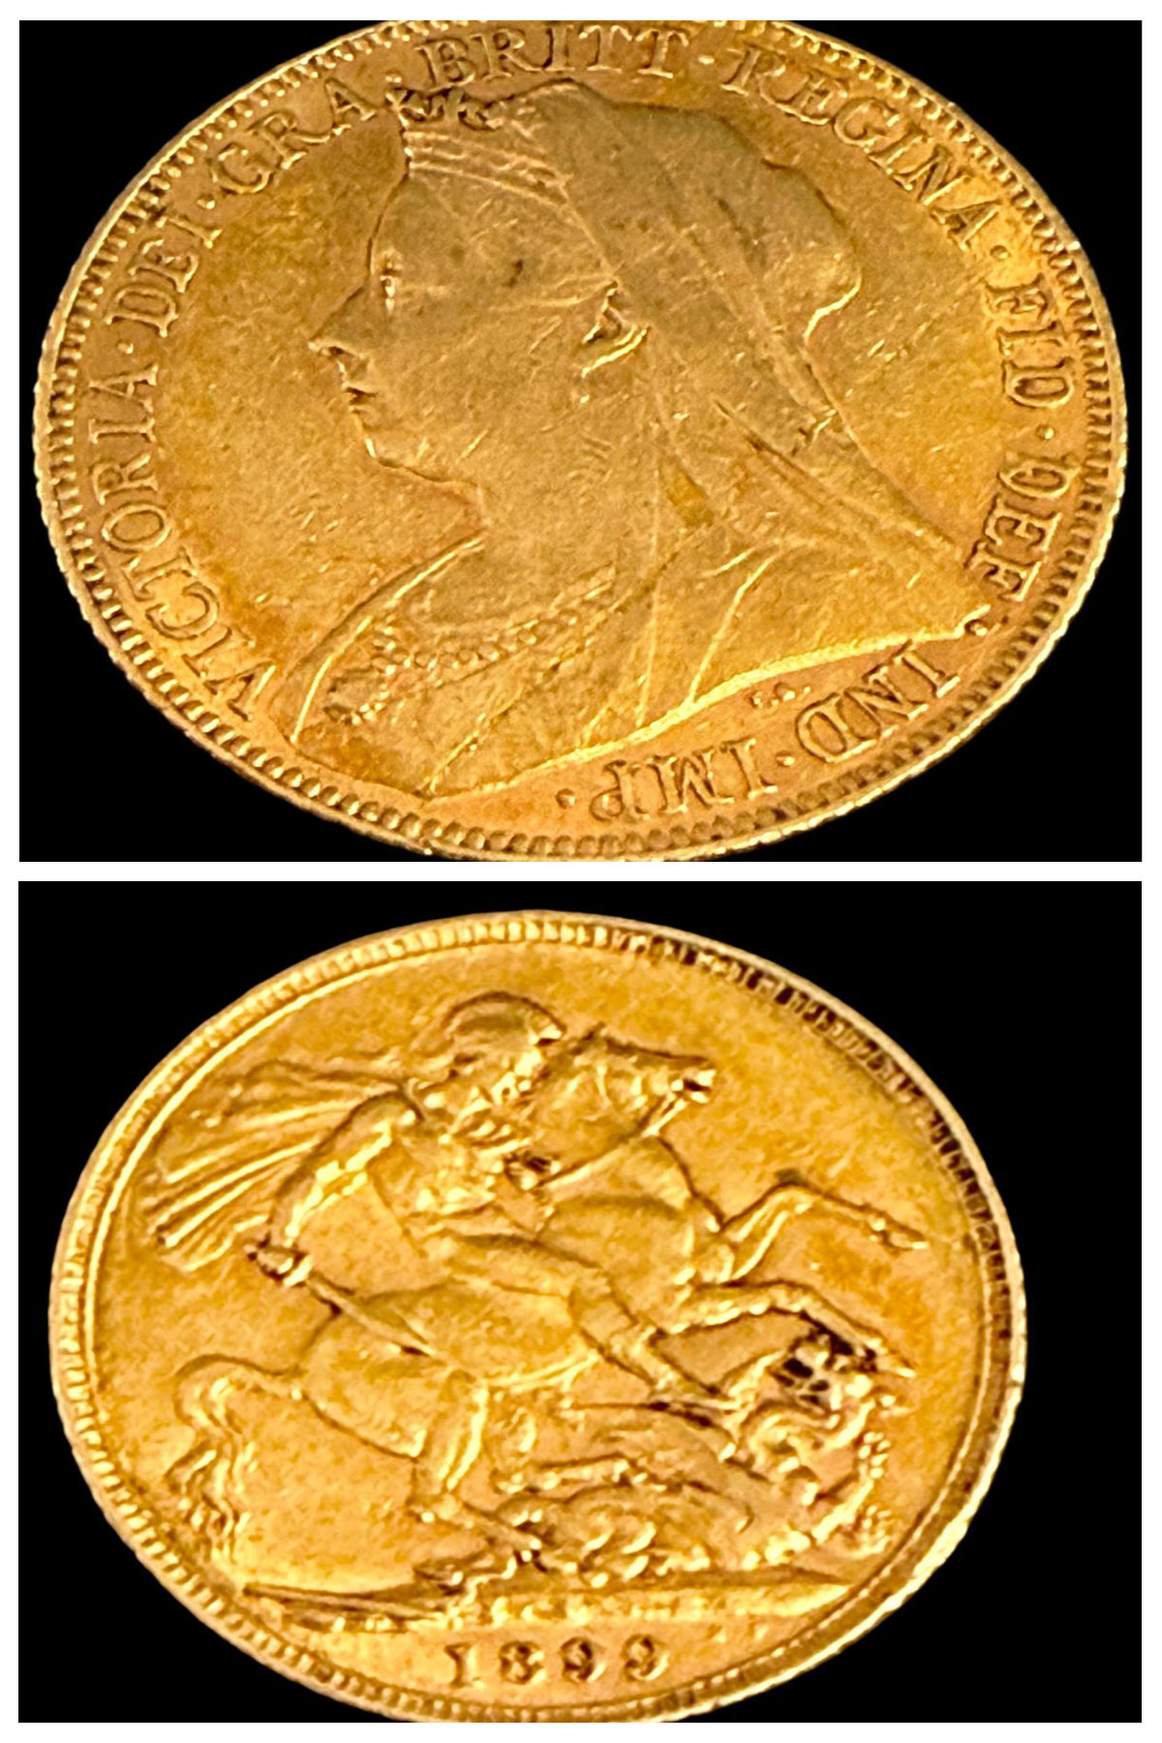
Lot 251 – A Victorian 1899 sovereign with jubilee head. Est: £450-£550
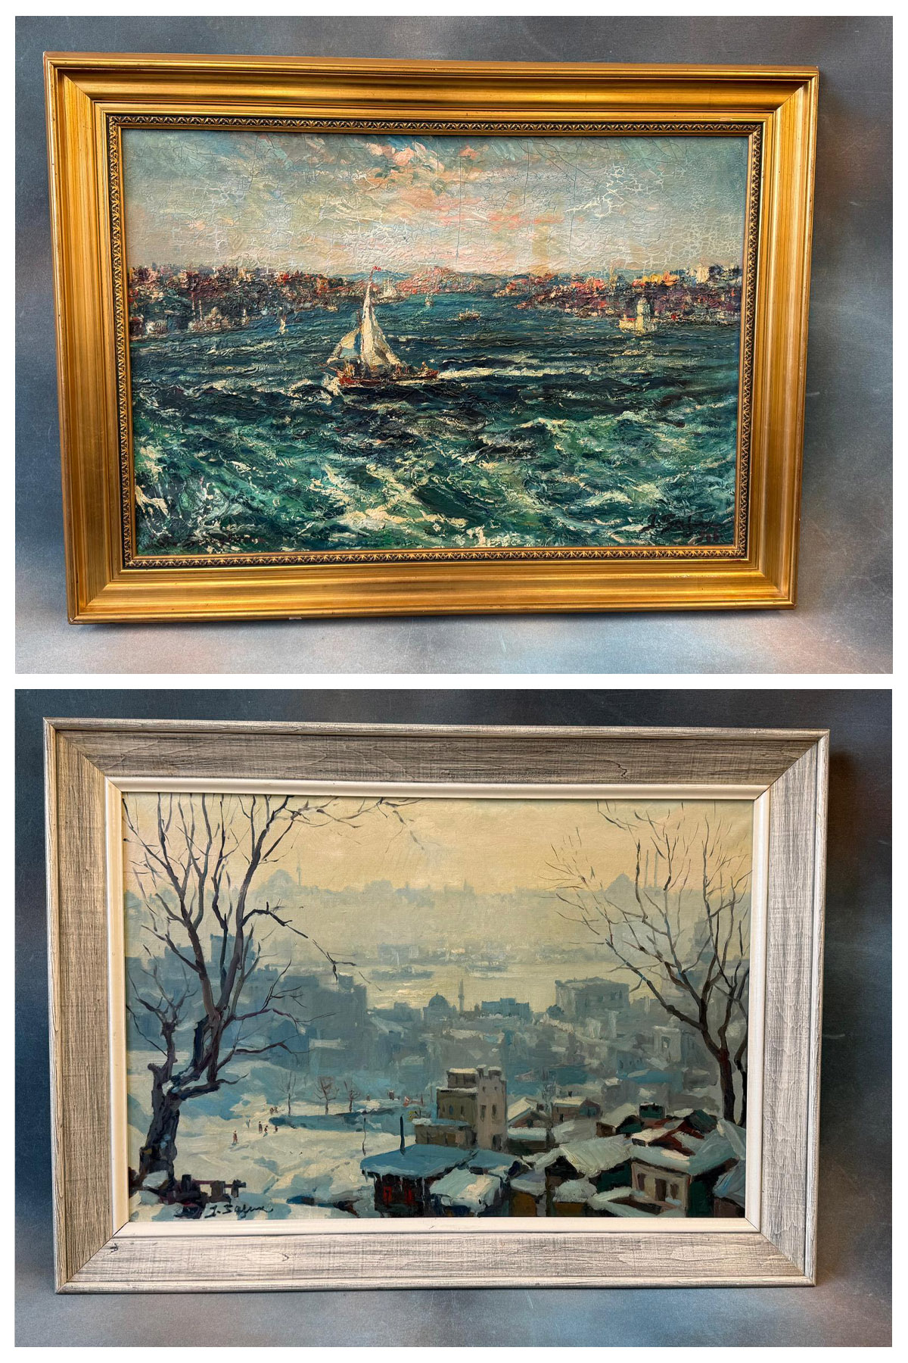
Lot 265 – Ibrahim Safi (1898-1983) – A yacht at sea near Istanbul, oil on canvas.
Est: £1200-£1500
Lot 264 – Ibrahim Safi (1898-1983) – View over a city, oil on canvas. Est: £1500-£1800

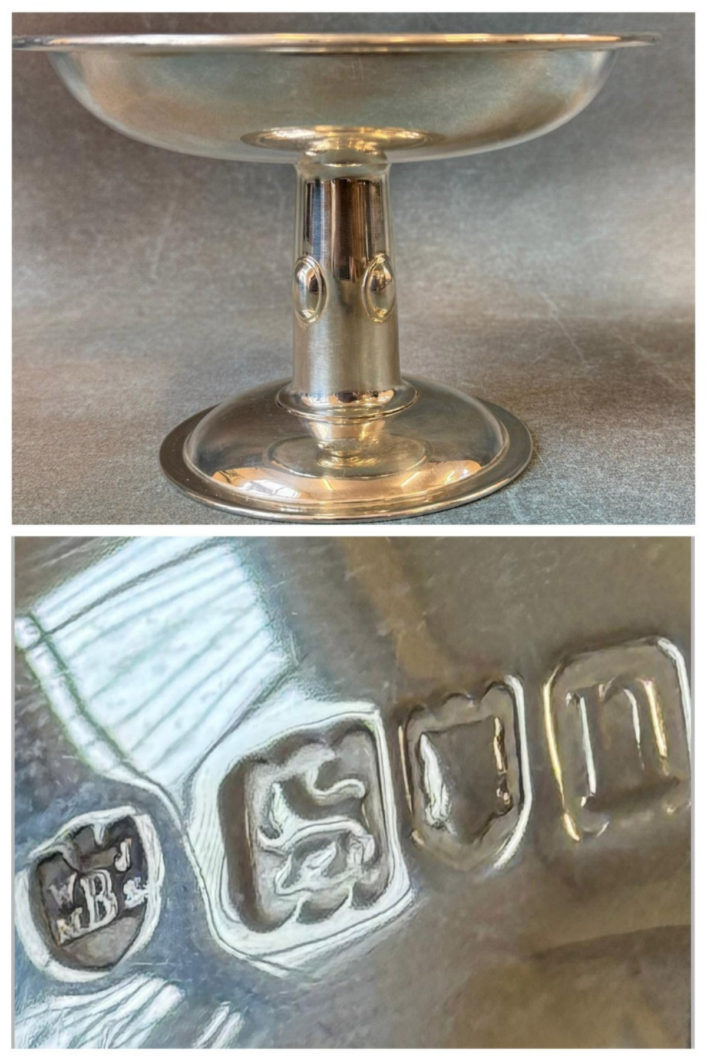
Lot 1 – An Edward VII silver tazza, approx. 12oz. Est: £250-£350
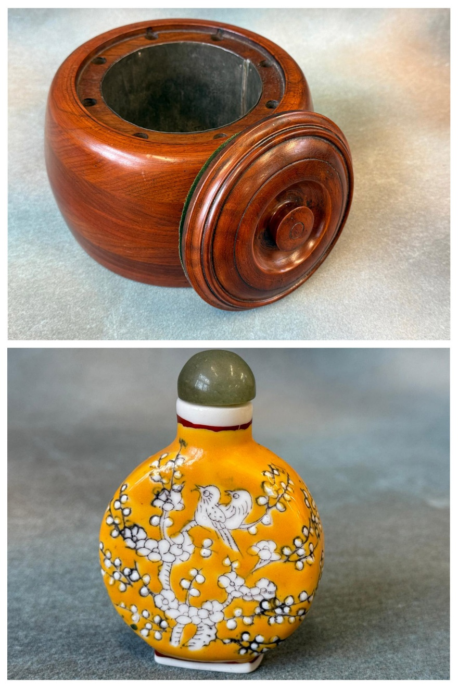
Lot 141 – A WWI mahogany aeroplane propeller hub, adapted into an ornamental container. Est: £40-£60
Lot 75 – A Chinese famille jeune scent bottle. Est: £150-£200
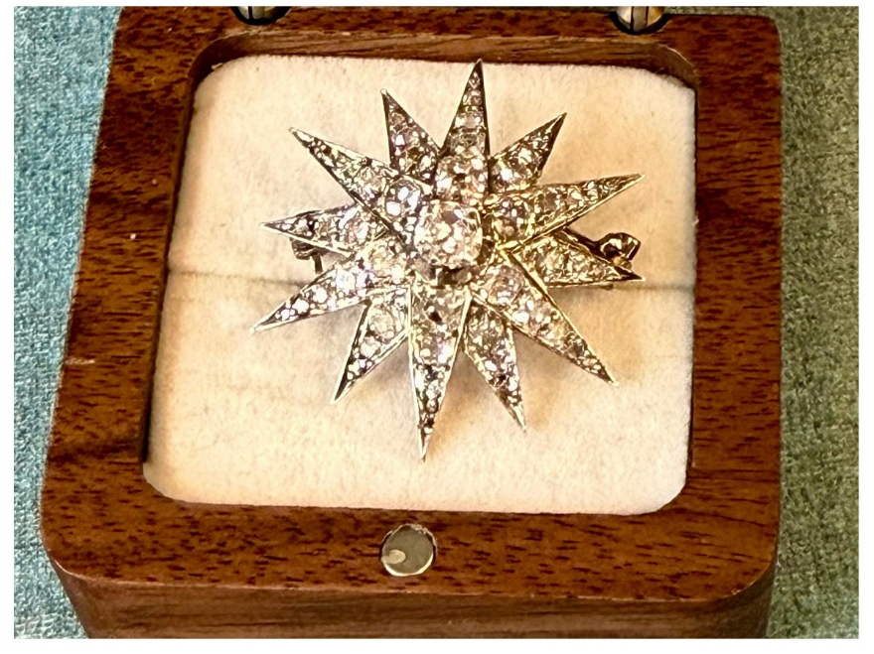
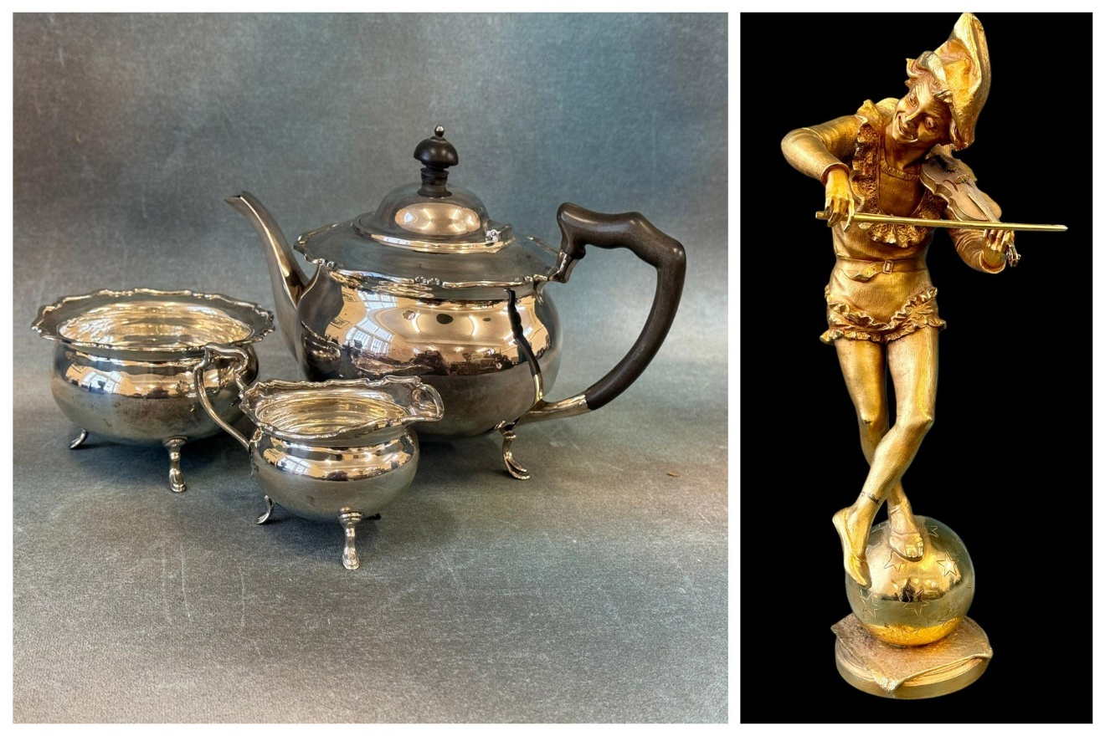
Lot 228 – A George V silver three-piece tea set. Est: £400-£600
Lot 310 – Jules Weyns (1849-1925) - A gilt bronze figure. Est: £600-£800
Lot 282 – A Victorian star brooch/pendant, set 49 diamonds. Est: £1800-£2200
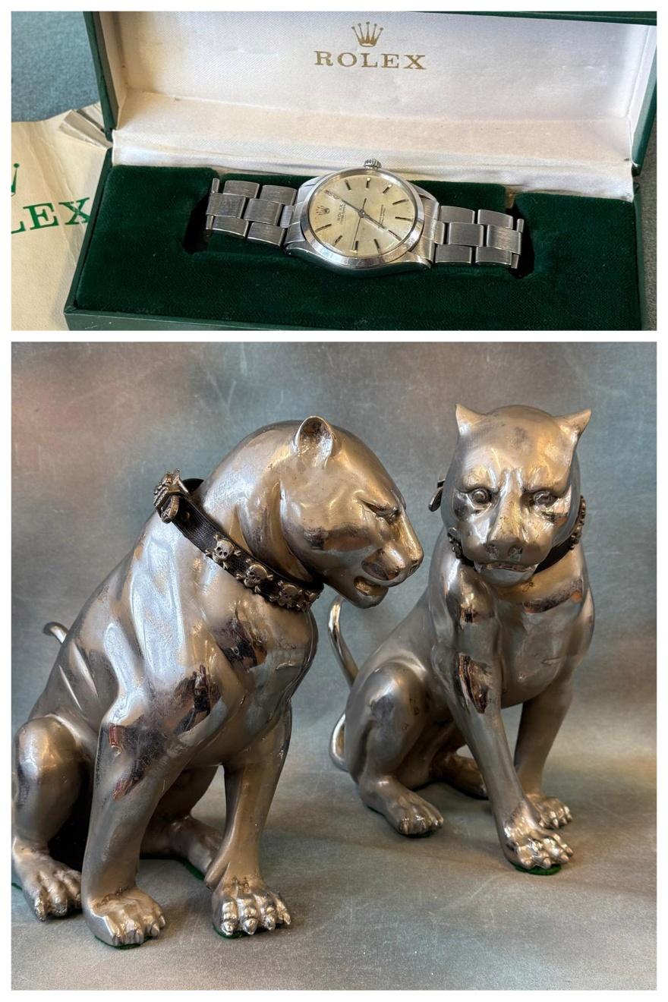
Lot 324 – A Rolex Oyster Perpetual stainless steel wristwatch. Est: £1500-£2000
Lot 301 – A pair of art-deco style chrome-plated figures of seated panthers, each 39cm high. Est: £3500-£4500
164. | A George V silver water jug with ebonised handle and finial, London 1934, a silver card case of purse form, Birmingham 1916, a silver spill vase, Birmingham 1907, a small silver-plated epergne, a pair of salts, and two silver-plated cream jugs, approx. 15oz weighable (8). | £200-£300
165. | A Dartington glass Nelson Bicentennial rummer to commemorate the Battle of Trafalgar, 14.5cm high, and a further commemorative rummer for the marriage of the Prince of Wales and Lady Diana Spencer, 18cm high (2). | £30-£50
166. | After Bayly - A Hundreds map of the lowey of Tonbridge, 50cm x 39cm. | £30-£50
167. | A Victorian rosewood whatnot fitted three shelves, drawer to base, with open fret carved gallery, 71cm wide x 119cm high. | £80-£120
168. | A pair of glass and gilt-metal table lamps with shades, 55cm high (2). | £30-£50
169. | A continental porcelain and gilt-brass vase-form table lamp decorated flowers, 78cm high, with shade. | £30-£50
170. | John Gale (b.1964) - "Southern Ocean Wanderer", oil on board, 94cm x 72cm. | £80-£100
171. | An Anatolian wool rug with three central medallions, red ground wide multi-coloured border, 75cm x 130cm. | £30-£50
172. | Attributed to Thomas Alom (1894-1872) - "View of Messina, Sicily", watercolour, gallery label verso, 18.5cm x 26cm. | £40-£60
173. | Queen Anne style mahogany swing-frame toilet mirror, with three drawers to base, 42cm wide. | £30-£50
174. | Victorian School - Fishing smack coming ashore, oil on canvas, indistinctly signed, 43cm x 87cm, in gilt frame, 62cm x 107cm. | £60-£80
175. | WITHDRAWN LOT
176. | WITHDRAWN LOT
177. | A panelled oak coffer with moulded decoration on block feet, 83cm wide. | £40-£60
178. | An 18th century mahogany low boy, fitted two drawers with replacement shaped plate handles, on cabriole legs and pad feet, 77cm wide. | £40-£60
179. | An Edwardian inlaid mahogany display cabinet of shaped outline with astragal glazed door, on six square tapering legs, united by a shelf stretcher, 115cm wide x 117cm high. | £30-£50
180. | An Edwardian inlaid mahogany cylinder bureau with brass gallery top, the cylinder enclosing a fitted interior, two drawers above and one drawer below, on four square tapering legs united by a stretcher, 77cm wide, stamped Maple & Co. | £200-£300
181. | A Victorian walnut extending dining table with wind out action and canted corners on heavy turned and reeded legs, with two extra leaves, 118cm x 234cm extended, together with a set of six early Victorian rail-back dining chairs, and a similarly upholstered grandfather chair (8). | £180-£220
182. | A bronze lacquered and pierced Chinese-style lamp 51.5cm high, and a similar ditto with relief decoration 31cm high (2). | £30-£50
183. | A carved and painted figure of Tintin with his dog Snowy, 33cm high, and a further figure of Captain Haddock, 35cm high (2). | £20-£30
184. | Wendy Reeves - "Highland Scene 1", pastel, 37cm x 55cm. | £80-£100
185. | A Japanese porcelain figure of Kannon or Guanyin, 21cm high. | £40-£60
186. | A single volume of "Browning's Poems" with binding for Gillingham Grammar School, Dorset. | £30-£50
187. | A single volume of "Percy McCoid's History of English Furniture, The Age of Walnut", dated 1919, in red binding, together with an Antique Dealers and Collectors Guide magazine, September 1946 (2). | £40-£60
188. | Wendy Reeves - Mallard ducks flying over a lake, oil on canvas, 50cm x 75cm. | £100-£150
189. | A George V silver vinaigrette by "Robb Ballater" Edinburgh 1911, approx. .88oz, a silver photo frame, a silver-plated photograph frame, a silver-plated ladle, a set of silver-plated tea knives, a silver pillbox, and a pair of salad servers (qty). | £120-£180
190. | An early Victorian mahogany stool on turned and ringed legs, 33cm wide. | £20-£30
191. | Pieter Lodewyck Kluyver (Dutch, 1816-1900) - A rural landscape, a woman to the fore, before cottages amidst trees, signed, oil on mahogany panel, 36cm x 51cm, in decorative gilt frame 49cm x 63cm. | £700-£1000
192. | Attributed to Margaret Lady Handley - a 19th century watercolour, "Stanborough Hill, Farnborough" inscribed verso, 17cm x 26cm. | £20-£30
193. | Chinese School - Coloured lithograph of humans and horses in a landscape, 95cm x 35cm. | £20-£30
194. | After Robert Hainard - A pair of Fulmars, lithograph, no 12/58, 39cm x 48cm, and another "Star Attacker", 38cm x 48cm (2). | £20-£30
195. | John Speede - "Map of Merionethshire" 42cm x 56cm, together with a further map by Robert Austen, of Rye and the Romney Marsh 46cm x 29cm (2). | £60-£80
196. | After Utagawa Hiroshige (1797-1858) - Woodblock print "Evening Cherry on Mount Yoshino", signed on mount, published by Shima Art Co. Ltd. New York & Tokyo, stamp verso, 13cm x 18cm, another from the Fifty Three Stations of the Tokaido Series, 3rd Station, "Kanagawa" embankment, 13cm x 18cm, and four others "Wild Geese alighting at Katata", "Evening Glow at Seta Bridge", "Suma Beach by Moonlight", and "Cherry Blossom near Arachiyama", mounted but unframed (6). | £60-£80
197. | After Chokosai Eisho - Small woodblock print, possibly of Courtesan Hanabito of the ogi-ya brothel, 13cm x 9cm, another after Kitagawa Utamaro - two geisha and a porter in the wind and rain, 9cm x 14cm, another after Sachimoto Hanjiro - "Palanquins by Evening", 13cm x 18cm, and another after Kitagawa Utamaro - "Saio Heads", 18cm x 12cm, mounted and signed, but unframed, contained in a folder stamped "Der Ling oriental shop carmel, California" (4). | £40-£60
198. | Two Balinese carved-wood and painted figures of male and female characters, 32cm & 30cm high respectively (2). | £60-£80
199. | A 20th century Korean stained-wood and brass-mounted chest with hinged fall front, 88cm wide. | £70-£100
200. | A smaller 20th century Korean stained-wood cabinet, enclosed by two doors with brass mounts, 58cm wide x 63cm high. | £50-£70
201. | A reproduction mahogany music canterbury, fitted single drawer, 47cm wide. | £20-£30
202. | A Regency-style part-inlaid mahogany sofa table with rounded corners, fitted two drawers and two simulated drawers, 146cm wide extended. | £60-£80
203. | A Regency mahogany part-inlaid toilet mirror, on animal feet, 58cm wide. | £20-£30
204. | A Regency mahogany work box 30cm wide, and three oriental-style lacquered boxes, one with mother-of-pearl and simulated bone decoration (4). | £40-£60
205. | A Queen Anne style stained beech and walnut child's elbow chair, on cabriole legs and claw and ball feet. | £60-£80
206. | A set of ten Italian Majolica plates with yellow borders, together with two pedestal bowls, and two pear-shaped dishes (14). | £60-£80
207. | A Nasrabad Hamadan rug, red round, wide border, 104cm x 145cm. | £60-£80
208. | A Bokhara rug with twelve guls on red ground, with wide multi-banded border, 100cm x 151cm. | £40-£60
209. | After Giorgio de Chirico - "The Divine Horses of Achilles, Balios and Xanthos", lithograph, 39cm x 29cm. | £50-£70
210. | An iron "Tammany Bank" figural money bank, depicting a seated man, possibly a corrupt politician, 14.5cm high, a.f. to paintwork, and mechanism. | £80-£120
211. | A Murano Millefiori glass paperweight, dated 1846, 7cm in diameter. | £40-£60
212. | A suite of silver-plated, stainless steel, and bone-handled table cutlery, by Garrard & Co Ltd, six place settings, in lined oak canteen, 49 pieces, presented by the Marley Tile Company. | £40-£60
213. | A pair of 19th century Chinese blue and white two-handled vases, decorated peacocks and dragons, stylised handles, each 35.5cm high (2). | £200-£300
214. | A 19th century cylinder-shaped vase, decorated two figural panels, 30cm high, a.f. | £100-£150
215. | A Cantonese blue and white two-handled vase, with scrolled and relief decoration, stylised handles, 35cm high, a.f. | £70-£100
216. | A set of French "Le Couvert Francais" white-metal cutlery comprising: large ladle, 12 tablespoons, 12 table forks, and 11 teaspoons, in lined case (one teaspoon missing), together with loose white-metal handled and stainless steel knives (qty). | £200-£300
217. | A Gray Nicholls cricket bat signed by the England and Pakistan cricket teams from 1962, including Ted Dexter, Colin Cowdrey, Ken Barrington, and others, together with another bat signed by Kent Cricket Team, including Matt Walker, Graham Dilley, Neil Taylor, Nigel Llong, and Matt Fleming, both a.f. (2). | £40-£60
218. | An England 2005 One Day cricket shirt signed by Geraint Jones, of Kent and England, in modern frame, 105cm x 86cm. | £40-£60
219. | An Australian One Day International cricket shirt, signed by Andrew Symonds of Australia and Kent, and other members of the 2003 World Cup winning squad, including Ricky Ponting, Adam Gilchrist, Michael Bevan, Glenn McGrath, Jason Gillespie, and Shane Warne, in mahogany frame, 76cm x 87cm, a.f. | £150-£180
220. | V. Temple - Images of five swan heads and bill markings, pencil, ink and colour wash, 25cm x 36cm, in oak frame. | £30-£50
221. | After Demetre Chiparus - gilt bronzed, and polychrome enamelled figure of woman fanning her dress, on metal square base, 49cm high. | £60-£80
222. | A decorative brass bust of Buddha, 37cm high, and a carved wood West African mask, a.f., 29cm high (2). | £30-£50
223. | A framed "Gutta Percha" golf ball c.1850, a Dunlop card, and a club head "The President, designed by W.G. Roy in 1879", 39cm x 24cm. | £40-£60
224. | Day and Son, after Walters - "The Great Eastern Steam Ship" proof lithograph, 38cm x 61cm, a smaller ditto "The Steam Ship Liverpool", 39cm x 50cm, and a further print of "The Great Eastern", 25cm x 38cm (3). | £30-£50
225. | A small tabletop brush in a George V silver coal hod shaped holder, London 1921, a silver cigarette case Birmingham 1918, a small dish Sheffield 1910, a butter shell Birmingham 1901, a silver vesta case, a small capstan inkwell a.f., a silver-backed hairbrush, a silver thimble, together with a silver-plated miniature troika, and several other small silver and silver-plated objects, approx. 8oz weighable (qty). | £80-£120
226. | A pair of Edwardian silver spill vases, Birmingham 1902, a pair of George V silver candlesticks Birmingham 1926, a set of five pierced silver-plated napkin rings, and a further pair of napkin rings, all a.f. (11). | £50-£70
227. | A George V silver small tazza with pierced edge Birmingham 1912, a late Victorian decorative silver sugar bowl Birmingham 1876, and a George V silver sugar caster by Adie Brothers Birmingham 1926, approx. 7oz weighable (3). | £100-£150
228. | A George V silver three-piece tea set with scalloped edge, ebonised finial and handle, maker Henry Adams, Sheffield 1916, approx. 25oz (3). | £400-£600
229. | A silver-plated cruet stand with mixed bottles and jars, one with silver top a.f., a silver-plated hot water jug, together with two part-sets of silver-plated and bone-handled fish knives and forks, a set of silver-plated tea knives, and other silver-plated cutlery, in four cases (7). | £40-£60
230. | A Royal Crown Derby part afternoon tea set comprising: 12 cups, 12 saucers, 12 side plates, a milk jug, a slop bowl, and two bread and butter plates, one cup a.f.,(40 pieces). | £50-£70
231. | A Poole pottery traditional-ware table lamp base, two small similar dishes, a green glazed bowl, and five further pieces in different patterns (9). | £30-£50
232. | Two 9ct gold ladies' "Hamilton" wristwatches, one on 9ct gold strap, other on gold-plated strap, a gents' Smiths wristwatch with presentation inscription from British Rail, five further lady's wristwatches, and three compacts (11). | £100-£150
233. | A 9ct gold half-hunter cased pocket watch, keyless-wound movement, white enamelled dial inscribed Thomas Russell & Son Liverpool, 7cm in diameter. | £200-£300
234. | An 18ct gold small curb-link watch chain, approx. 27g, together with a gold-plated hunter-cased pocket watch by "Waltham", keyless wound movement (2). | £600-£800
235. | Basar (20th century) - Portrait of old Indonesian woman, oil on canvas, 69cm x 49cm. | £40-£60
236. | A 1930s style double-fronted dolls house, 110cm wide, together with a quantity of furniture. | £30-£50
237. | A small chest of watch movements and cases, some tools, clock cases, and parts, together with clock books (4). | £30-£50
238. | A number of 400-day clocks, together with glass domes, clock parts, and accessories (qty). | £30-£50
239. | A quantity of Art-Deco style and other mantel clocks and cases, 400-day clocks, electric clocks, and some accessories (4 boxes). | £30-£50
240. | A quantity of clock tools, clock parts, and other accessories (3 boxes). | £25-£40
241. | A Type 502A oscilloscope, an electrical oscillator, an Admiralty insulation tester, and other electrical testing equipment (qty). | £20-£30
242. | A Type 546 oscilloscope, various electrical testing meters, a transistor tester, and other related equipment (qty). | £30-£50
243. | A quantity of art-deco style mantel clocks and cases, 400-day clocks, and parts (3 boxes). | £20-£30
244. | A quantity of mantel clocks, cases, glass domes, 400-day clocks, and parts (5 boxes). | £30-£50
245. | Two slate and marble-cased mantel timepieces, one missing pendulum, together with mantel clocks, 400-day clock, cases, parts, and tools (qty). | £30-£50
246. | A quantity of clock tools, tool boxes and chests, a testing meter, and other accessories (qty). | £20-£30
247. | An Olympus OM-2 camera, a tripod, other cameras and equipment, plate camera bodies, and accessories (qty). | £30-£50
248. | Two boxes containing testing meters, some in bakelite cases, clock tools, and other accessories for electric clocks, and instruments (2). | £20-£30
249. | A small oscilloscope, other testing equipment, and accessories (qty). | £30-£50
250. | An 18ct gold amethyst and seed-pearl oval-form brooch, 3cm in diameter, approx. 9.5g gross, boxed. | £450-£550
251. | A Victorian 1899 sovereign with jubilee head. | £450-£550
252. | A 14ct gold dress ring, set a yellow topaz, approx. 2.9g gross. | £150-£200
253. | An "Accurist" ladies 9ct gold wristwatch, on link strap, approx. 8.7g, a.f. | £250-£350
254. | A 9ct gold brooch set a Victorian 1887 sovereign, behind convex glass, approx. 16.7g gross. | £550-£650
255. | A three-coin brooch comprising: a German ten mark coin, a Prussian ten mark coin, and a further German ten mark coin, on bar fitting. | £250-£350
256. | A metalware heart-shape brooch "unmarked", a small pewter shield earring, a shall-shaped metalware scarf clip, and three Elizabeth II coronation crowns (6). | £40-£60
257. | A 14ct gold cased gents open-faced keyless-wound pocket watch, with white enamel dial, Swiss movement, approx. 81g gross, glass missing. | £300-£400
258. | A yellow-metal bangle with two flowerheads set a small diamond and a small ruby. | £250-£350
259. | A yellow-metal link bracelet, a pair of 9ct gold loop earrings, a ball necklace on slender link chain, a 22ct gold slender wedding band, a further band, a gold and enamelled "Erinnerung" locket, two moon-shaped ear clips, an amber-coloured pendant, a costume earring, a George VI threepenny coin 1937, a German 50 pfennig coin, and a Dutch 10 cent coin 1897, approx. 8.4g weighable (14). | £270-£290
260. | An Edward VII 1909 gold sovereign. | £450-£550
261. | A ladies 14ct gold fob watch (in poor condition), an oval enamelled locket (unmarked), a turquoise-set dress ring, a gold-plated Elizabeth II coronation crown (boxed), a zircon-set crescent brooch, a marcasite brooch, a baby brooch, a pair of metal Aztec-pattern earrings, two single marcasite ear clips, a Victorian 1845 crown, a 1935 Silver Jubilee crown, and a 1958 half-crown (13). | £180-£220
262. | A gents 9ct gold signet ring, a gent's wristwatch in 9ct gold case (a.f.), a ladies metal fob watch, a 14ct gold dress ring, together with gents metalware cufflinks, a number of general coins, and a Parker rollaball pen, approx. 7g weighable (qty). | £150-£200
263. | Margaret Foreman - Portrait of seated lady, oil on canvas, 34cm x 24cm, in moulded frame, 46cm x 36cm, faintly signed. | £200-£300
264. | Ibrahim Safi (1898-1983) - View over a city, possibly Istanbul, oil on canvas, signed bottom left, 48cm x 71cm, in modern frame, 62cm x 85cm. | £1500-£1800
265. | Ibrahim Safi (1898-1983) - A yacht at sea near Istanbul, oil on canvas, laid on board, 48cm x 71cm, in modern gilt frame, 65cm x 87cm, signed bottom right. | £1200-£1500
266. | A late 19th century slate mantle clock case with a movement together with three boxes of electrical and mechanical clocks, and an American wall clock (a qty). | £30-£50
267. | Six slate clock cases, two with movements, a 400 day clock in four glass case, and a small tool chest (8). | £20-£30
268. | A monocular microscope in wood box a.f., a box of magic lantern slides, together with a quantity of clock parts and tools various. | £30-£50
269. | Four boxes of electrical and mechanical mantel clocks and time pieces, some in the art deco style (4). | £30-£50
270. | A rectangular oak wall clock with striking movement by 'Guildhall of Perryvale', together with 5 boxes of mantel and other clocks, some tools and spare parts (6). | £30-£50
271. | A black lacquered binocular microscope by 'Cooke, Troughton, and Simms Limited', together with a further binocular microscope spare lenses, tools and testing meters and other pieces (a qty). | £30-£50
272. | A 'mutual conductance' model 4S D valve tester, an amp and volt meter, a circuit analyzer, a quantity of transistor valves, and some other similar equipment. | £50-£70
273. | Three boxes of 400 day clocks, tools and spare parts, together with a number of clock domes (4 boxes). | £30-£50
274. | An Olympus IS2000 SLR camera, with digital screen, together with other cameras, accessories, lenses and a tripod. | £40-£60
275. | Six boxes of clocks various including mantel and 400 day clocks (6). | £50-£70
276. | A 'Wayne Kerr laboratories limited', component bridge, a 'regloscope', an electric tuning fork, a pulse generator and other electrical instruments (a qty). | £40-£60
277. | A late 19th century burr veneered mantel clock with French striking movement, and five other boxes of mantel, 400 day, and other clocks, together with a number of glass domes. | £50-£70
278. | A Victorian silver inkstand, with ribbed and gadrooned edge, London 1898, with inscription, 'Captain R. Startin OBE AM, Royal Navy DNE Bath, 6 October 1939 to 15 June 1946', on four decorative shell design feet, 24cm wide approx 5oz, with glass ink bottle. | £100-£150
279. | A 20th Century diamond and cultured pearl circular brooch, total stone weight approx 1.32 carats, in box. | £800-£1000
280. | A citrine set single stone brooch, approx 71.06 carats, believed tested as 15 carat gold. | £200-£300
281. | A 20th Century sapphire and diamond naval crown brooch, set 8 diamonds and 8 sapphires, diamond weight approx .16 carats. | £300-£500
282. | A Victorian unmarked star brooch/pendant, set 49 diamonds, approx 3.6 carats overall, 3cm in diameter, believed tested as 15 carat gold. | £1800-£2200
283. | A pair of twentieth century yellow metal citrine ear studs stone weight approx 4.30 carats, and another pair of ear studs. | £120-£180
284. | A 20th Century flower spray brooch, set a zircon and other stones, believed of Sri Lankan  manufacture. | £600-£800
285. | A 14 carat gold and platinum naval crown bar brooch set sapphire and diamonds, gross weight 3.2 grammes. | £150-£200
286. | A metal name bar brooch 'Anne', set 26 rose cut diamonds. 3cm wide. | £150-£200
287. | Flower spray broach set white sapphires and rubies 6cm long. | £80-£100
288. | A pair of cultured pearl ear studs and a smaller pair of ear studs. | £40-£60
289. | A yellow metal circular pearl and white sapphire brooch, 4.1cm in diameter. | £80-£100
290. | An amethyst set brooch of celtic revival style, 4.5cm wide. | £180-£220
291. | A white and green sapphire brooch in criss cross pattern, the single green sapphire approx 6.3 carats and 5 white sapphires, approx 7.8 grams gross. | £250-£300
292. | A 20th Century foliate bar brooch set 5 sapphires and 6 diamonds, approx 0.18 carats. | £300-£500
293. | A pair of 20th Century jadeite drop earrings in cabochon style. | £200-£300
294. | A pair of amethyst single stone ear studs, yellow metal unmarked. | £50-£80
295. | A loose trap cut citrine, approx 4.62 carats. | £80-£100
296. | An emerald cut yellow sapphire approx 4.66 carats. | £200-£300
297. | An oval cut yellow tourmaline, approx 1.55 carats. | £60-£80
298. | 4 oval green sapphires approx 8.1 carats overall (4). | £150-£200
299. | Fourteen oval cut garnets, mixed sizes (14). | £40-£60
300. | Three yellow metal intaglio cut seal fobs (3). | £80-£120
301. | A pair of art-deco style chrome-plated figures of seated panthers, each with a Versace boot belt collar, believed to have been part of a set of four, from a Hollywood mansion, in the US, each 39cm high. (2). | £3500-£4500
302. | A Blenko design sapphire blue glass vase, after Don Shepherd, on a stepped black glass square-form base, 31cm high. | £40-£60
303. | A "Waldor & Co" lady's stainless steel wristwatch, in branded box, a "Trussardi" ditto wristwatch in branded box, two "Gossip" watches, a "DMQ" lady's wristwatch in gold-plated and stainless steel case, decorated paste stones, boxed, together with seven other lady's quartz watches unboxed (12). | £70-£100
304. | A quantity of decorative and costume jewellery by August Woods, Miranda Ko, Mint Velvet, Komplatt, and other modern brands, some boxed, and some loose (qty). | £60-£80
305. | Sandra Kennedy - "Edge of Winter", oil on canvas, 80cm x 80cm, exhibition label verso. | £20-£30
306. | An early 20th century milk-glass tile with Victorian-school painting of children playing on a gate, 12cm x 16cm. | £20-£30
307. | Gani Fakeye - A Nigerian carved wood figure of a Yorube huntsman, 34cm high. | £30-£50
308. | A Chinese carved wood figure of Qing dynasty style, probably for worship, remains of custom seal to back, 27cm high, together with a smaller Chinese deity figure, 19cm high, and a small carved wood bust, head of Buddha, 16cm high (3). | £60-£80
309. | A pair of pop shoe Converse-style high-top trainers, after the design by Peter Blake, size 7.5, in plain white, part branded box. | £40-£60
310. | Jules Weyns (1849-1925) - A gilt bronze figure of a violinist standing on a ball, in a pose, 53cm high. Ex-lot 309 22nd Jan 2025. | £600-£800
311. | A small rent ledger dating from 1892 to 1924, some entries with postage stamp receipts. | £30-£50
312. | A colourwash film poster for the 1939 film "The Rains Came", starring Myrna Loy, Tyrone Power, and George Brent, also inscribed "For Michael Courtenay, from Sandy Wilson", 54cm x 75cm, and Sandy Wilson - costume design for a 1920s flapper dress, ink, crayon, and colourwash, 30.5cm x 40.5cm (2). | £40-£60
313. | After Elizabeth Vigee Le Brun (1755-1842) - Portrait of the artist, in a straw hat, oil on canvas, unsigned, unframed, 53cm x 42cm. | £300-£400
314. | Attributed to Count Amedeo Preziosi (Maltese 1816-1882) - Set of four studies of men in national costume "Albanian", "Water Seller (Cairo)", "Persian", and an untitled street food seller, possibly Turkish, ink and colourwash, unsigned, each approx. 21cm x 16cm (4). | £800-£1000
315. | An early 20th century mahogany station wall timepiece, with repainted cream dial, 39cm in diameter. | £80-£100
316. | A mahogany and silver-plated three bottle tantalus, with lockable top, 34cm wide, slightly a.f. | £60-£80
317. | A pewter quart tankard, and cover a.f., a quart jug, together with various pewter mugs, and a goblet (10). | £40-£60
318. | A part suite of silver-plated and bone-handled cutlery, in an art-deco style oak canteen, Winegartens label verso, 37cm wide (incomplete). | £40-£60
319. | A part suite of "Viners Parish Collection" beaded-edge silver-plated cutlery, in simulated mahogany canteen, 45cm wide (57 pieces of 58). | £40-£60
320. | Two silver-plated bottle coasters, a small quantity of silver-plated tourist spoons, and some other loose cutlery (qty). | £30-£50
321. | A part suite of Edinburgh Crystal thistle-pattern drinking glasses, approx. 24 pieces. | £60-£80
322. | A Poole pottery hors d'oeuvres set, on circular wood tray, 30cm in diameter, a shaped plant holder, and a mid-century fruit bowl, cracked (3). | £60-£80
323. | A part set of silver-plated loose cutlery, a pair of silver-plated and bone-handled fish servers, with silver ferrules, in lined case, a silver-handled cake slice and knife set, boxed, and other cutlery, various (qty). | £50-£70
324. | A Rolex Oyster Perpetual stainless steel wristwatch, stamped 7835, on oyster strap, the oyster swimpruf hang tag numbered 1027/7835, on one side, and 2470064 on other side, in green box, with booklet, and green outer box. | £1500-£2000
325. | A yellow-coloured metal laurel pendant/brooch, set 10 sapphires. | £40-£60
326. | Four boxes of clock movements, tools, chapter rings, and other related items (4). | £30-£50
327. | Three boxes of mantel clocks, movements, tools, and other related items (3). | £30-£50

END OF SALE
UPCOMING DATES

Auctions

Wednesday 21st January 2026
Wednesday 18th March 2026
Wednesday 13th May 2026
Wednesday 15th July 2026
Wednesday 9th September 2026
Wednesday 11th November 2026

Viewing on Monday and day before sale from 10am to 5pm
and on morning of sale from 9am to 10.30am
Sale commences at 11am

Valuation Days

Wednesday 26th November 2025
Wednesday 17th December 2025
Wednesday 28th January 2026
Wednesday 25th February 2026
Wednesday 25th March 2026
Wednesday 22nd April 2026
Wednesday 20th May 2026
Wednesday 17th June 2026
Wednesday 19th August 2026
Wednesday 16th September 2026
Wednesday 14th October 2026
Wednesday 18th November 2026
Wednesday 9th December 2026

Sevenoaks Saleroom, Argyle Road,
Sevenoaks TN13 1HJ
Between 11am - 4pm

Notes

