Welcome to Ibbett Mosely Auctions
Wednesday 9th March 2022 Auction Catalogue

This sale will also be held online at www.easyliveauction.com/ibbettmosely/
please visit the website to register or log in to view and bid.

Alternatively, commission bids (bids left ‘on the book’) may be left with us, as well as a limited amount of telephone bids. Please telephone 01732 456731 or email auctions@ibbettmosely.co.uk for further details.

Please be aware there is viewing strictly by appointment only. Any walk-ins will not be allowed viewing. The full catalogue, complete with images of each lot and condition reports will be available at easyliveauction.com/ibbettmosely/

Please telephone 01732 456731 or email auctions@ibbettmosely.co.uk with any questions.

Collection of items is available on Thursday 10th March from 10am - 5pm. Collection of items from 11th March onwards, by prior appointment only.

You are welcome to collect in person, or via your own carrier, but local courier PSP Logistics are available to carry out deliveries of items. Please contact them directly to arrange and pay for delivery.

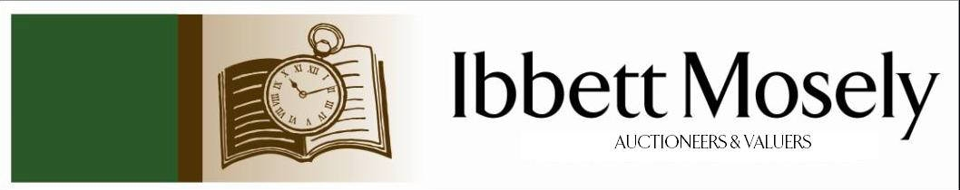

Catalogue of Antique, Edwardian and Victorian
Furniture and Effects
to be Auctioned on

Wednesday 9th March 2022
at 11.00am

IBBETT MOSELY AUCTION ROOMS
ARGYLE ROAD, SEVENOAKS, KENT TN13 1HJ
Via
www.easyliveauction.com/ibbettmosely/

Viewing at Sale Room on:

Monday 7th March
Tuesday 8th March

Between 10.00am –5.00pm.

STRICTLY BY APPOINTMENT ONLY.

Please wear a face covering when in the Saleroom.

Catalogues: £2.00

Auctioneer and Valuer: Alan White FNAVA
Consultant Auctioneer and Valuer: Derek Hodge
Trainee Valuer and Clerk: Nicola Rainsley-Hughes
Auction Clerk and Administrator: Emily Frederick

Please be aware we are not able to offer food or drink at this sale.
1. | A Longines lady's watch in gold plated case, with leather strap, in box, No. 24559621. | £50-£70
2. | A Dunhill gold-plated lighter, made in Switzerland, unboxed, and a Consul gold and black coloured rectangular lighter, both a.f. (2). | £80-£100
3. | A gent's Seiko quartz square form stainless-steel wristwatch, No. 872061, silvered dial, a circular gent's gold-plated and stainless-steel wristwatch, No. 180451, both a.f., a chrome plated cigar cutter, a pair of modern metal ware cufflinks, and a tie stud (6). | £60-£80
4. | A "Met Stone" collection wristwatch, with coloured enamel dial, on leather strap, a gent's Seiko quartz L.C. wristwatch, and three lady's quartz watches, various (5). | £50-£70
5. | A pair of Victorian green button upholstered tub form salon type chairs, on turned legs, with castors (2). | £80-£100
6. | A Victorian mahogany straight-front chest of two short and three long drawers, with knob handles, on plinth base, 11cm wide. | £80-£100
7. | A Victorian mahogany swing-frame toilet mirror, on shaped base, 52cm wide. | £40-£60
8. | An Edwardian inlaid mahogany pot cupboard, fitted a panelled door, on square slightly tapering legs, with castors, 57cm wide, and a mahogany bedroom chair (2). | £40-£60
9. | A let Victorian brass and mesh fender, on animal feet, 117cm wide, and a brass hanging oil lamp, with white glass shade (2). | £30-£50
10. | W.J. Steggles (British, 1908-1997) - landscape, near Lewes, inscribed verso, oil on panel, 32m x38.5cm. | £300-£500
 | 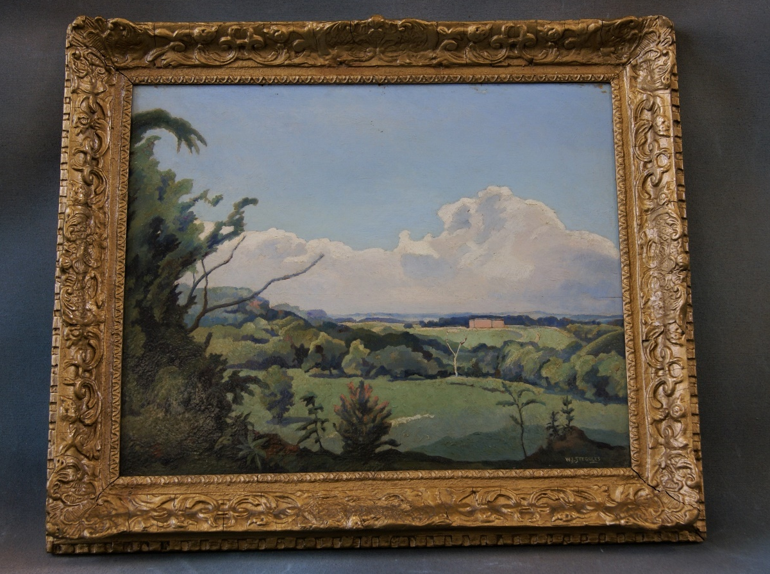 | Lot 10
11. | A mid 20th century metal kitchen cabinet, by "Howden", with open shelves, and enclosed top, a Formica work surface below, four drawers, flanked by two doors, to base, 137cm wide, in need of restoration. | £100-£150
12. | A pair of Edwardian inlaid mahogany corner elbow chairs, with pad seats, on turned tapering legs, and pad feet, united by stretchers. | £60-£80
13. | A silver table fork, a fish knife, a pair of napkin rings, a pair of spill vases, a silver-plated fruit set in case, a silver-plated crumb scoop, and other plated decorative pieces. | £40-£60
14. | A Royal Automobile Club associate members badge, 8cm in diameter. | £30-£50
15. | A quantity of Royal Doulton and Coalport porcelain figures, including "Christmas Day 2005", "Day Dreams" HN1731, "Victoria" HN2471, "Elyse" HN474, "The Last Waltz" HN2315, and "Spring Song", together with others, and boxed (13 overall). | £100-£150
16. | A set of six "Eames DSR" plastic side chairs, in pale grey, by "Vitra" of Germany, on chrome pylon base legs, and black plastic pad feet. | £200-£300
 | 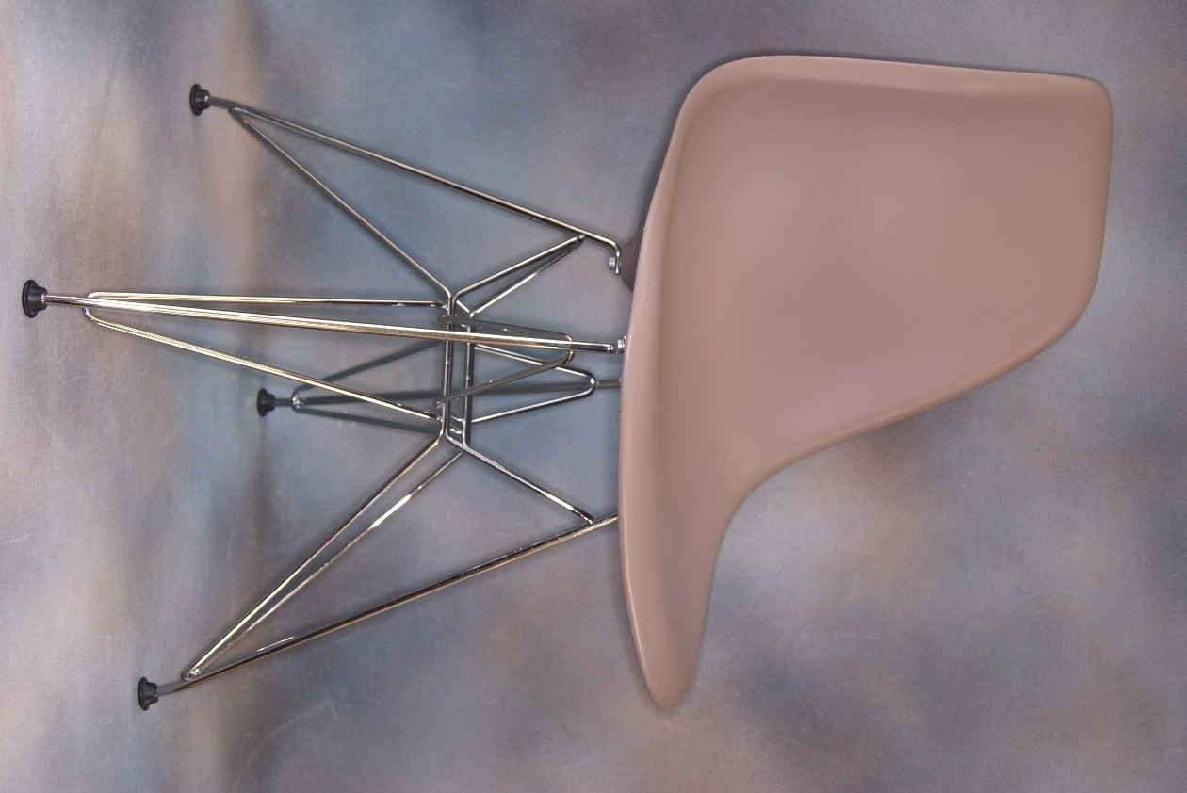 | Lot 16
17. | A small Victorian stamp album, a Lincoln stamp album, and a Triumph stamp album, all containing British, World, and Dependant State stamps (3). | £80-£100
18. | Two one dozen Victorian penny red stamp sets, with plate numbers verso (2). | £40-£50
19. | An Albany china chestnut stallion figure, 27.5cm high. | £30-£50
20. | A pair of Neale & Co bookend cats, 17cm high. | £20-£30
21. | A pair of early 20th century teacups and saucers. | £20-£30
22. | A gilt brass carriage timepiece, in travelling case, 14cm high. | £50-£70
23. | A French Chinese style papier mache and lacquered stamp box, 9cm wide, and an early 20th century shallow pottery dish. | £30-£50
24. | Three Fumival and Sons "Clifton" pattern oval graduated eat platters, and eight dinner plates (11). | £30-£50
25. | A reproduction German army helmet, with camouflaged band, cover, and camouflage net. | £40-£60
26. | A reproduction German army helmet with Wehrmacht decals and camouflaged cover. | £40-£60
27. | A reproduction German coal scuttle helmet with Luftwaffe insignia, together with a German army uniform book, 1939-1945, and a Waffen in Action book. | £40-£60
28. | A Clarice Cliffe style bowl by "A.J. Wilkinson Ltd", "Honeyglaze" ware, 19.5cm in diameter. | £40-£60
29. | J.O.H. 1928 - "The Cutty Sark" and "Port Jackson" tea clipper ships in seascapes, oil on canvas, initialled and dated, 50cm x 76cm, a pair. | £50-£80
30. | A small tin money box, based on the "Queen's Dolls House", 11cm wide, a further tin box, "Co-operative Wholesale Society Ltd", and a small wood and bone shoe (3). | £20-£30
31. | Two paper and wood parasols, with simulated bamboo handles, each 53cm long, a.f. | £20-£30
32. | A "Coracle" automobile picnic set, in wicker lined case, fitted with "Bandalasta" and "Thermos" plates boxes, and other containers, together with silver-plated and bone handled cutlery, 61cm wide. | £60-£80
33. | A Faience scalloped edge dish, probably Portuguese, 33cm in diameter, together with a small cloisonné pot, no cover (2). | £30-£50
34. | After David Waterson - "Bishops Close", inscribed recto and verso, etching, 21cm x 14cm, a.f. to glass. | £20-£30
35. | A. Chamberlains Worcester porcelain part tea set, blue, white, and gold pattern, decorators mark 274 to base, 18 pieces, 5 a.f. | £40-£60
36. | An Edwardian inlaid mahogany kidney shaped two handled tray, 68cm wide. | £60-£80
37. | A mixed quantity of silver-plated cutlery, and a set of tea knives, some pieces a.f. | £40-£60
38. | An early Victorian silver fiddle pattern berry spoon, with gilded bowl, maker John Osmont, Exeter 1838, approx. 2oz. | £40-£60
39. | An Edwardian leather bound swagger stick, with foliate scroll silver top, Birmingham 1903, indistinctly engraved with name, 72 cm long, together with an enamelled brass brooch, "South Lancashire Regiment (Prince of Wales Volunteers)", a photograph, and a newspaper cutting relating to Corporal A.E. Smith, killed in action (4). | £80-£120
 | 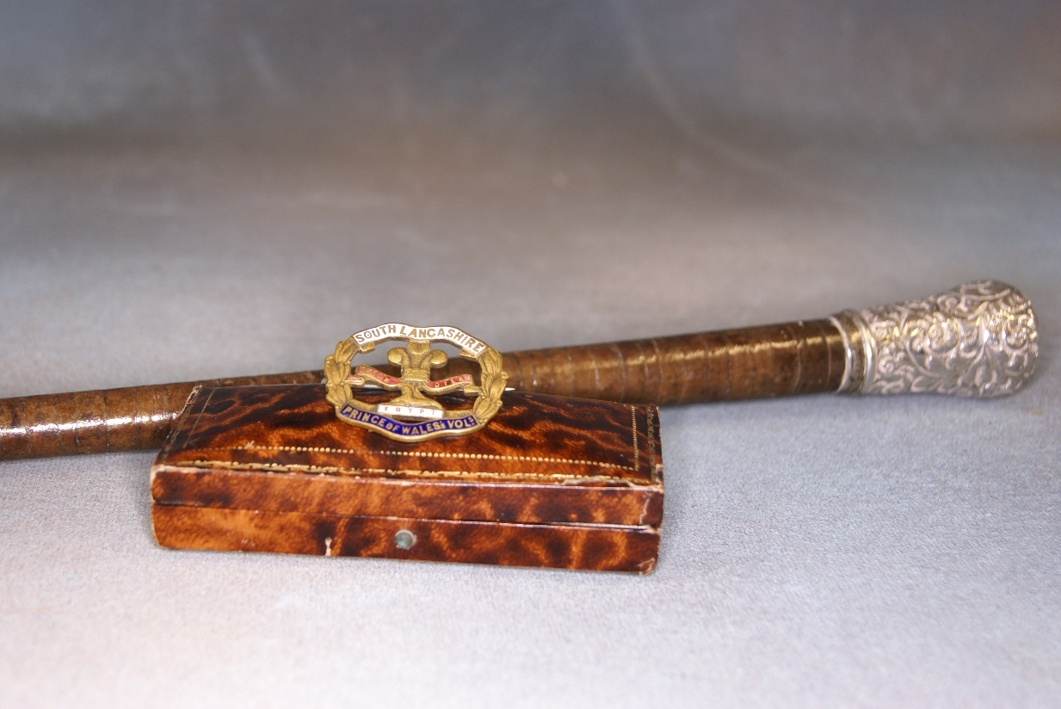 | Lot 39
40. | An 18th century style mahogany wall mirror, with gilt scalloped shell to top, 34cm wide x 59cm high. | £20-£30
41. | A Royal Doulton stoneware vase, blue and brown mottled body, decorated flowerheads, shape number 8218, 18cm high. | £20-£30
42. | An Edwardian bone inlaid, mahogany and stained-beech tub-shaped elbow chair, with pad seat, united by a stretcher, on turned legs. | £20-£30
43. | An early Victorian mahogany d-shaped gateleg card table, on turned and ringed legs, 100cm wide. | £60-£80
44. | A small mahogany revolving bookcase, 43cm x 43cm, and a small bow fronted bedside cabinet, 33cm, a.f. (2). | £30-£40
45. | Two leather hangers, each with four horse brasses, 42cm long, together with two floral lithographic prints (4). | £15-£20
46. | An early 20th century oak hanging corner cupboard, with panelled door, enclosing shaped shelves, 64cm wide. | £20-£30
47. | A "J.W Lawler Dynosure" wooden head driver golf club with hickory shaft, 108cm long, a "J.W Tolley & Co Ltd Autograph "driver with hickory shaft, 104cm long , and a "Maurice" driver by "Jack Whitegolf Co Ltd, London" with metal shaft, 109cm long (3). | £50-£70
48. | 45 rpm record "Cry for a Shadow" by "The Beatles", marked copyright control, the B-side "Why" (Sheridan) from when the band appeared with Tony Sheridan, on Polydor label in white sleeve. | £40-£60
49. | An "Alpa" record album of 45 rpm single records, including "8 Days A Week" by The Beatles, "Wild One" by Bobby Rydell, "I Get Around" by The Beach Boys, and others by Jess Conrad, Lonnie Donegan and various artists, 23 overall (23). | £30-£50
50. | A gold plated watch chain and fob together with a continental gents open face pocket watch. | £100-£150
51. | A lady's open faced fob watch in continental silver case, with rope twist watch chain and a lady's "Montine" gold plated and stainless steel wrist watch. | £50-£70
52. | A lady's Omega "Deville" wristwatch, rectangular dial with bar numerals, on gilt metal strap, No. 59271204, a.f., mechanical movement. | £80-£120
53. | A "Tissot" lady's gold-plated and stainless-steel wristwatch, rectangular dial, with bar numerals, "Rado" ditto with circular dial and day date, and a "Citizen" ditto with quartz movement, and rectangular dial (3). | £70-£100
54. | A gilt metal brooch, set a small porcelain plaque of gentleman in landscape, 4.5cm long, slightly a.f. | £40-£60
55. | An Indian carved hardwood plate, 28cm in diameter, slight warp. | £30-£50
56. | A wooden commemorative medallion inscribed "Guiseppe Garibaldi" 11cm in dia. | £20-£30
57. | A pair of early 20th century elm and beech child size stick back chairs on turned legs united by stretchers. | £60-£80
58. | A pair of French gilt metal candlesticks, probably from a clock garniture, 24cm high. | £40-£60
59. | A small silver carnation holder, London 1904, a silver photo frame, Birmingham 1918, a silver plated hand mirror and two silver plated swan salts. | £40-£60
60. | A 20th century teak extending dining table by "Arner Hovmand Olsen, for Mogens Kold" on turned tapering legs, and two folding centre leaves, 100cm x 270cm, extended, together with six concave rail back dining chairs, with paper cord seats on turned tapering legs, labels underneath (7). | £300-£500
61. | A late Victorian/early Edwardian mahogany side display cabinet, with rosewood crossbanding, ebony and boxwood stringing and inlaid with flower and ribbon decoration on shaped square tapering legs, 122cm wide. | £150-£200
62. | A Royal Doulton biscuit barrel, with silver plated mount and cover, decorated flowers, foliage and foliate scrolls, 16cm high, a decorative glass fruit bowl, with silver mount Birmingham 1906, 21 cm in diameter, a small silver plated telescopic beaker in leather case and three other pieces (6). | £40-£60
63. | A Victorian oval inlaid walnut loo type breakfast table with snap top, on quadruple turned supports and four carved splay legs, with castors 102cm x 134cm. | £300-£400
64. | Two satin Christening robes with embroidered decoration together with a crochet work robe, and a bonnet, in unassociated box (4). | £40-£60
65. | A Victorian inlaid walnut work box a.f. to interior, 25cm wide, a larger rosewood box, together with six further boxes, including a money box (8). | £30-£50
66. | A set of six silver handled pastry forks, Sheffield 1966, a set of six silver pastry forks, Birmingham 1939, boxed, two sets of silver teaspoons, in single box together with a part set of mother of pearl fruit knives and forks with silver ferrules, loose, a silver plated and bone handled crumb scoop and sliver plated ware. | £50-£70
67. | An Elizabeth II silver Millenium bottle coaster, Birmingham 2000, a silver muffineer, Birmingham 1893, an Elizabeth II silver pepper mill, London 1977, a small bowl Birmingham 1936, and a pedestal mustard pot, Birmingham 1975, approx. 12oz, weighable (5). | £150-£200
68. | An Elizabeth II silver handled cake knife, Sheffield 1975, a cake slice 1970, another 1976, together with a quantity of small silver and silver handled pieces, including small fish knives, a caddy spoon, sugar nips, and other similar pieces. | £50-£70
69. | A pair of Victorian silver old English pattern table spoons, London 1893, four fiddle pattern dessert spoons, London 1839, and 1866, an old English pattern dessert spoon, Sheffield 1931, and a rat-tail trefid type spoon with shallow bowl, approx. 12oz (8). | £140-£160
70. | A small late Victorian silver gilt scent bottle by Samuel Mordan and Co, London 1853, a pair of two handled salts, Chester 1899, a small pair of pepperettes, London 1901, a tea strainer, Birmingham 1913, a brandy decanter label, a.f., a small photo frame, two silver topped bottles, a napkin ring, and a salt spoon, approx. 6oz, weighable (12). | £80-£100
71. | A George V silver sauce boat on three feet, Birmingham 1913, a small cream jug, Sheffield 1889, a glass toilet bottle with silver top, Mappin and Webb, London 1894, a silver backed hairbrush, Birmingham 1905, and a hand mirror, Chester 1907, approx. 4.5oz (5). | £70-£100
72. | A 20th century Dresden porcelain vase, with painted and transfer printed decoration of flowers, white and gilt ground, 24cm high, small chip to foot. | £40-£60
73. | A three strand simulated pearl necklace, a ditto two strand necklace, a beaded necklace, two filigree brooches, together with a quantity of decorative and costume jewellery. | £30-£40
74. | A Conway Stewart "Dinkie" fountain pen, in green lacquered case, and original box. | £20-£30
75. | A Pelham puppet of Muffin the Mule, unboxed, and a Pelham puppet of a caterpillar, 28cm long, also unboxed (2). | £20-£30
76. | A Victorian mahogany dining table with rounded corners, and wind-out action, on turned and ringed legs, together with extra leaf, and winding handle, 116cm x 195cm, extended. | £100-£150
77. | A quantity of 20th century coloured postcards, views of various locations, including Rome, French views, some Kent and UK views (approx. 100 plus). | £20-£30
78. | A Venetian style rectangular shaped wall mirror, with scrolled crest and bevelled edges, 40cm wide x 74cm high. | £30-£50
79. | No lot.
80. | A dress ring set five baguette emeralds, unmarked, stones flawed. | £150-£200
81. | A silver and jade bangle, boxed, a pair of Mexican silver and enamelled earrings, and a brooch, together with a silver and gem set thistle brooch (4). | £60-£80
82. | An Italian 9ct gold curb and oval link necklace, approx. 19.7g and a twist link necklace, approx. 8g (2). | £400-£500
83. | A lady's stainless steel "Rolex" Oysterdate wristwatch, gilt dial, back stamped 62, a.f., no paperwork. | £500-£600
 | 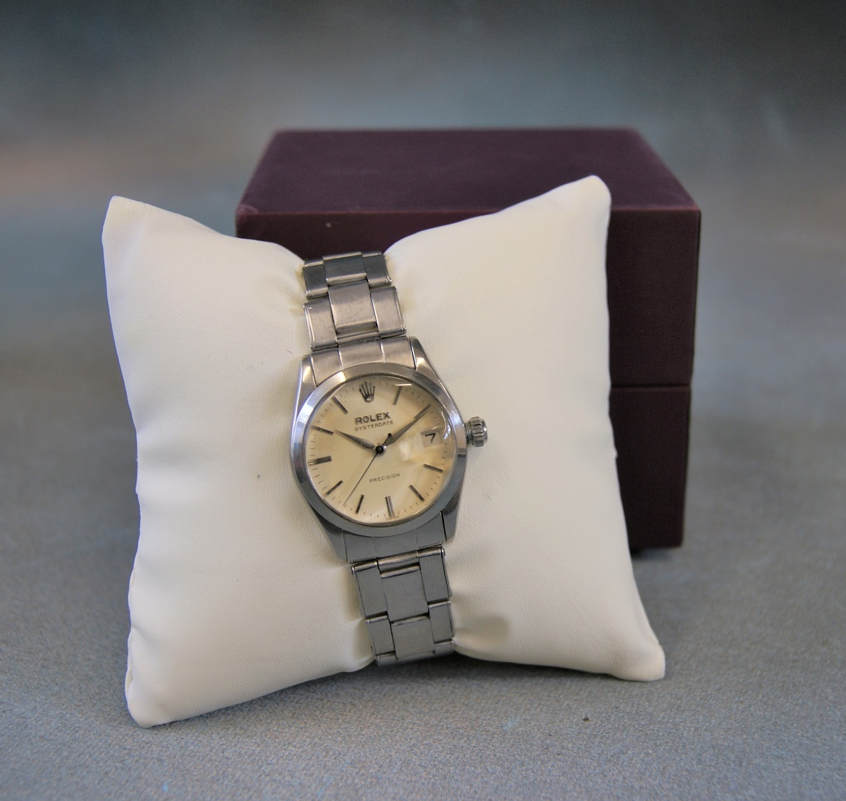 | Lot 83
84. | A lady's 9ct gold wristwatch, with Arabic numerals on leather strap, a further 9ct gold wristwatch, with strap, and a "Solvil et Titus" gent's wristwatch on leather strap, in box, and a further lady's gold watch, mostly a.f. (4). | £260-£280
85. | A 9ct gold wedding band, approx. 1.9g, an unmarked decorative gem set band form ring, and an 18ct gold dress ring, set a central emerald, and small diamonds (3). | £150-£200
86. | A single strand pearl necklace, with white metal clasp, a similar necklace with marcasite clasp, two further necklaces, two pairs of ear studs, together with other beaded necklaces, decorative and costume jewellery, and two bone bracelets. | £160-£180
87. | A continental yellow metal band ring, a 9ct gold seed pearl set brooch, an 18ct gold bar brooch, set a peridot, a small pair of 15ct gold earrings, set seed pearls and other decorative pieces. | £200-£250
88. | A 9ct gold part watch chain, 23cm long, approx. 15.6g, a.f. | £200-£300
89. | A Regency mahogany rounded rectangular breakfast table, on quadruped base, 107cm x 77cm. | £100-£150
90. | A Georgian mahogany bow fronted hanging corner cupboard, 71cm wide. | £30-£50
91. | A stripped pine bench seat of pew type, with shaped ends, 227cm wide. | £20-£30
92. | A 20th century pottery shallow bowl, blue glaze, 34cm in diameter. | £15-£20
93. | A George III mahogany bureau, the fall above four long drawers, 93cm wide. | £20-£30
94. | E Ollers (Swedish? 1888-1959) - view of harbour and boats, through alley, oil on board, signed and dated 1946, 32cm x 21cm. | £20-£30
95. | A Danish white metal tea pot, of oval footed form, with ebonised handle and finial, approx. 14oz, marks rubbed. | £150-£200
96. | A late Victorian mahogany and stained beech chaise longue, with seat end, on slender cabriole legs, 162cm wide. | £40-£60
97. | An Armand Marseilles bisque head doll, mould No. 390, two further later general dolls, a small quantity of clothing, and a miniature doll (4). | £20-£30
98. | A quantity of Giles cartoon annuals, from the 1960's to 1990, including some compilation volumes, in commemoration, together with a further volume "The Giles Family", by Peter Tory (approx. 40 volumes). | £15-£20
99. | Henry Bright, September 6th 1860 (1814-1873) - "Matterhorn", inscribed on mount, watercolour, 28cm x 22cm. | £150-£200
100. | Robert Gallon - Two figures punting on river, town on far bank, watercolour, 20cm x 36cm. | £30-£50
101. | Maurice C. Wilks (Irish, 1910-1984) - "Donegal Highland", "From Glen Gormley, Co. Antrim", "Donegal Homestead", and "Glenmalure", all inscribed verso, four unframed watercolours, signed, each 24cm x 30cm, a.f., and two small watercolours signed Ella Spicer (6). | £120-£180
102. | Victorian and later pewter mugs, and tankards, in mixed sizes. | £20-£30
103. | Late 19th century American school- a steam yacht, raising American flag, passing a Dutch clipper ship, watercolour, 31cm x 45cm. | £40-£60
104. | A George Jones and Sons, Crescent china part dinner service, red and gilt decoration, LG monogram to centre, 38 pieces including sauce tureen and three meat platters, together with smaller Bishop oriental pattern plates, a.f. (42). | £20-£30
105. | A small 19th century mahogany chiffonier, 76cm wide, a.f. | £40-£60
106. | A mahogany wall mirror, with ho-ho bird crest, 90cm x 50cm. | £30-£50
107. | A plaster bust, head of Japanese man, brown lacquer finish, 45cm high. | £40-£60
108. | A 19th century rosewood stick barometer, by "G. Lowdon of Dundee", 95cm high. | £150-£200
109. | A pair of Japanese pottery figures, each 14cm high, a Nanking Cargo bowl and saucer, a small Wang Tam Cargo vase, and four pieces of Staffordshire pottery (9). | £80-£100
110. | A George III mahogany snap-top bird cage occasional table, on tripod base, 59cm in diameter. | £80-£100
111. | An early 20th century mahogany hanging corner cupboard, 71cm wide, and a tapestry upholstered duet footstool (2). | £50-£70
112. | A mahogany torchere on tripod base, and two reproduction bookcases (3). | £20-£30
113. | H.B Willis (1810-1884)- watercolour of old shire horse, 27cm x 33cm, and a small map of Kent (2). | £80-£90
114. | A Regency style mahogany dwarf side cabinet, fitted drawers and panelled doors, on plinth base, 153cm wide. | £100-£150
115. | An early 20th century mahogany work table, 49cm wide, and two decorative boxes (3). | £30-£50
116. | A late Victorian mahogany and stained wood dressing chest, 106cm wide, and a swing frame toilet mirror (2). | £40-£60
117. | M.M Turner- Girl feeding pigeons, watercolour, 23cm x 34cm, and a smaller watercolour of cattle, watering (2). | £20-£30
118. | Professor Mario Manesa- Grand Canal, Venice, oil on canvas, signed 38cm x 50cm, | £80-£100
119. | An 18th century style walnut lowboy, on cabriole legs as a dressing table, and a tri-partite dressing table mirror, 92cm wide. | £60-£80
120. | A reproduction walnut and beech chest on chest, 72cm wide x 153cm high. | £80-£100
121. | A small George III style mahogany chest of four long graduated drawers, 58cm wide. | £80-£100
122. | A reproduction mahogany pedestal desk, 120cm wide. | £80-£100
123. | An early 20th century beech dressing stool and a Chinese style pottery umbrella stand (2). | £30-£50
124. | A small set of mahogany open wall shelves, with bobbin turned supports, 64cm wide. | £30-£50
125. | After Juliet Simpson - "The pigs are out, No. 15", a resin group, on landscaped base, weighted, 42cm long. | £30-£50
126. | A silver plated figure of a lion, a pair of silver plated dog knife rests, two small spill vases, two bottle coasters and other pieces (15). | £40-£60
127. | A mid 20th century teak sideboard of Danish manufacture, designed by "Hans Wegner" for Ry Mobler, the top enclosed by two sliding doors, the base fitted two sets of three graduated drawers, with flat wedge handles, on conforming legs, 180cm wide x 180.5cm high. | £300-£500
 | 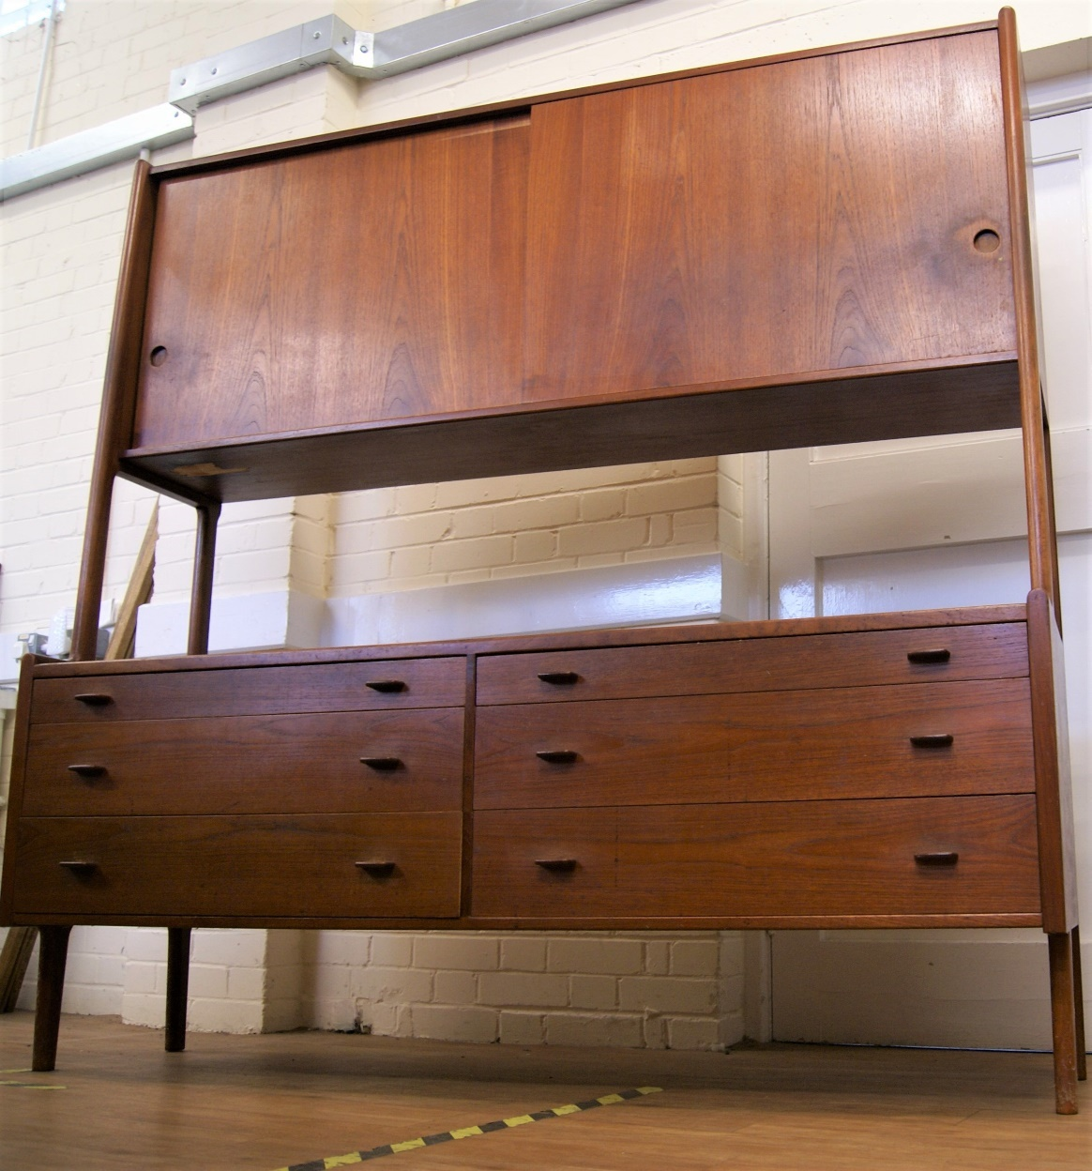 | Lot 127
128. | A "Jaeger Le Coultre" Atmos mantel timepiece, with blue chapter ring, behind an opening glass front panel, in gilt lacquered steel case, central corners, 23.5cm high, No. 405770, in need of restoration. | £250-£350
129. | A Stained wood bagatelle board, with balls, 76cm long, and a shove ha'penny board, 65cm long (2). | £15-£20
130. | A Hickory shafted wooden driver golf club, by "Josh Taylor", 98cm long, together with three irons, by the same manufacturer (4). | £40-£60
131. | Four Hickory shafted iron golf clubs, by "H.L. Curtis, Bournemouth", including a Mashie Niblick, mixed heights between 87cm and 100cm (4). | £40-£60
132. | Five Hickory shafted iron golf clubs, by "Fred Sanders, Highgate", between 95cm and 100cm long (5). | £40-£60
133. | A late 19th century carved circular form shell, the panels decorated biblical events, including the last supper, 17cm in diameter, together with an oval form shell decorated panels depicting the life and death of Christ, 16cm, a.f. to edge (2). | £60-£80
134. | Fourteen miniature bottles of spirits, and other alcohol, comprising nine full and unused bottles, including one whisky, one port, two Tia Maria, and two cognac, together with four partial full bottles of Rocher peach liqueur, and a Warninks black current liqueur, ullage levels vary (14). | £15-£20
 | 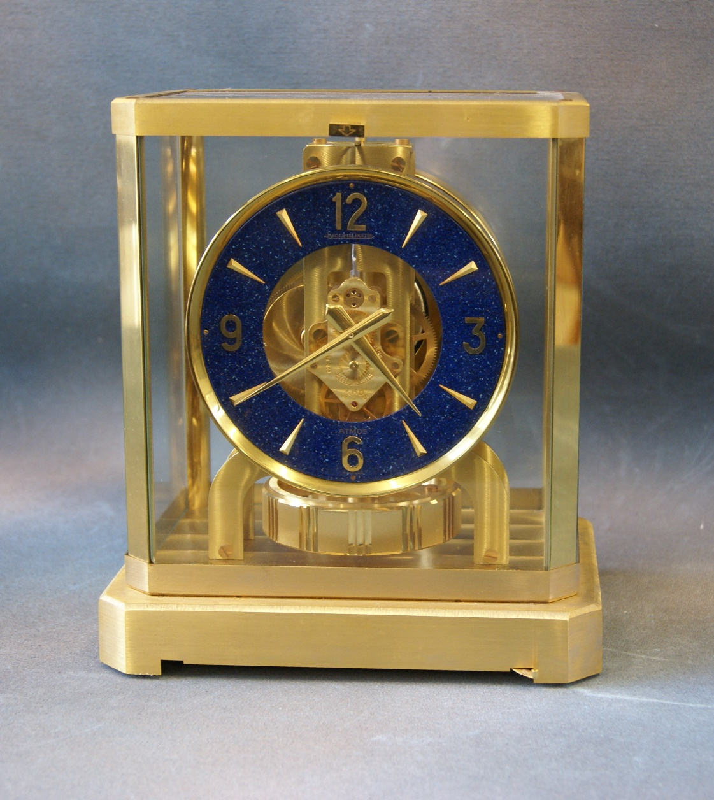 | Lot 128
135. | Two albums (one partially filled) of early 20th century picture postcards, including views of Rome, Warsaw, Aberdeen, Shipping, Children, and other subjects, approx. 207. | £30-£50
136. | Produced by Jonathan Miller - poster of English National Opera version of "Verdi's Rigoletto, at the London Coliseum", 75cm x 49cm. | £30-£50
137. | Two tintype photographs of a family group, in paper frames, 8cm x 12cm, a pair of silhouette pictures, a photo of an early motorbike and side car, and a small group of other photographs (16). | £15-£20
138. | A "Hooper, Struve and Co" soda syphon bottle, with etched decoration, and remains of label, 33cm high. | £15-£20
139. | A bronze Life Saving Society medal, awarded to Margaret Ewart, boxed, together with an enamelled medal awarded in 1914, other associated medals and badges, two photographs, and a conference programme, 1933 (10). | £15-£20
140. | Stancliffe - "Golf Do's and Don'ts", published by Methven and Co, 1902, 17cm x 11cm. | £15-£20
141. | Of medical interest - Michael Underwood - "A Treatise on the Diseases of Children", 1811, volume one, only, of three, together with "An Essay of Health and Long Life", by George Cheyne, eighth edition, 1734, and one volume "The New Family Physician", by John Abernathy, all a.f. (3). | £40-£60
142. | Eugene Labaume, "A Narrative of the Campaign in Russia in 1812", translated from the French, London 1815, together with one volume "The Boys of 76, a History of the Battles of the Revolution", 1877, by Charles Carlton Coffin, and one volume "Bullet and Shell", by Geo F. Williams, illustrated, 1882, a.f. (3). | £30-£50
143. | John Brown - "Anecdotes and Characters of the House of Brunswick", London 1821, and one German Volume "Märchen", by William Hauff, Stuttgart (2). | £20-£30
144. | A Victorian pale mahogany oval form dining table, with moulded edge, wind out action and three extra leaves, on heavy turned and fluted legs, with porcelain casters, 135cm x 294cm, extended. | £700-£900
145. | A set of six pale mahogany Chippendale style dining chairs with carved decoration, upholstered drop in seats, on cabriole legs, with claw and ball feet, including a pair of elbow chairs (6). | £400-£600
146. | A set of six late Victorian silver fiddle pattern dessert spoons, maker John Round and Son Limited, Sheffield 1897, and six fiddle pattern dessert forks, maker Francis Higgins, London 1859, approx. 21oz (12). | £280-£320
147. | A set of six Victorian silver reeded Hanoverian pattern table forks, maker George Adams, London 1842, a set of six Albert pattern tea spoons, London 1924, approx. 20oz, and a set of four silver plated soup spoons (16). | £250-£350
148. | A brass fender 179cm wide, a late Victorian oak and brass coal scuttle, and two modern fireguards (4). | £140-£180
149. | A Victorian rosewood wall plaque, with petit point decoration, of shaped outline, 57cm wide. | £100-£150
150. | A modern yew wood bowl, initialled verso, G.S., 40cm in diameter. | £80-£100
151. | A pair of curling stones, of unknown manufacture, each 26cm in diameter. | £100-£150
 | 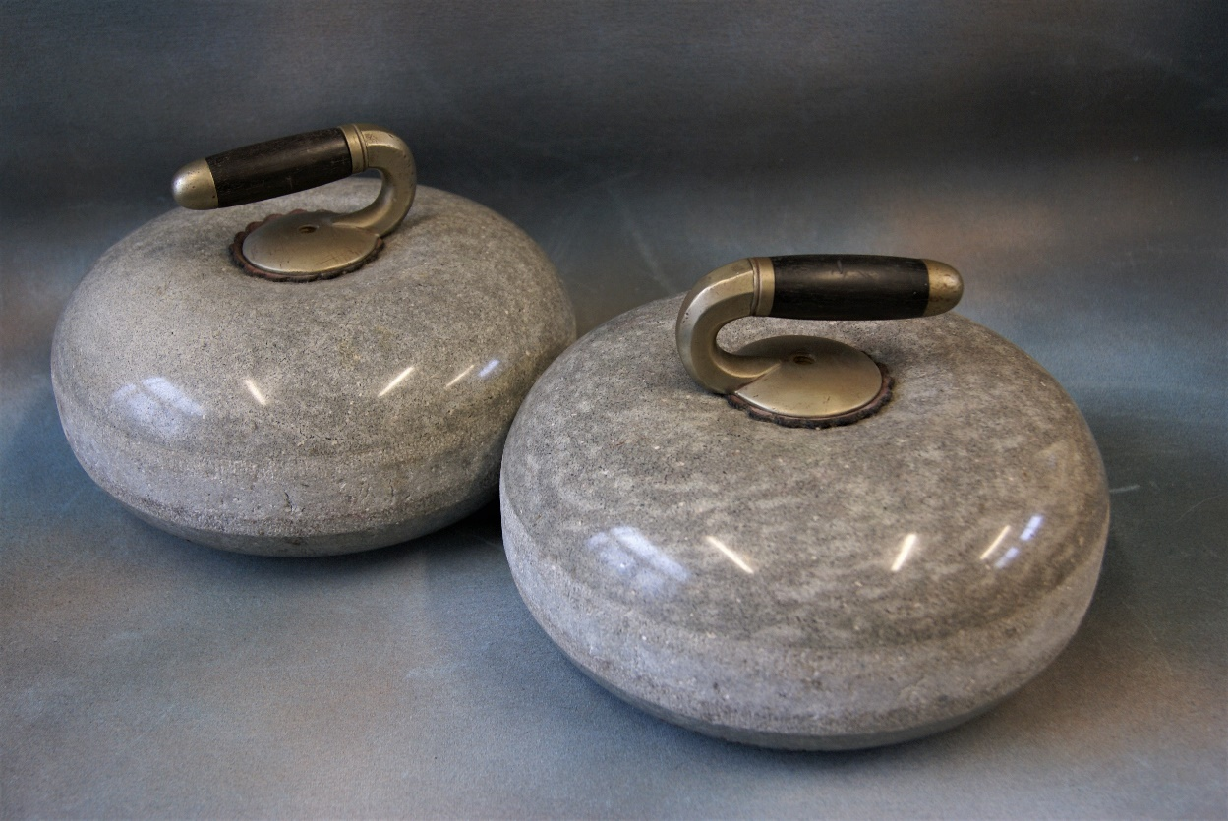 | Lot 151
152. | A carved oak umbrella stand of square form, 44cm wide. | £30-£50
153. | A Bentwood hat and coat stand, 190cm high. | £30-£50
154. | After Archibald Thorburn-"Winter's Sunset", chromolithograph, 43cm x 57cm. | £60-£80
155. | 20th century school- etching of spaniel following ducks, 21cm x 39cm. | £40-£60
156. | A Lapis bead necklace, 45cm long. | £100-£150
157. | A pair of diamond ear studs of double bar form, each set eight stones, in unassociated box. | £200-£300
158. | After P. Henry Rathbone- Retriever dog bringing back a dead duck to his master, coloured etching, 18cm x 22cm, and two small chromolithographs, after Alfred de Breanski Junior. (3). | £80-£100
159. | After Leon Danching - Mallard ducks in flight, limited edition etching No.17/500, 26cm x 35cm. | £80-£100
160. | After Archibald Thorburn- Startled grouse taking off, limited edition lithograph, a pair, each 38cm x 52cm, signed in mount and with trade guild seal (2). | £80-£100
161. | After Nigel Holdsworth- "Fisherman's map of salmon pools on the River Dee", with mounted fly fishing hooks, below, chromolithograph, 42cm x 90cm. | £150-£200
162. | A framed Ferrari poster to mark the winning of the 1975, 76,77 and 1979 Formula 1 world championships "Race Winners" and "Road Winners", 48cm x 68cm.
163. | An 8746 G telephone, in cream, with clear dial, 21cm long. | £20-£30
164. | A boxed set of table bowls, a Rhom Brick set, and two sets of dominoes, in mahogany box (3). | £20-£30
165. | An enamelled shoe cleaning tin box, labelled "Black" and "Brown", 22cm x 26cm. | £15-£20
 |  | Lot 157
166. | An early 20th century school - a heather covered landscape, watercolour, 9.5cm x 18cm. | £15-£20
167. | A pair of mother of pearl overlaid opera glasses, in bag, slightly a.f. | £15-£20
168. | A Victorian rosewood beaded footstool, and two evening bags (3). | £15-£20
169. | A "Lock and Co" grey top hat, in box, with brush, and a bowler hat, unboxed, by the same retailer (2). | £30-£50
170. | A late Victorian umbrella, by "T. Fox and Co Ltd", with fruitwood handle, having silver terminal, Birmingham 1893, and in paper part cover, 87cm long. | £40-£60
171. | An Art Deco style mottled glass plafonnier, with fittings, but no chain, 26cm in diameter. | £15-£20
172. | A "TWA" linen seat back, or large napkin, with embroidered logo, 41cm x 44cm. | £15-£20
173. | An Edward VII hobnail cut glass toilet box, with silver top, Chester 1906, a silver backed clothes brush, Birmingham 1906, a silver-plated nurses buckle, a crown Staffordshire Mona Lisa pendant, and an enamelled 1946 farthing pendant (5). | £40-£60
174. | Ten Victorian glass fluted jelly glasses, each on circular feet, in mixed sizes, between 6cm and 11cm high (10). | £30-£50
175. | A Victorian faded walnut and beech jewellery box, with fitted interior, 30cm wide. | £20-£30
176. | A small oak table form cutlery canteen containing a mixed quantity of silver plated and bone handled cutlery, 49cm wide. | £40-£60
177. | An Italian Art Pottery bowl with blue glazed interior, and three further art pottery vessels (4). | £40-£60
178. | A quantity of Delft style tiles, decorated pastoral and rural, and biblical scenes, each 13cm x 13cm, some damaged. (46) | £150-£200
179. | A late Victorian oak mantel clock, with German striking movement, and silvered dial, 38cm high. | £60-£80
180. | Two spelter figures of ladies as water carriers, each 37cm and 43cm high, respectively. | £80-£100
181. | An Elizabeth II silver napkin ring, boxed, Birmingham 1952, a silver plated mesh evening bag (slightly a.f.), together with a quantity of costume and decorative jewellery. | £60-£80
182. | A Louis Vuitton lady's purse, 19cm wide. | £20-£30
183. | A Bakerlite exchange telephone, Maidenhead, and a shove ha'penny board (2). | £20-£30
184. | Ricardo Arenys- white horses, oil on canvas 81cm x 59cm. | £40-£60
185. | A Corgi Toys gift set boxed, no 23 "Chipperfields Circus Models", slightly a.f., and a boxed transporter, with giraffes (2). | £70-£100
186. | A Corgi Major "Euclid TC-12 Tractor" no 1107, boxed, two further boxed cars, a "Spot On" E-type Jaguar, together with three empty boxes, an unboxed car transporter, nine further unboxed models, and three Dinky die-cast vehicles, unboxed (20). | £100-£150
187. | A Louis Marx and Co battery operated "Dalek" toy, boxed, a Japanese "Moon Explorer" toy, boxed, and two other unboxed toy (4). | £40-£60
188. | A box of "Tri-ang Minic" motorway track, a boxed customs post, together with a quantity of vehicles, a motor racing car ramp box only, and a motor rally box only (5). | £30-£50
189. | A box of Meccano pieces and two outfit brochures. | £20-£30
190. | Mwenze Kibwanga (Congolese, 1925-1999)- tribal figures cooking and eating, oil on canvas, 30cm x 43cm. | £250-£350
191. | A quantity of Tri-Ang Hornby HO/00 locomotives, boxed, some rolling stock, boxed, together with boxed and unboxed accessories by other manufactures and some track. | £250-£350
192. | A 9ct gold gent's hunter cased key-less wound pocket watch, white enamelled dial, some engine turned decoration, Waltham movement, 6.5cm in diameter, inscribed interior. | £200-£300
193. | An early 20th century decorative pendant necklace, set peridot, pearls and seed pearls, on 9ct gold link necklace. | £150-£200
194. | A 9ct gold bar brooch with amethyst set leaves, and seed pearls, with safety chain and replacement unmarked pin. | £60-£80
195. | A marcasite set floral wheelbarrow form watch brooch, the case of octagonal form, 5cm wide, Swiss movement. In good general condition, pin slightly bent. | £40-£60
196. | A costume paste necklace set white and red stones, in a J.W Benson watch box. | £30-£50
197. | A Lady's 9ct gold "Hamilton" wristwatch, silvered dial on 9ct gold bark bracelet strap, in Waltham box. | £100-£150
198. | A Lady's Seiko wristwatch, white dial, on link strap, quartz movement and a Tissot watch on bracelet strap. | £50-£70
199. | A Thai 18k gold yellow sapphire and diamond necklace, approx. 2.98 carats, and 0.05 carats respectively, and a pair of matching earrings, approx. 0.97 carats, and 0.24 carats respectively (3). | £400-£600
 | 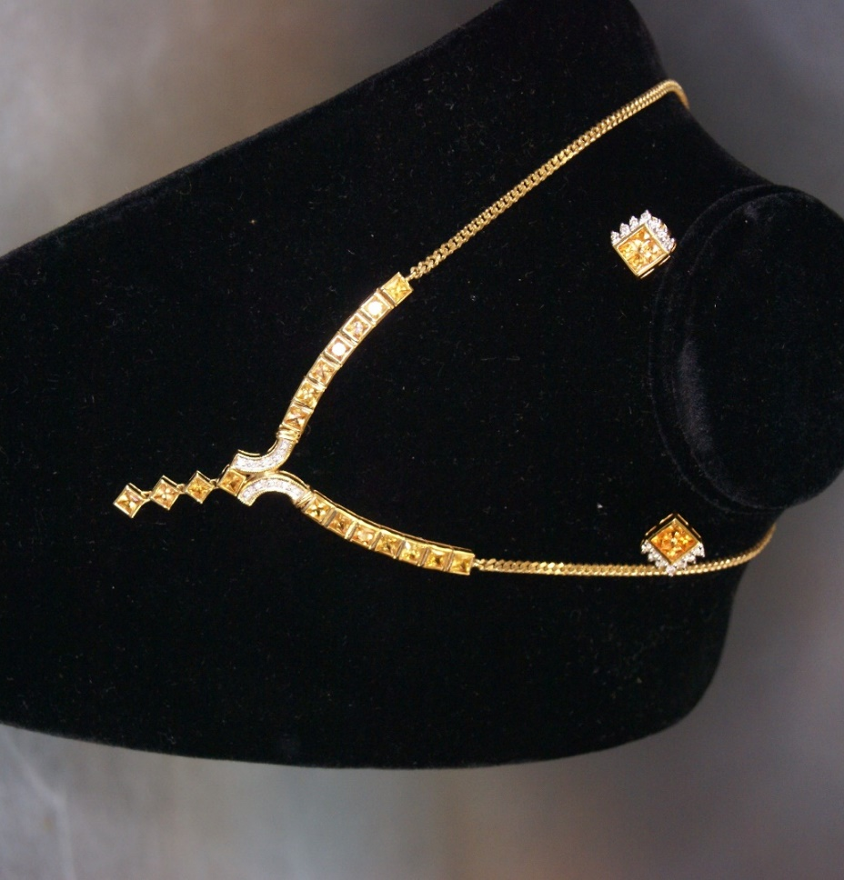 | Lot 199
200. | A silver gent's watch chain with bar, 33cm long, marks rubbed. | £30-£50
201. | An 18th century oak mule chest with panelled front, above two drawers, on block feet, 120cm wide. | £100-£150
202. | A 19th century oak hanging corner cupboard with carved door, 80cm wide. | £30-£50
203. | An oak oval gateleg table, on turned and ringed legs, 130cm x 185cm, extended and a set of eight oak and beech ladderback chairs, including two elbow chairs (9). | £150-£200
204. | An 18ct century stained oak dresser, with planked rack, the base fitted five drawers and two panelled doors, 160cm wide x 192cm high, part pine carcase. | £300-£500
205. | A mahogany bow-fronted corner cupboard, now freestanding on three legged base, 70cm wide x 143cm high. | £30-£50
206. | A Regency mahogany bow-fronted chest of two short and three long drawers, with turned handles, on splay feet, 104cm wide. | £80-£100
207. | A George III mahogany bureau, the sloping fall above two short and three long drawers, with brass swan neck handles, on ogee type bracket feed, 91cm wide. | £30-£50
208. | A quantity of Georgian and later pewter objects including two chargers, two plates, a food warmer, a pair of candlesticks, an ink well, some measures and some tankards, some with broken glass bottoms. | £30-£50
209. | A George V silver three piece condiment set, Birmingham 1936, unboxed, a silver plated bottle coaster, two dishes, to Danish silver spoons in larger box, six silver plated coffee bean spoons in case, together with other pastry forks, tea knives and spoons, in lined cases. | £30-£50
210. | A composite suite of silver plated, stainless steel and bone handled cutlery, in an oak Mappin and Webb canteen, 50cm wide, approx. 91 pieces. | £80-£100
211. | A part suite of silver plated, stainless steel, and bone handled table cutlery in pale oak Mappin and Webb canteen, 45cm wide, 53 pieces, some missing, together with a Victorian walnut writing box, a.f. (2). | £50-£80
212. | A small 18th century style oak gateleg table, on turned and ringed legs, and fitted a drawer to one end, 80cm x 100cm, extended. | £50-£70
213. | A Belgian machine made tapestry decorated floral panels and foliate scroll fielded panels, 123cm x 178cm. | £60-£80
214. | An Edwardian mahogany gentleman's toilet cabinet, the upper part enclosed by two doors, the lower part with deep drawer, on reeded square tapering legs, 52cm wide x 128cm high. | £80-£100
215. | An early Victorian rosewood piano stool, with adjustable circular seat, on vase form pedestal and circular plateau base, and knurled feet, 34cm in diameter. | £60-£80
216. | An elm and beech kitchen Windsor elbow chair, on turned and ringed legs, reduced in height and lacquered in pale green. | £40-£60
217. | A pale stained elm and beech kitchen Windsor elbow on turned and ringed legs, reduced in height. | £30-£50
218. | A Regency style inlaid and crossbanded mahogany circular snap top breakfast table, on turned column and splay legs, with brass terminals and casters, 129cm in diameter. | £200-£300
219. | A late Victorian mahogany concave sided cylinder commode with hinged lid and fitted a drawer below, 41cm in diameter. | £30-£50
220. | A Middle Eastern style tented wardrobe, after Robinsons and Liberty's, the interior fitted double hooks at two levels, enclosed by a door, of octagonal form, with decorative finial to top, approx. 77cm in diameter x 240cm high. | £400-£600
221. | An 18ct gold ruby and diamond set dress ring, size L. | £180-£220
222. | An 18ct gold ruby and diamond set dress ring, size O, inscribed to interior of shank "1953 WJK-IMK 1993". | £200-£300
223. | A gun metal coloured Argyll and Sutherland Highlanders brooch, in Brook and Son of Edinburgh box, a pearl necklace, boxed, a further pearl necklace, unboxed a quantity of loose pearls and two costume jewellery brooches. | £50-£70
224. | A small silver plated mug, a pierced pedestal bowl, a Christening set boxed, a set of six teaspoons, together with some loose cutlery and a pepperette. | £20-£30
225. | A Victorian silver mug, Birmingham 1886, another Birmingham 1923 an open salt, marks rubbed, a small mustard pot, Birmingham 1948, a teaspoon and fork, a small glass pot and an extending pipe with silver bowl, boxed. | £100-£150
226. | A 9ct gold white gold and diamond set dress stud and cufflink set, in Mappin and Webb box. | £80-£100
227. | An 18ct gold wedding ring, a metal mourning ring, a further metal ring, a gold part watch chain, a set of four gilt metal dress-studs and a silver plated brooch (9). | £80-£100
 | 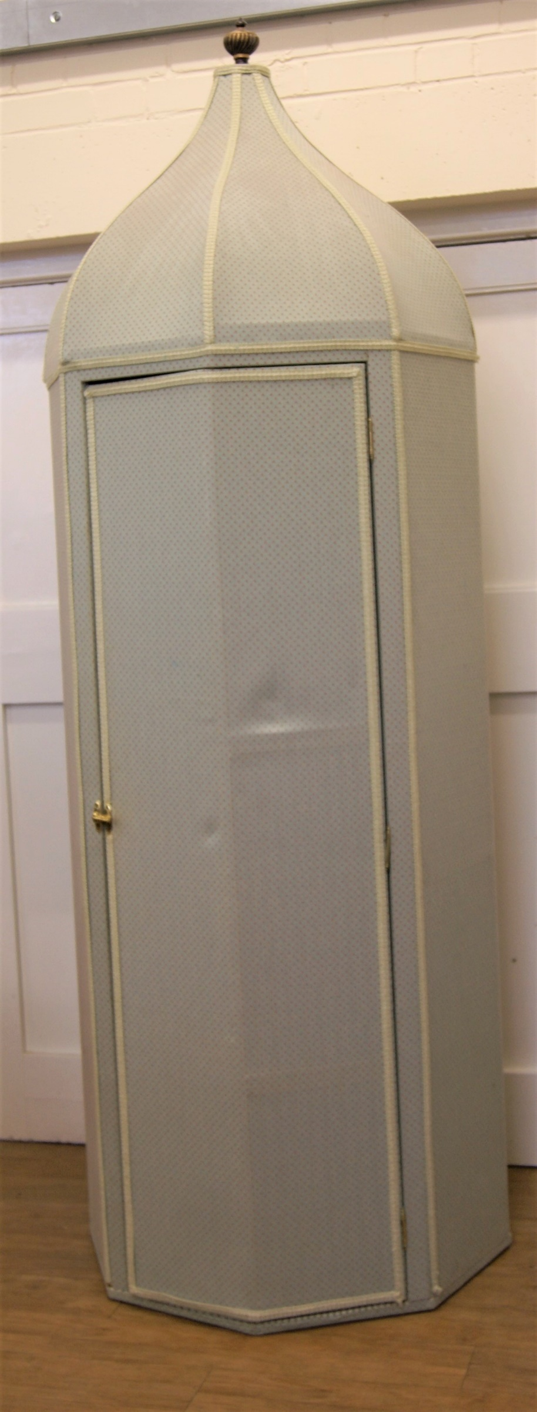 | Lot 220
228. | An Art Deco style platinum brooch set three Swiss cut diamonds, possibly replacing sapphires and forty three round cut stones. | £400-£600
 | 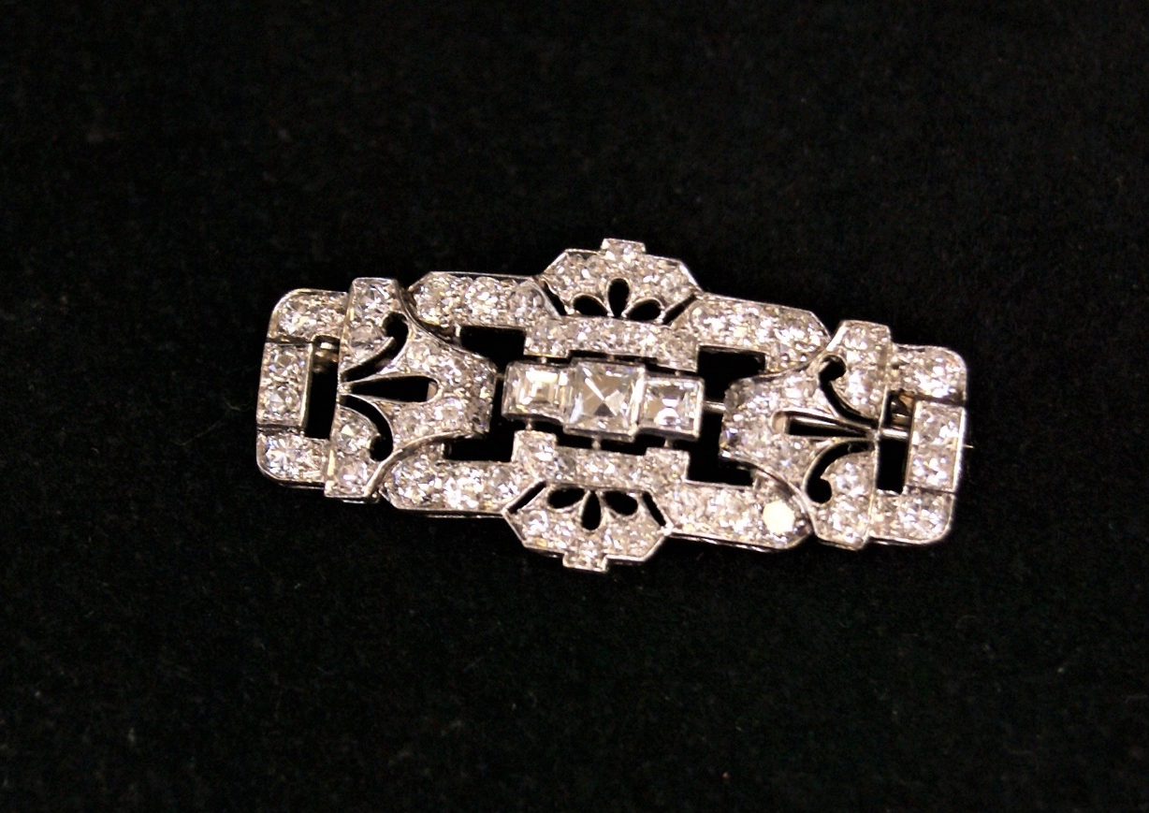 | Lot 228
229. | A decorative silver-plated dish stand with adjustable feet, 30cm in diameter, an oval entrée dish, a muffin dish, and other pieces. | £30-£50
230. | A silver-plated cheese dish, two dish holders, no liners, two bottle coasters, a biscuit barrel, no liner, and five other pieces (11). | £30-£50
231. | A set of six reproduction mahogany shield-back dining chairs, on turned and fluted legs, and a reproduction mahogany circular top breakfast table, on quadruped base, 130cm in diameter (7). | £30-£50
232. | A set of six simulated oak and stained beech spindle back dining chairs, with rush seats, on turned legs with pad feet (6). | £30-£50
233. | A set of six early 20th century stained beech Carolean style high back dining chairs, with pen work decoration, and cane seats and back panels, some a.f., including one elbow chair (6). | £30-£50
234. | A 9ct gold gent's key-less wound open-faced pocket watch with white enamelled dial inscribed "J.W. Benson, London", Swiss movement, in box. | £300-£500
235. | An 18k gold key-less wound open faced pocket watch, with part engraved gilt dial, Swiss movement, glass missing, in unassociated box. | £250-£350
236. | An Edward VIII/George VI silver salver, with pie-crust and presentation inscription from the "United Pastrycooks and Confectioner's Society, presented to H.J Matthews Esq, April 13th 1937" on four squat claw and ball feet, maker James Dixon and Sons Ltd, Sheffield 1936, approx. 40oz. | £550-£650
237. | An oval mourning brooch in mount, the photograph of old gentleman, lock of hair verso, also a label inscribed "Photographer, Middle Street, Kings Road, Brighton" snake form edge to frame, indistinctly marked, 4cm x 6cm. | £100-£150
 | 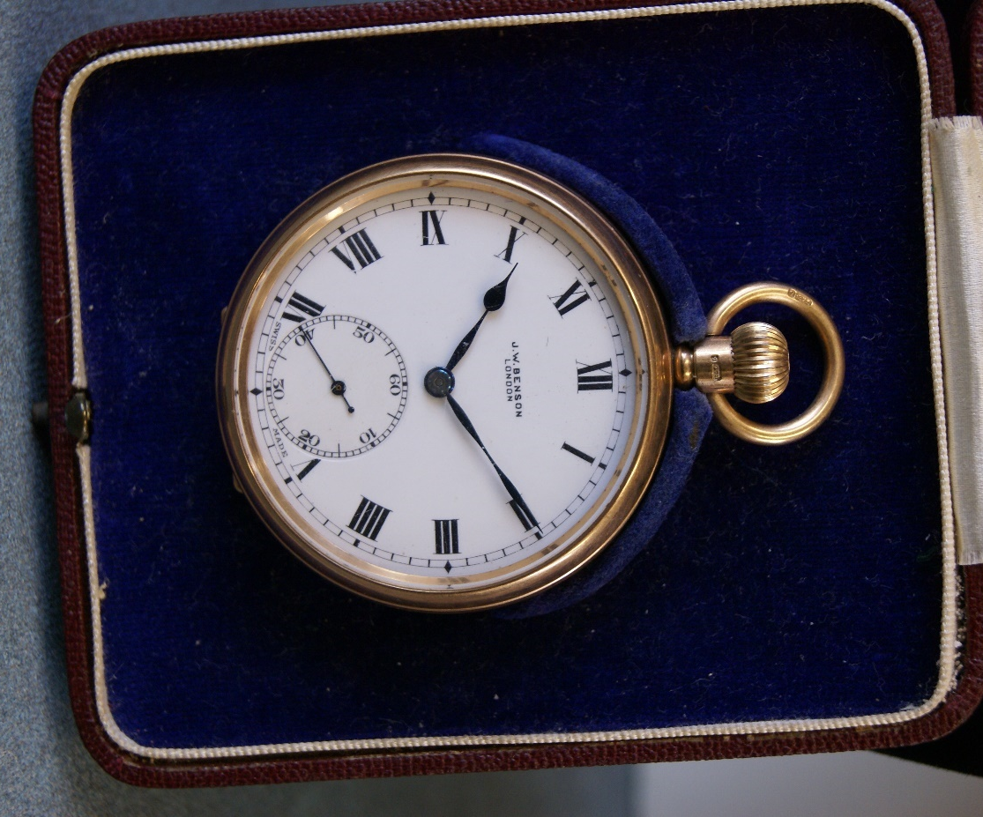 | Lot 234
 | 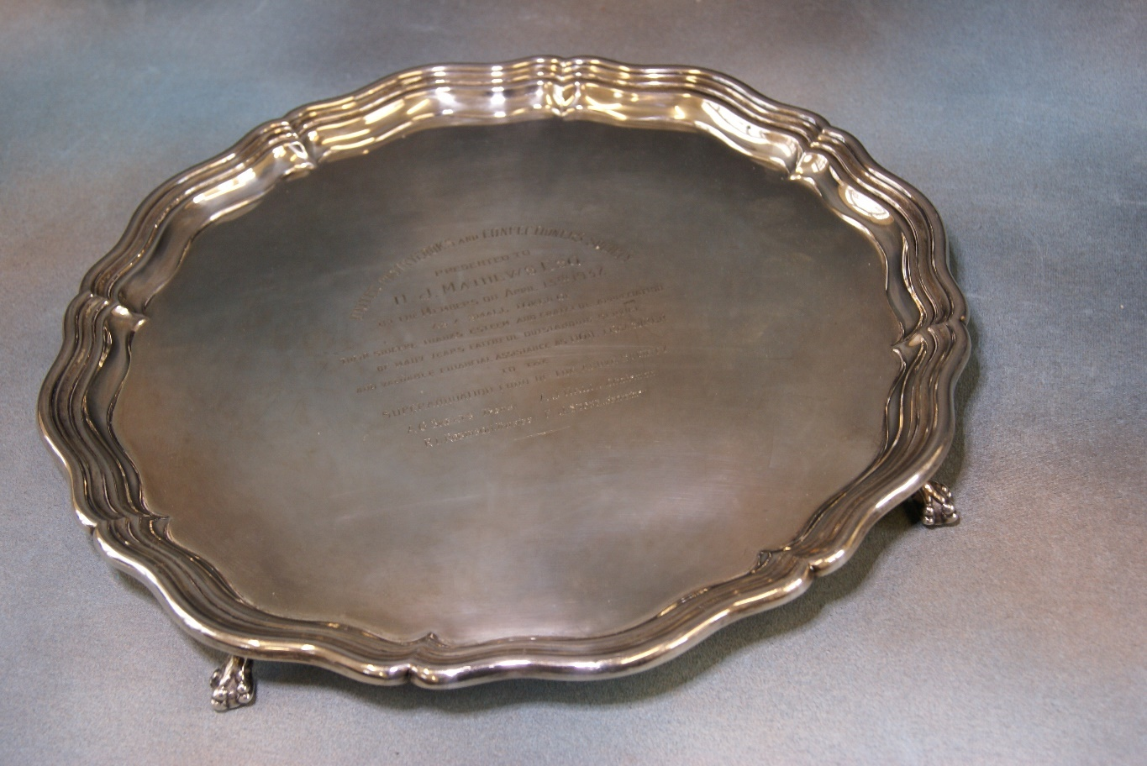 | Lot 236

AUCTION DATES 2022

Wednesday 27th April 2022
Wednesday 8th June 2022
Wednesday 20th July 2022
Wednesday 7th September 2022
Wednesday 26th October 2022
Wednesday 7th December 2022
Viewing on Monday and day before sale from 12.00 pm to 19.00 pm.
Sale commences at 11.00 am

VALUATION DAYS 2022

Wednesday 16th March 2022
Wednesday 4th May 2022
Wednesday 15th June 2022
Wednesday 27th July 2022
Wednesday 21st September 2022
Wednesday 2nd November 2022
Wednesday 14th December 2022
Sevenoaks Saleroom, Argyle Road,
Sevenoaks TN13 1HJ
11.00 a.m. – 4.00 p.m.

Notes

