Welcome to Ibbett Mosely Auctions
Wednesday 26th January 2022 Auction Catalogue

Unfortunately, due to the rise in Covid-19 infection rates, this sale will be held online only, with no in person bidding to be allowed, to ensure the safety of our buyers and staff.

This sale will be held online ONLY at www.easyliveauction.com/ibbettmosely/
please visit the website to register or log in to view and bid.

Alternatively, commission bids (bids left ‘on the book’) may be left with us, as well as a limited amount of telephone bids. Please telephone 01732 456731 or email auctions@ibbettmosely.co.uk for further details.

Please be aware there is viewing strictly by appointment only. Any walk-ins will not be allowed viewing. The full catalogue, complete with images of each lot and condition reports will be available at easyliveauction.com/ibbettmosely/

Please telephone 01732 456731 or email auctions@ibbettmosely.co.uk with any questions.

Collection of items is available on Thursday 27th January from 10am - 5pm. Collection of items from 28th January onwards, by prior appointment only.

You are welcome to collect in person, or via your own carrier, but local courier PSP Logistics are available to carry out deliveries of items. Please contact them directly to arrange and pay for delivery.



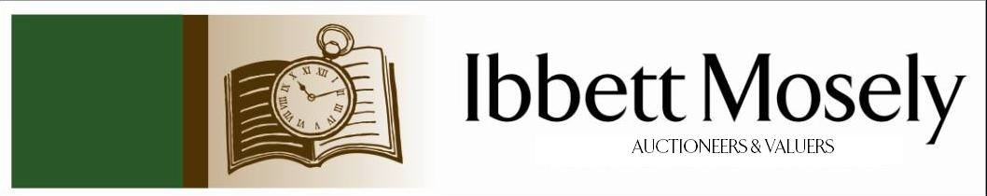

Catalogue of Antique, Edwardian and Victorian
Furniture and Effects
to be Auctioned on

Wednesday 26th January 2022
at 11.00am

IBBETT MOSELY AUCTION ROOMS
ARGYLE ROAD, SEVENOAKS, KENT TN13 1HJ
Via
www.easyliveauction.com/ibbettmosely/

Viewing at Sale Room on:

Monday 24th January
Tuesday 25th January

Between 10.00am –5.00pm.

STRICTLY BY APPOINTMENT ONLY.

Unfortunately, due to the rise in Covid-19 infection rates, this sale will be held online only, with no in person bidding to be allowed, to ensure the safety of our buyers and staff.

Please wear a face covering when in the Saleroom.

Catalogues: £2.00

Auctioneer and Valuer: Alan White FNAVA
Consultant Auctioneer and Valuer: Derek Hodge
Trainee Valuer and Clerk: Nicola Rainsley-Hughes
Auction Clerk and Administrator: Emily Frederick

Please be aware we are not able to offer food or drink at this sale.

1. | A Dunhill chrome plated aeroplane table lighter, in the form of an F-86 Sabre Jet Fighter, with push button action, on circular base, 16.5cm long x 8.5cm high. | £90-£120
 | 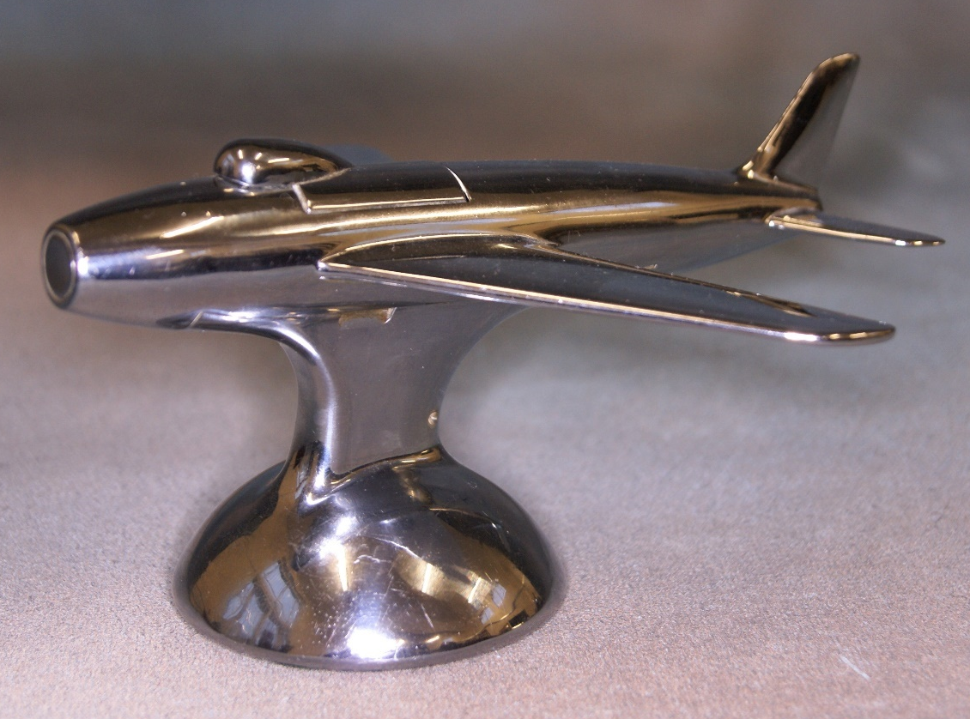 | Lot 1
2. | A Chinese Shakyamuni bronze of seated Buddha, approx. 18cm high. | £80-£120
3. | An early 20th century Chinese silver three piece part tea set by Zeewo, Shanghai, circa 130, together with a tea strainer, approx. 40oz. | £300-£500
 | 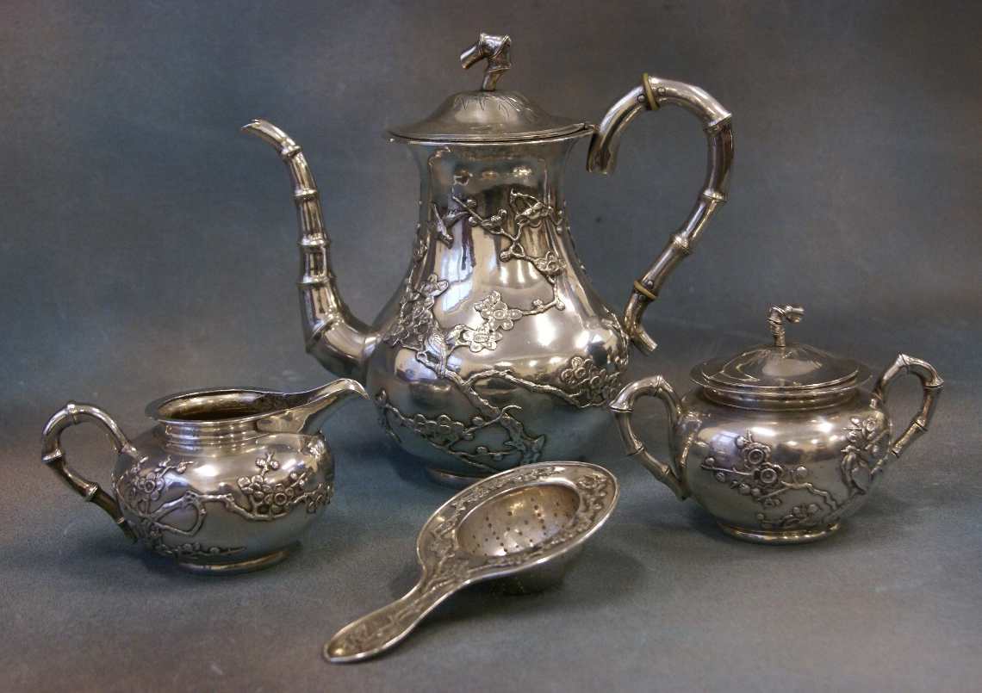 | Lot 3
4. | A pair of 20th century silver Chinese fish servers, by Zeesung, with relief decoration, approx. 10oz, and a small oval unassociated tray, 25cm wide, marks rubbed (3). | £140-£180
5. | An 18th century style mahogany wall mirror, with gilt scalloped shell to top, 34cm wide x 59cm high. | £30-£50
6. | A 20th century tripartite dressing table mirror, of arched form, 82cm wide x 56cm high. | £40-£60
7. | J. Dungemans (1921-2001, South African) - hilly landscape, oil on board, signed, 24cm x 38cm. | £100-£150
8. | Benson Hancock (South Africa) - Farmstead in landscape, oil on board, 29.5cm x 39.5cm. | £100-£150
9.
10. | A modern mahogany and silver plated two bottle tantalus, 27cm x 34cm. | £40-£60
11. | An early 20th century lacquered brass and green plastic travel timepiece, green dial, with white Arabic numerals, retailed by "E & R.S. Harrison, Tunbridge Wells", in box inscribed "Paddock Wood Lodge, 4291, 1st Ladies Evening 1927", slightly a.f. | £30-£50
12. | Eight porcelain "Chelsea Flower Show" plates, and German porcelain "Hunting Museum" plate (9). | £15-£20
13. | Three stamp albums of world stamps, three albums of First Day covers, and a quantity of loose First Day covers, boxed. | £40-£60
14. | A gent's "Rotary" quartz circular wristwatch, in 9ct gold case, with leather strap, boxed, together with a later Rotary "Dolphin" wristwatch, in gold-plated and stainless-steel case, boxed (2). | £110-£160
15. | A Royal Doulton stoneware vase, blue and brown mottled body, decorated flowerheads, shape number 8218, 18cm high. | £25-£35
16. | An Edwardian bone inlaid, mahogany and stained-beech tub-shaped elbow chair, with pad seat, united by a stretcher, on turned legs. | £30-£50
17. | A nest of three simulated walnut occasional tables, a late Victorian corner bracket, and a small oak Sutherland table (3). | £20-£30
18. | A set of six Regency style mahogany rail back dining chairs, on turned legs, united by stretchers, with drop-in seats. | £80-£100
19. | A reproduction mahogany serpentine side table, fitted two drawers, on square tapering left, with spade feet, 99cm wide. | £40-£60
20. | An early Victorian mahogany d-shaped gateleg card table, on turned and ringed legs, 100cm wide. | £100-£150
21. | A small reproduction mahogany Regency style sideboard, fitted drawers and cupboards, on square tapering legs, with spade feet, 107cm wide. | £40-£60
22. | A 20th century Marquetry picture, "Lake Windermere", and inscribed verso "Inlaid by Frank Oswald Kirkaldy 1946", 36cm wide x 32cm high. | £30-£50
23. | A small mahogany revolving bookcase, 43cm x 43cm, and a small bow fronted bedside cabinet, 33cm, a.f. (2). | £50-£70
24. | A carved and stained mahogany standard lamp, 149cm high. | £20-£30
25. | A Victorian pale walnut harlequin dining suite, comprising a wind out dining table, with three leaves, 131cm x 294cm, extended, on turned, fluted, and reeded legs, a set of eight slat-back dining chairs, on square fluted legs, and a part carved sideboard base, 197cm wide, a.f. (10). | £200-£300
26. | Twelve "Edinburgh" crystal long stemmed wine glasses, twelve sherry glasses, eleven spirit tumblers, and two larger unassociated whisky tumblers (37). | £60-£80
27. | Two leather hangers, each with for horse brasses, 42cm long, together with two floral lithographic prints (4). | £20-£30
28. | An early 20th century oak hanging corner cupboard, with panelled door, enclosing shaped shelves, 64cm wide. | £30-£50
29. | A Victorian walnut three tier buffet, with architectural top, and two middle drawers, 122cm wide. | £100-£150
30. | A modern rectangular wall mirror in gilt frame, 73cm x 104cm. | £20-£30
31. | A quantity of Sci-Fi and Fantasy genre film posters advertising the home release of various films (some on DVD and VHS). Titles include several copies of "Matrix Revolutions", "Van Helsing", and "Spider Man 2", among others, approx. 60cm x 43cm, some slightly smaller (13). | £15-£20
32. | A mixed quantity of Crime, Thriller, and Mystery genre film posters, all advertising the home release (some released on DVD and VHS), including "Stepford Wives", and "Once Upon a Time in Mexico", approx. 60cm x 43cm, some slightly smaller (9). | £10-£15
33. | Ten Children and Family genre film posters advertising the home release (some released on DVD and VHS), including "Harry Potter and the Prisoner of Azkaban", "Hunger Games: Catching Fire", and Disney's "Holes", approx. 60cm x 43cm (10). | £15-£20
34. | Seven Romance and Drama genre film posters advertising the home release (some DVD and VHS), including "Calendar Girls", "Eternal Sunshine of the Spotless Mind", and "Love Actually", approx. 60cm x 43cm, sizes vary (7). | £15-£20
35. | A mixed quantity of Horror genre film posters advertising the home release (some DVD and VHS), including "Leather Face", "Cabin Fever", and "Texas Chainsaw Massacre" (2003) (9). | £10-£15
36. | Ten theatre posters from The Churchill Theatre, Bromley, advertising several dramas, including "The Adjustment", and "Murder at the Vicarage", from the late 90's - early 00's, approx. 65cm x 50cm (10). | £10-£15
37. | A quantity of Music, Musical, and Dance theatre performance posters from The Churchill Theatre, Bromley, dating from the late 90's - early 00's, including "Rocky Horror", "Girls night Out", "Smokey Joe's Café", and "Black Goes With Anything", approx. 65cm x 50cm, some slightly smaller (45). | £10-£15
38. | Twelve Comedy and Panto theatre performance posters, all advertising productions at The Churchill Theatre, Bromley, between the late 90's - early 00's, including "Gasping by Ben Elton and Dick Whittington", featuring the Demon Headmaster and S.V. Pollard, approx. 65cm x 50cm (12). | £10-£15
39. | A gilt brass five branch electrolier, 49cm in diameter, together with two matching wall lights (3). | £40-£60
40. | A Victorian walnut octagonal tapering work table, on carved and stained beech tripod base, 43cm in diameter, a.f. | £40-£60
41. | Six African carved wood tribal busts, mixed sizes, and a Buddhist carved wood mask (7). | £20-£30
42. | W. Don Campbell (1930-2012) - "Thompson's Gazelle" in landscape, pastel, 46cm x 60cm. | £20-£30
43. | A Wilvorst grey mourning suit, retailed by Simpsons of Piccadilly, trouser waist 32in, together with a Moss Bros top hat, size 7 1/8in, and a pair of nylon gloves. | £40-£60
44. | A 20th century Dresden porcelain vase, with painted and transfer printed decoration of flowers, white and gilt ground, 24cm high, small chip to foot. | £80-£100
45. | A Clarice Cliff "Bizarre" Latona style bowl, decorated in the stained glass pattern, 23cm in diameter, slightly a.f. | £80-£100
46. | A three strand simulated pearl necklace, a ditto two strand necklace, a beaded necklace, two filigree brooches, together with a quantity of decorative and costume jewellery. | £40-£60
47. | A Conway Stewart "Dinkie" fountain pen, in green lacquered case, and original box. | £40-£60
48. | A Pelham puppet of Muffin the Mule, unboxed. | £40-£60
49. | A Pelham puppet of a caterpillar, 28cm long, unboxed. | £40-£60
50. | A Victorian mahogany dining table with rounded corners, and wind-out action, on turned and ringed legs, together with extra leaf, and winding handle, 116cm x 195cm, extended. | £150-£200
51. | A Victorian mahogany bow-fronted chest of two short and three long drawers, with knob handles, on turned feet, 121cm wide. | £60-£80
52. | A quantity of 20th century coloured postcards, views of various locations, including Rome, French views, some Kent and UK views (approx. 100 plus). | £30-£60
 | 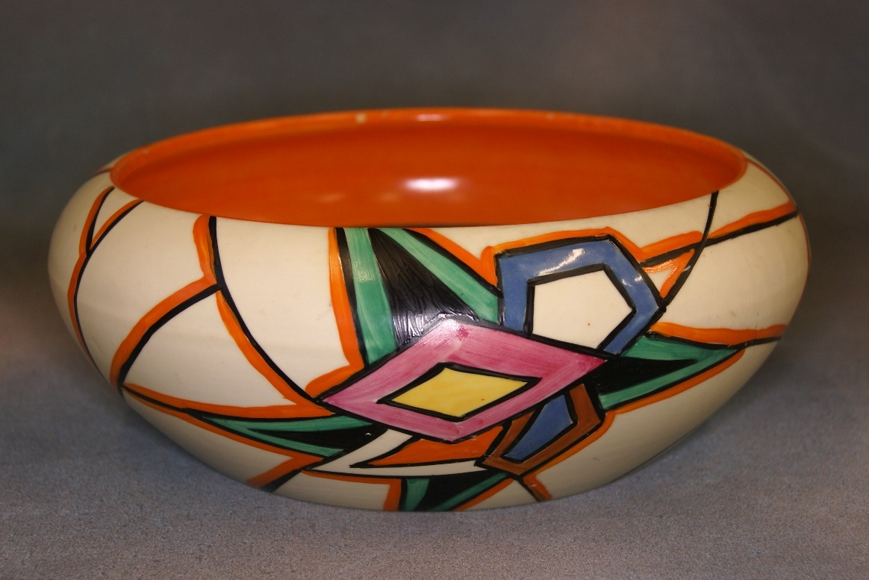 | Lot 45
53. | A 20th century Chinese carved and bone ceremonial staff, with dragon head, 91cm long, a.f. | £30-£50
54. | A Victorian silver christening mug, Exeter 1878, two silver-plated part cruet sets, with glass bottles, together with seven crudely marked silver necklaces, a metal bracelet, and two further necklaces (13). | £40-£60
55. | An early 20th century Chinese style interior painted banister finial, decorated figures, junks, and landscapes, encased in thick glass, 11cm, slightly a.f. | £80-£100
56. | An American made Snoopy dial wristwatch, a ladies Rotary wristwatch, a gent's "Geneva" quartz wristwatch, together with various wristwatches and pocket watches (16). | £60-£80
57. | A Japanese plastic and tin-plate clockwork toy, in the form of a kitten playing with a ball, 15cm long. | £40-£60
58. | A late Victorian brass magnifying lens, Anchor trademark, in cylinder form case, 5cm in diameter. | £20-£30
59. | A set of bone handled and silver-plated fish knives and forks, with silver ferrules, Sheffield 1923, one a.f., in lined case. | £20-£30
60. | A steel yard, lacking its weight, an 18th century trammel, and a log pick (3). | £40-£60
61. | A white metal seven panel bracelet, decorated white enamel, turquoise beads, and seed pearls, 18cm long. | £60-£80
62. | A silver-plated and black enamelled crucifix pendant, 5cm long. | £30-£50
63. | A lady's gold-plated Omega Seamaster quartz wristwatch, gilt dial, on leather strap, a.f. | £40-£60
64. | A small 20th century Chinese cloisonné vase and cover, 11cm high. | £30-£40
65. | A Victorian silver cased key-wound pocket watch, with white enamelled dial, and a lady's fob watch, a.f. (2). | £30-£40
66. | A Black Staffordshire lustreware teapot with floral decoration, and dated 1794, a.f. | £30-£50
67. | A large silver-plated gravy boat, a two handle oval dish, a small ice bucket, circular dish, two pepperettes, and other small pieces. | £40-£60
68. | A late 19th century slate and marble mantel timepiece, French movement, white enamelled dial, inscribed "J.W. Benson, Ludgate Hill, London", 29cm high, slightly a.f. | £40-£60
69. | Printed and published by J. Salmon - "Guide to Sevenoaks, and the Neighbourhood", brown paper covers, a.f., with a modern volume "Sevenoaks Chronicle of the Century", Ogley and Perkins, together with two unassociated black and white etchings, Salisbury and Bruges (4). | £15-£20
70. | A set of six Regency style mahogany and stained beech dining chairs, with brass inlaid decoration, and cane seats, on sabre legs, a.f. | £80-£100
71. | A Russian style tin plate clockwork dancing figure, boxed, a "Roli Zoli" clockwork toy figure, boxed, a magnetic metal rod, and a "Progress" gyroscope top, boxed (4). | £15-£20
72. | A lady's Omega "Deville" wristwatch, rectangular dial with bar numerals, on gilt metal strap, No. 59271204, a.f., mechanical movement. | £80-£120
73. | A "Tissot" lady's gold-plated and stainless-steel wristwatch, rectangular dial, with bar numerals, "Rado" ditto with circular dial and day date, and a "Citizen" ditto with quartz movement, and rectangular dial (3). | £120-£180
74. | A crescent shaped brooch, set graduated seed pearls, and a leaf shaped brooch, also set graduated seed pearls (2). | £80-£120
75. | An Italian made five stone dress ring, claw setting, shank adjusted, size L. | £200-£300
76. | A gilt metal brooch, set a small porcelain plaque of gentleman in landscape, 4.5cm long, slightly a.f. | £60-£80
77. | A lady's articulated bracelet, set tiny zircons, and 44 blue coloured stones, one missing. | £60-£80
78. | An Elizabeth II silver gent's signet ring, set an intaglio cut agate, decorated a horse in a landscape, approx. 0.5oz weighable, London 1975. | £50-£70
79. | A lady's Gucci silver-plated cocktail watch, with white enamelled dial, on circular bar link bracelet strap, in box, with paperwork. | £80-£100
80. | A gent's silver "Tissot" wristwatch, with square blue silvered and white dial, on articulated strap, a small leather and simulated snakeskin card case, inscribed "Captain J.C. Frances 5th Battalion, Light Infantry", and a hunter cased pocket watch, in gilt metal case (3). | £80-£100
81. | A Scottish late Victorian silver presentation key, to "Henry Ballantine Esq., upon the opening of the Peebles Co-operative Bakery, 19th Nov. 1897", Edinburgh 1897, together with seven other presentation keys, in mixed metals, five miniature penknives, a small knight in armour figure, and a small box of coins, various (14). | £70-£100
82. | An Edward VII silver vesta case, inscribed "T. Lovegrove 2nd in Whitchurch Troop Shooting Competition QOOH, 1905", Birmingham 1903, together with two small silver pepperettes, a small toilet jar, with silver top, and a silver-plated cigarette case (5). | £30-£50
83. | A cameo brooch, in pinchbeck mount, a smaller ditto, in marcasite mount, a small silver thistle brooch, a small silver brooch on amber set necklace, a pair of earrings, together with two silver part cufflinks, a silver-plated locket, and other decorative pieces. | £50-£70
84. | A small George V silver pedestal bowl, London 1917, a silver capstan inkwell, Birmingham 1936, and a set of six silver egg spoons, Sheffield 1931, approx. 5oz weighable (8). | £50-£70
85. | R. Marshall - a pair of oils on card, river landscapes, and a pair of decorative prints, in gilt frames, each 54cm 65cm (4). | £20-£30
86. | After F. Robson - "Along the River Maas, Holland", chromolithograph, 32cm x 15.5cm. | £15-£20
87. | Six dessert knives with silver-plated kings pattern handles, and seven dessert forks bearing the crest for the United Services Club (13). | £30-£50
88. | A tan leather handbag, "The Bridge, Italy", a "Tignanello" green leather handbag, and a green leather backpack bag (3). | £20-£30
89. | An "Asahi Pentax 1000" SLR camera, with Takumar 1:2/55 lens, together with two further lenses, and a flash, all in case, together with a Canon Autofocus camera, in case (2). | £30-£50
90. | A fruitwood Parat type shallow dish, possibly of Indian manufacture, 59cm in diameter. | £20-£30
91. | A model of a Spitfire MK IX, wood carcase, together with die cast models of Spitfire, hurricane, and Messerschmitt 109E, Lancaster and Stuka, other models in brass and alloy, and a pair of book ends, some a.f. | £40-£60
92. | A Pakistan Bokhara runner, on red ground, 80cm x 309cm. | £40-£60
93. | Noel Harry Leaver (British, 1889-1951) - "A Tranquil Stream", inscribed verso on label, watercolour, signed, and another of thatched cottage in a wooded landscape, watercolour, signed, each 25cm x 36cm (2). | £250-£350
94. | A Cabinet War Rooms postcard autographed by Winston Churchill MP (grandson of Winston Churchill, former Prime Minister), together with a signed photograph of Margaret Thatcher, a card with newspaper portrait signed by Sir Stanley Matthews, a similar card signed by the Reverend Ian Paisley, and other ephemera signed by Eartha Kitt, Jack Charlton, Timothy West, Prunella Scales, and other personalities (18 pieces). | £60-£80
95. | A black and white photograph of Queen Elizabeth II and Charles of Edinburgh, signed in mount Cecil Beaton, Associated Press stamp verso, a further photograph of Charles of Edinburgh, dated 15th December 1949, two photographs of George VI and family, after Dorothy Wilding, together with an order of service for the memorial of the 11th Duke of Devonshire, and other ephemera relating to the Royal Family (10). | £60-£80
96. | Two early 19th century Chinese plates, decorated in the Japanese Imari style, 23cm in diameter, and two similar soup plates, 23cm in diameter (4). | £40-£60
97. | A reproduction map after Abraham Ortelius, of the Arabian Peninsula, 28cm x 36cm. | £10-£15
 | 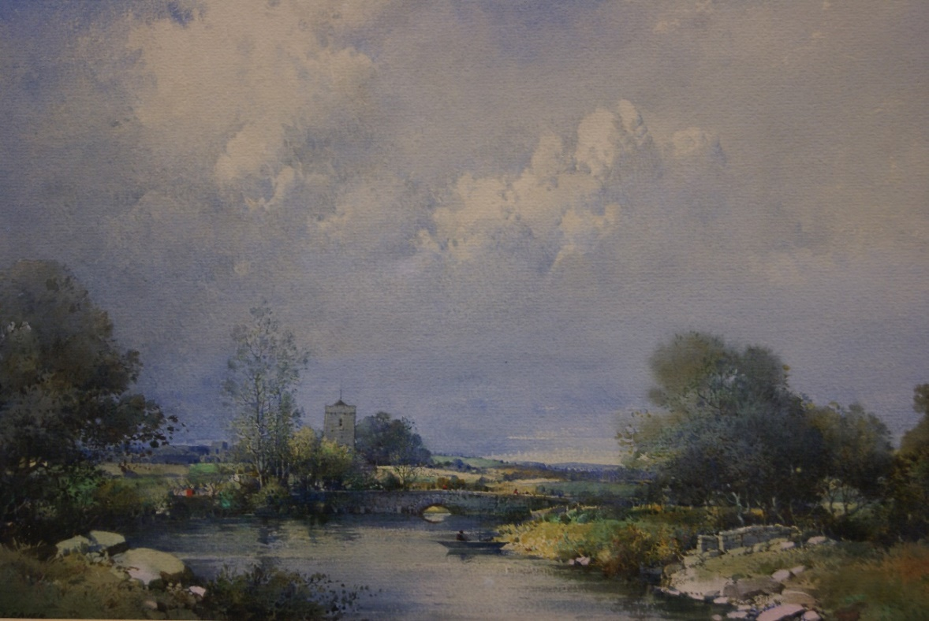  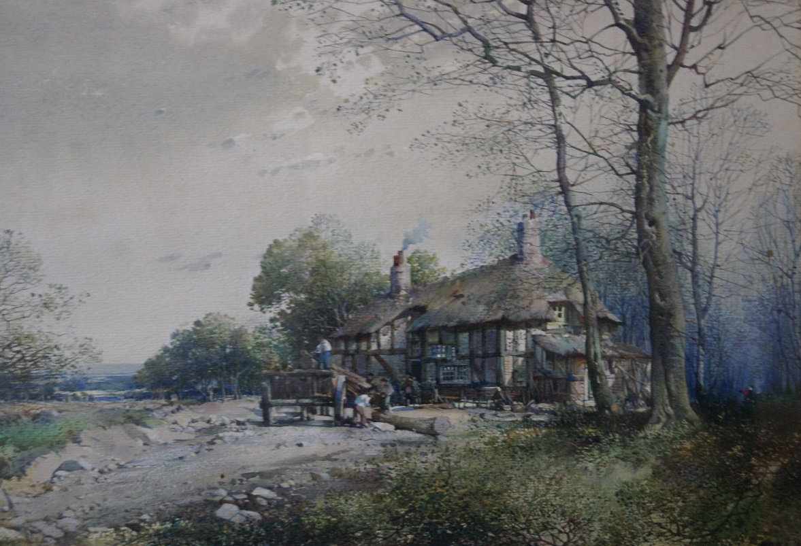 | Lot 93
98. | A pair of cut glass spirit decanters, with silver collars, London 1968, with silver vodka and sherry labels, inscribed Concorde, Birmingham 1986, each 28cm high, together with a Hooper, Struves and Co ltd soda syphon (3). | £50-£70
99. | A pair of 20th century Chinese hardwood corner elbow chairs, with shaped stick backs, on shaped legs united by stretchers (2). | £40-£80
100. | A modern Chinese porcelain table lamp, blue ground with vines, 59cm high, and a cream coloured square form porcelain table lamp, 60cm high (2). | £30-£50
101. | Two gilt frame rectangular form wall mirrors, 81cm x 63cm (2). | £30-£50
102. | A 20th century Chinese rosewood sideboard, fitted four drawers above four panelled doors, 182cm wide. | £60-£80
103. | A 20th century Chinese hardwood alter table, with moulded ends, the four legs united by stretchers, 123cm wide. | £80-£100
104. | A Balinese hardwood x-frame stool, with slatted ends, 67cm wide, slightly a.f. | £30-£50
105. | 20th century Indian school - three figural and landscape scenes, colour wash and gouache, 22cm x 16cm, up to 26cm x 19cm. | £20-£30
106. | A 20th century Bulgarian school icon depicting the life of Christ, in wood frame, 29cm x 26cm, together with a smaller icon with panels of Christ and the Virgin Mary, by Dimitar Voinov, 29cm x 18cm (2). | £30-£50
107. | A 20th century provincial Middle Eastern rug, red ground with wide border, 116cm x 190cm, silky pile, and a Caucasian runner, 71cm x 287cm (2). | £30-£40
108. | A Mintons "Haddon Hall" porcelain part combination set, including two meat platters, 81pieces, some slightly a.f. | £150-£200
109. | A quantity of late George III silver cutlery, 12 place setting, comprising 12 teaspoons, 12 dessert spoons, 12 tablespoons, 12 dessert forks, and 12 table forks, 60 pieces, maker Wm Eley, Wm Fearn, and William Chawner, London 1809, 1810, and 1813, approx. 72oz. | £900-£1200
110. | A quantity of Christies, Sotheby's, Bonham's, Phillips, and other auction and exhibition catalogues, covering mainly Chinese and Oriental ceramics and works of art, approx. 150 plus. | £30-£50
111. | A pair of Japanese late Satsuma ware vases, decorated figural and internal scenes, on shaped bases, each 40cm high. | £40-£60
112. | John Worsley (1919-2000) - "Loading Grain at Antwerp", five ships including "Similarity" and "Speciality", of the fleet operated by "Everard of Greenhithe", watercolour, signed, 25cm x 35cm. | £70-£100
113. | John Worsley (1919-2000) - "M.V. Apricity at Oslo", operated by "Everard of Greenhithe", watercolour, signed, and dated 1968, 25cm x 36cm. | £70-£100
114. | Sydney Vale (1916-1991) - a merchant ship at sea, passing a sailing barge, a vessel belonging to "Everard of Greenhithe", watercolour, signed, 33cm x 49cm. | £30-£40
115. | Sydney Vale (1916-1991) - a merchant ship in calm waters, with two barges close by, and a skiff, watercolour, signed, 35cm x 50cm. | £30-£40
116. | H.L. Harvey 1941 - a Thames sailing barge, in full sale, watercolour, 23cm x 29cm. | £30-£40
 | 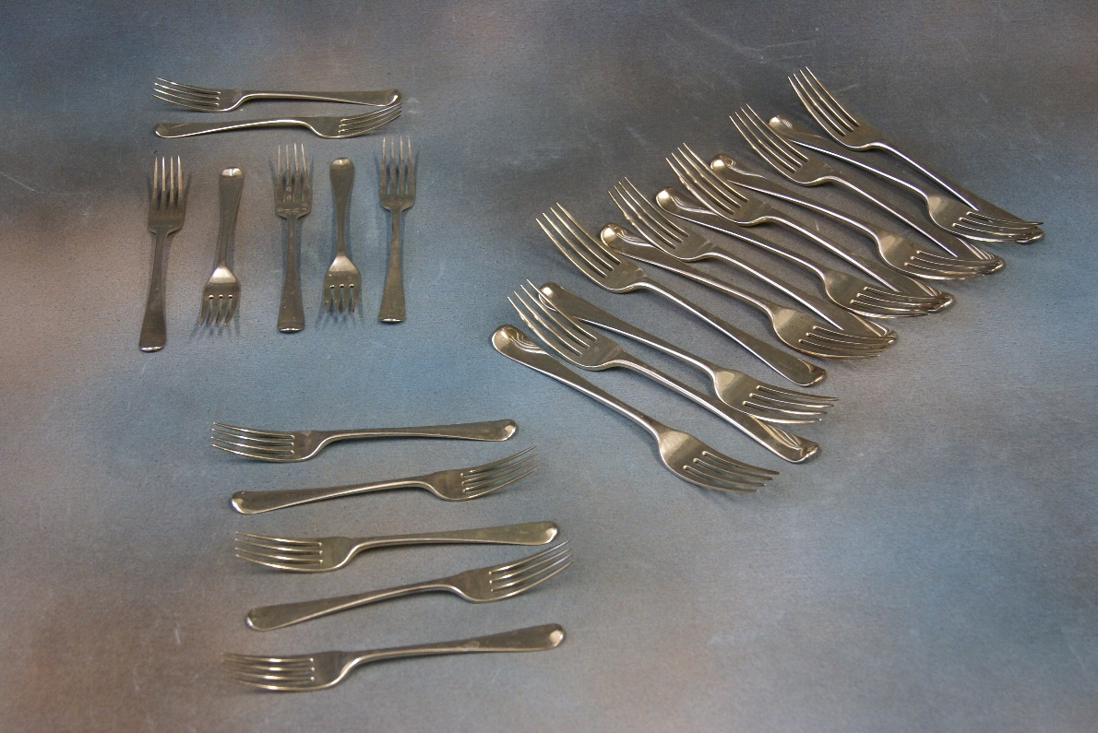  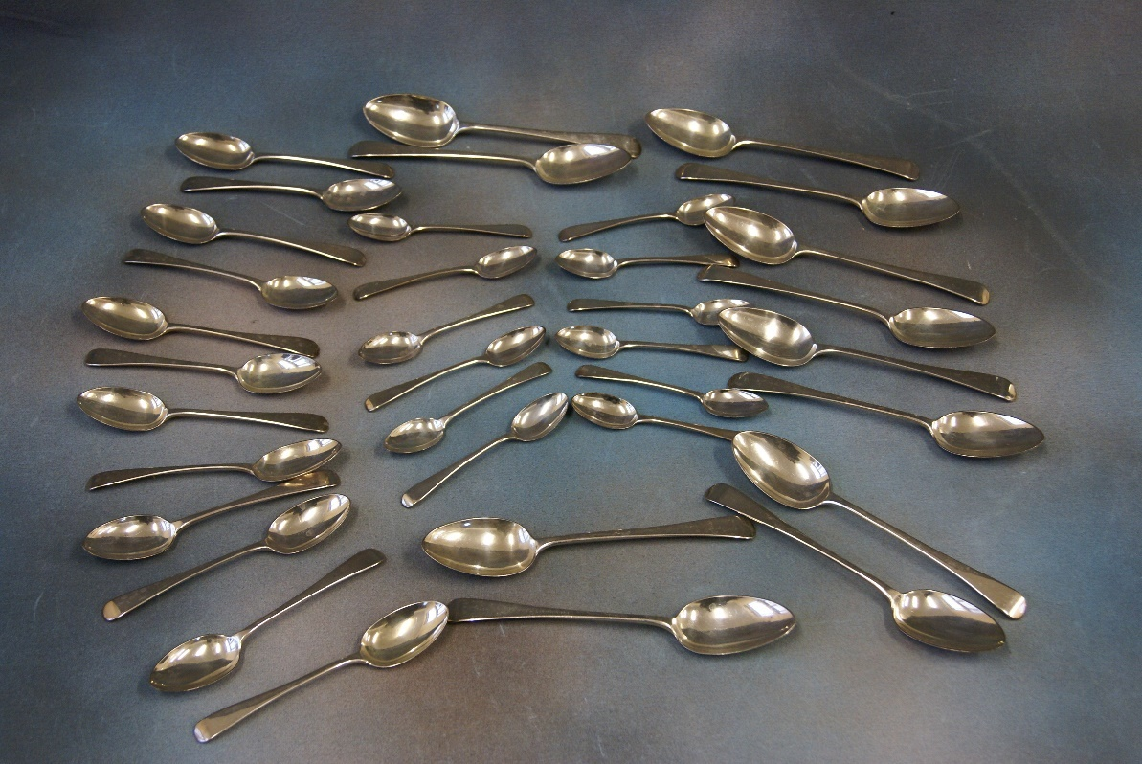 | Lot 109
117. | Sydney Vale (1916-1991) - a merchant ship in rough seas, a vessel belonging to the fleet of "Everard of Greenhithe", 35cm x 50cm, signed. | £30-£40
118. | Sydney Vale (1916-1991) - merchant ship leaving dockside, a vessel belonging to the fleet of "Everard of Greenhithe", watercolour, signed, 35cm x 50cm. | £30-£40
119. | Sydney Vale (1916-1991) - a merchant ship at sea, passing a sailing barge, a vessel belonging to "Everard of Greenhithe", watercolour, signed, 35cm x 50cm. | £30-£40
120. | K.S. Garrett 1990 and 2017 - two volumes "Everard of Greenhithe", tracing the history and ships of F.T. Everard and Sons Limited, the merchant shipping company. | £15-£20
121. | A Ferrari poster "Decisions, Decisions", slightly a.f., in one corner, 79cm x 60cm. | £15-£20
122. | An 8746 G telephone, in cream, with clear dial, 21cm long. | £30-£50
123. | A boxed set of table bowls, a Rhom Brick set, and two sets of dominoes, in mahogany box (3). | £40-£60
124. | An enamelled shoe cleaning tin box, labelled "Black" and "Brown", 22cm x 26cm. | £20-£30
125. | An early 20th century school - a heather covered landscape, watercolour, 9.5cm x 18cm. | £20-£30
126. | A pair of mother of pearl overlaid opera glasses, in bag, slightly a.f. | £20-£30
127. | A Victorian rosewood beaded footstool, and two evening bags (3). | £20-£30
128. | To 2087, Private A.W.G. Kench Royal Sussex Regiment - 1914-15 star, war medal and victory medal, no ribbons, together with a special Constabulary medal, and a Second World War trio (7). | £60-£80
129. | A "Lock and Co" grey top hat, in box, with brush, and a bowler hat, unboxed, by the same retailer (2). | £40-£60
130. | A Regency rosewood sarcophagus shaped tea caddy, with fitted interior, mixing bowl missing, 29cm wide. | £40-£60
131. | A late Victorian umbrella, by "T. Fox and Co Ltd", with fruitwood handle, having silver terminal, Birmingham 1893, and in paper part cover, 87cm long. | £50-£70
132. | An Art Deco style mottled glass plafonnier, with fittings, but no chain, 26cm in diameter. | £20-£30
133. | A small set of late Victorian mahogany wall shelves, with some stained and carved decoration, 61cm x 59cm high, together with an Edwardian mahogany and stained beech flap top work table, and a crochet counter (3). | £50-£70
134. | John M. Bromley (FL 1880-1904) - cottage and trees near a river, watercolour, signed, 42cm x 75cm. | £80-£100
135. | A "TWA" linen seat back, or large napkin, with embroidered logo, 41cm x 44cm. | £20-£30
136. | An Edward VII hobnail cut glass toilet box, with silver top, Chester 1906, a silver backed clothes brush, Birmingham 1906, a silver-plated nurses buckle, a crown Staffordshire Mona Lisa pendant, and an enamelled 1946 farthing pendant (5). | £50-£70
137. | Ten Victorian glass fluted jelly glasses, each on circular feet, in mixed sizes, between 6cm and 11cm high (10). | £50-£70
138. | A Victorian faded walnut and beech jewellery box, with fitted interior, 30cm wide. | £30-£50
139. | A decorative silver-plated dish stand with adjustable feet, 30cm in diameter, an oval entrée dish, a muffin dish, and other pieces. | £50-£70
140. | A silver-plated cheese dish, two dish holders, no liners, two bottle coasters, a biscuit barrel, no liner, and five other pieces (11). | £50-£70
141. | A.D. Bell - "Fishing Trawlers", 1990, and "With a Fair Breeze", 1995, watercolours, signed, each 26cm x 36.5cm (2). | £50-£70
142. | E.W. Haslehurst - a skiff moored up by a waterside cottage, watercolour, signed, 40cm x 47cm. | £50-£70
143. | A set of six reproduction mahogany shield-back dining chairs, on turned and fluted legs, and a reproduction mahogany circular top breakfast table, on quadruped base, 130cm in diameter (7). | £50-£80
144. | A set of six simulated oak and stained beech spindle back dining chairs, with rush seats, on turned legs with pad feet (6). | £40-£60
145. | A set of six early 20th century stained beech Carolean style high back dining chairs, with pen work decoration, and cane seats and back panels, some a.f., including one elbow chair (6). | £40-£60
146. | A late Victorian mahogany and walnut bedside cabinet, on plinth base, 39cm wide. | £30-£50
147. | A 20th century oak grandmother clock, with silvered dial, two train movement, 129cm high. | £20-£30
148. | A 19th century longcase clock, the thirty-hour movement, with square brass dial, 25cm wide, on plinth base, 188cm high, signed "Samuel Ollive, Tunbridge". | £60-£80
149. | A Victorian mahogany work table, of shaped outline, the hinged lid revealing a mahogany and pollard oak interior, on carved and turned end supports, and shaped legs, united by a turned stretcher, 49cm wide. | £80-£120
150. | A Victorian inlaid walnut and stained beech centre table, a.f., 72cm in diameter, and a Victorian oak side chair (2). | £30-£50
151. | A late Regency faded rosewood fold over swivel top card table, on shaped and facetted column, and quadriform base, with lion paw feet, 89cm wide, a.f. | £60-£80
152. | A pair of "Bussey Imperial" bowling balls, in carrying case. | £15-£20
153. | Nine volumes of Wisdens Cricketers Almanack, 1951-1959, mostly soft covers, one volume of Who's Who in Cricket, 1954, thirteen volumes of sporting books, including West Indian Adventure, by E.W. Swanton, together with a full size and a miniature autographed cricket bats (25). | £20-£30
154. | A quantity of masonic regalia for the Pickwick, West Kent, and other lodges, together with a rosewood gavel. | £30-£40
155. | A Dinky Supertoys "Foden" red flatbed lorry, a Dinky Toys "23S" racing car, a silver racing car, a red and silver racing car, and a green "Cooper Bristol" racing car, all unboxed (6). | £40-£60
156. | A gilt metal and enamelled past chairman's medal, for the "Incorporated Society of Auctioneers and Landed Property Agents", an enamelled army catering corps medal, for five years' service, boxed, and an unboxed "Outward Bound" badge (3). | £20-£30
157. | A Venetian style rectangular shaped wall mirror, with scrolled crest and bevelled edges, 40cm wide x 74cm high. | £40-£60
158. | A George III mahogany circular snap top occasional table on tripod base, 68cm in diameter (restored). | £30-£40
159. | An early 18th century walnut chest of two short and three long drawers, with later handles, on bracket feet, 105cm wide. | £150-£200
160. | A pair of Dresden porcelain square slender neck vases, decorated alternate panels of flowers and lovers, with small floral decorated covers (bases drilled) for adaption into table lamps. | £60-£80
161. | A Regency mahogany circular snap-top breakfast table, crossbanded decoration, on triangular pedestal tri-form base, and lion paw feet, 140cm in diameter. | £200-£300
162. | A Stained wood bagatelle board, with balls, 76cm long, and a shove ha'penny board, 65cm long (2). | £20-£30
163. | A Hickory shafted wooden driver golf club, by "Josh Taylor", 98cm long, together with three irons, by the same manufacturer (4). | £60-£80
164. | Four Hickory shafted iron golf clubs, by "H.L. Curtis, Bournemouth", including a Mashie Niblick, mixed heights between 87cm and 100cm (4). | £60-£80
165. | Five Hickory shafted iron golf clubs, by "Fred Sanders, Highgate", between 95cm and 100cm long (5). | £70-£90
166. | A late 19th century carved circular form shell, the panels decorated biblical events, including the last supper, 17cm in diameter, together with an oval form shell decorated panels depicting the life and death of Christ, 16cm, a.f. to edge (2). | £80-£100
167. | Fourteen miniature bottles of spirits, and other alcohol, comprising nine full and unused bottles, including one whisky, one port, two Tia Maria, and two cognac, together with four partial full bottles of Rocher peach liqueur, and a Warninks black current liqueur, ullage levels vary (14). | £20-£30
168. | Two albums (one partially filled) of early 20th century picture postcards, including views of Rome, Warsaw, Aberdeen, Shipping, Children, and other subjects, approx. 207. | £40-£60
169. | Produced by Jonathan Miller - poster of English National Opera version of "Verdi's Rigoletto, at the London Coliseum", 75cm x 49cm. | £40-£60
170. | Two tintype photographs of a family group, in paper frames, 8cm x 12cm, a pair of silhouette pictures, a photo of an early motorbike and side car, and a small group of other photographs (16). | £20-£30
171. | Victorian school - after Richard Ansell - "The Fight for The Standard", lithograph, depicting Serjeant Ewart of the Scots Greys, at Waterloo, in maple frame, 94cm x 78cm, a.f. | £30-£50
172. | A Victorian commemorative copy of the Time newspaper from October 3rd 1798, covering Nelson's victory at the Battle of the Nile, glazed both sides, oak frame, 54cm x 70cm. | £20-£30
173. | 19th century school - windmill in a fenland landscape, oil on copper, 22cm x 25cm. | £40-£60
174. | Victorian school - shipping in stormy seas, near harbour, oil on canvas, 45cm x 60cm. | £60-£80
175. | A Victorian ironstone oval meat plate, by E.F. Bodley and Co, "Prince of Wales" pattern, diamond mark verso, 50cm wide, circa 1862. | £20-£30
176. | A small number of mainly studio photographs of First World War officers and other ranks, approx. 15, together with a mixed quantity of other family type photographs from the period, approx. 65 overall. | £30-£40
177. | A "Hooper, Struve and Co" soda syphon bottle, with etched decoration, and remains of label, 33cm high. | £15-£20
178. | A gent's dress stud set, comprising a pair of gold-plated cufflinks, and three mother of pearl shirt studs, in box, together with a Ronsen table lighter, in red glass case (2). | £20-£30
179. | A bronze Life Saving Society medal, awarded to Margaret Ewart, boxed, together with an enamelled medal awarded in 1914, other associated medals and badges, two photographs, and a conference programme, 1933 (10). | £20-£30
180. | A 1st edition volume of "Harry Potter and the Prisoner of Azkaban", published by Bloomsbury, 1999, author J.K. Rowling, printed by Clays Ltd, St. Ives PLC, with dust jacket. | £20-£30
181. | Stancliffe - "Golf Do's and Don'ts", published by Methven and Co, 1902, 17cm x 11cm. | £15-£20
182. | Robert Southey, 1814 - "The Life of Nelson", second edition, volume one of two, printed for John Murray, a.f. | £60-£80
183. | Of medical interest - Michael Underwood - "A Treatise on the Diseases of Children", 1811, volume one, only, of three, together with "An Essay of Health and Long Life", by George Cheyne, eighth edition, 1734, and one volume "The New Family Physician", by John Abernathy, all a.f. (3). | £60-£80
184. | Eugene Labaume, "A Narrative of the Campaign in Russia in 1812", translated from the French, London 1815, together with one volume "The Boys of 76, a History of the Battles of the Revolution", 1877, by Charles Carlton Coffin, and one volume "Bullet and Shell", by Geo F. Williams, illustrated, 1882, a.f. (3). | £40-£60
185. | John Brown - "Anecdotes and Characters of the House of Brunswick", London 1821, and one German Volume "Märchen", by William Hauff, Stuttgart (2). | £30-£50
186. | Published by the Illustrated London News - "The Illustrated War News", 1914-1918, eight volumes, with illustrations (8). | £20-£30
187. | One volume "VRI, Her Life and Empire", by the Marquis of Lome, later Duke of Argyll, published by Hamsworth Bros Ltd, circa 1900. | £30-£50
188. | A 17th century leather bound composite bible, circa 1608-9, the book of Psalms included, with music, illustrated with wood cut prints, a.f. | £30-£50
189. | Three albums of early 20th century black and white photographs, taken by Miss Lucy Hills of Maidstone, comprising one album of Scotland, and the North of England, and two albums of locations in England, in particular Cornwall, Devon, and West Country, together with Wales, and some of Rome and art works in Florence, some a.f. (3). | £100-£150
190. | A modern faience tureen and cover, decorated flowers and butterflies, on saucer dish, 27cm in diameter, and a Dresden porcelain tea caddy, a.f. (2). | £30-£50
191. | After Samuel and Nathaniel Buck - "The West Prospect of His Majesty's Dockyard, Chatham", coloured engraving, 30cm x 79cm, a further engraving of a naval engagement, a.f., and a black and white engraving of "Knole". (3). | £40-£60
192. | A Regency mahogany rounded rectangular breakfast table, on quadruped base, 107cm x 77cm. | £150-£200
193. | L.E. Garrido - harbour view, possibly Coen, oil on board, 20cm x 26cm. | £100-£150
194. | A Continental rectangular gilt wood centre table, with marble inset top, and bow form ends, gadrooned mouldings, on fluted and turned legs, united by shaped stretchers, 89cm wide. | £300-£400
195. | Eugene Damoye 1908 - landscape with gateway to farmstead, oil on canvas, 65cm x 97cm. | £200-£300
196. | A 19th century mahogany escritoire with moulded cornice, and frieze drawer, the interior below, enclosed by a fall front, above three drawers, of Scandinavian or German manufacture, 107cm wide. | £200-£300
197. | A Georgian mahogany bow fronted hanging corner cupboard, 71cm wide. | £60-£80
198. | A stripped pine bench seat of pew type, with shaped ends, 227cm wide. | £30-£50
199. | A 20th century metal and gilt brass circular coffee table, of Italian style, on four square legs, united by c-form stretchers, 121cm in diameter. | £80-£100
200. | An Aynsley "Balmoral" pattern part dinner service, 23 pieces, and a Coalport part tea set, 18 pieces (41). | £20-£30
201. | A Royal Copenhagen floral pattern part combination set, including plates, a tazza, and a part coffee and tea set, 59 pieces, and a part coffee set, in the Berlin style, 19 pieces (78). | £70-£100
202. | A pair of 19th century Chinese famille rose plates, each 24cm in diameter, a.f., a small elongated octagonal form dish, and six Chinese style plates, a.f. (9). | £40-£60
203. | A Royal Copenhagen "Flora Danika" pattern Monteith, 33cm wide, a two handled floral bowl, and a Danish blue and white potpourri vase, of figural form (3). | £50-£70
204. | A 20th century pottery shallow bowl, blue glaze, 34cm in diameter. | £20-£30
205. | A Swedish porcelain part combination set, with gilt edging, 48 pieces. | £40-£60
206. | A small bronzed metal figure of crying cherub, on landscaped base, signed by Ruth Milles, 15cm high, and a small statuette. | £80-£100
207. | Early 19th century mahogany Pembroke table, the flaps with rounded corners, 80cm wide. | £60-£80
208. | An early 19th century gilt frame pier glass, with two piece plate, and decorative frieze, 53cm wide x 135cm high. | £100-£150
209. | A George III mahogany bureau, the fall above four long drawers, 93cm wide. | £40-£60
210. | A 19th century work table, on tripod base, 50cm wide, a George III mahogany side table, and a reproduction towel rail. | £50-£70
211. | A diamond plaque brooch, of square shape, unmarked, set 128 stones, in baguette, brilliant, and single cut, approx. 3 carats overall, in 1940's style, 3cm x 4cm, overall. | £1500-£2000
212. | A lady's "Patek Phillipe and Co" circular cased wristwatch, 19g, including movement, 18k, a.f. | £600-£800
213. | A lady's "Beuche-Girod" 9ct gold wristwatch, rectangular case, on link strap, 27g weighable, unboxed. | £400-£500
214. | A pearl set dress ring, with tiny chip diamond shoulders, a dress ring set 10 green garnets, a three stone dress ring, central stone, cracked, a pair of turquoise set earrings and matching brooch, two gold-plated quartz wrist watches, two pairs of costume earrings, and a seal fob (13). | £70-£100
215. | E Ollers (Swedish? 1888-1959) - view of harbour and boats, through alley, oil on board, signed and dated 1946, 32cm x 21cm. | £40-£60
 | 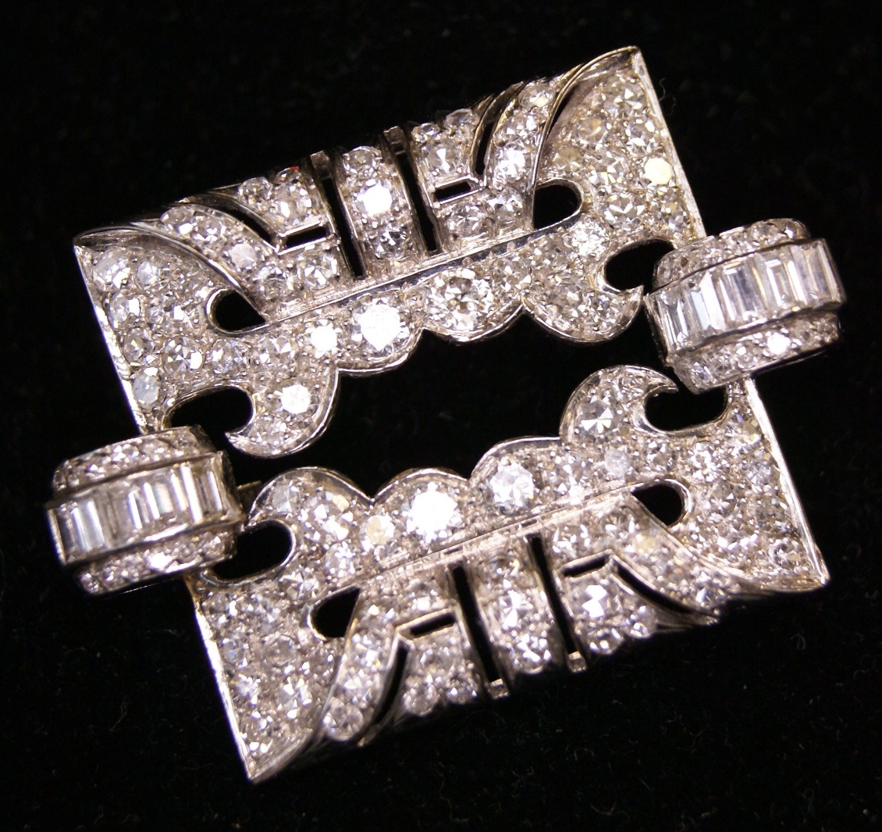 | Lot 211
 | 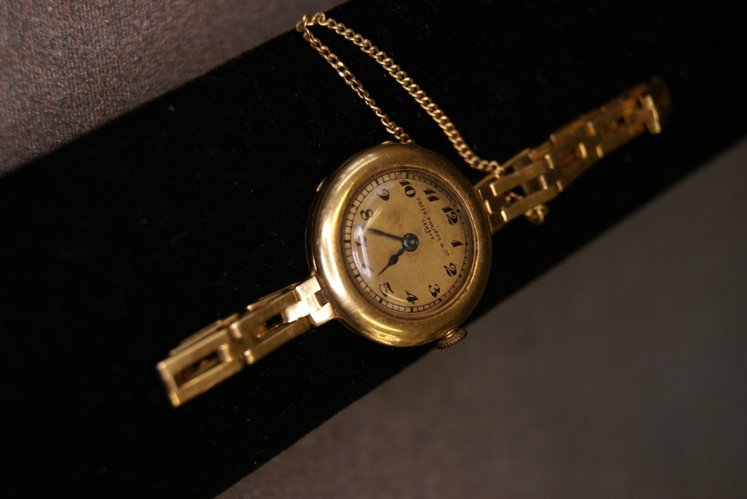 | Lot 212
216. | Sigmund Erickson 1962 - winter landscape, with mountains in background, oil on canvas, 55cm x 67cm. | £50-£70
217. | A Danish white metal tea pot, of oval footed form, with ebonised handle and finial, approx. 14oz, marks rubbed. | £200-£250
218. | A silver-plated oval piecrust dish, 60cm wide, a circular dish, with similar edge, 35cm in diameter, three toast racks, a pedestal bowl and a coffee pot (7). | £40-£60
219. | A pair of George V silver sauce boats, and a pair of small ladles, maker E.V., Sheffield 1932, in case, together with two pepperettes, a small goblet, and an egg cup, marks rubbed, approx. 11oz. | £150-£200
220. | A Danish white metal back three-piece dressing table set, unboxed, and a shallow bowl, with enamelled centre (4). | £40-£60
221. | A mixed pattern Swedish white metal part suite of table cutlery, by Hallbergs and Carlstrom, believed dated between 1948 and 1951, approx. 97.5oz, weighable, in fitted canteen. | £1300-£1500
222. | A small Oriental style oak and brass cabinet, fitted two doors, above a drawer arrangement, 56cm wide. | £60-£80
223. | A Late 19th Century Swiss made ratchet operated cylinder music box, playing eight airs, and fitted with visible drum and four bells, in rosewood, ebonised, and inlaid case, 49cm wide, a.f. | £250-£350
224. | A canteen of mixed silver-plated and bone handled cutlery, together with two oval dishes, a part egg cup stand, and other silver-plated objects. | £30-£50
225. | A 20th century oak draw-leaf dining table, 75cm x 229cm, extended, and a set of five Cromwellian style dining chairs, including an elbow chair (6). | £100-£150
226. | A Victorian stained beech side table, with part crossbanded top, on turned and ringed legs, 74cm wide. | £30-£50
227. | A small late 19th century French rosewood vitrine, with some gilt brass edges, some inlaid and strung decoration, on cabriole shaped legs, 68cm wide x 112cm high. | £80-£100
228. | Late Victorian school - Italianate landscape, with figures in distance, oil on canvas, 48cm x 58cm, in need of restoration. | £30-£50
229. | A mahogany demi-lune side table on four square tapering legs, with spade feet, 87cm wide, and a mahogany shield back elbow chair (2). | £20-£30
230. | A late Victorian mahogany and stained beech chaise longue, with seat end, on slender cabriole legs, 162cm wide. | £60-£80
231. | A pair of Chinese carved hardwood urn stands, on cabriole form legs, with claw and ball feet, each 41cm wide, a.f. | £70-£100
 | 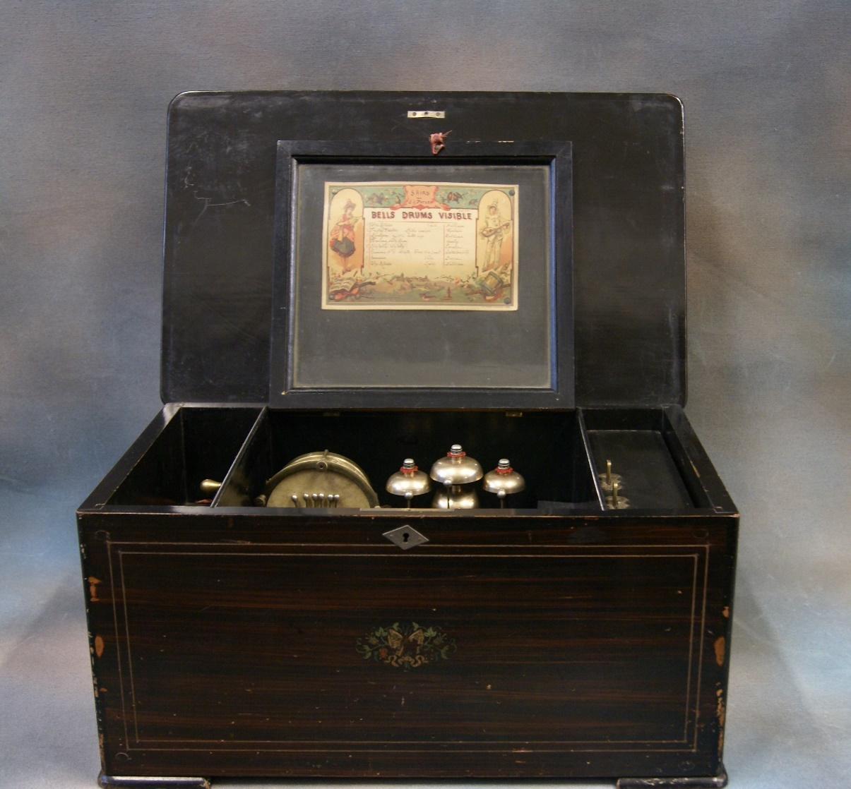  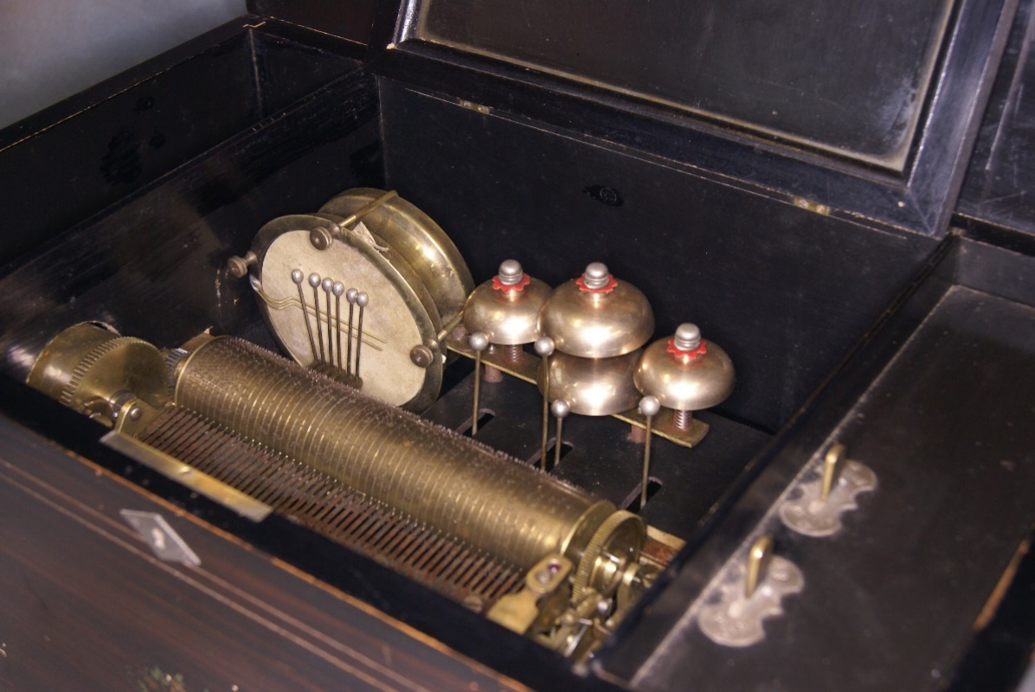 | Lot 223
232. | A small Victorian mahogany cabinet, with four shelf superstructure, above a panelled door, 49cm wide x 124cm high. | £30-£50
233. | A famille vert Cantonese style fruit bowl, the panels decorated figures and flowers, 26cm in diameter, and a similar plate, a.f. (2). | £30-£50
234. | A large Japanese Satsuma ware vase, Meiji period, the panels decorated figures of ladies in a landscape, one side, Samurai warriors, the other, 46cm high. | £150-£200
235. | A Georgian style mahogany display cabinet, fitted a pair of astragal glazed doors, above a drawer and two panelled doors, 61cm wide x 174cm high. | £40-£60
236. | A George III style mahogany display cabinet, enclosed by a pair of astragal glazed panel doors, below a Greek key pattern cornice, and above two drawers, on bracket feet, 105cm wide x 188cm high, a.f. | £60-£80
237. | An 18th century style mahogany wall mirror, with some gilt decoration, and ho-ho bird crest, 51cm wide x 89cm high. | £50-£70
238. | An Armand Marseilles bisque head doll, mould No. 390, two further later general dolls, a small quantity of clothing, and a miniature doll (4). | £30-£50
239. | Four opaque twist stem wine glasses, one chipped, each 15cm high, and a further glass with spiral interior twist stem, chipped (5). | £30-£50
240. | A square footed and etched glass runner, 14.5cm high, a pair of delicate wine glasses, five custard glasses, and two further glasses (10). | £20-£30
241. | A quantity of Giles cartoon annuals, from the 1960's to 1990, including some compilation volumes, in commemoration, together with a further volume "The Giles Family", by Peter Tory (approx. 40 volumes). | £20-£30
242. | Three silver gilt and enamelled medals for the "Order of Oddfellows", boxed (3). | £20-£30
243. | Henry Bright, September 6th 1860 (1814-1873) - "Matterhorn", inscribed on mount, watercolour, 28cm x 22cm. | £200-£300
244. | A Harmsworth Atlas and Gazetteer, possibly circa 1907, two volumes of Marvels of the Universe, a Fred Richards sketchbook - Venice, with lithographic illustrations, together with ten further similar sketchbooks, after various artists (14, overall). | £30-£50
245. | A glove box containing pairs of gloves, and a pair of ebonised glove stretchers, together with a stained wood cigarette box, with musical movement (2). | £20-£30
246. | An Art Deco style Smith's electric mantel timepiece, in marble case, 19cm high, together with a small sundial, and tobacco jar and cover (3). | £50-£70
247. | A small pair of early 20th century Chinese cloisonné vases, yellow ground, with black and grey panels, decorated stylised birds, and butterflies, 15cm high, together with a pair of small cloisonné pots and covers (4). | £60-£80
248. | Robert Gallon - Two figures punting on river, town on far bank, watercolour, 20cm x 36cm. | £40-£60
249. | A late Regency mahogany bow fronted chest of two short and two long drawers, on later turned feet, 91cm wide. | £40-£60
250. | A late Victorian silver trophy cup of goblet form, with inscription, marks rubbed, a silver cigarette case, Birmingham 1947, a leather and silver cigar case, London 1866, and a set of silver handled tea knives, marks rubbed, in a case, approx. 11oz, weighable (4). | £120-£180
251. | A set of six white metal and gilt coffee spoons, with coloured enamel decoration, in lined case, retailed by "Boyes, Bassett and Co, Shanghai", two christening spoons, in cases, five silver bowling club spoons, and two glass jars, with silver hair tidy tops, a.f. | £50-£70
252. | A silver-plated breadbasket, a toast rack, cruets, napkin rings, and other pieces, together with a glass biscuit barrel, with silver-plated cover, and a sugar castor, with silver-plated top. | £20-£30
253. | A lady's 9ct gold "Pinnacle" wristwatch, on black linen strap, a silver-plated ditto, a yellow metal link chain, a locket pendant, on slender 9ct gold chain, two silver-plated pocket watches, various small penknives, and other mixed objects. | £80-£100
254. | A Chinese silver tea kettle, with planished decoration, on simulated bamboo stand, with burner, marks rubbed and indistinct, together with two metal ware ashtrays, eight small dishes, and a teaspoon (12). | £80-£100
255. | A mixed quantity of silver-plated and bone handled loose cutlery, together with sugar nips, a waiter, a small pierced bowl, and other objects. | £20-£30
256. | A miniature portrait on tortoiseshell of lady in period costume, a.f., 10cm x 8cm, a small painting on glass of an ermine, 6cm x 9cm, a.f., and a miniature pencil sketch of a young woman (3). | £30-£50
257. | A German First World War steel belt buckle, with "Gott Mit Uns" inscription, a British First World War medal to 76853 Private E.E. Olley 3rd London Regiment, a silver-plated I.D. bracelet, to 44269 L.E. Bennett, Bedfordshire Regiment, a woman's own cookery medal, and a special constabulary medal (5). | £20-£30
258. | A Caucasian rug, with pale ground central field, black ground corners, and triple border, 142cm x 216cm, a.f. | £30-£50
259. | A gent's 9ct gold Omega "Seamaster" wristwatch, with automatic movement, silvered dial, with mixed baton and Arabic numerals, a.f. to glass, on a mesh link bracelet strap, original winding crown, unboxed, and lacking paperwork. | £900-£1200
 | 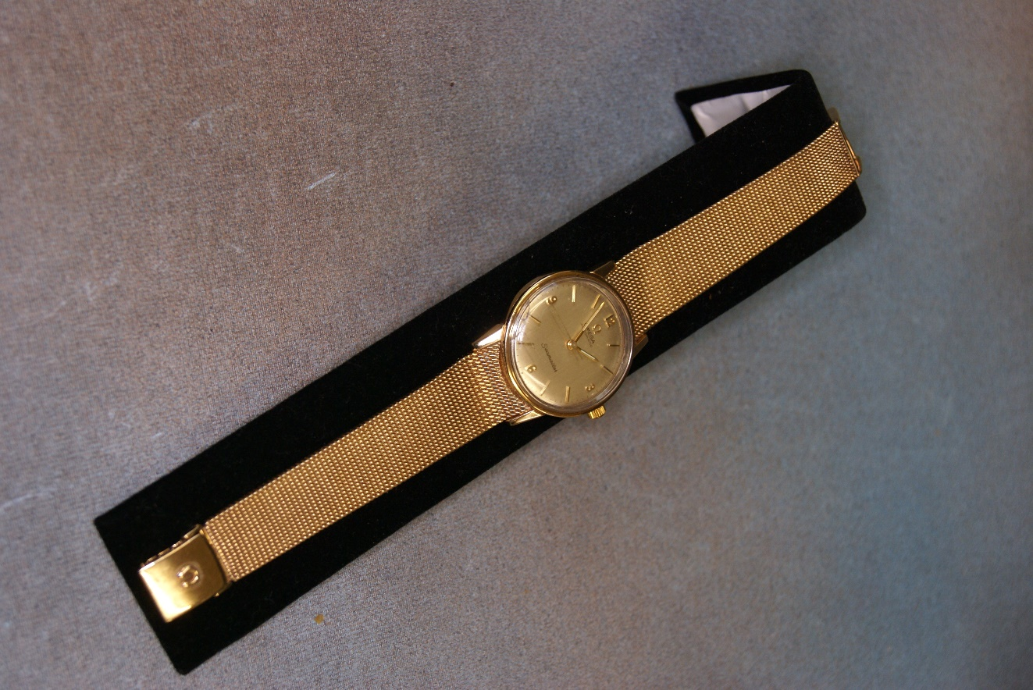  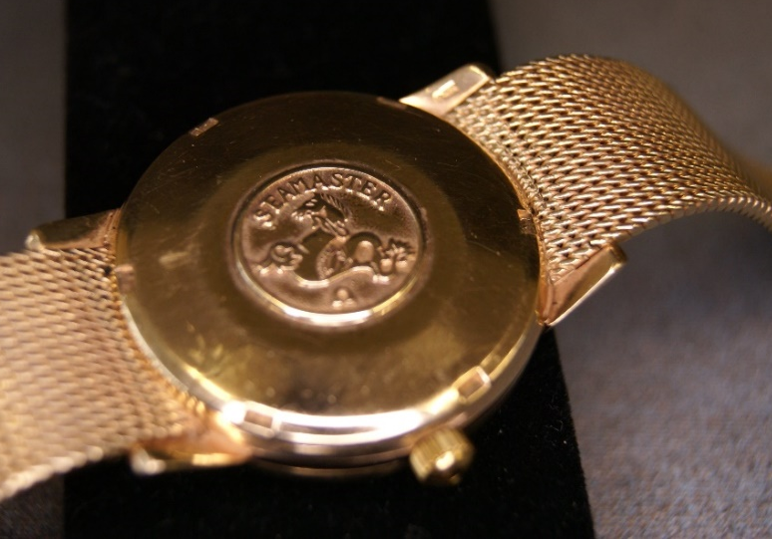 | Lot 259
260. | Thomas Stevens 91 - wheat cutters in a field, watercolour, 41cm x 66cm. | £80-£100
261. | A 19th century corner cupboard, with glazed upper doors, 96cm wide x 221cm high. | £80-£100
262. | A George III mahogany longcase clock, the arched hood with three painted finials, one a.f., eight-day movement with painted dial inscribed "Warren of Canterbury" the trunk door with moulded edge, on plinth base with bracket feet. | £300-£400
263. | A Victorian mahogany pot cupboard, 40cm wide, and a small George III mahogany washstand, 34cm wide. | £40-£60
264. | A reproduction magazine table, 54cm wide and a small late Victorian two drawer chest, 38cm wide (2). | £20-£30
265. | A Limoges M. Redon part dessert service, floral pattern comprising twelve plates, three scrolled dishes and two tazzas. | £80-£100
266. | After J.W. Carmichael and E. Duncan - two maritime prints, each 26cm x 41cm, and five smaller maritime prints (7). | £20-£30
267. | A late Victorian oak fold over swivel top card table, on turned and ringed legs, 91cm wide. | £80-£100
268. | A Victorian oak and simulated elm oval occasional table, with twin turned end supports, and trestle feet, united by a stretcher, 100cm wide. | £60-£80
269. | A Victorian mahogany hall chair on turned legs, and an elm and beech stick back chair (2). | £20-£30
270. | A late Victorian stained wood button upholstered two seater settee, on slender cabriole legs, 139cm wide, a.f. to upholstery. | £80-£100
271. | A late Victorian inlaid rosewood bow and breakfront sideboard, fitted open shelves and cupboards on square tapering legs, 152cm wide, a.f. | £50-£80
272. | Two resin novelty cribbage boards, each 21cm wide. | £30-£50
273. | A stripped pine dresser with plate rack and spice drawers, above drawers and panelled doors, 164cm wide x 193cm high. | £80-£100
274. | A Sindy Doll, with blond hair, based on "country walks" model, with tweed skirt and suede jacket, circa 1963, 29cm long, unboxed. | £40-£60
275. | A pair of Royal Doulton stoneware vases, with mottled green bodies, each 14cm high, one a.f., together with two Staffordshire pottery flat-back groups, each 18cm high, and a spill group, 16cm high, a.f. (5). | £20-£30
276. | A 9ct gold diamond solitaire dress ring, claw setting. | £100-£150
Future Dates

AUCTION DATES 2022

Wednesday 9th March 2022
Wednesday 27th April 2022
Wednesday 8th June 2022
Wednesday 20th July 2022
Wednesday 7th September 2022
Wednesday 26th October 2022
Wednesday 7th December 2022
Viewing on Monday and day before sale from 12.00 pm to 19.00 pm.
Sale commences at 11.00 am

VALUATION DAYS 2022

Wednesday 2nd February 2022
Wednesday 16th March 2022
Wednesday 4th May 2022
Wednesday 15th June 2022
Wednesday 27th July 2022
Wednesday 21st September 2022
Wednesday 2nd November 2022
Wednesday 14th December 2022
Sevenoaks Saleroom, Argyle Road,
Sevenoaks TN13 1HJ
11.00 a.m. – 4.00 p.m.

Notes

