Welcome to Ibbett Mosely Auctions, Wednesday 31st March 2021 Auction Catalogue

This sale will be held online only, at www.easyliveauction.com/ibbettmosely/
please visit the website to register or log in to view and bid.

Alternatively, commission bids (bids left ‘on the book’) may be left with us, as well as a limited amount of telephone bids. Please telephone 01732 456731 or email auctions@ibbettmosely.co.uk for further details.

Due to Covid-19, there is viewing strictly by appointment only. Any walk-ins will not be allowed viewing. The full catalogue, complete with images of each lot and condition reports will be available at easyliveauction.com/ibbettmosely

Please telephone 01732 456731 or email auctions@ibbettmosely.co.uk with any questions.

Collection of items can only take place with prior appointment from 1st April. You are welcome to collect in person, or via your own carrier, but local courier PSP Logistics are available to carry out deliveries of items.
Please contact them directly to arrange and pay for delivery.

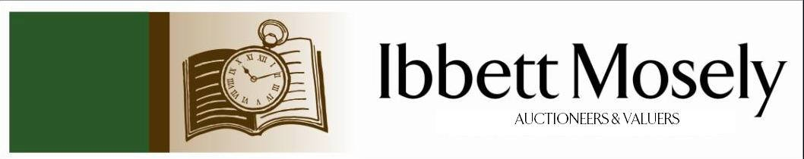

Catalogue of Antique, Edwardian and Victorian
Furniture and Effects
to be Auctioned on

Wednesday 31st March 2021
at 11.00am

IBBETT MOSELY AUCTION ROOMS
ARGYLE ROAD, SEVENOAKS, KENT TN13 1HJ
Via www.easyliveauction.com/ibbettmosely/

Viewing at Sale Room on:

Monday 29th March
Tuesday 30th March

Between 10.00am –5.00pm.

STRICTLY BY APPOINTMENT ONLY.
(Limited numbers)

Catalogues: £2.00

Auctioneer and Valuer: Alan White FNAVA
Consultant Auctioneer and Valuer: Derek Hodge
Trainee Valuer and Clerk: Nicola Rainsley-Hughes
Auction Clerk and Administrator: Emily Frederick

1. | Silver cigarette box 12cm x 9cm, Birmingham 1970, set of four silver salts with shell pattern and two spoons (boxed), silver mustard pot with blue glass liner, a.f., and silver pepper. | £40-£50
2. | A selection of EPNS including a three-branch candelabra with sconces, height 46cm, six division toast rack, two bottle coasters, a salver, a sugar bowl with spoon, cream jug, a basket and sundries. | £50-£55
3. | A Cauldon meat plate 19cm x 15cm, nine Royal Worcester china ramekin dishes, a Royal Worcester cake plate, Durand glass cake plate with leaf pattern and five Hammersley china plates with fruits motif, (four plus one). | £30-£35
4. | A Cobalt blue banded china dinner service of approx. 42 pieces including x10 dinner plates, x9 small plates, two meat dishes, gravy boat and saucer, two lidded serving dishes and one open serving dish etc. | £20-£25
5. | Two sets of six Baccarat wine glasses in original boxes, 11 tall wine glasses, set of 8 Stewart crystal tumblers and 8 matching crystal goblets and sundry glass ware. | £35-£40
6. | Three Napoleon brandy Collectors Flasks (full) and a selection of miscellanea including a table cigar lighter, as trays and tankards etc. | £25-£30
7. | Continental style easel mirror with cherubic figures on either side, encrusted floral border, 29cm x 21cm. | £50-£60
8. | Royal Crown Derby four-piece tea service comprising teapot, cream jug, sucrier (no cover), 4 cups, 4 saucers, 4 plates and 7 Royal Crown Derby plates, 20cm in dia. (non-matching tea service.) | £30-£40
9. | Noritaki pattern coffee service comprising coffee pot, cream jug, 6 cups, 6 saucers, 5 Woods Ware bowls 24 cm dia., Masons Ironstone Mandalay jug, matching large cup and saucer, rectangular shaped sandwich plate, a.f., and sundry china. | £20-£30
10. | Brass hanging bell complete with bracket inscribed "Qui me tangit vocem meam audit" (who touches me, hear my voice.) Length 22cm. | £50-£60
11. | A Continental china figure of a seated Lady. Height 8cm, ditto seated figure reading a book, height 6cm. Two other figures, one a.f., each showing a mark, possibly Meissen. | £70-£90
12. | A Continental china group of a seated lady with child on a settee with a cat resting on arm, a.f., 19cm x 23cm. | £40-£50
13. | A selection of Continental china figures including a group of seated lady holding a baroque style instrument and a gentleman standing, by raised on an oval base, five other figures in sizes, various, and a small Coalport vase, some pieces a.f. | £20-£30
14. | Oak bookcase, pair of leaded glazed doors enclosing shelves below, enclosed cupboard 108cm wide. | £50-£60
15. | An '0' gauge toy train coal tender, possibly by 'Bowman', 22cm long, a commemorative set of steam train prints, a quantity of Hornby '0' gauge track, rolling stock, some by Webster's, and an 0-4-0 locomotive, together with a small number of other die-cast toys, and a small stationary steam engine. | £40-£60
16. | A small collection of painted lead animals, some by 'Hill & Co', including two lions and two tigers, and three trees, approx. 16, overall, contained in a stork margarine box, and a tobacco tin. | £25-£40
17. | A small set of drawing instruments, possibly of German manufacture, in lined case. | £20-£30
18. | A Marconiphone model no 25 Bakerlite gramophone pick up, in box, together with a cleaning pad, and a box of needles. | £20-£30
19. | A Metropolitan police helmet plate, a whistle by 'J. Hudson and Co' and two pairs of epaulettes (6). | £20-£30
20. | A 9K gold dress ring set tiny diamonds in a flower head cluster, size T. | £70-£100
21. | A 9ct gold dress ring in the Celtic style, set an oval opal, size S. | £50-£70
22. | A single strand cultured pearl necklace with yellow metal clasp, set six turquoise stones, a pair of cultured pearl ear studs in 9ct gold mounts and a small freshwater pearl bracelet. | £60-£80
23. | A three-strand cultured, freshwater and simulated pearl necklace and a later similar bracelet. | £30-£50
24. | A lady's modern silver wristwatch with quartz movement and mother of pearl dial, by Shipton & Co, boxed. | £30-£50
25. | A German single strand cultured pearl necklace in box and three pairs of simulated pearl ear studs. | £30-£50
26. | A silver dress ring, set oval green agate stone and four further decorative dress rings, all boxed. (5). | £30-£40
27. | A single strand freshwater pearl necklace with gilt coloured clasp, and part three strand necklace in blue bag. (2). | £20-£30
28. | A lady's 9ct gold 'Buren Grand Prix' wristwatch, on sprung expanding bracelet strap. | £40-£60
29. | A lady's Rotary wristwatch in gold plated and stainless-steel case, no. 190966, on thin articulated strap. | £40-£60
30. | J. Cantrill 1889- "Farm at Adlington", inscribed verso, watercolour, 16.5cm x 24cm | £30-£50
31. | A Victorian decorative mourning brooch, and a decorative ring, with badge crest (2). | £60-£80
32. | An album of early 20th century and later picture postcards, including views of The Tamar Bridge, Woking, Sandringham, Dover, Miss Phyllis Dare and others, approx. 144. | £60-£80
33. | A postal Heritage Society album of Queen Elizabeth II silver Jubilee first day covers, approx. 65. | £20-£30
34. | A Danbury Mint Queen Elizabeth II Silver Jubilee silver ingot, in presentation box, together with four first day covers, in lined box, approx. 3oz, weighable. | £30-£50
35. | A number of 78 r.p.m. classical music records, including 'Symphonic Variation by Dvorak', conducted by Sir Henry Wood, in two boxes, the property of E.N.S.A, together with a HMV folio of records, by Schumann. (3). | £30-£50
36. | A late 19th century onyx garniture de cheminee of architectural form, with French striking movement, the two flanking pavilions with internal figures, clock 38cm high, pavilions 23cm high. | £100-£150
37. | A Stanley lacquered brass theodolite, with repair slip, 47cm long with base, in mahogany box, 58cm wide, and with table base, and a Dumpy Level, 33cm long, in mahogany box, 38cm wide (2). | £100-£150
38. | A Beanstalk Group 1/18 scale James Bond Aston Martin Vanquish toy car "Die Another Day", in box. | £20-£30
39. | Hitler Youth bugle, early type, a.f., a collection of period and possibly later Nazi insignia, medals etc, a collection of Queen Elizabeth II type Royal Artillery badges, a bagged quantity of commemorative and other pins, and a North Korean fitted cap. | £250-£350
40. | Late 19th century English School- Dutch barges, and other vessels in Calm Seas, oil on canvas, 22cm x 32cm. | £60-£80
41. | G.M- Sailing Ships, in rough seas, oil on canvas, 24cm x 44cm. | £30-£40
42. | A pewter Art Nouveau style circular photograph frame, with relief decoration of semi-nude young woman, 16cm in diameter. | £30-£50
43. | An Elizabeth II silver arrow-head link belt, maker SHG, London 1994, 106cm long, approx. 5.8oz. | £100-£150
44. | A 9ct gold gem set 'Dearest' ring and bangle, both boxed. (2). | £80-£120
45. | A 9ct gold red garnet set single stone dress ring, in box. | £30-£50
46. | A silver key less wound pocket watch, English movement, white enamelled dial. | £30-£50
47. | An English plush teddy bear, with growler, a.f., a Merrythought puppy dog and a West German made drumming monkey soft toy (3). | £80-£120
48. | A Royal Doulton figure "Rose" HN1368 11cm high, another figure "Tender Moment" HN3303, 17cm high, and a small Meissen dish (3). | £15-£20
49. | A Royal Doulton "Morning Star" part combination set, approx. 80 pieces. | £50-£70
50. | A Paragon " Belinda" pattern part tea-set, together with some Royal Albert bowls in the same pattern and a Gainsborough china part tea-set (59 pieces overall). | £15-£20
51. | A glass claret jug, with silver plated mounts, 30cm high, and sugar caster, with silver plated cover. (2). | £20-£30
52. | A bone handled and silver plated six place fish knife and fork set, with servers, in oak canteen, a further set of fish knives and forks, a part set of mother of pearl handled fruit knives and forks, cased, and a nut cracker set, boxed. (4). | £30-£50
53. | A set of brass and steel drawing instruments in a mahogany and brass case, and a set of 'Simplon' instruments, in case. (2). | £80-£100
54. | Late 18th century mahogany bureau, the fall flap crossbanded with centre inlaid 'shell' pattern enclosing fitted interior below four graduated drawers, crossbanded, brass handles on ogee feet, 99cm wide. | £60-£80
55. | Edwardian chair upholstered in pattern material with padded arms, turned spindles below, on turned taper front legs, ending casters. | £30-£50
56. | Georgian style mahogany dining table on twin pedestals, brass claw feet, 263cm x 100cm, including two inserts. | £30-£50
57. | Archibald Thorburn- 'Ptarmigan' print 25cm x 17cm. | £15-£20
58. | A set of eight etchings - The Quorn Hunt (The Death, Full Cry Second Horses, Snob is Beat, etc) 52cm x 31cm. Drawn and etched by H. Alken. | £30-£50
59. | Antique oak lowboy single frieze drawer, brass handle on turned taper legs, pad feet, 75cm wide. | £100-£150
60. | Olivia M Boyd (?) crayon drawing of a huntsman, 20cm x 26cm. | £15-£20
61. | A set of three Vanity Fair Spy prints- Cricketer, Judge and Man with Pipe 19cm x 34cm and four hunting prints, End of The Hunt, Breaking Cover, etc 49cm x 12cm (7). | £20-£30
62. | A selection of thirteen glass decanters, one with silver collar, some with stoppers, together with a collection of miscellaneous stoppers and a Claret jug with pewter handle. | £20-£30
63. | George II oak bureau, fall front, enclosing fitted interior below, two short and two long cock beaded drawers, brass handles, 96cm. | £20-£30
64. | A reproduction Italian walnut dwarf open bookcase, with some gilt painted decoration, 142cm wide. | £40-£60
65. | After Eli Ofir - A house portrait of "Tie Post", print with ink and monotone wash, 41cm x 58cm, a pair. | £15-£30
66. | An Early 20th Century Bridge set, in book form case together with two pairs of candle snuffers. | £15-£20
67. | Thirteen glass apothecary's glass bottles, various, some with labels (13). | £40-£60
68. | James A. Turner - portrait of Major Maurice E. Turner R.A., as a Captain, pencil and charcoal, with some highlights in white, 43cm x 29cm. | £20-£30
69. | A Honerband Mouth Organ, boxed, a small St. Louis mouth organ, boxed, and a Bandmaster mouth organ, unboxed (3). | £15-£20
70. | Early 19th century walnut and marquetry inlaid pendulum wall clock in working condition, 80cm tall, with key. | £80-£100
71. | Wooden brief case style box made from genuine parts from The Old Waterloo Bridge, with metal plaque, 32cm x 21cm x 12cm in diameter. | £20-£30
72. | Two Victorian sets of scales in original mahogany boxes. | £40-£60
73. | Working model of a miniature ship's cannon, 29cm long. | £150-£200
74. | A Chinese style hardwood tray, with shallow carved decoration, 49m wide. | £20-£30
75. | A silver-plated octagonal form salver, a double entrée warming dish, a coffee pot, a pair of silver-plated fish servers, boxed, a sugar scuttle, a rectangular shallow dish and four smaller pieces. | £60-£80
76. | A silver-plated entrée dish, with gadrooned edge, a circular salver with pie-crust edge, an Art Nouveau style shallow dish, a sugar scuttle, a boxed fruit/dessert set a.f., to box, a sauceboat and four other pieces of silver-plated ware. | £50-£70
77. | An album of picture postcards, views of Seal, Kemsing, Godden Green, and local area (approx. 110). | £80-£120
78. | A small collection of Chinese and Chinese style horse figures, mainly white and green, in mixed positions (approx. 15). | £60-£80
79. | No Lot
80. | No Lot
81. | No Lot
82. | A late Victorian wax display of fruit and nuts, under a glass dome, 32cm high. | £150-£200
83. | A Halcyon Days enamel patch box, decorated yachts, in box together with two smaller boxes, a Crummles and Co box, and two Nelson collection porcelain boxes. (6). | £40-£60
84. | A mixed lot of silver-plated ware, including some fish eaters. | £40-£60
85. | A pair of biscuit porcelain and cast metal figural lamp bases, each approx. 18cm high, and a ruby glass vase. | £20-£40
86. | No Lot
87. | No Lot.
88. | A George III style mahogany wardrobe in the form of a linen press, with simulated drawers, 148cm wide x 210cm high. | £150-£200
89. | After Jan Gossaert - Madonna and Child, playing with veil, oil on wooden panel, 44cm x38cm in gilt frame. | £400-£600
90. | A pair of early 20th century spelter figures of female basket carriers, each 26cm high. | £80-£120
91. | A 20th century Dresden porcelain figure of a mounted hussar on horseback, 27cm high, a figure of a dismounted hussar, 25cm high, and another of a dismounted staff officer, 23cm high. | £60-£80
92. | A Victorian mahogany drop leaf table, 118cm x 136cm. | £80-£120
93. | A similar table, 105cm x 140cm. | £60-£80
94. | An Edwardian inlaid mahogany occasional table, with part break front top, 61cm wide, and a mahogany towel rail, 67cm wide (2). | £20-£30
95. | A modern white wood desk, with drop-leaves, 80cm x 152cm, extended. | £15-£20
96. | A Victorian kidney back elbow chair, a bentwood smoker's chair, a cane elbow chair, and a pair of Victorian bedroom chairs (5). | £20-£30
97. | A Victorian walnut kidney shaped writing table, with davenport style writing surface on carved and turned end supports and splay legs, united by a stretcher, 117cm wide. | £200-£300
98. | An Edwardian mahogany revolving bookcase, 51cm x 51cm. | £80-£120
99. | A Victorian mahogany drop leaf worktable on turned legs, 51cm x 79cm. | £60-£80
100. | A Regency mahogany and amboyna crossbanded rounded rectangular snap-top breakfast table, on turned reeded column, and four splay legs, the top 105cm x 115cm. | £100-£150
101. | A 19th century walnut secretaire chest of Biedermeier influence, fitted top drawer, with fall front, above three long graduated drawers, canted corners, marble inset top, 116cm wide. | £150-£200
102. | An oval bevelled edge wall mirror in decorative frame, 90cm wide. | £20-£30
103. | A small pair of Child's clogs. | £35-£50
104. | Ten gem, seed pearl, and zircon set cross pendants, in Victorian gothic style, mixed sizes (10). | £80-£120
105. | A lozenge cut glass claret jug, with silver plated mount and handle, 21cm high, a brass large chamberstick style candlestick, an album of mixed cigarette cards and a simulated pearl necklace with 9ct gold clasp (4). | £30-£50
106. | Four small stock book type albums of mixed world stamps. | £30-£50
107. | A silver plated Maltese cross brooch, set 49 small diamonds and four garnets, crown to centre. | £180-£220
108. | A silver Queen Elizabeth the Queen Mother birthday crown, a Charles and Diana silver crown, a Coronation Crown, a Churchill Crown, a common market 50p coin, all boxed or in packaging, a 1983 £1 coin, and a "Pulsar" Lady's wristwatch. | £35-£50
109. | A late Regency mahogany drop-leaf rounded rectangular breakfast table, fitted a drawer, and a simulated drawer on carved pedestal, and quadriform base, with knurled feet, 97cm x 112cm, extended (top cracked). | £30-£50
110. | A "Dynatron Mazurka" radiogram, in walnut case, retailed by "C. Milson and Son, Bath", 51cm wide, together with a speaker/record cabinet of the same width (2). | £60-£80
111. | A reproduction pale oak display cabinet, enclosed by leaded light glazed doors, above carved and moulded panel doors, 108cm x 161cm. | £80-£100
112. | A 1/200 scale model by Trumpeter Models, of the "USS Arizona", Pennsylvania class battleship, in box together with a boxed "Futabe" digital radio control signal. | £80-£100
 | 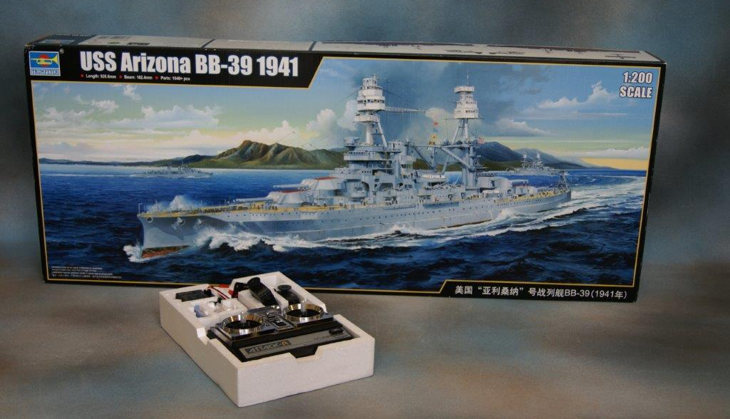 | Lot 112
113. | A 1/200 scale model by Nichimo of the "Yamato" the Japanese Yamato class battleship, in box. | £80-£100
 | 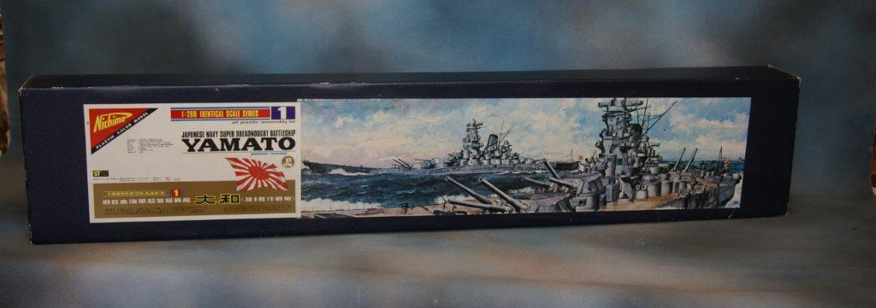 | Lot 113
114. | Vic Trevett (b.1930)- "From Folley Fort, Cornwall" oil on canvas, 20cm x 15cm, after Arthur Rackham- "A Fond Farewell", chromolithograph, 13cm x 19cm, after Edmund Dulac- "The Tempest" chromolithograph, 17cm x 13cm and a further print of coastal harbour (4). | £20-£30
115. | An oval iron railway works plate "Head Wrightson and Co Ltd, Thornby on Tees" 1947 23cm wide, a.f. | £60-£80
116. | An LNER railway wagon plate "21 tons 1944, Darlington, no. 269 148", a.f., 28cm x 16cm. | £80-£100
117. | A 20th century oak bookcase, enclosed by leaded glass and linenfold panel doors, 79cm wide x 131cm high. | £20-£30
118. | An early 20th century oak frame reclining chair, with pale grey upholstery, together with a small stained wood firescreen (2). | £30-£50
119. | A reproduction mahogany bow fronted two drawer bedside chest, 42cm wide, a small oval occasional table, and a stained oak tea-trolley (3). | £20-£30
120. | Two Georgian style mahogany washstands, fitted a drawer, 34cm and 35 cm wide respectively. | £30-£50
121. | P.R Welsh 90- A 2-10-0 Austerity class steam locomotive, no. 92018, in winter landscape, oil on canvas, 70cm x 90cm. | £30-£50
 | 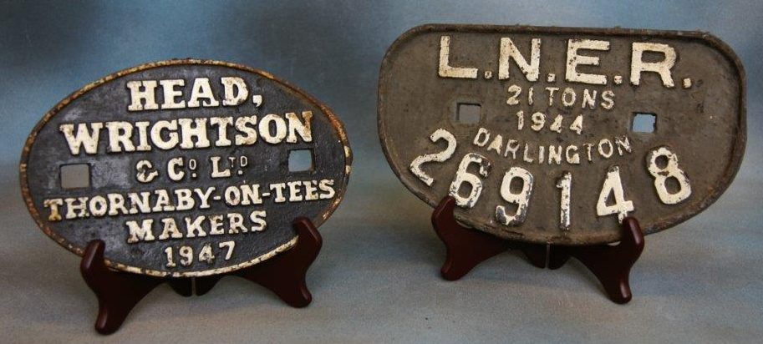 | Lot  115 & 116
122. | A late Victorian ebonised and inlaid pier cabinet, with gilt metal mounts and enclosed by a glazed panel door, 78cm wide, a.f. | £80-£100
123. | Thos H.J Pryce- "Salmaston Grange 05" and "Runswick 08" watercolours, a pair, 16.5cm x 24cm (2). | £60-£80
124. | An early 20th century brown glazed pottery toby jug, 24cm high and three small Wedgwood blue jasper ware dishes of differing shape, one repaired (4). | £30-£50
125. | A Regency rosewood side cabinet, with bronzed metal mounts and marble top, above mesh panelled doors on plinth base, 135cm wide. | £100-£150
126. | A French album of world stamps, a small mercury stamp album of mixed stamps, a quantity of loose stamps in small boxes, and envelopes, and a 1948 edition of the catalogue of word postage stamps, by Whitfield, King and Co, part two only. | £30-£50
127. | A Wedgwood "Ashford" pattern part dinner service, including two tureens and covers, two meat dishes, eight dinner plates, seven dessert plates, eight side plates and eight soup plates, 37 pieces overall. | £40-£60
128. | A four-piece silver-plated breakfast tea set, by James Deakin and Sons, Sheffield, with ebonised handles, and three large brandy glasses (7). | £20-£30
129. | A late Victorian ebonised and part gilded bookcase cabinet, in the oriental style, with gilt brass fittings 93cm wide x 163cm high. | £600-£800
130. | A Victorian mahogany Pembroke table, fitted a drawer and a simulated drawer, on turned and ringed legs, 100cm x 103cm extended. | £40-£60
131. | A part Late 18th/Early 19th Century chinoiserie lacquered longcase clock by "Isaac Nichols, Wells", 213cm high, restored and adapted. | £200-£300
132. | A Victorian stripped pine chest of two short and three long drawers with knob handles, on plinth base, 102cm wide. | £60-£80
133. | A 20th Century stripped pine dressing table mirror, fitted two drawers, 85cm wide. | £20-£30
134. | A stripped pine bathroom cabinet enclosed by a panelled door, moulded cornice, 50cm x 59cm. | £20-£30
135. | A Victorian stripped pine side table, fitted two drawers with porcelain knob handles, on turned and ringed legs, 106cm wide. | £30-£50
136. | A Victorian mahogany bookcase, enclosed by a pair of glazed panel doors below a moulded cornice on plinth base, 104cm wide x 119cm high. | £30-£50
137. | A copper gas wall light, with glass shade and later fitting, approx. 27cm long. | £30-£50
138. | John Powney- a two shire horse plough team, watercolour, signed and dated 1991, 25cm x 34cm. | £20-£30
139. | A Goliath type pocket watch, in silver plated case, white enamelled dial and a "Yachtsman" stopwatch, in silver-plated case (2). | £30-£50
140. | A 19th Century oak longcase clock, the thirty-hour movement with square painted dial, inscribed "Davey of Kenninghall", 208cm high. | £80-£100
141. | A late 19th Century mahogany dining table, with wind out action, on cabriole legs with claw and ball feet, and two extra leaves, 99cm x 267cm, extended, together with seven Chippendale style dining chairs, with drop in seats (8). | £150-£200
142. | A late Victorian carved oak kneehole desk, fitted seven drawers, on plinth bases, 135cm wide. | £80-£100
143. | A George III oak freestanding corner cupboard enclosed by two pairs of panelled doors, below a moulded cornice, 91cm wide x 183cm high. | £40-£60
144. | A 19th Century inlaid mahogany freestanding corner cupboard, enclosed by astragal glazed and moulded panel doors, below a dentil cornice, 93cm wide x 213cm high. | £60-£80
145. | A lacquered brass monocular microscope by "Smith and Beck, 6 Coleman Street, London", together with a selection of lenses, and accessories and a small five drawer brass telescope by "J. Winter, London", 8.5cm long, both a.f. | £50-£70
146. | The story of the Mikado by W.S Gilbert, 1921, illustrated by Alice Woodward, one volume, a volume of Shakespeare's works, circa 1920, together with other mixed books and an empty postcard album (13). | £20-£30
147. | Three bronze Rugby school sports medals 1911, 1912, and 1914, a First World War medal, a Second World War medal, and a number of Masonic and other medals and badges. | £30-£50
148. | A brass hanging bell, a brass Widdecombe Fair doorknocker, and a 400-day clock, under glass dome (3). | £40-£60
149. | A pair of stoneware figures of seated bears, each 19cm high, a smaller group of three bears, and two further bears (5). | £20-£30
150. | An ebonised and pale beech chess set, in open box (32 pieces). | £20-£30
151. | A "Calibri" lighter, and cigarette case set, boxed, a small number of Ronson and other lighters, and seven packs, of playing cards, various, some in double packing (12). | £25-£40
152. | A reproduction Nazi German flag, of rectangular form 64cm x 61cm, with short pole. | £30-£50
153. | Two Peruvian copper charger type dishes, probably table tops, each 58cm in diameter (2). | £40-£60
154. | Leonardo Lucchi (b. 1952)- bronze group "Lovers" circa 2011, no 2/8, signed verso, on mahogany base, labelled, 30cm wide x 38cm high. | £900-£1200
155. | Mylo- an art deco style bronze figure of semi clad woman, on slate base, signed 42cm high. | £120-£180
156. | J. Hennion- hunting scenes, a pair, oil on canvas, 44cm x 59cm, | £30-£50
157. | I. Costello- windmill and other buildings, near river, oil on canvas, 60cm x 90cm. | £20-£30
158. | Gordon Linsey- Sheep in a landscape oil on canvas, 45cm x 59cm. | £20-£30
159. | A 20th century lacquered gramophone cabinet, with hinged lid, and fall front, on cabriole legs, 55cm wide. | £300-£350
 | 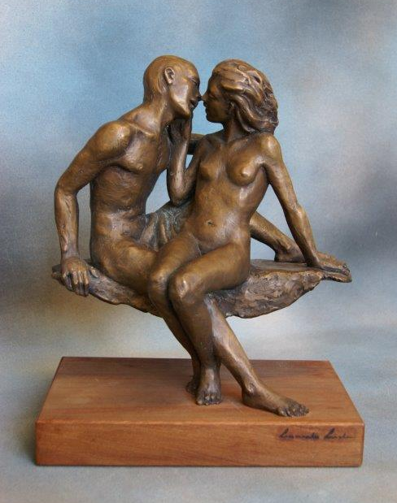 | Lot 154
 | 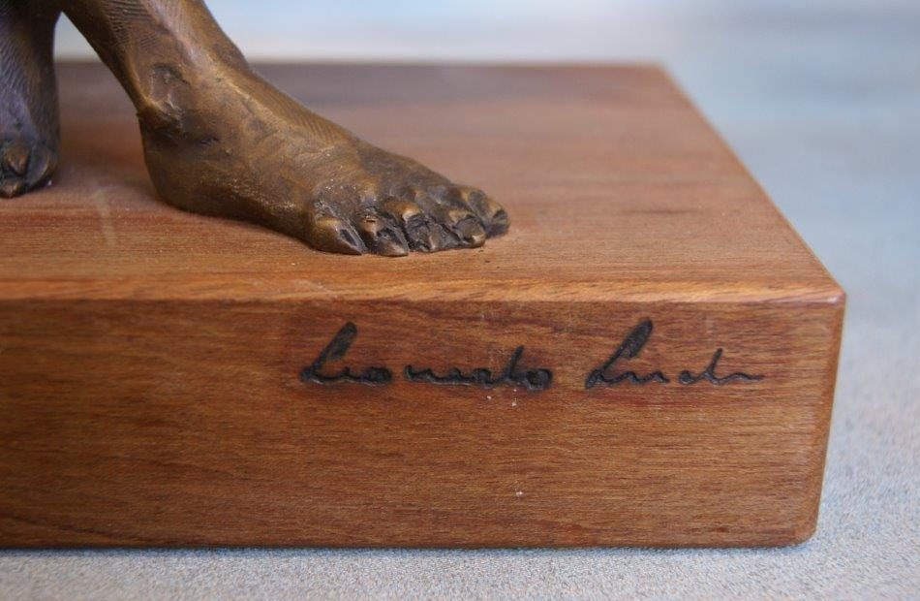
160. | A modern Persian style rug with overall flower pattern, on black ground, 91cm x 160cm together with a pictorial Chinese rug, decorated parrots, 91cm x 152cm, and a similar rug, decorated blossom, 89cm x 140cm as wall hangings (3). | £80-£100
161. | After Picasso- image possibly based on Marie Therese Walter, one of the artists mistresses, lithograph after chalk and charcoal original, 49cm x 65cm. | £60-£80
162. | An oak oval gateleg table, on spiral twist legs, 92cm x 139cm, extended. | £20-£30
163. | An oak extending recliner chair, with cane panels, and a further similar chair, with slatted sides (2). | £30-£50
164. | A late 19th Century oak side table, with carved frieze on spiral twist legs, united by stretchers, 68cm wide. | £30-£50
165. | An Early 20th century mantel clock, in stained beech architectural case, with "Junghans" movement, 47cm high. | £40-£60
166. | An Edwardian inlaid mahogany circular centre table, with stretchered undertier, 84cm in diameter, and an Edwardian inlaid mahogany plant stand, 99cm high (2). | £30-£50
167. | D. Southwick 1909- pair of still life floral subjects, oil on board, a pair, each 68cm x 29cm. | £40-£60
168. | After David Dent-"Doing the Business, The Cheltenham Gold Cup 1999" and "Call to Glory, the 1999 Queen Mother Champion Chase", a pair, no 281/500 limited edition chromolithographs signed by the artist and the first three jockeys (2). | £60-£80
169. | A Belleek porcelain trefoil shaped basket, with rope twist and relief flowerhead decoration, 13cm in diameter, impressed mark. | £50-£70
170. | A reproduction oak open dwarf bookcase with two shelves and moulded panel doors below, 107cm wide. | £40-£60
171. | A Royal Doulton figure "Sweet and Twenty" HN.1589 (style two) 9cm high. | £70-£90
172. | Two volumes of Dr John Kittos' illustrated family bible, with around twelve hundred engravings, in mixed sizes, published by James Sangster and Co, London and one volume "Unknown Sussex" by Donald Maxwell, illustrated, circa 1923 (3). | £50-£70
173. | A German stoneware pottery moonflask jug shaped vase, with relief decoration, and single handle on circular footed base, 36cm high. | £60-£80
174. | A "Urago" 1/43 scale die-cast toy car, "Fiat Cinquecento" boxed, a Rowntree's Jelly van, boxed, together with a quantity of Matchbox vehicles, unboxed (26). | £30-£50
175. | Seven letters, dated between 1928 and 1962, from the private secretary of Edward, Duke of Windsor to a Miss E. Mordaunt, of Sussex, in reply to various greetings and sentiments expressed, together with six picture postcards relating to the Duke and one relating to his sister Princess Mary and her children (14) overall. | £50-£70
176. | A 7x5 signed black and white photograph of Laurence Olivier, dedicated to E.S Mordaunt, framed together with a flyer for a Strand Theatre production of "Ionesco's" produced by Orson Wells (2). | £60-£80
177. | A programme signed by Laurence Olivier, from the first performance of "Coriolanus" at the Shakespeare Memorial Theatre, 7th July 1959, together with a signed photograph of unknown date and two unsigned photographs of Olivier as Othello and Maggie Smith as Desdemona (4). | £30-£60
178. | A programme for the Oaklands Park Festival 1962, directed by Laurence Olivier, being the opening season at The Chichester Festival Theatre, 1962, signed by Laurence Olivier, Joan Plowright, John Neville, Sybil Thomdyle and other performers, together with a 5.5 x 3.5 signed photograph of Laurence Olivier (2). | £50-£70
179. | A 7x5 signed black and white photograph of Laurence Olivier as "Hamlet" in 1948. | £30-£50
180. | A two sided handwritten letter from Laurence Olivier to Miss E. Mordaunt of Sussex, with thanks for a birthday card dated 22nd May 1971, together with further letters, dated 1959 from Vivien Leigh, 1961 for Joan Olivier, and 1958 from Laurence Olivier (4). | £40-£60
181. | A letter to Miss Mordaunt dated 1958 regarding the New York Season of "The Entertainer" another dated 1961, posted from New York, another dated 1969 and another dated 1972 (4). | £40-£60
182. | A letter to Miss E. Mordaunt regarding the Chichester Plays, dated 1962, and three further typed letters, dated 1963, 64 and 1967 (4). | £40-£60
183. | A letter dated 1967 to Miss E. Mordaunt from Laurence Olivier after his illness, in later envelope, franked 1979, a further letter dated 1977 and another dated 1982 (3). | £30-£50
184. | A Regency mahogany swing frame toilet mirror, the base with three drawers, 52.5cm wide. | £40-£60
185. | A small Regency bow fronted chest of two short and two long drawers, on turned feet, 91cm wide. | £60-£80
186. | A Regency mahogany bow fronted chest of two short and three long drawers, on small bun feet, 103cm wide. | £70-£90
187. | An Art Deco style walnut veneered and simulated walnut circular form display cabinet, the glazed shelves enclosed by two centrally hinged glazed panel doors, on conforming base, 265cm wide. | £150-£200
188. | An Art Deco style walnut veneered bookcase, enclosed by two glazed and moulded panel doors, above two panelled doors, 91cm wide x 155cm high. | £60-£80
189. | A small reproduction mahogany hall or lamp table, fitted a drawer, on turned legs, united by a stretcher, 65cm wide and a small oak refectory style coffee table, 77cm wide (2). | £30-£50
190. | Two glass Mallet form spirit decanters, an engraved glass sherry decanter and an inverted tapering decanter, between 26cm high and 28cm high (4). | £20-£30
191. | Two boxes of six Edinburgh crystal "Torrent" pattern glass tumblers (12). | £30-£50
192. | A box of six Edinburgh crystal glass champagne flutes, a box of six tumblers and a box of six wine glasses (3). | £30-£50
193. | A set of silver-plated and stainless-steel cutlery in Grecian style pattern, approx. 45 pieces, in unassociated canteen. | £20-£30
194. | A Mintons pottery poppy pattern vase, with relief handles, 27cm high. | £15-£30
195. | A late Victorian carved mahogany show-wood framed bergère form salon chair, upholstered in pink dralon, on squat cabriole legs. | £60-£80
196. | A Regency style mahogany hall table with moulded drawer fronts on turned and reeded legs, 107cm, wide. | £80-£100
197. | A Victorian silver-plated double preserve stand with two hob nail cut and engraved glass bowls and ladles, together with a salver, christening mug and some cutlery. | £50-£70
198. | A small Turkish white metal pin tray with coin inset to centre, 9cm in diameter. | £20-£30
199. | An Elizabeth II silver bottle coaster, maker "Mappin and Webb" Birmingham 1978, a pair of silver candlesticks, Birmingham 1923, a pepperette, 1913, a silver photograph frame, Sheffield 1985, and a pot lid Birmingham 1956, mostly filled or weighted (6). | £100-£150
200. | Four George III silver bright cut teaspoons, London 1800, six coffee bean spoons, Birmingham 1939, a christening spoon with orb terminal, London 1938, together with a napkin ring, sugar nips, and two other pieces, approx. 7oz. | £90-£120
201. | A French style gilt brass carriage timepiece by "St James, London", 12cm high. | £60-£80
202. | An Elizabeth II Civil Defence medal, boxed, two enamelled W.R.N.S badges, three further enamelled badges, three coronation/jubilee medals and 15ct gold bar brooch, and an Edward VII lapel badge (11). | £40-£60
203. | An 18th century style gilt wood framed rectangular wall mirror, with foliate scroll decoration, 70cm x 51cm. | £80-£100
204. | A Chinese pottery and pewter tea set, with applied relief decoration and a cloisonné vase, a.f. (5). | £80-£120
205. | A Villeroy and Boch stoneware beer jug, with relief decoration 25cm high, and a pair of Delft wall lights, one repaired (3). | £50-£70
206. | A Tibetan copper and pewter coffee pot and a copper jug (2). | £40-£60
207. | A cameo brooch, in pinchbeck mount, the relief decoration depicting a mythological scene, 6cm x 4cm (some discolouration). | £200-£300
 | 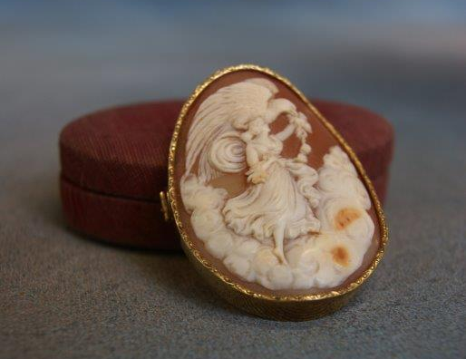 | Lot 207
208. | A continental porcelain rectangular painted plaque, portrait of young woman, as a brooch in silver plated mount, 4cm wide. | £100-£150
 | 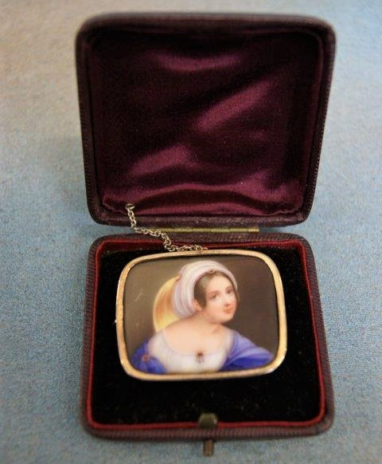 | Lot 208
209. | A Parian ware group of Madonna and Child on horseback, landscaped base, 26cm high under a glass dome, 36cm high. | £100-£150
210. | A Copeland Cadogan type tea pot, decorated flowers and foliage, 17cm high, a.f. to spout. | £30-£50
211. | A pair of silver-plated candlesticks, each 24cm high, a set of six silver teaspoons, Birmingham 1923, a silver napkin ring, a silver bon bon dish, marks rubbed, together with mixed silver-plated ware, including tea knives, sugar tongs and other pieces. | £100-£150
212. | A Chinese crackglaze vase, and cover surmounted by chi-chi 21.5cm high. | £60-£80
213. | An early 20th century carved and ebonised tribal figure of woman grinding, 34cm high a.f., a female tribal bust 20cm high, and a carved wood kneeling figure (3). | £100-£150
214. | Two carved and ebonised tribal figures wearing capes and two smaller figures, 29cm, 27cm 24cm and 23cm high. respectively. | £150-£200
215. | A pair of early 20th century Japanese lacquered and bone panels, decorated flowers, foliage, and butterflies, each 60cm x 36cm wide, a.f. (2). | £80-£100
216. | A family bible, dated 1833, in need of extensive restoration. and an Agatha Christie paperback book (2). | £20-£30
217. | A Lady's wristwatch, in circular shaped gold case, a further watch, a coral necklace, a cross pendant, a small gold backed mourning brooch together with decorative and costume jewellery. | £100-£150
218. | A small bone group of elephant and three other pieces of bone work, a.f. (4). | £50-£70
219. | An Early 20th Century oak two bottle tantalus, with two moulded body decanters, and silver-plated mounts, 25.5cm wide x 23cm high. | £80-£100
220. | A late Victorian ebonised toilet box, with silver plated mounts, lion mask handles, and cantilever action, the part fitted interior with silver plated covers, and one replacement wood cover, 24cm wide. | £60-£80
221. | A "Hughes" kitchen scale "Family Scale", metal case, with plated pan, 26cm high. | £30-£50
222. | A composite suite of drinking glass ware, some by Cavan of Ireland, approx. 24 pieces, together with other glass ware, including three decanters and some ruby tinted pieces. | £150-£200
223. | A silver-plated Samovar' with burner, two covered water jugs, a coffee pot with faceted body, a pierced dish, a cup holder and a biscuit barrel (liner missing), 7 pieces overall. | £80-£100
224. | A gilt brass 400-day timepiece, under glass dome, approx. 27cm high. | £40-£60
225. | A set of four gilt lacquered brass church candlesticks, of spiral form, with ball and flower petal mounts, on inverted taper bases and ball feet, each 56cm high. | £100-£150
226. | A Georgian style stained mahogany display cabinet, with galleried top, and enclosed by two astragal glazed doors, on square tapering legs, with spade feet, 75cm wide x 129cm high. | £30-£50
227. | A Victorian walnut whatnot with pierced gallery top, music Canterbury section below and fitted a drawer on short turned tapering legs and castors, 56cm wide x 98cm high. | £150-£250
228. | A Late Victorian cast iron cathedral burner with pierced decoration and two brass handles, 90cm high. | £20-£30
229. | A mahogany French style coffee table on cabriole form legs with carved decoration, 97cm long. | £20-£30
230. | A pair of wing back and tapestry upholstered easy chairs of 18th century style, on squat cabriole legs and claw and ball feet, 20th century. | £80-£100
231. | An 18th century style mahogany low boy, with some mother of pearl stringing, fitted three drawers, on tapering legs, with shaped feet, 81cm wide. | £40-£60
232. | A set of mahogany period style library steps, three tread on turned and reeded legs, 45cm wide x 80.5cm high. | £30-£50
233. | A Queen Elizabeth II Irish silver Britannia standard four-piece tea and coffee set, with ebonised handles, on stepped circular bases, maker L.P.G (possibly later mark for Larry Gunning), Dublin 1977 and 1978, approx. 65oz, overall. | £800-£1000
 | 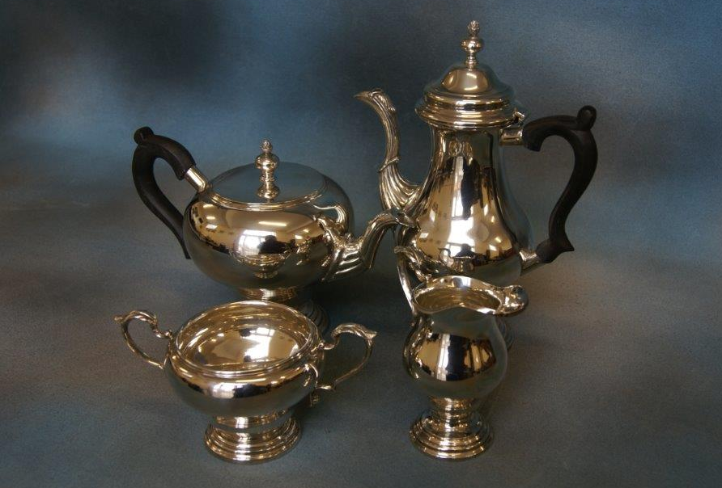 | Lot 233
234. | A Royal Doulton bulbous form vase, decorated geese and other figures, signed Joseph Hancock, 15cm high. | £40-£60
235. | A Royal Worcester cabinet cup and saucer decorated cock and hen pheasants, signed James Stinton, date code 1917, 5.5cm high. | £60-£80
236. | A Neale and Co creamware figure of a shepherd with sheep over shoulders, on square base, 23cm high. | £100-£150
237. | A pair of Staffordshire pottery figures of black and white spaniels, each 20cm high. | £20-£30
238. | A barograph, in oak case, with bevelled glass panels, stamped "C.S.S.A. Ltd, London", 36cm wide. | £300-£400
 | 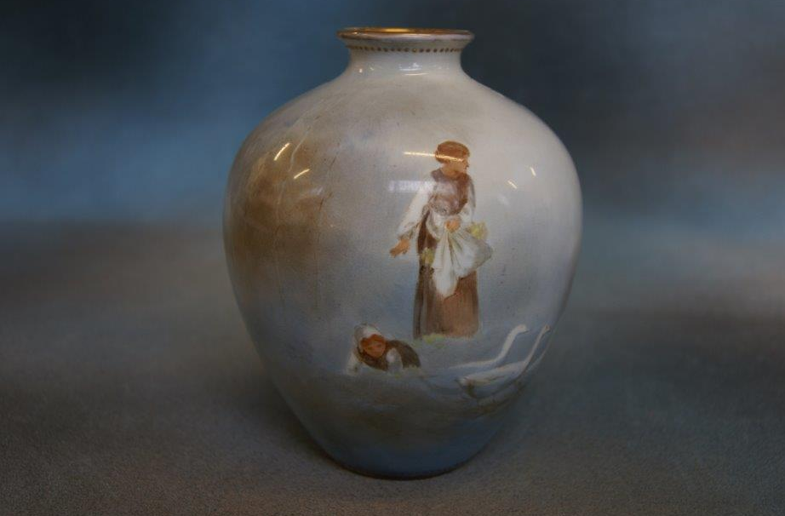 | Lot 234
 | 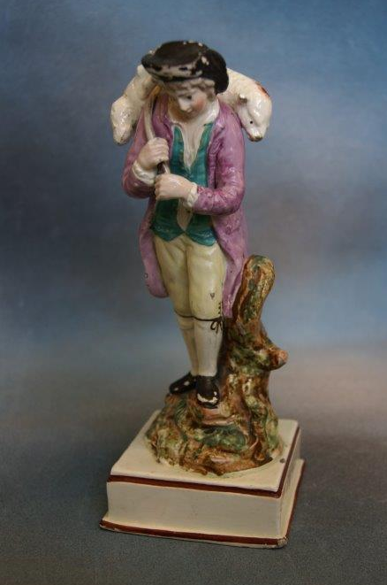 | Lot 236
239. | An Early 20th century Chinese blue and white bowl, decorated figures in wooded landscape, 25cm in diameter. | £40-£60
240. | A 19th Century Chinese famille rose bowl, decorated panels of flowers, 23cm in diameter. | £70-£90
241. | An Early 20th century Imari bowl in traditional colours, 25cm in diameter. | £20-£30
242. | An Early 20th Century late satsuma ware vase, decorated various figures, 49cm high. | £40-£60
243. | A 19th Century Chinese carved hardwood head rest, 52cm wide x 33cm high. | £80-£100
244. | Charlton- Malaysian beach scene, with hut, watercolour, signed 33cm x 24cm. | £40-£60
245. | A B Ibrahim- Malaysian lake scene, with fishing vessels, watercolour, signed 28cm x 38cm. | £40-£60
246. | A First World War period Union Jack flag, by Kirkhall and Co, Kidacre Street 1915, and stamped "10 Brigade" approx. 189cm x 420cm, a.f. 10th Infantry Bridge was part of the 4th Infantry Division, and fought the Second Battle of Ypres between 23rd April and 25th May 1915. | £80-£100
 | 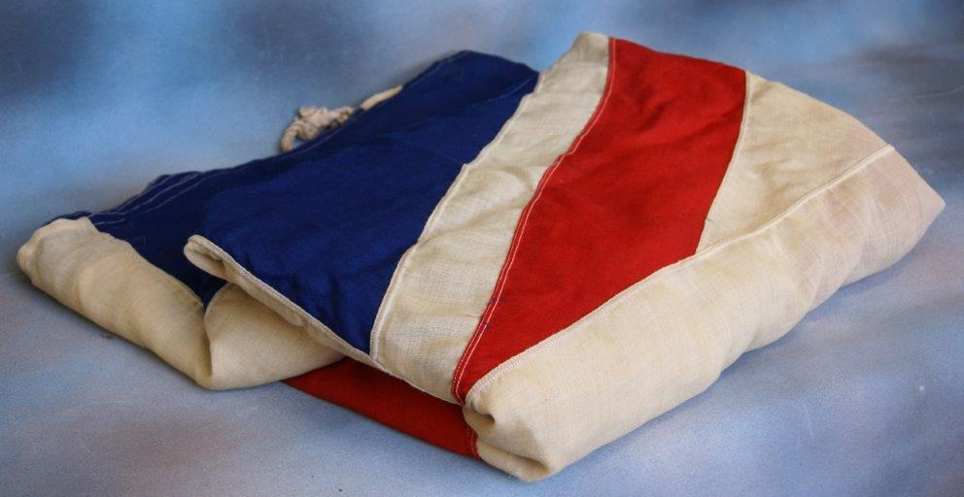  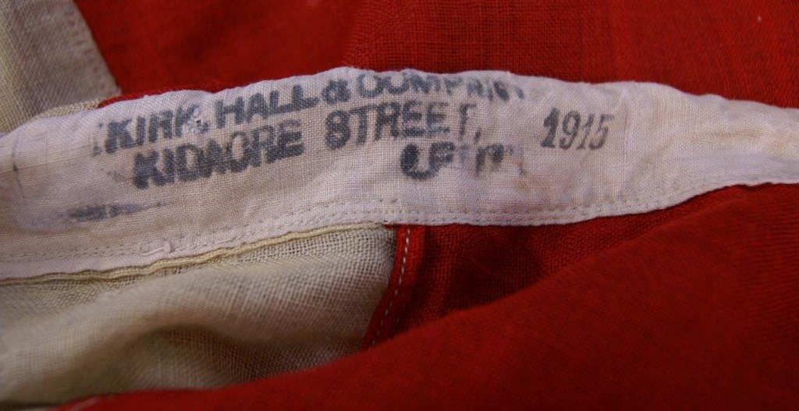 | Lot 246
247. | Attributed to Sir Garrett Powell- Yacht in full sail, with other vessels in distance, watercolour. 14cm x 19cm, inscribed verso. | £50-£70
248. | B. Doctor -"Cutty Sark" and other vessel at sea, watercolour, 23cm x 38cm. | £20-£30
249. | G.H.G.- Village scene, with church and a landscape, with cottage and bridge, watercolours, a pair signed, and 1883 and 1888, 16cm x 24cm. | £30-£50
250. | A late Victorian glass decanter, with hob nail and other cut decoration, quadrefoil form base, silver collar, Sheffield 1897, 34cm high. | £60-£80
251. | A small Portuguese lady's circular dressing mirror, in white metal relief floral frame, bearing marks for Porto, retailers label for J. Rodrigues, Lisbon, 12cm in diameter. | £40-£60
252. | A Keswick school silver plated bowl, with planished and beaten decoration, initialled K.S.I.A, 17cm in diameter. | £40-£60
253. | A late Victorian pottery Grecian style two handled vase, decorated figures, on black background, on circular base 46cm high. | £30-£50
254. | Two Beswick Peter Rabbit figural table lamps, on tree trunk bases, each 24cm high. | £40-£60
255. | A late 19th century French Art Nouveau style figural mantel timepiece, in gilt metal case with relief floral decoration, 37cm high. | £400-£600
256. | A Doulton Burslem pedestal vase, blue and gilt body, decorated three little girls, slender neck, 28cm high (restored). | £20-£30
257. | An Oriental pottery figure, with Sang de Boeuf coloured glaze, of deity, 25cm high. | £50-£70
258. | Two boxes of mixed loose stamps, various. | £20-£30
259. | A North American Western style revolver, as a half relief display, framed 22cm x 39cm. | £20-£30
260. | A 20th Century Chinese carved wood and pierced roundel, 25cm in diameter and a circular fruitwood tray, 33cm in diameter (2). | £30-£50
261. | Two Early 20th Century silk embroidered pictures of birds and foliage, each 43cm x 36cm (2). | £20-£30
262. | Frederick Taylor for C. Hullmandel- "Dead Stag and Eagle" black and white lithograph, 27cm x 36cm. | £20-£30
263. | 20th Century school- Two coloured etchings of locations in Venice, signed on mount, 25cm x 39cm and 32cm x 22cm, respectively (2). | £30-£50
264. | J. and P. Kandler, published Te Leiden by Honkeep, Amsterdam, August 1794- engraved map, Captain Cook's first voyage, 1769, by the tip of South American via Cape Horn and Tierra del Fuego, 32cm x 36cm. | £80-£100
 | 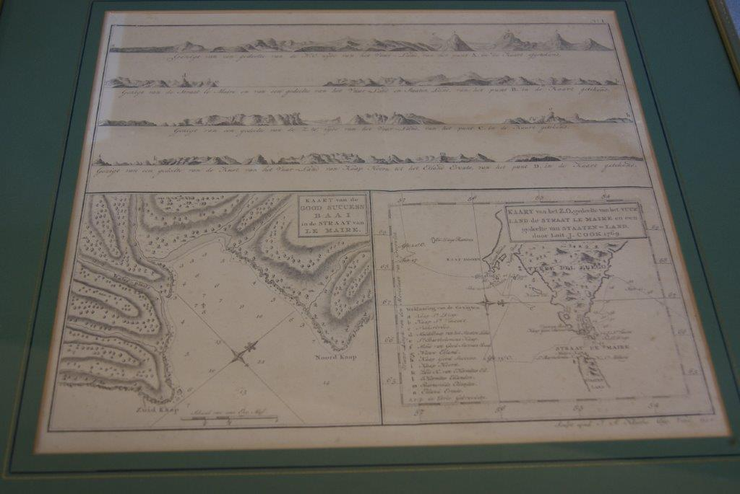 | Lot 264
265. | A Loose 'Bayko' plastic building set, in unassociated box, and 3x Converting set, in box. | £20-£30
266. | A WWI German 40mm cannon shell inscribed to base June 1918 now adapted as piece of trench art inscribed "The Queen's Regiment". | £20-£30
267. | A Gent's Omega "Constellation" wristwatch, quartz movement in stainless-steel case, on small link strap. | £100-£150
268. | An Early 20th Century Chinese bronze pipe, decorated a dragon and sun, with silver plated ends, 30.5cm long. | £80-£100
269. | An antique glass rummer on ringed stem, and circular foot, 14cm high. | £30-£50
270. | A Royal Canadian navy silk embroidered crest, 40cm x 36cm, in oak frame. | £20-£30
271. | S. Rogers, after A. Pugin "New London Bridge", engraving, 23cm x 46cm and two further engravings of London by other hands (3). | £40-£60
272. | A pair of Spanish fencing rapiers, with flat tips, each 104cm long, inscribed "Toledo". | £20-£30
273. | A Hollywood "Regency" coffee table, with glass top, 59cm wide. | £80-£100
274. | An "Ainsworth" type F.D.J. Micro balance scale, with keyboard operated weight carrier, and part electrified superstructure, 86cm high. | £50-£70
275. | A quantity of Royal Doulton Flambe ware figures of animals, including cats, elephants and a fox, together with a squat vase, 11cm high (13). | £100-£150
276. | A small collection of Royal Doulton small character jugs, mixed sizes, including "Jane Eyre and Mr Rochester" "The Sleuth" "Charles Dickens" "Sir Winston Churchill", a stoneware jug of Nelson, and others (16). | £80-£100
277. | A Royal Doulton stoneware tobacco jar, with silver mount, London 1903, 16cm high and a match holder (2). | £60-£80
278. | A small Victorian Doulton Lambeth ice pail with silver mount, London 1880, together with two biscuit barrels, three tobacco jars, a pair of pot pourri vases, and an autumn leaf pattern match holder, some pieces a.f. (9). | £70-£100
279. | A pair of Doulton stoneware vases, with mixed colour mottled grounds, and floral swags, 14cm high, a taper vase with silver mount, marks indistinct, together with a hunting pattern beaker, a slaters patent jug, a Victorian golden Jubilee ale jug and other vessels (15). | £80-£100
280. | A Royal Doulton whisky decanter, decorated figure of Britannia, 19cm high, a further decanted decorated portrait of Ben Jonson" no stopper, an usher's candlestick, two miniature Dickens ware vases, other small pieces, and a pair of ewer shaped vases (13). | £80-£100
281. | A Royal Doulton figure of "Grace Darling" HN3089, no 500/9500, 23cm high, another of Florence Nightingale, HN3144, another of "Eliza Farren" Countess of Derby HN442, together with two decorative candlesticks, a spill holder and four miniature dishes (15). | £50-£70
282. | A. Gorbashoff- portraits of Chinese men, watercolours, a pair, each 24cm x 20cm. | £80-£100
283. | A Royal Doulton Lambeth ware "Will O the Wisp" pattern part combination set, 64 pieces. | £40-£60
284. | A pair of Staffordshire pottery spaniel dog figures, with lustre decoration, 16cm high, a further pair of smaller figures, five other spaniel figures, and two-part sandwich sets, some pieces a.f., 22 pieces. | £20-£30
285. | A T.G Green & Co Cornish ware "milk" measuring jug and cover, 15cm high, spout chipped, a "sugar" sifter, a pair of salt and pepper pots, together with storage jars, bowls, mugs, egg cups and mixed plated, some a.f. (42 pieces) mostly unnamed. | £20-£30
286. | A small 19th century map of Kent, 19cm x 25cm, a small statistic and mileage map, 19cm x 15cm, together with three small engravings of "Chipstead Place", "Knole", and "Brabrourne" (5). | £30-£50
287. | A collection of small Royal Doulton Dickens figures including "Scrooge", "Uriah Heep", "Stiggins", "Micawbar" and "Dick Swiveller each 11cm high (24). | £100-£150
288. | Six Austrian gold 1 ducat coins, Franz Joseph 1, 1915 (6). | £600-£800
 | 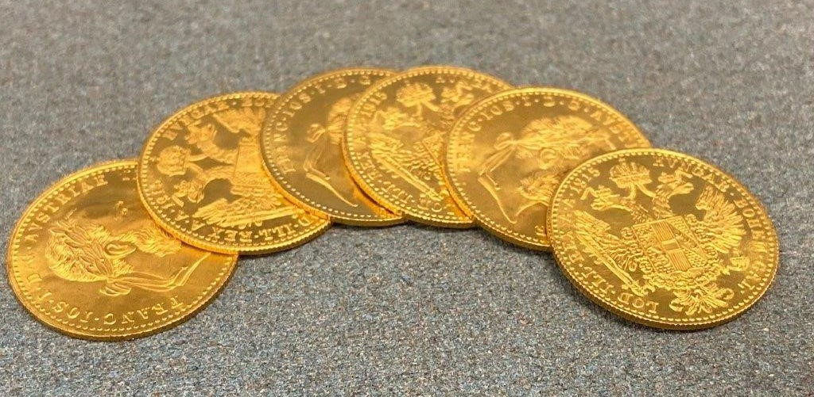 | Lot 288
289. | A similar lot of five 1 ducat coins, Franz Joseph I, 1915 (5). | £500-£700
290. | A similar lot of five 1 ducat coins, Franz Joseph I, 1915, (5). | £500-£700
291. | A similar lot of five 1 ducat coins, Franz Joseph I, 1915 (5). | £500-£700
292. | An Austrian 4 ducat coin, Franz Joseph I, 1915. | £300-£400
 | 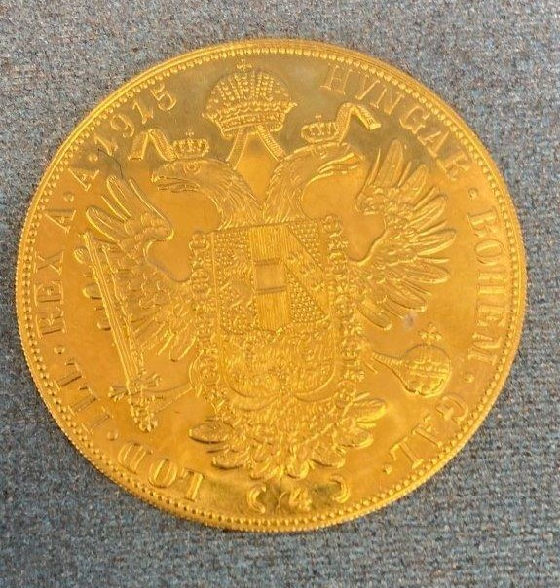 | Lot 292
293. | A Turkish gold 100 kurush coin, Muhammed V, 1909-1918. | £200-£300
294. | A German states 20 mark gold coin Frederick I, 1872, Baden. | £120-£180
295. | An Austrian 10 corona coin, Franz Joseph I,1905. | £100-£150
296. | A Russian 5 ruble gold coin, 1899. | £150-£200
297. | A U.S Liberty gold 5 dollar coin, 1898, as pendant. | £80-£100
298. | A Victorian diamond Jubilee issue silver Eimer 1817, 25mm diameter, 1897, and an 1891 crown (2). | £30-£50
299. | A reproduction gilt wood console table on swept foliate front supports, 121cm wide. | £80-£100
300. | A Royal Crown Derby porcelain figure of a dwarf, advertising the Theatre Royal, Haymarket, 19cm high. | £40-£60
301. | A bottle of late WWII Moet and Chandon Champagne "Reserved for Allied Armies" to label, ullage high shoulder. | £60-£80
302. | A gilded alloy Campana shaped flower vase, decorated in the classical style, together with a gilded beech pedestal plinth, 141cm high overall. | £60-£80
303. | A pair of "Carl Zeiss Jena" 10x50 binoculars in leather case. | £20-£30
304. | An Italian ewer shaped glass and silver-plated decanter containing cacao spirit 30cm high, and a miniature vessel containing apricot brandy, (2). | £30-£50
305. | A Lumium ware silver plated cocktail shaker and six tot size beakers, on Bakelite feet, together with a pair of silver plated and bone handled fish servers, boxed (8). | £20-£30
306. | A plated NP15/NP18 telescope, no. 1396, 59.5cm long, extended, in leather bag. | £40-£60
307. | A gent's pocket watch in gold plated hunter case, white enamelled dial inscribed "Thomas Russell and Son, Liverpool", a gent's wristwatch in 14k yellow metal case, movement by the "Banner Watch Co", rectangular dial with cushion glass, and a gent's signet ring, a.f. (3). | £80-£120
308. | A George III style mahogany snap-top occasional table, with pie crust edge, on tripod base, 78cm in diameter. | £40-£60
309. | A 20th century oak sideboard, with carved panel doors and trestle base, 168cm wide. | £30-£50
310. | A reproduction tv cabinet of 18th century chest form 86cm wide. | £60-£80
311. | A suite of silver-plated cutlery, Greek pattern, in a walnut two drawer table form canteen on cabriole legs and claw and ball feet, 79cm wide, approx. 160 pieces, one teaspoon missing and two additional pieces. | £200-£300
312. | A walnut mantel timepiece of Georgian style, the dial inscribed "Tempus Fugit", 33cm high, fitted an inscribed plate, and an oak mantle clock (2). | £100-£150
313. | A Georgian style mahogany side or writing table, fitted three drawers on square tapering legs, 102cm wide. | £80-£100
314. | A 20th Century walnut cocktail cabinet, the satin veneered interior fitted a glazed shelf, enclosed by two doors, on carved cabriole legs with claw and ball feet, 98cm wide x 161cm high. | £80-£100
315. | A late 19th Century French gilt metal and dark blue and gilt porcelain garniture de cheminee, the clock with striking movement, and a pair of flanking three branch candelabra, each 38cm high. | £200-£300
316. | An oak Art Deco style tea table, 46cm wide, and a pie crust top table, 65cm in diameter (2). | £30-£50
317. | A reproduction mahogany sofa type coffee table, with leather top, 128cm wide and a circular onyx top occasional table, 81cm in diameter (2). | £30-£50
318. | A Georgian style mahogany side table fitted a drawer, with ring handles, on square tapering legs, 84cm wide. | £40-£60
319. | A 20th century mahogany bureau, the fall above two moulded and shaped fruit drawers, on cabriole legs, 74cm wide. | £40-£60
320. | A Victorian mahogany three tier whatnot with drawer to base, on short turned legs, with castors, 46cm wide x 96cm high. | £100-£150
321. | A Victorian mahogany oval Sutherland table, with double gateleg action, 88cm x 87cm, extended. | £60-£80
322. | A pair of Late 19th Century Cantonese slender neck vases, decorated panels, with figures and flowers, a.f., each 25cm high. | £100-£150
323. | A Dresden vase and pierced cover, encrusted with flowers, and with two figures of cherubs, on scrolled base, 43cm high. | £100-£150
324. | Two Dresden four-branch candelabra with figural and floral bases, on scrolled feet, each 61cm high, adapted to electricity, and two figural table lamps, parents and children, a.f. (4). | £150-£200
325. | A gilt metal four branch candelabra, adapted for electricity, 52cm high, together with three pairs of unassociated twin branch wall lights, and a single wall light (8). | £80-£120
326. | Two Hornby Dublo 4-6-2 "City of London" locomotives and tenders, in unassociated boxes, together with two Hornby H0/00 locomotives, boxed, a quantity of station buildings, rolling stock and accessories, including track, mostly unboxed. | £80-£120
327. | Bofill- a pair of spelter figures, of soldiers in part armour, on circular landscaped bases and ebonised siècles, each 34cm high. | £150-£200
328. | A mother of pearl handled and silver-plated fruit set, in mahogany canteen, twelve place settings, 24 pieces. | £40-£60
329. | A Border Fine Arts group of black face ewe, and three lambs, 12cm high, slightly a.f. | £40-£60
330. | Set of Victorian silver handled and bladed dessert knives and forks, King's pattern, Sheffield 1848, twelve place settings, 24 pieces, one knife a.f. (24). | £250-£350
331. | A pair of George III silver tablespoons, Hanoverian pattern, London 1793, approx. 3oz. | £80-£100
332. | A Late 19th Century Austro-Hungarian white metal claret jug, with hinged cover, and swept handle, 38cm high, approx. 36 oz. | £450-£550
 | 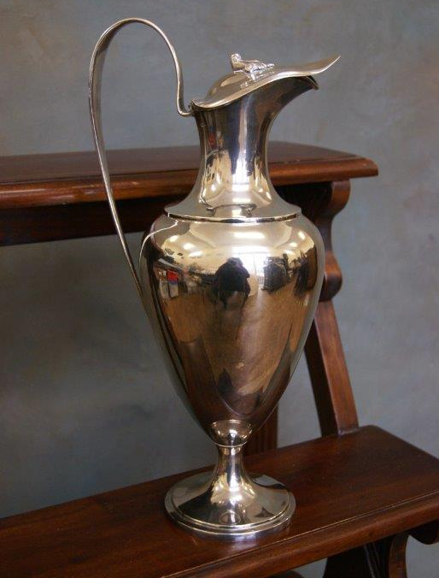 | Lot 332
333. | Ada Raab (1872-1950)- still life flowers in a bowl, and flowers in a vase, oil on canvas, a pair, each 45cm x 36cm, signed (2). | £350-£450
334. | A pair of "Carl Zeiss Jena" 10x50 binoculars in case, and a pair of Cooke Hill 8x21 binoculars, un-cased (2). | £40-£60
335. | A brass desk lamp, of banker's style, with brown mottled Bakerlite shade, 44cm high. | £150-£200
336. | A Papworth leather attaché case, 46cm x 32cm, with outer cover. | £400-£500
337. | A Queen Elizabeth II silver ashtray, "Royal Lytham St Anne's Golf Club", maker Adie Brothers, Birmingham 1979, a small dish, Sheffield 1979, a further ashtray, Birmingham 1977, with 1980 inscription, together with a set of six pistol grip silver handled tea knives, marks rubbed, in lined case, approx. 9.5oz, weighable (4). | £180-£220
338. | A Victorian silver claret jug, with hinged cover, vine finial, and handle, on circular foot, London 1871, 35cm high, approx. 28oz. | £550-£650
 | 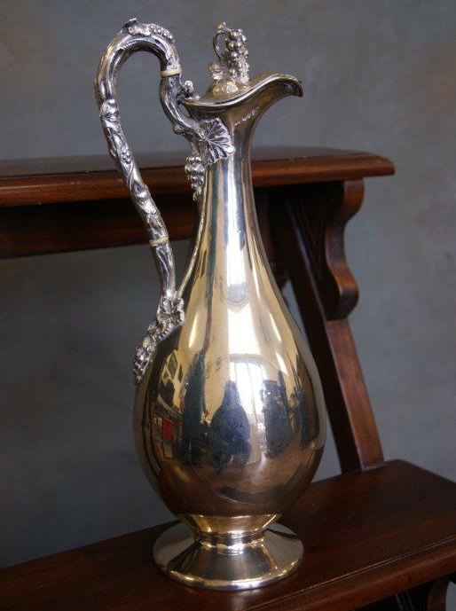 | Lot 338
339. | Two Victorian show-wood frame nursing chairs, on cabriole form legs, needlework upholstery (2). | £40-£60
340. | A Royal Doulton floral pattern part dinner service, approx. 25 pieces. | £20-£30
Future Dates

AUCTION DATES 2021

Wednesday 12th May 2021

Wednesday 16th June 2021

Wednesday 21st July 2021

Wednesday 15th September 2021

Wednesday 27th October 2021

Wednesday 1st December 2021

Viewing on Monday and day before sale from 12.00pm to 19.00pm
and on morning of sale from 9.00am to 10.30am
Sale commences at 11.00 am.
(Please note that due to current restrictions, these viewing times do not apply to the 31st March sale.)

VALUATION DAYS 2021

Wednesday 26th May 2021

Wednesday 23rd June 2021

Wednesday 28th July 2021

Wednesday 29th September 2021

Wednesday 3rd November 2021

Wednesday 8th December 2021

Sevenoaks Saleroom, Argyle Road,
Sevenoaks TN13 1HJ
11.00am – 4.00pm

Notes

