Welcome to Ibbett Mosely Auctions, Wednesday 28th July 2021 Auction Catalogue

This sale will be held online only, at www.easyliveauction.com/ibbettmosely/
please visit the website to register or log in to view and bid.

Alternatively, commission bids (bids left ‘on the book’) may be left with us, as well as a limited amount of telephone bids. Please telephone 01732 456731 or email auctions@ibbettmosely.co.uk for further details.

Please be aware there is viewing strictly by appointment only. Any walk-ins will not be allowed viewing. The full catalogue, complete with images of each lot and condition reports will be available at easyliveauction.com/ibbettmosely

Please telephone 01732 456731 or email auctions@ibbettmosely.co.uk with any questions.

Collection of items can only take place with prior appointment from 29th July. Collection of items is available on Thursday 29th July from 10am - 2pm, only.

You are welcome to collect in person, or via your own carrier, but local courier PSP Logistics are available to carry out deliveries of items.
Please contact them directly to arrange and pay for delivery.

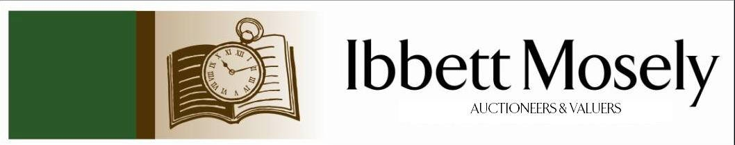

Catalogue of Antique, Edwardian and Victorian
Furniture and Effects
to be Auctioned on

Wednesday 28th July 2021
at 11.00am

IBBETT MOSELY AUCTION ROOMS
ARGYLE ROAD, SEVENOAKS, KENT TN13 1HJ
Via
www.easyliveauction.com/ibbettmosely/

Viewing at Sale Room on:

Monday 26th July
Tuesday 27th July

Between 10.00am –5.00pm.

STRICTLY BY APPOINTMENT ONLY.
(Limited numbers)

Please wear a face covering when in the Saleroom.

Catalogues: £2.00

Auctioneer and Valuer: Alan White FNAVA
Consultant Auctioneer and Valuer: Derek Hodge
Trainee Valuer and Clerk: Nicola Rainsley-Hughes
Auction Clerk and Administrator: Emily Frederick

1. | An Edward VII silver backed hair brush, with scrolled decoration, Birmingham 1909, together with a silver plated hand mirror, hair brush, and clothes brush (4). | £40-£60
2. | A lady's "Verity" 9ct gold wristwatch, on rolled gold strap, a gent’s "Crusader" wristwatch, part silvered dial, on brown leather strap (2). | £100-£150
3. | An 18ct gold diamond solitaire dress ring, illusion setting, a 22ct gold wedding ring (marks rubbed), and a further metal-ware ring, (3). | £100-£150
4. | A Victorian satinised mahogany Sutherland table, on twin turned end supports, trestle feet, gateleg action, 60cm x 68cm, extended. | £60-£80
5. | A Regency mahogany bow fronted chest of two short and three long drawers, with ring handles, on slender bracket feet, 102cm wide.
6. | A small oak bookcase, containing a set of Encyclopaedia Britannica, thirteenth edition, enclosed by glazed panel doors, 60cm wide, together with six small booklets. | £30-£50
7. | A pair of lacquered brass table lamps, with shades, each 47cm high, a brass oil lamp, with coloured glass shade, 53cm high, adapted for electricity, and a pottery table lamp (4). | £40-£60
8. | A mahogany side table, on square tapering legs, 107cm wide (formerly a dining table end) and a Victorian mahogany circular tripod table, 61cm in diameter (2). | £40-£60
9. | A late Victorian mahogany wind-out dining table, on cabriole legs and pad feet, with castors, two extra leaves, 103cm x 178cm, extended. | £100-£150
10. | A 20th century Turkish rug, the centre with single gul on rust ground, wide border, 128cm x 201cm, and a small Chinese rug, cream ground, blue boarder, 95cm x160cm (2). | £40-£60
11. | A painted brass adjustable gun sight, 28cm long. | £30-£50
12. | A reproduction mahogany side table, fitted two drawers on square tapering legs, 96cm wide. | £30-£50
13. | A George V silver five piece tea and coffee set, with decorated edges and stained wood handles and finials, on circular feet, maker John Round and Son Ltd, Sheffield 1919 and 1921, approx. 60oz (5). | £600-£800
 | 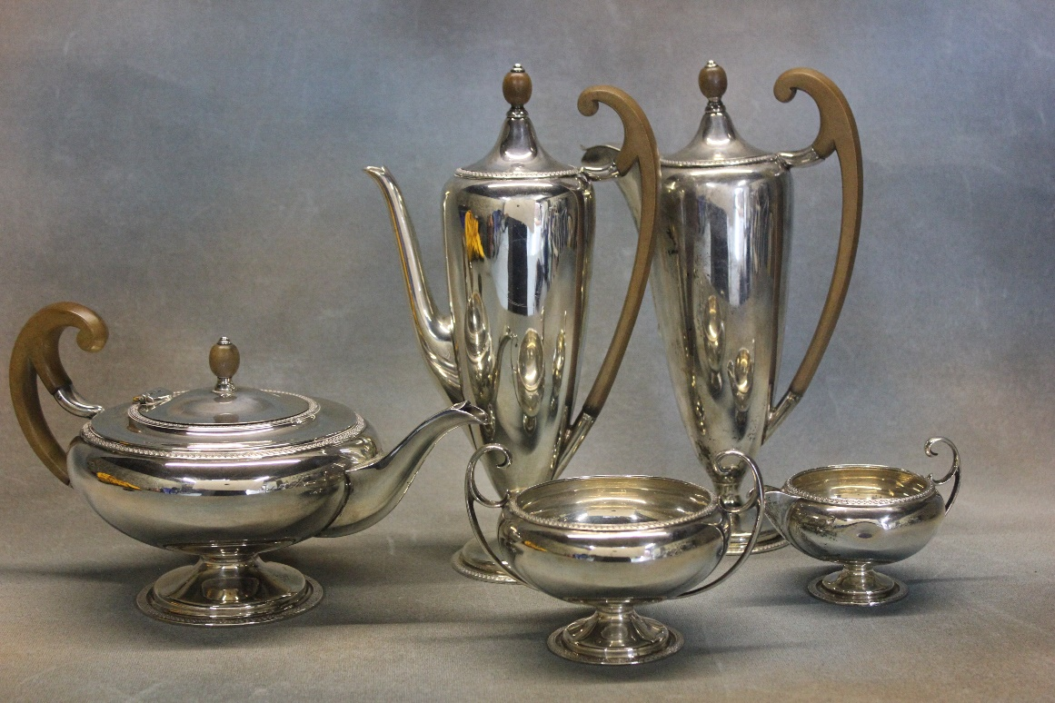 | Lot 13
14. | A late Victorian silver cream jug, London 1900, a George V silver cream jug, with bound handle, Birmingham 1912, and a pair of WMF silver plated Dutch style vases decorated Dutch figures approx. 8oz, weighable (4). | £100-£150
15. | A set of six Edwardian silver coffee spoons, and nips in a box, London 1903, a three piece condiment set, Birmingham 1960, boxed, a silver scrolled and pierced dish, marks rubbed, two sets of bone handled fish knives and forks, boxed, together with a quantity of small loose silver and silver plated objects, and some boxed. | £80-£120
16. | A reproduction mahogany lady's bureau, 53cm wide, and a small open bookcase, 36cm wide (2). | £30-£50
17. | Leia John- small portrait of woman, 23cm x 17cm and two decorative prints. (3) | £30-£50
18. | A late Victorian pottery Jardinière, blue ground, 36cm in diameter and a brown ground jardinière (2). | £40-£60
19. | A Lladro figure of Don Quixote seated in chair, 37cm high a.f., a figure of "Pancho", a.f., and an akita figure of Pheasant, a.f., (3). | £30-£50
20. | A Lladro figure of Don Quixote standing, 30cm high and a group of two children on a see-saw log (2). | £30-£50
21. | A pair of Rudolfstedt Volkstedt figures of youth and maiden, each 22cm high, one repaired, and a modern Dresden figure (3). | £50-£70
22. | A Saxe figure in Napoleonic style of a solider from the 2nd Footguards, 23cm high, a further figure of an Infantry Officer and a Naples type figure of a Hussar (3). | £40-£60
23. | A Royal Doulton figure "Taking Things Easy" HN 2677 18cm high, another "A Good Catch" HN2258, 19cm high, a Bairstow Manor Pottery figure of Winston Churchill commemorating the 60th Anniversary of D-Day, and a Carlton Ware "Rouge Royale" vase (4). | £30-£50
24. | A Seiko kinetic wristwatch, black finish, in box with spare strap links, a further Seiko stainless steel wristwatch, a Citizen Eco Drive wristwatch, boxed, and a Mappin and Webb quartz wristwatch (4). | £80-£120
25. | A George V silver photo frame with engine turned decoration, Birmingham 1931, on a "framecraft" easel stand, 30.5cm x 21cm. | £100-£150
26. | A gold and platinum three stone diamond and sapphire dress ring, a further three stone ring, marks rubbed, a three stone diamond set dress ring, and 18ct gold diamond solitaire dress ring, a 9ct gold wedding band and a small 9ct gold brooch, set seed pearls (6). | £180-£220
27. | A Victorian button upholstered salon armchair, on cabriole form legs, with casters. | £40-£60
28. | An over-mantle mirror in silver painted frame 97cm x 74.5 cm. | £20-£30
29. | A rectangular wall mirror in carved and stained wood frame, 103cm x 72cm. | £20-£30
30. | An Edwardian mahogany pot cupboard, enclosed by two panelled doors, on square tapering legs, 52cm wide, in need of restoration. | £20-£30
31. | Two Staffordshire pottery spill figures, each 29cm high, a watch-stand group, 22cm high, and two smaller figures, all a.f. (5). | £20-£30
32. | A Victorian carved show-wood spoon back chair with buttoned upholstery, on squat cabriole legs and casters. | £30-£50
33. | An Eden gift soft toy "Peter Rabbit" in box, together with a Peter Rabbit race game, in box (2). | £20-£30
34. | A 19th Century stained beech child's or dolls rail back chair, with caned seat, and a decorative miniature bureau (2). | £30-£50
35. | A quantity of mixed beaded and decorative costume jewellery. | £20-£30
36. | A small Victorian mahogany Pembroke table, on turned legs, a.f., 74cm x 52cm, extended. | £30-£50
37. | A late Victorian carved wood grandmother type salon chair, on turned and ringed legs, with castors. | £40-£60
38. | Arthur Smith-Knaresborough, watercolour 33cm x 23cm and Derek Lucas-watercolour of a Kentish farmhouse, 24cm x 35cm (2). | £30-£50
39. | Four small nursery rhyme prints, initialled K.G., each 12cm x 7cm, in maple frames, and three modern Japanese prints, landscapes (7). | £20-£30
40. | Moghul School- small Indian print of elephant, another of tiger hunt, in single frame, together with two further framed prints (3). | £30-£50
41. | Two Pelham standard puppets, boxed, and an unassociated puppet, unboxed, a Chad Valley "Give a Show" projector, a "Bambi" book and two other children's books (7). | £20-£30
42. | A set of six George VI silver coffee bean spoons, Birmingham 1938, in lined case (6). | £15-£20
43. | A "Pioneer" cover album, containing a quantity of R.A.F. first day covers (70), a further similar album of armed forces and commemorative covers, an album of general first day covers, four other albums of mixed first day covers, two books on Kent postcards, an ARP book, some facsimile newspapers, and two other books (14). | £30-£50
44. | Seven albums of British and world stamps, mainly Queen Elizabeth II issues, eight stock book size albums of mixed stamps, together with five boxes of loose stamps, and an empty album (20). | £60-£80
45. | A Bridgewood China part dinner service flower and fruit pattern, 12 pieces, one tureen lid missing. | £20-£30
46. | A 20th century Chinese silk skirt or coat panel, framed, 63cm x 33cm. | £20-£30
47. | A 20th century Chinese limed teak coffee table, 139cm x 78cm. | £40-£60
48. | A cylinder form umbrella stand, with foliate decoration, 61cm high. | £20-£50
49. | A set of four graduated miniature fruitwood storage boxes. | £15-£20
50. | A plywood kidney shaped dressing table, 120cm wide, and a matching stool (2). | £20-£30
51. | A pair of reproduction mahogany American style two tier occasional tables, with tooled leather tops, each 62cm wide. | £80-£100
52. | An oak spiral twist torchere, on tripod base, 98cm high. | £30-£50
53. | A set of six Queen Elizabeth II silver rat-tail tea-spoons, bearing the hallmarks of six main assay offices, and dated 1953, in lined case, approx. 2.3oz (6). | £40-£60
54. | A Victorian ebonised and gilded button upholstered tub chair on turned legs, and a George III style ladder back elbow chair (2). | £40-£60
55. | An Early 20th century brass Petzval camera lens, by "Dallmeyer", series B3, No 63499, with one lens cover, 21cm long, approx. 1901-1902. | £800-£1200
 | 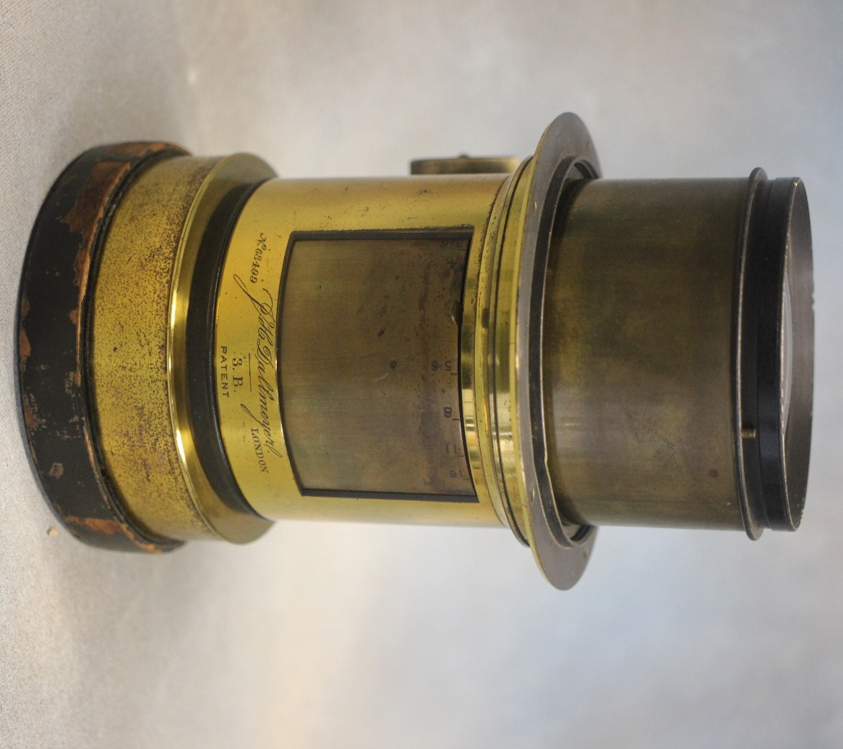  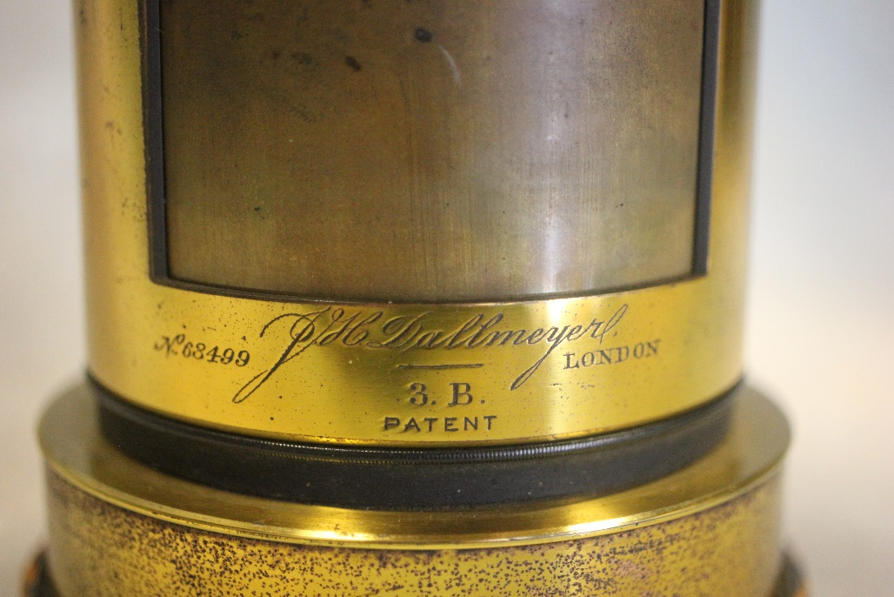 | Lot 55
56. | A late Victorian/ Early Edwardian bamboo and horn handled umbrella with 9ct gold mount, 92cm long. | £80-£100
57. | A folio for Dr. R. E Lurring MB.BCH.BAD.BA containing ten mezzotint engravings by Arthur Hogg and Eugene Tilly of paintings after old masters, including "The Laughing Cavalier" by Franz Hals, portrait of Jan Steen as the "Lute Player", "The Duet" after Gabriel Metsu. "The Sleeping Sportman" after Gabriel Metsu, and others, together with a letter from The Museum Galleries, London (10). | £200-£300
58. | A 20th century Chinese hardwood and brass mounted jewellery cabinet of chest form with hasp and padlock, 36cm wide. | £100-£150
59. | A part early 20th century ebonised, brass bound, and inlaid trinket chest, with fitted interior of tray and small compartments, 61cm wide. | £100-£150
60. | A late 19th century gilt painted spelter mantel clock, with some porcelain panels and surmounted by cherubic and putti figures, French striking movement, 52cm high. | £150-£200
61. | Three John Rabone and Sons Surveyors tape measures in embossed leather cases, and a small mathematical instrument set by W.H Harling in mahogany box (4). | £40-£60
62. | A quantity of WWI and other black and white coloured post cards, including views of Ypres and Japanese soldiers, serving with Canadian troops. | £80-£100
63. | A Lincoln stamp album, containing a collection of Great Britain, Empire, and World Stamps, including Victorian issues together with a quantity of loose stamps. | £80-£120
64. | A 9ct gold peridot set pendant, set in an Art deco style triangle, on a slender link chain, a pair of 9ct gold cubic zirconia set "Huggie" earrings and two silver bangles (4). | £30-£50
65. | A 3/4 size English violin "The Maidstone" retailed by Murdoch Murdoch and Co Ltd of London. 34cm long, not including button, 36cm long including button, length overall 56cm, together with a bow (missing string) in original coffin style case. | £30-£50
66. | Low- "Winston" seated on a step, chromolithograph, 29cm x 22cm, and a photographic print, "our skipper" 45cm x 34cm (2). | £30-£50
67. | A modern burr poplar shallow bowl by "Tony Page" 32cm in diameter. | £20-£30
68. | A reproduction circular relief plaque of Italian style of two young children in gilt and black painted frame, 41cm x 36cm. | £30-£50
69. | A Victorian mother of pearl veneered and white metal card case, with Maltese cross to cover inscribed "Mrs Spires", 10.5cm x 8cm, a.f. | £50-£70
70. | After Pablo Picasso - blue period nude, chromolithograph, 41cm x 33cm. | £60-£80
71. | A pair of modern pottery leaf pattern dishes, green ground each, 19cm wide, signature to base (2). | £40-£60
72. | A reproduction mahogany serving table, fitted three drawers on square tapering legs with spade feet, 122cm wide. | £40-£60
73. | A small quantity of fragments of Roman pottery, and minerals (14). | £40-£60
74. | A part No. 2 dress uniform formally worn by Lt. Col R.K. Collins of the Army Intelligence Corp, an officer's mess kit, No. 1 dress cap in box, together with a pair of boots, service belts, ties, a coloured commemorative print, and other ephemera. | £100-£150
75. | 20th Century English school "Lyminge, Kent", watercolour 36cm x 53cm | £20-£30
76. | A pair of practise fencing rapiers and two reproduction decorative swords (4). | £20-£30
77. | A reproduction mahogany towel rail with part open carved ends on shaped feet, 75cm wide. | £30-£50
78. | A Victorian cast brass scuttle with hinged lid on circular foot, 48cm and a decorative brass oil lamp with glass chimney, 65cm high, slightly a.f. (2). | £50-£70
79. | A 19th century rectangular wall mirror in gilt moulded frame, 96cm x 120cm, a.f. | £40-£60
80. | An American mahogany roll top desk, with tambour shutter top, and four drawers, fitted interior, 106cm wide. | £150-£200
81. | A Late 19th Century slate cased mantel timepiece, French movement, 35cm high. | £30-£50
82. | An Early 20th Century mahogany display cabinet, with glazed and moulded panel doors, on squat cabriole legs, 76cm x 124cm. | £20-£30
83. | 19th Century school- Miniature oval portrait of French officer, probably in summer uniform, 4.5cm x 5cm, a.f., and a small painted Indian school transparency of bearers and guards, 13cm x 17cm, a.f. (2). | £50-£70
84. | A Late Victorian painted treen box, decorated landscape, fitted interior, decorated monkey and butterfly, 17cm wide, a small decorative puzzle box, and Indian lacquered fan panel, six enamelled and wooden match box holders and a small pin tray (10). | £40-£60
85. | A small continental art glass bowl, 11cm in diameter, a small cauldron bowl, and a decorative porcelain tea-set and milk jug (4). | £15-£20
86. | A "Red Star" coopered wooden washing machine with turning handle to top, on four feet, 120cm x 67cm. | £20-£30
87. | A Victorian inlaid walnut davenport desk, with lidded stationary compartment, and sloping writing surface, four side drawers, and four simulated drawers, on conforming feet, with casters, 53cm wide. | £100-£150
88. | An Edwardian inlaid mahogany corner elbow chair, on slender turned legs, united by stretchers. | £40-£60
89. | Three brass gas wall lights, and a freestanding gas lamp, all converted to electric and with mixed glass shades, and two spare mounts (6). | £30-£50
90. | A four piece silver plated tea-set, of faceted design, together with a circular engraved tray (5). | £40-£60
91. | A 19th century carved oak longcase clock, the eight-day movement, with square brass dial and silvered chapter ring, inscribed "Richard Chalken, Wrotham", 195cm high. | £80-£100
92. | After Norman Ackroyd (British b.1938)- "Ballymaloe House, Co. Cork" etching no. 50/90 55cm x 43cm, a smaller etching " Study of Bacchus, La Mission Haut Brion 15/20",21cm x23.5cm, and another, "Study for Chateau Beychevelle, 21/20" 21.5cm x 27cm, smudge stain to mount, together with four publication brochures (7). | £100-£150
93. | After Norman Ackroyd (British b.1938)- "Midsummer Morning, Charleston 15/60" etching 65cm x 70cm cm, a smaller etching "On Twyford Down, Deacon Hill 16/90", 16.5cm x 26cm and another "Camel Estuary 36/65", 16.5cm x 25cm, smudge to mount, all signed, together with three publication brochures (6). | £100-£150
94. | After June Berry- "Cows at Pressigny 8/75" etching, 25cm x 25.5cm, and a smaller etching after D Holmes "Avebury" 13cm x15.5cm (2). | £30-£50
 | 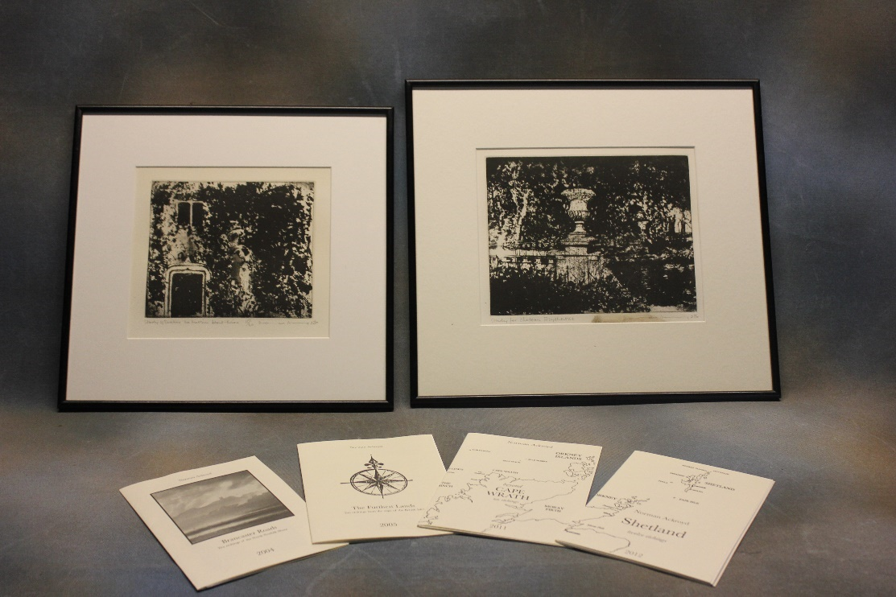 | Lot 92
95. | To 16698 Private A.S.H Picking 5th Field Ambulance, Australian Army Medical Corps- Three Medal Group, comprising:- George V military medal, 1914-1918 war medal, and Victory Medal, boxed, together with copy citation, a soft cover book illustrated by the recipient, and a letter from the Australian war memorial. The citation reads "Private Picking volunteered and went out to No Man's Land under a heavy barrage near Daisy Wood east of Zonnebeke, on the morning of the 10th of October 1917, to dress wounds and bring several men back to his own lines (third battle of Ypres), he was wounded 21/12/1917 and 13/6/1918. | £300-£500
 | 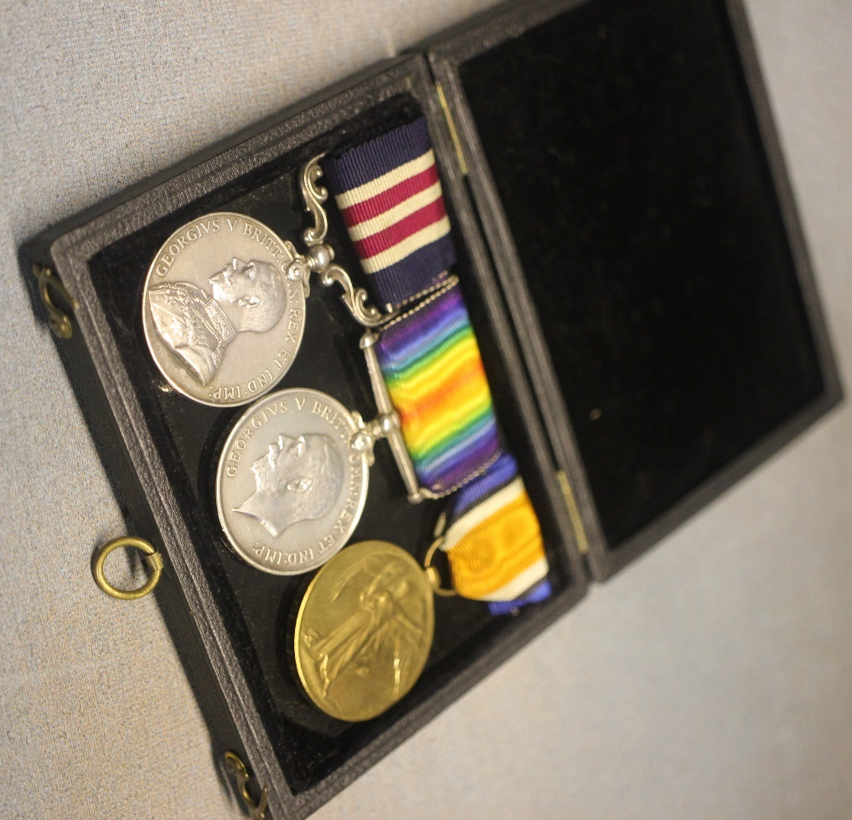 | Lot 95
96. | A Victorian inlaid walnut oval snap-top breakfast table, with decorative oval to centre on quadruple turned pedestal, and carved quadruped base, 88cm x 119cm, together with four Victorian kidney-back chairs (5). | £200-£300
97. | A French brass silver-plated and mother of pearl saxophone for "Besson of London" 83cm long, with spare mouthpiece and other accessories, together with a silver-plated clarinet of French manufacture, 66cm long, in single case (3). | £100-£150
98. | A silver plated and mahogany "Grand Concert Banjo by J.E Brewster no. 562" with bone tuning keys, three strings present, in leather case, 94cm long. | £80-£100
99. | A 20th century oak grandmother clock, with arched dial, retailed by "Pleasance and Harper, Bristol", three train movement, 167cm high. | £120-£150
100. | A Victorian mahogany three tier buffet with turned supports, on squat turned legs, with casters, 69cm wide. | £200-£250
101. | A Victorian and ebonised piano stool, with circular adjustable seat on tripod base. | £100-£120
102. | A pale beech bentwood hat and coat stand, 186cm high. | £60-£80
103. | A pair of reproduction carved beech fauteuils with tapestry upholstery on slender cabriole form legs. | £120-£150
104. | A reproduction harlequin mahogany dining suite by Wm Tillman, comprising:- a twin pedestal dining table, with two extra leaves 107cm x 248cm, extended, a set of eight shield-back dining chairs, and a serpentine sideboard, 138cm wide (10). | £300-£500
105. | A reproduction mahogany serpentine serving table, of Adam style by Wm Tillman fitted two drawers, fluted decoration, on four fluted tapering legs, spade feet, 162cm wide. | £100-£150
106. | A reproduction mahogany circular breakfast table, on turned column and four splay legs, with brass terminals and castors, 91cm in diameter, by Wm Tillman, and two Georgian style side chairs (3). | £70-£100
107. | L. Mazzini- "Looking towards the Grand Canal, Venice", inscribed on a Ravensbourne Gallery label verso, oil on canvas 39cm x 49cm. | £300-£500
108. | W. Shayer- "Farming Family", oil on canvas, 60cm 89cm. | £200-£300
109. | A reproduction mahogany and brass twelve bottle wine rack on moulded base, 48cm 25cm. | £30-£50
110. | A George V 1927 proof coin set comprising: crown, half crown, florin, shilling, sixpence, and threepence coins in case (faded.) | £180-£220
111. | A 15ct gold peridot and seed pearl set pendant, on unmarked slender link chain, approx. 10g, and a three stone dress ring (2). | £250-£350
112. | A platinum three stone dress ring, set central sapphire, and two diamonds, together with a slender platinum wedding band, approx. 10g. | £240-£280
113. | A 9ct gold dress ring set a yellow topaz, a small signet type ring, an unmarked eternity ring, and a gent's signet ring, approx. 10g, weighable (5). | £150-£200
 | 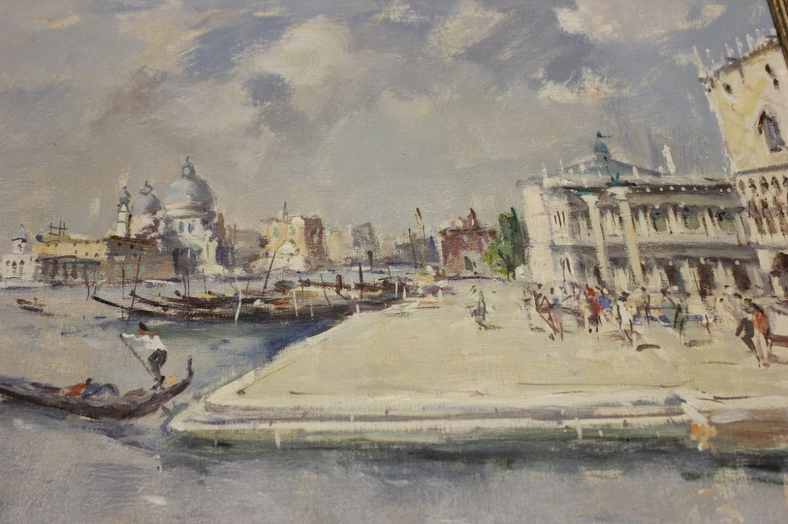 | Lot 107
114. | A Boucheron fourteen flowerhead bracelet, 391, boxed, a Tissot stainless steel lady's wristwatch, together with a turquoise set brooch, a white metal gem set brooch, a pair of pearl set earrings, and two pairs of costume earrings. | £150-£200
115. | An Edward VII glass and silver ale stein with some enamelled decoration, 1901., 23cm high | £200-£300
116. | A late Victorian silver powder bottle, with part glass top, London 1898, a hobnail cut glass toilet bottle, with silver top, London, 1896, a pair of ink wells with silver tops, Birmingham 1934, a further box, with top, and two napkin rings mixed dates (8). | £130-£180
117. | An Edwardian silver bowl, London 1903, a silver two handled horseshow sporting trophy, Sheffield 1927, a silver sauce boat, Sheffield 1029, a candlestick with weight to base, Birmingham 1910, a pair of pepperettes and two small trays, approx. 16oz, weighable (8). | £250-£350
118. | A late Victorian silver-plated three piece set, a sugar and cream jug, bottle coaster, a toddy ladle, condiment, pieces and other silver-plated ware. | £130-£180
119. | A late Victorian tortoiseshell veneered and gilt metal inkstand, in need of restoration, 24cm wide, an oak and chrome plated inkstand, with calendar and three glass toilet jars, a.f. (5). | £120-£180
120. | A quantity of copper and brass to include shallow pan, a measuring jug, ladles, and other kitchen objects and other pieces. | £50-£70
121. | A Victorian walnut lap desk, 38cm wide and a carved pine lamp base (2). | £50-£70
122. | A late 19th century mantel clock, in brass case with enamelled panels, decorated blue tits and other birds, French striking movement, 35cm high. | £150-£200
123. | A late 19th century gilt brass carriage clock, of squat form, with oval silvered dial, inscribed the retailers name "L. Vincent Avignon", 14cm high, a.f. to one glass panel. | £120-£180
124. | A small gilt brass oval box with miniature inset to top box, 9cm wide, a small enamelled elephant brooch, boxed, a small enamelled box, and a Limoges box (4). | £40-£60
125. | A continental 15ct gold brooch, two pearl set lapel pins, an Omega gold lady's wristwatch, not working, a 9ct gold lady's wristwatch of unknown manufacture, a 9ct gold bangle, dented, a lady's gold wristwatch, no strap, a lapel pin, set zircons, an unmarked decorative brooch, and some small pieces of gold and yellow metal, in poor condition, approx. 60g, weighable. | £800-£1000
126. | A pair of 18ct gold gent's oval cufflinks, with engine turned decoration, a gent's mother of pearl dress stud set, boxed, a pair of decorative cufflinks, a.f., and four further dress studs, approx. 10g weighable. | £300-£500
127. | A 9ct gold St. Christopher pendant, a 22ct gold wedding band, an 18ct gold amethyst set dress ring, a further 22ct gold wedding band of slender form, and three gold dress rings, in poor condition, approx. 20g, weighable (7). | £600-£800
128. | A cameo brooch, in part filigree mount, together with a small quantity of decorative and costume jewellery, and a lady's stainless-steel wristwatch. | £110-£130
129. | A Regency rosewood sarcophagus shaped tea-caddy, with part fitted interior, 34cm wide. | £40-£60
130. | A Regency style mahogany side cabinet, fitted a drawer, above two folded satin panelled doors, flanked by carved and fluted pilasters, on plinth base, 110cm wide. | £100-£150
131. | A reproduction mahogany circular snap-top breakfast table, on tripod base, 105cm wide, and a set of four mahogany dining chairs, with pierced splats (5). | £60-£80
132. | A mahogany Military style chest of three drawers, with brass corners, and recessed handles, on bracket feet, 81cm wide. | £80-£100
133. | A Victorian pale mahogany button upholstered tub form salon chair, with spindle turned decoration, on square tapering legs, and castors. | £40-£60
134. | A reproduction walnut veneered serpentine chest of four graduated drawers, with brushing slide, on bracket feet, 70cm wide. | £80-£100
135. | An Edwardian silver rose bowl, with scrolled and gadrooned decoration, on circular foot, 18cm in diameter, maker H.A., Sheffield 1903, approx. 10oz, together with a silver-plated spill vase, on weighted base, 21cm high (2). | £100-£150
136. | A gilt-brass carriage time piece, with serpentine front, retailed by "Wm. Bruford and Son, Eastbourne and Exeter", 12cm high. | £80-£100
137. | A pair of Vienne porcelain vases, part lustre and gilt ground, decorated female figures, and signed "Rimu", on triform bases, each 19cm high, together with a further vase and cover, 27cm high, and two plates (5). | £80-£100
138. | A 19th Century mahogany wine cooler, of sarcophagus form, with part original interior lining, but no fittings, 77cm wide. | £200-£300
139. | A Victorian mahogany pot cupboard, with panelled door, on plinth base, 39cm wide. | £30-£50
140. | After Montague Dawson (1894-1973) - "The Pagoda Anchorage", chromolithograph, signed to mount, 67cm x 79cm. | £30-£50
141. | A George III pearwood tea caddy, with part lined interior, stalk to top, and with steel key escutcheon, 14cm high. | £1000-£1200
142. | Four Baedeker's guide books, "Southern Italy", "Great Britain", "Switzerland", and "Belgium and Holland", 1900, 1910, 1899, and 1910, together with four further guide books, and another book, "Where to Live Round London", second edition, 1907 (9). | £30-£50
143. | A Late 19th century brass samovar, a.f. to top, on square footed base, 49cm high, together with two copper kettles, and two copper measuring jugs (5). | £40-£60
144. | A Late 19th Century 30-hour longcase clock movement, striking on a bell, with square painted dial inscribed "Atwood of Lewes", 30.5cm. | £50-£80
 | 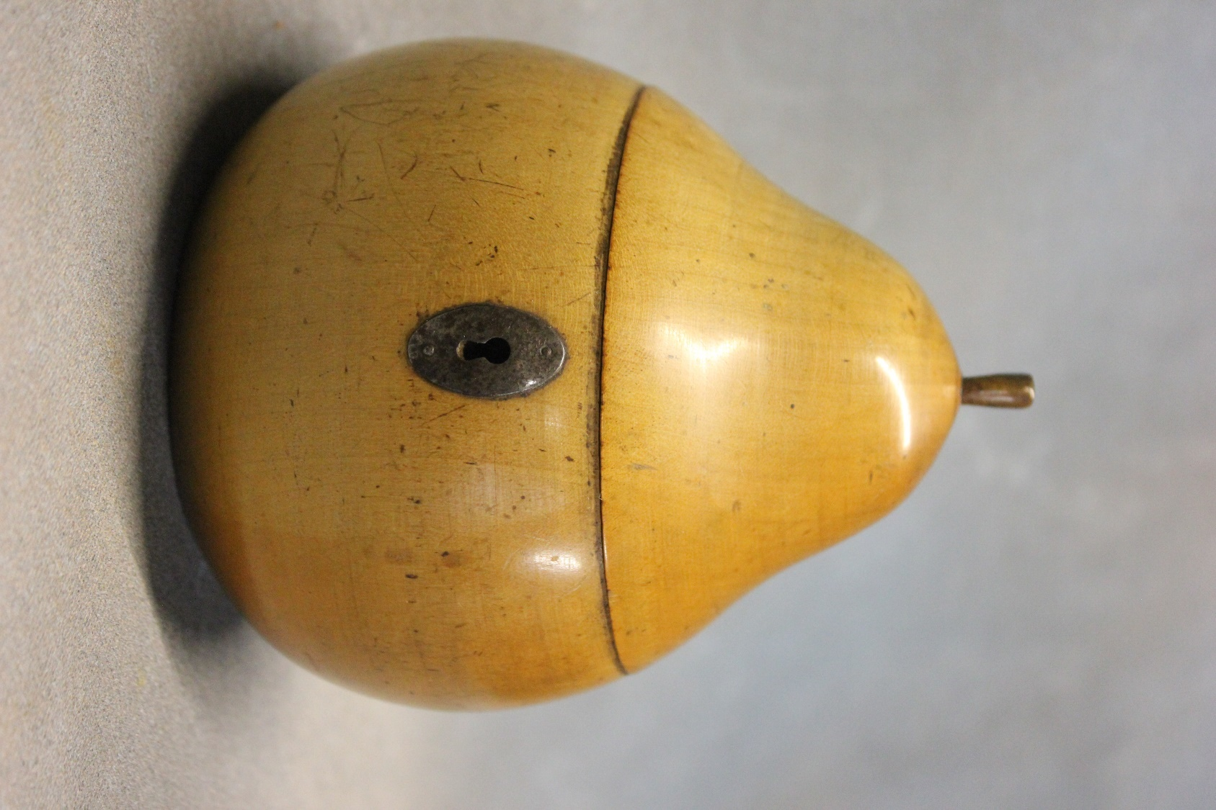 | Lot 141
145. | A small group of black and white press photographs, comprising: Aston Martin 1.5 litre Le Mans, at 1931 motor show, the Arnaulet sports four 16 h.p., at the same show, The King presenting Leeks to officers of the Welsh guards 1/3/1936, the Duchess of Gloucester, 18/1/1936, the Queen Mary, 24/3/1936, the body of King George V arriving in London, 23/1/1936, together with a newspaper supplement of the order of ceremonial for King George V's funeral (7). | £20-£30
146. | A set of six George V silver gilt and enamelled coffee spoons, by "Liberty and Co", Birmingham 1925, approx. 2oz overall, in lined case. | £40-£60
147. | A Late Victorian walnut and inlaid work box, a.f. to interior, together with a small silver thimble, and a Parker 17 fountain pen, in lined box (3). | £30-£50
148. | A pair of 19th Century Helena Wolfson Dresden bottle vases, each 23cm high. | £60-£80
149. | A Davenport opaque china part dinner service, approx. 5 pieces, and two Royal Doulton figures, "Stephanie", and "Top of the Hill" (7). | £40-£60
150. | G.B. Walmersley - figures on wooded path, church in background, oil on canvas, 60cm x 90cm. | £50-£70
151. | A continental double barrel percussion pistol, with mahogany part carved handle, 23cm long, and a reproduction flintlock pistol (2). | £80-£100
152. | A Wedgewood "Corn Poppy" pattern part dinner service, after Susie Cooper, approx. 39 pieces. | £30-£50
153. | A Midwinter "Stylecraft" pattern part dinner service, approx. 21 pieces. | £50-£70
154. | A quantity of "Thos Webb" drinking glassware, various, and five "Brierley" hock glasses. | £90-£100
155. | A Late 19th/Early 20th Century Japanese porcelain bowl, in the Chinese famille vert style, decorated kittens, butterflies, and flowers, 25cm in diameter. | £150-£200
156. | A 20th Century Japanese folding wall panel, painted on silk, with gilt highlights, landscape, with Mount Fuji in background, 43cm x 60cm. | £40-£60
157. | S. Kleiner, after I.A. Corvinus - prospect of Vienna, showing the church of St. Mary and other buildings, circa 19th Century, after an earlier original, print on silk, 30cm x 42cm. | £40-£60
158. | A copy of a Christies Auction poster, announcing the sale of five old sherries from the cellar of Queen Victoria, and King Edward VII, 24th June, 1901, chromolithograph, 74cm x 48cm. | £20-£30
159. | 19th Century North European school - city harbour scene, with boats, church, and other buildings, watercolour, unsigned, 74cm x 53cm. | £80-£100
160. | After Thomas Sydney Cooper - cows in landscape, oil on canvas, bears a signature, 76cm x 127cm. | £60-£80
161. | Alphonse Leroy, 1853, after Raphael - Christ after lowering from the cross, lithograph, 41cm x 45cm. | £40-£60
162. | A large fossil vertebra believed to be rhino or bos (early cattle), excavated from the Aylesford area circa 1932, approx., 27cm wide. | £80-£120
 | 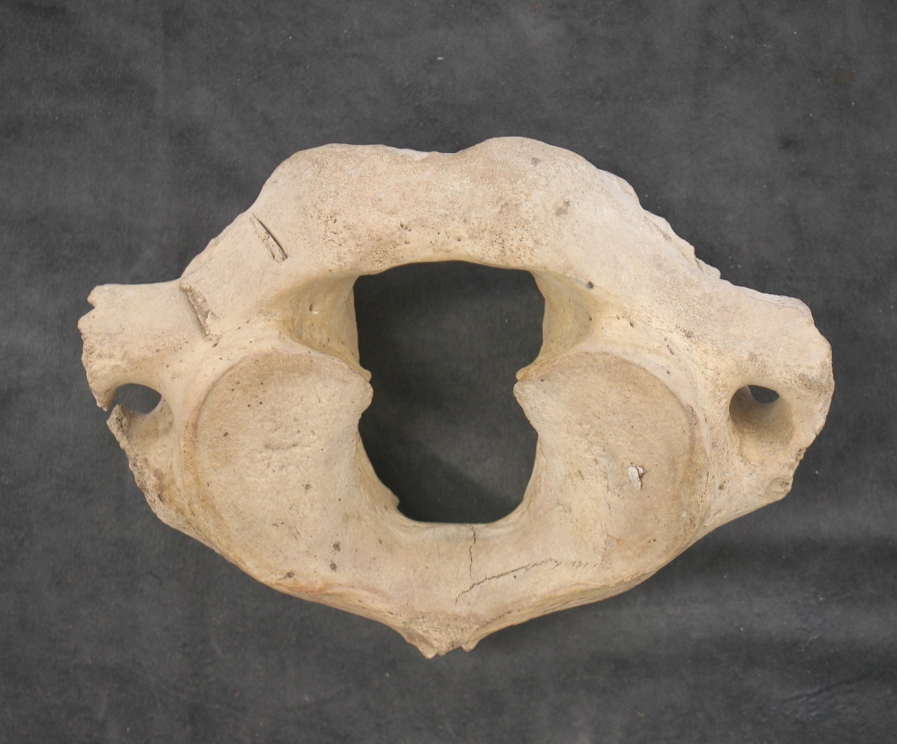 | Lot 162
163. | Seven Robinson's golly badges, in various uniforms and outfits (7). | £15-£20
164. | A part sheet of Chinese bond certificates, two albums of Late 20th Century notes, from Poland, Ukraine, Russia, Trinidad, and Tobago, various South American countries, together with BT phonecards, various. | £30-£50
165. | Four albums of World stamps, mainly Queen Elizabeth II era, and a small number of earlier issues, together with a small stock-book album, two empty albums, a small number of first day covers, and some loose stamps. | £40-£60
166. | A chrome plated and enamelled P6 Rover Owners Club badge, an R.A.F. car badge, an Association of Men of Kent and Kentish Men badge, and four further badges (7). | £40-£60
167. | A set of Salter kitchen scales, circa 1977, with copper weighing pan, a set of seven shallow copper pans, three brass colanders, and a brass teapot (12). | £20-£30
168. | A quantity of "Matchbox Models of Yesteryear", together with "Days Gone", and other die-cast models, unboxed, a "Solido" Rolls Royce Coupe, in plastic box, and seven other boxed die-cast models. | £30-£50
169. | A Scalextric track layout, with mixed racing and rally cars, unboxed, a boxed digital lap counter, two transformers, and other accessories. | £60-£80
170. | HO/00 scale model railway - a Hornby G.W.R. 4-6-0 King class "Edward I" steam locomotive, a class 50 "Agincourt" diesel electric locomotive, several pieces of rolling stock, together with Bachmann "Branchline" locos and rolling stock, all boxed, a Hornby Elite digital power unit, boxed, station buildings, unboxed, platforms, track, and accessories (a quantity). | £100-£150
171. | After W. Ruckin - oval portrait of gentleman, lithograph, 21cm c 14cm, two watercolour landscapes, by unknown hand, and two other pictures (5). | £20-£30
172. | A modern pale oak dining table, of refectory style, with draw-leaf action, 106cm x 313cm, extended, together with eight dining chairs, with square panel backs, and gothic style arched centre panels, on square chamfered form legs, including a pair of elbow chairs (9). | £400-£600
173. | A modern upholstered easy chair, covered in a striped pattern material, on squat cabriole legs. | £150-£200
174. | A Victorian mahogany show-wood spoon-back salon style chair, with green buttoned upholstery, on turned and ringed legs. | £80-£100
175. | A 20th Century mahogany granddaughter clock, with arched dial, 138cm high. | £100-£150
176. | A coopered oak butter churn, on elm stand, by "H. Llewellin and Son, Royal prize churn works, size no. E2, Haverfordwest", 120cm high, with both iron and brass fittings. | £200-£300
177. | A Thai carved wood panel, depicting dancers, and a phoenix on a horse drawn carriage, 68cm x 52cm. | £150-£200
178. | An Early 20th Century Singer sewing machine, on fitted base, 43cm long, missing its cover. | £15-£20
179. | A modern wall mirror, in heavy stripped pine frame, 112cm x 79cm. | £40-£60
180. | A 20th Century Chinese print, on silk, decorated birds and blossom, 60cm x 120cm, and two small modern oil paintings on canvas, each 40cm x 29cm (3). | £30-£50
 | 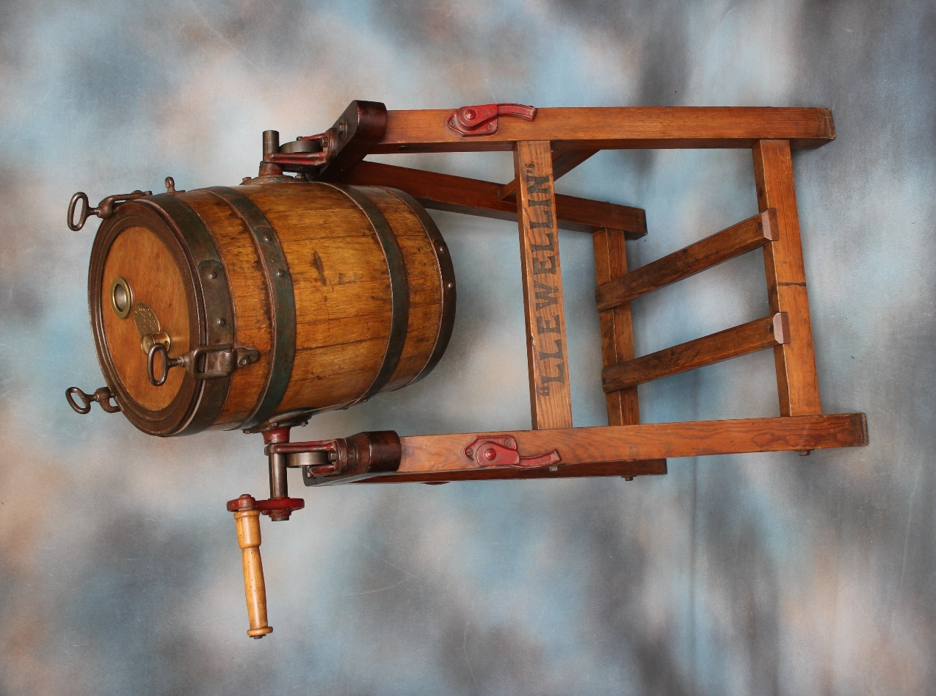  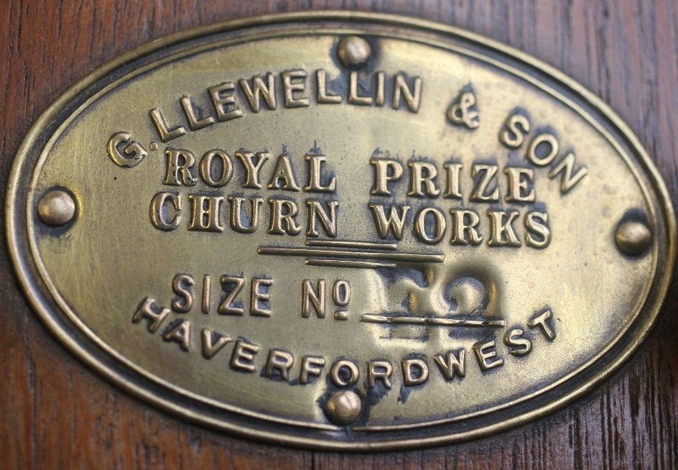 | Lot 176
181. | After Alfred Daniels, 1981 - "The Royal Exchange", and "Leaden Hall market, London", limited edition chromolithographs, 53cm x 65cm, and 48cm x 61cm (2). | £20-£30
182. | An Early 20th Century oak and stained beech wall clock, with silvered dial, 77cm long. | £20-£30
183. | A silver-plated three bottle tantalus, with hob-nail decanters, and lockable cover, 34cm wide. | £200-£300
184. | A George V silver sugar caster, London 1934, with Jubilee mark, 17cm high, a pair of sugar nips (marks rubbed), a pair of silver-plated grape scissors, a pewter quaich, together with some silver-plated and bone-handled cutlery, a hip flask, and other objects. | £70-£90
185. | A Lladro figure of two nuns, three further figures of girls, another of a monk, a figure by another manufacturer, and two Oriental resin figures (8). | £70-£90
186. | An Elizabeth II silver backed three piece part dressing table set, Birmingham 1952, a Continental silver vase, 15cm high, three other smaller pieces, and two modern photograph frames (9). | £60-£80
187. | A silver-plated salver, a galleried circular tray, two bottle coasters, four napkin rings, and an evil eye large pendant/wall hanging (9). | £60-£80
188. | Edwin Alfred Pettitt (1840-1912) - figure in wooded landscape, watercolour, 25cm x 25cm. | £150-£200
189. | A small modern Lalique glass figure of an owl, 10cm high, and two small bird figures (3). | £60-£80
190. | After Jonathan Andrews, A. Dury, and William Herbert - reproduction copy of a topographical map of the County of Kent, after the 1769 original, printed in 1968, in folio form. | £30-£50
191. | A lady's 14k wristwatch, no strap, a gent's Waltham pocket watch, in gold-plated case, glass missing, a small 9ct gold pocket watch, a small hammered silver scent flask, a silver-plated sovereign case, three mixed quartz wristwatches, and other small objects. | £40-£60
192. | Two white metal necklaces, one with earrings, a liver bangle, a silver trinket box, together with a quantity of mixed decorative and costume jewellery, and a cameo brooch. | £80-£100
193. | A 9ct gold dress ring, set a frosted stone, a 9ct gold garnet flowerhead cluster dress ring, thee further decorative dress rings, and a pair of ear studs (7). | £60-£80
194. | A part suite of silver-plated cutlery, by Viners of Sheffield, the Parish Collection, approx. 60 pieces, but not completely matching, in mahogany canteen. | £40-£60
195. | A "Kein" 400-day mantel timepiece, under a plastic dome, 20cm high.
196. | A pair of cast brass candlesticks, on square stepped and weighted bases, 19cm high. | £30-£50
197. | After H. Cassiers - Dutch scenes, with figures and barges, lithographs, three, 30cmx 20cm. | £40-£60
198. | A Chinese money doll, with wood hands, 37cm long. | £160-£180
199. | A set of twelve silver plated apostle type spoons with cherubic terminals and spiral twist handles, together with a pair of sugar nips in lined leather case. | £80-£100
200. | A set of six George V tea knives, with blue and gilt enamelled pistol grip handles and silver ferrules by Elkington and Company, Birmingham 1910, in lined case (6). | £60-£80
201. | A lady' Tissot art deco style wristwatch in 9ct gold case with decorative link strap, in later watch box. | £100-£150
202. | A metal stencil type British Rail sign "Bethnal Green" 55cm wide. | £30-£50
203. | An Imari bowl on circular foot, scalloped edge, 24.5cm in diameter, chips to rim, together with two small lidded vases, each 15cm high. | £30-£50
204. | A 20th century Limoges charger dish with silver plated rim and decorated in the Oriental style, 30cm in diameter. | £40-£60
205. | A Gent's Waltham gold plated hunter cased pocket watch, a similar Elgin pocket watch and a Lady's Elgin fob watch (3). | £140-£180
206. | A quantity of late 19th century stoneware inkwells and small vessels, mixed sizes. | £30-£50
207. | A Doulton Lambeth stoneware tyg, initials to base, decorated in the Art Nouveau style, with brown mottled ground, 18cm high. | £40-£60
208. | A Royal Doulton porcelain Art Deco style coffee set for six, decorated coloured bands to edges. | £60-£80
209. | A 19th century Chinese mug, the panels decorated figures and birds, blue and white bands on circular foot, 14cm high, a.f. | £40-£60
210. | Two picture frames containing a number of European embroidered shoulder badges (2). | £15-£20
211. | A pair of small Chinese bronze buddha figures on small mahogany stand, 10cm high. | £40-£60
212. | Seven Chinese metalware finger puppets of deities (7). | £100-£150
213. | A 1930's Jacques croquet set in original box, 114cm wide. | £100-£150
214. | An African hunting spear on pale stained wooden shaft, 106cm long. | £40-£60
215. | A small African carved wood fertility stand with a circular top, in form of naked native woman, 27cm high. | £80-£100
216. | A pair of carved African hardwood figural bookends, each 20cm high (2). | £30-£50
217. | A quantity of brass and staybright Royal Navy, Army and other buttons, together with a quantity of military and police fabric badges including US 82nd Airborne and Pegasus. | £30-£50
218. | A pair of 20th century Oriental watercolours on silk, depicting butterflies and blossom, 59cm x 24cm, framed (2). | £60-£80
219. | A pair of late 19th century Arts and Crafts style planished and wrought copper three branch candelabra, each 26cm high (2). | £80-£100
220. | A stained beech stereoscopic viewer with hinged handle, 32cm long, together with a book form box, containing approx. 75 "Realistic Travels", stereoscope slides, taken during WWI, Third battle of Ypres, the Somme etc. | £100-£150
221. | A quantity of small black and white photographs mainly of military interest of pre-WWII and war time interest, Desert Rats, circa 1941/42, Tripoli and North Africa, in a Kodak box. | £40-£60
222. | A small quantity of WWI silk postcards, eight altogether (8). | £30-£50
223. | A small quantity of black and white photographic postcards relating to the 1936 Berlin Olympics (approx. 35). | £20-£30
224. | To 3-6494 Private B.W Barker, Norfolk Regiment- First World War pair group, War and Victory medals, and to 54-064377 Private M. Tynan Army Service Corps- 1914/1915 Star (3). | £50-£70
225. | To 12488 Private W.C Richards RAMC- five medal group comprising:- Queens South Africa medal, with three claps, "Transvall", "Relief of Ladysmith" and "Twgela Heights", First World War trio, 1914-1915 Star ,War Medal and Victory Medal and Imperial Service Medal (5). | £180-£220
226. | To 17258 Private R. Knight 7th (pioneer) Battalion York and Lancaster Regiment, four medal group comprising:- George V Military Medal, 1914-1915 Star, War Medal and Victory Medal, Private Knight is believed to have been wounded during the Battle of the Bluff on 14th February 1916. Award of MM appeared in London Gazette issue 30540, page 2424, 22nd February 1918 (4). | £250-£350
227. | An early 20th century sherry glass with etched and faceted decoration on circular foot and a later glass (2). | £30-£50
228. | A folder of late 20th century Chinese bank notes (20). | £20-£30
229. | A carved soapstone figure of Ho-Tei, on carved wood stand, 10cm high. | £30-£50
230. | A late 19th century Chinese blue and white crackle glaze vase and cover, 25cm high. | £40-£60
231. | A 19th century Chinese blue and white vase and cover, decorated birds, flowers, and foliage, 27cm high. | £60-£80
232. | Two Victorian Royal Doulton fruit plates with scalloped edges, blue and gilt borders, decorated exotic birds, each 23cm in diameter (2). | £20-£30
233. | A clockwork Hornby O gauge 4-4-0 steam locomotive and tender in LMS Livery and 0-4-0 clockwork steam locomotive and non matching tender, in LNER livery (2). | £100-£150
234. | A late Victorian brass three branch candelabra, 43cm high. | £30-£50
235. | A Chinese terracotta dragon vase, 25cm high with some gilded edges. | £30-£50
236. | An early 20th century Caucasian rug, floral pattern on rose ground, wide border, 123cm x 200cm. | £20-£30
237. | A small silver link bracelet 20cm long in box. | £10-£15
238. | A porcelain figure of a seated Chinese lady, 7cm high and a nodding head figure, now fixed, both a.f. (2). | £50-£70
239. | A 20th century Chinese embroidered silk coat or skirt panel, 58cm x 25cm. | £20-£30
240. | An RAF MK2/MK2A Navigators flying suit from 39 Squadron, together with two peaked caps (3). | £30-£50
241. | Two planishing hammers, a miniature anvil, a micrometer, two grips, a miniature vice and other small tools. | £20-£30
242. | A forged steel ships anchor, with folding action, 146cm long overall. | £30-£50
243. | A New Zealand Victorian style ruler, 37cm long. | £15-£20
244. | A simulated amber necklace, on metal beaded chain, 42cm long. | £20-£30
245. | A modern Chinese mah-jong set in fitted case, 32cm wide. | £20-£30
246. | An Edwardian inlaid mahogany balloon shaped mantel timepiece with French movement and white enamelled dial, 23cm high. | £30-£50
247. | S. Hobbs after Edgar Degas- "Edwardian French Beach Scene" inscribed on a label, oil on canvas, signed, 49cm x 60cm. | £200-£300
248. | After Edgar Degas- "Figures Dining in a French open air restaurant", oil on canvas, unsigned, 51cm x 61cm. | £300-£500
249. | E. Cabe (American 19th Century)- "Admiring the Painting", oil on canvas, signed bottom right, 43cm x 33.5cm. | £300-£500
250. | John Bridges (British 1818-1854)- half length portrait of a seated Victorian Lady in lace trimmed dress, oil on panel, signed lower left, 41cm x 36cm. | £400-£600
251. | Attributed to John Faed SRA (British 1820-1902)- "Serving the Enlisting Papers" inscribed on label verso, oil on canvas, 76cm x 63cm. | £3000-£5000
252. | A Regency rosewood circular snap-top breakfast table, on part faceted pedestal, and circular plateau base, with three knurled feet, 120cm in diameter, a.f., to top. | £100-£150
253. | A set of six dark stained beech wheel-back side chairs, with added upholstered pad seats on turned legs, united by stretchers (6). | £60-£80
 | 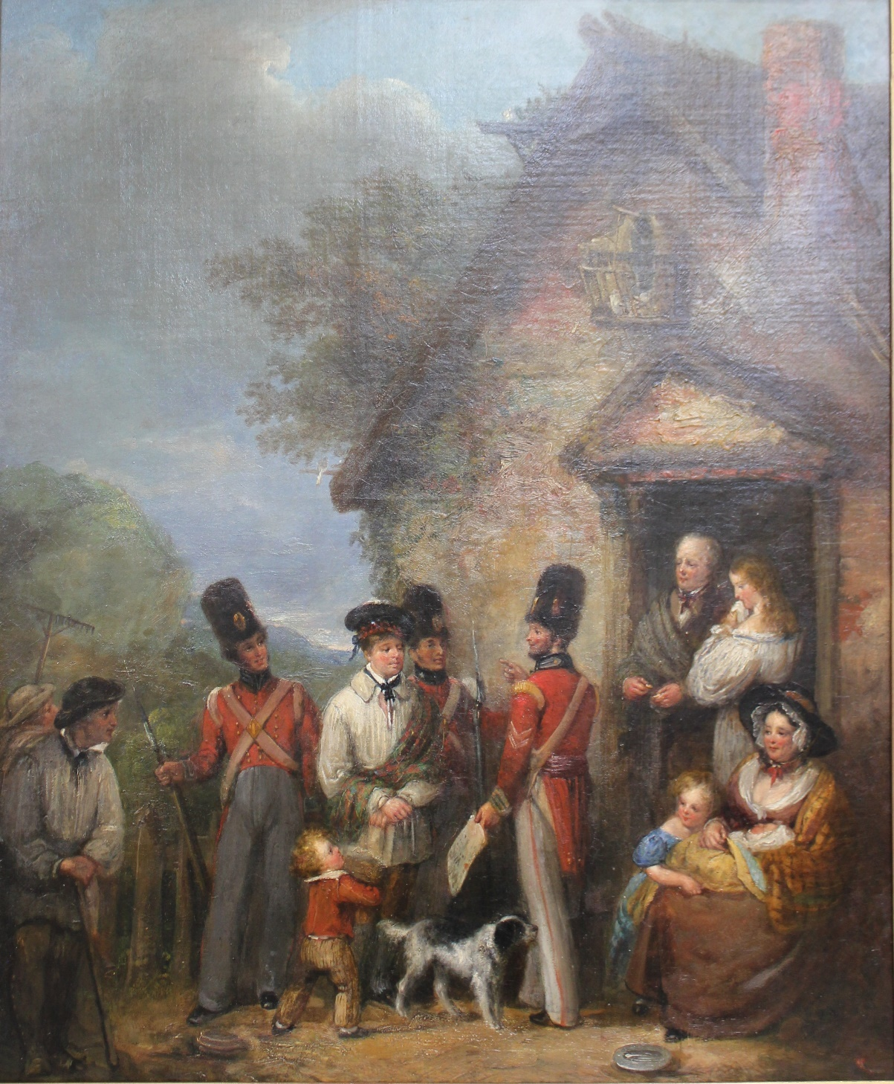 | Lot 251
 | 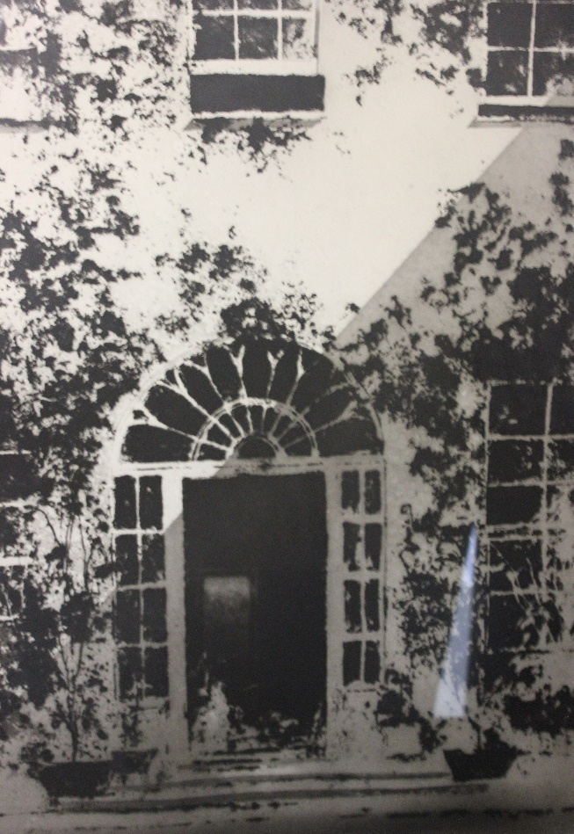 | Part of Lot 92
Future Dates

AUCTION DATES 2021

Wednesday 15th September 2021

Wednesday 27th October 2021

Wednesday 1st December 2021

Viewing on Monday and day before sale from 12.00pm to 7.00pm
and on morning of sale from 9.00am to 10.30am
Sale commences at 11.00 am.
(Please note that these viewing times do not apply to the 28th July sale.)

VALUATION DAYS 2021

Wednesday 4th August 2021

Wednesday 29th September 2021

Wednesday 3rd November 2021

Wednesday 8th December 2021

Sevenoaks Saleroom, Argyle Road,
Sevenoaks TN13 1HJ

11.00am – 4.00pm
Notes

