Ibbett Mosely Auctions, Wednesday 27th October Auction Catalogue

Important Notice: We are happy to welcome you back into our saleroom for live bidding on the day of sale!

Also live online at:
www.easyliveauction.com/ibbettmosely/

Commission bids (bids left ‘on the book’) may be left, as well as a limited amount of telephone bids. Please telephone 01732 456731 or email auctions@ibbettmosely.co.uk for further details.

Please be aware there is viewing strictly by appointment only. Any walk-ins will not be permitted. The full catalogue, complete with images of each lot and condition reports will be available at easyliveauction.com/ibbettmosely/

Please telephone 01732 456731 or email auctions@ibbettmosely.co.uk with any questions.

Collection of items is available on Thursday 28th October from 10am - 5pm. Collection of items from 29th October onwards, by prior appointment only.

You are welcome to collect in person, or via your own carrier.
Alternatively, local courier PSP Logistics are available to carry out deliveries of items. Please contact them directly to make arrangements.


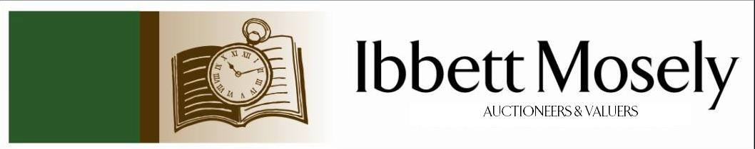

Catalogue of Antique, Edwardian and Victorian
Furniture and Effects
to be Auctioned on

Wednesday 27th October 2021
at 11.00am

IBBETT MOSELY AUCTION ROOMS
ARGYLE ROAD, SEVENOAKS, KENT TN13 1HJ

Live In Room Bidding
& via
www.easyliveauction.com/ibbettmosely/

Viewing at Sale Room on:

Monday 25th October
Tuesday 26th October

Between 10.00am –5.00pm.

STRICTLY BY APPOINTMENT ONLY.

Limited numbers to be allowed on day of sale, please contact our office on
01732 456731 for more information.

Please wear a face covering when in the Saleroom.

Catalogues: £2.00

Auctioneer and Valuer: Alan White FNAVA
Consultant Auctioneer and Valuer: Derek Hodge
Trainee Valuer and Clerk: Nicola Rainsley-Hughes
Auction Clerk and Administrator: Emily Frederick
1.† | James Metcalf (American 1925-2012)- Untitled, abstract figure on square base, cast bronze and alloy mix, 40cm high, a.f. | £300-£400
 | 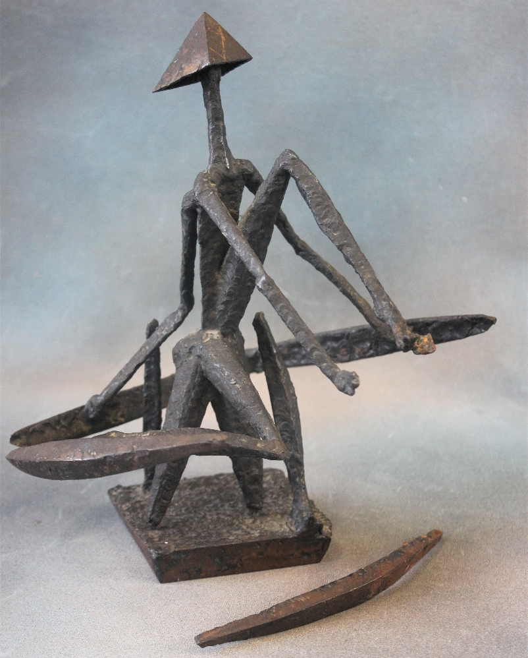 | Lot 1
2.† | James Metcalf (American 1925-2012)- Untitled, abstract bust, base missing, bronze alloy mix, 22cm high, a.f. | £200-£300
 | 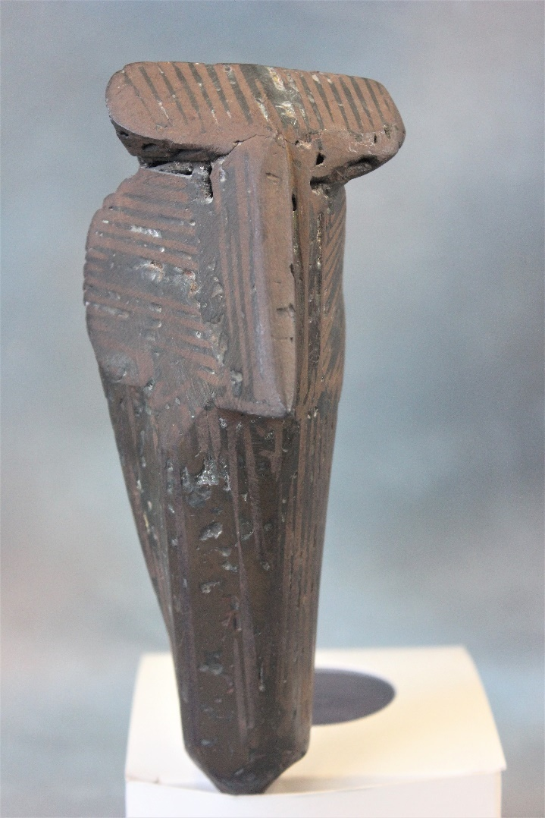 | Lot 2
† ARR will be subject to additional fees. See last page for more details.
3.† | James Metcalfe (American 1925-2012)- Untitled, abstract figure in bronze and alloy mix, 26cm high, base missing, a.f. | £200-£300
 | 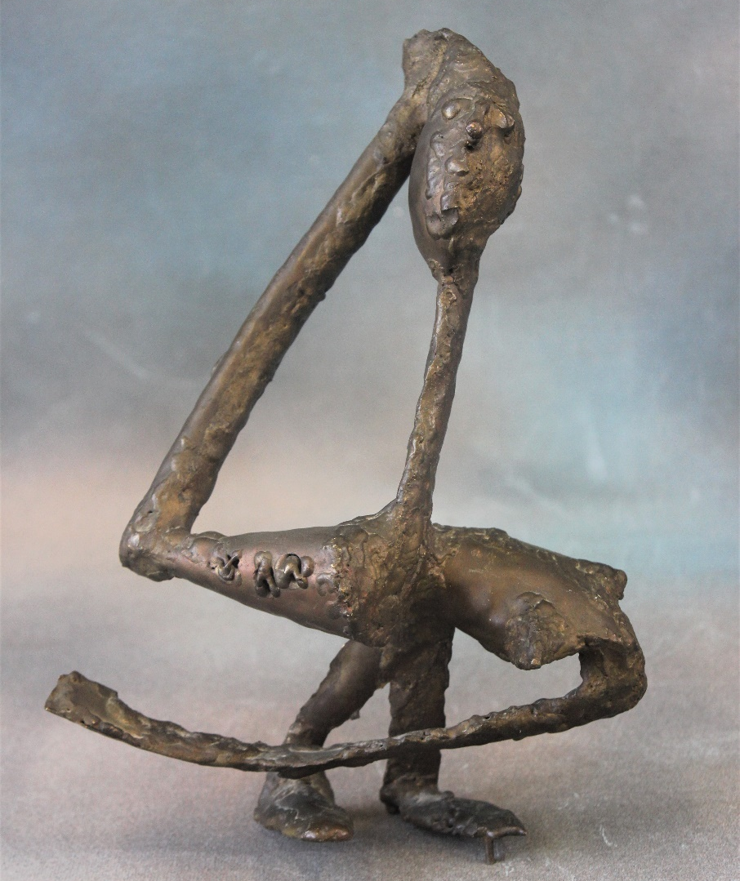 | Lot 3
4. | A Sitzendorf porcelain figure of maiden as shepherdess, 15cm high, slightly a.f., and two Royal Doulton figures "Noelle" HN2179 and "Autumn Breezes" HN2147, 18cm and 19cm, respectively (3). | £25-£35
5. | A 20th century mahogany stick barometer of 19th century style, with bone dial, retailed by "I. Blatt of Brighton", 89cm long. | £80-£100
6. | Wendy Pawley- "Kamilaroi County" mixed media of An Australian Aboriginal scene, on fabric, Bulurru Published, 41cm x 52cm in modern steel frame. | £60-£80
7. | 19th century station type mahogany time piece, white enamelled dial, 50cm high, no pendulum. | £80-£100
8. | A pair of small bulbous satsuma ware vases, decorated birds and foliage on orange ground in the Taizan Yohei style each 12cm high, one chipped. | £80-£100
9. | A late Victorian Doulton Lambeth jardinière, circa 1880, 18cm high cracked, two Neale and Co style pottery figures of cobbler and his wife, 17cm high, a.f., and two brown pottery ale jugs, pewter covers missing (5). | £30-£50
† ARR will be subject to additional fees. See last page for more details.

10. | After A. Giannelli- Resin bust of Beethoven on marble base, 13cm high, and a further figure in standing pose, 15cm high (2). | £30-£50
11. | A Victorian silver-plated tea and coffee set, a pair of sugar tongs, and a bone handled and silver plated crumb scoop (6). | £40-£60
12. | A 20th century opium pipe, with blue and white porcelain elephant head bowl, and copper stem, 18cm long, and a corkscrew with resin scrimshaw style handle (2). | £20-£30
13. | Two albums of picture and greetings card, various, including views of Hythe, and Folkestone, Kent, along with other locations and various subjects to include shipping, comedy, advertising and other subjects, approx. 293 cards (293). | £180-£220
14. | A late Satsuma ware vase, decorated figures in landscapes, dark blue and gilt ground, 33cm high. | £40-£60
15. | A Doulton Lambeth stoneware ale jug, decorated in relief with hunting and tavern scenes, silver mount, London 1899, 19cm high. | £40-£60
16. | A 20th century famille vert style case, with rabbit form handles decorated figural panels and stylized birds, 35cm high. | £80-£100
17. | A part set of bone handled fish knives and forks in case, a silver-plated fish knife and fork, and a pair of fish servers in same case (14), together with a silver-plated spill vase, a.f. (15 altogether). | £20-£30
18. | A Victorian simulated coromandel lady's vanity box, with fitted interior containing glass jars and boxes with silver plated covers and mixed manicure tools, together with secret drawer containing a small oval locket, a cameo brooch, two photographic society medallions, a memento mori woven hair bracelet and other decorative objects, including a 9ct gold lapel pin, 31cm wide, circa 1866. | £250-£350
19. | A Bavarian porcelain wall plate, central transfer printed panel "Venus" after Angelica Kauffman 25cm in diameter. | £20-£30
20. | A Wedgewood Florentine Arras pattern part afternoon tea set, 32 pieces. | £40-£60
21. | A Minton Cockatrice pattern part afternoon tea set, approx. 44 pieces. | £40-£60
22. | A gold-plated and stainless-steel lady's quartz wristwatch with black circular dial with bar movement, and date at six o'clock, no. 0200M and 001-459, in box. | £60-£80
23. | A resin ring, with portrait of lady to centre. | £20-£30
24. | A George III mahogany secretaire chest, the top drawer with fitted interior and fall front above three long graduated drawers with decorative brass handles on bracket feet, 93cm wide. | £150-£200
25. | A bottle of "Glenkinchie" ten year old single malt whisky in box, level low neck. | £15-£20
26. | A bottle of "Crystal Louis Roederer" rose champagne 1983 in box, sediment in bottom of bottle. | £20-£30
 | 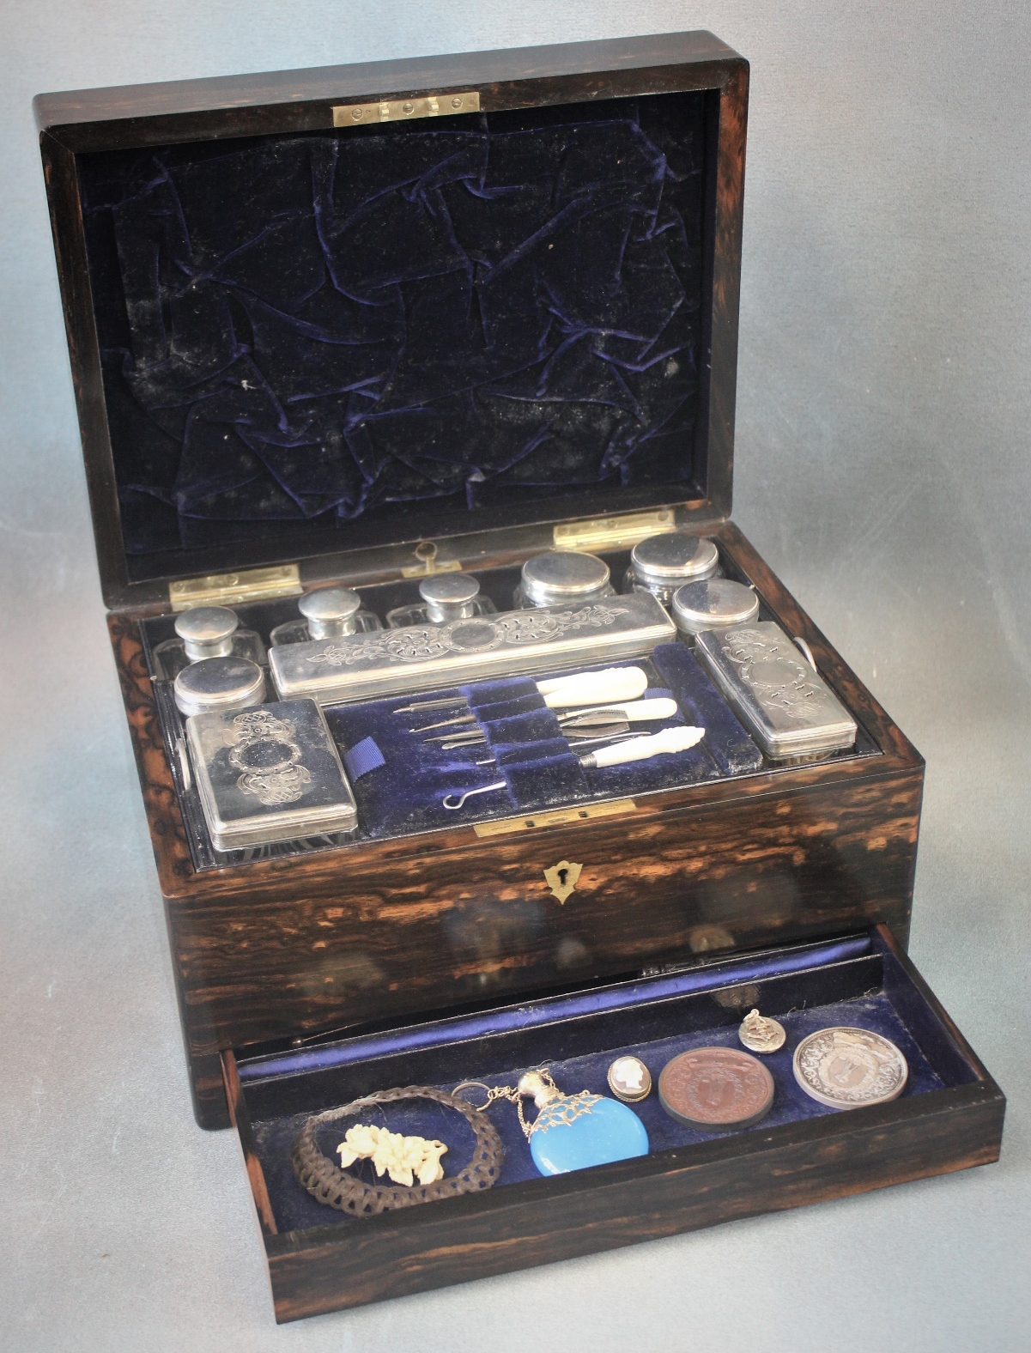 | Lot 18
27. | A large brass and mesh fender form fire guard, 124cm wide. | £40-£60
28. | An Armand Maiselle bisque head baby doll, mould number 351/2.5 K composition body, 33cm long, a.f. | £60-£80
29. | Two gilded spelter figures of stylised soldiers on black slate and marble bases, each repaired and restored, 46cm high (2). | £40-£60
30. | A teak refectory style dining table of continental style, on triple turned end supports, scrolled trestle feet, united by stretchers, the top 91cm x 183cm, restored. | £80-£100
31. | A printed silk scroll panel, the farewell speech of King Edward VIII 11th December 1936, 48cm x 49cm, a.f. in places. | £20-£30
32. | A small brass and leather three draw telescope, 39cm long, extended, and a small pair of opera glass type binoculars, a.f. (2). | £30-£50
33. | Four albums of photographs, postcards, cuttings, and ephemera, relating to Captain Bowyer, a trinity house pilot, showing images of various ships, including the "Majestic", the French liner "Atlantique", on fire, "HMS Montague", together with dinner menus, photographs, and postcards, a.f. (4). | £150-£200
34. | Carl Stringfellow (Australian b. 1954) - "Water Birds A295", inscribed verso, oil on board, signed, 50cm x 60cm. | £100-£150
35. | A pair of English pottery "Nanking" vases, decorated flowers, one with cover, the other repaired, 52cm high, one a.f. (2). | £20-£30
36. | A pair of Dresden style vases, decorated in the Vienna manner, with figural and foliate panels, together with covers, each 28cm high. | £40-£60
37. | A Victorian pottery part fruit set, in Imari colours, a large oval meat plate and a Royal Doulton pixie pattern plate (13 pieces). | £20-£30
38. | A late Regency rosewood fold over swivel top card table, 93cm wide. | £150-£200
39. | A late Regency mahogany bow fronted chest of two short and three long drawers 153cm wide. | £80-£100
40. | After Lionel Edwards- Hunting scene lithograph, 35cm x 51cm, a small watercolour of Chipstead, and three Paul Henry prints (5). | £30-£50
41. | Four paperknives and a crocodile figure, and a mother of pearl paper knife (6). | £60-£80
42. | A small mahogany open bookcase. | £40-£60
43. | A Royal Doulton figure of a Pekinese dog, 10cm long. | £10-£20
44. | A Noritake Deloraine pattern combination set, approx. 115 pieces. | £80-£100
45. | A Victorian light oak bookcase cabinet, 104cm wide x 222cm high. | £80-£100
46. | Two cobra skin handbags. | £30-£50
47. | After James Pollard- two racing prints, and five interior prints (7). | £30-£50
48. | A quantity of general paintings and prints to include works by C.N. Tay "Behind Bars", works by African artists and others, together with two Gaugee prints, six modern Japanese silk prints and four prints of old Dublin (19). | £50-£80
49. | A large silver-plated gravy boat, a two handle oval dish, a small ice bucket, circular dish, two pepperettes, and other small pieces. | £80-£100
50. | A leather covered crucifix with figure of Christ, in cast metal, contained in lancet shaped box, bears a trade label "Tancredi, Roma", 20cm long. | £60-£80
51. | A 19th century boxwood and ivory ring flute, with eight brass keys, by " D'almaine and Co, Late Goulding and D'almaine, Soho Square", 65cm long. | £200-£300
 | 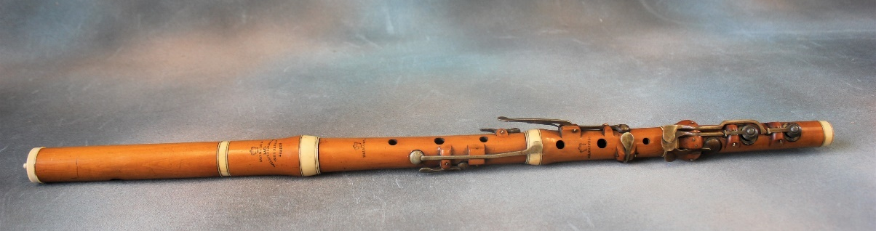
 | 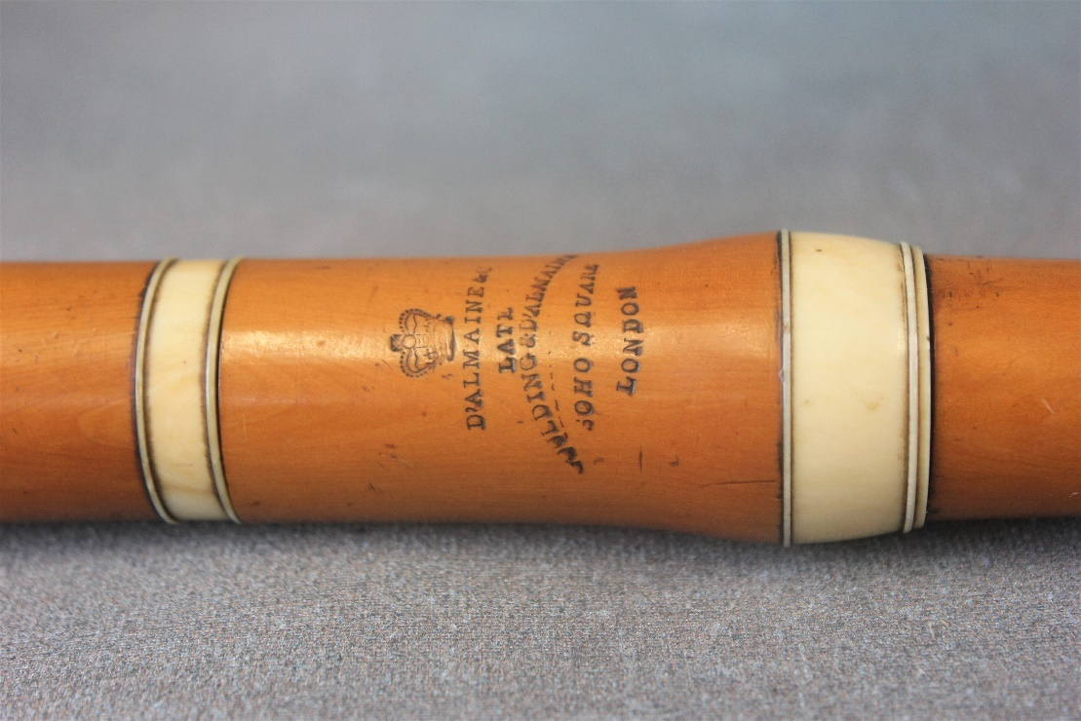 | Lot 51
52. | An early 20th century Francois Borgel 18ct Gold Trench Wristwatch, white enamelled dial, with Arabic numerals, case marked F.B., and bears a date letter similar to Sheffield 1919, but no import mark, case no. 113708, on leather strap. | £300-£500
53. | A 19th century Renaissance style circular shield, with relief decoration depicting the battle of Marathon in 490 BC, 56cm in diameter. | £150-£200
54. | Four crystal glass wine glasses on silver plated stems and feet, six small brandy glasses with etched decoration of steeplechasers, a set of six bamboo decorated beakers, a decanter and stopper together with other drinking glasses (35). | £30-£50
55. | A single volume of the "Illustrated London News Record" of the Transvaal War, 1899-1900, a.f. | £30-£50
 | 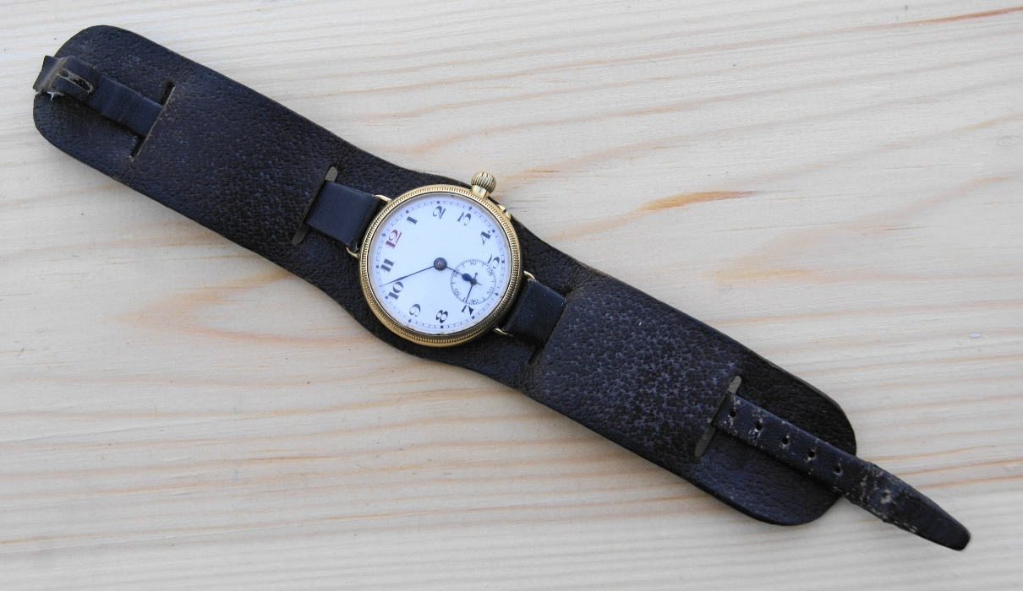 | Lot 52
56. | A Victorian mahogany dining table, with rounded corners, on carved and octagonal turned legs and large porcelain castors, formerly having wind-out action, 105cm x 151cm together with a set of six late Victorian dining chairs with carved top rails (7). | £250-£350
57. | A pair of 14K white gold hoop style earrings, set black and white diamonds, approx. .34 and .33ct, overall. | £200-£300
 | 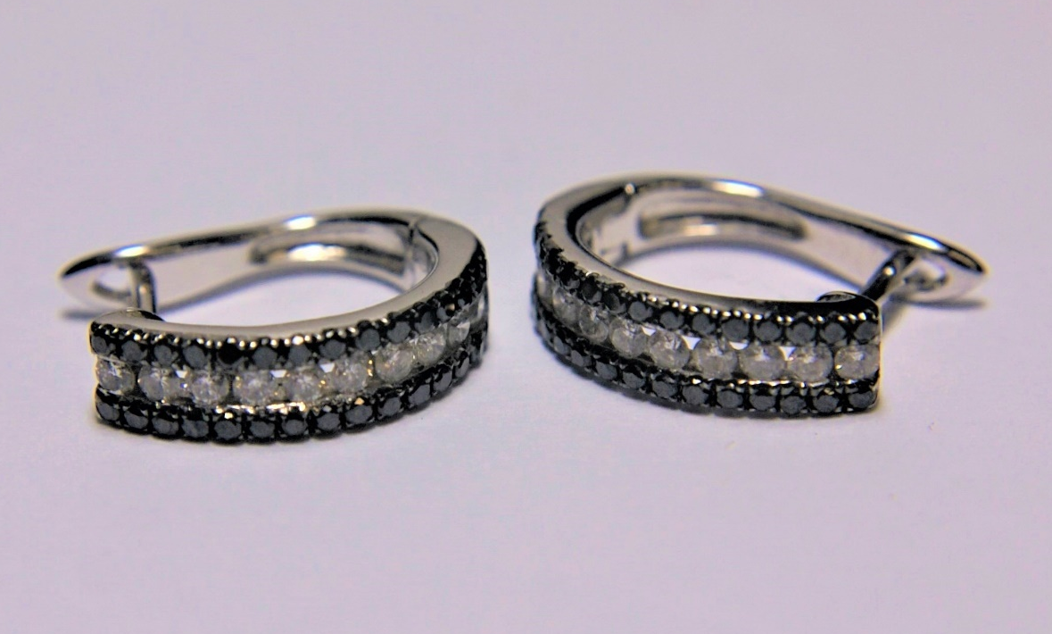 | Lot 57
58. | A pair of 18ct gold diamond shaped and pierced earrings, each 2.5cm long, approx. 6g. | £100-£150
59. | A David Andersen silver gilt and green enamelled bracelet with rectangular and square panels, 20cm long, boxed. | £150-£200
 | 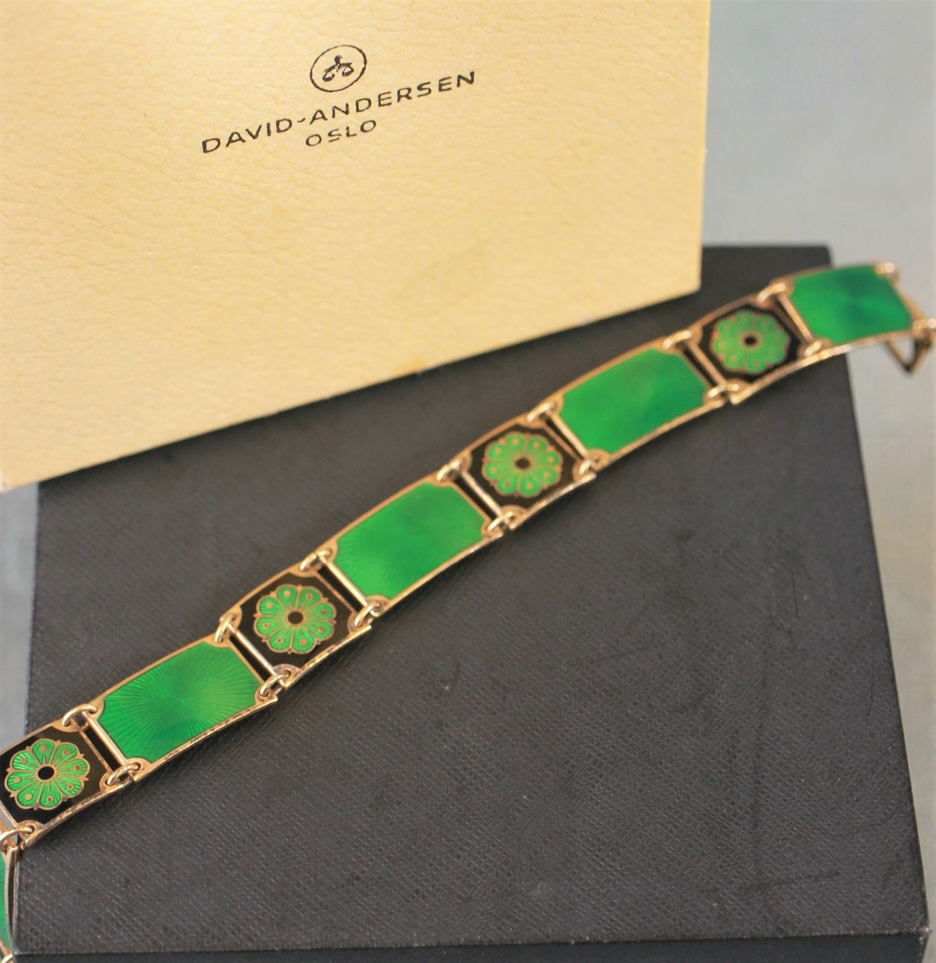 | Lot 59
60. | A gilt metal Joseff of Hollywood flowerhead and hummingbird brooch, with central cabochon stone, 7cm in diameter, in unassociated box. | £20-£30
61. | A silver gilt brooch and earring set of half moon design, London 1995, boxed. | £30-£50
62. | A pair of Norwegian silver and enamelled mushroom shaped pepperettes, marked for Norsk Sølvvareindustri AS Oslo, each 4.5cm high, approx. 1.25oz, (2). | £30-£50
63. | An open faced keyless wound pocket watch, white enamel dial in white metal case, 6.5cm in diameter. | £40-£60
64. | A small silver bowl with scrolled edge, hallmarked for London (rubbed) a silver mustard pot, with spoon, Sheffield 1918, and an open silver George II salt, London 1758, approx. 6oz (3). | £120-£180
65. | A pair of Irish George IV silver sugar tongs, Dublin 1826, a silver crested spoon "Bellingham Bowles Club" Birmingham 1932, and a silver coffee bean spoon, Birmingham 1933, approx. 2.25 oz. | £40-£80
66. | A continental porcelain jardinière painted with decorative panels, heads of Egyptian style women, on orange ground, with black and gold highlights, 24cm high. | £30-£50
67. | A "Turn of Vienna" pottery vase, pale green ground decorated flowerheads and foliage, 34cm high, slight repair to neck rim. | £20-£30
68. | A pair of small Cantonese vases, with figural and foliate panel decoration, each 20cm high, a.f., and a small covered pot, 6.5cm high, several small chips to cover (3). | £40-£60
69. | A small Cantonese porcelain slender neck vase, with figural and foliate decoration, 11cm high, six Japanese sake cups, a miniature blue and white vase, two blue and white spice jars, one cover missing, and three carved hardwood stands (13). | £30-£50
70. | A Korean style pottery vase, decorated in blue on hardwood stand, fitted as a lamp, 34cm high. | £60-£80
71. | A small silhouette of man in top hat, 19th century style ebonised frame, 13cmx 11cm. | £40-£60
72. | A pair of purple and black slag glass ribbon type plates, a tea mixing bowl, a vase, a beaker, and a frosted glass shallow dish, decorated birds (6). | £40-£60
73. | A small pair of small orange glass vases, with gilt decoration, each 12cm high, a pair of ruby red floral decorated jars and covers, each 17cm high, and a gilt decorated glass pot and cover (5). | £50-£70
74. | A pair of cut glass ceiling bowls, with gilt metal and brass fittings, each 16cm in diameter (2). | £40-£60
75. | A leather Gladstone bag, with lined interior, 42cm long. | £40-£60
76. | A 20th century leather suitcase, the Chinese made lock stamped H.C., black striped decoration, 61cm wide. | £40-£60
77. | An oval form tin hat box, 39cm wide. | £40-£60
78. | A milliner's wooden hat stand for a bowler hat, 38cm high, together with three stained beech and other wig or hat stands, mixed sizes (4). | £40-£60
79. | A gilt lacquered and floral painted oval trinket box, 11cm wide, together with a pair of Art Deco style oak bookends (3). | £30-£50
80. | A crochet edge tablecloth or bedspread approx. 184cm x 246cm, in unassociated bag, | £30-£50
81. | A "Burroughs" 81 button calculation machine, serial number S 490 879, possibly a model 5205, 24cm x 29cm. | £40-£60
82. | An Edwardian inlaid mahogany pot cupboard, adapted from a wind-up gramophone cabinet, on square tapering legs, with spade feet, 43cm wide. | £50-£70
83. | A silver pendant brooch, and earrings by Sue Wainwright, London 2017, a pair of American silver-plated ski brooches, two marcasite brooches, an enamelled lizard brooch, a silver-plated butterfly brooch, together with a mixed quantity of costume jewellery. | £30-£50
84. | After Ou Chinin (b1950)- "Peaceful Sleep" chromolithograph, inscribed verso, on label, 90cm x 120cm. | £30-£50
85. | An early 20th century Chinese hardwood and burr veneered cabinet, fitted a door, on block feet, 80cm wide x 124cm high, a.f. | £100-£150
86. | A J. Gooseman 87- Portrait of horse, oil on board, 53cm x 44cm, Patricia Cork- mountainous landscape, oil on board, 40cm x 50cm, after Howard Daniels- coloured print "Aztec Rose" 44cm x 40cm and a Victorian style landscape, oil on canvas (4). | £30-£50
87. | A set of five Victorian rosewood kidney back dining chairs on turned, ringed and lappeted legs. | £60-£80
88. | A modern Chinese style blue and white vase and cover, 37cm high and a delft vase, 34cm high (2). | £30-£50
89. | A Holy Bible "The Gift of Sir John Ferrer to the Parish of Bermondsey", circa 1884-85, together with a mini Webster's dictionary (2). | £30-£50
90. | An Atlas of Female Anatomy, by "Bailliere", sixth edition, card cover, revised by Katherine Armstrong. | £20-£30
91. | Five Liberty style slip-ware pottery plates, each 21cm in diameter, slightly a.f. (5). | £20-£30
92. | An Edwardian inlaid mahogany corner elbow chair, on slender turned legs, united by stretchers. | £20-£30
93. | A George III style mahogany hanging corner cupboard, the panelled door enclosing three shaped shelves, below a blind-fret carved frieze, and dentil cornice, flanked by fluted and canted corners, 67cm x 96cm. | £20-£30
94. | A Victorian mantel clock in ebonised case, with French striking movement, white enamelled dial, 40cm high. | £30-£50
95. | A later model Sindy doll, with a selection of clothes, and three further plastic dolls, with some clothes (4). | £20-£30
96. | A G-Plan "China White" range sideboard, blond oak and painted, fitted six small drawers, above four large drawers, on black stained base, with four legs, 149cm wide, E-Gomme stamp to drawer, a.f. to drawer fronts. | £120-£180
97. | A volume of the Great Exhibition catalogue, 1851, "The Arts Journal Illustrated Catalogue", published by James S. Virtue, London, a.f. | £30-£50
98. | An early 20th century German bisque head doll, mould no.390, by "Armand Marseille" with open mouth, and rolling eyes, composition body, 50cm long. | £40-£60
99. | A.A. Milne- "The House at Pooh Corner" 1928, illustrations by E.H. Sheppard, first edition, with Christmas 1928 inscription. | £80-£100
100. | A stripped pine dresser with plate rack and spice drawers, above drawers and panelled doors, 164cm wide x 193cm high. | £80-£100
101. | A Sindy Doll, with blond hair, based on "country walks" model, with tweed skirt and suede jacket, circa 1963, 29cm long, unboxed. | £40-£60
102. | A German mantel clock, in stained oak and beech case, 40cm high, and a small Vienna regulator type wall clock with musical movement, 62cm high, one a.f. (2). | £40-£60
103. | A Victorian double size brass and oxidised metal bed, 125cm wide, a.f. | £40-£60
104. | After J.M.W Turner- a set of six reproduction coloured prints "The Ports of England Series", each 15.5cm x 22cm, published by Lawrence and Turner (6). | £20-£30
105. | An early 20th century oak sideboard, with carved decoration, on bulbous carved legs, united by stretchers, 152cm wide. | £20-£30
106. | A reproduction mahogany pedestal desk, fitted six drawers, and a panelled door, in partners desk style, 173cm wide x 81cm high x 53cm deep. | £60-£80
107. | An early 20th century oak bureau bookcase, the upper part fitted leaded glass panels, 77cm wide x 164cm high. | £40-£60
108. | A mixed part combination set, by Colclough and Grindley's, in "Sandon" and similar patterns. | £20-£30
109. | A stained wood canteen of mixed table cutlery, 37cm wide. | £30-£50
110. | An Ingersoll "Dan Dare" keyless wound pocket watch, version No. 1, with eagle crest on back of chrome case, 6cm in diameter, including winding crown. | £80-£100
111. | A set of six silver-plated goblets, in lined blue case, and a moulded glass sherry decanter, with silver-plated mount, 26cm high (2). | £20-£30
112. | A Rev. John Brown Family Bible, with black and white illustrations, published by "A. Fullarton and Co, Glasgow". | £30-£50
113. | A late Victorian needlework sampler, by "G. French, aged 12, 1888", 31cm x 19cm, and another sampler of similar date, 16cm x 35cm (2). | £30-£50
114. | An 18ct gold diamond solitaire dress ring, approx. 0.33 carat round cut stone. | £180-£220
115. | An 18ct white gold wedding band, shaped to be connected to a solitaire ring, set tiny diamonds. | £150-£200
116. | A 9ct gold half eternity ring, set fifteen tiny diamonds. | £100-£150
117. | A pair of 9ct white gold earrings, each set a pear shaped aquamarine, and twelve tiny diamonds, in lined box. | £150-£200
118. | A brass oil lamp, in the Middle Eastern style, with snuffers, on circular foot, 62cm high, a brass ladle, and a copper warming pan, with turned wood handle (3). | £20-£30
119. | Art Nouveau pewter candlesticks, a large coffee pot, a hammered tea and coffee set, a cocktail shaker, four glass holders, and other pieces (14 pieces). | £50-£70
120. | A Nauticalia part set of ten hardback books of Arthur Ransome's works, in blue open case, Swallows and Amazons, and Swallowdale missing (10 volumes, two missing). | £100-£150
121. | A late Victorian stripped pine and mahogany dressing table, with two short and one long drawer, on square tapering legs, 107cm wide. | £30-£50
122. | An Art Nouveau style stripped pine and mahogany wash stand, with open shelf above two drawers, on shaped bracket feet, splash back missing, 92cm wide. | £30-£50
123. | A silver-plated punch ladle, a pair of serving spoons, two salts and other objects (13). | £30-£50
124. | A set of silver-plated and bone handled fish knives and forks, a further set, a pair of mother of pearl handled butter knives, all boxed and a further set of fish knives and forks, in card box (4). | £30-£50
125. | A "Paillard" cine projector, in carrying case, a "Pathéscope" projector, 13cm high, together with fifteen pathéscope and Pathé films, on rolls (17). | £60-£80
126. | S.M. Smith 1859- Landscape, with figures, possibly near Sheen, indistinctive description verso, oil on canvas, 28.5cm x 29.5cm. | £80-£120
127. | Keith Burtonshaw 2002- watercolour of fishing boats, with added form of HMS Victory, sailing nearby, letter from "The Nelson Society" and related postcard verso, 36cm x 52cm, together with a print of Wellington, and the 52nd Foot at Waterloo, a print of Napoleon, two prints relating to Nelson's funeral, and a portrait print (6). | £30-£50
128. | A Waterford glass shallow John Rocha fruit bowl, with etched marks, and moulded decoration, 34cm in diameter. | £60-£80
129. | An early 20th century brass and gilt brass piano stool, with circular adjustable seat, by C.H. Hare, patentee, Simplex No. 1644, on four tubular legs, a.f. | £30-£50
130. | A small mahogany work box, no inner tray, 21cm wide, and a small mahogany box, with bone edge to lid, 11.5cm wide (2). | £20-£30
131. | A near full set of Chinese style milk glass lamp bulbs, decorated coloured foliage, some in fitted box, some a.f. (23). | £60-£80
132. | A Continental oval porcelain plaque, painted with a portrait of Lavinia Titian, the artist's daughter, in the Berlin style, 17cm x 12.5cm, in stained mahogany frame. | £100-£150
133. | An early 20th century gilt brass carriage timepiece, gilt dial with silvered chapter ring and Arabic numerals, 11.5cm high, in leather travelling case. | £40-£60
134. | A Queen Elizabeth II silver bottle coaster, Birmingham 1989, a late Victorian silver vesta case, Birmingham 1897, together with a silver-plated pie-crust tray, an ice bucket, two small bowls, mixed spoons, and other objects. | £50-£70
135. | A small Japanese bronze slender vase, with some gilt decoration, 18.5cm high, and a German stoneware beer stein (2). | £30-£50
136. | A Beswick figure of a black panther, on landscaped base, 30cm long, and an Italian pottery figure of a recumbent leopard, 60cm long (2). | £30-£50
137. | A bronze commemorative Israel/Egypt Peace Accord medallion, in olivewood box, a Queen Elizabeth II Silver Jubilee medallion, boxed, two Churchill crowns, boxed, a Mikimoto tie clip, and three pieces of costume jewellery (8). | £40-£60
138. | Five Edwardian glass toilet jars, and boxes with silver covers. mixed dates, a sugar caster, with silver-plated top, and a powder bowl, with enamelled top (7). | £30-£50
139. | Six African carved wood tribal busts, mixed sizes, and a Buddhist carved wood mask (7). | £40-£60
140. | W. Don Campbell (1930-2012) - "Thompson's Gazelle" in landscape, pastel, 46cm x 60cm. | £40-£60
 | 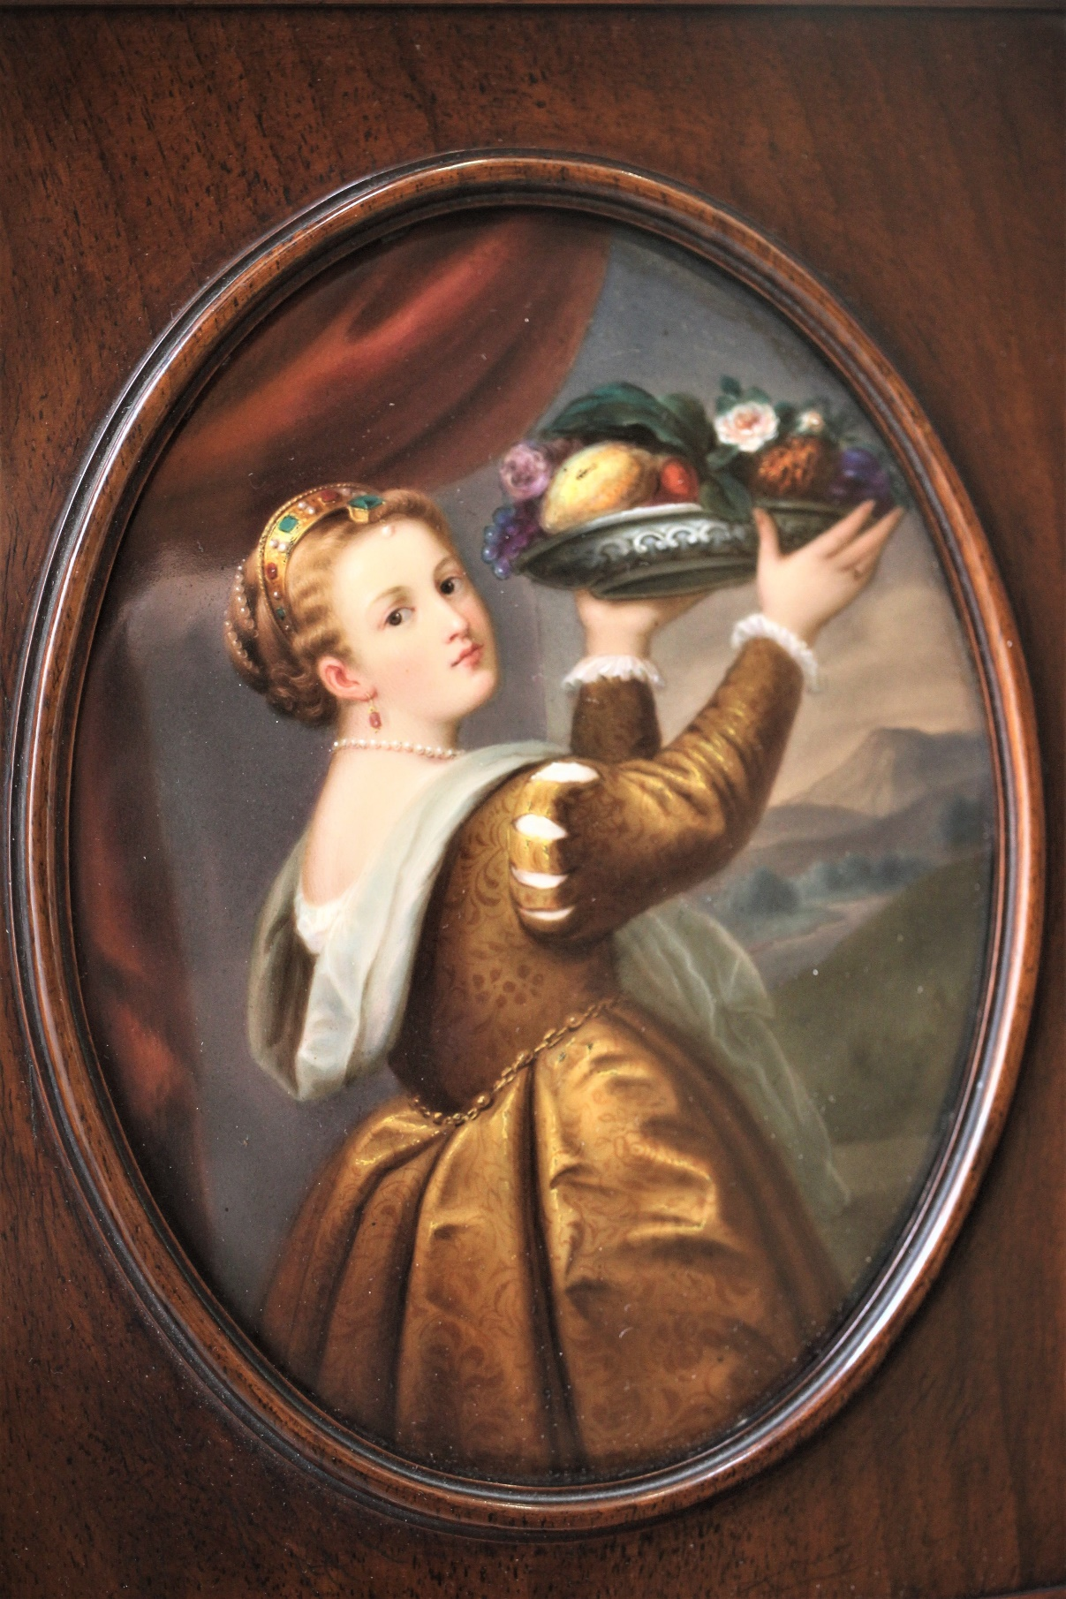 | Lot 132
141. | A small 20th century oak and Dutch Bombe shaped chest of three drawers, on animal feet, 63cm wide. | £60-£80
142. | A fruitwood walking cane, with bone handle and silver-plated collar, 87cm long. | £50-£70
143. | An early 20th century oak grandmother clock, with three train movement, 181cm high. | £80-£100
144. | Six Aynsley & Co rose pattern dinner plates, five dessert plates, and six side plates (17). | £20-£30
145. | A 20th century stained and carved beech three piece Bergère suite, with single caned panels, on claw and ball feet (3). | £100-£150
146. | An Ercol pale elm and stained beech coffee table, 104 cm long. | £30-£50
147. | A walnut kneehole dressing table, fitted five drawers, on oak cabriole legs, and pad feet, 106cm wide. | £40-£60
148. | After Sir Edwin Landseer - "A Distinguished Member of the Royal Humane Society", proof print, and "My Horse", proof print, each 52cm x 41cm. | £20-£30
149. | A quantity of silver-plated horse jumping sports trophies, and a small quantity of pewter ware. | £40-£60
150. | Three small carved wood figures of black forest style seated bears, 7cm to 12cm high, respectively, together with a small figure of a monkey, 8cm high (4). | £30-£50
151. | A mahogany and brass bound writing slope, 35cm wide, a.f. | £20-£30
152. | A late Victorian three-piece silver-backed dressing table set, London 1890 and 1894, respectively (3). | £40-£60
153. | A 9ct gold five stone illusion set dress ring, a solitaire illusion set dress ring, two pairs of drop earrings, and a small quantity of decorative and costume jewellery. | £100-£150
154. | A pair of French made opera glasses, by the Industrial Opera Glass Company, unboxed, and a pair of early 20th century binoculars, in leather case, a.f. | £10-£15
155. | An arts and crafts style diamond shaped wall mirror, in hammered pewter frame, 74cm long. | £40-£60
156. | Two tins containing a mixed quantity of English and foreign coins. | £20-£30
157. | A large quantity of Victorian and later cutlery, jewellery, and watch boxes, including Lotus, Rotary, and Seiko, etc. | £40-£50
158. | A Second World War 100mm shell case, 63cm high. | £20-£30
159. | A large quantity of Royal family, First World War, and later postcards, including George V, George VI, and the current Queen (150+). | £70-£90
160. | An antique Indian metal ware vase, 35cm high. | £20-£30
161. | A Second World War Canadian issue machete, with English steel blade, circa 1940-42, in leather scabbard, 53cm long. | £80-£100
162. | A large quantity of foreign bank notes, including Reich's marks, Vietnamese, Argentinian, and some Armed Forces notes, approx. 115 in an album, and six loose notes. | £30-£50
163. | Two army recruitment posters, 49cm x 75cm, and a Whitbread Brewery poster (3). | £50-£70
164. | Eight Chinese white metal commemorative People's Republic medals, loose (8). | £20-£30
165. | An album of mixed Victorian and later coins, various, including a number of threepenny coins. | £30-£50
166. | Two boxes, each containing two gold and silver-plated commemorative coins, "Expo 2010, Shanghai, China" (2). | £40-£60
167. | A stainless-steel and gold-plated Omega Seamaster wristwatch, with quartz movement, in lined box, no paperwork. | £40-£60
168. | Two Japanese late Satsuma ware pottery vases, decorated priests and battle scenes, approx. 30cm high, and a similar vase and cover, cracked, 40.5cm high. | £70-£100
169. | A Japanese Satsuma Ware two handled vase and cover, decorated figures in landscapes and partly in kakiemon colours, cover cracked, 30cm high. | £50-£70
170. | A Carter Stabler and Adams Poole Pottery biscuit barrel and cover, handle missing, 15cm high, a nut bowl, a floral pattern preserve pot, cover cracked and two unassociated triangular shaped dishes (5). | £20-£30
171. | A pair of Royal Doulton stoneware vases, blue glazes, with heart shaped emblems, 17.5cm high. | £50-£70
172. | A pair of Royal Doulton stoneware vases, with blue and green mottled glazes, and relief decoration of fruit, 24cm high. | £40-£60
173. | A pair of Chinese cloisonne ware vases, decorated in multi colours, 24cm high. | £40-£60
174. | An Edwardian Sheraton revival style kidney shaped writing table, circa 1900, fitted three drawers, with brass knob handles, on x-frame fluted legs, with casters, united by a turned stretcher, 101cm wide. | £100-£150
175. | A mahogany scroll end window seat, with pink foliate and floral upholstery, on moulded square taper legs, 112cm wide. | £40-£60
176. | A 20th century circular mahogany occasional table with a Limoges enamelled hors d'oeuvres set, 44.5cm in diameter. | £80-£100
177. | W.H. Hodges- Cottages with cattle, fowl and cow herder, watercolours, a pair, 26cm x 21cm. | £40-£60
178. | H. Parkinson 1895- village scene with cottages and figures, 24cm x 35cm, watercolour, and an East Anglian scene, with sailing boat, watercolour 16cm x 24cm, unsigned (2). | £30-£40
179. | H.T. 79- village scene with cottages, church and shepherd, watercolour, 21cm x 45cm, faded, and a pair of small English school watercolours, rural scenes with cottages, 16cm x 24.5cm (3). | £40-£60
180. | W.T., 1870- a pair of Scottish loch scenes with boats and figures, watercolours, one initialled and dated, 20cm x 31.5cm and E. Hollyoak, village church in landscape, watercolour, 19.cm x 25cm (3). | £40-£60
181. | Late 19th century school-engraving of shell species, 23cm x 13cm and a butterfly print, 23cm x19cm (2). | £20-£30
182. | A. Tozzoni- "Fishing boats on the Nile", watercolour 14.5cm x 25cm. | £40-£60
183. | A. Clint 1860-Cottage with horse tethered and small barrel wagon nearby, watercolour, 22cm x 30cm and John Baragwanath, village scene with ducks, watercolour, 19cm x 25cm (2). | £40-£60
 | 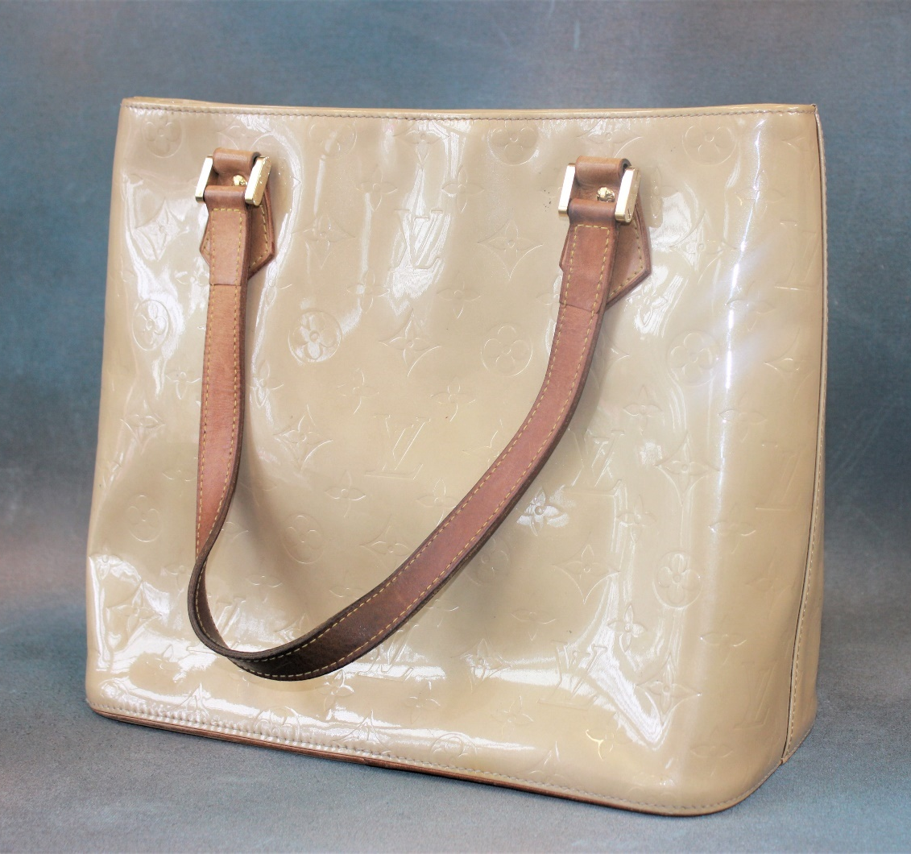 | Lot 186
184. | A small Tunbridge Ware backed clothes brush, decorated flowers and foliage, rounded ends, 11cm long together with an ebonised hand mirror, and a small hobnail cut glass toilet box, silver cover, Chester 1913 (3). | £20-£30
185. | Arnold Axon 1982- "The Veil Dancer" inscribed on label on base, a carved elm figure in dancing pose, 44cm high, signed stud to base. | £80-£100
186. | A Louis Vuitton gold monogram Vermis Houston handbag, LM0012, 29cm wide x 25cm high. | £200-£300
187. | An Emilio Pucci purple handbag, 40cm wide x 60cm high. | £80-£100
188. | A Solomon Islands 25 Dollar gold plated Spitfire coin, 2005, a ditto ME262 coin, a ditto AV8-B Harrier coin, an AN-225 coin, a Wright 1903 Flyer coin, a ditto China Clipper coin and a Queen Elizabeth and Prince Philip diamond wedding anniversary coin, all in plastic cases, in a presentation box, no certificate. (7). | £120-£180
 | 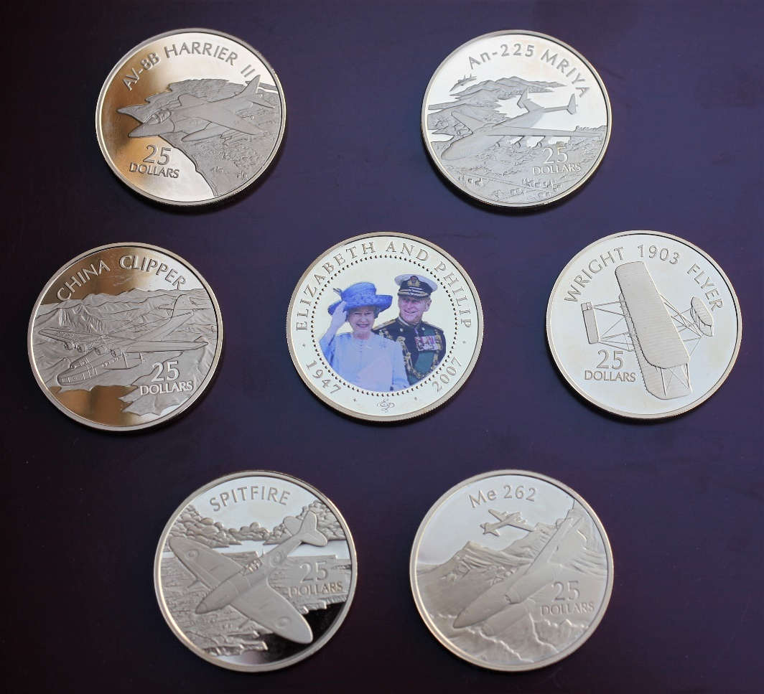 | Lot 188
189. | Six Solomon Islands silver-plated Fighting Ship's Series twenty-five Dollar coins, 2005, a Nations touch five pound coin, 2009, a 100 Years of Naval Aviation five pound coin, two further five pound coin, two Britannia two pound coins, 2006 and 2008, and two further coins, in hard and soft plastic cases, in a presentation box, no certificates (14). | £100-£150
190. | A wood and leather bound shooting case, with part fitted interior, and brass bound corners, the top embossed/stamped J.S Ward, the Ryle Brigade", 48cm wide, a.f. | £30-£50
191. | A post war alloy fishing reel by "A. Carter & Co Ltd of London", in unassociated box, a "Furlow and Company Holdfast" fishing reel, unboxed, three further unboxed fishing reels, a small gaff, a small pair of pliers, a brass net winder and some accessories. | £70-£90
192. | An alloy fishing reel by "The Helical Casting Reel Company Reddich" a "Four Brothers" fishing reel, an "Oreno" casting reel, no 1000A, in a Hardy Brothers box, together with a brass gaff, two tin fly boxes, a small quantity of fishing line and other accessories. | £100-£150
 | 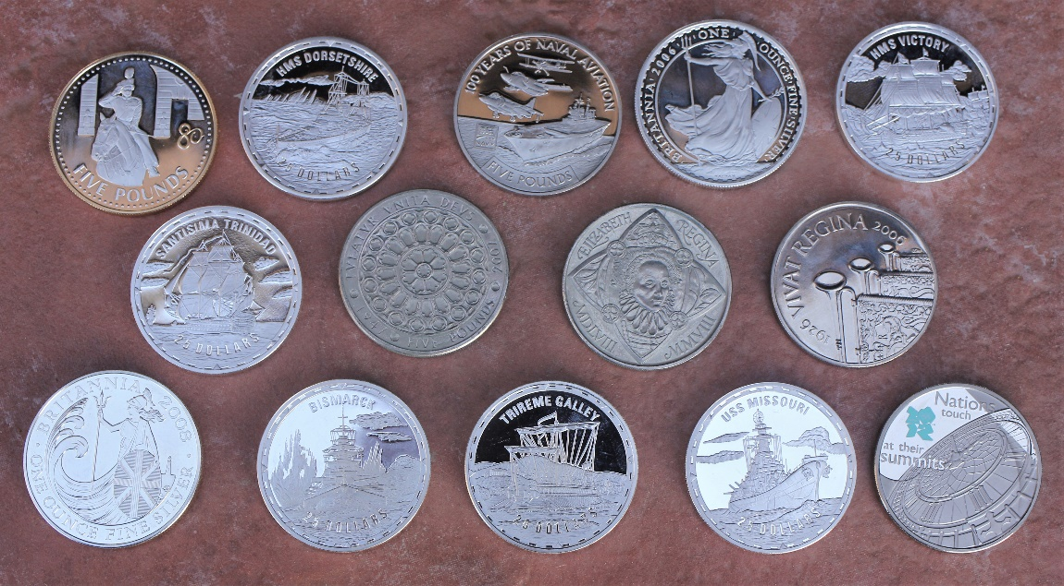 | Lot 189
193. | An alloy "Hardy's Patent Uniqua" fishing reel, 8cm in diameter, unboxed, a Hardy Brothers Mark II duplicated reel and a handy oiler bottle (3). | £70-£100
194. | A "Hardy Perfect" fly fishing reel, approx. 3.5 inches, with ebonite handle, 9cm unboxed. | £60-£80
195. | A Hardy Brothers alloy "St. John" fishing reel approx. 3.8 inches, in earlier Hardy Brothers box, 10cm in diameter. | £80-£100
196. | A Hardy Brothers brass fishing reel, unboxed, 6cm in diameter and a further un-named brass fishing reel, unboxed, 6cm in diameter (2). | £80-£100
197. | A pair of George III style upholstered side chairs on square chamfered legs united by stretchers slight camel back tops. | £80-£120
198. | A reproduction mahogany bow and breakfront pedestal sideboard with some gilt decoration on carved claw feet, possibly of Chinese manufacture, 209cm. | £80-£100
199. | An Edwardian inlaid mahogany dressing table with swing frame mirror on square tapering legs, 197cm wide. | £30-£50
200. | A reproduction mahogany circular top breakfast table on quadruped base, 130cm in diameter. | £40-£60
201. | An oval hammered pewter tray "Hutton of Sheffield" 45cm wide, a hammered pewter tazza 28cm in diameter, together with a number of tankards, a tea pot and a part tea set (14). | £50-£70
202. | A George III mahogany chest of two short and three long drawers, with satin wood banded top, and boxwood and ebony inlaid decoration, brass pierced plate handles, on ogee bracket feet, 81cm wide. | £200-£300
203. | A Regency mahogany sarcophagus shaped tea caddy with glass mixing bowl on bun feet 32cm wide. | £60-£80
204. | A 19th mahogany cellarette with crossbanding and inlaid with stringing, part fitted interior on inlaid stand with square tapering, legs 51cm wide. | £300-£400
 | 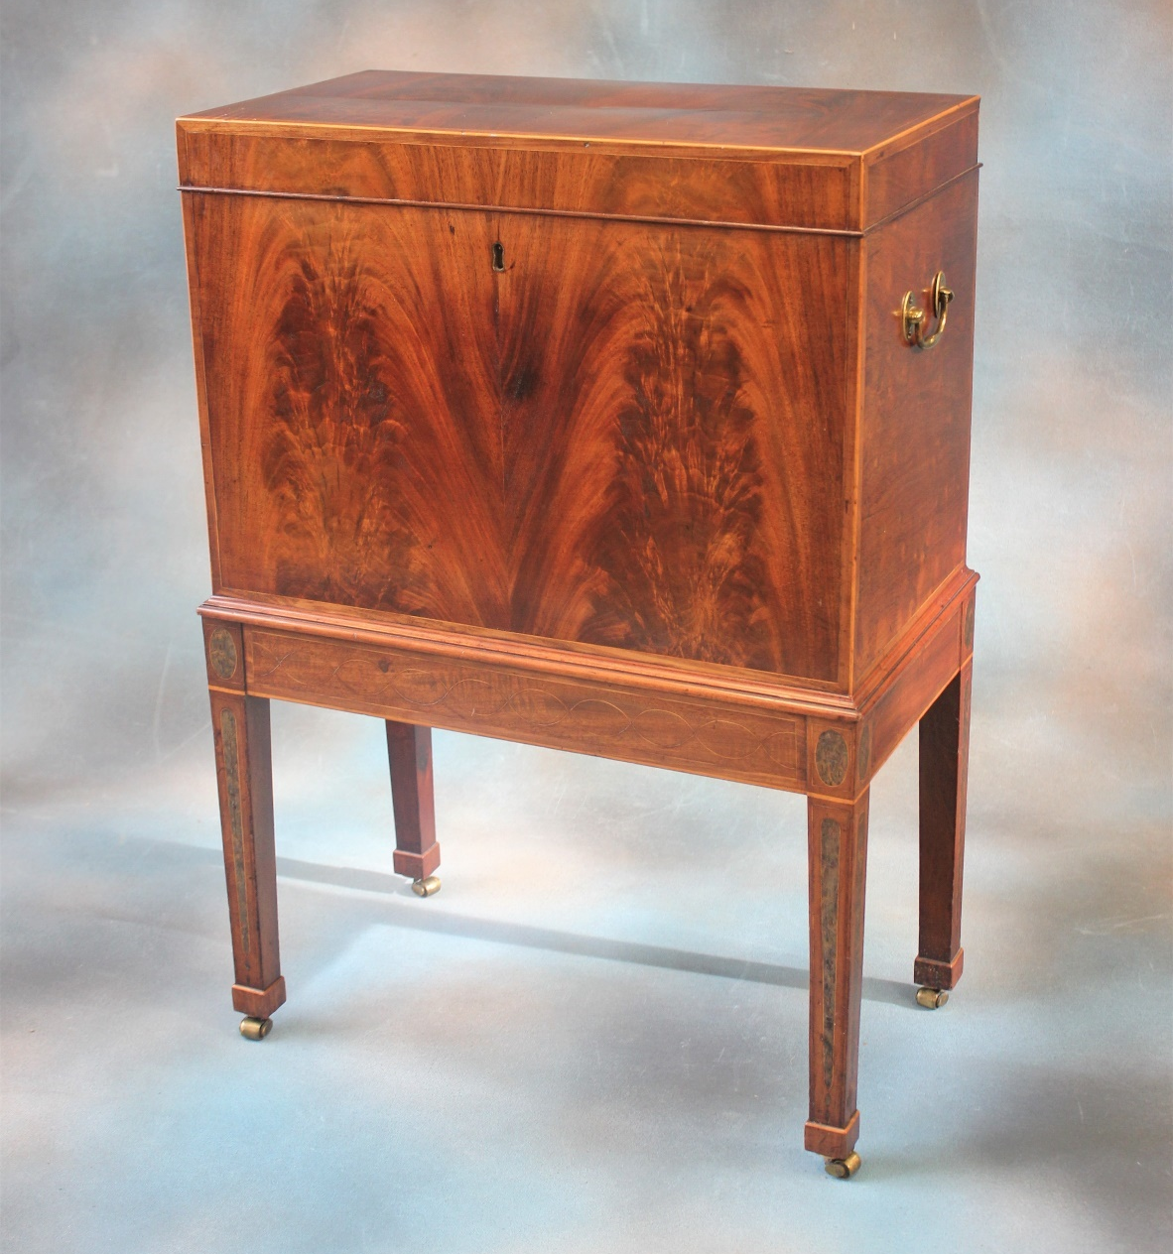 | Lot 204
205. | A Regency mahogany corner washstand fitted drawer and two false drawers on square slightly splayed legs, 59cm wide. | £30-£50
206. | A pair of Chinese hardwood occasional tables, 38cm x 46cm. | £100-£150
207. | A nest of two Chinese hardwood occasional tables on turned and carved legs, 60cm wide. | £100-£150
208. | A George III inlaid mahogany octagonal wine cooler with brass banding on stand with four square tapering legs, one castor missing and a.f. to interior, 43cm in diameter. | £150-£200
 | 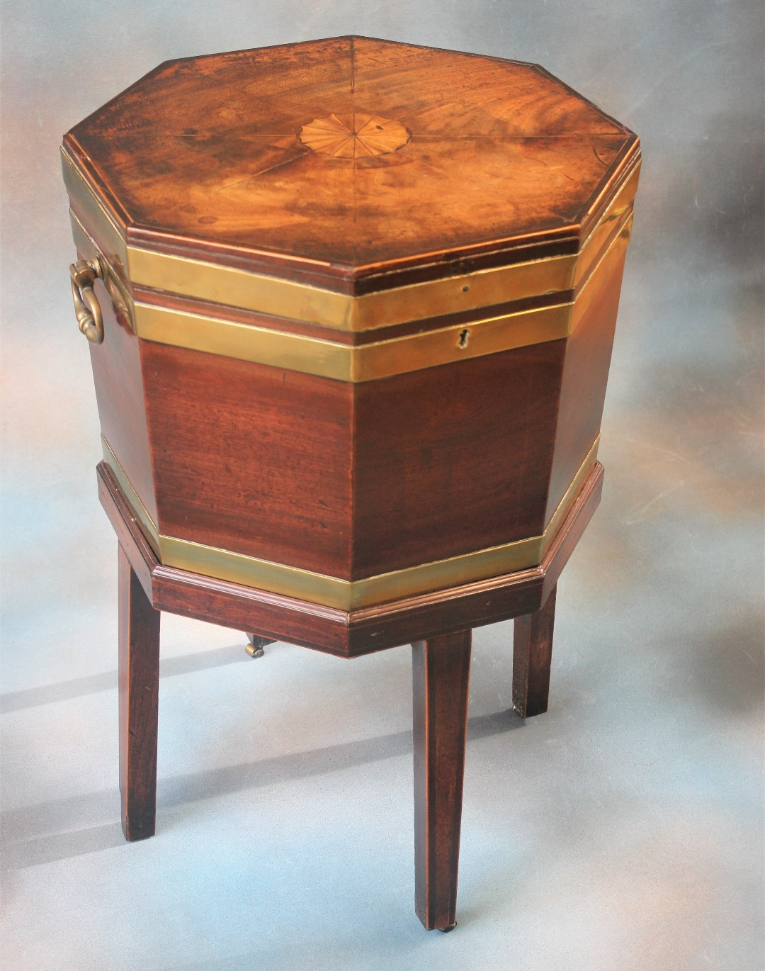 | Lot 208
209. | A small Murano millefiori style glass paperweight, a French style egg shaped paperweight, two glass dump weights, other weights various and a glass lamp extinguisher (13). | £100-£150
210. | A 20th century Lalique Hedera pattern vase, etched "Lalique, France", 18cm high. | £200-£300
211. | A late 19th/early 20th century mahogany mantel clock silvered dial, German striking movement, 38cm high. | £200-£300
212. | A George III mahogany serpentine fronted fold over swivel top card table with gateleg action on square reeded tapering legs, 87cm wide. | £150-£200
213. | A reproduction mahogany twin pedestal dining table with extra leaf, 86cm x 211cm, extended, together with a harlequin set of eight George III and later Chippendale style dining chairs (9). | £150-£200
214. | A George III mahogany wash stand on square tapering legs, 37cm wide. | £30-£40
215. | A 19th century mahogany d-end dining table on square tapering legs and spade feet, with extra leaf, 104cm x 149cm, extended and a set of five George III style dining chairs, with shaped splats, together with three further dining chairs with pierced splats (9). | £200-£300
216. | A late Victorian three piece silver tea set, London 1894, approx. 27oz. | £250-£350
217. | A late Victorian silver bachelors tea set, London 1893, approx. 11oz. | £150-£200
218. | A George V silver two piece part tea set, Sheffield 1910, and a late Victorian silver caddy, London 1888, approx. 30oz. | £300-£400
219. | A set of Georg Jensen silver fish knives and forks, import marks for London 1922, approx. 18oz (12). | £220-£240
220. | A Victorian silver card case, Birmingham 1852, a Victorian three piece Christening set, in box, a set of six enamelled silver coffee spoons, Birmingham 1959, boxed. | £80-£100
221. | A late Victorian silver sweetmeat basket, Chester 1895, and an Elizabeth II silver cigarette box, 1963, approx. 3.5oz weighable. | £50-£70
222. | A mixed quantity of small silver objects, including bonbon dishes, napkin rings, ashtray, a sugar bowl, dressing table pieces etc, mixed dates, approx. 34 pieces. | £200-£300
223. | An oak canteen containing mixed cutlery, a small canteen containing mother of pearl dessert knives and forks, and an oak and silver-plated oval tray (3). | £60-£80
224. | An oval silver-plated entrée dish, a circular dish and cover, two sauce boats, a pair of fish servers, boxed, together with a sugar castor, small pair of candlesticks, cutlery and other pieces. | £80-£100
225. | A George V silver column form candlestick, Sheffield 1930, weighted base, and a silver-plated column form table lamp base, 30cm and 45cm, respectively (2). | £40-£60
226. | A Minton Greenwich pattern part tea set, 23 pieces and a Minton salt glaze jug (24). | £30-£50
227. | A number of Halcyon Days and Bilston reproduction enamelled pill and patch boxes, together with some small porcelain boxes and covers (14). | £40-£60
228. | An 18th century style oak dresser base, fitted six drawers and two panelled doors, on bracket feet, 150cm wide. | £200-£300
229. | A Wedgwood part combination set, green border with gilt edging, approx. 70 pieces. | £80-£100
230. | An Edwardian inlaid mahogany bureau bookcase, 76cm wide x 222cm high. | £80-£100
231. | A quantity of Dresden floral pattern china, some pieces matching including teacups and saucers, coffee cans, a teapot, a powder bowl and cover, hors d'oeuvres dishes, and other pieces, approx. 34. | £200-£300
232. | A late 19th or early 20th century inlaid rosewood mantel clock, with French striking movement, 30cm high. | £200-£300
233. | A George III mahogany chest on chest, of two short and six long drawers, pine sides below a dentil cornice on bracket feet, 114cm wide x 180cm high. | £200-£300
234. | A small gilt frame pier glass type wall mirror, 38cm wide x 85cm high. | £80-£120
235. | A Rockingham style teapot, a slop bowl and cover, bread and butter plate, four mixed cups and saucers, together with some Copeland Spode fruit plates and dishes, 27 pieces. | £50-£70
236. | Four glass candlesticks, 19cm high, two glass mallet form decanters, two glass bowls and two tall spill vases (10). | £20-£30
237. | A quantity of mixed drinking glasses, together with eight ruby tinted wine glasses. | £30-£50
238. | A reproduction walnut bow fronted chest of four long drawers, with brushing slide. | £80-£100
239. | After T. Cruickshank- set of eight engravings "The Drunkard's Children" 27cm x 36cm, and an Italian engraving of Florence (9). | £80-£100
240. | Two mahogany bedside tables, the legs united by under-tiers 50cm wide. | £60-£80
241. | A 19th century mahogany chest of two short and three long drawers, on ogee bracket feet, 122cm wide. | £80-£100
242. | An Edwardian inlaid mahogany linen cabinet, fitted two doors above a drawer, on ogee bracket feet, 61cm wide. | £30-£50
243. | An Edwardian inlaid mahogany dressing table fitted five drawers on turned and reeded legs, 106cm wide. | £60-£80
244. | A Regency inlaid mahogany oval swing frame toilet mirror, the bow fronted base fitted three drawers, 40cm wide. | £40-£60
245. | A George III oak bureau, the fall front above four long drawers, on bracket feet, 91cm wide. | £60-£80
246. | An Edwardian inlaid mahogany swing frame toilet mirror, with straight front base, 36cm wide, and a dressing stool on cabriole legs (2). | £40-£60
247. | A mahogany urn stand, on four tapering legs, 30cm wide, and a dressing stool on cabriole legs (2). | £30-£50
248. | A mahogany work table, adapted from a bidet, 50cm and a small wine table (2). | £20-£30
249. | A 19th century inlaid mahogany drop leaf work table, fitted two drawers on turned legs, 102cm wide, extended. | £100-£150
250. | A small Chinese hardwood cabinet, 74cm wide. | £80-£100
251. | A Victorian mahogany, later upholstered, blanket box, 107cm wide. | £30-£50
252. | A Regency mahogany and satinwood crossbanded d-shaped card table on four square tapering legs, with spade feet, 92cm wide. | £150-£200
253. | A small stained wood display cabinet, fitted two glazed doors, 75cm wide. | £20-£30
254. | A George III mahogany chest of four long drawers on bracket feet, 76cm wide. | £80-£100
255. | A Victorian nursing chair, on turned and fluted legs, later upholstery. | £40-£60
256. | A Paddington Bear with blue duffle coat and red Dunlop wellingtons, 50cm high together with a Paddington Bear VHS video. | £40-£60
257. | A Hornby O-O gauge "Queen of Scots" A4 class Pullman electric trainset, boxed. | £40-£60
258. | A Hornby O-O gauge Thomas and Friends "James" passenger train set in box. | £30-£50
259. | A model railway layout on board, fitted O-O gauge oval and figure of 8 track, 107cm x 173cm, together with box of rolling stock, a tunnel, a Hornby oast house and other buildings and accessories. | £70-£80
260. | A Samuel Mortlock and Son, bowler hat in plan in plain box and an unboxed Tweedy "Attaboy" waterproof hat, size 6.7 inches | £30-£50
261. | A John Cooper Challenge Scalextric set, no. 2, with advance track system, in box, together with a quantity of spare track. | £30-£50
262. | A "Tonka" tin plate "Might Crane", 43cm log, 57cm high, unboxed. | £20-£30
263. | A scratched built metal open model bus advertising Haig whisky, 41cm long. | £20-£30
264. | An "Ertle" green metal "John Deere" tractor with an agricultural trailer attached, 54cm long, unboxed. | £30-£40
265. | A quantity of die cast toy vehicles, some boxed, including Eddie Stobart lorries, a Tesco lorry, vehicles from Eddie Stobart children's stories together with two DVD's, Jaguar E-Type and Aston Martin D.B.5, approx. 22 pieces. | £15-£20
266. | A quantity of Dinky, Corgi and Days Gone military vehicles, unboxed, approx. 170, a.f. | £70-£90
267. | A quantity of Dinky, Matchbox, Hot Wheels and other toy construction vehicles, unboxed, approx. 65. | £25-£75
268. | A quantity of Days Gone, Lledo, Matchbox and other die cast and plastic vehicles of yesteryear, unboxed, approx. 130. | £50-£70
269. | A quantity of Realtoy, Matchbox, Whizz Wheels and other small diecast and plastic toy fire, rescue and airport vehicles, unboxed, approx. 100. | £40-£60
270. | A quantity of Vanguard, Oxford, Matchbox and other die cast and plastic and ambulance vehicles, unboxed, approx. 60. | £30-£50
271. | A leather bound hunting whip with horn handle and silver collar engraved "J.I.F.K. Clewer Lodge, Windsor", hallmarked London 1899, 80cm long. | £50-£70
Artist Resale Rights
ARR is calculated in Euros. Exchange rates are updated daily.
ARR is cumulative and applies to lots with a hammer over €1000
€0 - €50,000 - 4%
€50,000 - €200,000 - 3%
€200,000 - €350,000 - 1%
€350,000 - €500,000 - 0.5%
€500,000+ - 0.25%
ARR is capped at €12,500

Future Dates

AUCTION DATES

Wednesday 1st December 2021

Our first to be held in the new year will be
Wednesday 26th January 2022.

Viewing on Monday and day before sale from 12.00pm to 7.00pm
and on morning of sale from 9.00am to 10.30am
Sale commences at 11.00 am.

VALUATION DAYS

Wednesday 3rd November 2021

Wednesday 8th December 2021

Sevenoaks Saleroom, Argyle Road,
Sevenoaks TN13 1HJ

11.00am – 4.00pm

271. | 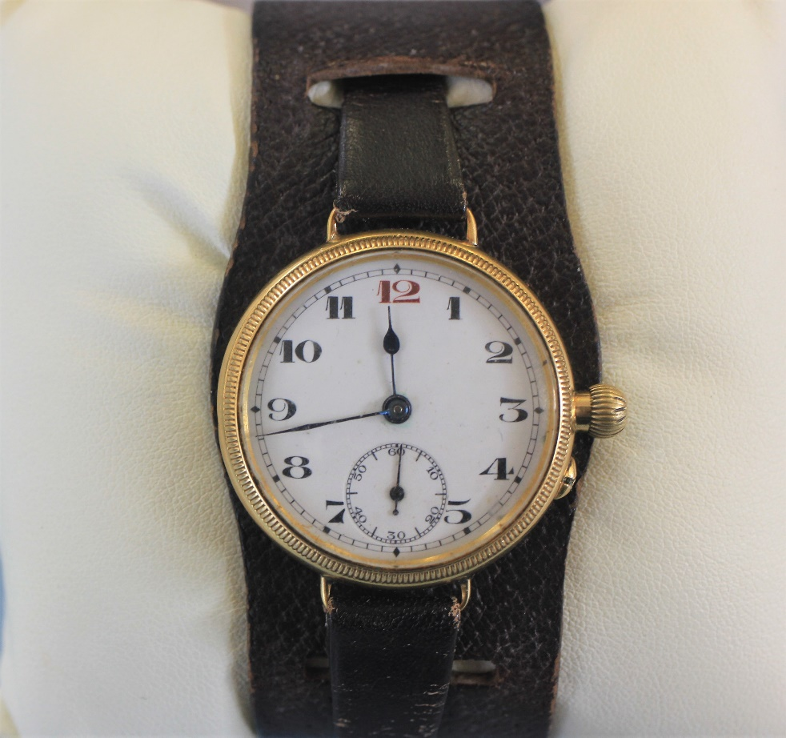 | Lot 52

Notes

