Welcome to Ibbett Mosely Auctions, Wednesday 16th June 2021 Auction Catalogue

This sale will be held online only, at www.easyliveauction.com/ibbettmosely/
please visit the website to register or log in to view and bid.

Alternatively, commission bids (bids left ‘on the book’) may be left with us, as well as a limited amount of telephone bids. Please telephone 01732 456731 or email auctions@ibbettmosely.co.uk for further details.

Due to Covid-19, there is viewing strictly by appointment only. Any walk-ins will not be allowed viewing. The full catalogue, complete with images of each lot and condition reports will be available at easyliveauction.com/ibbettmosely

Please telephone 01732 456731 or email auctions@ibbettmosely.co.uk with any questions.

Collection of items can only take place with prior appointment from 17th June. You are welcome to collect in person, or via your own carrier, but local courier PSP Logistics are available to carry out deliveries of items.
Please contact them directly to arrange and pay for delivery.

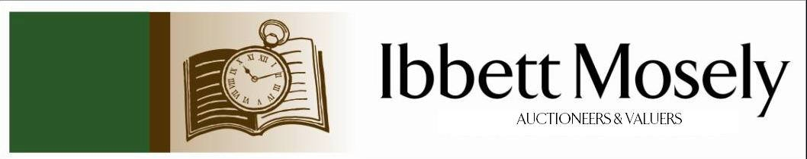

Catalogue of Antique, Edwardian and Victorian
Furniture and Effects
to be Auctioned on

Wednesday 16th June 2021
at 11.00am

IBBETT MOSELY AUCTION ROOMS
ARGYLE ROAD, SEVENOAKS, KENT TN13 1HJ
Via

Viewing at Sale Room on:

Monday 14th June
Tuesday 15th June

Between 10.00am –5.00pm.

STRICTLY BY APPOINTMENT ONLY.
(Limited numbers)

Catalogues: £2.00

Auctioneer and Valuer: Alan White FNAVA
Consultant Auctioneer and Valuer: Derek Hodge
Trainee Valuer and Clerk: Nicola Rainsley-Hughes
Auction Clerk and Administrator: Emily Frederick

1. | A Victorian button upholstered salon armchair, on cabriole form legs, with casters. | £60-£80
2. | A late Satsuma ware style vase, the decorative panels depicting geisha girls, in garden setting, 32cm high. | £50-£70
3. | Sydney Pitcher- a permanent photograph "The Lighthouse of the Vale", 28cm x 31cm. | £30-£50
4. | Mack- Napoleonic style figures, Hussar and Trumpeter of the Co. Generals Regiment, colourwash, 29cm x 39cm. | £80-£100
5. | Noel Harrold 1915 "The Treasure Hunters" colourwash and gouache a pair, 27cm x 19cm, probably book illustrations. | £80-£100
6. | Early 20th century Japanese school, birds in and around blossoming trees, watercolours, a pair 26cm x 36cm each. | £80-£100
7. | Peter Grahame- Venetian scene, etching, 22cm x 18cm and E. Haker after J.F. Herring Jnr- "Hobbie Nobel" reproduction engraving" 33cm x 39cm (2). | £20-£30
8. | Giovanni Girolamo Frezza after C. Maratta "The Judgement of Paris", circa 1708, believed originally from the collection of Francis Howard, 5th Earl of Wicklow, steel engraving, 38cm x 44cm. | £100-£150
9. | After Raphael "Justitia" engraving 44cm x 39cm and John Hall after Carlo Maratti "Pope Clement The 9th" 58cm x 43cm. | £40-£60
10. | A 20th Century Japanese school Samurai axeman, mixed media, 62cm x 44cm. | £30-£50
11. | An 18th Century mahogany framed wall mirror with some scrolled decoration 80cm x 54cm, re-silvered plate. | £80-£100
12. | Hillick 1958-Portrait of African native woman, watercolour and gouache, 50cm x 40cm. | £60-£80
13. | A 20th century Russian Lomonosov porcelain figure of an Inuit boy, with fish, 14cm high, together with three stoats, a reclining fawn, a pair of racoons, two bears, a further bear, two dogs and a badger (13). | £60-£80
14. | A 20th century Lomonosov Russian porcelain figure of a reclining white tiger, 29cm long, a similar figure of reclining Siberian tiger, a pair of cubs, two further cubs, two lion cubs, a further tiger and recumbent giraffe (10). | £70-£100
15. | 1889 Victorian sovereign necklace, mounted, on slender chain. | £350-£450
16. | Green cameo brooch in part filigree mount, in resin, and a further brooch in alloy mount, a.f. (2). | £40-£60
17. | Gold plated and stainless steel ladies watch, mechanical, movement. | £40-£60
18. | A 9ct gold dress ring, set smoky quartz, a double flowerhead set ring, an enamelled shilling pendant, and three pairs of decorative ear studs. | £80-£120
19. | A 9ct gold peridot set pendant, set in an Art deco style triangle, on a slender link chain, a pair of 9ct gold cubic zirconia set "Huggie" earrings and two silver bangles (4). | £40-£60
 | 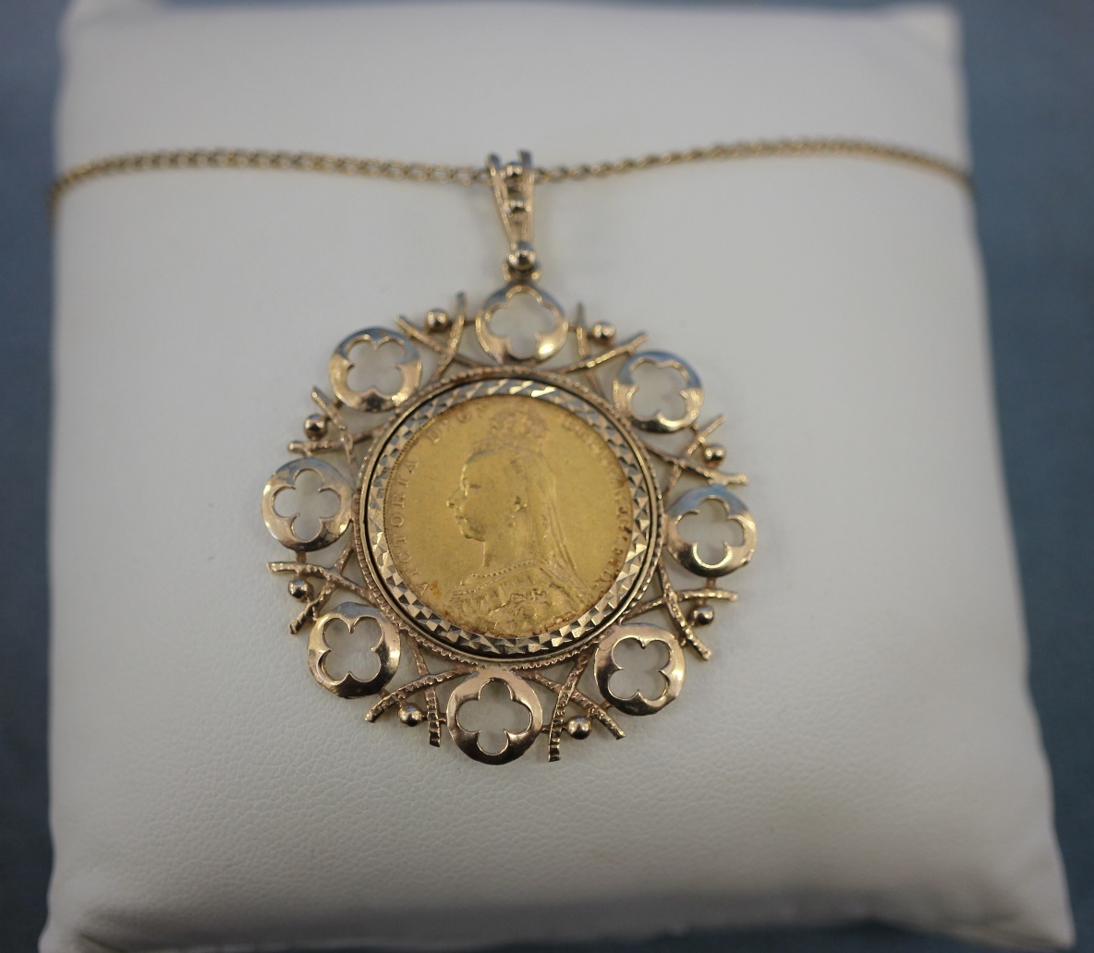 | Lot 15
20. | A 3/4 size English violin "The Maidstone" retailed by Murdoch Murdoch and Co Ltd of London. 34cm long, not including button, 36cm long including button, length overall 56cm, together with a bow (missing string) in original coffin style case. | £40-£60
21. | An Edwardian inlaid mahogany two handled tray with shaped edge, 66cm wide. | £30-£50
22. | An Edwardian style inlaid mahogany longcase clock, with three train movement, the dial inscribed "tempus fugit" 206cm high. | £80-£100
23. | Edwardian inlaid mahogany mantel clock with white enamelled dial and French movement, 27cm high. | £40-£60
24. | A Late Victorian mahogany and brass bound blanket chest of military style on later casters, 101cm wide. | £40-£60
25. | A Late Victorian mahogany music cabinet, fitted four drop front drawers, above two panelled doors, 48cm wide. | £60-£80
26. | A 9K gold dress ring set tiny diamonds in a flower head cluster, size T. | £20-£30
27. | A single strand freshwater pearl necklace with gilt coloured clasp, and part three strand necklace in blue bag. (2). | £20-£30
28. | A lady's Rotary wristwatch in gold plated and stainless-steel case, no. 190966, on thin articulated strap. | £20-£30
29. | An Early Victorian mahogany side cabinet, enclosed by panelled doors, 102cm wide. | £20-£30
30. | A reproduction tv cabinet of 18th century chest form 86cm wide. | £30-£50
31. | A Georgian style mahogany side or writing table, fitted three drawers on square tapering legs, 102cm wide. | £30-£50
32. | An oak Art Deco style tea table, 46cm wide, and a pie crust top table, 65cm in diameter (2). | £20-£30
33. | A circular onyx top occasional table, 81cm in diameter. | £15-£20
34. | A small Late Victorian oak letter box, with decorative brass front, and hinged lid, 26cm wide, and a modern Chinese style carved wood figural table lamp, 59cm high (2). | £20-£30
35. | A small plush teddy bear, in worn condition. | £15-£20
36. | A pair of white metal and enamelled cufflinks, four bangles, various, a decorative buckle, a brass bangle decorated tiger, a band ring, two silver plated tablespoons and a copper bangle (12). | £20-£30
37. | A reproduction set of 4lb kitchen scales, with brass pans, 40cm long, no weights. | £20-£30
38. | A "Royal" typewriter, in grey finish, 38cm wide. | £20-£30
39. | A pair of Indonesian carved wood table lamps, with foliate decoration on square form bases, each 51cm high. | £20-£30
40. | A pair of slender Zambian ebonised tribal figures, with beaded decoration on square bases, each 36cm high. | £15-£20
41. | An Indonesian decorative copper spittoon, with foliate and symbolic decoration, on circular foot, 37.5cm high. | £30-£50
42. | A cabinet containing two Japanese geisha dolls, and a paddle doll, 53cm high, and a further cabinet, with a small doll, and another paddle doll, 63cm high (2). | £30-£50
43. | Three modern lighters, decorated with North American Indian heads and a cigarette case (4). | £15-£20
44. | A small oak card box, containing two packs of playing cards and a set of draughts, in stained wood box (2). | £15-£20
45. | A pair of silver plated five division toast racks, with glass preserve bowls, each on a silver plated oval dish, with swan handles, together with two small entrée dishes, a tea pot, a coffee pot and two hot water pots (8). | £80-£100
46. | A Victorian glass taxidermy dome, on circular stained wood base, 79cm high. | £100-£150
47. | A small reproduction mahogany demi-lune table, on sabre form legs, 60cm wide. | £15-£20
48. | A 20th century oak draw-leaf dining tale, on spiral twist legs, 90cm x 151cm, extended and a set of six dining chairs (7). | £40-£60
49. | A 20th century Japanese pottery vase, decorated a dragon and the sun, on dark blue and gilt cloisonné style ground, three spiral handles, 20cm high. | £40-£60
50. | H. Vader- fishing boats landing, probably on the Dutch coast, oil on canvas, a pair 21cm x 26cm, and a pair of lithographs, after Nick Lowston, each 29cm x 21cm (4). | £20-£30
51. | An over-mantle mirror in silver painted frame 97cm x 74.5 cm. | £20-£30
52. | A rectangular wall mirror in carved and stained wood frame, 103cm x 72cm. | £20-£30
53. | A Regency style inlaid mahogany swing frame toilet mirror, on shaped feet, 76cm wide. | £20-£30
54. | An Edwardian mahogany pot cupboard, enclosed by two panelled doors, on square tapering legs, 52cm wide, in need of restoration. | £30-£50
55. | Annie Tempest (b.1959)- "Charades" part of the tottering by gently series, limited edition chromolithograph, No. 40/600, 50cm x 43cm. | £30-£50
56. | After Mary Cassatt (1844-1926)- interpretation of a girl in a blue armchair, oil on board, 54cm x 69cm, framed. | £150-£200
57. | Cort Jacobsen 1911-1967- figures clearing snow from a street, oil on canvas, signed bottom right, 61cm x 46cm, in need of restoration. | £100-£150
58. | Low- "Winston" seated on a step, chromolithograph, 29cm x 22cm, and a photographic print, "our skipper" 45cm x 34cm (2). | £40-£60
59. | After Kneller- portrait of William Cavendish 2nd Duke of Devonshire, oleograph on canvas, 24cm x 19cm in gilt frame. | £30-£50
60. | A modern burr poplar shallow bowl by "Tony Page" 32cm in diameter. | £30-£50
 | 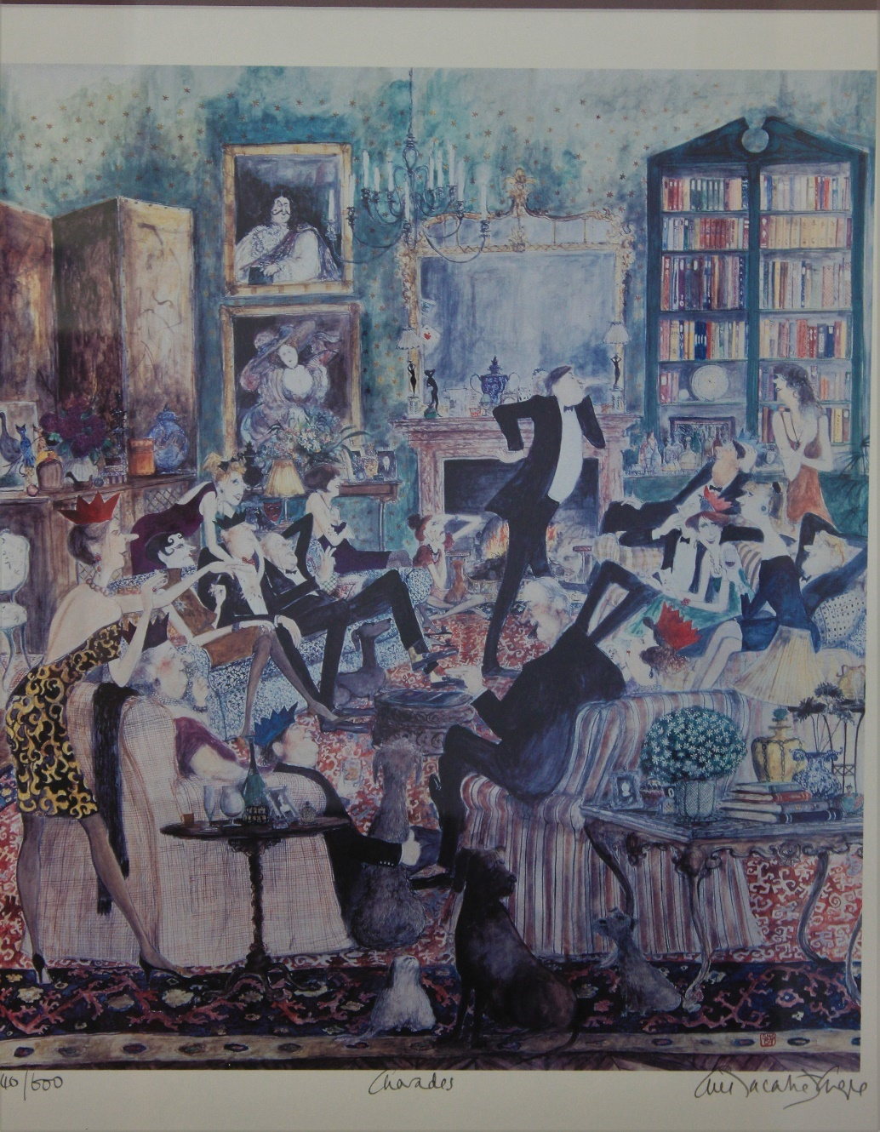 | Lot 55
 | 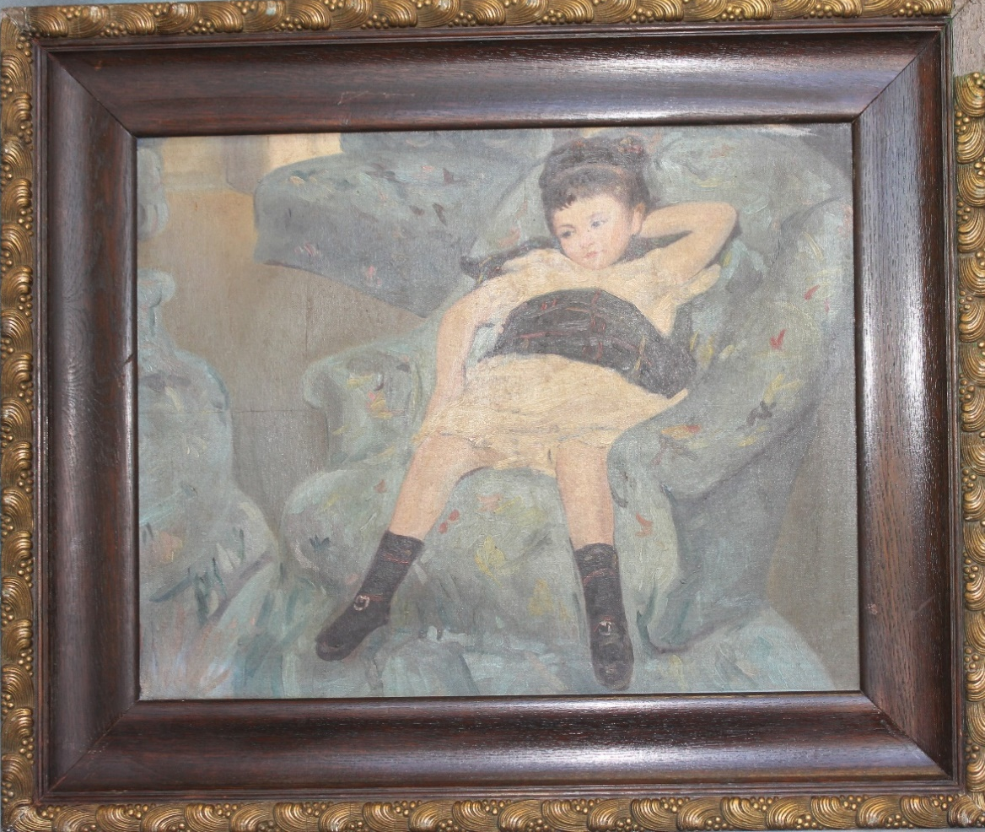 | Lot 56
61. | A reproduction circular relief plaque of Italian style of two young children in gilt and black painted frame, 41cm x 36cm. | £40-£60
62. | An Art Deco style brass wall timepiece of hexagonal form, adapted to a modern battery movement with Arabic numerals, 35cm wide, believed to have come from "Barkers of Kensington" department store, written verso "4th West" (4th floor, west wall) the building was originally designed by the architect Bernard George (1884-1964) who worked for the inhouse design team between 1928 and 1969. | £100-£150
 | 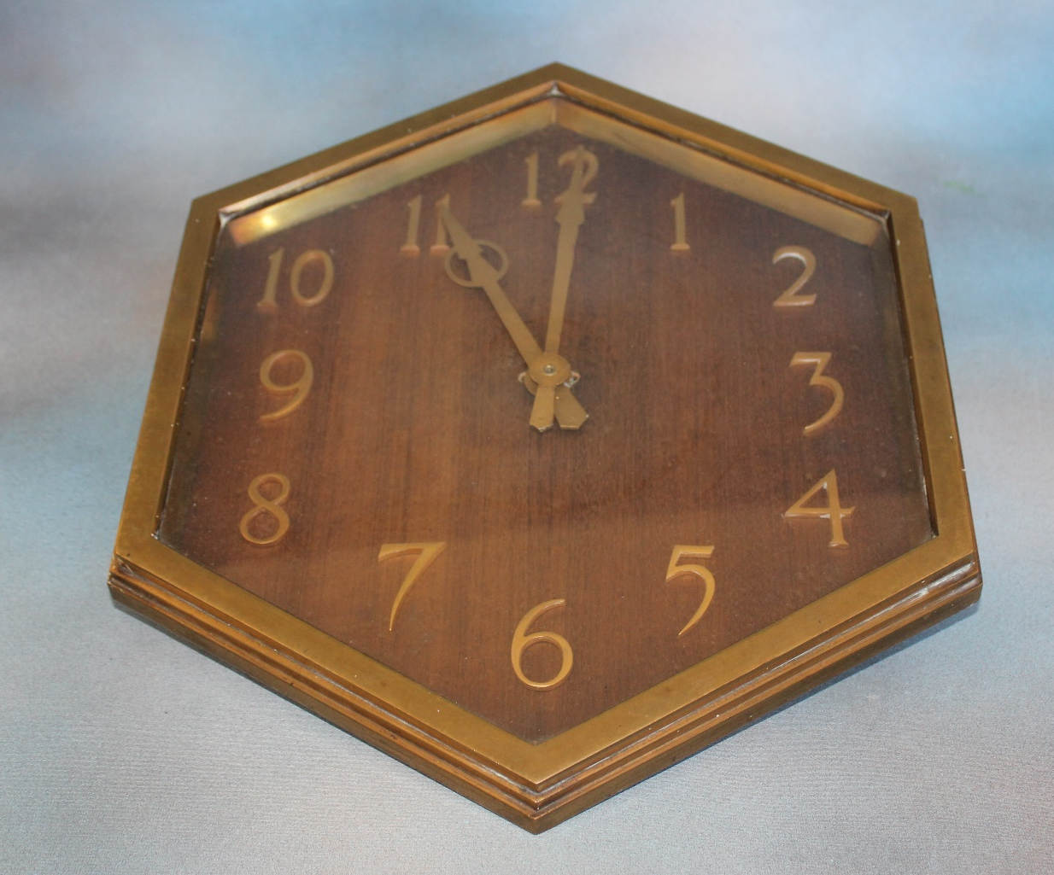 | Lot 62
63. | An Early 20th Century oak and silver plated, two bottle tantalus inscribed on a plaque "J.J.B. From HCB X Christmas 1914" 34cm, one decanter with chipped neck. | £60-£80
64. | A 19th Century crewel work bell bull, decorated with flower buds, and fruit, approx. 268cm long. | £40-£60
65. | A pair of 19th Century Chinese celadon green ground plates, decorated flowers and butterflies, each 19cm in diameter, one repaired, together with eight English pottery cabbage leaf plates (10). | £30-£50
66. | Attributed to Tom Mostyn (1864-1930)- exotic garden scene, oil on canvas, 49cm x 67cm, the artist was MAFA president between 1917 and 1920. | £100-£150
 | 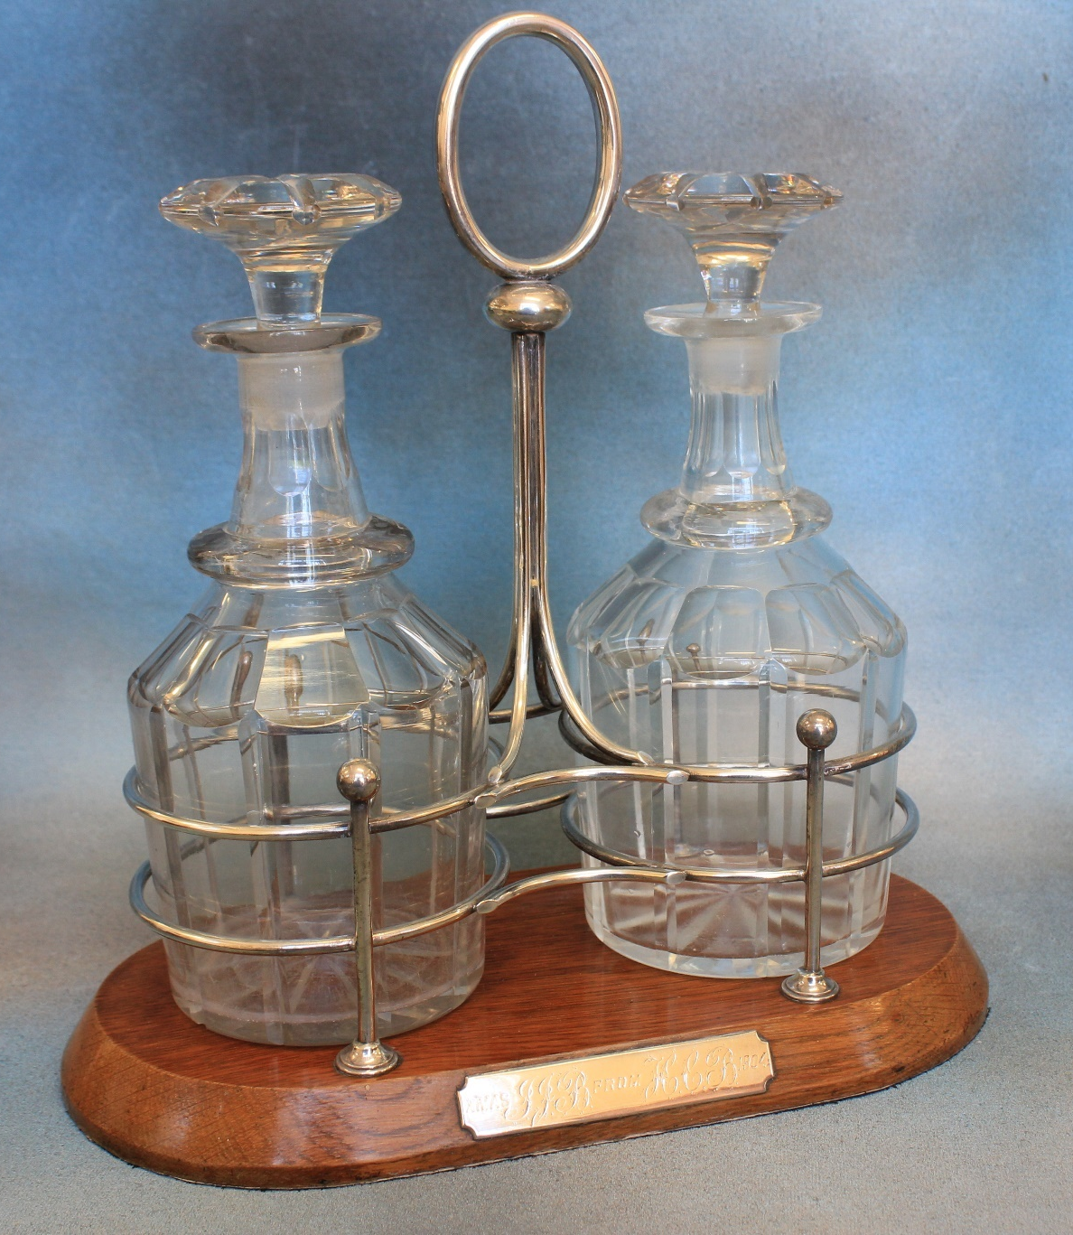 | Lot 63
67. | Early 19th Century English school- a circular miniature portrait of young woman in bonnet, approx. 7.5cm in diameter, in moulded gilt frame. | £80-£100
68. | A Victorian mother of pearl veneered and white metal card case, with Maltese cross to cover inscribed "Mrs Spires", 10.5cm x 8cm, a.f. | £60-£80
69. | A Victorian style 9ct gold dress-ring, set five graduated garnets, a costume bracelet set red coloured stones, a similar necklace, and a pair of ear pendants (5). | £40-£60
70. | A Swiss white metal ingot as pendant, on chain, approx. 0.6oz, a white metal link bracelet inscribed "Mark", a decorative simulated pearl set brooch, boxed, and a quantity of decorative and costume jewellery. | £40-£60
71. | A "Pioneer" cover album, containing a quantity of R.A.F. first day covers (70), a further similar album of armed forces and commemorative covers, an album of general first day covers and four other albums of mixed first day covers (8). | £40-£60
72. | Three Royal Mail cover albums of mixed covers, a further large album of mixed covers, a small album of R.A.F. covers, three further albums, eleven albums of tea cards, and a box of loose covers, approx. 700 covers (19). | £60-£80
73. | Seven albums of British and world stamps, mainly Queen Elizabeth II issues, eight stock book size albums of mixed stamps, together with five boxes of loose stamps, and an empty album (20). | £80-£100
74. | Three albums of British and commonwealth stamps including some Victorian issues, together with a box of mixed packs of British stamps (4). | £50-£70
75. | Of Second World War Interest- a quantity of war office military booklets on small arms training for the "Thompson" and "Sten" sub-machine guns, patrolling, map reading, use of grenades, home guard proficiency, a German phrase book, together with notebooks, message forms and ephemera. | £40-£60
76. | A Bridgewood China part dinner service flower and fruit pattern, 12 pieces, one tureen lid missing. | £20-£30
77. | A reproduction mahogany nest of tables on x- frame legs 56cm wide. | £30-£50
78. | A set of six William IV mahogany rail back dining chairs with carved mid rails on turned and fluted legs, slightly a.f. | £80-£100
79. | A Victorian mahogany three tier what-not, 53cm wide and four Late Victorian carved mahogany side chairs (5). | £60-£80
80. | An Edwardian inlaid mahogany display cabinet on square tapering legs, 63cm x 150cm. | £40-£60
81. | Early 20th century English school- view from Toys Hill, inscribed verso, watercolour, 14cm x 35cm and H. Simmonds- set of three post card sized images "Old Tonbridge", in single frame, 42cm x 22cm (2). | £20-£30
82. | Two Chinese silk coat or skirt panels decorated birds, butterflies and flowers in gilt frames, 48cm x 38cm and 48cm x 48cm respectively (2). | £40-£60
83. | G Rockhill- Thames scene watercolour, 24cm x 35cm, and Elsie W. Neve- Charmouth Coast" watercolour, 22cm x 27cm (2). | £30-£50
84. | W.P.E. 1892- "Somerton, Staithe, Norfolk" watercolour 34cm x 25cm, a further watercolour of sailing boats, unknown hand, 24cm x 34cm and after William Russell Flint- print of nude female, 8cm x 14cm (3). | £40-£60
85. | A Middle Eastern wood prayer book stand with folding action, 34cm wide. | £30-£50
86. | After John Speed- a dark stained map of Kent, 37cm x 49cm, trimmed, a.f. | £30-£50
87. | An Edwardian inlaid mahogany envelope card table, fitted with a frieze draw on square tapering legs, united by stretchers, 56cm wide. | £80-£100
88. | A silver plated oval entrée dish, a galleried tray, a pair of bone handled fish servers, a bottle coaster, a sugar scuttle, and a small oval dish (6). | £30-£50
89. | An Elizabeth II silver octagonal napkin ring, maker "Mappin and Webb", Birmingham 1956, two silver plated napkin rings marked "A and S", a silver plated "Whisky" decanter label, a galleried sugar bowl, two candle snuffers, a pair of fish servers, boxed, a set of six pastry forks, boxed and two white metal rings (11). | £40-£60
90. | A part set of steel drawing instruments, in lined case, a.f. | £15-£20
91. | A "Frontalini- Italia" piano accordion, decorated with paste stones, in leatherette carrying case, 57cm wide. | £80-£100
92. | A black lacquered "Greenkat PMI" microscope, no. 220 885, with polished metal fittings and lenses, 31cm high, in carrying case, an "ESC" student's microscope, in cardboard box and two Bakelite pen tidiers (4). | £20-£30
93. | A stained beech stereoscope viewer, together with eighteen slides, mainly by "Underwood and Underwood" including one passing through the Great Wall of China and Olivet and Gethsemmne (19). | £30-£50
94. | A Schuco tinplate toy car, clock work, finished in orange, with tin plate wheels, a.f. to paintwork with key, no box. | £30-£50
95. | A quantity of "Elastolin" toy figures, comprising: - three highlanders, three Indians, British First World War machine gun team, and a gunner, together with some farm animals, by other manufactures (approx. 23). | £20-£30
96. | A pair of Victorian silver and bone handled fish servers, with pierced and engraved decoration, maker "Lee and Wigfull" Sheffield 1895, approx. 8oz, weighable (2). | £120-£140
97. | A First World War heart pin cushion, from the "Prince of Wales's Volunteers (South Lancashire Regiment)", with central watercolour, mixed pin decoration and two sentiment bands, 25cm wide, slightly a.f. | £80-£120
98. | A Regency style gilt frame over-mantle mirror, with decoration of ribbons and swags, the oval central plate with bevelled edge, flanked by two rectangular form plates, 132cm wide x 82cm high (re-gilded). | £80-£120
99. | A Royal Dux pottery group of two male and female musicians each holding a lyre and in classical costume, 38.5cm high. | £80-£120
100. | A reproduction oriental shell picture, relief decoration of birds and flowers, in agate and shell lining, 70cm x 40 cm. | £20-£30
101. | A Middle Eastern Persian style carved and ebonised square shaped two tier occasional table, the four legs united by stretchers, 50cm wide. | £60-£80
102. | A Coalbrookdale cast metal circular plaque, decorated images of Neptune, water nymphs, foliate scrolls, pierced ground, 20cm in diameter. | £40-£60
103. | Two early 20th century Chinese copper small plates, with engraved decoration, each 20cm in diameter. | £20-£30
104. | A small union jack flag, attached to a beech handheld pole, 43cm x 83cm, and a smaller Welsh flag, both British made. | £20-£30
105. | A small Japanese Nippon porcelain shallow basket, decorated horses, fish and symbols of prosperity, white ground, multi coloured border, handle over, 25cm wide. | £60-£80
106. | An early print issue of the "Wisconsin State Journal", morning 21st July 1969, announcing the moon landing, together with a signed photograph of Neil Armstrong, framed, 81cm x 61cm, | £150-£200
107. | A precision micro projector by "Flatters and Garrett, no 909, Oxford Road, Manchester", on three feet, together with a power unit, 50cm high. | £20-£30
108. | A George V black despatch case, used by Dr R.A. Farrar M.D., who served on "The Committee on the Causes and Prevention of Blindness", maker John Peck and Sons, with Bramah lock, 46cm wide. Mr Farr served as medical secretary to the committee, and died in Russia in 1921. | £100-£150
109. | A brass plaque from the "S.S. Matina" built by Swan Hunter and Wigham Richardson Ltd, serving at sea from 1904 to 1928, including British Government Service between 1917 to 1919, mounted on ebonised backing plaque, 32cm x 22cm, together with a framed black and white photograph of the vessel, at sea (2). | £50-£70
110. | A continental mahogany games box, the original interior missing, with brass hinges, 24cm wide. | £15-£20
111. | A stained wood mantel clock, with "Junghans" movement, turned and carved decoration, and fake mercury pendulum, 45cm high. | £70-£90
112. | W.H Earp- watercolour of fishing vessels on lake, in mountain landscape, 25cm x 52cm. | £40-£50
113. | Minna Twentyman- watercolour, of birds and their nests, two, dated 16th May and 4th July 1878, and signed, each 17cm x 25 cm (2). | £80-£100
114. | An Art Nouveau inlaid mahogany French timepiece 19cm high, and an Art Deco style mantel clock, 23cm high (2). | £30-£50
115. | A Victorian silver plated tea pot, two sauce boats, a sugar bowl, two pairs of sugar tongs and other objects. | £50-£70
116. | A 19th century scrap book of National Costume, with some hand coloured illustrations (approx. 98) a volume on the French Revolution, 1913, together with a volume "Les Miserables" by Victor Hugo, and four other general books (7). | £40-£60
117. | A white pottery group "Faith, Hope and Charity" 25cm high. | £40-£60
118. | A pair of gilt brass and mother of pearl opera glasses, by "J.H Steward of Cornhill and The Strand, London", in case, and a further pair of opera glasses, unboxed (2). | £60-£80
119. | An early Ikea pine milking type three legged stool, the circular seat stamped beneath Habitat "Ingvar Kamprad", 32cm in diameter, and 35cm high. | £80-£100
 | 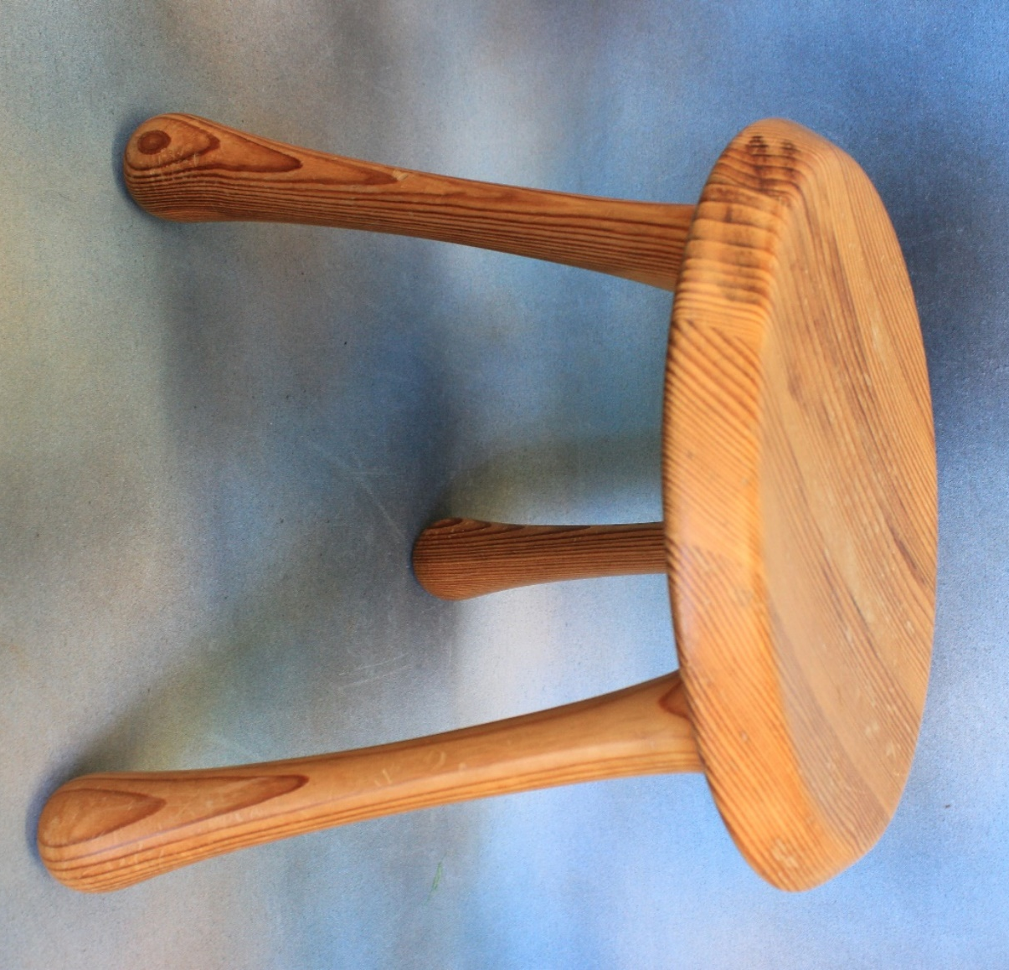 | Lot 119
120. | An Omega automatic de ville stainless-steel wristwatch, a Bulova quartz wristwatch, two Favre-Leuba wristwatches, stainless-steel, and three further lady's and gent's wristwatches (8). | £60-£80
121. | A Seiko gold-plated and stainless-steel gent's wristwatch, case No. 5020-5010, model No. 512287, a lady's watch, on leather strap, No. 680 510, a Favre-Leuba gent's wristwatch, an Emirates wristwatch, and four further quartz, or automatic wristwatches, two without straps (8). | £60-£80
122. | A Royal Crown Derby pottery achete, blue, white, and gilt pattern, 54cm long. | £20-£30
123. | Mid-19th Century school - river scene, with mixed boats and figures, oval oil on canvas, laid on glass, slightly a.f., 46cm wide. | £30-£50
124. | An Erickson Beamon lady's cocktail wristwatch, quartz movement, stainless-steel, set paste stones, in box. | £20-£30
125. | Five albums of mixed world stamps, an album of first day covers, and twelve loose first day covers (18). | £40-£60
126. | Three canteens or boxes of mixed bone handled, and silver-plated table cutlery, not all matching (3). | £30-£50
127. | Two large Mille Fiori pattern glass paperweights, both scratched. | £20-£30
128. | A pair of Zenith 10x50 binoculars, in plastic case. | £20-£30
129. | A modern Chinese style blue and white pottery head-rest, 21cm wide, together with a quantity of modern Oriental china, various. | £30-£50
130. | A Late Victorian oval pears type print, children re-enacting a wedding, in gilt scrolled frame, 83cm x 66cm. | £20-£30
131. | A 1934 book, "Covenants With Death", published by Daily Express Publications, relating to the casualties of the First World War. | £15-£20
132. | A stained beech coffee grinder by "Peugeot Freres", 20cm high. | £20-£30
133. | After Banksy - Christ with shopping bags, unframed print, 81cm x 51cm, together with a quantity of pictures and prints (9). | £20-£30
134. | A Caucasian runner, on faded red ground, 83cm x 288cm, a.f. | £20-£30
135. | A North American Indian headdress, with feathers, together with a book on the various tribes (2). | £20-£30
136. | A handbag bearing the Chanel logo, two Liberty's scarves in packaging, and a quantity of loose designer scarves, various. | £30-£50
137. | A set of six Carlo Moretti Murano green tinted glass wine glasses, believed purchased from SAKS 5th Avenue, New York, Circa 1965, each 14cm high. | £80-£100
 | 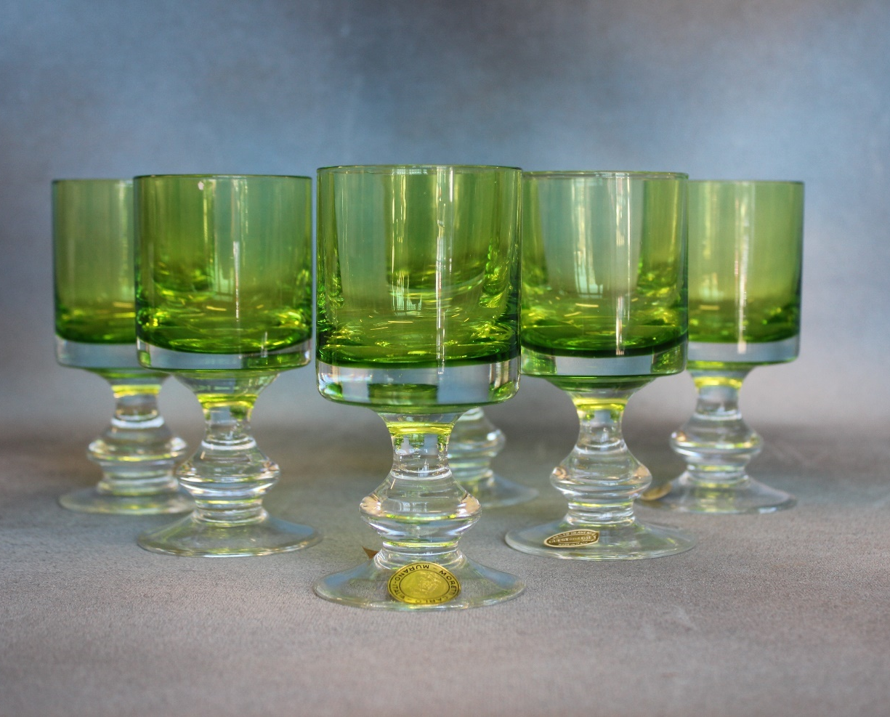 | Lot 137
138. | After Pierre Auguste Renior - Lady in a chair, chromolithograph, 42cm x 34cm. | £60-£80
139. | After Pablo Picasso - blue period nude, chromolithograph, 41cm x 33cm. | £80-£100
140. | Hal Hurst (EXB - 1896 - 1913) - "St. Johns College, Cambridge", inscribed verso, watercolour and colourwash, 45cm x 29cm. | £30-£50
141. | A George III mahogany chest of two short and three long drawers, with brass swan-neck handles, on bracket feet, 88cm wide. | £60-£80
142. | Two Staffordshire pottery spill figures, each 29cm high, a watch-stand group, 22cm high, and two smaller figures, all a.f. (5). | £30-£50
143. | A two strand pearl necklace, with 9ct gold pearl set clasp, and a single strand necklace, with white metal clasp (2). | £50-£70
144. | A late Victorian stripped pine hallstand, 186cm high. | £60-£80
145. | A Victorian walnut fold over top card table, on carved column, and quadruped base, 90cm wide. | £150-£200
146. | A late Victorian inlaid mahogany davenport, 52cm wide and a mahogany whatnot (2). | £80-£100
147. | Wm. A Toplis, 96 - Coastal landscape, and stormy seas watercolour, 24cm x 34cm and another of fisherman's cave, 25cm x 36cm, dated 1909 (2). | £100-£150
148. | De Brie 1913- Bretagne Market, in square, with figures, watercolour 38cm x 55cm. | £150-£200
149. | A late 19th century pale coloured marble cased mantel clock, 24cm high | £60-£80
150. | A Royal Doulton stoneware vase, 15cm high, a Royal Doulton tobacco jar, top missing, a small biscuit barrel, a.f., and a Royal Doulton figure "Janice", HN2165, chipped (4). | £30-£50
151. | A part coloured map of Kent by Robert Morden, 38cm x 64cm. | £60-£80
152. | After Donald Crawford- Rye Church, and a view of Rye, etchings, two, 17cm x 11cm and 14cm x 16cm and three further etchings, various (5). | £20-£30
153. | A silver plated three piece tea set, a pair of fish servers in box, together with three canteens of silver plated fish knives, bone handled dessert knives and forks, and bone handled fish knives and forks, a set of stained bone handled tea knives, boxed and a small tray. | £80-£100
154. | A late Victorian inlaid mahogany and upholstered tub form elbow chair, on turned legs, with castors. | £30-£50
155. | Robert Morden- map of Kent, circa 1696, 36cm x 65cm, with some later hand colouring. | £40-£60
156. | A Regency rosewood circular snap-top breakfast table, on part faceted pedestal, and circular plateau base, with three knurled feet, 120cm in diameter, a.f., to top. | £100-£150
157. | A set of six dark stained beech wheel-back side chairs, with added upholstered pad seats on turned legs, united by stretchers (6). | £60-£80
158. | A set of six Waterford crystal John Rocha tumblers, each 11cm high. | £40-£60
159. | A Waterford glass shallow John Rocha fruit bowl, with etched marks and moulded decoration, 34cm in diameter. | £100-£150
160. | A deeper similar bowl, from the John Rocha series, etched marks, moulded decoration, small chip to edge, 30cm in diameter, together with an unrelated preserve pot and cover, 11cm (2). | £80-£100
161. | A Waterford glass figure of an elephant, 18cm high, a "Waterford Times Square 2000" paperweight together with a number of glass animals by Bacarat and Villeroy and Bosch, including pelican, rabbit, seal, penguin, frog and owl (11 overall). | £80-£120
162. | A "Tiffany and Co" glass bowl in bamboo lattice pattern, 23cm in diameter. | £100-£150
 | 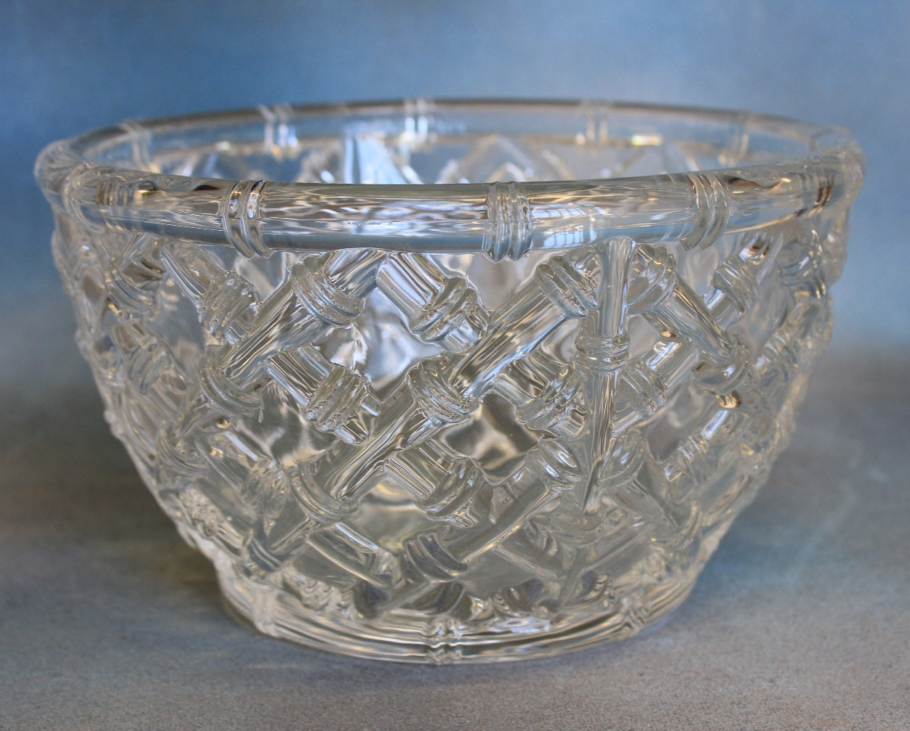 | Lot 162
163. | A "Tiffany and Co" glass vase, with cut decoration, 20cm high. | £60-£80
164. | A 19th century elm and ash Windsor elbow chair, on turned legs, united by stretchers, and a part caned elbow chair (2). | £150-£200
165. | A Victorian carved show-wood spoon back chair with buttoned upholstery, on squat cabriole legs and casters. | £40-£60
166. | A pair of Edwardian mustard button upholstered tub form easy chairs, on square tapering legs. | £40-£60
167. | An Eden gift soft toy "Peter Rabbit" in box, together with a Peter Rabbit race game, in box (2). | £30-£50
168. | A 19th Century stained beech child's or dolls rail back chair, with caned seat, and a decorative miniature bureau (2). | £40-£60
169. | A quantity of mixed beaded and decorative costume jewellery. | £20-£30
170. | A small Victorian mahogany Pembroke table, on turned legs, a.f., 74cm x 52cm, extended. | £30-£50
171. | A late Victorian carved wood grandmother type salon chair, on turned and ringed legs, with castors. | £60-£80
172. | Arthur Smith-Knaresborough, watercolour 33cm x 23cm and Derek Lucas-watercolour of a Kentish farmhouse, 24cm x 35cm (2). | £60-£80
173. | Four small nursery rhyme prints, initialled K.G., each 12cm x 7cm, in maple frames, and three modern Japanese prints, landscapes (7). | £20-£30
174. | Moghul School- small Indian print of elephant, another of tiger hunt, in single frame, together with two further framed prints (3). | £40-£60
175. | A Victorian pine linen press, the tray fitted interior enclosed by two panelled doors above two short and two long drawers, 126cm x 207cm high, plinth base, a.f. | £150-£200
176. | A Victorian Royal Letters Patent on three vellum sheets, 31st October 1848, a pre-printed document, with manuscript insertions, regarding the founding of Queens College, Harley Street, London, in 1848, by Frederick Denison Maurice, whose ambition was to provide an education to girls and young women, 75cm x 52cm, together with a green wax seal, 16cm in diameter, contained in a shaped mahogany box, 81cm wide. Also, to be sold with a letter from Clarence House, 1955, and some photographs of Queen Mary and Queen Elizabeth, the Queen Mother relating to the "Governess' Benevolent Institution, Chislehurst", and an embroidered portrait of King George V, presented to Queen Mary House. | £300-£500
 | 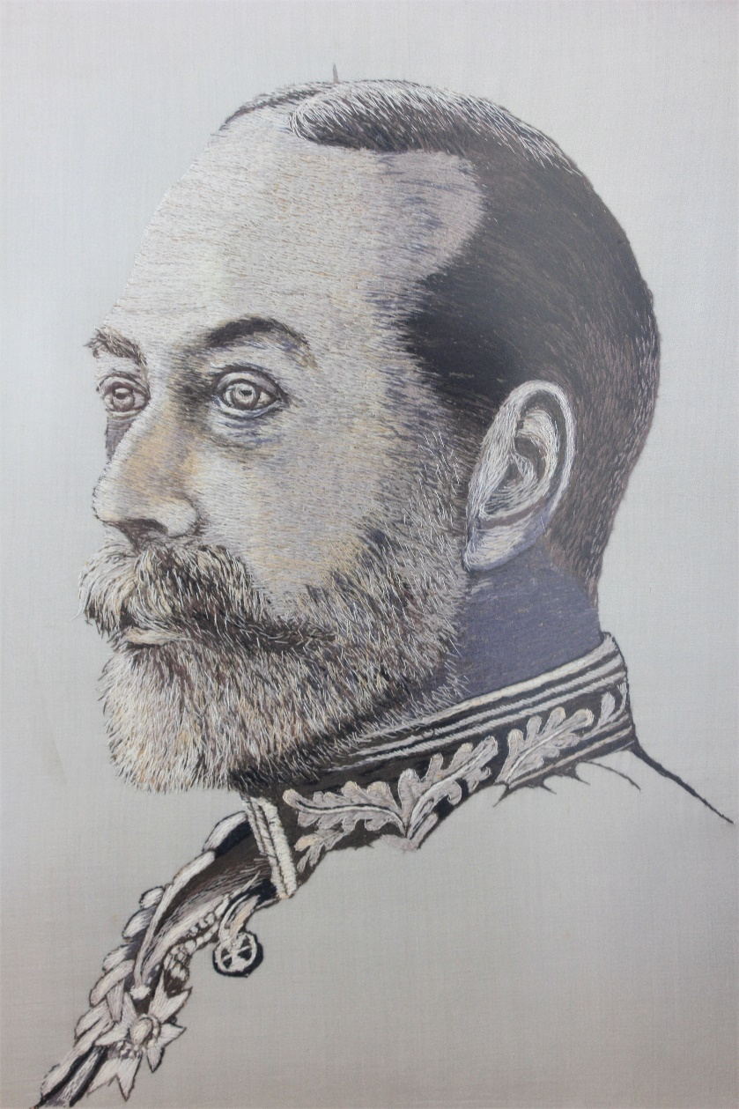 | Lot 176
 | 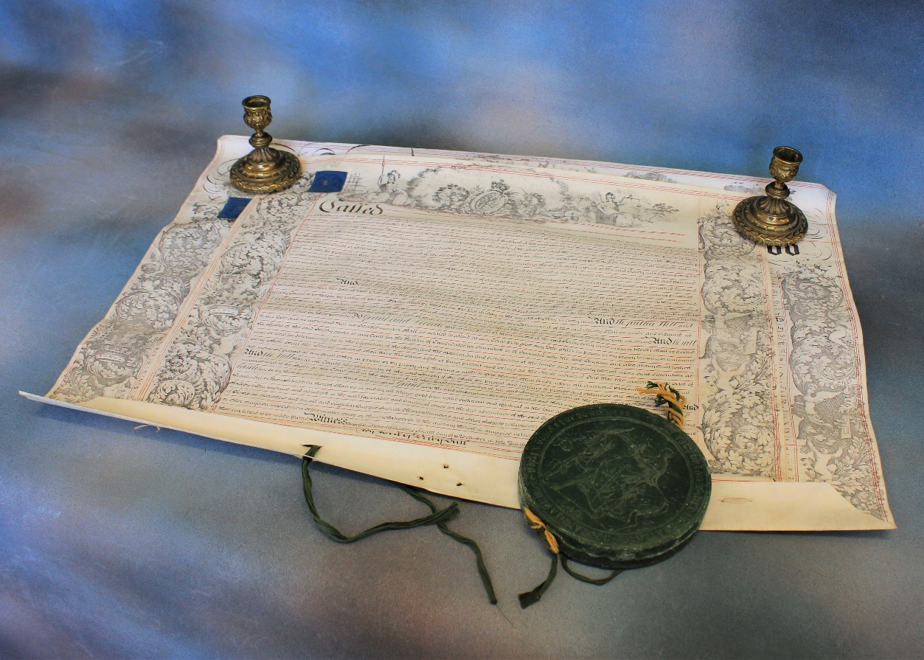  (Candlesticks not included)  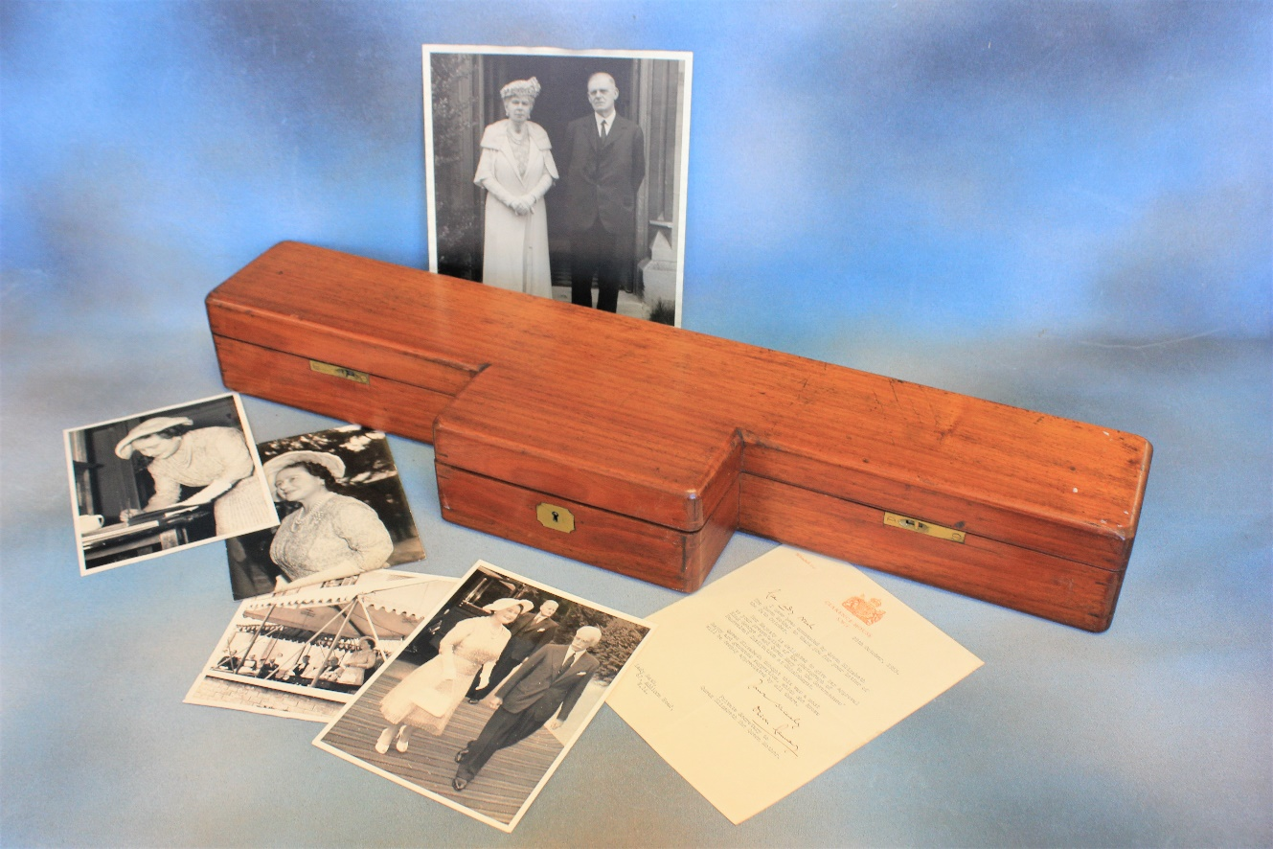 | Lot 176
177. | A pair of early 20th century elm, ash, and beech Windsor elbow chairs, with pierced splats, on turned legs, united by stretchers, together with a stick back side chair (3). | £180-£220
178. | A Persian rug, dark blue ground, wide multi-coloured border, 144cm x 209cm. | £60-£80
179. | A 20th century oak dining suite, comprising:- a drawer leaf dining table of refectory style, 101cm x 271cm, extended, a set of eight ladderback dining chairs, and a sideboard, 175cm wide (10 pieces). | £150-£200
180. | A reproduction oak side table with moulded and thumb carved decoration, on turned legs, united by stretchers, 106cm wide. | £60-£80
181. | A 20th century Chinese blue and white crackle glazed, dish, 37cm in diameter. | £100-£150
182. | A pair of modern pottery leaf pattern dishes, green ground each, 19cm wide, signature to base (2). | £60-£80
183. | A reproduction mahogany serving table, fitted three drawers on square tapering legs with spade feet, 122cm wide. | £60-£80
184. | A reproduction mahogany oval occasional table, on four splay legs, 117cm wide, and a small sofa table form coffee table, 102cm wide, extended. (2) | £50-£80
185. | A silver George V tasting cup, Birmingham 1926, an open salt cellar, London 1906, an Elizabeth II silver butter shell, Birmingham 1961, together with a pair of silver plated candelabra, 36cm high, and further silver plated and metal objects. | £80-£100
186. | A modern part suite of table cutlery, by "Arthur Price" of England, in stained mahogany canteen, 46cm wide, and a boxed soup ladle, some pieces missing. | £40-£60
187. | A small Spanish porcelain figure of Napoleon, after Edgar Davids, slightly a.f., two small Dresden figures, a Bing and Grohndahl vase, a.f., a quantity of blue and white china pieces, a small Delft tile and two Imari plates (16). | £80-£100
188. | A small quantity of fragments of Roman pottery, and minerals (14). | £60-£80
189. | After J.M.W. Turner- "Dover" and "Hastings" steel engravings, a pair of 53cm x 67cm (2). | £40-£60
190. | After Marino Marini 1952- "Cavello" coloured lithograph, 53cm x 39.5cm. | £30-£50
191. | A part No. 2 dress uniform formally worn by Lt. Col R.K. Collins of the Army Intelligence Corp, an officer’s mess kit, No. 1 dress cap in box, together with a pair of boots, service belts, ties, a coloured commemorative print, and other ephemera. | £150-£200
192. | A reproduction fruit wood, chest of three long drawers, 127cm wide and two bedside chests, each 50cm wide (3). | £60-£80
193. | 20th Century English school "Lyminge, Kent", watercolour 36cm x 53cm | £20-£30
194. | A pair of practise fencing rapiers and two reproduction decorative swords (4). | £40-£60
195. | A reproduction mahogany towel rail with part open carved ends on shaped feet, 75cm wide. | £40-£60
196. | An Art Deco oak occasional table, fitted single drawer on U shaped end supports, united by a stretcher, 60cm wide, top warped. | £40-£60
197. | A Victorian cast brass scuttle with hinged lid on circular foot, 48cm and a decorative brass oil lamp with glass chimney, 65cm high, slightly a.f. (2). | £70-£100
198. | An 18th century oak and elm side table fitted single drawer, a.f. to lock and handles, on square tapering legs, 75cm wide. | £40-£60
199. | A 19th century rectangular wall mirror in gilt moulded frame, 96cm x 120cm, a.f. | £60-£80
200. | Attributed to J.B Spencer 1929-1899 (American)- Portrait of little urchin-esque girl on chair, oil on canvas, 42cm x 33cm in decorative gilt frame 58cm x 49cm. | £200-£300
201. | An American mahogany roll top desk, with tambour shutter top, and four drawers, fitted interior, 106cm wide. | £200-£300
202. | A Late 19th Century slate cased mantel timepiece, French movement, 35cm high. | £40-£60
203. | A set of six Early Victorian mahogany rail back dining chairs, upholstered stuff over seats, on turned and ringed legs. | £150-£200
204. | An Edwardian mahogany revolving bookcase, with slatted ends, 60cm x 60cm. | £100-£150
205. | An Early 20th Century mahogany display cabinet, with glazed and moulded panel doors, on squat cabriole legs, 76cm x 124cm. | £40-£60
206. | A Victorian walnut and brass bound writing slope, slightly a.f., 30cm wide and a set of post scales, with weights (2). | £20-£40
207. | 19th Century school- Miniature oval portrait of French officer, probably in summer uniform, 4.5cm x 5cm, a.f., and a small painted Indian school transparency of bearers and guards, 13cm x 17cm, a.f. (2). | £60-£80
208. | A Late Victorian painted treen box, decorated landscape, fitted interior, decorated monkey and butterfly, 17cm wide, a small decorative puzzle box, and Indian lacquered fan panel, six enamelled and wooden match box holders and a small pin tray (10). | £60-£80
209. | A small continental white metal and carved shell oval box, decorated scene of lovers, in garden landscape, 7cm wide and small Chinese white metal and carved scent bottle, both a.f. (2). | £40-£60
210. | A small continental art glass bowl, 11cm in diameter, a small cauldron bowl, and a decorative porcelain tea-set and milk jug (4). | £20-£30
211. | A 19th Century book "Picturesque Views of the Southern Coast", 1826, illustrated with engravings after Turner and others a.f., together with a small volume "Percy's London", some small testaments and miniature classics, approx. 11. | £20-£30
212. | A "Red Star" coopered wooden washing machine with turning handle to top, on four feet, 120cm x 67cm. | £30-£50
 | 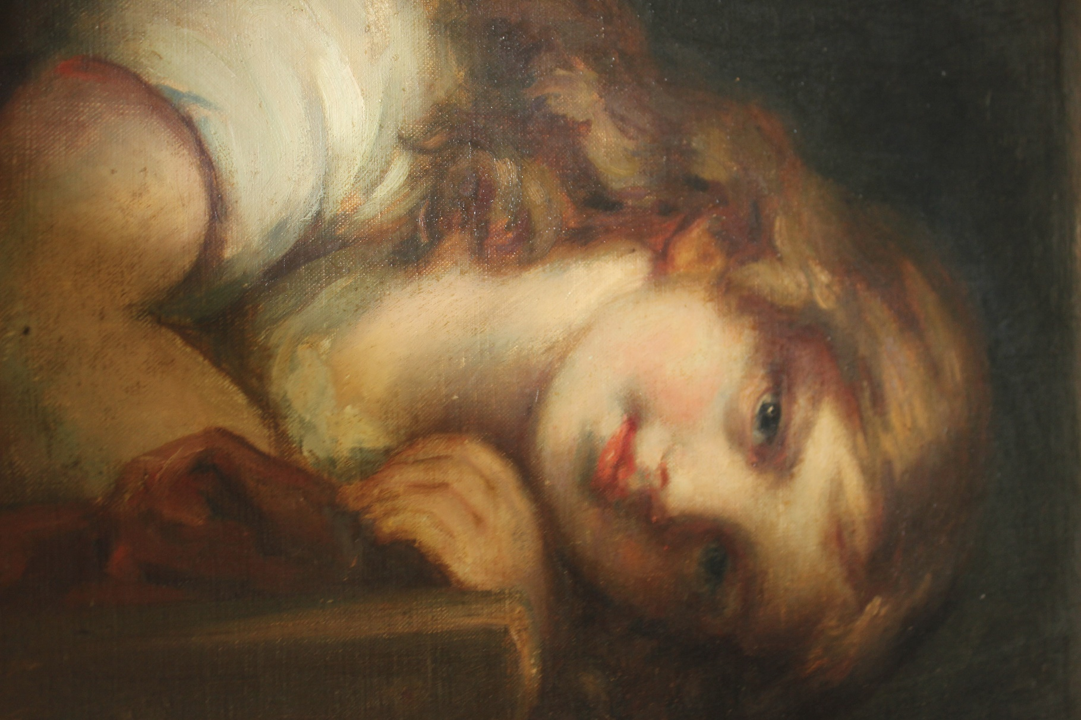 | Lot 200

Future Dates

AUCTION DATES 2021

Wednesday 28th July 2021

Wednesday 15th September 2021

Wednesday 27th October 2021

Wednesday 1st December 2021

Viewing on Monday and day before sale from 12.00pm to 7.00pm
and on morning of sale from 9.00am to 10.30am
Sale commences at 11.00 am.
(Please note that due to current restrictions, these viewing times do not apply to the 16th June sale.)

VALUATION DAYS 2021

Wednesday 23rd June 2021

Wednesday 4th August 2021

Wednesday 29th September 2021

Wednesday 3rd November 2021

Wednesday 8th December 2021

Sevenoaks Saleroom, Argyle Road,
Sevenoaks TN13 1HJ

11.00am – 4.00pm

Notes

