Welcome to Ibbett Mosely Auctions, Wednesday 15th September 2021 Auction Catalogue

This sale will be held online at www.easyliveauction.com/ibbettmosely/
please visit the website to register or log in to view and bid.

Alternatively, commission bids (bids left ‘on the book’) may be left with us, as well as a limited amount of telephone bids. Please telephone 01732 456731 or email auctions@ibbettmosely.co.uk for further details.

Limited numbers to be allowed on day of sale, please contact our office on 01732 456731 for more information.

Please be aware there is viewing strictly by appointment only. Any walk-ins will not be allowed viewing. The full catalogue, complete with images of each lot and condition reports will be available at easyliveauction.com/ibbettmosely/

Please telephone 01732 456731 or email auctions@ibbettmosely.co.uk with any questions.

Collection of items is available on Thursday 16th September from 10am - 5pm. Collection of items from 17th September onwards, by prior appointment only.

You are welcome to collect in person, or via your own carrier, but local courier PSP Logistics are available to carry out deliveries of items.
Please contact them directly to arrange and pay for delivery.

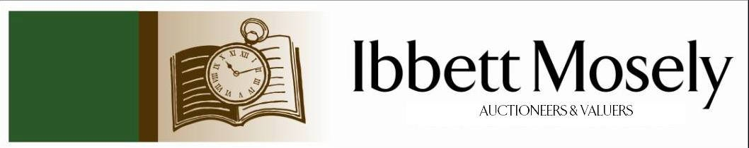

Catalogue of Antique, Edwardian and Victorian
Furniture and Effects
to be Auctioned on

Wednesday 15th September 2021
at 11.00am

IBBETT MOSELY AUCTION ROOMS
ARGYLE ROAD, SEVENOAKS, KENT TN13 1HJ
Via
www.easyliveauction.com/ibbettmosely/

Viewing at Sale Room on:

Monday 13th September
Tuesday 14th September

Between 10.00am –5.00pm.

STRICTLY BY APPOINTMENT ONLY.

Limited numbers to be allowed on day of sale, please contact our office on
01732 456731 for more information.

Please wear a face covering when in the Saleroom.

Catalogues: £2.00

Auctioneer and Valuer: Alan White FNAVA
Consultant Auctioneer and Valuer: Derek Hodge
Trainee Valuer and Clerk: Nicola Rainsley-Hughes
Auction Clerk and Administrator: Emily Frederick

Please be aware we are not able to offer food or drink at this sale.

1. | An early 19th century mahogany and brass telescope inscribed "Mackneil London, Apprentice of the Late Mr. Ramsden", may refer to Jesse Ramsden, 107cm long. | £100-£150
 | 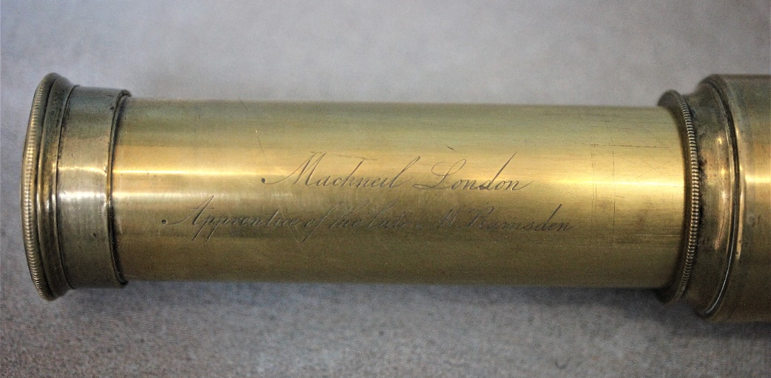 | Lot 1
2. | A volume of the Great Exhibition catalogue, 1851, "The Arts Journal Illustrated Catalogue", published by James S. Virtue, London, a.f. | £40-£60
3. | Two gilded spelter figures of stylised soldiers on black slate and marble bases, each repaired and restored, 46cm high (2). | £60-£80
4. | A J. Gooseman 87- Portrait of horse, oil on board, 53cm x 44cm, Patricia Cork- mountainous landscape, oil on board, 40cm x 50cm, after Howard Daniels- coloured print "Aztec Rose" 44cm x 40cm and a Victorian style landscape, oil on canvas (4). | £40-£60
5. | An early 20th century German bisque head doll, mould no.390, by "Armand Marseille" with open mouth, and rolling eyes, composition body, 50cm long. | £60-£80
6. | A 1997/98 Manchester United football bearing 17 signatures, including David Beckham, Ole Gunner Solskjaer, Gary Neville, Ryan Giggs, and others, ball no. 38. | £40-£60
7. | A Clarice Cliffe Fantasque bowl in a geometric pattern, 18cm in diameter. | £80-£100
8. | A decorative metal and glass drop chandelier, 31cm in diameter, and a gilt brass square form lantern adapted for electricity, 41cm high. | £30-£50
9. | An inlaid mahogany wheel barometer with silvered dials and broken arch pediment, 96cm long. | £40-£60
 | 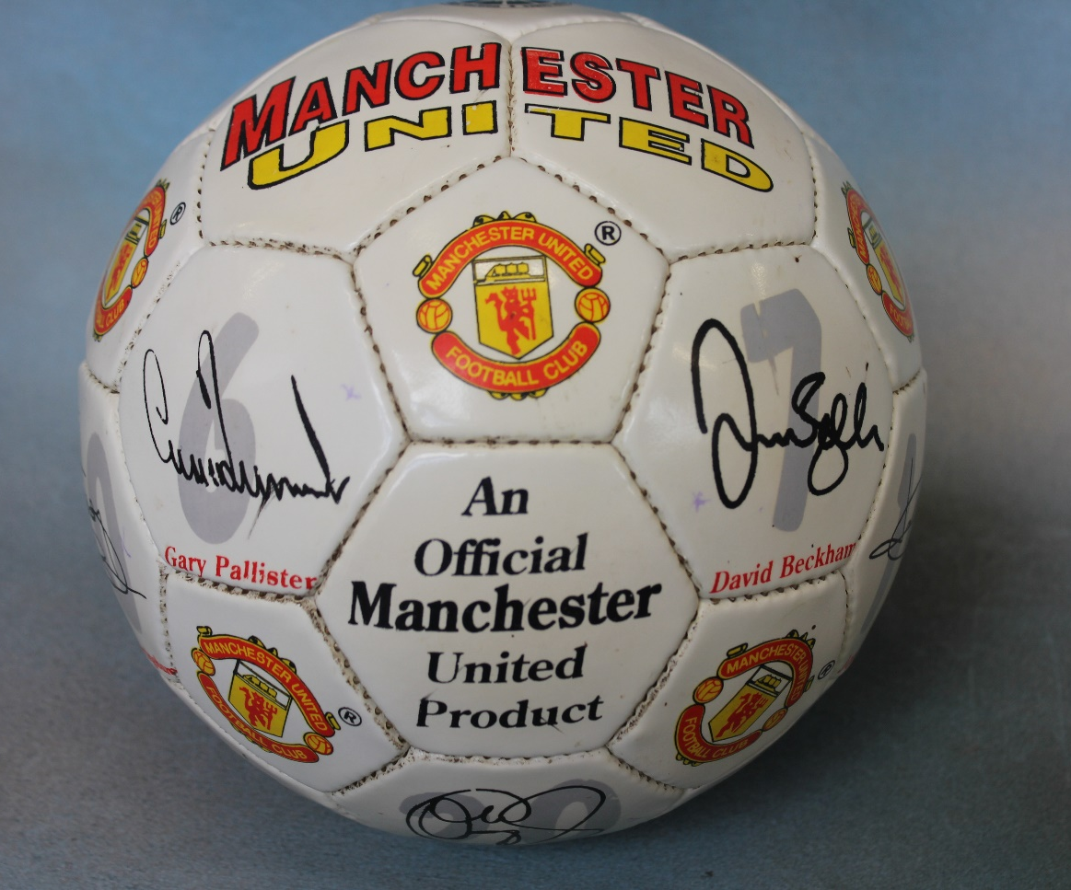 | Lot 6
10. | An Edwardian inlaid mahogany bijouterie table on square tapering legs united by an undertier, 60cm wide. | £100-£150
11. | Bertrand Brunt- miniature on ivory of old gentleman in gilt frame, 7.5cm x 9.5cm and a small miniature of Austrian Army officer, signed P. Carbonifi 3cm x 5cm, unframed. | £100-£150
12. | After Counis- miniature portrait of Pauline Borghese in bone frame, 9cm x 8cm, together with five further miniature prints after well known artists, two small Dresden portrait plaques, a small oval print on glass head of Byron and a small print on glass of William Shakespeare (10). | £150-£180
13. | A 1990 commemorative crown- visit of John Paul II to Malta and a Roman style replica coin. | £50-£60
14. | A continental silver and 14k pendant set faceted purple stone and a yellow metal pendant set pink and white brilliants. | £100-£150
15. | A set of 10 painted lead Napoleonic style horse mounted figures including Napoleon, Two Royal Artillery figures and various Hussars and cavalry (10). | £50-£70
16. | A large Islamic style bulbous copper and enamel vase, 68cm high (dented). | £100-£150
17. | A.A. Milne- "The House at Pooh Corner" 1928, illustrations by E.H. Sheppard, first edition, with Christmas 1928 inscription. | £100-£150
18. | A set of five Victorian rosewood kidney back dining chairs on turned, ringed and lappeted legs. | £80-£100
 | 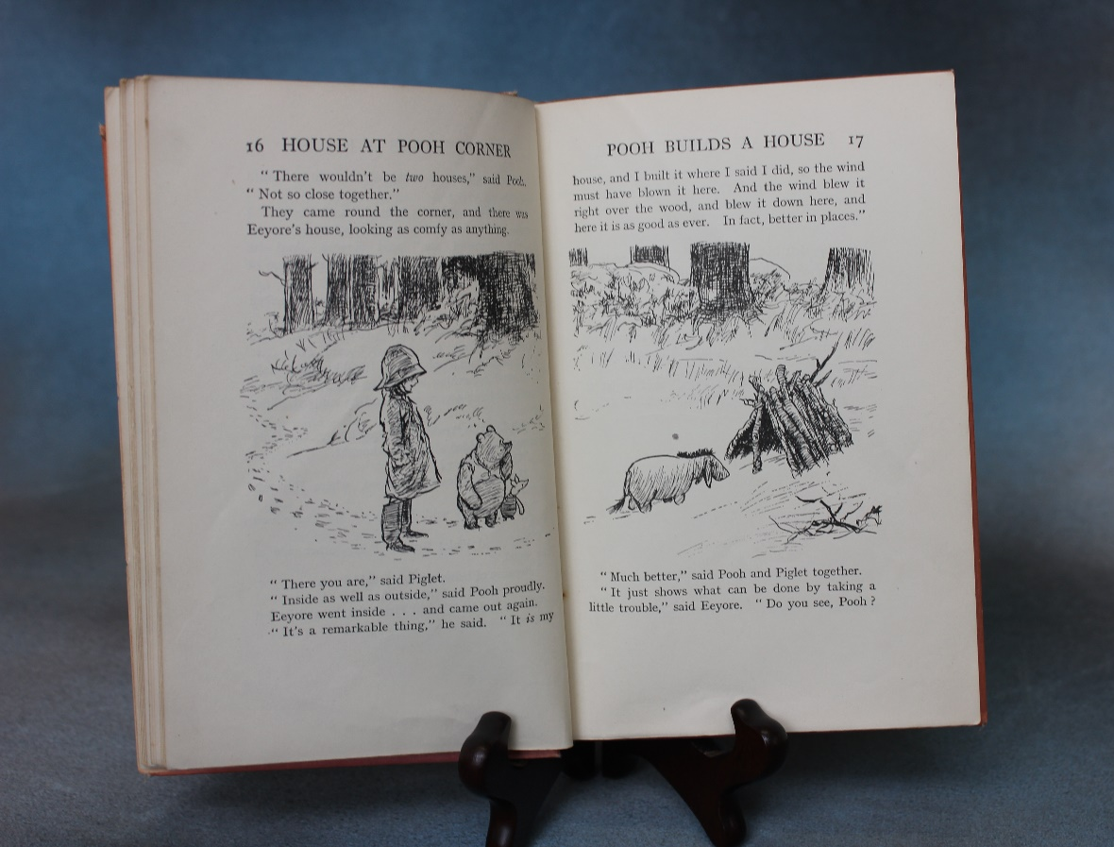  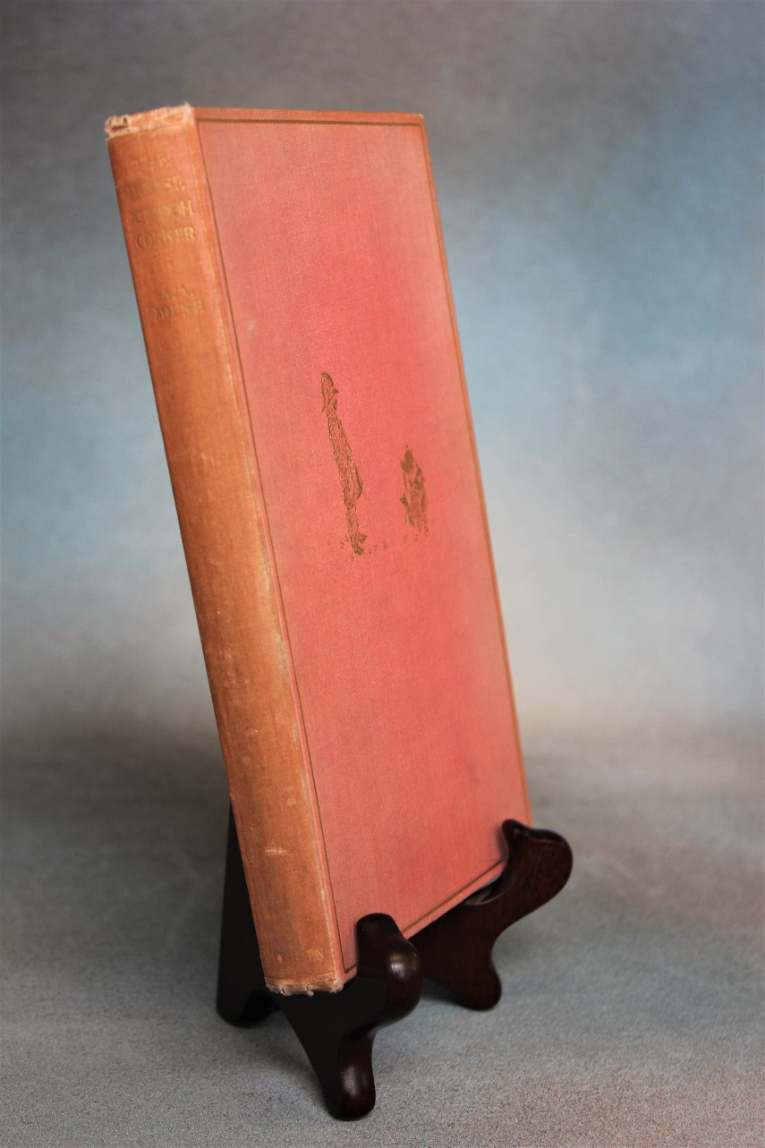 | Lot 17
19. | A late Victorian hobnail cut glass toilet bottle, with silver top, and remains of infuser, Birmingham 1898, 16cm high and a silver-plated dressing tray, a.f. (2). | £30-£50
20. | A 9ct gold link neck chain, approx. 52cm long, approx. 20g. | £250-£350
21. | A modern Chinese style blue and white vase and cover, 37cm high and a delft vase, 34cm high (2). | £40-£60
22. | A stripped pine dresser with plate rack and spice drawers, above drawers and panelled doors, 164cm wide x 193cm high. | £100-£150
23. | A Sindy Doll, with blond hair, based on "country walks" model, with tweed skirt and suede jacket, circa 1963, 29cm long, unboxed. | £60-£80
24. | A teak refectory style dining table of continental style, on triple turned end supports, scrolled trestle feet, united by stretchers, the top 91cm x 183cm, restored. | £100-£150
25. | Oak bureau bookcase, the upper part with pair of glazed doors, writing flap below, fitted interior three drawers under, on short cabriole legs, ball and claw feet. | £30-£35
26. | Walnut bow fronted display cabinet, pair of glazed doors enclosing two shelves, cupboard under on short legs, ball and claw feet. | £30-£35
27. | Police Long Service and Good Conduct Medal awarded to Inspector Frank Lovejoy, complete with ribbon, boxed. Set of Maundy Money 1989, boxed and a collection of commemorative coins. | £40-£55
28. | A collection of copper and brass including two copper and brass ship lamps, brass bell complete with anchor hanger, brass horse and chariot, copper ewer, three piece brass companion set, warming pan length 102cm and other copper. | £150-£175
29. | A pair of brass horse hames, with some iron fittings, each 87cm long. | £40-£45
30. | A selection of Royal Doulton plates and figures including a set of five plates, The Falconer D6279, The Squire D6284, Jester D6277, Hunting Man D6288, Admiral D6278. Royal Doulton tankard Old Charley, figurines of The Lobster Man H N 2317 and Fortune H N 2159. | £50-£70
31. | A silver medal inscribed Tottenham P S Runner Up Lytton Cup 1908 and an eternity ring, single row of tiny diamonds, 39 to 40 (one missing), band of white gold. | £80-£90
32. | A small oak bookcase, containing a set of Encyclopaedia Britannica, thirteenth edition, enclosed by glazed panel doors, 60cm wide, together with six small booklets. | £20-£30
33. | A pair of lacquered brass table lamps, with shades, each 47cm high, a brass oil lamp, with coloured glass shade, 53cm high, adapted for electricity, and a pottery table lamp (4). | £30-£50
34. | A mahogany side table, on square tapering legs, 107cm wide (formerly a dining table end) and a Victorian mahogany circular tripod table, 61cm in diameter (2). | £30-£50
35. | A late Victorian mahogany wind-out dining table, on cabriole legs and pad feet, with castors, two extra leaves, 103cm x 178cm, extended. | £80-£100
36. | A reproduction mahogany lady's bureau, 53cm wide, and a small open bookcase, 36cm wide (2). | £20-£30
37. | Leia John- small portrait of woman, 23cm x 17cm and two decorative prints (3). | £20-£30
38. | A Royal Doulton figure "Taking Things Easy" HN 2677 18cm high, another "A Good Catch" HN2258, 19cm high, a Bairstow Manor Pottery figure of Winston Churchill commemorating the 60th Anniversary of D-Day, and a Carlton Ware "Rouge Royale" vase (4). | £20-£30
39. | An Edwardian mahogany pot cupboard, enclosed by two panelled doors, on square tapering legs, 52cm wide, in need of restoration. | £15-£20
40. | A late 19th century gilt painted spelter mantel clock, with some porcelain panels and surmounted by cherubic and putti figures, French striking movement, 52cm high. | £100-£150
41. | A Victorian inlaid walnut oval snap-top breakfast table, with decorative oval to centre on quadruple turned pedestal, and carved quadruped base, 88cm x 119cm, together with four Victorian kidney-back chairs (5). | £150-£200
42. | A 20th century oak grandmother clock, with arched dial, retailed by "Pleasance and Harper, Bristol", three train movement, 167cm high. | £80-£120
43. | A Victorian mahogany three tier buffet with turned supports, on squat turned legs, with casters, 69cm wide. | £100-£150
44. | A Victorian and ebonised piano stool, with circular adjustable seat on tripod base. | £80-£100
45. | A pale beech bentwood hat and coat stand, 186cm high. | £40-£60
46. | A pair of reproduction carved beech fauteuils with tapestry upholstery on slender cabriole form legs. | £80-£120
47. | A Regency rosewood sarcophagus shaped tea-caddy, with part fitted interior, 34cm wide. | £40-£60
48. | Seven Robinson's golly badges, in various uniforms and outfits (7). | £10-£15
49. | A part sheet of Chinese bond certificates, two albums of Late 20th Century notes, from Poland, Ukraine, Russia, Trinidad, and Tobago, various South American countries, together with BT phonecards, various. | £20-£30
50. | Four albums of World stamps, mainly Queen Elizabeth II era, and a small number of earlier issues, together with a small stock-book album, two empty albums, a small number of first day covers, and some loose stamps. | £30-£50
51. | A Scalextric track layout, with mixed racing and rally cars, unboxed, a boxed digital lap counter, two transformers, and other accessories. | £40-£60
52. | A 1930's Jacques croquet set in original box, 114cm wide. | £80-£100
53. | A G-Plan "China White" range sideboard, blond oak and painted, fitted six small drawers, above four large drawers, on black stained base, with four legs, 149cm wide, E-Gomme stamp to drawer, a.f. to drawer fronts. | £150-£200
 | 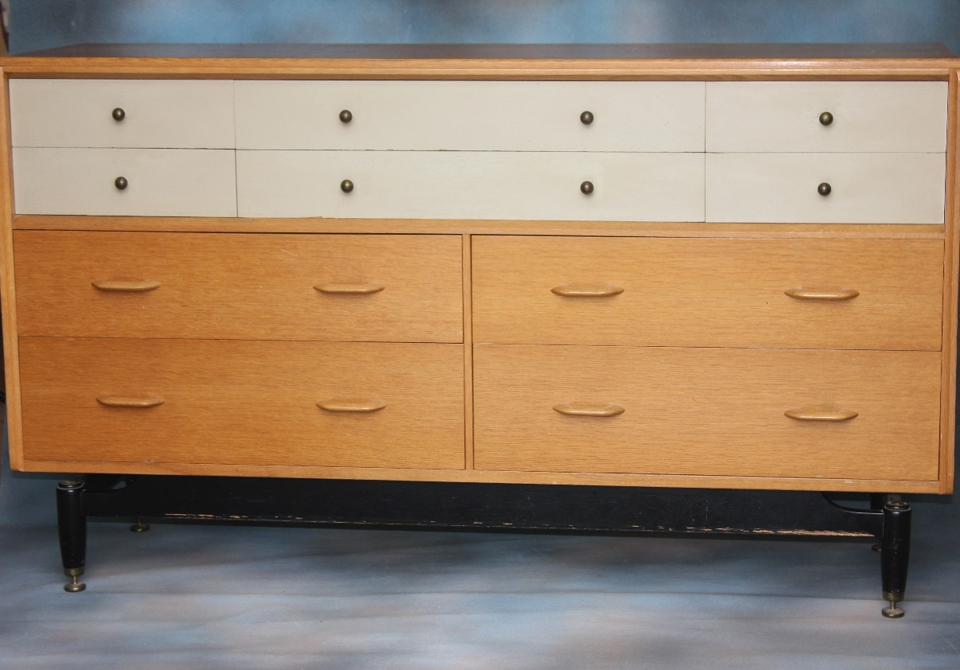 | Lot 53
54. | A 9ct gold amethyst and seed pearl cluster dress ring. | £120-£180
55. | After Chabridon - a pair of French etchings, wooded river scenes, with chateau, each 63cm x 17cm, together with a pastel painting of a yacht (3). | £30-£50
56. | After David Goddard - "The Oast House", and "Catts Place, Kent", two small coloured etchings, 12cm x 17cm, and 12cm x 16cm, respectively (2). | £20-£30
57. | A modern "Kutani" pattern table lamp, 75cm high, with shade. | £30-£50
58. | A George V horn handled, and silver mounted three-piece carving set, in lined case, London 1913 and 1915. | £80-£100
59. | A silver backed part dressing table set, mixed dates and pattern, together with a toilet jar, and silver cover, marks rubbed (4). | £50-£70
60. | J. Corbett - cattle in river landscape, drinking, oil on canvas, in gilt frame, 59cm x 72cm, a.f. | £40-£60
61. | An American .30 calibre ammunition box, probably for the M1 Garand rifle, 27cm long. | £30-£50
62. | A Queen Elizabeth II silver castle top pill box, probably Windsor, Birmingham 1977, a small modern circular box, London 1950, a silver coin holder, Birmingham 1985, and a small circular photograph frame, London 1978, approx. 3oz (4). | £50-£70
63. | A meat skewer, possibly George III, Newcastle, marks rubbed a small silver-plated meat skewer, a silver handled shoe horn, and button hook, Birmingham 1912, and a pair of George V silver grape scissors, Sheffield 1912, approx. 6.5oz weighable (5). | £80-£100
64. | A George III silver pap boat, probably London 1786, a small white metal dish, the centre set with Turkish coin, a silver-plated wine taster "Avignon", and a silver-plated wine label "Madeira", approx. 1.5oz weighable (4). | £30-£50
65. | A late Victorian silver lamp extinguisher, maker H.B., London 1897, and Edwardian silver buttonhole flower holder, Birmingham 1905, a silver-plated candle snuffer, a George III silver marrow scoop, Edinburgh 1814, a shallow bowl spoon, Birmingham 1927, and two late Victorian salts, London 1881, approx. 4.5oz weighable (7). | £50-£70
66. | An Edwardian silver sauce ladle, Sheffield 1904, a late Victorian silver sifter spoon, Birmingham 1893, a white metal mote spoon, eight silver salt or mustard spoons, mixed dates, and four silver-plated spoons, approx. 7oz weighable (15). | £80-£120
67. | A printed silk scroll panel, the farewell speech of King Edward VIII 11th December 1936, 48cm x 49cm, a.f. in places. | £40-£60
68. | A small brass and leather three draw telescope, 39cm long, extended, and a small pair of opera glass type binoculars, a.f. (2). | £40-£60
69. | A Victorian stained mahogany tripod piano stool, with adjustable seat, and a small stained wood hanger (2). | £30-£50
70. | A Second World War civilian pattern respirator, in card carrying box, together with a number of newspapers, covering major events, 1981-2000. | £20-£30
71. | Four albums of photographs, postcards, cuttings, and ephemera, relating to Captain Bowyer, a trinity house pilot, showing images of various ships, including the "Majestic", the French liner "Atlantique", on fire, "HMS Montague", together with dinner menus, photographs, and postcards, a.f. (4). | £200-£300
 | 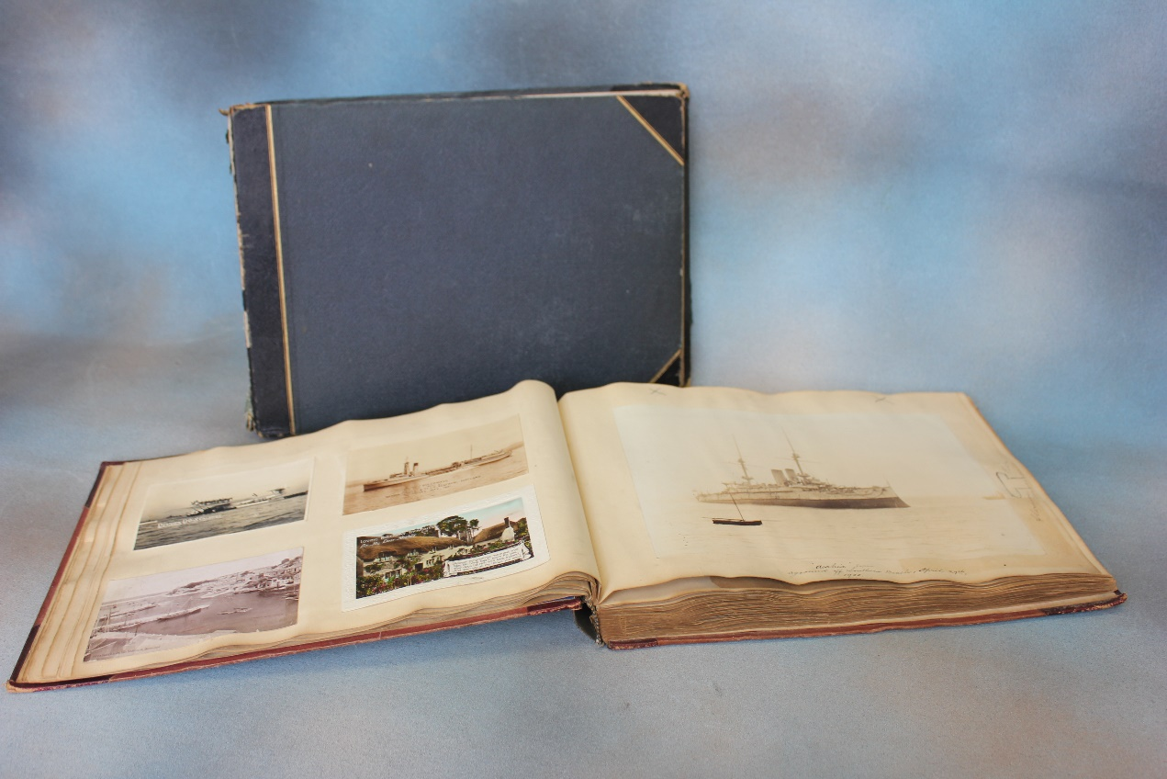 | Lot 71
72. | W. Beattie-Brown R.S.A (1931-1909) - highland landscape with loch, oil on panel, 14cm x 22cm. | £200-£300
 | 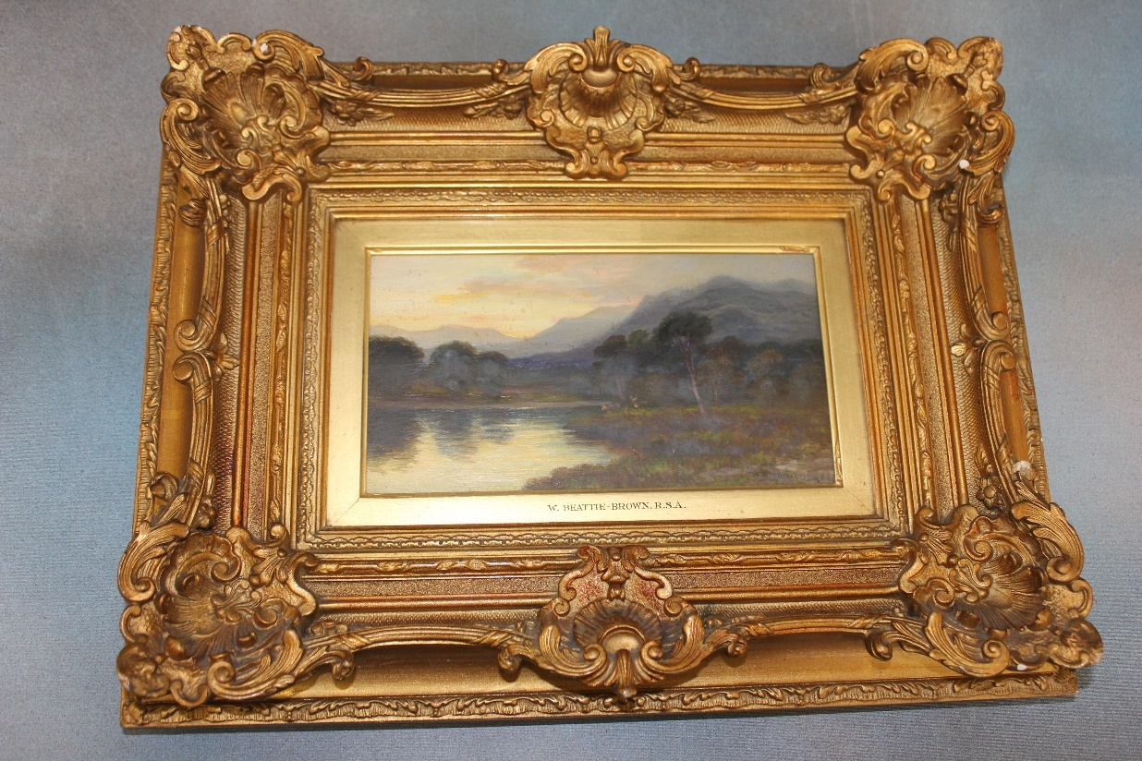 | Lot 72
73. | A Holy Bible "The Gift of Sir John Ferrer to the Parish of Bermondsey", circa 1884-85, together with a mini Webster's dictionary (2). | £40-£60
74. | Bertha Stamp - portrait of young black and white cat on windowsill, oil on board, 39cm x 29cm. | £20-£30
75. | An Atlas of Female Anatomy, by "Bailliere", sixth edition, card cover, revised by Katherine Armstrong. | £30-£50
76. | A mixed quantity of slide rules, various, mostly in box form cases, and in used condition, approx. eight, together with some ink pens. | £20-£30
77. | A Copeland part dinner service, floral pattern to centre, 29 pieces. | £40-£60
78. | Five Liberty style slip-ware pottery plates, each 21cm in diameter, slightly a.f. (5). | £30-£50
79. | A Japanese biscuit porcelain doll, wearing a kimono, 26cm high, and four further dolls and figures, in sizes (5). | £30-£50
80. | Two silk embroidered panels, a number of modern Japanese dolls, and carved figures, together with packets of incense and other objects. | £30-£50
81. | A set of eight late Victorian oak harlequin dining chairs, two with carved top rails, tapestry upholstery, on turned legs (8). | £80-£100
82. | An early 20th century walnut bureau de dame, of period style, the fall above one long and five short drawers, on cabriole legs, and pad feet, 61cm wide. | £80-£100
83. | A German mantel clock, in stained oak and beech case, 40cm high, and a small Vienna regulator type wall clock with musical movement, 62cm high, one a.f. (2). | £60-£80
84. | A Victorian double size brass and oxidised metal bed, 125cm wide, a.f. | £60-£80
85. | A pair of French style beech and simulated Kingswood veneered beside/boudoir chests, each fitted three drawers on slender cabriole legs, each 37cm wide (2). | £60-£80
86. | After J.M.W Turner- a set of six reproduction coloured prints "The Ports of England Series", each 15.5cm x 22cm, published by Lawrence and Turner (6). | £40-£60
87. | A pair of reproduction mahogany American style two tier occasional tables, with tooled leather tops, each 62cm wide. | £60-£80
88. | An oak spiral twist torchère, on tripod base, 98cm high. | £20-£30
89. | Three John Rabone and Sons Surveyors tape measures in embossed leather cases, and a small mathematical instrument set by W.H Harling in mahogany box (4). | £30-£50
90. | A pair of modern pottery leaf pattern dishes, green ground each, 19cm wide, signature to base (2). | £20-£30
91. | A reproduction mahogany serving table, fitted three drawers on square tapering legs with spade feet, 122cm wide. | £30-£50
92. | A small quantity of fragments of Roman pottery, and minerals (14). | £30-£50
93. | 20th Century English school "Lyminge, Kent", watercolour 36cm x 53cm | £15-£20
94. | A pair of practise fencing rapiers and two reproduction decorative swords (4). | £15-£20
95. | An American mahogany roll top desk, with tambour shutter top, and four drawers, fitted interior, 106cm wide. | £100-£150
96. | 19th Century school- Miniature oval portrait of French officer, probably in summer uniform, 4.5cm x 5cm, a.f., and a small painted Indian school transparency of bearers and guards, 13cm x 17cm, a.f. (2). | £40-£60
97. | An Edwardian inlaid mahogany corner elbow chair, on slender turned legs, united by stretchers. | £30-£50
98. | A reproduction harlequin mahogany dining suite by Wm Tillman, comprising:- a twin pedestal dining table, with two extra leaves 107cm x 248cm, extended, a set of eight shield-back dining chairs, and a serpentine sideboard, 138cm wide (10). | £200-£300
99. | L. Mazzini- "Looking towards the Grand Canal, Venice", inscribed on a Ravensbourne Gallery label verso, oil on canvas 39cm x 49cm. | £200-£300
100. | W. Shayer- "Farming Family", oleograph, 60cm 89cm. | £40-£60
101. | A reproduction mahogany and brass twelve bottle wine rack on moulded base, 48cm 25cm. | £20-£30
102. | A quantity of copper and brass to include shallow pan, a measuring jug, ladles, and other kitchen objects and other pieces. | £40-£60
103. | A reproduction mahogany circular snap-top breakfast table, on tripod base, 105cm wide, and a set of four mahogany dining chairs, with pierced splats (5). | £40-£60
104. | After Montague Dawson (1894-1973) - "The Pagoda Anchorage", chromolithograph, signed to mount, 67cm x 79cm. | £20-£30
105. | A Late 19th century brass samovar, a.f. to top, on square footed base, 49cm high, together with two copper kettles, and two copper measuring jugs (5). | £30-£50
106. | A Late 19th Century 30-hour longcase clock movement, striking on a bell, with square painted dial inscribed "Atwood of Lewes", 30.5cm. | £40-£60
107. | A Davenport opaque china part dinner service, approx. 6 pieces, and two Royal Doulton figures, "Stephanie", and "Top of the Hill" (8). | £30-£50
108. | A Wedgewood "Corn Poppy" pattern part dinner service, after Susie Cooper, approx. 39 pieces. | £20-£30
109. | A Midwinter "Stylecraft" pattern part dinner service, approx. 21 pieces. | £30-£50
110. | A quantity of "Thos Webb" drinking glassware, various, and five "Brierley" hock glasses. | £60-£80
111. | A modern upholstered easy chair, covered in a striped pattern material, on squat cabriole legs. | £100-£150
112. | A Victorian mahogany show-wood spoon-back salon style chair, with green buttoned upholstery, on turned and ringed legs. | £60-£80
113. | A coopered oak butter churn, on elm stand, by "H. Llewellin and Son, Royal prize churn works, size no. E2, Haverfordwest", 120cm high, with both iron and brass fittings. | £150-£200
114. | A Thai carved wood panel, depicting dancers, and a phoenix on a horse drawn carriage, 68cm x 52cm. | £80-£100
115. | A modern wall mirror, in heavy stripped pine frame, 112cm x 79cm. | £20-£30
116. | A 20th Century Chinese print, on silk, decorated birds and blossom, 60cm x 120cm, and two small modern oil paintings on canvas, each 40cm x 29cm (3). | £20-£30
117. | A silver-plated three bottle tantalus, with hob-nail decanters, and lockable cover, 34cm wide. | £150-£200
118. | A Lladro figure of two nuns, three further figures of girls, another of a monk, a figure by another manufacturer, and two Oriental resin figures (8). | £50-£70
119. | Edwin Alfred Pettitt (1840-1912) - figure in wooded landscape, watercolour, 25cm x 25cm. | £100-£150
120. | S. Hobbs after Edgar Degas- "Edwardian French Beach Scene" inscribed on a label, oil on canvas, signed, 49cm x 60cm. | £150-£200
121. | After Edgar Degas- "Figures Dining in a French open air restaurant", oil on canvas, unsigned, 51cm x 61cm. | £200-£300
122. | Attributed to John Faed SRA (British 1820-1902)- "Serving the Enlisting Papers" inscribed on label verso, oil on canvas, 76cm x 63cm. | £2000-£3000
123. | A Regency rosewood circular snap-top breakfast table, on part faceted pedestal, and circular plateau base, with three knurled feet, 120cm in diameter, a.f., to top. | £80-£100
124. | A set of six dark stained beech wheel-back side chairs, with added upholstered pad seats on turned legs, united by stretchers (6). | £60-£80
125. | An oak refectory style dining table, with planked top, on inverted tapering end supports, and trestle feet, 105cm x 274cm, together with a set of ten carved and panelled high-back dining chairs, including a pair of elbow chairs (11). | £400-£600
126. | An early 20th century oak sideboard, with carved decoration, on bulbous carved legs, united by stretchers, 152cm wide. | £30-£50
127. | A reproduction mahogany pedestal desk, fitted six drawers, and a panelled door, in partners desk style, 173cm wide x 81cm high x 53cm deep. | £80-£100
128. | An early 20th century oak bureau bookcase, the upper part fitted leaded glass panels, 77cm wide x 164cm high. | £60-£80
129. | A Waterford glass shallow John Rocha fruit bowl, with etched marks, and moulded decoration, 34cm in diameter. | £80-£100
130. | Carl Stringfellow (Australian b. 1954) - "Water Birds A295", inscribed verso, oil on board, signed, 50cm x 60cm. | £150-£200
 | 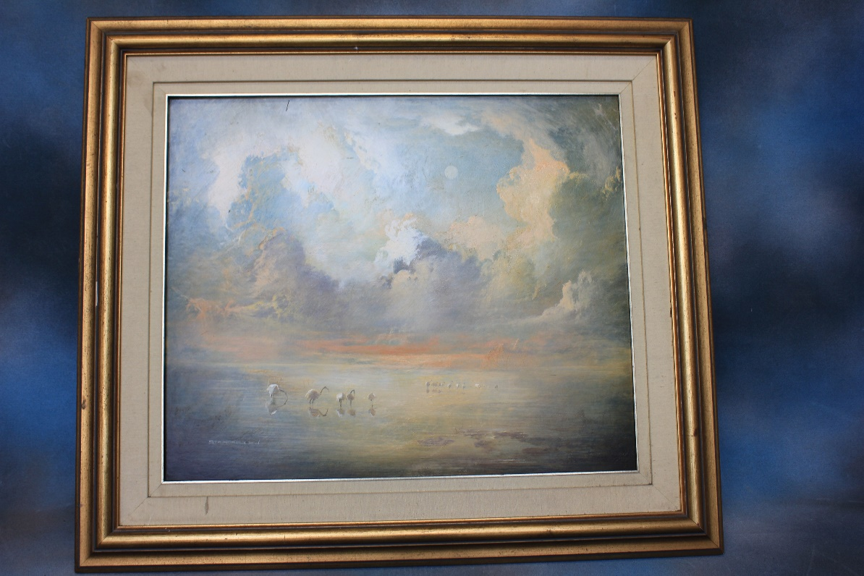 | Lot 130
131. | Six H.M.V. 78 rpm records of Churchill's speeches, in card covers (6). | £20-£30
132. | A Hornby '00' gauge tank type locomotive, three rail, 14cm long, in LNER livery. | £20-£30
133. | A quantity of mixed brass objects, including a pair of squat candlesticks, various boots, and a pixie mounted letter holder. | £20-£30
134. | A mixed part combination set, by Colclough and Grindley's, in "Sandon" and similar patterns. | £30-£50
135. | A stained wood canteen of mixed table cutlery, 37cm wide. | £40-£60
136. | An Ingersoll "Dan Dare" keyless wound pocket watch, version No. 1, with eagle crest on back of chrome case, 6cm in diameter, including winding crown. | £100-£150
137. | A set of six silver-plated goblets, in lined blue case, and a moulded glass sherry decanter, with silver-plated mount, 26cm high (2). | £30-£50
138. | A lady's small silver toilet box, with foliate scroll decoration, Birmingham 1893, and a small oval pill or patch box, unmarked, with part-gilt lining (2). | £30-£50
139. | A quantity of football cards, and ephemera, loose, and in albums, including 103 Topical Times cards 1938/39, a further 30 in an album, two part sets of A4 size cards, together with famous teams and stars, five Topical Times albums, five sport team picture books, together with envelopes and some loose photographs. | £100-£150
140. | A Rev. John Brown Family Bible, with black and white illustrations, published by "A. Fullarton and Co, Glasgow". | £40-£60
141. | A late Victorian needlework sampler, by "G. French, aged 12, 1888", 31cm x 19cm, and another sampler of similar date, 16cm x 35cm (2). | £40-£60
142. | A stained oak engineers tool chest, with fall front, fitted five short and three long drawers, containing tools and pocket books, 46cm wide. | £60-£80
143. | A mahogany and brass cabinet maker's plane, 25cm long, and a miniature cast metal plane, 10cm long (2). | £50-£70
144. | A SL type miner's lamp, by "The Protector Lamp, and Lighting Co Ltd", believed to have been used at Seaton Colliery, County Durham, 24cm high. | £20-£30
145. | A World War Two Afrika Korps belt, with "Gott Mit Uns" buckle, together with a canvas bag, a webbing belt, some newspaper cuttings and ephemera, in de-mob type suitcase. | £40-£60
146. | A pair of English pottery "Nanking" vases, decorated flowers, one with cover, the other repaired, 52cm high, one a.f. (2). | £30-£50
147. | A pair of Dresden style vases, decorated in the Vienna manner, with figural and foliate panels, together with covers, each 28cm high. | £60-£80
148. | An 18ct gold diamond solitaire dress ring, approx. 0.33 carat round cut stone. | £250-£350
149. | An 18ct white gold wedding band, shaped to be connected to a solitaire ring, set tiny diamonds. | £200-£300
150. | A 9ct gold half eternity ring, set fifteen tiny diamonds. | £150-£200
151. | A pair of 9ct white gold earrings, each set a pear shaped aquamarine, and twelve tiny diamonds, in lined box. | £200-£300
152. | A simulated rosewood music chest of twelve drawers, of wellington chest style, 61.5cm wide x 134cm high x 41cm deep. | £80-£100
153. | A George III style mahogany hanging corner cupboard, the panelled door enclosing three shaped shelves, below a blind-fret carved frieze, and dentil cornice, flanked by fluted and canted corners, 67cm x 96cm.
154. | A Victorian mantel clock in ebonised case, with French striking movement, white enamelled dial, 40cm high. | £40-£60
155. | Two bisque head and composition body dolls, probably of German manufacture, with a selection of later clothes, 54cm high, and 57cm high, respectively. | £40-£60
156. | A later model Sindy doll, with a selection of clothes, and three further plastic dolls, with some clothes (4). | £30-£50
157. | An early 20th century Staffordshire Pottery doll's or child's tea set, transfer printed decoration, circa 1917, 16 pieces. | £20-£30
158. | A quantity of Lego, with some catalogues, and instruction leaflets, together with a small quantity of Duplo pieces, various. | £40-£60
159. | A pair of small Edwardian art Nouveau style silver pedestal salts, maker Goldsmith and Silver Smiths Co Ltd, London 1901, a small mustard pot, Birmingham 1902, a small Scottish silver dish, Edinburgh 1898, a small Art Nouveau style bowl, Sheffield 1903, three mixed napkin rings, a Victorian fiddle pattern dessert spoon, London 1838, together with some small silver spoons, and other objects, some silver-plated pieces, and a silver-plated breakfast serving dish, approx. 16.5oz, weighable. | £200-£250
160. | A part suite of Edwardian silver fiddle pattern cutlery, London 1908, approx. 34oz. | £400-£500
161. | A pair of silver-plated and mother of pearl fish servers, a soup ladle, together with fish knives and forks, an ice hammer, a marrow scoop, a sifter spoon, two sauce ladles, other pieces, and two jugs. | £70-£90
162. | A brass oil lamp, in the Middle Eastern style, with snuffers, on circular foot, 62cm high, a brass ladle, and a copper warming pan, with turned wood handle (3). | £30-£50
163. | An oak canteen of silver-plated bone-handled, and stainless-steel cutlery, fiddle pattern, in oak canteen, 65 pieces, not all matching, together with a set of dessert knives and forks in oak canteen (2). | £60-£80
164. | A set of five pewter covered jugs, on circular feet, together with a number of jugs and tankards, measuring jugs, ladles, and ale jugs (20 pieces). | £80-£100
165. | Art Nouveau pewter candlesticks, a large coffee pot, a hammered tea and coffee set, a cocktail shaker, four glass holders, and other pieces (14 pieces). | £70-£90
166. | A Nauticalia part set of ten hardback books of Arthur Ransome's works, in blue open case, Swallows and Amazons, and Swallowdale missing (10 volumes, two missing). | £150-£200
 | 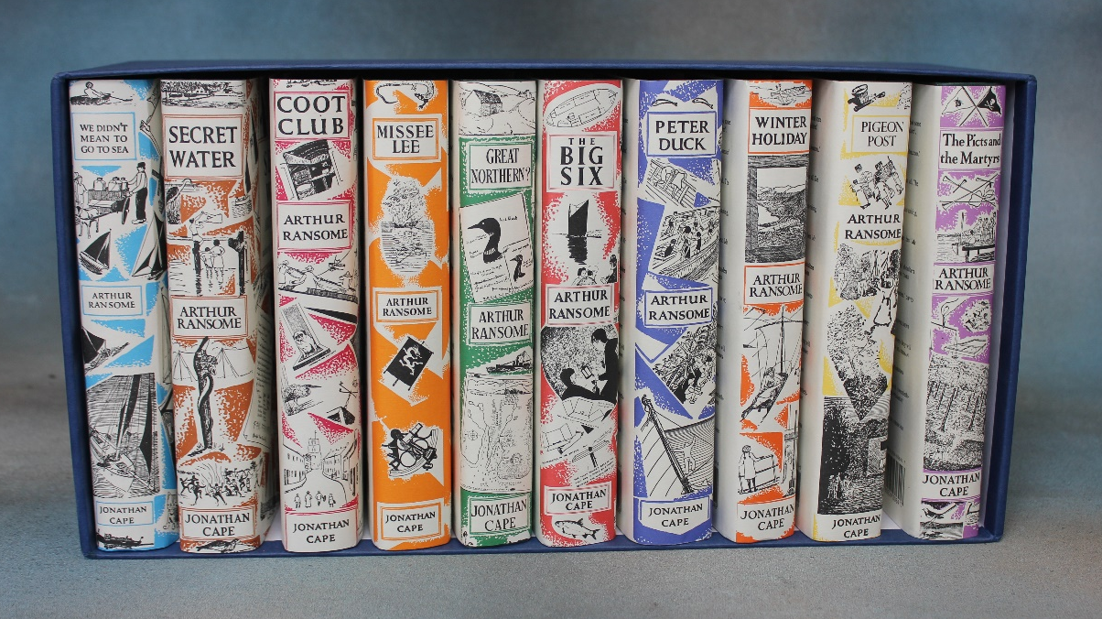 | Lot 166
167. | A Victorian pottery part fruit set, in Imari colours, a large oval meat plate and a Royal Doulton pixie pattern plate (13 pieces). | £40-£60
168. | A set of ten vols of Shakespeare's works, Bells edition, 1786, British Library a.f. (10). | £30-£50
169. | A late Regency rosewood fold over swivel top card table, 93cm wide. | £250-£350
170. | A late Regency mahogany bow fronted chest of two short and three long drawers 153cm wide. | £150-£200
171. | After Lionel Edwards- Hunting scene lithograph, 35cm x 51cm, a small watercolour of Chipstead, and three Paul Henry prints (5). | £50-£70
172. | Four paperknives and a crocodile figure, and a mother of pearl paper knife (6). | £80-£100
173. | A quantity of V.E Day bunting, a soldier's patent folding mess tin, ephemera and a Royal Air Force Merlin piston ashtray. | £90-£120
174. | A small mahogany open bookcase. | £60-£80
175. | A copper fireguard, coal box, kettle, warming pan and a letter rack (5). | £40-£60
176. | A Royal Doulton figure of a Pekinese dog, 10cm long. | £15-£20
177. | A Victorian inlaid walnut sewing box, a writing box, and a small tortoiseshell box and contents (3). | £60-£80
178. | A quantity of Waterford lozenge cut wine glasses and tumblers, together with other glass ware. | £150-£250
179. | A Noritake Deloraine pattern combination set, approx. 90 pieces. | £100-£150
180. | A Victorian light oak bookcase cabinet, 104cm wide x 222cm high. | £100-£150
181. | Two cobra skin handbags. | £40-£60
182. | A quantity of silver-plated ware, including a part tea set, a mother of pearl handled fish eater set, mixed spoons and other flatware, candlesticks, other tea ware and two trays. | £80-£100
183. | Five silver handled tea knives, two silver backed dressing table sets, and two squat candlesticks. | £80-£100
184. | A George V Irish silver Britannia standard circular presentation tray, Dublin 1925, 30oz. | £450-£550
 | 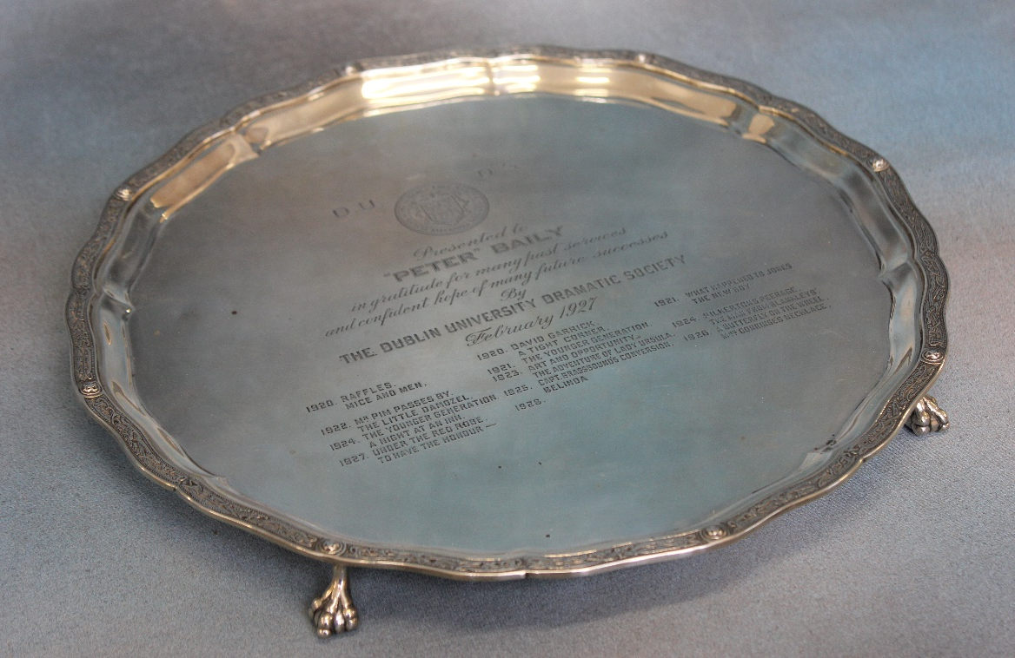 | Lot 184
185. | A small silver condiment set, two small bowls, mixed spoons, and two silver plated bowls. | £150-£200
186. | A Bokhara green ground rug, 180cm x 255cm a small rug, 129cm x 183cm, a pale ground Turkish rug, 125cm x 148cm, and a Kashan style rug, 134cm x 206cm (4). | £80-£100
187. | After James Pollard- two racing prints, and five interior prints (7). | £50-£70
188. | A quantity of general paintings and prints to include works by C.N Tay "Behind Bars" works by African artists and others, together with two Gaugee prints, six modern Japanese silk prints and four prints of old Dublin (19). | £80-£120
189. | A pair of Queen Elizabeth II silver two branch candelabra, 24cm high, Birmingham 1974 (weighted bases.). | £250-£350
190. | A George V silver waiter, Chester 1928, approx. 7oz. | £100-£150
191. | A George III silver waiter London, 1760, approx. 8oz. | £120-£150
192. | A George II silver waiter, London 1737, approx. 6oz. | £100-£150
193. | A George V silver salver, by James Dixon and Sons, Sheffield 1929 approx. 18oz. | £250-£350
194. | A Victorian style silver plated basket with handle, a bread board holder and two circular galleried trays (4). | £80-£120
195. | An Edwardian silver sauceboat, London 1903, two silver pepperettes, two salts, a further salt and two mustard pots. | £100-£150
196. | A set of six Edwardian silver teaspoons, and sugar nips, in case, two sets of silver coffee bean spoons and three napkin rings. | £80-£100
197. | A pair of small silver candlesticks, Birmingham 1972, weighted, bases, a small bowl, four napkin rings, a pepperette, a small pedestal bowl and a sugar castor (10), approx. 12oz. | £150-£200
198. | A three-piece silver-plated tea set, a silver plated sugar bowl and cream jug, together with an oval two handled tray with pie crust edge, 61cm wide (6). | £50-£70
199. | A large silver-plated gravy boat, a two handle oval dish, a small ice bucket, circular dish, two pepperettes, and other small pieces. | £100-£140
200. | An Iranian gold "Prince Reza Pahlavi" 18th birthday coin, contained in plastic wallet, approx. 20g. | £400-£600
201. | A late Regency pale mahogany writing table, with leather top, fitted three drawers, on turned and ringed legs, 92cm wide, in need of restoration. | £40-£60
202. | A late Victorian stripped pine and mahogany dressing table, with two short and one long drawer, on square tapering legs, 107cm wide. | £40-£60
203. | An Art Nouveau style stripped pine and mahogany wash stand, with open shelf above two drawers, on shaped bracket feet, splash back missing, 92cm wide. | £40-£60
204. | Cyril Trevor Smith - "Neither Fish Nor Fowl", a piece of resin and fibreglass sculpture of wave form, 57cm x 37cm high. | £80-£120
 | 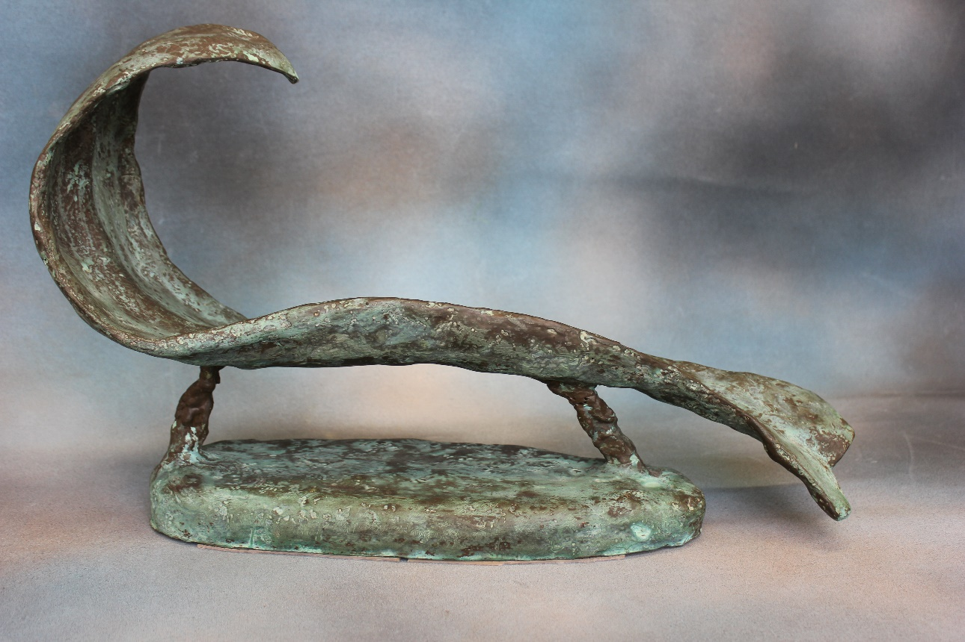 | Lot 204
205. | A silver-plated rectangular tray, a cocktail shaker, hot water and coffee pots, two sauce boats, a small breakfast server, and a goblet (8). | £60-£80
206. | A silver-plated punch ladle, a pair of serving spoons, two salts and other objects (13). | £40-£0
207. | A George V silver sugar caster, by Adie Brothers, Birmingham 1934, approx. 7oz. | £100-£150
208. | A small Edwardian silver tea-caddy, by Walker and Hall, Chester 1906, and a Christening mug, Sheffield 1964, approx. 7oz (2). | £100-£150
209. | A silver sugar bowl, London, date mark rubbed, approx. 8oz | £100-£150
210. | A George V silver cigarette case, Chester 1912, a continental silver cigarette case, and a box of small napkin rings. | £60-£80
211. | A set of silver-plated and bone handled fish knives and forks, a further set, a pair of mother of pearl handled butter knives, all boxed and a further set of fish knives and forks, in card box (4). | £50-£70
212. | A George III silver Hanoverian pattern basting spoon, London 1792, and four dessert spoons, London 1793, approx. 110z (5). | £160-£180
213. | An Edwardian silver sugar bowl, Birmingham 1902, three napkin rings, two egg cups, a small caddy, and a pepperette (8). | £60-£80
214. | A small late Victorian silver cruet stand, with glass bottles and jars, London, Birmingham, and Sheffield 1899 (7). | £100-£150
215. | A small quantity of mixed loose silver and silver-plated spoons, a small boxed set of silver teaspoons, Sheffield 1974, and two part sets of silver-plated spoons, boxed. | £40-£60
216. | An oak canteen containing a part suite of silver spoons and forks, Sheffield 1927, 1928, and 1955, 28 pieces, together with bone handled and stainless-steel knives, 44oz weighable. | £400-£500
217. | Six George III silver old English pattern table forks, two sauce ladles, and eight teaspoons, some pieces later, London 1813, 1832 and 1833 (28 pieces) approx. 25oz, weighable, in an unassociated oak canteen. | £350-£450
218. | A "Paillard" cine projector, in carrying case, a "Pathéscope" projector, 13cm high, together with fifteen pathéscope and Pathé films, on rolls (17). | £80-£100
219. | A Hornby '0' gauge Pullman railway coach boxed, a French railway sleeping coach, unboxed, a 4-4-0 "Country of Bedford" locomotive, and unassociated tender, all unboxed, together with track and other accessories. | £80-£120
220. | S.M. Smith 1859- Landscape, with figures, possibly near Sheen, indistinctive description verso, oil on canvas, 28.5cm x 29.5cm. | £120-£180
221. | An Early 20th century bamboo officer's cane, the silver-plated tip bearing the badge of 17th/21st Lancers, 89cm long. | £40-£60
222. | A George V silver three piece sea set, of faceted design, maker Goldsmiths and Silversmiths Co Ltd, Sheffield, 1918, approx. 31oz. | £400-£500
223. | A pair of George V silver sugar castors, in lined box, Chester 1921, approx. 17oz (2). | £250-£350
224. | A set of six George VI silver tea knives, Sheffield 1937, a further tea knife, and a cigarette box, Birmingham 1931, with later inscription, a.f. (8). | £40-£60
225. | A four piece silver plated tea set of Arts and Crafts style by "Easi-Nest" together with a small stand (5). | £60-£80
226. | A pair of silver-plated oval entrée dishes, a pair of candlesticks, a.f., two coasters, a small ice pail and other pieces, approx. 18. | £60-£80
227. | Harold Wyllie, after W.L Wyllie- "The First Journey of Victory, 1778" lithograph, 45cm x37cm, a ditto "The Last Journey of the Victory, 1992", a chromolithograph "Goodbye My Lads", two framed jigsaw puzzles relating to Nelson, together with other pictures (12). | £60-£80
228. | Keith Burtonshaw 2002- watercolour of fishing boats, with added form of HMS Victory, sailing nearby, letter from "The Nelson Society" and related postcard verso, 36cm x 52cm, together with a print of Wellington, and the 52nd Foot at Waterloo, a print of Napoleon, two prints relating to Nelson's funeral, and a portrait print (6). | £50-£70
229. | The U.K Hydrographic Office- a bicentenary print of Nelsons Voyage on H.M.S Victory, leading to the Battle of Trafalgar, published 2005, 59cm x 83cm, a further Nelson commemorative print, a small engraving, after a miniature portrait of Nelson, and six further prints and engravings relating to Nelson and the Battle of Trafalgar (9). | £60-£80
230. | A Seiko stainless-steel wristwatch of Divers Style, no. 8309-735MR the winding crown at 4 o’clock, case no. 758517. | £80-£100
231. | An Omega gent's silver cased wristwatch, white enamelled dial, case no. 597 1244, on leather strap, a.f. | £80-£100
232. | A "Casio" quartz wristwatch, a "Smiths" gold plated wristwatch, two Swiss Army wristwatches in working order, boxed, and a mixed quantity of further wristwatches, boxed and unboxed (11). | £200-£300
233. | A leather covered crucifix with figure of Christ, in cast metal, contained in lancet shaped box, bears a trade label "Tancredi, Roma", 20cm long. | £80-£100
234. | A Hohner "Marine Band" harmonica, boxed, and a further silver-plated harmonica, unboxed (2). | £20-£30
235. | A gent's stainless-steel Dirty Dozen "Lemania" pilot's monopush chronograph type wristwatch, with war department symbol, and stamped "HS 9A, 80312" now on a Rolex link strap, no paperwork and contained in an unassociated bag. | £1500-£2000
 | 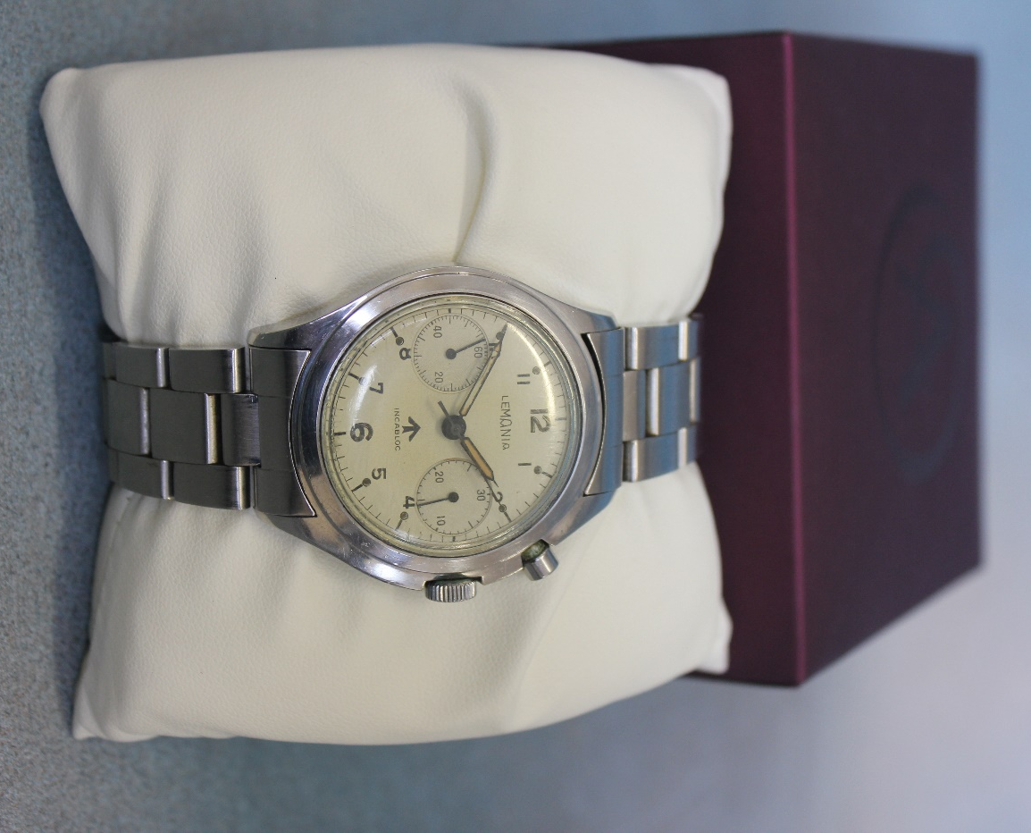  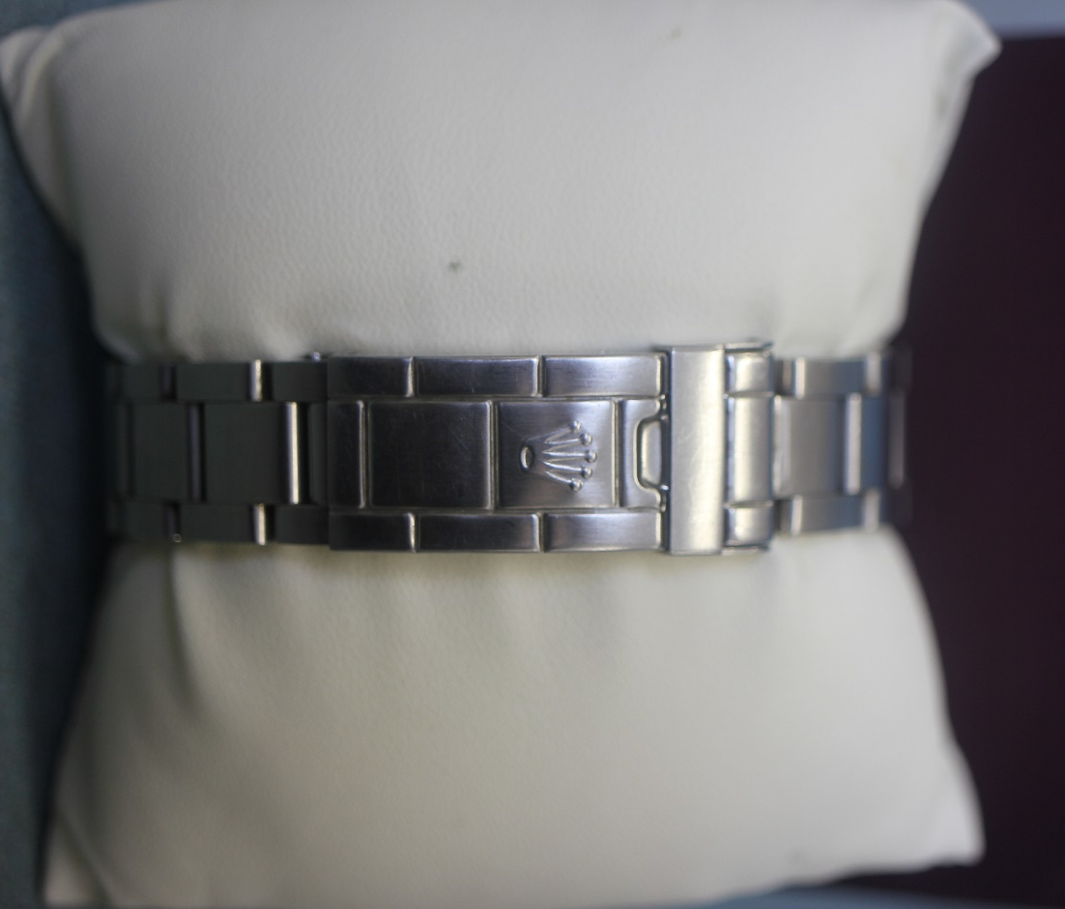 | Lot 235

Future Dates

AUCTION DATES 2021

Wednesday 27th October 2021

Wednesday 1st December 2021

Viewing on Monday and day before sale from 12.00pm to 7.00pm
and on morning of sale from 9.00am to 10.30am
Sale commences at 11.00 am.

(Please note that these viewing times do not apply to the 15th September sale.)

VALUATION DAYS 2021

Wednesday 29th September 2021

Wednesday 3rd November 2021

Wednesday 8th December 2021

Sevenoaks Saleroom, Argyle Road,
Sevenoaks TN13 1HJ

11.00am – 4.00pm

Notes

