We are very glad that we are now able to hold our first auction since the Covid-19 lockdown. Due to social distancing, we are making changes to how we hold our auction, and it is imperative these rules are followed.

Our sale is ONLINE ONLY. You must register with easyliveauction.com and follow their steps to create an account. You can then follow our page, www.easyliveauction.com/ibbettmosely/ where you will find a full catalogue, fully illustrated, plus condition reports of each lot. EasyLiveAuction have a charge of 3%.

Alternatively, commission bids (bids left ‘on the book’) may be left with us, as well as a limited amount of telephone bids.
As previously, if you have not registered to bid with us, you must now register directly with us to leave commission bids or telephone bids.
If you intend to follow the auction online and bid, this does not apply.

We can offer viewing of the sale BY APPOINTMENT ONLY IN LIMITED NUMBERS. Please do contact us to book a suitable time slot.

And finally, collection of items purchased cannot take place in the normal fashion, unless an agreement is in place.
Courier PSP Logistics will carry out deliveries of all items. You MUST contact them directly to arrange and pay for delivery.


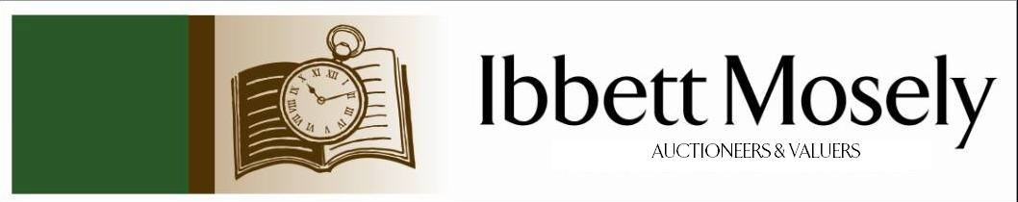

Catalogue of Antique, Edwardian and Victorian
Furniture and Effects
to be Auctioned on

Wednesday 17th June 2020
at 12.30pm

IBBETT MOSELY AUCTION ROOMS
ARGYLE ROAD, SEVENOAKS, KENT TN13 1HJ
Via www.easyliveauction.com/ibbettmosely/

On View:
www.easyliveauction.com/ibbettmosely/
and at Sale Room on
Monday 15th June 2020
Tuesday 16th June 2020
STRICTLY BY APPOINTMENT ONLY. (Limited numbers)

Catalogues: £2.00

Auctioneer and Valuer: Alan White FNAVA
Consultant Auctioneer and Valuer: Derek Hodge

Trainee Valuer and Clerk: Nicola Rainsley-Hughes
Auction Clerk and Administrator: Emily Frederick


1. | A silver medallion engraved ‘Presented to M H Wonnall 1943 for 15 years Faithful Service’ (Hudson Bay Company) together with blue ribbon and three bars, boxed, weight adbury 40 grams. | £50-£70
2. | A 9ct gold medallion engraved ‘presented to M H Wonnall 1958 for 50 years Faithful Service’ (Hudson Bay Company) weight adbury 39.17 grams. | £400-£450
3. | 9ct gold cigarette case, Chester, weight 99.4 grams. | £1100-£1200
4. | A gold hat pin. | £25-£30
5. | George V gold sovereign 1918. | £175-£200
6. | George V gold sovereign 1915. | £175-£200
7. | A Reich 1889 gold 20 Mark coin. | £160-£170
8. | A Reich gold 10 Mark coin. | £90-£110
9. | A Gentleman’s 9ct gold signet ring, 9ct gold ring with single ruby and a Gentleman’s 9ct gold signet ring with crest, total weight 24.5 grams. | £300-£350
10. | A reproduction oak sideboard, fitted three frieze drawers, brass handles, below cupboards enclosed by two double and one single door on flat bass 205cm wide. | £50-£60
11. | A gilt framed wall mirror 106 x 74cm. | £40-£45
12. | A Victorian walnut oval table with inlaid top on twin turned end pedestals, single stretcher, 86 x 47cm. | £60-£75
13. | A crystal glass wine decanter with hallmarked silver collar and pouring lip complete with stopper. | £40-£55
14. | An Edwardian mahogany occasional table, shaped top with undertier on square cabriole 70cm dia. Somewhat similar table and a mahogany plant stand on square taper legs, swept ends. | £40-£60
15. | Oak occasional table with galleried undertier on square cabriole legs, 53cm wide. Oak bedside cupboard 39cm wide, a string top stool and a nest of three tables, inset leather tops on turn table legs. | £35-£40
16. | A Windsor chair with arms, high spindle rail back on shaped front legs and a Victorian mahogany hall chair, shaped back, solid seat on turned shaped front legs. | £40-£45
17. | 19th century mahogany plant stand, turned column, on square tripod legs and a Victorian gilt bedroom. (2) | £40-£45
18. | 19th century table with flaps fitted two drawers, wood knob handles opposite dummy drawers on turned shaped castors, 44cm wide and a mahogany bed side table with undertier complete with single drawer, 34cm wide. | £50-£60
19. | Pair of 19th century vases with floral pattern in a cartouche on a blue ground, height 30cm. | £40-£50
20. | Painting, cottage garden scene, oil on board, 53 x 50cm, unsigned. | £30-£35
21. | “Ruiz” A Still Life, bowl of flowers in mixed colours white, red etc and leaves, oil on canvas, 90 x 63cm. | £30-£35
22. | A mahogany gate-leg oval flaps on turned taper legs, 99cm wide. | £40-£45
23. | Edwardian tub shape chair upholstered in floral pattern material on turned taper legs, ending castors. | £35-£40
24. | Reproduction dressing table fitted three frieze drawers on either side, raised on short cabriole style legs, 180cm wide, a dressing mirror and two matching bedside cupboards, each with single frieze drawer, cupboard under enclosed by pair of doors, 61cm wide. | £60-£70
25. | A pair of bulbous shaped table lamps with pattern of exotic bird complete with white shade, height 59cm, and bulbous shaped blue and white ditto cream shade. | £30-£40
26. | Gentleman’s chair with arms upholstered in red studded leather, button back on square legs. | £40-£50
27. | A small mahogany bookcase, a Victorian rosewood tripod table, and a rosewood occasional table. (3) | £20-£25
28. | Gilt framed wall mirror with scrolls of acanthus leaves, 120 x 68cm. | £25-£30
29. | A pine dresser, the upper part fitted three plate shelves, three frieze drawers brass handles, breakfront cupboard enclosed by doors, 155cm wide. | £70-£80
30. | George III mahogany chest of two short and three long graduated drawers, brass handles on ogee feet, 84cm wide. | £80-£90
31. | Edwardian inlaid mahogany towel rail, a Victorian dining chair, and sundry items. (5) | £20-£25
32. | Gilt framed bevelled wall mirror 83 x 39cm, and  a carved wood mirror. (2) | £20-£25
33. | Pair of china bulbous lamps, each decorated with Japanese figures complete with white shades, height 63cm. | £30-£35
34. | Mahogany reproduction chest of four drawers, oxidised handles on flat base. | £30-£40
35. | Reproduction dining table on shaped end pedestals, 57 x 91cm. | £20-£25
36. | Set of six reproduction dining chairs with shaped ladder style backs, padded seats. | £20-£25
37. | Pair of Georgian silver sauce boats, gadroon edge with lion mask on claw feet, flying dolphin handle, crest of a Jester, London 1809, maker C F (marks rubbed).  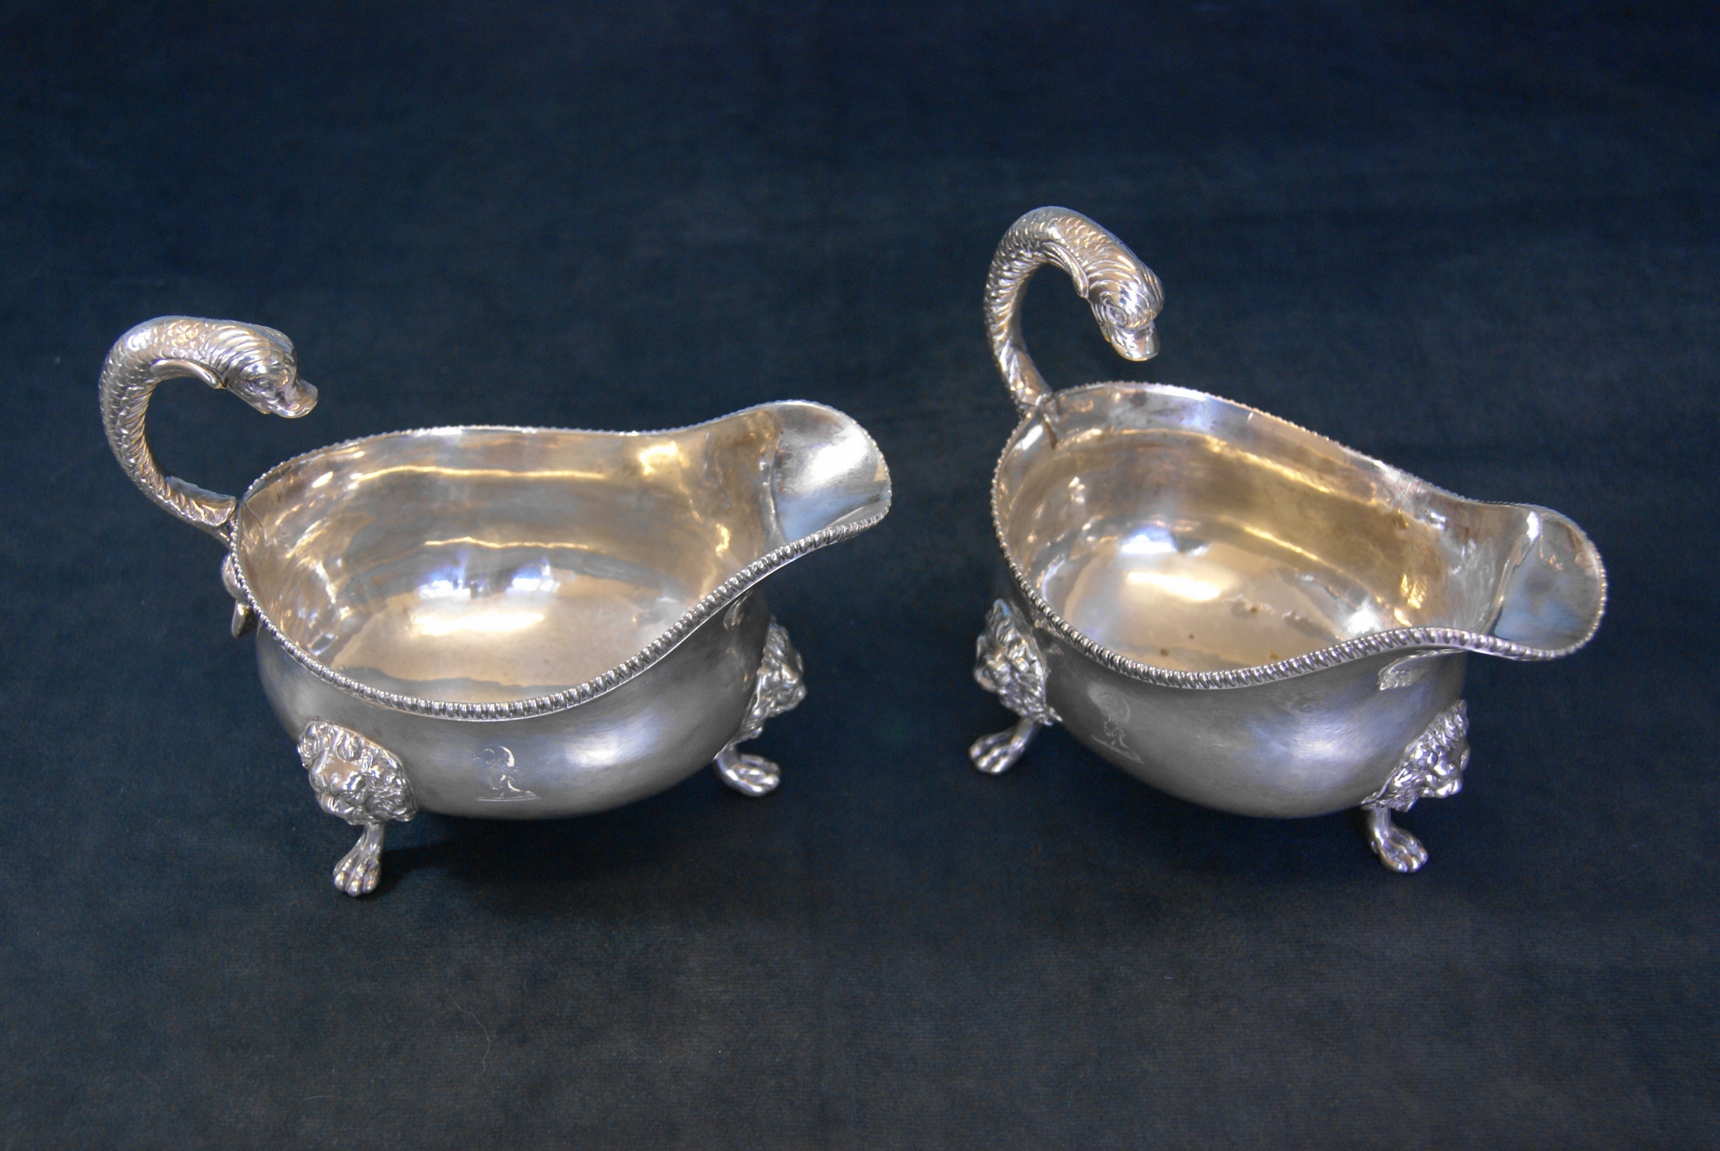 | £280-£290
38. | A Russian silver parcel gilt cake slice, the blade pierced with scrolling and foliage, the handle chased with scrolls etc. | £140-£160
39. | Pair of George III silver card trays shaped with bead mount on ball and claw feet, 15cm dia, London 1774, maker RR. | £240-£260
40. | EPNS fruit bowl with carrying handle raised on footed base, 30cm dia, and an oval dish (2) | £40-£45
41. | A mixed collection of china and figurines including a Booths ‘Mandarin’ bowl with cover, an oval Wedgewood dish decorated blue and white flowers, small Noritake bowl, glass paper weight, a decorative china plate 20cm dia, two Country Artists bird figures, small cup by W H Goss and Sundry china. | £25-£30
42. | Carlton Ware beer tankard, Carlton Ware dish, three piece Art Decco Devon ware cruet set on stand, one piece a/f, pottery vase decorated stylised flowers, two handled Noritake vase, hexagonal shaped pot on stand, four lidded decorative tea pots, two Susie Cooper plates and sundry china. | £25-£30
43. | Mahogany corner hanging display cupboard with single astragal glazed door, 56cm wide. | £40-£50
44. | Walnut display cabinet with low raised back, pair of glazed doors enclosing two glass shelves, 90cm wide. | £30-£35
45. | Oak reproduction Dutch style dresser the upper part with three plate shelves, below two frieze drawers and cupboard 87cm wide. | £40-£45
46. | Glass cabinet with single door enclosing four shelves, 40x 48cm height 180cm. | £45-£55
47. | 19th century mahogany longcase clock, silvered dial, seconds hand, strikes on a bell by Brockbanks, London, height 210cm.  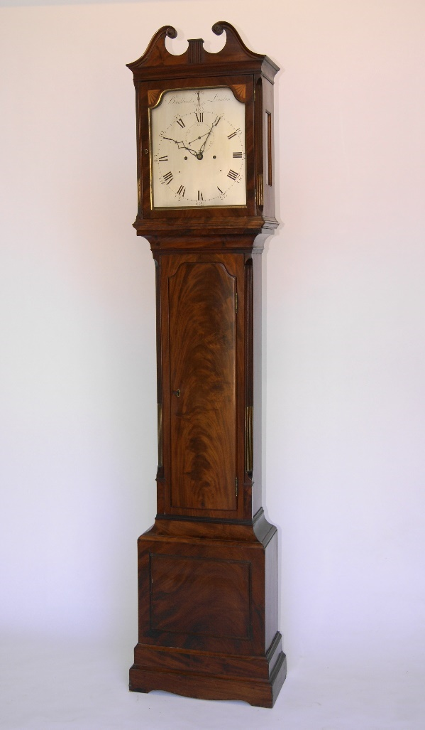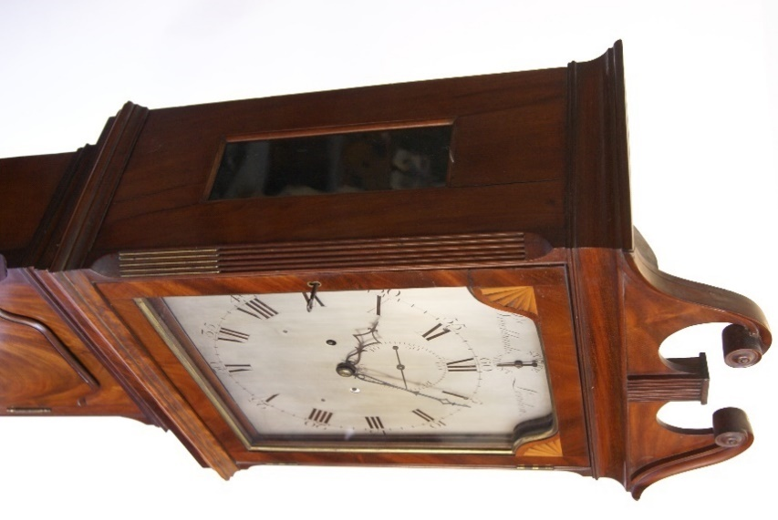 | £250-£275
48. | A selection of tinted glassware including vases etc. | £30-£40
49. | Victorian rosewood work box, single frieze drawer, wood knob handles and shaped supports, raised on a stand either end, and stile feet 57cm wide. | £80-£100
50. | Oriental camphor wood chest decorated in the Chinese style on bracket feet, 91cm wide. | £40-£60
51. | A pair of Staffordshire soup plates, a Royal Worcester Daedalus and Icarus plate, four ribbon type plates, and a blue and white teapot, with pewter lid, and two dishes. (10) | £15-£20
52. | NO LOT
53. | William IV mahogany pole screen with needlework panel on part tulip cupped stem, flat base on bun feet height 126cm and a 19th century mahogany plant stand height 128cm. | £60-£80
54. | A copper warming pan length 113cm and two Oriental brass bowls in sizes. | £20-£30
56. | Painting of Madonna and Child, attributed to Edith Gulmann (signed Edith), 53cm x 30cm on panel, and one other. | £30-£50
57. | An Early 20th Century glass two branch epergne, with green tinted edges, 41cm high. | £40-£60
58. | Three lady’s wristwatches, with quartz movements, two boxed, one unboxed (3). | £40-£60
59. | A 9ct gold gent’s signet ring, in box. | £150-£200
60. | A cold painted bronze of boar, 5cm long. | £80-£100
61. | A Art Nouveau style silver plated pen tray, three I dishes, and other silver plated ware, various. | £20-£30
62. | After Redoute – five flower prints, each 27cm x 20cm.
63. | G.S. Walters R.B.A. 1917 – View of Venice, with gondolas and fishing boats in foreground, watercolour, 24cm x 43cm. | £100-£150
64. | After Stephen Whittle – small print “The Pleasure Boat”, 14cm x 15cm. | £15-£20
65. | After Barry Clarke – “High Halden Road”, chromolithograph of tank locomotive, 50cm x 75cm. | £10-£20
66. | A Victorian pale mahogany Pembroke table fitted one drawer bearing a label for “T.H. Filmer of London”, on turned and ringed legs, 97cm x 94cm, extended. | £40-£60
67. | An Edwardian inlaid mahogany settle, on square tapering legs with castors, , 109cm wide. | £40-£60
68. | A Walker and Hall silver plated teapot, inscribed “LNER”, 12cm high. | £15-£20
69. | A George VI glass inkwell, with hobnail cut base, silver mount, and cover, London 1948, 12.5cm high, a.f., with two small glass inkwells, one a.f. (3). | £20-£30
70. | A pair of Teplitz Vienna porcelain vases, decorated flowers and foliage, 21cm high. | £15-£20
71. | Henry G. Walker – lobster fisherman’s cottage, coloured etching, 17cm x 34cm. | £15-£20
72. | 19th Century school – Crofter’s cottage, in landscape, watercolour, 25cm x 35cm. | £20-£30
73. | W.H. Pearson – “Herring Boat”, in rough seas, watercolour, 26cm x 63cm. | £40-£60
74. | T. Mortimer 1871 – mixed shipping, near harbour, watercolour, 18cm x 34cm. | £20-£30
75. | L.O. Linnell – Mediterranean scene, slope towards a lake, watercolour, 33cm x 24cm. | £20-£30
76. | Gorman Morris – “Off the East Coast”, watercolour, 18.5cm x 53cm. | £30-£50
77. | T. Mortimer – “Cornish Coast”, inscribed, watercolour, 24cm x 53cm. | £20-£30
78. | Linnell – winter scene, with lodges, pastel, 26cm x 36cm, together with four still life flower pictures (5). | £15-£30
79. | Anthony Van Dyke Copley Fielding (1787-1855), moorland landscape, with figure and cottages, watercolour, 16.5cm x 22cm. | £15-£20
80. | L.M. – Venetian flower and fruit sellers, watercolour, a pair, foxed, 33cm x 48cm. | £40-£60
81. | Three Rosenthal porcelain dishes, three flower pattern fruit plates, and a bowl (7). | £20-£30
82. | 19th Century school – figures by watermill on canal, watercolour, 30cm x 25cm. | £15-£20
83. | J.C. Jonas – fishing smacks leaving and coming ashore, watercolour, 18cm x 45cm. | £20-£30
84. | Norman Bradley – “Haytime”, and “Near Godalming”, watercolours, a pair, each 17.5cm x 37cm. | £20-£30
85. | After Joseph Farquharson – feeding the sheep in winter, engraving, 57cm x 82cm, and after Alfred de Breanski, etching of sheep (2). | £10-£15
86. | A rosewood toilet mirror, and four Victorian dining chairs. | £15-£20
87. | A pair of floral porcelain vases, each 19cm high. | £15-£30
88. | An Edwardian inlaid mahogany display cabinet, 61cm wide. | £20-£30
89. | P.I. Cross – rear of Quebec House, Westerham, oil on board, 39cm x 58cm. | £80-£100
90. | A Dresden style porcelain table lamp, in the form of a maiden and putto, with shade, 48cm high, two small Samson porcelain groups of cherubs and lambs, a Dresden dish, 15cm wide, and eight miniature pieces (12). | £20-£50
91. | A silver plated tazza, with head of George III to centre, a silver plated teapot, a water jug, a faceted spill vase, together with mugs, other pieces, and a volume of “History of Old Sheffield Plate”, by Frederick Bradbury, 1968. | £20-£30
92. | A set of six Victorian walnut kidney back dining chairs, on turned legs, a.f. (6). | £40-£60
93. | A Victorian family Bible, with family register, and other information relating to the Cowdrey family between 1844 and 1886, relating to earlier members of the cricketing family, in need of restoration. | £80-£100
94. | A Japanese egg shell porcelain part tea set, and an English porcelain part tea set, decorated in the Oriental style. | £15-£20
95. | A Japanese table centrepiece in the form of a bonsai tree. | £15-£20
96. | Three graduated pottery figures of Shi-Shi, and two other highly decorated figures (5). | £20-£30
97. | A game of Chien Tung, in papier mache cylinder container. | £10-£15
98. | A graduated set of three Bretby pottery circular wall plaques, decorated in the Japanese style (3). | £15-£20
99. | An Early 20th Century French gilt metal and sevres style porcelain garniture vase, 27cm high. | £20-£30
100. | An Imari bowl with scalloped edge, decorated floral and foliage panels, 27cm in diameter. | £40-£60
101. | Le Comte – a biscuit porcelain bust of Marie Antoinette, bears a Sevres style mark verso, on decorative adbur and gilt metal base, 51cm high. | £150-£200
102. | An Edwardian mahogany circular centre table on turned and reeded legs, united by an undertier, 68cm in diameter. | £20-£30
103. | A small carved Whitby Jet brooch in lined box, together with a quantity of mixed decorative and costume jewellery, also a pink comact dish with Scottish Thistle. | £40-£60
104. | A reproduction filled sterling silver roundel, No. 306 of 750, copied from the Chellens Madonna bronze after Donnatallo, maker Pobloy Mint, London 1976. | £20-£30
105. | An Early 20th Century continental oak bookcase, enclosed by a pair of glazed doors, with applied flowerhead decoration, 131cm x 178cm high. | £80-£100
106. | An Early 20th Century North European oak bookcase, with central blazed bow shaped centre door, and two panelled doors, on reeded tapering feet, 180cm x 155cm, together with a pair of display cabinets, with bevelled glass panels, each 52cm x 130cm, and a two tier tea table (4). | £150-£200
107. | A oak kneehole desk, matching the previous lot, 161cm wide, together with an office elbow chair, two side chairs, and a green upholstered settee (5). | £100-£150
108. | An Early 20th Century Chinese lacquered urn stand, decorated dragons, and figures in ladscapes, 42cm in diameter, 53cm high. | £40-£60
109. | A Chinese Lacquered papier mache vase, 54cm high. | £20-£30
110. | A carved and ebonised hanging cabinet, the door with bevelled mirror panel, 41cm wide. | £20-£30
111. | An octagonal shaped wall mirror, in pale green frame. | £15-£20
112. | A pair of Wilkinson blade rapiers, with bound grips (2). | £40-£60
113. | A brass and white metal bound Kris type dagger, 45cm long overall, and two wood and white metal inlaid daggers (3). | £40-£60
114. | A small Jambya type dagger, with bone handle, and a similar white metal dagger (2). | £30-£50
115. | A crudely carved Inuit type snow knife, the name “G. Dumeaux”, inscribed to a label, 27cm long. | £40-£60
116. | An Indian Katar dagger,in bound wood scabbard, 27cm long. | £80-£100
117. | A small bone tribal hunting knife, possibly Canadian or North American, carved with figures of elk, and some pierced decoration, 25cm long and a further hunting knife in scabbard (2). | £60-£80
118. | A late Victorian oak dining table, on square shaped legs, with extra leaf, 104cm x 171cm extended. | £80-£100
119. | A late Victorian oak open bookcase, with seven shelves, 97cm x 112cm. | £80-£100
120. | An early 20th Century oak hall stand, 75cm wide x 188cm high. | £80-£100
121. | A Pingdemon pottery dish, decorated a fish, 31cm in dia. | £30-£50
121A. | A pair of early 20th Century Imari charger dishes, each 40cm in dia. | £80-£100
121B. | A blue and white part dinner service, adbury 53 pieces. | £40-£60
121C. | A pair of Doulton stoneware vases, with green mottled bodies, 28cm high. | £60-£80
122. | A Set of silver plated fish knives and forks in canteen, six of each. | £15-£20
123. | Diane Kelder – “The Great Book of French Impressionism”, published 1980. | £20-£30
124. | A clocking-in clock by the “National Time Reorder Company limited”, 98cm high and a card rack.  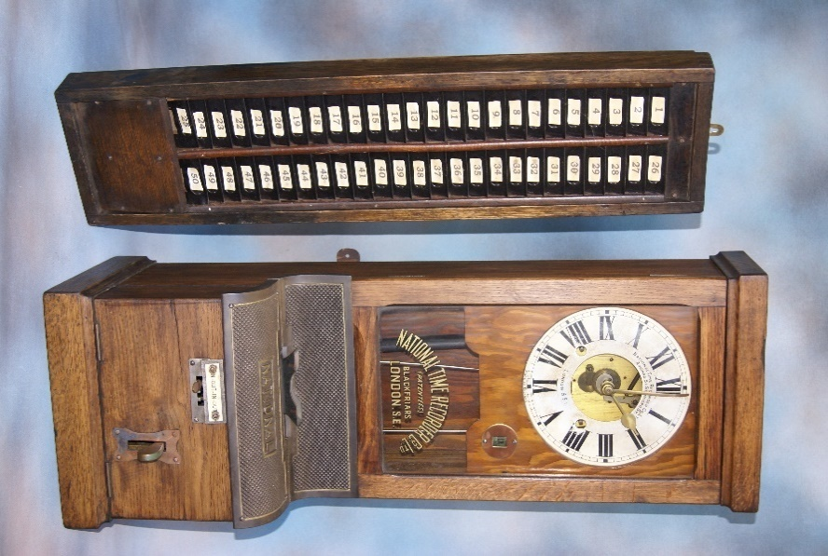 | £250-£350
125. | Debucourt after Norblin – set of aquatints of various trades, 24cm x 16cm. (14) | £150-£200
126. | Large silver framed mirror. | £100-£150
127. | Carved Sperm Whale tooth, 19th Century. | £200-£300
128. | Four rare sheets of German WWII period stamps. (4) | £30-£50
129. | A Chinese decorative charger dish, 41cm in dia. | £150-£200
130. | NO LOT
131. | To Private H Spackman 7829 Second Wiltshire Regiment, A WWI three medal group, framed, together with a number of cards and photographs, some later. | £50-£70
132. | Austrian Art Deco style figure on marbleised base, 28cm high. | £80-£100
133. | Quantity of corgi and dinky toys in boxes. | £160-£200
134. | Large box containing loose coins and proof coins with certificates. | £200-£300
135. | Four 17th Century Dutch tiles, each 13cm x 14cm. | £30-£50
136. | Album of stamps and cigarette cards, and a quantity of loose cigarette cards. | £40-£60
137. | Fusee silver pocket watch. | £30-£50
138. | NO LOT
139. | Two silver bangles, other small silver items, and mixed decorative jewellery. | £25-£35
140. | Two small Roman silver coins. | £20-£30
141. | Lady’s gold cased watch with gold stamp “W.O.” | £120-£150
142. | Four pairs of silver amber earrings, an amber and silver necklace and bangle, and a gold unmarked amber ring. | £180-£220
143. | A seven diamond 18ct gold dress ring. | £280-£320
144. | A 19th Century hand painted paper mache tray.
145. | A Victorian flower centre piece in domed case. | £80-£100
146. | A Dutch 19th Century oil on canvas, 37cm x 27cm. | £140-£180
147. | Two complete boxed Triang train sets, with spare track in further box. | £60-£80
148. | A Vienna regulator wall clock, in stained wood case, 75cm long. | £30-£50
149. | A “Starlon” gent’s wristwatch, a lady’s Ingersoll wristwatch, and a further lady’s wristwatch. (3) | £30-£50
150. | A “Jie of Sweden” pottery figure, possibly an incense burner, 16cm high. | £20-£30
151. | A pair of cut and etched glass decanters, with stoppers, and a sherry decanter. (3) | £20-£30
152. | Three albums of autographs from the theatre and music hall, including Hattie Jacques, Norma Wisdon, and others. (3) | £150-£200
153. | An album of autographed photographs including Norman Wisdon, John Le Mesurier, and others. | £80-£120
154. | A George III needlework sampler, dated 1789, set into a William IV mahogany polescreen, 123cm high. | £80-£100
155. | A three legged stool with carved decoration. | £20-£30
156. | A Chinese part incense burner with decorative upper band, 32cm diameter. | £40-£60
157. | A terracotta vase with green glazed flaking, 38.5cm high. | £40-£60
158. | An African carved wood mask, inset with three bone lozenges, probably Tanzania. | £50-£70
159. | An ebonised small axe, with carved shaft, and a hunting sword. (2) | £40-£60
160. | A Chinese small hardwood chest, 43cm wide, and a set of opium scales. (2) | £50-£70
161. | An inlaid oak ladder back chair, decorated with hunting scenes, 44cm wide. | £60-£80
162. | A Chinese Jade two part seal, in hard wood box. | £80-£100
163. | Two Chinese wicker baskets, a decorative stained wood bowl and cover (3) | £40-£60
164. | An Early 20th Century Chinese low hardwood table, 86cm wide. | £80-£100
165. | A adburyte figure of a hawk, on wood base, 31cm high. | £30-£50
166. | An Omani wicker work bowl and platter. (2) | £20-£30
167. | A Modern Chinese decorative black tea-set, in lined box. | £20-£30
168. | A Certina automatic gent’s wristwatch, in stainless steel case, with leather strap. | £60-£80
169. | A Jingdezhen porcelain bulbous vase, decorated with fictional characters and pterodactyls, boxed and with paperwork. | £80-£100
170. | A set of six 20th Century light oak dining chairs, cane backs. | £80-£100
171. | T.G. Green and Co Ltd – a graduated set of six “Ming” pattern jugs, decorated in the oriental style, and a mid-winter “Yang” pattern jug. (7) | £40-£60
172. | A motor Calormeter, by “Wilmott Breeden Ltd”, originally from an Austin 7. | £30-£50
173. | A French gilt metal mounted mantel clock, Louis XVI style, 79cm high, in need of some restoration.  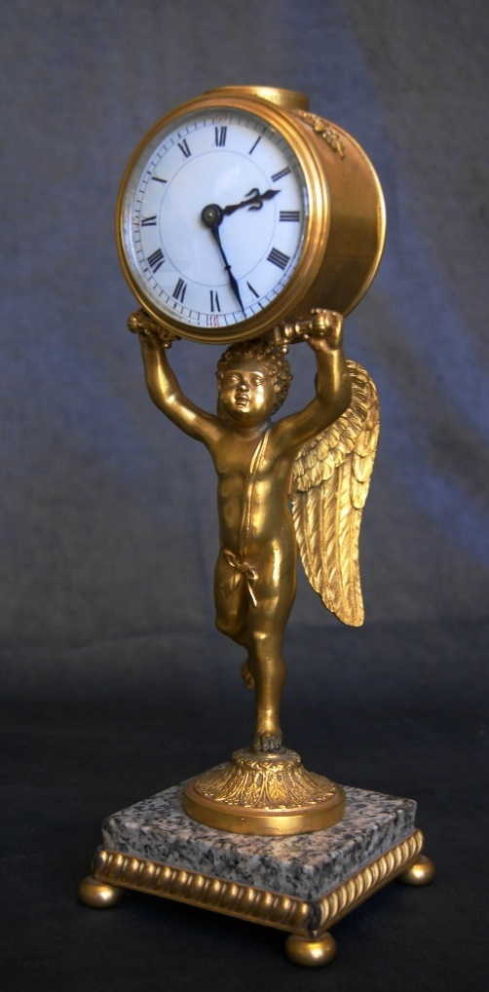 | £300-£500
174. | A 19th Century burr walnut mantel clock, with square dial, 46cm high. | £250-£350
175. | A late 19th century gilt brass carriage clock, with repeat button, retailed by “ J W Benson London “ 13.5 cm high. | £100-£150
175A. | An early 20th Century carriage clock with repeat button, retailed by “J W Benson London” 13cm high. | £100-£150
176. | A French brass mantel clock, with scrolled and pierced decoration, 8 day movement 23cm high. | £200-£300
177. | A late Victorian silver gilt silver smith’s freedom casket, inscribed verso “Presented to John Aynsley Esq, JP, Mayor 1886 – 1890, with the freedom of the Borough of Longton, 3rd October 1899”, possibly retailed by W H Ashton of Longton, maker “ S. Blanckensee & Son Ltd”,Birmingham 1899, on velvet and ebony base, 36cm wide.  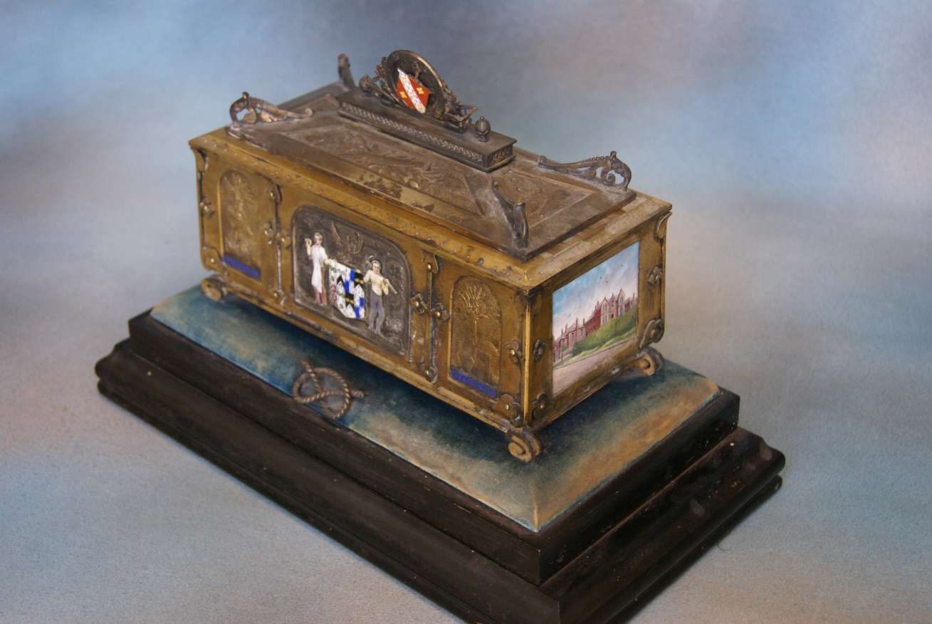 | £2500-£3500
178. | A 19th Century French gilt metal figural mantel clock, the case supported by a cherub, on marble and gilt metal base, 34cm high. | £500-£800
179. | T. Dingle -Smith – pair of agricultural scenes , with figures and corn stooks, oils on panel, 12cm x 16cm. | £150-£200
180. | A 19th Century school- reclining child on a cross, oil on panel, 13cm x 16cm, in gilt frame on gilt and velvet panel, 30cm x 31cm adbury. | £150-£200
181. | Furlong – Abstract subject, mixed media, 33cm x 46cm. | £30-£50
182. | A Victorian inlaid walnut dome top tea-caddy, in need of restoration.
183. | Published by Stationers Hall – “Cox and Yehma, London”, The Rules of Snookers and Pool, framed.
184. | A Vienna regulator wall clock, in stained wood case.
185. | A 1922 folio copy of an ordinance survey map of England and Wales.
186. | A Late Victorian swivel office chair with slat back.
187. | A 9ct gold link and bar bracelet, adbury. 3.5g, a chromed pendant, ad a pair of earrings, set paste stones, a “Rosita” simulated pearl necklace, with paste set clasp, together with a mixed quantity of costume and decorative jewellery. | £40-£60
188. | Walter Gregory – “At York Road Terminus, Wandsworth, April 1948”, pencil drawing, 29cm x 41cm.
189. | Walter Gregory – “The Aldgate Tram”, No 67, pencil drawing, 39cm x 59cm.
190. | After Richard Borridge – “North End, Croydon 1948”, chromolithograph, 50cm x 65cm.
191. | Sidney Parsons – carved wood portrait plaque of his wife, 28cm x 22cm.
192. | Sidney Parsons – a cast plaster plaque, portrait of little girl, 25cm x 25cm, probably his adbury, Evelyn.
193. | Four wooden toy locomotives with some tenders, made by Alfred Bloxam, who was a Journeyman organ builder. (4)
194. | Five boxes of early Meccano Dinky Toy vehicles, including lorries, buses, and other vehicles, various.
195. | An “Express” playing card game, an “Ian Allan train card came, together with Happy Families, and others. (7)
196. | A small collection of picture postcards of Blackpool, Liverpool, and other locations, showing trams in service.
197. | An Alec Bedser Cricket Benefit Book, 1953, together with a small collection of cricket score cards, including “Gentlemen of England V. Australians, 1948”, “Surrey V. Kent, 1959”, and a magazine “The Story of Test Cricket, England V. Australia”.
198. | A small collection of Railway Records of Locomotives, various, including A4 class, schools class, and others. (12)
199. | Victorian school – small landscape, with croft type cottage, and figures, oil on canvas, 15.5cm x 26cm, unframed. | £20-£30
200. | W.E. Ellis – landscape with cottage and various figures, oil on canvas, in need of restoration, 24cm x 38cm. | £30-£50
201. | Patty Mayor – tree in a landscape, oil on board, 31cm x 40cm. | £40-£60
202. | J.G. – a seated French soldier, with red kepi, oil on canvas, 30.5cm x 25cm. | £40-£60
203. | A George III mahogany chest-on-chest, fitted three short and seven long drawers, with brass ring handles, canted corners, inlaid with stringing, 117cm wide x 219cm high. | £250-£350
204. | A Regency mahogany linen press, the upper part enclosed by oval panelled doors, above four long drawers, on splay feet, 127cm wide x 211cm high. | £150-£200
205. | G. Virtue – a map of Kent, 34cm x 41cm, together with two small maps of Orkney and Shetland Islands. (3) | £20-£30
206. | P. Schenke and G. Valk – a map of Pembrokeshire, 46cm x 59cm, and a map of Milford Haven. (2) | £30-£50
207. | D. Ioanni Scott – a map of the Orkney and Shetland Islands, 47cm x 60cm, and a later map “Scotland III”. (2) | £40-£60
208. | After Archibald Thorburn – “St. Kilda House Mouse, and”Common Mouse”, lithograph, 29cm x 23cm, a further lithograph “The Common Mouse”, and a quantity of mixed prints. (11) | £20-£30
209. | A 19th Century rosewood and Mother of Pearl inlaid wheel barometer, inscribed “Davison of Kettering”, 93cm high. | £80-£100
210. | A Late 19th Century dark carved oak side table, 106cm wide. | £30-£50
211. | An oak blanket chest, and a Victorian circular top games table (top warped), 50cm in diameter. (2) | £30-£50
212. | A coopered and brass bound bucket, a barrel form coal scuttle, and a George III style dining chair. (3) | £40-£60
213. | A mixed quantity of silver plated ware. | £20-£30
214. | A carved oak corner cupboard, in need of restoration, 82cm wide x 137cm high. | £30-£50
215. | F. Garnett – portrait of young girl, oval, pastel, signed, 45cm x 34cm.
216. | A quantity of ‘Christofle’ beaded edge table cutlery, together with a non-matching cake slice (25 pieces) | £150-£200
217. | Late Regency rosewood dwarf bookcase, fitted three shelves, carved pilasters, on bun feet 160cm wide, small section of veneer missing.  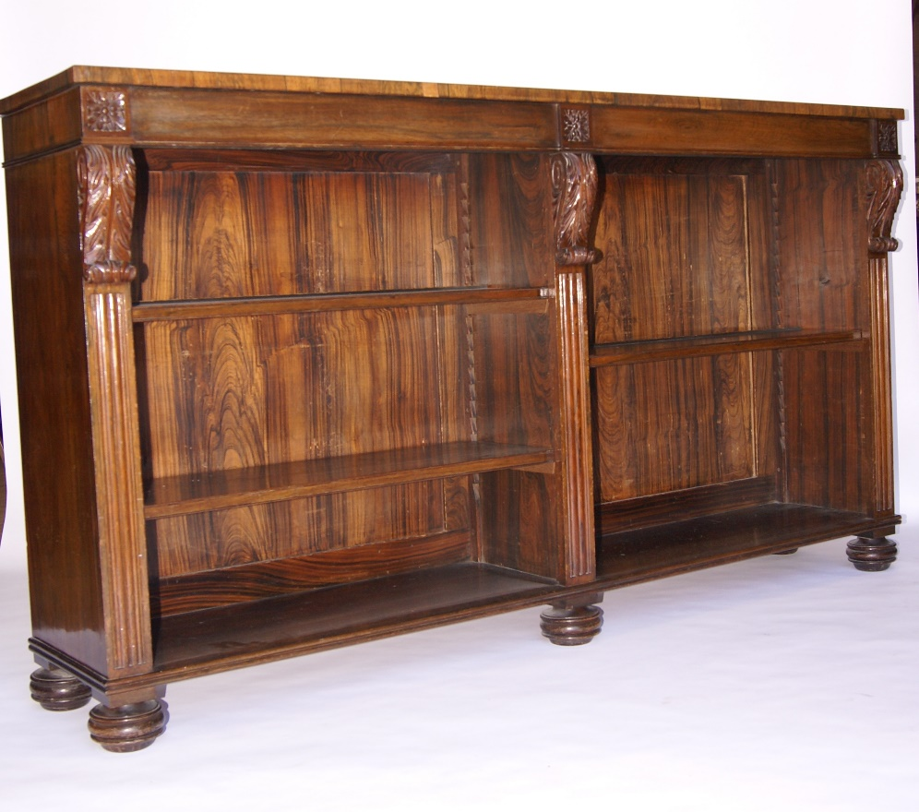 | £150-£200
218. | A William IV writing table, rosewood on a mahogany carcass, with brass gallery to the writing surface, and two frieze drawers below, on carved end supports and reeded bun feet, one piece of veneer missing and some cracking, 165cm wide.  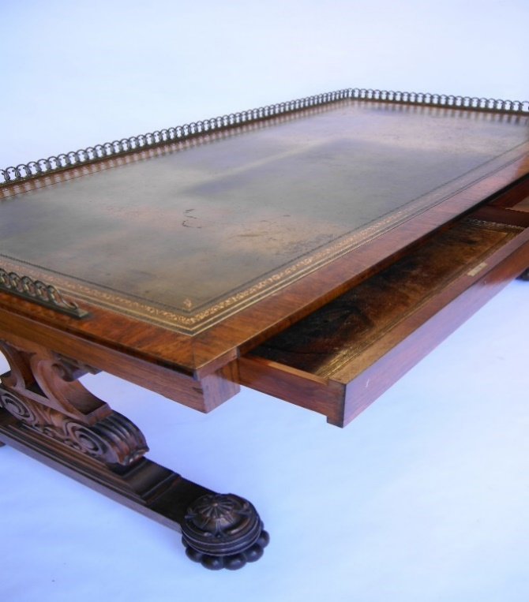 | £750-£1000
219. | A platinum diamond solitaire dress ring, adbury 0.20ct. | £300-£500
220. | An 18ct white gold dress-ring, set eight tiny diamonds, and a baguette cut tanzanite. | £150-£200
221. | A small collection of pottery toby and character jugs, together with some bottle stoppers. | £30-£50
222. | A Japanese resin box and cover, with relief decoration. | £40-£60
223. | A Danish porcelain figural bottle, 15cm high, four Utrecht pottery plaques, and a pale ale bottle (6). | £30-£50
224. | A cat form corkscrew, a far eastern style small box and cover, with adbury label, a pewter salt, a brass plaque, and a patch box(5). | £20-£30

Our Next Sale will be held on Wednesday 22nd July

For general house clearance, and furniture removals, Clear-It are ready to help!
Contact Paul Lester on: 01892 544433/07768 820459

