Please note that due to the new Anti-Money Laundering Regulations 2019, it is now a legal requirement to have photographic ID to be a registered bidder.

All buyers purchasing from Ibbett Mosely Auction Rooms must provide photographic ID, and re-register to bid in this auction.

All buyers purchasing from Ibbett Mosely Auction Rooms are required to register to bid no less than one hour before the sale commences.

IMPORTANT NOTICE

THIS SALEROOM OPERATES A BUYERS PREMIUM OF 15% PLUS V.A.T.

PLEASE NOTE IT IS IMPERATIVE THAT ALL GOODS ARE PAID FOR AND REMOVED FROM THE HALL BY 6.00 P.M. ON DAY OF SALE. THERE ARE NO STORAGE FACILITIES WHATSOEVER AVAILABLE. LIMITED TRANSPORT FOR LOCAL DELIVERIES.

THE SALEROOM IS A NO SMOKING AREA

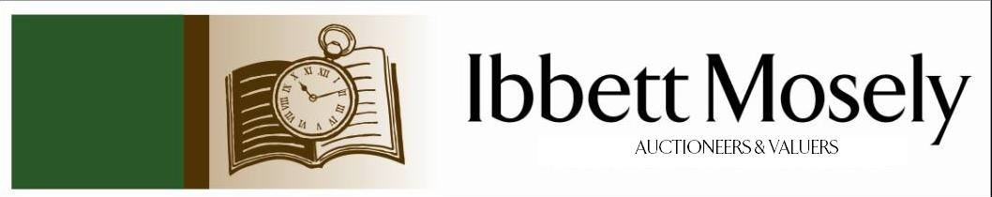

Catalogue of Antique, Edwardian and Victorian
Furniture and Effects
to be Auctioned on

Wednesday 22nd January 2020
at 12.30pm

IBBETT MOSELY AUCTION ROOMS
ARGYLE ROAD, SEVENOAKS, KENT TN13 1HJ

On View:

Tuesday 21st January 2020
12.00pm to 19.00pm

also

Morning of Sale
10.00am to 12.30pm

Catalogues: £2.00

Auctioneer and Valuer: Alan White FNAVA
Consultant Auctioneer and Valuer: Derek Hodge

Trainee Valuer and Clerk: Nicola Rainsley-Hughes
Auction Clerk and Administrator: Emily Frederick

Photographs credited to Lee Wells 01732 740280

1. | 19th Century gilt framed bevelled wall mirror carved eagle with acanthus leaf panels twist side supports 93 x 37cm. | £120-£140
2. | Mahogany nest of two open bookshelves with tray top 61cm wide, two 19th Century dining chairs, and an oak three-legged table, beaded edge, 37cm dia. | £25-£30
3. | A small Victorian nursing chair | £120-£130
4. | Indian decorative octagonal shaped brass tray side carrying handles 61 x 35cm. | £25-£30
5. | Bronze figure of an elephant complete with tusks, height 19cm. | £25-£30
6. | Two limited prints of Zebras and Elephants by Maurice Fietch, 9/150, 54 x 35cm. | £20-£35
7. | Regency mahogany chiffonier raised back two frieze drawers, cupboard under, enclosed by pair of doors raised on a flat base, 93cm wide. | £115-£130
8. | George III mahogany bookcase, the upper part with glazed brass edged doors, enclosing three shelves below enclosed cupboard, on bracket feet, 94cm wide. | £115-£130
9. | Set of eight George III mahogany dining chairs shaped inlaid top rail ‘cross’ framed backs studded leather seats, on square taper legs spade feet, two with arms. | £350-£375
10. | George III mahogany dining table, on square taper legs spade feet, extended size approx. 264 x 207cm. | £180-£200
11. | Regency rosewood three compartment tea caddy (no mixing bowl), 30 x 15cm. | £20-£40
12. | A large copper tray, 86cm dia, and stand. | £40-£45
13. | Ernest Briggs – Cattle by Water in a Landscape, watercolour 44 x 28cm. | £30-£35
14. | A 19th Century two-seater settee, upholstered in pink dralon, pierced rail under padded back, on square swept front legs. | £160-£180
15. | A 19th Century mahogany square shaped table, with undertier fitted single drawer wood knob handles, on short taper legs ending brass casters, 52cm wide, and a somewhat similar table. | £90-£120
16. | A mahogany circular top occasional table, turned column brass claw feet ending brass casters, 63cm dia. | £40-£45
17. | A Lady's upholstered chair, with part padded back, on square swept legs. | £40-£45
18. | An antique Dutch style serpentine fronted chest of three drawers, brass handles, knopped style feet, 122cm wide, a.f. | £250-£275
19. | A 19th Century gilt framed wall mirror, 'shell' cresting, 38cm x 56cm. | £70-£75
20. | A brass repeater carriage clock, bevelled glass panels, white enamel dial, height with dial 15cm, and a mahogany mantle clock. | £60-£65
21. | A 19th Century copper coal cauldron, brass side handles, brass claw feet, 42cm wide. | £20-£25
22. | A 19th Century oak coffer, carved front panel, on short style legs, 74cm. | £65-£75
23. | A canteen of 'Argentum' silver plated cutlery. | £60-£70
24. | A pine rectangular kitchen table, on square legs. 150cm x 73cm. | £40-£50
25. | An oak bookcase, the upper part in three sections, each enclosed glazed doors, below cupboards under each section with panelled doors, on flat base, 265cm wide. | £100-£125
26. | A pine cupboard, two frieze drawers, wood knob handles, enclosed cupboards under, on flat base, 91cm wide. | £30-£40
27. | Royal Copenhagen green melodi comprehensive dinner service, complete with dinner plates, side plates, soup bowls with saucers, two vegetable dishes with covers, meat plates, etc. | £40-£60
28. | A comprehensive collection of miscellaneous drinking glasses, including wine, flutes, sherry, tumblers, liquor, fruit dishes, etc. | £50-£60
29. | A silver framed bevelled glass easel mirror, Birmingham, 31cm x 23cm, glass pin jar with silver top, Chester, a silver gravy boat on three hoof feet, and a silver salver on four scrolled feet, 25cm dia, Sheffield, and a small embossed cream jug, a silver teapot, a vase and sugar bowl. | £175-£190
30. | A pine kitchen table with oval flaps, on baluster legs, stretchers all round, 123cm wide. | £40-£45
31. | A quantity of mixed silver plate, including kettle on stand, entree dish with cover and handle, coffee/water jugs, sugar castor, etc. | £60-£70
32. | A miscellaneous collection EPNS. | £30-£40
33. | A selection of Adams Baltic china, Spode Chinese rose, and Royal Worcester ovenware, etc. | £30-£40
34. | A selection of brass and copper. | £30-£35
35. | A Victorian oak 'fan' back hall chair, solid seat, on turned front legs, and a small kneehole desk (2) | £25-£30
36. | A collection of eight white metal fishes in sizes, with coloured glass eyes, scales and fins, each with an articulated body. | £40-£60
37. | A canteen fitted two drawers (no contents). | £15-£20
38. | A collection of five silhouettes, various. | £40-£45
39. | A 19th Century mahogany sofa table, with satinwood stringing, two frieze drawers opposite dummy drawers, on a pedestal base, and brass claw feet and casters, 104cm wide.
40. | A resin figure, based on a bronze of a First World War soldier, from the 51st Highland Division, 37cm high, and a further figure of a soldier of the King's African Rifles, 25cm high. | £60-£80
41. | A Late 18th Century inlaid mahogany folding card table, part 'shell' top, baize lined, on square taper legs and spade feet, 90cm wide. | £100-£120
42. | A 19th century marquestry circular top pedestal table, on tripod legs, 50cm dia. | £65-£70
43. | A Late 18th Century mahogany bow fronted chest of two short and two long cockbeaded drawers, brass ring handles, shaped apron, on open splayed legs, 90cm wide. | £115-£130
44. | A Windsor chair, with high back and arms, on turned shaped legs, with crinoline bar. | £60-£70
45. | An oak rectangular shaped table, on bluster turned legs, stretchers all round, 91cm wide, and an Edwardian inlaid mahogany clothes airer. | £25-£30
46. | A 19th Century copper bowl, a jug, and miscellaneous silver plate. | £30-£35
47. | A collection of four Venetian glass bowls, and various pieces of green tinted glassware. | £25-£30
48. | A silver gent's watch, with key, ID 376136, hallmarked date 1899. | £90-£120
49. | Two George III brass game tokens, with imitation Guinea spade, 1790. | £20-£25
50. | An EPNS photograph frame, 34cm x 28.5cm (Italian). | £25-£30
51. | 18ct gold ring set three sapphires flanked by four small diamonds | £350-£450
52. | Georgian silver pocket watch fusee movement white enamel dial, key wind, engraved Straub and Hastings 77 Blackmore Street, London dated 1802 | £750-£900
53. | Gold brooch with nine graduated diamonds in the shape of a horseshoe | £350-£400
54. | A Late Victorian part carved oak pedestal desk, fitted nine drawers, on plinth bases, 137cm x 76cm x 70cm. | £100-£150
55. | A Victorian easy chair, button upholstered in brown dralon, on turned legs, and a Victorian kidney back dining chair. (2) | £40-£60
57. | A Late Victorian "Holyrood Folding Table," by "J and S Smith, Peables," with octagonal top, 75cm in diameter, together with an Edwardian occasional table, and a needlework panel firescreen. (3) | £30-£50
58. | A Victorian satin beech swing-frame toilet mirror, 50cm wide, a beech piano stool, and a folding table. (3) | £30-£40
59. | A brass coal box, with concave front, 36cm wide, and a pottery toilet bowl and ewer. (3) | £30-£50
60. | A Late 19th/Early 20th Century French bureau, with brass gallery top, and gilt metal mounts, part Cantilever mechanism, on cabriole form legs. | £250-£350
 | 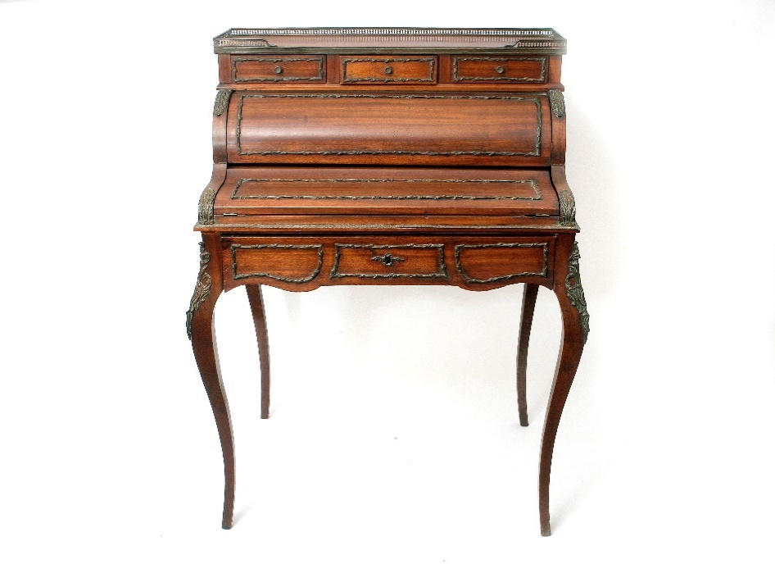 | Lot 60
61. | A Stradivarius copy violin, length of back 35.5cm long, 58.5cm overall, together with a bow, a.f., in case. | £80-£120
62. | An Early 20th Century stained beech piano stool. | £20-£30
63. | Crown Devon Fieldings bowl, pair of candlesticks, cream jug, flower holders, plate, bowls, sugar bowl, dish with cover etc (13) and two somewhat similar pieces | £40-£45
64. | Victorian rosewood work box, single frieze drawer, wood knob handles and shaped supports, raised on a stand either end, and stile feet 57cm wide | £150-£175
65. | Victorian polescreen with wool work tapestry panel, turned mahogany columns on tripod legs, height 149cm | £60-£75
66. | Oriental camphor wood chest decorated in the Chinese style on bracket feet, 91cm wide | £80-£90
67. | Cased set of replica golf balls through the ages, dating from 1848 to 1932, frame 45cm x 45cm | £150-£200
68. | Attributed to Augustus John - portrait of Celia Keddie nee Turner, graphite drawing, 27cm x 21cm, on paper laid on board, unsigned, in frame, together with a photograph of the sitter, believed to be aged sixteen | £80-£100
69. | A pair of Staffordshire soup plates, a Royal Worcester Daedalus and Icarus plate, four ribbon type plates, and a blue and white teapot, with pewter lid, and two dishes. (10) | £25-£40
70. | A brass standard lamp, possibly of Cornish manufacture, 136cm high. | £40-£60
71. | A pair of Victorian silver apostle spoons, maker J.D. and W.D., Sheffield 1987, approx. 2oz, together with a silver-plated fruit spoon, and four pairs of silver-plated sugar nips. (7) | £30-£40
72. | Five albums and stock books of mixed world stamps. (5) | £30-£50
73. | A George III mahogany chest of two short and three long drawers, with oval plate handles, 107cm wide. | £60-£80
74. | A leather suitcase and a set of military cigarette cards in two frames. (3) | £20-£30
75. | A silver-plated folding sandwich case. | £15-£20
76. | A pair of Victorian mahogany dining chairs on turned legs. | £20-£30
77. | A small Georgian style mahogany hanging corner cupboard, 39cm wide, a small 18th Century style wall mirror, and a later wall mirror. (3) | £20-£30
78. | Desiree Thomassin (Austrian, 1858-1933) hay making scene, with figures and animals in field, oil on panel, 48cm x 33cm. | £300-£500
79. | A Late Victorian English walnut secretaire bookcase, the upper part fitted three shelves and enclosed by two doors, in need of restoration, the carved and panelled fall with fitted interior, above two drawers and two panelled doors, 122cm wide x 220cm high. | £50-£80
80. | A Cavadini Surveyor wrist chronograph, cv-870, with yellow dial and stainless-steel bracelet strap. | £20-£30
81. | A Ronson quartz wrist chronograph, with cream dial and two-colour stainless-steel bracelet, no. S2312JG-GG8. | £15-£20
82. | A Seiko Aviator style wristwatch chronograph, 100 metres, silvered dial, stainless steel bracelet strap, no. 220138. | £30-£50
83. | An Accurist water resistant wrist chronograph yellow dial, black case, with black leather strap. | £15-£20
84. | A George III mahogany chest of four long graduated drawers, with two handles, on bracket feet, 77cm wide. | £40-£60
85. | A silver-plated inkstand, with two glass pots, a Late Victorian bone handled crumb scoop, a small silver plated candelabrum, six goblets, condiment pieces, various, together with spoons, a circular tray, and other silver-plated ware. | £40-£60
86. | An open-faced pocket watch, with white enamelled dial, retailed by Thos Russell of Liverpool, on wire link chain. | £40-£60
87. | A 9ct gold dress ring, set seed pearls, and central emerald. | £100-£150
88. | An 18ct gold dress ring, set a small central diamond, and two chip diamonds. | £40-£60
89. | An alloy pin cushion in the form of a young bison, 8cm long, and another of a pig. (2) | £40-£60
90. | A part set of Late Victorian King's pattern silver cutlery, six place settings, comprising six table forks, six dessert forks, six dessert spoons, and six tablespoons, London 1896, some marks rubbed, approx. 60oz | £500-£700
 | 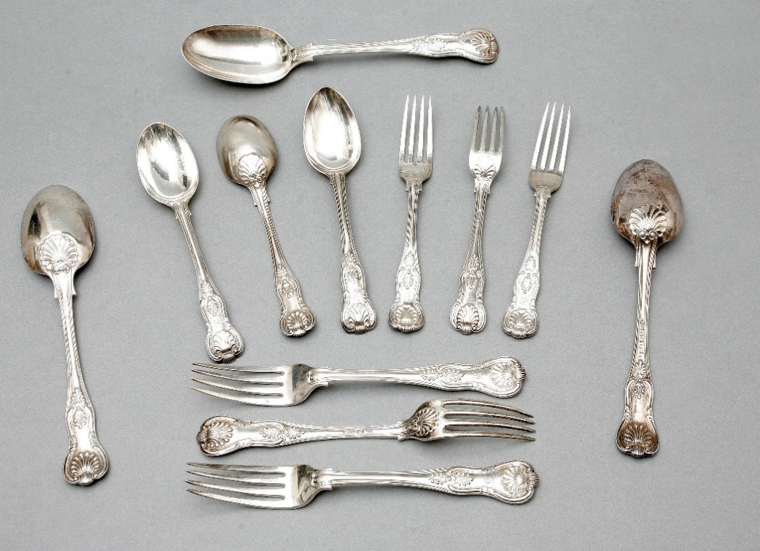 | Lot 90
91. | A Late Victorian silver and ruby tinted glass sugar caster, maker Haseler Bros, London 1899, a christening set, with bone handled knife, in lined case, London 1984, and a continental silver oval photograph frame, 5g weighable. (3) | £60-£80
92. | An Edwardian VII silver mustard pot, with blue glass liner, Birmingham 1905, with Chester 1905 spoon, a pair of small squat candlesticks, Birmingham 1971, weighted bases, a small silver watch holder, Sheffield 1996, a continental silver handles shoe horn, London 1903, a Jerusalem brooch, and a mother of Pearl handled silver bladed penknife, Sheffield 1868, in leather case. (7) | £50-£70
93. | A B.O.A.C. bag form compact in box, and a French compact with lipstick attached, in box, and a Bakerlite ash tray. (3) | £20-£30
94. | A stained beech figure of a cat, in the tribal style, 24cm long, on African game of “Bao,” two simulated rosewood candlesticks, and a pot and cover. (5) | £30-£40
95. | A Swedish Maleras glass sculpture of an owl, designed by Mats Jonasson, No 34105, 13.5cm high, the medium size figure of a series, in lined box. | £30-£50
96. | An Early 20th Century Chinese enamelled scent bottle, and four porcelain scent bottles, one missing its top. (5) | £60-£80
97. | A small continental timepiece, in coloured and frosted glass case, 8cm high, and a silver-plated back hand mirror, and hairbrush. (3) | £20-£30
98. | An early 20th Century porcelain part afternoon tea set, floral decorations, with gilt edges, bears a Berlin mark, approx. 20 pieces. | £20-£30
99. | A Gillingham football club home shirt, autographed by members of the 2016/17 team. | £30-£50
100. | A Lloyd Loom woven fibre linen basket, a further linen basket, and a woven fibre tub chair. (3) | £20-£30
101. | A Pair of modern Chinese vases, 24cm high, and a vase decorated swallows. (3) | £30-£50
102. | A pair of Royal Doulton stoneware ewer form jugs, flowerhead pattern, 29cm high, one repaired, a pair of Slaters patent vases, 25.5cm high, together with some blush ivory, and other pieces. | £150-£200
103. | A tin “Milner’s” cash box, 38cm wide. | £30-£50
104. | A single volume book “Earlie Rising,” by a late philosopher, illustrated by Lady Frances Bushby, in need of restoration. | £50-£60
105. | A ‘Marx’ tin plate and plastic toy figure of an American style fireman, climbing a ladder, 56cm high, slightly a.f. | £20-£30
106. | An Early 20th Century mahogany folding cake stand, an elm milking type stool, and two miniature carved tables. (4) | £30-£40
107. | A set of bone handled fish knives and forks, in lined case, a set of pastry forks, in lined case, and various sets of tea knives, in lines cases, together with some unboxed. | £30-£50
108. | An Ercol elm and pale beech stick back rocking chair. | £60-£80
109. | Two early 19th Century yew, elm, and beech Windsor elbow chairs, with crinoline stretchers, on turned and ringed legs. | £150-£200
110. | Victorian school – an over-painted photographic portrait of old gentleman in Military uniform, 37cm x 29cm, and a further portrait of his wife, 37cm 29cm. | £30-£50
111. | A Gilt-bronze medal, “the Lord Mayor of London Medal,” 1972-73, presented to Lt General Sir Ian Gourlay, former Commandant General of the Royal Marines, in case, together with a United Nations Medallion, and other commemorative crowns, other coins, and ephemera. | £40-£60
112. | A silver ingot produced by Johnson Matthey, No 002 196, approx. 5oz. | £50-£80
113. | An album of signed Christmas cards, some with personal messages, and photographs from the Royal family to Lt General Sir Ian and Lady Gourlay, between 1967 and 1989. | £40-£60
114. | Two copies of the order of service for the marriage of Charles, Prince of Wales to the Lady Diana Spencer, on 29th July 1981, together with two copies of the Ceremonial, other ephemera, and magazines. | £30-£50
115. | An Early 20th Century Japanese cloisonné slender neck vase, with stamped signature to base, 16cm high, and two Chinese cloisonné slender neck vases, each 16cm high, two pieces slightly a.f. (3) | £60-£80
116. | A pair of 20th Century Chinese cloisonné, double gourd form vases and covers, 27cm high, a further pair of Japanese style cloisonné vases, two later enamelled vases, and four other vessels, various, some pieces a.f. (10) | £50-£70
117. | A pair of Japanese grey ground cloisonné vases, showing Mount Fuji, 25cm high, a Chinese cloisonné squat vase, decorated birds and blossom, a Japanese red ground vase, and a Chinese cloisonné bowl. (5) | £50-£70
118. | An Early 20th Century Japanese cloisonné reeded form vase and cover, decorated flowerheads and birds, 19cm high, a pair of Japanese cloisonné vases decorated phoenix and foliage, 19cm high, a small cloisonné vase decorated birds and blossom, 15cm high, and a number of small vases and jars, various. (13) | £60-£80
119. | Three pairs of 20th Century Chinese cloisonné vases, and two single cloisonné vases, all in need of restoration. (8) | £40-£60
120. | A pair of 20th Century Chinese cloisonné vases, decorated birds of paradise and butterflies, 20cm high, five Japanese and Chinese cloisonné, various, and five incense jars and covers, and a small stained wood stand. (13) | £60-£80
121. | Three 20th Century Chinese cloisonné shallow dishes, 37cm wide, and two each 30cm wide, together with three vases, various, in need of restoration. (6) | £40-£60
122. | A Late Victorian simulated rosewood and decorative brass watch stand, 8cm wide, and a gold-plated open-faced pocket watch with ‘Waltham’ dial and movement. (2) | £60-£80
123. | Six Wedgewood porcelain coffee cans with Greek key pattern border in silver holders, Walker and Hall, Sheffield, 1916, together with six saucers, and five coffee spoons, and an Adams Pottery winter scenes plate, and a small French enamelled pottery vase. (19) | £20-£30
124. | A pair of modern Chinese porcelain figures of seated cats, each 15cm high, a pottery incense burner, a small decorative tea pot, and an English pottery bowl with silver plated handle. (5) | £20-£30
125. | An Early 20th Century Chinese carved wood visiting card case, 12cm long, and a small decorative box. (2) | £30-£50
126. | A Japanese carved wood netsuke of a rabbit sitting on a piece of fruit, signature to base, 5cm high, together with a small hardstone figure, a small group of two fighting dragons, and two small carved wood figures. (5) | £40-£60
127. | A Japanese carved bone figure of reclining nude female, 14cm long, a carved resin figure of ‘Ho-Tei,’ two small carved wood figures, a decorative bracelet, and six miniature carved wooden pieces. (11) | £40-£60
128. | Two coral beaded necklaces, with clasps. (2) | £30-£50
129. | Two boxes of Sotheby’s and Christie’s auction catalogues of Japanese works of art, and other oriental objects, together with some books. | £20-£30
130. | Follower of Joseph Highmore – portrait of a lady, oil on canvas, J & H Reeve of London label verso, 128cm x 103cm. | £2000-£3000
131. | A harlequin set of eight George III/George III style mahogany dining chairs, with pierced back splats, on cabriole legs, and pointed hoof feet, 3 period, 5 reproduction. (8) | £150-£200
 | 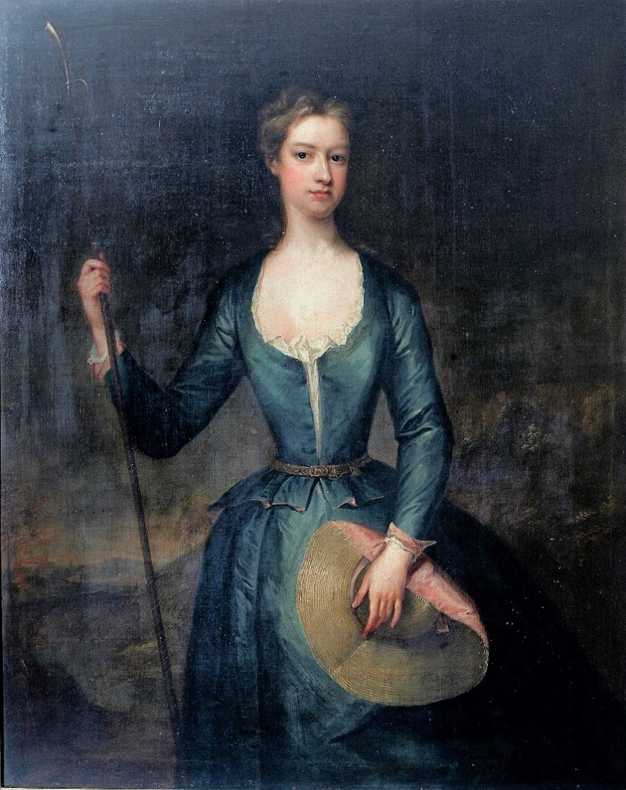 | Lot 130
132. | A set of four George III style mahogany dining chairs, with pierced splats, on square tapering legs, restored. (4) | £40-£60
133. | An Early 19th Century satin beech, rosewood crossbanded, and amboyna side table, fitted a drawer, on square tapering legs, with spade feet, 71cm wide. | £40-£60
134. | An 18th Century oak coffer, with inlaid arched panel front, thumb carved frieze, on block feet, 159cm wide, later restoration. | £150-£200
135. | A Coca-Cola advertising mirror, in stained wood frame, 67cm x 98cm. | £20-£30
136. | A colour wash artists proof poster for the Louis Bromfield film “The Rains Came,” starring Tyrone Power and Myrna Loy, with inscription from costume designer Sandy Wilson, 55cm x 75cm, and a second crayon and colour wash sketch of a costume design by Sandy Wilson, 33cm x 43cm, and a unattributable costume design, inscribed “Carrie De Pinna,” 42cm x 28cm (3) | £80-£100
137. | A gent’s Longines “Ultra-Chron” automatic wristwatch, in stainless steel case, No 15898280, movement No 21060, with bracelet. | £100-£150
138. | A Military issue stainless steel wristwatch, with Arabic numerals. | £80-£100
139. | A Tudor 9ct gold gent’s wristwatch, the case cracked, and a rotary wristwatch. (2) | £100-£150
140. | A George V silver cream jug, by William Hallett and Co, Ltd, Birmingham 1921, and a silver handled fork, Birmingham, 1900. (2) | £40-£60
141. | A Late 19th Century walnut and stained beech Vienna regulator wall clock, with turned finials, 83cm high, in need of some restoration. | £40-£60
142. | A Georgian style toddy ladle, with stained bone handle, and coin set into the bowl. | £60-£80
143. | After Robert Taylor “Climbing Out,” a Lancaster bomber, chromolithograph, signed in mount, by Sir Arthur (Bomber) Harris, and by the artist, and another “Lancaster,” signed by Leonard Cheshire, chromolithographs, two. (3) | £40-£60
144. | A Schwartz porcelain figure for the History in Porcelain Company, of a member of an R.A.F. ground crew, 30cm high, slightly a.f., in box. | £80-£100
 | 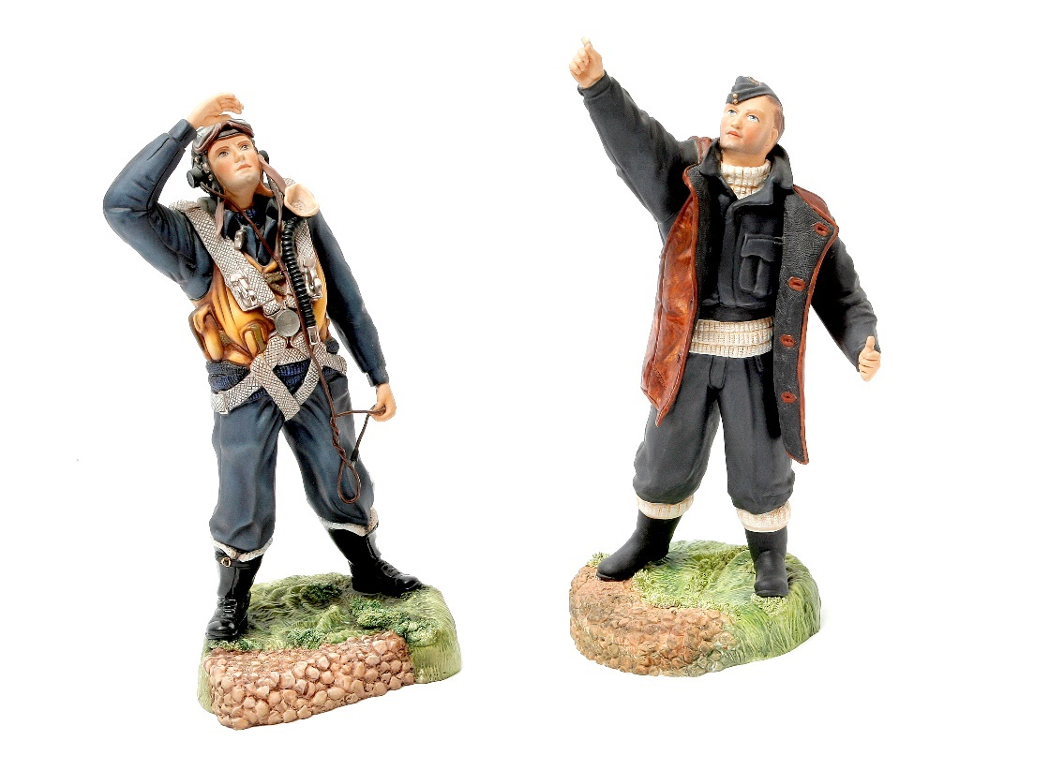 | Lot 145 to the left.  Lot 144 to the right.
145. | An Ashmores of Worcester porcelain figure of an R.A.F. bomber pilot, based on the R.A.F Aircrew Europe memorial, 30cm high, in box. | £80-£100
146. | A pair of Dresden figural four branch candelabra, each 41cm high. | £100-£150
147. | A small pair of Dresden porcelain three branch candelabra, surmounted by cherubs, each 24cm high, slightly a.f. | £60-£80
148. | Two Dresden porcelain figural table lamps, one repaired, each 41cm high. | £50-£70
149. | H. Bunbury, after S.D. Sorron – six stipple engravings of late 18th/Early 19th Century soldiers, comprising: “A Sergeant of Infantry,” “A Light Horseman,” “A Light Infantry Man,” “A Foot Soldier,” “A Drummer,” and “A Life Guardsman,” each in maple frames and 57cm x 45cm. | £250-£350
150. | An Early 20th Century French/Swiss longcase clock in stained beech case, believed to have been from the Jura district, the movement with upside-down crown wheel escapement, 235cm high. | £80-£100
151. | An Early 20th Century fruit wood gent’s walking cane with cigarette lighter in the pommel, a simulated bamboo walking cane, a lady’s walking cane with silver plated handle, and a further gent’s ebonised walking cane, with broken shaft (4). | £30-£50
152. | Henry G. Walker – lobster fisherman’s cottage, coloured etching, 17cm x 34cm. | £30-£50
153. | J.H. Wadham – tree lined lane, watercolour, 38cm x 27cm. | £80-£100
154. | 19th Century school – Crofter’s cottage, in landscape, watercolour, 25cm x 35cm. | £80-£100
155. | W.H. Pearson – “Herring Boat”, in rough seas, watercolour, 26cm x 63cm. | £150-£200
156. | T. Mortimer 1871 – mixed shipping, near harbour, watercolour, 18cm x 34cm. | £100-£150
157. | L.O. Linnell – Mediterranean scene, slope towards a lake, watercolour, 33cm x 24cm. | £80-£120
158. | William Havell 1892 – track near a pond, with figure in distance, watercolour, 12cm x 17cm. | £60-£80
159. | Gorman Morris – “Off the East Coast”, watercolour, 18.5cm x 53cm. | £150-£200
160. | A Victorian mahogany hall chair and a small bow-fronted chest (2). | £60-£80
161. | T. Mortimer – “Cornish Coast”, inscribed, watercolour, 24cm x 53cm. | £150-£200
162. | Chester Silverlock – “Mevagissey”, watercolour, 16cm x 24cm. | £30-£50
163. | T.B. Hardy 1874 – “Greenwich Hospital”, watercolour, 46cm x 71cm. | £600-£800
164. | B. Bennett 1924 – “Marchporth”, watercolour, 14cm x 23cm. | £30-£50
165. | 19th Century school – landscape with spired church, and separate tower, watercolour, 27cm x 40cm. | £80-£100
 | 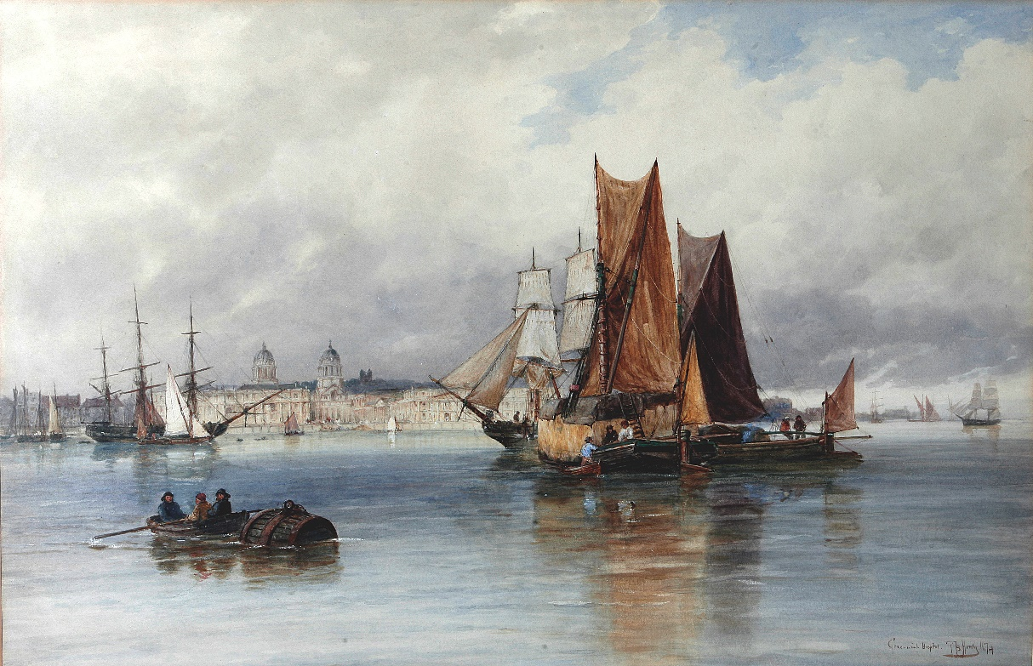 | Lot 163
166. | Naïve school – portrait of spaniel dog, in landscape, oil on board, 23cm x 32cm, Early 20th Century school – drawing of watermill, 35cm x 49cm, and an engraving after Morland, “Duck Shooting”, 29cm x 37cm (3). | £60-£80
167. | A Victorian carved wood music stool, and a small gilt mirror (2). | £60-£80
168. | An oak mantel clock. | £30-£50
169. | Linnell – winter scene, with lodges, pastel, 26cm x 36cm, together with four still life flower pictures (5). | £50-£70
170. | Anthony Van Dyke Copley Fielding (1787-1855), moorland landscape, with figure and cottages, watercolour, 16.5cm x 22cm. | £80-£100
171. | After Samuel Prout – landscape with figure and dog, watercolour, 26cm x 39.5cm. | £50-£70
172. | Attributed to Thomas Richardson – coastal scene, with cottages and church below a cliff, barge in foreground, watercolour, 25cm x 35cm. | £70-£100
173. | D. Buccianelli, Roma – mounted cavalier type soldier, being served wine in a yard, watercolour, 60cm x 45cm. | £200-£300
174. | E.B. Yait – “West Drayton,” watercolour, 24cm x 39cm. | £80-£100
175. | L.M. – Venetian flower and fruit sellers, watercolour, a pair, foxed, 33cm x 48cm. | £150-£200
176. | Charles Turner – “Upper Pool, London,” watercolour, 49cm x 72cm, | £150-£200
177. | A.D. Bell 1915 – “St Georges Island – Venice,” watercolour, 25cm x 36cm. | £150-£200
178. | W. Scott 1851 – thatched cottage, near river bridge, watercolour, 26cm x 40cm, and a further watercolour by another hand (2). | £60-£80
179. | E.B. Laim – landscape with cottage, and fishing on the fens, watercolours, two, each 19cm x 31cm (2). | £70-£100
180. | A late 19th Century French white marble mantel timepiece, under a glass dome, 31cm high. | £80-£100
181. | A Victorian oak stationary/envelope box, 21cm wide, and a small treen stamp box (2). | £20-£30
182. | A late 19th century French white marble and gilt-metal mounted mantel clock, with striking movement, 48cm high. | £200-£300
183. | A 19th Century Dresden porcelain figural table centrepiece, 40cm high. | £80-£100
184. | A glass decanter, with silver “Whisky” label, two further decanters, a fruit bowl, and a candlestick (5). | £50-£70
185. | Three Rosenthal porcelain dishes, three flower pattern fruit plates, and a bowl (7). | £70-£90
186. | A Victorian walnut circular snap-top breakfast table, on a tripod base, the top 126cm in diameter, trade label for T.H. Filmers, London. | £100-£150
187. | A set of six Victorian walnut balloon back dining chairs (6). | £100-£150
188. | A mixed quantity of silver- and silver-plated cutlery, and a letter opener. | £200-£300
189. | T.B. Hardy 1874 – “London Bridge, Morning”, watercolour, 43cm x 71cm. | £600-£800
 | 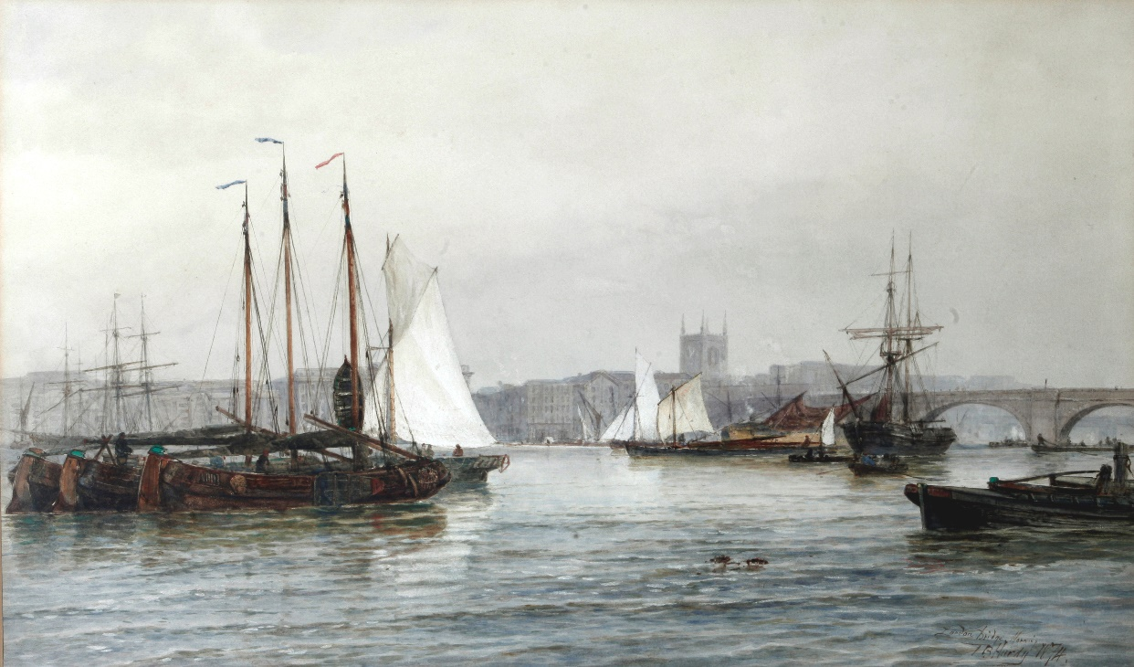 | Lot 189
190. | Franz Albert – winter landscapes, with figures, oil on board, a pair, each 28.5cm x 39cm, stacey marks verso. | £100-£150
191. | R. Cooper 75 – landscape with cattle drover on bridge, watercolour, foxed, 34cm x 50cm. | £40-£60
192. | R. Cooper, 1871 – landscape with wheat cutters, sheep, and boy with fishing rod, watercolour, foxed, 62cm x 46cm. | £80-£100
193. | 19th Century school – landscape with cottage and figure on donkey, watercolour, foxed, 25cm x 39cm. | £40-£60
194. | A. Thorburn 1904 – grouse in flight, watercolour, signed and dated, 17cm x 22cm. | £200-£300
195. | 20th Century school – still life, flowers, oil on panel, 49cm x 39cm. | £20-£30
196. | Late 19th Century school – fishermen on banks of lake, vessels on water, mountainous landscape, watercolour, 13cm x 36cm. | £60-£80
197. | Newton John – “Clovelly”, landscape, with view of the harbour, watercolour, 48cm x 35cm. | £100-£150
198. | 19th Century school – figures by watermill on canal, watercolour, 30cm x 25cm. | £30-£50
199. | Two Victorian button upholstered tub chairs, and a corner elbow chair (3). | £30-£50
200. | Three wine tables, a walnut coffee table, and a centre table (5). | £40-£60
201. | A Victorian mahogany octagonal top worktable, a Victorian dining chair, and a cabriole leg footstool (3). | £80-£100
202. | A Victorian inlaid and simulated walnut davenport desk, 53cm wide. | £100-£150
203. | A pair of painted French style side chairs. | £80-£100
204. | A painted display cabinet, flanked by open shelves, 115cm wide, adapted from a sideboard. | £60-£80
205. | An Early 20th Century Dresden porcelain figural candlestick, 33.5cm high, a two-branch candelabra, 30cm high, a pedestal bowl, and a two-handled vase, some pieces a.f. (4). | £150-£200
206. | Three small Dresden porcelain figures, depicting months of the year, each 9.5cm high, two further figures emblematic of the seasons, and a further small figure (6). | £80-£100
207. | A small Dresden porcelain inkstand, three bird figures, a decorative vase, and a small bowl (6). | £80-£100
208. | A quantity of Dresden and other porcelain, including a miniature tea-set, teacups and saucers, two pratt-ware pot-lids and other decorative pieces. | £100-£150
209. | A small Late 19th Century gilt-brass carriage timepiece, 15cm high. | £80-£100
210. | A gilded spelter and sevre style porcelain figural clock garniture, with French striking movement, and a two-branch candelabra (3). | £180-£220
211. | A Dunhill humidor and cigars. | £80-£100
212. | F.J. Widgery – moorland scene, watercolour, 28cm x 45cm, and two further watercolours, by different hands (3). | £60-£80
213. | Gorman Morris – “Misty Night”, and “Night”, watercolours, a pair, each 19cm x 53cm. | £100-£150
214. | J.C. Jonas – fishing smacks leaving and coming ashore, watercolour, 18cm x 45cm. | £80-£100
215. | Norman Bradley – “Haytime”, and “Near Godalming”, watercolours, a pair, each 17.5cm x 37cm. | £80-£100
216. | After Joseph Farquharson – feeding the sheep in winter, engraving, 57cm x 82cm, and after Alfred de Breanski, etching of sheep (2). | £20-£30
217. | A Victorian walnut chest of two short and three long drawers, 109cm wide. | £80-£100
218. | A rosewood toilet mirror, and two Victorian dining chairs (3). | £20-£30
219. | A pair of floral porcelain vases, each 19cm high. | £20-£30
220. | An Avia Lady’s stainless-steel wristwatch, together with a quantity of decorative and costume jewellery. | £50-£70
221. | A George III oak chest of two short and three long drawers, 95cm wide. | £80-£100
222. | A Victorian mahogany kneehole writing desk, fitted five drawers, 118cm wide. | £100-£150
223. | A Victorian toilet mirror, a Victorian dining chair, and a wall mirror, in decorative frame (3). | £20-£30
224. | A Webley Raider .22 air rifle, with telescope sight, and two smaller calibre air rifles (3). | £30-£50
225. | Late 18th Century oak longcase clock broken arch pediment brass spandrels silvered chapter ring with strike by Rob Scholfield, Rochdale, height 220cm, 8-day movement. | £250-£450
226. | Still Life – Fruit with flowers, oil on canvas 34 x 44cm, unsigned. | £75-£100
227. | Sampler – including text surrounded by flowers by Sarah Keys Lichfield, 1782. | £45-£65
228. | 19th Century circular gilt framed convex mirror with ‘Eagle’ cresting, 35cm dia. | £90-£120
229. | Pair of 19th Century Oriental decorative vases with figures and boats in a cartouche surrounded by decorative flowers, height 63cm (one cracked). | £50-£70
230. | 19th Century bulbous shaped porcelain jar with ‘Eagle’ finial on cover, decorated figures in a garland cartouche height 35cm, and a green pottery wine jug (2). | £45-£65
231. | Bronze casket in the form of an inkwell with two glass pots 14 x 9cm. | £80-£100
232. | Japanese bulbous shaped china table lamp decorated with Warrior type figures side dummy handles complete with shade, height 35cm, a.f. | £50-£70
233. | Antique oak table fitted single frieze drawer on turned legs pad feet, 78cm wide. | £75-£100
234. | Two 19th Century miniatures each of a Lady one in a tortoiseshell frame the other framed 14 x 11cm and 12 x 10cm, both unsigned. | £125-£150
235. | Nest of three walnut tea tables oval bordered top on spindle legs, and a Regency oak toilet mirror (2). | £30-£50
236. | A pair of unsigned oil on board paintings, "Vessels in a Rough Sea," 17 x 24cm. | £100-£150
237. | Pair of bronze figures of Classical figures one holding a Mask both signed Durrel, height 39cm. | £250-£350
238. | Pair of trumpet shaped vases pierced stem raised on a square base height 15cm. | £30-£50
239. | Set of eight Victorian mahogany salon chairs shaped backs overstuffed seats on cabriole legs (2 a.f.). | £100-£150
240. | Wm IV mahogany circular top breakfast table on faceted column shaped flat base bun feet, 101cm dia. | £75-£100
241. | A Late 19th Century bronze figure of the Duke of wellington, mounted on horseback, probably Copenhagen, on landscaped plinth base, 54cm high. | £150-£200
242. | A collection of tea prints of Oriental figures in interior scenes 27cm x 18cm framed, some colourwash highlights (9). | £90-£120
243. | A 19th Century school Napoleonic warship at sea, with other vessels in background, oil on canvas, 60cm x 90cm, signed indistinctly. | £100-£150
244. | A pair of Cantonese famille vert plates decorated foliage and birds, 22cm in diameter, a.f., and a oriental hard stone vase with decorative mount, 17cm high (3). | £30-£50
245. | A black top hat by Dunn and Co, of London, and an opera top hat by Tress and Co, in oval box. | £40-£60
 | 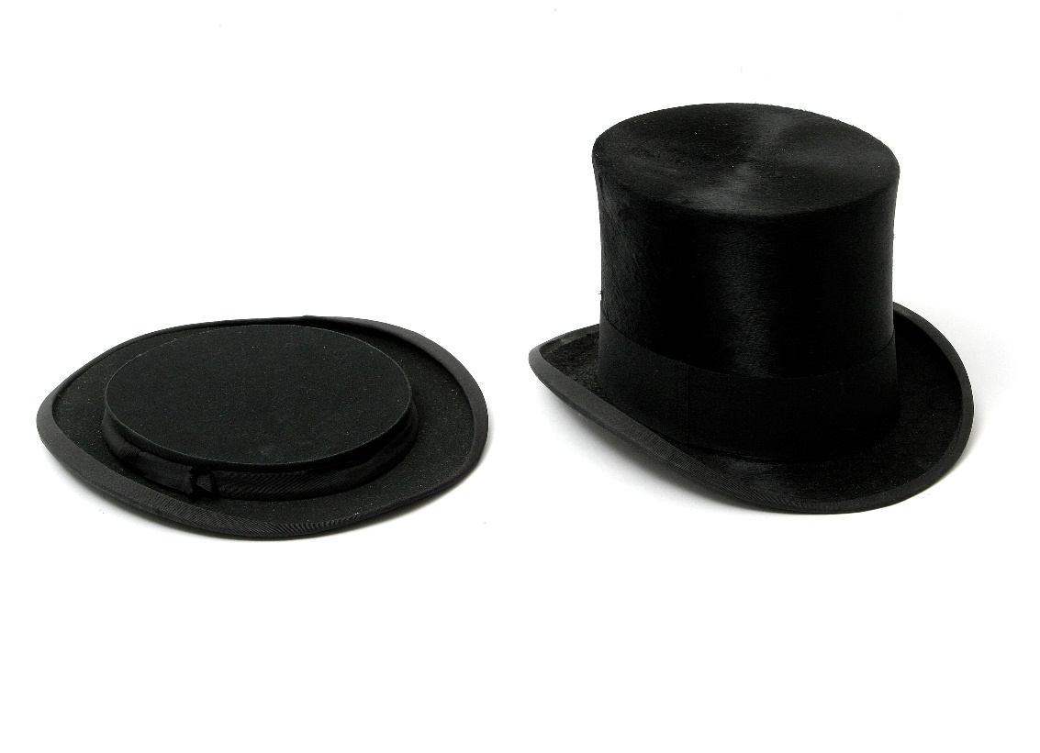 | Lot 245
246. | A silver plated three bottle tantalus, the decanters with silver mounts and one stopper, Birmingham 1946, 36cm high, and a silver plated campana shaped wine cooler (2). | £40-£60
247. | A Victorian copper tea urn, 36cm high, two copper kettles, and a copper (4). | £20-£30
248. | A small pair of Japanese style embroidered panels, 11cm x 30cm, and three small prints of Chinese Junks (5). | £20-£30
249. | A 19th century map of Middlesex, 19cm x 26cm, a small print of Margate pier, and three decorative prints (5). | £20-£30
250. | An 18ct gold link neck chain, 31.2g approx., 46cm long. | £650-£750
251. | A small 9ct gold link chain, approx. 6.9g, 53cm long. | £60-£80
252. | A 22ct gold wedding band, approx. 3.9g. | £90-£120
253. | An 18ct gold wedding band, approx. 2.5g. | £40-£60
254. | A gent's gold signet ring, with engraved initials, marks indistinct, approx. 3.9g. | £30-£50
255. | An Art Deco style diamond pendant/brooch, with three yellow diamonds, approx. 1.8ct in total, one on base of chain, and fifty-four white diamonds in mixed sizes, together with three diamonds to the clasp, and two to the base of the chain, approx. 2.21 ct, 4.01 ct overall. | £2500-£3500
 | 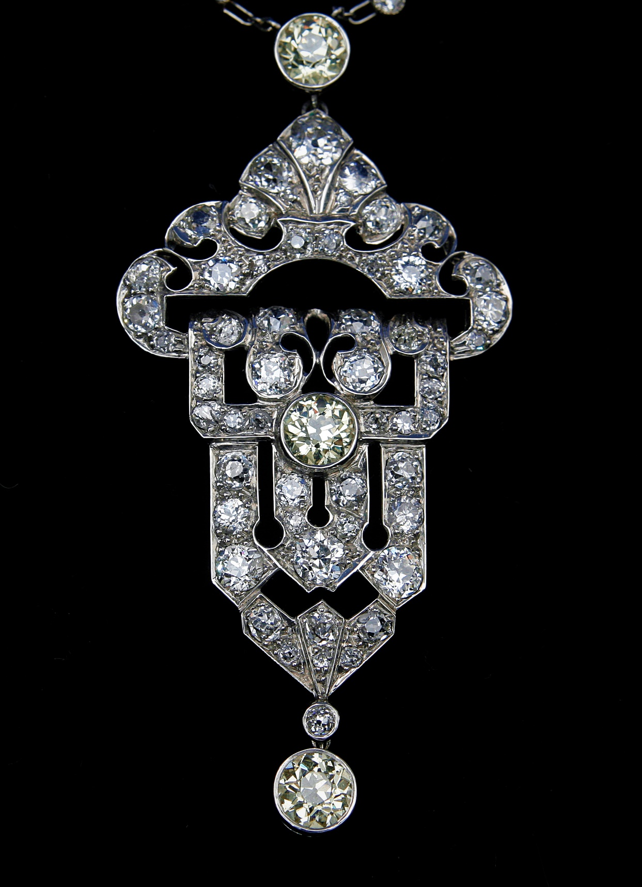 | Lot 255
256. | A pair of Early 20th Century gilt-brass and mother of pearl opera glasses by "Donat Optitians, 51, Bd St. Michel, Paris," in later case. | £80-£100
 | 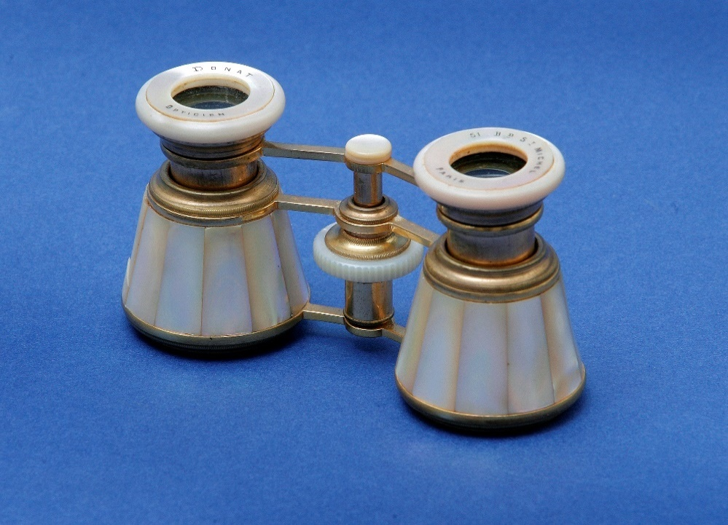 | Lot 256
257. | Edwardian inlaid mahogany knee-hole writing desk/dressing table fitted five cock beaded drawers, brass drop handles, square taper legs 105cm wide | £50-£70
258. | Oak reproduction court cupboard in the traditional style 122cm wide | £40-£60
259. | William IV mahogany pole screen with needlework panel on part tulip cupped stem, flat base on bun feet height 126cm and a 19th century mahogany plant stand height 128cm | £80-£95
260. | Pair of decorative bulbous shaped table lamps complete with shades, carved wooden table lamp in the Chinese style and an Oriental blue and white china table lamp decorated dragons both with shades (4) | £60-£70
261. | A copper warming pan length 113cm and two Oriental brass bowls in sizes | £30-£35
262. | Painting of Madonna and Child, attributed to Edith Gulmann (signed Edith), 53cm x 30cm on panel, and one other. | £120-£150
263. | George III mahogany coal perdonium with metal interior, side brass carrying handles, brass cover with handles on claw feet, 29cm square | £80-£90
264. | An Arsenal F.C. commemorative medal, 1971, medal No: 0613, together original case. | £50-£80
265. | Mahogany bookcase the upper part with pair of glazed doors enclosing two shelves below, two frieze drawers and enclosed cupboard under on bracket feet 91cm wide | £70-£90
266. | Pine kneehole dressing table with bevelled mirror back three drawers either side wood knob handles 140cm wide
267. | Pair of matching two drawer bedside chest, wood knob handles, bracket legs 49cm wide | £35-£40
268. | Reproduction inlaid mahogany cupboard/chest, pair of doors brass handles, enclosing two drawers to one side, opposite a sliding tray and shelf, under ogee feet, 95cm wide. | £60-£75
269. | Walnut cupboard with pair of folding doors enclosing single shelf on bun feet, 79cm wide | £50-£60
270. | A two-seater upholstered pink settee 'polka' pattern and three loose cushions | £50-£60
271. | A resin figure of a young woman holding an upturned urn height 85cm | £80-£90
272. | A full set of Gainsborough ladies’ shoes, limited edition (21) complete with certificate and boxes and two posy holders | £150-£175
273. | Light oak dresser, the upper part, one with a gallery, the third one sliding 'doors', two frieze drawers, enclosed cupboard under, on stile legs, 110cm wide | £65-£75
274. | Album of autographs including Terry Scott, Una Stubbs, Spike Milligan, Willie Rushton, Johnny Morris, Vic Reeves, Jeremy Irons, Andrew Sachs, Robert Lindsay, Gene Kelly, Harry Enfield, Omar Sharif, Ian McShane, Dick Van Dyke, Tommy Steele, Johnny Matthis, Sid James, Derek Jacobi, amongst others. | £80-£100
275. | Lady's Silver Gilt Cartier quartz wristwatch number 0932215 and S90004 with leather strap. | £100-£150

AUCTION DATES 2020

Ibbett Mosely Auction Rooms, Argyle Road,
Sevenoaks, TN13 1HJ

Wednesday 22nd January
Wednesday 26th February
Wednesday 8th April
Wednesday 13th May
Wednesday 17th June
Wednesday 22nd July
Wednesday 16th September
Wednesday 28th October
Wednesday 2nd December
Viewing on day before sale from
12.00 pm to 19.00 pm
and on morning of sale from
10.00 am to 12.30 pm
Sale commences at 12.30 pm

Valuation Day

Our next valuation date is

Wednesday 29th January

At Ibbett Mosely Auction Rooms from
11.00am to 16.00pm

