Please note that due to the new Anti-Money Laundering Regulations 2019, it is now a legal requirement to have photographic ID to be a registered bidder.

Unless done so in January sale, buyers purchasing from Ibbett Mosely Auction Rooms must provide photographic ID, and re-register to bid in this auction.

All buyers purchasing from Ibbett Mosely Auction Rooms are required to register to bid no less than one hour before the sale commences.

IMPORTANT NOTICE

THIS SALEROOM OPERATES A BUYERS PREMIUM OF 15% PLUS V.A.T.

PLEASE NOTE IT IS IMPERATIVE THAT ALL GOODS ARE PAID FOR AND REMOVED FROM THE HALL BY 6.00 P.M. ON DAY OF SALE. THERE ARE NO STORAGE FACILITIES WHATSOEVER AVAILABLE. LIMITED TRANSPORT FOR LOCAL DELIVERIES.

THE SALEROOM IS A NO SMOKING AREA

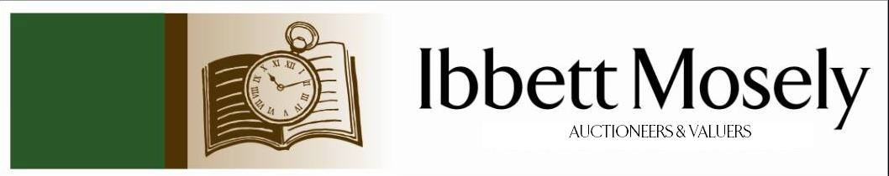

Catalogue of Antique, Edwardian and Victorian
Furniture and Effects
to be Auctioned on

Wednesday 26th February 2020
at 12.30pm

IBBETT MOSELY AUCTION ROOMS
ARGYLE ROAD, SEVENOAKS, KENT TN13 1HJ

On View:

Tuesday 25th February 2020
12.00pm to 19.00pm

also

Morning of Sale
10.00am to 12.30pm

Catalogues: £2.00

Auctioneer and Valuer: Alan White FNAVA
Consultant Auctioneer and Valuer: Derek Hodge

Trainee Valuer and Clerk: Nicola Rainsley-Hughes
Auction Clerk and Administrator: Emily Frederick

Photographs credited to Lee Wells 01732 740280

1. | A selection of copper-coal scuttle, Samovar, kettle, saucepans and jelly mould. | £40-£50
2. | A set of brass scales and weights, pair of candlesticks and sundry brass. | £35-£45
3. | Edwardian tub shaped chair barley twist side supports and front legs cross stretchers and carved seat. | £30-£35
4. | Three bisque cherubic figures, three gilt cherubic figures in poses and four glass paper weights. | £75-£90
5. | Victorian mahogany framed gents spoon back chair, upholstered in oatmeal coloured material button back on turned feet. | £90-£120
6. | Victorian mahogany pole screen with oval needlework panel, complete stand and a circular top pedestal table on tapered legs. | £80-£90
7. | Lady's Victorian button back bedroom/occasional chair turned shaped front legs, ending porcelain casters. | £80-£100
8. | Oak sideboard two frieze drawers and two smaller dittos under brass swan neck handle turned legs, stretchers all round, 133cm wide. | £120-£140
9. | Framed needlework sample, inscribed 'Charlotte Sandon's work finished June 28 1833, aged 12 years', 37 x 29cm. | £40-£50
10. | Oak grandfather clock, flat hood, brass dial-quarters. Thos Sharp, Stratford upon Avon, strikes on bell, height 191cm. | £400-£600
11. | Victorian mahogany occasional chair, part padded back, flanked by barley twist sides, seat gold dralon on cabriole feet, legs knopped at ends. | £45-£60
12. | Antique oak dresser upper part fitted four plate shelves below base, three drawers brass handles on square tapered legs, 195cm wide. | £100-£150
13. | French brass carriage clock bevelled glass panels, white enamel dial, height with handle 15cms, retailed by F.W Chandler, Paris. | £80-£90
14. | Edwardian mahogany beaded clock, strike on coil, decorated dial, height 35cm, dome top. | £140-£160
15. | Joseph Horlor-Landscape with trees and waterfall with figure standing by, oil on canvas 26cm x 17cm, signed.
16. | Cut glass salt swan overlaid with silver, silver bowl with pierced sides, Birmingham, a selection of (5) silver handled button hooks (Victorian) and an overlaid scent bottle. | £75-£80
17. | Late 18th century mahogany chest of two short and three long graduated cockbeaded drawers, brass ring handles shaped apron splayed legs 107cm wide (a.f). | £180-£220
18. | Antique walnut and brass pistol (no makers name). | £140-£160
 | 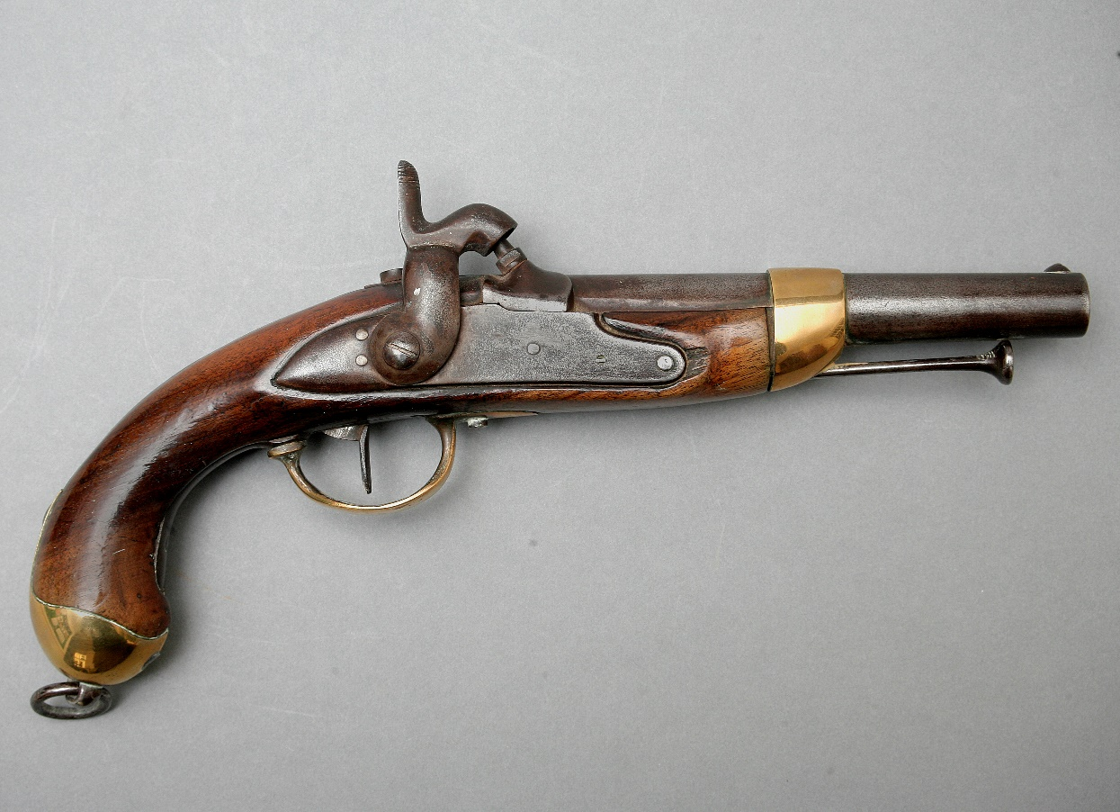 | Lot 18
19. | Edwardian tub shaped chair with arms upholstered in green dralon on turned taper front legs ending casters. | £40-£50
20. | Pair of cane seated bedroom chairs with bobbin turned sides and front stretcher on baluster legs. | £40-£50
21. | Victorian ormolu and painted decorative painted bell. | £25-£30
22. | Set of four hoop and spindle back chairs, solid seats with squabs on turned shaped front legs and two Victorian Windsor chairs with arms, crinoline stretcher on tool shaped front legs. | £150-£170
23. | Victorian white glass oil lamp with white glass bowl and funnel, height 54cm. | £40-£50
24. | Oak gateleg table on baluster legs. | £25-£30
25. | Sterling silver 925 easel photograph frame and a three-piece silver christening set, Sheffield, mixed dates, circa 1924/28, cased.
26. | Victorian gold sovereign 1900.
27. | Heather Willis- Country Lane with thatched cottages, watercolour, 30cm x 15cm, signed.
28. | Silver photograph frame 15cm x 10cm, Birmingham EPNS serviette ring and an EPNS flatware service three place setting and a selection of stainless-steel knives.
29. | A pair of figures male and female in the Dresden style, height 14cm.
30. | Two George III brass game tokens, with imitation Guinea spade, 1790. | £20-£25
31. | An EPNS photograph frame, 34cm x 28.5cm (Italian). | £25-£30
32. | 18ct gold ring set three sapphires flanked by four small diamonds | £250-£350
33. | Georgian silver pocket watch fusee movement white enamel dial, key wind, engraved Straub and Hastings 77 Blackmore Street, London dated 1802 | £300-£500
34. | Gold brooch with nine graduated diamonds in the shape of a horseshoe | £100-£150
35. | 19th Century gilt framed bevelled wall mirror carved eagle with acanthus leaf panels twist side supports 93 x 37cm. | £60-£80
36. | A small Victorian nursing chair | £70-£90
37. | A limited print of Zebras and Ostriches by Maurice Fietch, 9/150, 54 x 35cm, one only. | £20-£35
38. | Regency mahogany chiffonier raised back two frieze drawers, cupboard under, enclosed by pair of doors raised on a flat base, 93cm wide. | £90-£110
39. | George III mahogany dining table, on square taper legs spade feet, extended size approx. 264 x 207cm. | £100-£150
40. | A mahogany circular top occasional table, turned column brass claw feet ending brass casters, 63cm dia. | £40-£45
41. | A 19th Century gilt framed wall mirror, 'shell' cresting, 38cm x 56cm. | £40-£60
42. | A pine rectangular kitchen table, on square legs. 150cm x 73cm. | £30-£40
43. | A pine cupboard, two frieze drawers, wood knob handles, enclosed cupboards under, on flat base, 91cm wide. | £30-£40
44. | A pine kitchen table with oval flaps, on baluster legs, stretchers all round, 123cm wide. | £40-£45
45. | A 19th Century mahogany sofa table, with satinwood stringing, two frieze drawers opposite dummy drawers, on a pedestal base, and brass claw feet and casters, 104cm wide. | £100-£150
46. | A Late Victorian "Holyrood Folding Table," by "J and S Smith, Peables," with octagonal top, 75cm in diameter, together with an Edwardian occasional table, and a needlework panel firescreen. (3) | £25-£45
47. | A Victorian satin beech swing-frame toilet mirror, 50cm wide, a beech piano stool, and a folding table. (3) | £20-£30
48. | A brass coal box, with concave front, 36cm wide, and a pottery toilet bowl and ewer. (3) | £30-£50
49. | Victorian rosewood work box, single frieze drawer, wood knob handles and shaped supports, raised on a stand either end, and stile feet, 57cm wide | £125-£155
50. | Victorian polescreen with wool work tapestry panel, turned mahogany columns on tripod legs, height 149cm | £50-£70
51. | Oriental camphor wood chest decorated in the Chinese style on bracket feet, 91cm wide | £60-£80
52. | A pair of Staffordshire soup plates, a Royal Worcester Daedalus and Icarus plate, four ribbon type plates, and a blue and white teapot, with pewter lid, and two dishes. (10) | £25-£40
53. | A George III mahogany chest of four long graduated drawers, with two handles, on bracket feet, 77cm wide. | £40-£60
54. | A 9ct gold dress ring, set seed pearls, and central emerald. | £80-£120
55. | An 18ct gold dress ring, set a small central diamond, and two chip diamonds. | £40-£60
56. | A stained beech figure of a cat, in the tribal style, 24cm long, on African game of "Bao," two simulated rosewood candlesticks, and a pot and cover. (5) | £30-£40
57. | An Early 20th Century Chinese enamelled scent bottle, and four porcelain scent bottles, one missing its top. (5) | £40-£60
58. | A lady's Seiko wristwatch, a Sekonda wristwatch, and an Egyptian style filigree bracelet (3). | £30-£50
59. | An early 20th Century porcelain part afternoon tea set, floral decorations, with gilt edges, bears a Berlin mark, approx. 20 pieces. | £20-£30
60. | A Gillingham football club home shirt, autographed by members of the 2016/17 team. | £30-£50
61. | A pair of Royal Doulton stoneware ewer form jugs, flowerhead pattern, 29cm high, one repaired, a pair of Slaters patent vases, 25.5cm high, together with some blush ivory, and other pieces. | £120-£150
62. | A tin "Milner's" cash box, 38cm wide. | £30-£50
63. | A single volume book "Earlie Rising," by a late philosopher, illustrated by Lady Frances Bushby, in need of restoration. | £50-£60
64. | A set of bone handled fish knives and forks, in lined case, a set of pastry forks, in lined case, and various sets of tea knives, in lined cases, together with some unboxed. | £30-£50
65. | A pair of modern Chinese porcelain figures of seated cats, each 15cm high, a pottery incense burner, a small decorative tea pot, and an English pottery bowl with silver plated handle. (5) | £20-£30
66. | A set of four George III style mahogany dining chairs, with pierced splats, on square tapering legs, restored. (4) | £40-£60
67. | A George V silver cream jug, by William Hallett and Co, Ltd, Birmingham 1921, and a silver handled fork, Birmingham, 1900. (2) | £40-£60
68. | A Late 19th Century walnut and stained beech Vienna regulator wall clock, with turned finials, 83cm high, in need of some restoration. | £40-£60
69. | H. Bunbury, after S.D. Sorron - six stipple engravings of late 18th/Early 19th Century soldiers, comprising: "A Sergeant of Infantry," "A Light Horseman," "A Light Infantry Man," "A Foot Soldier," "A Drummer," and "A Life Guardsman," each in maple frames and 57cm x 45cm. | £250-£350
70. | An Early 20th Century French/Swiss longcase clock in stained beech case, believed to have been from the Jura district, the movement with upside-down crown wheel escapement, 235cm high. | £80-£100
71. | Still Life – Fruit with flowers, oil on canvas 34 x 44cm, unsigned. | £75-£100
72. | 19th Century circular gilt framed convex mirror with ‘Eagle’ cresting, 35cm dia. | £90-£120
73. | Japanese bulbous shaped china table lamp decorated with Warrior type figures side dummy handles complete with shade, height 35cm, a.f. | £50-£70
74. | A pair of unsigned oil on board paintings, "Vessels in a Rough Sea," 17 x 24cm. | £100-£150
75. | A 19th century map of Middlesex, 19cm x 26cm, a small print of Margate pier, and three decorative prints (5). | £20-£30
76. | A pair of Early 20th Century gilt-brass and mother of pearl opera glasses by "Donat Optitians, 51, Bd St. Michel, Paris," in later case. | £80-£100
77. | William IV mahogany pole screen with needlework panel on part tulip cupped stem, flat base on bun feet height 126cm and a 19th century mahogany plant stand height 128cm | £80-£95
78. | Pair of decorative bulbous shaped table lamps complete with shades, carved wooden table lamp in the Chinese style and an Oriental blue and white china table lamp decorated dragons both with shades (4) | £60-£70
 | 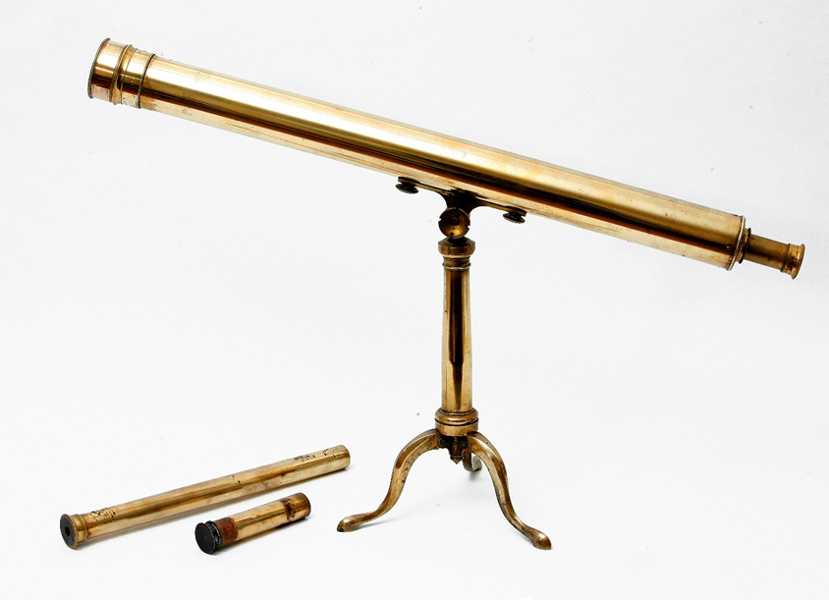 | Lot 89
79. | A copper warming pan length 113cm and two Oriental brass bowls in sizes | £30-£35
80. | Painting of Madonna and Child, attributed to Edith Gulmann (signed Edith), 53cm x 30cm on panel, and one other. | £100-£120
81. | Mahogany bookcase the upper part with pair of glazed doors enclosing two shelves below, two frieze drawers and enclosed cupboard under on bracket feet 91cm wide. | £70-£90
82. | Pine kneehole dressing table with bevelled mirror back three drawers either side wood knob handles 140cm wide.
83. | Pair of matching two drawer bedside chest, wood knob handles, bracket legs 49cm wide. | £35-£40
84. | Reproduction inlaid mahogany cupboard/chest, pair of doors brass handles enclosing two drawers to one side opposite a sliding tray and shelf under ogee feet 95cm wide. | £60-£75
85. | Walnut cupboard with pair of folding doors enclosing single shelf on bun feet, 79cm wide. | £50-£60
86. | A two-seater upholstered pink settee 'polka' pattern and three loose cushions. | £50-£60
87. | A resin figure of a young woman holding an upturned urn height 85cm. | £80-£90
88. | Light oak dresser, the upper part, one with a gallery, the third one sliding 'doors', two frieze drawers, enclosed cupboard under, on stile legs, 110cm wide. | £65-£75
89. | A Late 19th Century/Early 20th Century brass telescope, with two extra lenses, and a tripod base, in mahogany box. | £150-£250
90. | A patent calculating machine, distributed by the "Muldivo Calculating Machine Co LTD", 49, Queen Victoria Street, London, with plaque attached, in stained oak carrying case, a.f., 32cm wide. | £30-£50
 | 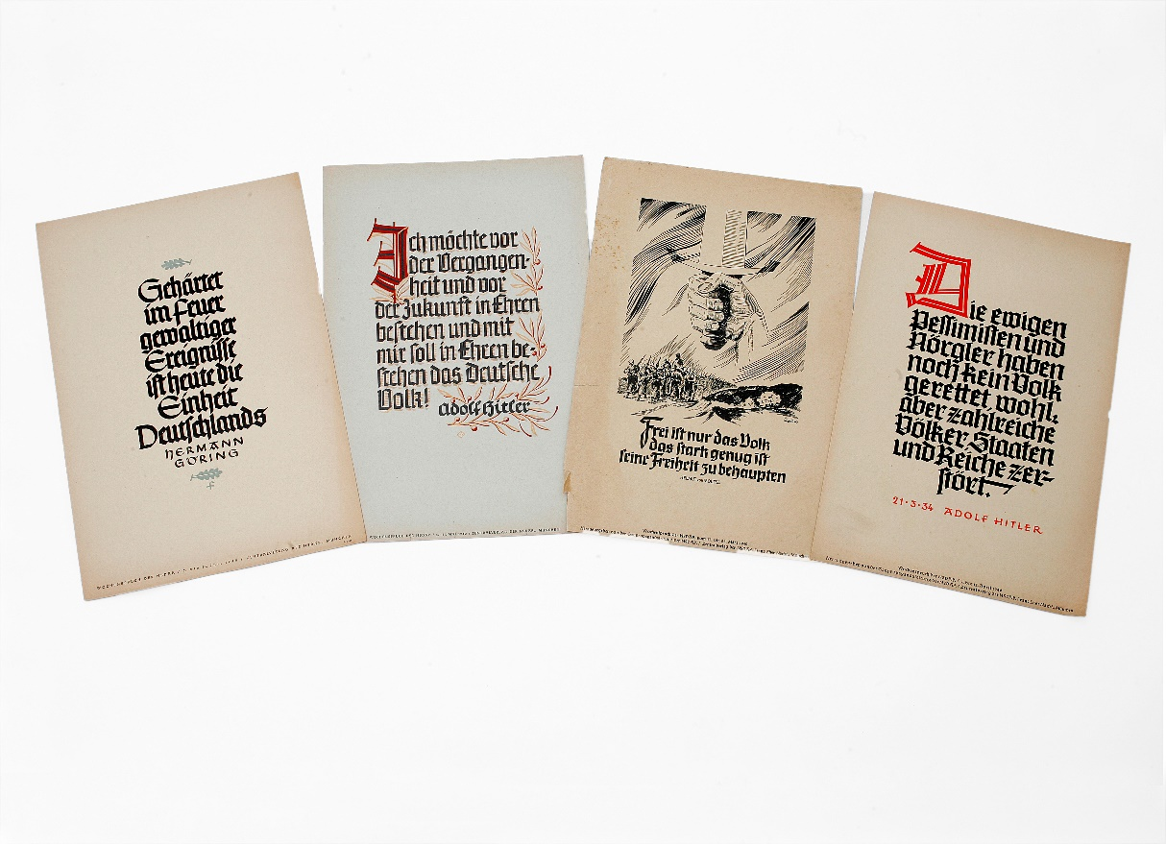 | Lot 97
91. | A calculating machine by "Burroughs of the U.S.A.", 31cm wide. | £30-£50
92. | A pair of Tiffany and Co white gold diamond set ear-studs, in lined box. | £200-£300
93. | A 14k diamond set heart pendant, Italian, white gold. | £150-£200
94. | A 14k Italian white gold anklet. | £30-£50
95. | An Edwardian amber, silver and veneered pipe, hallmarked Birmingham, 1909, a carved bone wolfs head pipe with silver collar, Birmingham 1897, and five further pipes and part pipes (7). | £100-£150
96. | L. Burliegh Bruhl - Dutch landscape, with windmill, signed bottom right, and inscribed "For the European War Fund, Sept 1914", watercolour, 32cm x 45cm. | £80-£100
97. | A folio of Pre and Early World War Nazi Political and Propaganda posters (34). | £150-£200
98. | After George Morland - Figures and livestock outside an inn, oil on canvas, 58cm x 72cm. | £40-£60
99. | A L'aclon lady's atomiser, and a small purse, containing a 9ct gold wristwatch, a.f., boxed. | £30-£50
100. | A set of six Victorian silver fiddle pattern dessert spoons, Exeter 1853 and 1854, three George III dessert spoons, 1814, an Irish silver spoon, a.f., together with mixed tea and coffee spoons, decorative sugar nips, tea-knives, a cigarette case, and two napkin rings, approx. 30oz. | £250-£300
101. | A gold diamond set dress ring, set 11 stones, in lined box. | £200-£300
102. | A four-string banjo, with silver plated fittings, 88cm long. | £60-£80
103. | A pair of cast brass firedogs, of lion form, and a pair of bellows (3) | £40-£60
104. | Lansell - Landscapes, oil on canvas, 49cm x 75cm, and 39cm x 59cm (2). | £40-£60
105. | W.A. Frickes, still life subjects, oil on board, 59cm x 49cm, and 44cm x 53cm (2). | £40-£60
106. | Trioond - pair of silk prints of tribal figures, 48cm x 45cm, and Sandi - print of two Balinese style dancers, 84cm x 66cm (3). | £30-£50
107. | A Late 19th/Early 20th Century stained pine clerk's desk, with rear compartment, and sloping top, 83cm wide, bearing a label for the "Educational Supply Association, Ltd". | £80-£100
 | 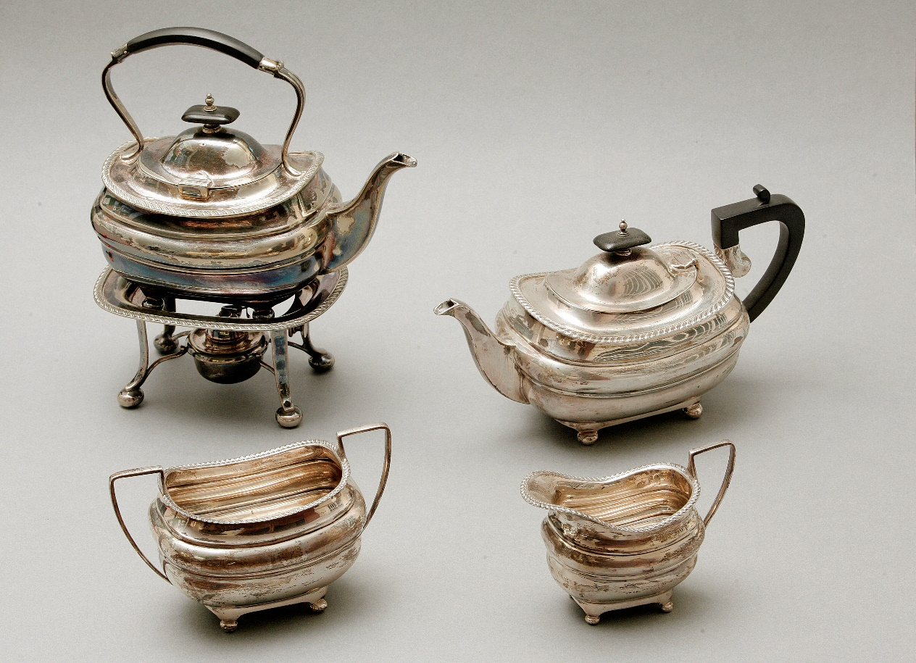 | Lot 112
108. | A Late Victorian oak and silver plated tantalus, with three-part hobnail cut decanters, 37cm wide. | £60-£80
109. | A George I map of Kent from John Harris' book "The History of Kent", engraved by Samuel Parker in 1719, after Philip Symondon, 57cm x 82cm. | £80-£100
110. | Caesar - path through woodland, oil on canvas, 52cm x 81cm. | £20-£30
111. | Two albums of Early 20th Century postcards, mainly views of well-known paintings and artists, approx. 200. | £40-£60
112. | A George V silver three-piece tea set, with gadrooned edge, maker Walker and Hall, Sheffield 1915, together with a similar silver-plated tea kettle, stand, and burner (4). | £350-£450
113. | A George V silver mustard pot, Seffield 1915, a pepperette 1913, a silver-plated cocktail shaker, three silver spoons, and a other silver plated objects. | £20-£30
114. | A 9ct gold gent's "Longines" wristwatch, movement No. 52019645, reg No. 23051, circa 1975, with booklet, in lined case, together with a "Montine" Lady's wristwatch, in case (2). | £100-£150
115. | An Early 20th Century glass two branch epergne, with green tinted edges, 41cm high. | £60-£80
116. | A carved oak Carolean style elbow chair, the front legs united by a carved stretcher, tapestry upholstery. | £150-£200
117. | Two Chinese hardwood stools, the three legs united by a stretcher. | £50-£80
118. | Three Tanzanian hardwood low stools, and a further African tribal stool, a.f. (4). | £100-£150
119. | A link bracelet, with mixed 9ct gold charms, and some metal, approx. 38g weighable. | £300-£400
120. | After Leslie Wilcox - "The Spithead Fleet Review", the Queen's Silver Jubilee 1977, chromolithograph, 50cm x 70cm.
121. | A pair of part green tinted spill vases, with silver mounts, each 20.5cm high, together with three teaspoons, a pickle fork, two glass trinket boxes, with silver tops, a silver backed clothes brush, and a glass toilet bottle, with silver top, some pieces a.f. (10). | £40-£60
122. | Four lady's "Amax" quartz wristwatches (4).
123. | Eleven Royal Doulton and Coalport figures of ladies (11).
124. | A Royal Worcester figure of a Queen Elizabeth II, diamond wedding anniversary, two Royal Doulton and Coalport figures of Dianna, Princess of Wales, and a Royal Doulton figure, "Just For You" (4).
125. | An Omega lady's wristwatch, with paperwork, circa 1975, in box and packaging. | £150-£200
126. | Three lady's wristwatches, with quartz movements, two boxed, one unboxed (3). | £80-£100
127. | A Rosenthal "Studio Linie" vase, in Art Deco style, 18cm high, a Bohemian glass scent bottle, a Caithness glass paperweight, together with Spode, Aynsley, and other porcelain objects, all boxed (12). | £60-£80
128. | A modern silver-plated candelabra. | £20-£30
 | 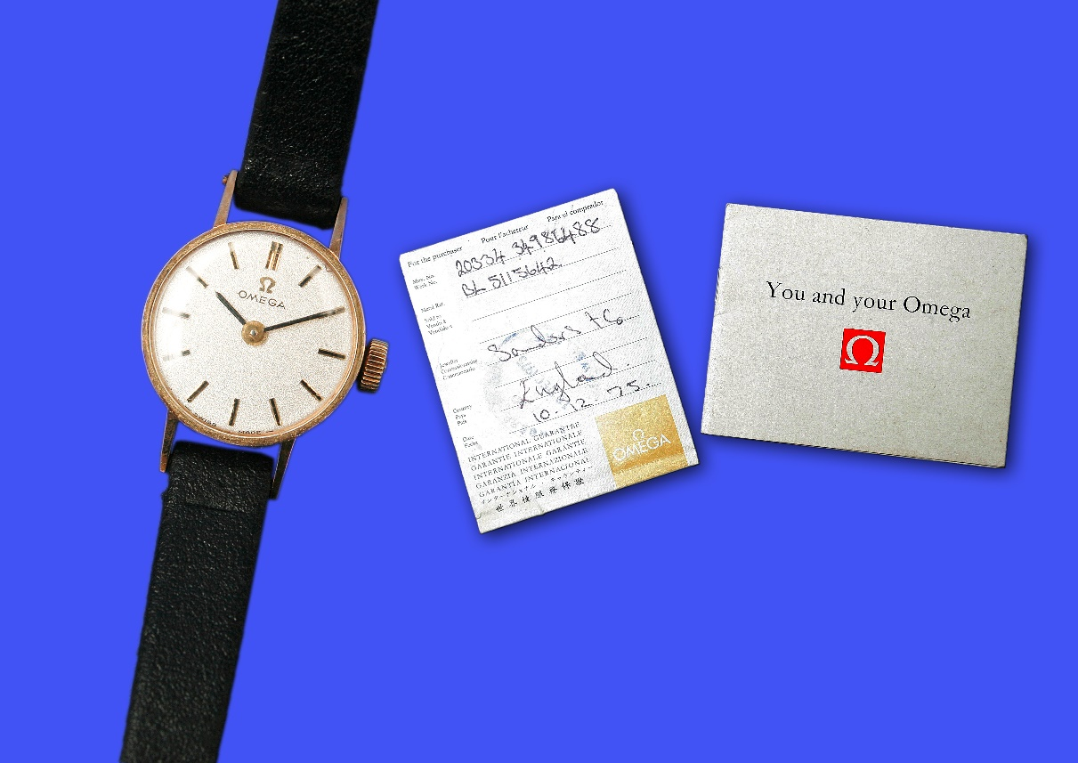 | Lot 125
129. | Two Dupont of pari's lighters (2). | £60-£80
130. | A two-colour onyx chess set, with board, in lined box. | £40-£60
131. | A 9ct gold gent's signet ring, in box. | £200-£250
132. | A Victorian 1900 gold sovereign. | £190-£210
133. | A Victorian 1892 gold sovereign. | £190-£210
134. | A Victorian 1871 gold sovereign. | £190-£210
135. | A George V silver condiment set, Birmingham, 1918, in lined case. | £60-£80
136. | A cold painted bronze of boar, 5cm long. | £150-£200
137. | An Indian silver model of a dhow, on ebonised base, 25cm high. | £40-£60
138. | A pair of glass match holders, with silver mounts, Birmingham 1878, and a filigree butterfly brooch (3). | £30-£50
139. | A pair of silver-plated serving spoons, a pair of salts, with silver spoons, two silver plated mustard pots, a cigarette case, a pair of candlesticks, a bell, and a Swiss pewter measuring jugs (13). | £40-£60
140. | A Staffordshire figure of Sir Walter Scott, with dog, slightly a.f., 37cm high, and two Portuguese religious figurines, a.f. (3). | £30-£40
141. | A pair of spelter figures of pointer type dogs, each 25cm long (2). | £30-£40
142. | L. Bureau - bronze of seated lion, on oval base, 19cm high. | £150-£200
 | 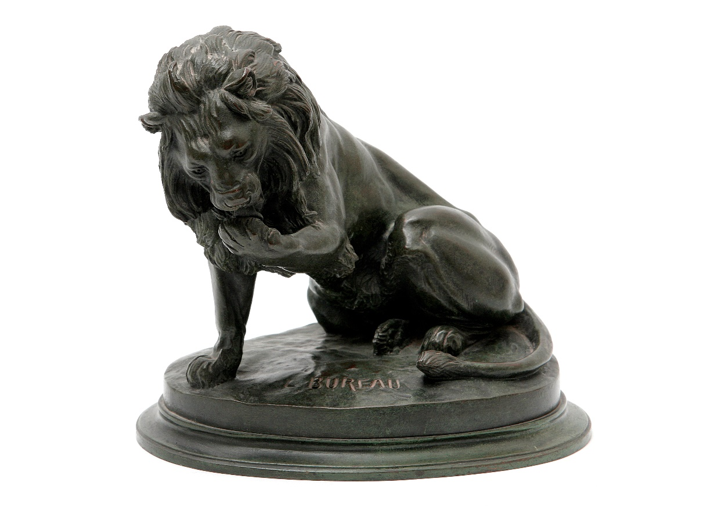 | Lot 142
143. | A copper oval shaped coalbox, and a copper bucket (2). | £60-£80
144. | Two small Chinese pictures on rice paper, of lantern bearers, 13cm x 8cm, in maple frames, and two vestment pieces (3). | £40-£60
145. | A Minton pottery gourd form pot, and two crackleglaze habitat vases (3). | £20-£30
146. | A glass Boden-Powell Mafeking plate, 25cm in diameter. | £15-£20
147. | A pair of squat brass candlesticks, and a small pair of spelter vases (4). | £30-£50
148. | A French pottery two-handled vase, 14.5cm high, slightly a.f. | £30-£50
149. | Of Royal West Kent Regiment, and Artist's Rifles Interest - one volume "The Queen's Own Royal West Kent Regiment 1914-1919", by C.T. Atkinson, one volume "From Kent to Kohima", by Stanley-Clarke and Tillott, and two further volumes, together with one volume "Artist's Rifles 1914-19 Roll of Honour", five further books of similar interest, two prints, and two regimental plaques (14). | £40-£60
150. | Four Naples style porcelain figures of Napoleonic soldiers, each 30cm high (4). | £40-£60
151. | A pair of George V silver candlesticks, by James Dixon and Sons, Sheffield 1928, weighted bases, a silver teapot, a.f., a George V silver basket, Birmingham 1929, a small sauceboat, Chester 1898, six mixed napkin rings, a silver backed hand mirror, a.f., and a pair of sugar nips, London 1899, approx. 24oz, weighable. | £180-£220
152. | A Art Nouveau style silver plated pen tray, three entree dishes, and other silver plated ware, various. | £20-£30
153. | A small Chinese silver waiter, by Woshing of Shang-Hai, a Chinese silver sugar bowl, and cover, and a tree piece Chinese silver backed dressing table set, approx. 11oz, weighable. | £100-£150
154. | An oval locket, and decorative link chain, boxed. | £30-£50
155. | After Redoute - five flower prints, each 27cm x 20cm.
156. | After Christopher Pendleton - five limited edition prints of British Birds, each 24cm x 19cm, part of a limited edition of 350.
157. | A 20th Century bamboo and black lacquered Chinese style writing table, fitted seven drawers, on x-frame base, 113cm wide. | £80-£100
158. | G.S. Walters R.B.A. 1917 - View of Venice, with gondolas and fishing boats in foreground, watercolour, 24cm x 43cm. | £150-£250
159. | After Stephen Whittle - small print "The Pleasure Boat", 14cm x 15cm. | £20-£30
160. | After Barry Clarke - "High Halden Road", chromolithograph of tank locomotive, 50cm x 75cm. | £10-£20
161. | A Victorian walnut Wellington chest of seven graduated drawers, flagged by two pilasters, one lockable, on plinth base, 51cm wide. | £80-£100
162. | A Victorian pale mahogany Pembroke table fitted one drawer bearing a label for "T.H. Filmer of London", on turned and ringed legs, 97cm x 94cm, extended. | £80-£100
163. | A reproduction mahogany Davenport desk, with hinged slope, and drawers to either side, 54cm wide. | £80-£100
164. | An Early 20th Century school - harbour scene, with fishing boats and bathing wagons, monogrammed and dated 1910, watercolour, 19cm x 30cm. | £30-£50
165. | J.A. Holmes - views of fishing smacks, various, oil on board, two signed, each 13.5cm x 21cm (4). | £100-£150
166. | A Victorian oval inlaid and walnut quarter veneered writing table, on twin turned end supports and carved legs, with porcelain castors, top 60cm x 105cm. | £150-£200
167. | An Edwardian inlaid mahogany settle, on square tapering legs with castors, 109cm wide. | £80-£100
168. | A Walker and Hall silver plated teapot, inscribed "LNER", 12cm high. | £15-£20
169. | A George VI glass inkwell, with hobnail cut base, silver mount, and cover, London 1948, 12.5cm high, a.f., with two small glass inkwells, one a.f. (3). | £30-£50
170. | A pair of Teplitz Vienna porcelain vases, decorated flowers and foliage, 21cm high. | £20-£30
171. | A Late Victorian ebonised extending and decorative brass book rack, 33cm wide. | £20-£30
172. | Two silver plated sugar castors, and a small domed butter dish (3). | £20-£30
173. | A small letter, on Downing Street paper, thanking a young lady for a donation to the Russian Fund, dated June 1945, from Clementine S. Churchill. | £30-£50
174. | Henry G. Walker – lobster fisherman’s cottage, coloured etching, 17cm x 34cm. | £20-£30
175. | 19th Century school – Crofter’s cottage, in landscape, watercolour, 25cm x 35cm. | £40-£50
176. | W.H. Pearson – “Herring Boat”, in rough seas, watercolour, 26cm x 63cm. | £70-£100
177. | T. Mortimer 1871 – mixed shipping, near harbour, watercolour, 18cm x 34cm. | £50-£70
178. | L.O. Linnell – Mediterranean scene, slope towards a lake, watercolour, 33cm x 24cm. | £40-£60
179. | William Havell 1892 – track near a pond, with figure in distance, watercolour, 12cm x 17cm. | £30-£40
180. | Gorman Morris – “Off the East Coast”, watercolour, 18.5cm x 53cm. | £70-£100
181. | T. Mortimer – “Cornish Coast”, inscribed, watercolour, 24cm x 53cm. | £70-£100
182. | B. Bennett 1924 – “Marchporth”, watercolour, 14cm x 23cm. | £20-£30
183. | 19th Century school – landscape with spired church, and separate tower, watercolour, 27cm x 40cm. | £40-£50
184. | A Victorian carved wood music stool, and a small gilt mirror (2). | £30-£40
185. | An oak mantel clock. | £15-£20
186. | Linnell – winter scene, with lodges, pastel, 26cm x 36cm, together with four still life flower pictures (5). | £20-£30
187. | Anthony Van Dyke Copley Fielding (1787-1855), moorland landscape, with figure and cottages, watercolour, 16.5cm x 22cm. | £40-£60
188. | Attributed to Thomas Richardson – coastal scene, with cottages and church below a cliff, barge in foreground, watercolour, 25cm x 35cm. | £30-£50
189. | D. Buccianelli, Roma – mounted cavalier type soldier, being served wine in a yard, watercolour, 60cm x 45cm. | £100-£150
190. | E.B. Yait – “West Drayton,” watercolour, 24cm x 39cm. | £30-£50
191. | L.M. – Venetian flower and fruit sellers, watercolour, a pair, foxed, 33cm x 48cm. | £70-£100
192. | Charles Turner – “Upper Pool, London,” watercolour, 49cm x 72cm, | £70-£100
193. | A.D. Bell 1915 – “St Georges Island – Venice,” watercolour, 25cm x 36cm. | £150-£200
194. | W. Scott 1851 – thatched cottage, near river bridge, watercolour, 26cm x 40cm, and a further watercolour by another hand (2). | £30-£40
195. | E.B. Laim – landscape with cottage, and fishing on the fens, watercolours, two, each 19cm x 31cm (2). | £30-£50
196. | A late 19th Century French white marble mantel timepiece, under a glass dome, 31cm high. | £40-£50
197. | A 19th Century Dresden porcelain figural table centrepiece, 40cm high. | £40-£50
198. | Three Rosenthal porcelain dishes, three flower pattern fruit plates, and a bowl (7). | £30-£40
199. | R. Cooper 75 – landscape with cattle drover on bridge, watercolour, foxed, 34cm x 50cm. | £20-£30
200. | R. Cooper, 1871 – landscape with wheat cutters, sheep, and boy with fishing rod, watercolour, foxed, 62cm x 46cm. | £40-£50
201. | 19th Century school – landscape with cottage and figure on donkey, watercolour, foxed, 25cm x 39cm. | £20-£30
202. | Late 19th Century school – fishermen on banks of lake, vessels on water, mountainous landscape, watercolour, 13cm x 36cm. | £30-£40
203. | Newton John – “Clovelly”, landscape, with view of the harbour, watercolour, 48cm x 35cm. | £50-£70
204. | 19th Century school – figures by watermill on canal, watercolour, 30cm x 25cm. | £15-£20
205. | A painted display cabinet, flanked by open shelves, 115cm wide, adapted from a sideboard. | £30-£50
206. | An Early 20th Century Dresden porcelain figural candlestick, 33.5cm high, a two-branch candelabra, 30cm high, a pedestal bowl, and a two-handled vase, some pieces a.f. (4). | £70-£100
207. | A gilded spelter and sevre style porcelain figural clock garniture, with French striking movement, and a two-branch candelabra (3). | £90-£120
208. | A Dunhill humidor and cigars. | £40-£60
209. | Gorman Morris – “Misty Night”, and “Night”, watercolours, a pair, each 19cm x 53cm. | £50-£70
210. | J.C. Jonas – fishing smacks leaving and coming ashore, watercolour, 18cm x 45cm. | £40-£60
211. | Norman Bradley – “Haytime”, and “Near Godalming”, watercolours, a pair, each 17.5cm x 37cm. | £40-£50
212. | After Joseph Farquharson – feeding the sheep in winter, engraving, 57cm x 82cm, and after Alfred de Breanski, etching of sheep (2). | £10-£15
213. | A rosewood toilet mirror, and two Victorian dining chairs (3). | £15-£20
214. | A pair of floral porcelain vases, each 19cm high. | £15-£30
215. | Six boxes of mixed books on Kent, Sussex, together with arms and armour, and a box of books on Winston Churchill (6).
216. | A box of books containing volumes of "A Saunter Through Kent, by Charles Igglesden", and three further boxes of books on Kent and architecture, and a box of books relating to Winston Churchill (5).
217. | A box of books on Kent and other subjects, also two boxes of books relating to the Churchill family (3).
218. | A bound set of magazines "History of the English Speaking Peoples", in one box, and four boxes of books relating to history, politics, and Churchill (5)
219. | A box of books covering architecture and history, a box of magazines "The Worlds Famous Pictures", and two boxes of magazines "The Great War" by Winston Churchill (4).
220. | Four boxes of books relating to architecture, politics, and natural history (4).
221. | A carved wood African style staff, with figures located in a base coiled snake form, 159cm high.
222. | Stanley Jackson - an unframed portrait of Sir Winston Churchill, oil on canvas, 71cm x 50cm, together with two printed portraits of Churchill, and a framed certificate, presented to the West Kent General Hospital after the First World War (4).
223. | A Late 19th Century Vienna regulator wall clock, in need of restoration. | £30-£50
224. | A 19th Century wall clock, with square brass dial, in oak and walnut architectural form case, 59cm high. | £80-£100
225. | A Victorian walnut credenza form sideboard, with mirrored back, 147cm wide. | £250-£350
226. | An Edwardian inlaid mahogany display cabinet, 61cm wide. | £40-£60
 | 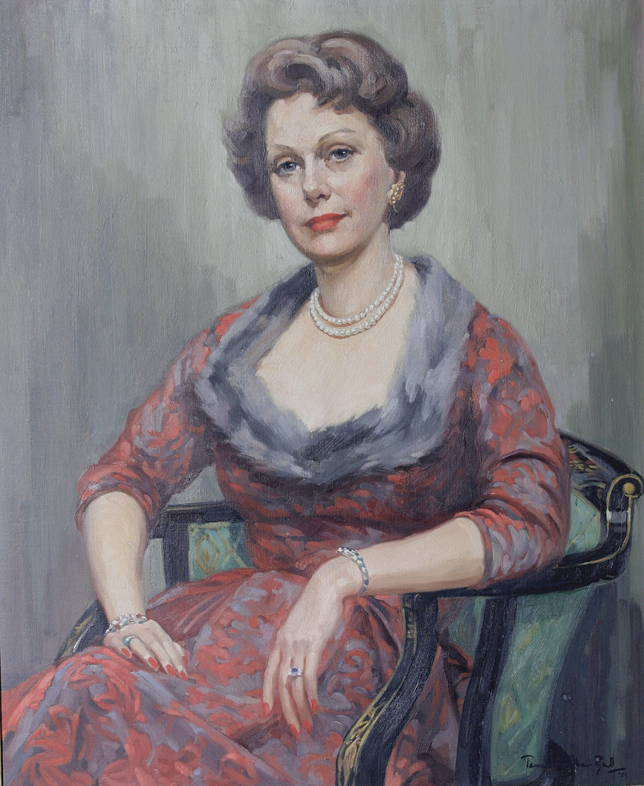 | Lot 227
227. | Pamela Thalben-Ball (1927-2012) - portrait of Mrs Enid Dence, nee Miller, signed and dated 59, 65cm x 62cm. | £250-£350
228. | P.I. Cross - rear of Quebec House, Westerham, oil on board, 39cm x 58cm. | £150-£200
229. | Miss D Freeman - "I. Ming", inscribed verso, watercolour, 47cm x 53cm. | £150-£200
230. | A pair of "Reinle (Russell and Bromley)", lady's fashion shoes of sandal form, two decorative evening bags, two parasols, some gloves, and a small umbrella. | £40-£60
231. | A 15ct gold link bracelet, with padlock, approx. 15g, together with beaded necklaces, and decorative costume jewellery, various. | £150-£200
232. | A Dresden style porcelain table lamp, in the form of a maiden and putto, with shade, 48cm high, two small Samson porcelain groups of cherubs and lambs, a Dresden dish, 15cm wide, and eight miniature pieces (12). | £30-£50
233. | A silver plated tazza, with head of George III to centre, a silver-plated teapot, a water jug, a faceted spill vase, together with mugs, other pieces, and a volume of "History of Old Sheffield Plate", by Frederick Bradbury, 1968. | £40-£60
234. | A Victorian silver pierced and scrolled dish, maker J.H., London 1895, together with a Dutch style caddy spoon, 6oz overall (2). | £50-£70
235. | A small George V silver mug, maker James Dixon and Sons, Sheffield 1920, two small pierced dishes, and three napkin rings, approx. 9oz. | £60-£80
236. | A Regency mahogany box, with secret drawer, 30cm wide, a small lacquered oriental box, a decorative plastic box, and an oak book rest (4). | £20-£30
237. | A George III mahogany chest of two short and three long drawers, with decorative brass handles, on ogee bracket feet, 106cm wide. | £100-£150
238. | A set of six Victorian walnut kidney back dining chairs, on turned legs, a.f. (6). | £100-£150
239. | A Victorian family Bible, with family register, and other information relating to the Cowdrey family between 1844 and 1886, relating to earlier members of the cricketing family, in need of restoration. | £80-£100
240. | To L-8641, Private G. Briggs, 1st Royal West Kent Regiment - 1914 Start, with 5th August to 22nd November 1914 clasp, together with War and Victory Medals, and to 92540, Gunner F.W. Allen, later 1257510 Acting Corporal F.W. Allen C.G.A., First World War pair, and L.S. and G.C. medal, in a Queen Mary box, with some related material. | £80-£100
241. | An album of postcards with views of Aldershot, other locations, together with some humorous cards, and some silent movie/music stars, approx. 117, a small scripture book, and a tin of mixed coins. | £40-£60
242. | A wooden and plastic scale model of H.M.S. Victory, in glazed case, 44cm wide. | £40-£60
243. | A plastic scale model of the Mauretania, in wood case, 46cm wide, and a small model of Stephenson’s Rocket, in box frame, 17cm wide (2). | £30-£50
244. | A quantity of silver-plated items including a three-piece tea set, a tazza, a bread board, an oval tray, and other pieces. | £40-£60
245. | A similar lot of mixed silver-plated ware, including a salver, a biscuit barrel, and other pieces. | £40-£60
246. | A further similar lot of mixed silver-plated ware. | £40-£60
247. | A Late Victorian silver Queen Anne style teapot with ebony finial and handle, maker Thomas Bradbury and Sons, Sheffield 1899, approx. 1899. 15oz. | £150-£200
248. | A George VI pierced low tazza, Sheffield 1943, and a pair of Edwardian silver salts, Birmingham 1907, together with two salt spoons, approx. 24oz weighable. | £200-£250
249. | A George V three-piece silver tea set, with ebony handle and finials, maker B.B.S. limited, Birmingham 1936, approx. 45oz. | £400-£500
250. | Two boxes of mixed postcards and first day covers, a quantity of cigarette and tea cards, a small quantity of lady's evening gloves. | £20-£30
251. | An Early 20th Century carved and stained beech music stool, on cabriole legs, united by stretchers, 46cm wide. | £20-£30
252. | A Royal Dux figure of a maiden filling a water jug, on shell base, 23cm high, and a pottery figure of an elephant, 16cm high (2). | £40-£60
253. | A cast iron "Jolly Nigger" moneybank, and a similar "Dinah" moneybank, together with a quantity of mixed and commemorative coins (3). | £30-£50
254. | A Late Victorian cutlery canteen, together with three other boxes containing tea knives, and other mixed cutlery (4). | £40-£50
255. | A set of six George VI silver teaspoons and sugar nips, in lined case, a silver fruit set, a carving set, and a pair of silver-plated serving spoons, all in lined cases (4). | £40-£60
256. | An Early 20th Century mantle clock in oak case, arched brass dial and striking movement, 36cm wide. | £80-£100
257. | A George V 1914 half sovereign, together with a sovereign purse, and a small quantity of costume and decorative jewellery, and a mesh evening bag (3). | £80-£100
258. | An Edward VII gold sovereign, 1910. | £180-£220
259. | A George V 1915 gold sovereign. | £180-£220
260. | A 9ct gold link watch chain, with a George V 1913 sovereign fob, 51g overall. | £300-£400
261. | A heavy Chinese reproduction gong, 51cm high, and two relief carved wooden figures of goddesses (3). | £40-£60
262. | A gilt brass tripartite dressing mirror, with Oriental and European style decorative panels. | £50-£70
263. | A heavy cast iron document box, 33cm wide. | £20-£30
264. | A Japanese egg shell porcelain part tea set, and an English porcelain part tea set, decorated in the Oriental style. | £15-£20
265. | A Japanese table centrepiece in the form of a bonsai tree. | £15-£20
266. | A carved soapstone figure of a carp, 30cm high, a hard-stone group of monkey and infant on rock, 26cm high, a modern pottery figure of a Shi-Shi (3). | £30-£50
267. | A pair of green hardstone figures of Shi-Shi, 18cm high, and a pair of carved wood figures, 25cm high. | £30-£50
268. | A blue decorative stone figure of an exotic fish, on hardstone base, 15cm high, three graduated pottery figures of Shi-Shi, and two other highly decorated figures (6). | £30-£50
269. | Five cast brass figures of a frog and other creatures, a cast metal figure of a dragon, and carved wooden figures (7). | £30-£50
270. | An Oriental style jardiniere decorated in the European manner, with simulated bonsai tree, 70cm high. | £40-£60
271. | A carved stone figure of squatting monkey, 14cm high, two further monkey figures, a decorative figure of a rat, a carved Netsuke of a grasshopper, and six other decorative figures (12). | £40-£60
272. | A Chinese pottery vase entwined with dragon, 37cm high, a Late Satsuma ware vase, decorated portrait figures, 23cm high, and three further decorative vases (5). | £30-£50
273. | Two Oriental carved wood and metal inlaid figures of priests, each 33cm high, a carved wood figure of a Shi-Shi, and a further of a cat (4). | £20-£30
274. | A Satsuma ware vase as an oil lamp, 58cm high, and a pottery koro, 32cm high (2). | £30-£50
275. | A game of Chien Tung, in papier mache cylinder container. | £20-£30
276. | Three glass drop chandeliers, various. | £20-£30
277. | A pair of small lacquered and mother of pearl decorated panels, 48cm x 26cm, two further decorative pictures, a small carving of a phoenix, and a lacquered letter rack (6). | £20-£30
278. | Four decorative Chinese paintings on rice paper, and two further decorative pictures (6). | £20-£30
279. | A Chinese relief needlework picture of two figures, 25cm x 22cm, a Moghul school text, a.f., and seven further decorative pictures and panels (9). | £40-£60
280. | A reproduction Chinese ebonised alter table, 152cm wide. | £100-£150
281. | A small Chinese carved wood table cabinet, 70cm wide, and a miniature carved table (2). | £60-£80
282. | A small carved wood Chinese style occasional table, 48cm wide. | £40-£60
283. | A part hammered pewter sunflower dish, 51cm long. | £20-£30
284. | A Chinese style lacquered occasional table, a lacquered tabletop, an oak crumb tray, and a decorative table lamp (4). | £20-£30
285. | A Chinese style lacquered oval occasional table on cabriole legs, 76cm wide. | £30-£50
286. | An octagonal tea table, with Chinese style lacquered decoration, 50cm wide, and a lacquered urn stand (2). | £40-£60
287. | A veneered torchere in the form of a Pharaoh, 106cm high, and a small number of related objects (2). | £30-£50
288. | A nest of three oak occasional tables, 61cm wide, and a decorative wood and hide box with cover (2). | £20-£30
289. | A graduated set of three Bretby pottery circular wall plaques, decorated in the Japanese style (3). | £20-£30
290. | A Chinese silk decorative panel, 41cm x 36cm, and six further decorative panels and pictures (5). | £30-£50
291. | A pair of Oriental style painted boxes with hinged lids, each 53cm wide. | £40-£60
292. | Two framed Chinese coat panels, each 66cm x 26cm, and three other decorative pictures and panels (5) | £30-£50
293. | A Chinese style lacquered coffee table with three cloisonne roundels to the top, on squat cabriole legs, 127cm long. | £80-£100
294. | A modern Chinese pottery model of a Shi-Shi, a late Satsuma ware bowl, and seven other decorative objects (9). | £40-£60
295. | A bamboo brush pot with carved decoration, two mother of pearl dishes, a puzzle box, and five other decorative pieces (9). | £20-£40
296. | An Early 20th Century French gilt metal and sevres style porcelain garniture vase, 27cm high. | £30-£50
297. | Two boxes of carved soapstone figures, and other decorative oriental objects. | £30-£50
298. | A. Austen - old lady peeling vegetables and old man smoking, oil on canvas, a pair, 29cm x 24cm each, signed. | £100-£150
299. | F.A. Rezia 1883 - interior of Bruge Cathedral, and an exterior view, oil on canvas, signed and dated, a pair, 75cm x 49.5cm. | £300-£500
300. | An Imari bowl with scalloped edge, decorated floral and foliage panels, 27cm in diameter. | £80-£100
301. | A 20th Century stained and carved oak circular display cabinet, on four cabriole form legs, 72cm in diameter. | £60-£80
302. | An Early 20th Century mahogany wind up gramophone cabinet, of French style, 59cm wide, fitted in 1960, with a Rogers Stereo Control Unit, and a Garrard Turntable. | £40-£60
303. | Le Comte - a biscuit porcelain bust of Marie Antoinette, bears a Sevres style mark verso, on decorative siecle and gilt metal base, 51cm high. | £400-£600
 | 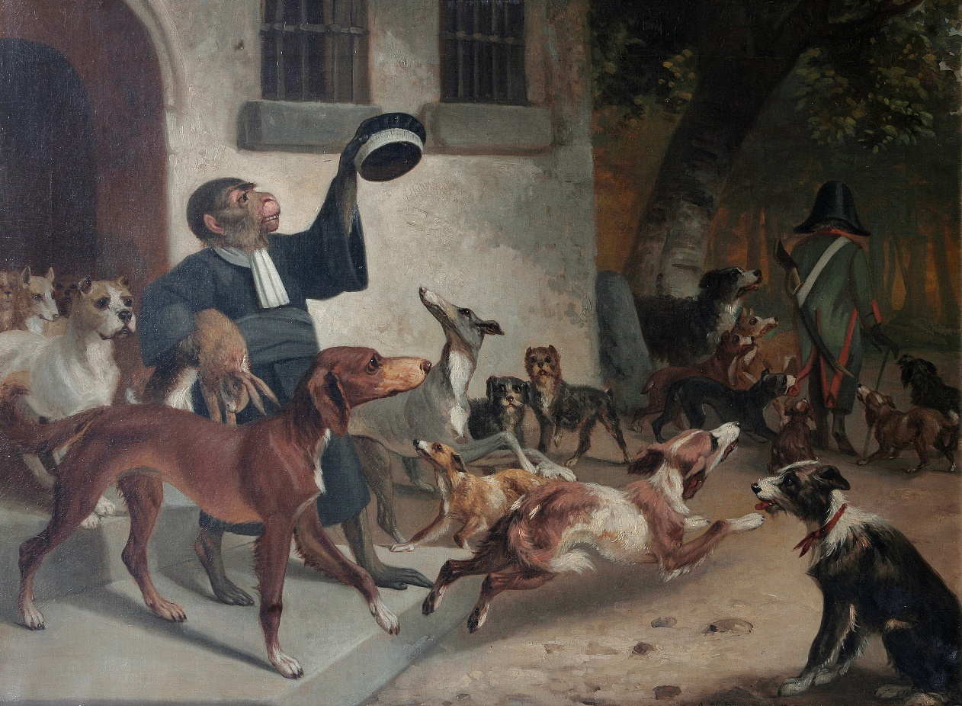 | Lot 309
304. | A pair of Late 19th Century Japanese porcelain vases, decorated figures in landscapes, each with two handles to the neck, each 91cm high. | £300-£500
305. | An Edwardian inlaid mahogany two handled tray, 63cm long. | £40-£60
306. | A Victorian mahogany square shaped centre table, on carved and pierced legs, united by a stretchered undertier, 78cm wide. | £80-£100
307. | H. Moore A.R.A. 1876 - rocky coastal scenes with ship in stormy weather, oil on canvas, signed and dated, each 24cm x 19cm. | £200-£300
308. | A 19th Century oval gilt frame girandole mirror, with shell crest, and foliate scroll decoration, 90cm high. | £100-£150
309. | A 19th Century school - scene of monkey dressed as cleric and holding dead hare, surrounded by dogs, waving at back of Napoleon, oil on canvas, 45cm x 61cm, based on a parody. | £400-£600
310. | Pierre Le Boeuff -"Abbeville", a view of the town square with small market, oil on canvas, 50cm x 75cm. | £300-£500
 | 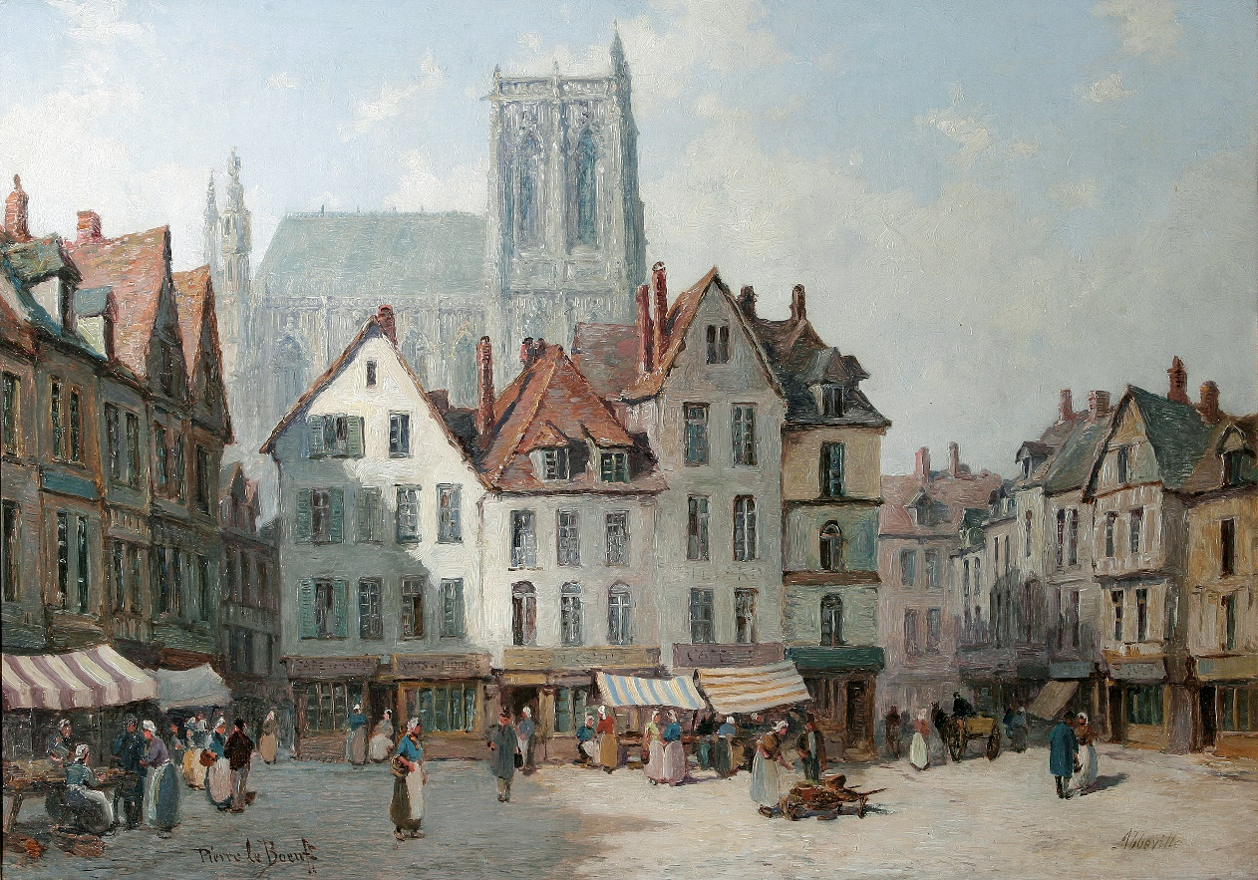 | Lot 310
311. | A pair of early 20th Century stained and leaded glass panels of kings Richard II and Henry III, each 37cm x 39cm. | £100-£150
312. | N. Drummond - gamekeeper with dogs and maiden carrying game outside cottage, oil on canvas, signed, 90cm x 70cm. | £300-£500
313. | A 20th Century limed wood and camphor blanket chest, with relief decoration, 100cm wide. | £40-£60
314. | An Edwardian mahogany circular centre table on turned and reeded legs, united by an undertier, 68cm in diameter. | £30-£50
315. | A small carved Whitby Jet brooch in lined box, together with a quantity of mixed decorative and costume jewellery, also a pink compact dish with Scottish Thistle. | £80-£100
316. | A circular freestanding dressing table mirror, with glass marble edge, 30cm dia., a small gilt metal stand, and a lacquered papier mache box (3). | £30-£50
317. | A reproduction filled sterling silver roundel, No. 306 of 750, copied from the Chellens Madonna bronze after Donatello, maker Pobloy Mint, London 1976. | £40-£60
318. | A George V silver three-piece tea set of octagonal form, maker S.B. & S. Limited, the teapot Birmingham 1926, the sugar and cream Chester 1927, 28oz overall. | £280-£320
319. | An Early 10th Century continental oak bookcase, enclosed by a pair of glazed doors, with applied flowerhead decoration, 131cm x 178cm high. | £100-£150
320. | An Early 20th Century North European oak bookcase, with central blazed bow shaped centre door, and two panelled doors, on reeded tapering feet, 180cm x 155cm, together with a pair of display cabinets, with bevelled glass panels, each 52cm x 130cm, and a two tier tea table (4). | £250-£350
321. | A oak kneehole desk, matching the previous lot, 161cm wide, together with an office elbow chair, two side chairs, and a green upholstered settee (5). | £200-£300
322. | An Early 20th Century French mahogany bedroom suite, with gilt mattress mounts, comprising: a wardrobe, 180cm wide x 210cm, a double size bed, a dressing table, 112cm wide, a pair of marble top bedside cabinets, each 40cm wide, and a pair of bedroom chairs (7). | £300-£500
323. | A late Victorian mahogany three-piece part salon suite, comprising a two-seater settee, and two elbow chairs, of scrolled design with carved decorations, on carved cabriole legs. | £150-£200
324. | An Early 20th Century Chinese lacquered urn stand, decorated dragons, and figures in landscapes, 42cm in diameter, 53cm high. | £60-£80
325. | An Early 20th Century Chinese wedding coat, and accessories. | £100-£150
326. | An octagonal occasional table, with elephant legs, and a small chair (2). | £40-£60
327. | A Chinese Lacquered papier mache vase, 54cm high. | £80-£100
328. | A carved and ebonised hanging cabinet, the door with bevelled mirror panel, 41cm wide. | £30-£50
329. | A Tiffany style floor lamp, with decorative shade, 147cm high. | £60-£80
330. | An octagonal shaped wall mirror, in pale green frame. | £20-£30
331. | Two Japanese leather Kendo face masks. | £40-£60
332. | A 19th Century French Chassepot bayonet, 1877, and a St. Ettienne bayonet, 1872, in scabbards (2). | £30-£50
333. | A WW2 German Mauser bayonet in scabbard, with frog, and a trench knife (2). | £50-£70
334. | A pair of Wilkinson blade rapiers, with bound grips (2). | £80-£100
335. | A brass and white metal bound Kris type dagger, 45cm long overall, and two wood and white metal inlaid daggers (2). | £100-£150
336. | A small Jambya type dagger, with bone handle, and a similar white metal dagger (2). | £80-£100
337. | A Scottish game keeper's or farrier's knife, with horn body, and multiple blades, 15cm long, folded. | £150-£200
 | 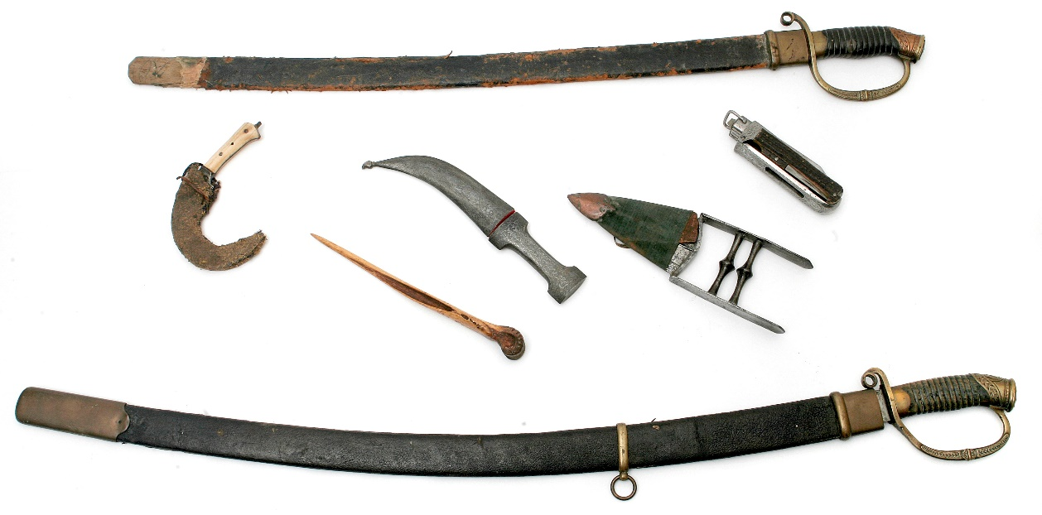 | Various lots between 332 - 358
338. | Three further horn game keeper's knives (3). | £80-£100
339. | A crudely carved Inuit type snow knife, the name "G. Dumeaux", inscribed to a label, 27cm long. | £80-£100
340. | A Scottish two blade horn handles game keeper's knife, by "Rogerson of Tozo", a bone handled folding knife, the blade by "Rogerson", and a Victorian ebony handled folding knife (3). | £90-£120
341. | An Indian Katar dagger, in bound wood scabbard, 27cm long. | £150-£200
342. | A WW2 German Kriegsmarine officer's car pennant, in blue cloth, eagle to centre on both sides, with pale fitting mount. | £300-£500
343. | A Victorian ivory and steel handled lock knife, circa 1870's, a similar bone handled knife, together with two further knives (4). | £80-£120
344. | A Dutch commando knife, with stained wood handle, 33.5 cm long overall. | £80-£100
345. | A horn handled hunting type knife, of a type issued to some British officers, in scabbard, 35cm long, overall, together with a cloth S.A.S. badge, in frame (2). | £150-£200
346. | A 19th Century Spanish Mediterranean dagger, turned handle, in leather scabbard, 29cm long, a Spanish lock knife with handle in the form of a hare, and a bone handled hunting knife (3). | £100-£150
347. | A hunting knife, with polished horn handle, the 15 cm blade by "Harrison Brothers and Harrison", in scabbard, a Congolese dagger, with scabbard, and an Indian style dagger (3). | £100-£150
348. | A 19th Century Spanish Mediterranean dagger, the blade by "Henrique Laport and Company", 18cm long, part polished spiral horn handle, with scabbard, a similar dagger with white metal, and a small decorative dagger (3). | £100-£150
349. | A fisherman’s knife with 10cm blade, by "Lund, Cornhill, London", stained wood handle in leather scabbard, a fisherman’s folding knife with stained wood handle, and a further folding blade knife (3). | £80-£100
350. | A small hunting knife, with fruit wood handle, in leather scabbard, a 19th Century Egyptian chopping knife, and a small hunting dagger (3). | £80-£100
351. | A part carved bone sacrificial dagger, 26cm long. | £60-£80
352. | A small bone tribal hunting knife, possibly Canadian or North American, carved with figures of elk, and some pierced decoration, 25cm long and a further hunting knife in scabbard (2). | £80-£100
353. | A Japanese lady's knife with hardwood handle and scabbard, 27cm long, and a small bone dagger, the scabbard carved with shields and warriors, 26cm long, and a small utility knife in bamboo scabbard (3). | £60-£80
354. | An Asian short blade dagger with bone handle in scabbard, 22cm long, together with three small daggers and hunting knives, and three lock knives (7). | £80-£100
355. | A Spanish horn handled, and brass mounted folding hunting knife by "Navasas of Toledo", 29cm long (folded), a further similar knife, four further dagger and knives, various (6). | £100-£150
356. | A George V 1895 pattern Royal Artillery Officers sword, the 82cm blade by "Hawksworth of Sheffield", in field service scabbard. | £150-£200
357. | An Imperial Russian Military Shashka, with broad slightly curved blade, 83cm long, with extensive stampings, brass stirrup hilt, the rear of the pommel bearing the monogram of Tsar Nicholas II in brass mounted leather and wooden scabbard. | £300-£500
358. | A similar Imperial Russian Shashka, with 74cm blade, with brass stamp hilt, the pommel bearing the monogram of Tsar Nicholas II, in brass mounted leather scabbard, a.f. | £200-£300
359. | A pair of Waterford glass "Sheila" pattern decanters, with stoppers, each 33cm high, and an Edinburgh Crystal whisky decanter, 25cm high (3). | £60-£80
360. | A set of six "Thos Webb" Crystal tumblers, in box, and a "Waterford" presentation box containing a set of six whisky tumblers (2). | £40-£60
361. | A mixed part suite of "Waterford" and "Stuart" Crystal drinking glass ware, including eight Stuart hock glasses, four Waterford tumblers, brandy goblets, six small wines, eight "Sheila" design champagne glasses, and other pieces, unboxed, approx. 43 total. | £60-£80
362. | A set of six Heinrich (Villeroy and Boch)" limited edition plates "Fairies of the Fields and Flowers" series, with three certificates (6). | £15-£20
 | 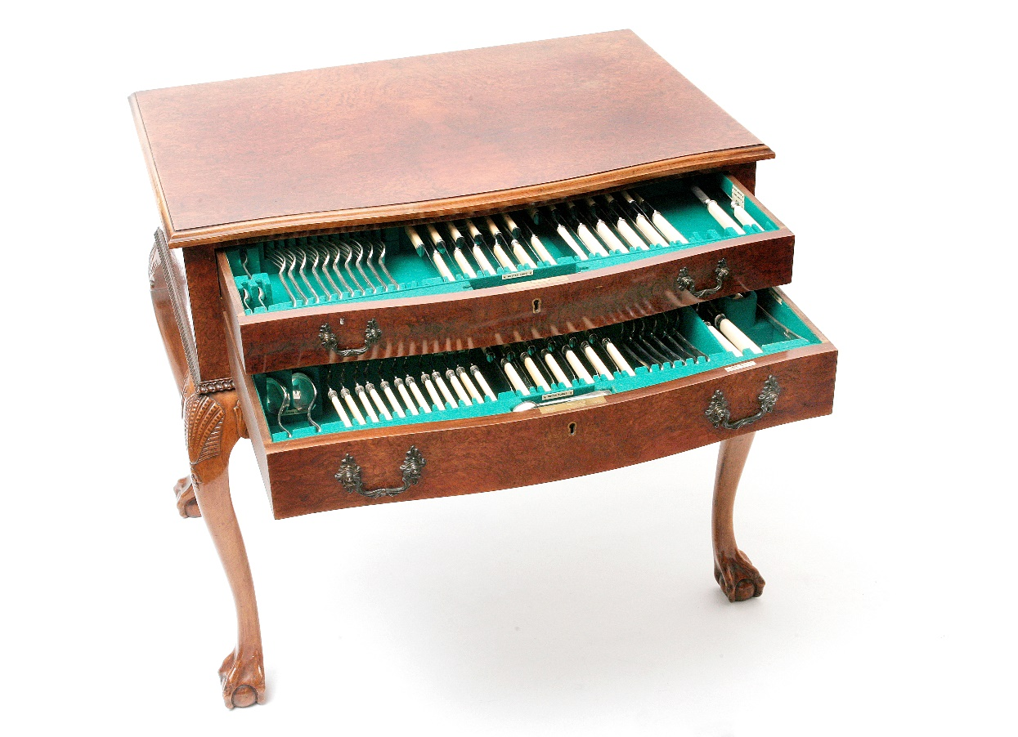 | Lot 363
363. | A suite of bone handled stainless steel, and silver cutlery, by "Walker and Hall", the table, dessert knives, and carving set with stainless steel blades, the fish eaters and remaining pieces in silver, Sheffield 1939 and 1940, approx. 100oz weighable, in a walnut veneered table form canteen, 79cm wide. | £800-£1200

AUCTION DATES 2020

Ibbett Mosely Auction Rooms, Argyle Road,
Sevenoaks, TN13 1HJ

Wednesday 8th April
Wednesday 13th May
Wednesday 17th June
Wednesday 22nd July
Wednesday 16th September
Wednesday 28th October
Wednesday 2nd December
Viewing on day before sale from
12.00 pm to 19.00 pm
and on morning of sale from
10.00 am to 12.30 pm
Sale commences at 12.30 pm

Valuation Day

Our next valuation date is

Wednesday 4th March

At Ibbett Mosely Auction Rooms from
11.00am to 16.00pm

